Application Functionality Report

Implementation of Attend Anywhere software to support video consultations during the covid-19 pandemic.

Author: Sue Hamer
Student Number: 2112925
11 March 2022

Introduction
Digital technology has been developing for decades, however in recent years the digital landscape has accelerated, more so with the impact and challenges the world has faced from the covid-19 pandemic. Introducing Health Information Technologies (HITs) has the potential to deliver care more effectively and efficiently (Prgomet et al, 2019); ensuring healthcare remains accessible and sustainable. Now is the time to embrace digital change more than ever.
The Welsh Governments policy, A Healthier Wales (2018) and A Digital Health and Social Care Strategy for Wales (2015) recognises digital as a key factor for transformational change, by introducing new ways of working and creating greater flexibility for the clinician and patient.
To address the communications gap, Technology Enabled Care Wales (TEC Cymru) and NHS Wales, developed a video consultation service in April 2020 for use by patients, clinicians, and admin teams, funded by Welsh Government to support health and social care. It was developed as a standalone system that does not integrate with any other system nor hold any patient data.
The objective of the software product as detailed by Digital Health Wales was to provide healthcare services in a safe and secure way to see patients via a video clinic, rather than seeing them in-person during the pandemic, and improved flexibility. Not only benefiting patients, but the product was also intended to support healthcare professionals who were shielding to continue providing frontline duties by working from home, as stated in the research by Johns et al (2021). The platform was intended to offer a consistent and agile solution for both professionals and patients.
With the challenges of rapid adoption to support an urgent need, phase 1 was about ensuring the platform was available to 405 general practices across Wales and phase 2 saw the scope extend to secondary care, community care and therapies a few weeks later.
Introducing a new product meant TEC Cymru had to ensure security measures, Information Governance and clinical assurances were met before health boards deployed the product, which was achieved by working alongside WG, Information Governance Management Advisory Group (IGMAG) and policy makers.
As suggested by Wherton et al, (2020) the application of providing video consultations as a way of providing a consultation with the patient and clinician has been growing steadily over the past 10 years. However, John et al (2021) argues that the method of seeing patients face to face has and remains the preferred method by patients (Johns et al, 2021).
With any new technology there is always resistance to change, but with the right implementation guidance and support, patients will receive a productive virtual appointment.
The aim of introducing Attend Anywhere (AA) was to transform the way appointments were managed, reducing the need to bring patients into a health care setting and controlling the spread of the highly infectious disease which required rapid adoption to ensure the NHS remained accessible during unprecedented times (Digital Health Wales, 2020).
Powys Teaching Health Board (PTHB), initially supported departments who expressed an interest in piloting the software, by arranging a team’s session to discuss how it would work, the benefits, key features, accessing training through TEC Cymru and going through the steps of a go-live checklist. A small project team was deployed to support the health board deploy the VC platform which was rolled out at pace.
Engagement continues within PTHB to support departments who have not yet embraced Virtual Consultations (VC). A webpage has been created to support professionals and patients access their virtual appointment which contains useful user guides and case studies. (PTHB Virtual Clinics, 2021)
Other platforms being utilised pre-covid and predominantly used by GP practices is accuRx, which was the software used by NHS England during the covid pandemic which was part of the GP IT Futures framework. The other platform that started to pick up pace during the pandemic was the use of Microsoft Teams due to its ease of use being able to provide group sessions and link to the MS Bookings App.
Johns et al, (2021) undertook an evaluation of using video consultation during the pandemic in Wales. The online survey completed by 1256 NHS professionals shared their experiences on the challenges and benefits of using the software product. Jackson et al (2021) has documented that there is evidence to suggest that VC is cost effective and efficient which can improve access, which is what this research aims to quantify.
The introduction of VC has meant changes to departments workflows, ensuring professionals are utilising a revised protocol and assessing whether a patient needs to be assessed in person or can a VC or telephone appointment suffice, and prioritising those at greater risk. Restructuring workflows can be challenging and often fail because they have not been implemented correctly and because well-embedded practices are hard to change. (NHS England, 2020)
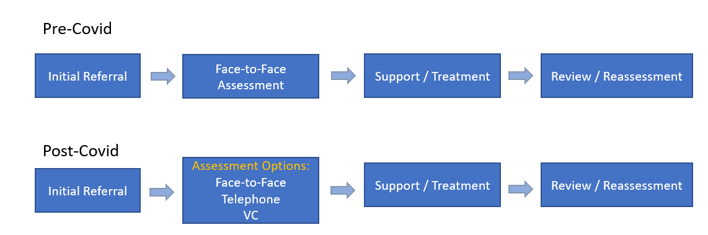
As evidenced by The Welsh Government (2019), the triage model becoming more widely used and the traditional face to face consultation is starting to become less the norm which has had an impact on clinical workflows (Figure 1). The first structured method for documenting process flow, was introduced by Frank Gilbreth (1921). The method developed was created to inform action, highlight issues, or identify opportunities for improvement.

Figure 1
AA Referral workflow diagram

Although the Welsh Government initially accelerated the rollout of the NHS Wales video consulting service to help the NHS in tackling Covid-19, the service continues to be widely available to allow patients to access healthcare in a convenient and timely manner both now and in the future. It is significant to acknowledge that although the last 2 years have been challenging, it has brought beneficial change which needs to continue to support our NHS.
With the product being funded until 2025, there is an opportunity to evaluate the effectiveness of the software product and to understand what NHS professionals and patients believe are benefits and limitations of the tool and any areas that pose challenges, by engaging with them to explore quantitative and qualitative user research.
As stated by Tsiknakis and Kouroubali (2008) in their literature research, healthcare continues to experience pressures from inside and outside, from an ageing population, increased demand on services and a reduction in the workforce. ICT is considered central to any strategy designed to improve care, control costs and enhance productivity.
Reviewing organisation factors that influence implementation are crucial to the health care sector, however previous evaluation models have missed to consider the interface between user and task, and if the software product “fits” within the organisation. Tsiknakis and Kouroubali (2008).
This formative evaluation will utilise the FITT framework (2006), taking into consideration how the VC product “fits” within PTHB, which can help improve the usability and functionality of the overall system in future developments, so more services engage with using the product, ensuring a sustainable platform long term.
Method
There have been many theory models developed for the adoption of IT. E Rogers (1995), was the first researcher to concentrate on diffusion and adoption.

The FITT framework is a recent model which is based on the principles that IT adoption should consider 3 key factors when procuring or implementing a new product as described by Ammenwerth et al (2006). These are referred to as the “fit” between individual and task, “fit” between individual and technology, and fit between task and technology. (Figure 2). The framework is an iterate process that can be evaluated at any stage of implementation, or when a product has been adopted to ensure it is fit for purpose and meets the intended requirements.

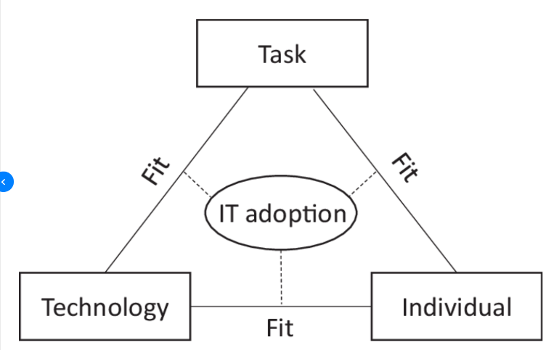

Figure 2
The HITT Framework: success of HIT acceptance relies on the fit between task, technology and individual.

The 3 factors consider how the system makes the individual feel i.e., anxious, or motivated, the characteristics of the technology i.e., usability, and the complexity of the task in using the system.
Information Technology has existed for about 40 years in health care, however, Davies & Lloyd-Williams (1999) states that not all projects have been successful due to lack of power, structure, planning, lack of stakeholder engagement and assessment of risk. These failures can lead to a loss of confidence in IT applications from users and senior management, and a loss of healthcare money.
For many years the approach has been a top-down model for healthcare information technology (IT) with Government embedded in the process of IT implementation. (Coiera, 2009). This has meant that co-creating a software product with the end user or patient in mind has not always been considered which has meant the product has not always been fit for purpose. (Eason & Waterson, 2014).
When issues or risks are discovered, utilsiing the FITT evaluation framework allows designers to systematically target improvements from user feedback, which can support implementation and adoption.
The Technology Acceptance Model (TAM) designed by Davis, (1989), was created to evaluate why users reject or adopt a system, which is widely used in health care. It is an influential model of technology acceptance that highlights the "perceived ease of use" and "perceived usefulness" to analyse attitude against actual system use. The interoperability of both components depends on what the system provides. (Figure 3).
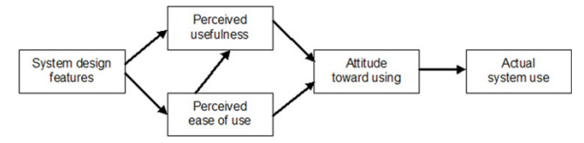

Figure 3
Technology Acceptance Model (TAM), by Davis.

Kim and Chang (2006) introduced the model and found that “perceived usefulness” was crucial when implementing a new product.
The aim of this study was to assess the views of both professionals and patients’ using VC, the benefits, and what they considered challenges using the system, using the FITT framework to evaluate the findings, incorporating the TAM model.
To evaluate the effectiveness of Attend Anywhere, NHS employees were sent a link to complete a Teams online form which was open for a period of 2-weeks from 4 February 2022 to 18 February 2022. Themes from previous discussions with individual departments and observations were also taken into consideration.
Due to the restrictions with COVID-19 and winter pressures, it meant interviews were difficult to arrange and were therefore discounted as a way of collecting data.
This study used a survey that incorporated a blend of questions with rating scales using a matrix and free text questions, which allowed the researcher to capture the views of professionals using AA.
This measure contains a mix of positive and negative questions, for example, ‘I think the system is easy to use and ‘I find the system very cumbersome to use’. Each question was rated using the 5-point Likert Scale with 1 being strongly disagree to 5 being strongly agree.
Demographics of the users were captured to see if there were any themes related to age and gender and the department they worked for to evaluate any themes in terms of engagement and usage. By using a cross-sectional survey, it allowed for AA to be viewed on a scale of variables to analyse trends arising within the quantitative data.
The departments were categorised as Community Care & Therapies, Mental Health & Learning Disabilities, Community Dental, Women & Children, Public Health and Nursing.
In addition, responders were asked whether they found any limitations/issues in using the system as a free text response, and what they found were the main benefits in using AA from a list of options and what would make them more inclined to use AA in the future, again from a list of options. This allowed for in-depth insights to be evaluated through qualitative feedback.
Patient involvement
A separate survey was shared with patients from 8 July 2021 to 20 December 2021. The study used a survey that incorporated a blend of questions with rating scales using a matrix and free text questions and drop-down options, which allowed the researcher to capture the views of patients’ using VC following their consultation. Demographics and area of residence were also captured to review any themes relating to age and gender.
Results
Quantitative and qualitative data has been gathered to give a rich insight into what users find as benefits, limitations or challenges with the system and reviewing data around the usability of the system.
NHS Professionals Involvement
517 email invitations were shared with NHS professionals, clinical and non-clinical, over a 2-week period and 26 (5%) responded. Of all respondents, the majority (31%) were in the age categories 55-64, 27% were aged 45-54, 23% were 35-44, 8% were between 25-34, 8% were under 24 and 3% were 65 and over. 77% were completed by a female. Most of the responses (46%) came from Community Care and Therapies, with 38% of the responses from Mental Health and Learning Disabilities Team. (Diagram 1).

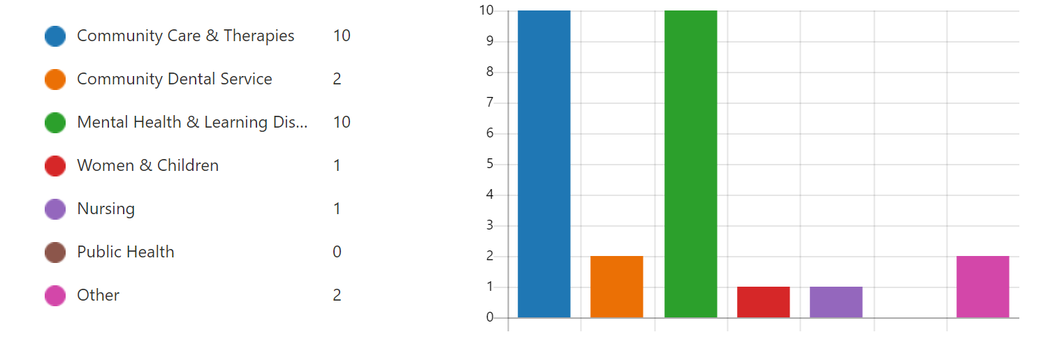

Diagram 1
PTHB Departments completing the survey
26 people responded to the 10 matrix questions which was developed using the 5-point Likert Scale, answering strongly disagree to strongly agree.
The results indicate that the average dropped when asked if they found the system cumbersome to use and that it increased admin tasks. Although they were able to learn the system quickly, liked using the system and found it easy to use. (Table 1). When asked if they were motivated to use the system, 58% rated between 4-5 “strongly agree”. 63% responded that they “strongly agree” that the introduction of AA had been successful for staff, patients, and the organisation.
Question | Average score
- I like using the system | 4.13
- I think the system is easy to use | 4.29
- I find the system very cumbersome to use | 2.96
- I learned to use the system very quickly | 4.29
- I need the support of a technical person to use the system | 1.46
- I am motivated to use the system | 3.83
- I find the system reliable and stable | 3.46
- I prefer to use video consultations than telephone consultations | 4.13
- I find video consultations increases admin tasks | 2.96
- I believe the introduction of Attend Anywhere has been successful for staff, patients & the org | 3.83
Table 1
Response to individual matrix questions using a 5-point Likert Scale

There was a theme from individual responses when asked if there were any limitations and issues when using AA. (Diagram 2)

Diagram 2
Response to System Issues / Limitations

16% stated they experienced picture freezing, lagging, delays with communication, video cutting out and 1 user reporting MS Teams was a better platform for stability. 32% raised problems with the local network / Wi-Fi, 29% suggested incorporating additional functionality i.e., chat and break out rooms, group meetings, a record of invitations being sent, introducing a whiteboard. 16% was about empowering patients to feel confident using the system and 8% focused on ensuring working rules were in place with patients i.e., confidential space, being committed to the appointment and remaining focused.
When asked what would make the healthcare professional more inclined to use the system, the main themes were; the ability to have a chat function, breakout rooms, recording and transcribing.
The benefits show many positives which align to the findings by Johns et al (2021). (Diagram 3). Being able to see the patient without the need to travel was categorised as the main benefit (35%) with saving time on travel and reducing the carbon footprint selected by 30% of respondents.

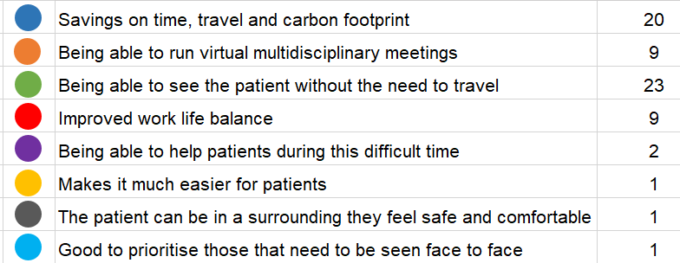

Diagram 3
Benefits to using Attend Anywhere

Patient involvement
Over a period of 5 months (8 July 2021 to 20 December 2021), patients were asked to complete a short survey following their AA appointment. 280 patients responded during this period.
The majority of the respondents (25%) were in the age category 65 and over, with the lowest (5%) being in the 18-24 category. (Diagram 4). This supports the finding by Tsiknakis and Kouroubali (2008), who discovered that introducing IT supports an ageing population and accessing health care without the need to travel.
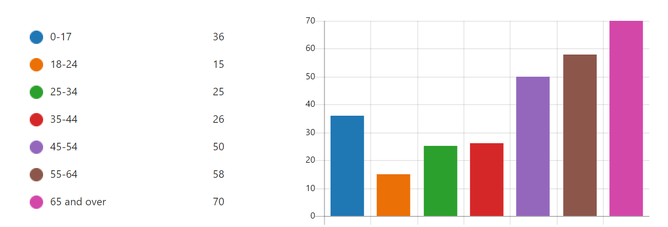

Diagram 4
Patient Demographics

The majority of the respondents (28%) had accessed VC to attend a physiotherapy appointment and the average rating for communication received by the clinician in advance of the appointment scored 4.7 stars.
Looking at ways to improve the process of providing further information to access the video call, 20 people responded on how they felt this could be achieved. 25% responded that connectivity was an issue and 25% noted that receiving an appointment reminder would be helpful. 15% requested an outlook calendar invitation, 10% had technical problems i.e., microphone not working, couldn’t see clinician, and 25% asked for a more seamless process i.e., advance warning it takes a few minutes to log on, step by step guide providing series of events and having a login to avoid adding the same information each time attending a VC.
When asked if they found accessing the VC service easy to use, 97% responded “yes”. When asked if support was available if required, 49% stated yes and 45% stated it was not required.
There was a significant positive response when patients were asked if they were happy to have a VC appointment to help manage their condition, with 85% responding “yes”. With the 6% who said no, the consensus was that they would have preferred a face-to-face appointment due to the nature of the appointment, for example, psychological therapy and exercises.
The benefits show many positives which are aligned to the findings in the Johns et al (2021) report. (Diagram 5). Not having to travel was categorised as the main benefit (34%) with 19% stating the importance of reducing the carbon footprint.
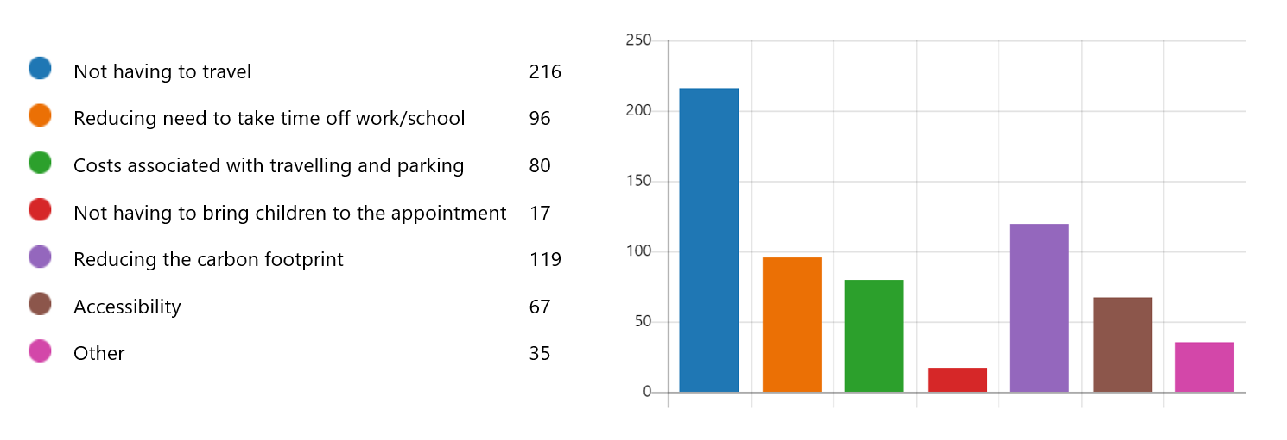

Diagram 5
Benefits of having VC

Other benefits provided were around covid control, VC being a better option than receiving a telephone call, and it meant they were seen by their healthcare professional sooner.
When asked if they would like to use VC as a means of receiving a healthcare appointment, 96% responded “yes”.
A further important benefit was the time spent not having to travel to an appointment. 32% of respondents saved over 1 hour (return journey) by not having travel to their appointment, and 30% saved between 31-59 minutes. (Diagram 6).

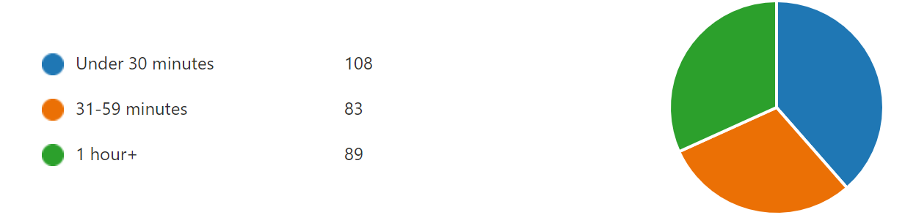

Diagram 6
Savings on Travel Time having a VC

Based on the analysis of the overall results, the following breakdown shows an uncomplicated IT adoption based on the fit between the task, technology and individual:
Fit between Individual and Task
The fit is uncomplicated and has more of an impact on the administrative workload as they need to schedule in the appointments, so the health care professional and patient access the correct video link. It’s not a “one fits all” option and is not suitable for some appointments, for example a conversation with the HBs Optometry Lead, Cottrell P highlighted that the resolution is not sharp enough to support eye care appointments, however it compliments other means of providing a consultation to suit the patient and health care professional.
This change requires adjusting the workflow to provide a further option from telephone consultation and a face-to-face appointment when the admin staff are arranging appointments. It also doesn’t integrate with any other system; therefore, the user still needs update the Welsh Patient Admin System (WPAS) following a consultation.
Fit between Individual and Technology
Results from the validated questionnaire shows that users liked using the system, they learned to use it very quickly and they didn’t need the support of a technical person to use it. However, when asked if they were motivated to use the system, the overall average fell-down slightly to 3.83.
Fit between Task and Technology
The benefits to using AA are strongly documented from the user and patients’ perspective, supporting patients access their consultations without the need to travel and minimising the spread of Covid-19 over the past 20 months, and is more beneficial then conducting a telephone consultation as the clinician still gets to see the patient. The objective and effectiveness of the system design has been achieved.
The qualitative feedback provides useful insights into the challenges of using the system which could be considered as being linked to being motivated to use the system, which is where the challenges were identified in the research carried out by Johns et al (2021), and where improvements are needed. Issues were reported with the quality of the platform when conducting a consultation and the Wi-Fi not being stable in some areas.
The reliability of the system seems problematic and incorporating additional functionality would make healthcare professionals more inclined to use AA compared to MS Teams which is what the aim should be, as funded by WG.
Intervention with regard to task:
None identified.
Intervention with regard to user:
None identified.
Intervention with regard to technology:
Improving the fit would involve introducing greater functionality which would fill the gap that other platforms are offering. For example, MS Teams. These include chat and break out rooms, group meetings, a record of invitations being sent and introducing a whiteboard.
The reliability of the system seems a limiting factor due to the network infrastructure and the quality of the platform needs consideration, which is a reason why some departments are not inclined to use.
Discussions
This study aimed to evaluate health care professionals and patients’ experiences of using a video consultation web-based application, especially its usability in providing access to care from consultants without the need to travel during a pandemic.
This paper has used the principles of the FITT framework which is one of the most recent models and was developed specifically for the health and care domain (Ammenwerth, 2006), which is a validated tool to apply. It is based on the interface between the task, technology and individual in which they operate to identify factors leading to either the failure of, or the successful adoption of technology. The FITT framework was used in conjunction with the TAM model to evaluate the attitude to using the system, the "perceived ease of use" and "perceived usefulness" in adopting AA to support video consultations during the covid-19 pandemic.
Both Galway et al (2021) and Sclafani et al (2021) research suggests that IT has the ability to enhance patient care by eliminating barriers to health care access, reducing the amount of time away from school and work, and re-enforcing patient education, which are consistent with the results of this review. It may also be more economically viable than a face-to-face encounter as evidenced in the benefits summary.
The analysis of the feedback from the professionals’ point of view and patients showed very similar themes when it came to benefits of the system and challenges, which could be a barrier to adoption. From internal discussions and observations, there are departments that continue not to engage with the platform, for example planned care, due to the quality of the platform and network infrastructure.
Welsh Government are in the process of going to tender for a new supplier, so this provides an optimum moment to include the requirements of additional functionality to attract more departments to use the software as Welsh Government funding has been extended until 2025.
Wyatt (2016) explains the importance of Using Evidence-based Health Informatics (EBHI), which evaluates the impact on system acceptability, its effectiveness or usage, which has been incorporated when reviewing the feedback from 280 patients. As Middleton et al (2013) confirms, the evaluation focuses on feedback from those using the system rather than relying on advice from experts. Having access to this rich data usually leads to safe, effective, and usable systems.
The concept of using the FITT model has been around since the early 2000s, and utilised by many authors, such as Nilsson et al (2020) and Dixon (1999), who found the FITT framework to be a reliable strategy to implement Information Technology. However, as Coiera (2009) states that with any new IT system, implementation does not always guarantee organisational change or success, and introducing a top-down model with consulting with staff who are required to use a new system always carries a level of risk.
Prgomet et al (2019), used an extended version of the FITT framework to evaluate Health Information Technology use in Australia. They found that even when the fit was adequate between the individual, task and technology, the additional factor was environment. This formed part of Johns et al (2021) review where environmental benefits were stated around the reduction of paper waste, petrol, and carbon footprint. This additional factor would have benefited this evaluation.
Due to the lack of formative evaluation frameworks, Creswell et al (2020), developed an evaluation tool to support HIT implementations that considered 4 factors: Technology, People, Organisation and Macroenvironment (TPOM). The tool was designed to help evaluate how the new system was being used, any emerging risks and what changes were required to support adoption.
From undertaken this formative review on AA, the author felt that the FITT framework is better aligned to a new system affecting an individual department or team at a small level. TPOM is more organisational wide, supporting large scale change which would have been a better fit for the evaluation of AA, as it was a health board wide system implementation that span across the whole of Wales.
Formative evaluations can help direct challenges that affect the successful adoption of HITs, as acknowledged by Cresswell & Sheikh 2014. They can support decision makers in shifting from a reactive state to proactive, which is where the implementation of AA is currently at. With WG going out to tender in the next few months, the results from this formative evaluation can be used to improve on developing the functionality of the system to ensure it remains as a sustainable platform for the future.
Research conducted by Coiera (2019) looked at the theory behind the value chain in health informatics. To ensure HITs work, the design and evaluation of a product is crucial. The evaluation must help determine if a system is fit for purpose and decide if a system is the best choice amongst alternatives. The response from professionals and patients evidences that AA is fit for purpose, however some departments are favouring MS Teams due to it being more reliable and it offers greater functionality.
Cresswell et al (2020) found that technology never exists in isolation; it is therefore important to appreciate that technological change can depend on the culture of an organisation and the wider landscape in which they are located, including economic climates, development of markets and health policies.
It is important to recognise the importance of seamless care, ensuring efficient and effective care continues when a system is introduced, and all those who are involved with a patient’s healthcare journey are aware of the workflow for continuity. Feedback showed that VC was offered so patients could see their healthcare professional sooner and meant those at greater risk could be prioritised.
Benefits of using Attend Anywhere
The benefits are clearly defined from the patients and professional’s point of view. A large proportion responded that they saved on time not having to travel and it supported the reduction of the carbon footprint. This is prevalent in Powys as 50% of Secondary Care is provided across the border, so patients can experience travel times in excess of 1 hour. This aligns with the findings of Jackson et al (2021) that providing VC is cost effective.

Challenges of using Attend Anywhere
Previous discussions held with department leads evidenced that some patients did not have access to technology to join a VC appointment and some didn’t feel confident in using technology to receive an appointment. Digital Facilitators have been employed to empower patients who are less digitally confident, and a pilot hub has been established so patients can access a VC appointment from a community location with the support of third sector volunteers.
Improvements needed
The current system does not integrate with any other system; however, this doesn’t seem to be an issue with AA. Areas that need consideration are improved connectivity, better Wi-Fi, and additional functionality for the user to allow for group sessions, break out rooms, facility to send appointment notifications and linking to a bookings App.
Limitations
The study presents some limitations from NHS staff feedback. The response rate of 5% is low and therefore the results are open to bias. Also 77% of the feedback came from Community Care & Therapies, and Mental Health & Learning Disabilities departments, which are the two main departments utilising the platform. Some could argue that their needs to be a 360-degree feedback from those who are not engaging with AA and the reasons why to understand any limitations and if alternative platforms are being used.
The author was unable to source any qualitative literature papers based on other VC platforms, for example AccuRx and MS Teams to carry out any comparative benefits against Attend Anywhere. With VC being more profound the past 2 years, it needs more time to be analysed to give further objectional view.
When carrying out any future user feedback, the researcher would look to use the SUS scale developed by John Brooke in 1986 as a valid tool for measuring usability, which would provide a benchmark score for differentiating between a usable and unusable system.
Conclusion
The unexpected onset of the Covid-19 pandemic forced the health service to provide new ways of working so patient communication and care could continue in a safe environment. The introduction of AA was a reactive and rapid response delivered by TEC Cymru and funded by Welsh Government across NHS Wales.
When implementing a new system, evaluating the factors that may affect adoption is critical, as introducing a change that can impact efficiency and effectiveness of clinical work practices won’t always lead to successful acceptance.
The majority of findings carried out evidence that WG have made a positive impact on communication by introducing AA. It is has allowed for patients to keep in contact with their health care professionals during a difficult period. Seeing a patient virtually can support mental health when patietns are isolating isolating times which has supported the population as the next best thing to being seen face to face.
From the evidence of the formative feedback, it is evident that the adoption of AA has been successful, and that VC should be offered and used where it is deemed clinically appropriate. The barriers did not out way the benefits of the product and incorporating minor interventions with the new version with regards to functionality and system issues can ensure a sustainable and usable system long-term, which can benefit both patient and health care professional.
It is important to recognise that not everything can be digital, and people can’t be excluded from accessing health care. VC allows the flexibility to give patient choice, which is what should always be considered.
about the impact on patient and health professional maybe and how technology is the future etc etc keeping communication open when it is difficult to travel due to shielding or isolating etc etc

Referencing
- Ammenwerth, E., Iller, C. and Mahler, C., 2006. IT-adoption and the interaction of task, technology and individuals: a fit framework and a case study. BMC medical informatics and decision making; BMC Med Inform Decis Mak, 6(1), pp. 3.
- Beynon-Davies, Paul & Williams, Michael. (1999). When health information systems fail. Topics in health information management. 20. 66-79.
- Coiera, Enrico. (2019). Assessing Technology Success and Failure Using Information Value Chain Theory. Studies in health technology and informatics. 263. 35-48. 10.3233/SHTI190109.
- Coiera, E. (2009) ‘Building a National Health IT System from the middle out’, Journal of the American Medical Informatics Association: JAMIA, 16(3), pp. 271–273. doi:10.1197/jamia.M3183.
- Cresswell, K. M., & Sheikh, A. (2014). Undertaking sociotechnical evaluations of health information technologies. Informatics in primary care, 21(2), 78–83. https://doi.org/10.14236/jhi.v21i2.54
- Cresswell, K., Williams, R., & Sheikh, A. (2020). Developing and Applying a Formative Evaluation Framework for Health Information Technology Implementations: Qualitative Investigation. Journal of medical Internet research, 22(6), e15068. https://doi.org/10.2196/15068
- Davis, F.D. (1989) ‘Perceived Usefulness, Perceived Ease of Use, and User Acceptance of Information Technology’, MIS quarterly, 13(3), pp. 319–340. doi:10.2307/249008.
- Digital Health NHS England (2021) Extends accuRx’s Contract for free video consultations. Available at: NHS England extends accuRx's contract for free video consultations (digitalhealth.net). (Accessed 21 February 2022).
- Digital Health Wales (2020). Available at NHS Wales Video Consulting Service | Digital Health Wales. (Accessed 18 February 2022)
- Dixon, D.R. (1999) ‘The behavioral side of information technology’, International journal of medical informatics (Shannon, Ireland), 56(1), pp. 117–123. doi:10.1016/S1386-5056(99)00037-4.
- Eason, K. and Waterson, P. (2014) ‘Fitness for purpose when there are many different purposes: Who are electronic patient records for?’, Health informatics journal, 20(3), pp. 189–198. doi:10.1177/1460458213501096.
- Galway, N. et al. (2021) ‘Fifteen-minute consultation: A practical approach to remote consultations for paediatric patients during the COVID-19 pandemic’, Archives of disease in childhood. Education and practice edition, 106(4), pp. 206–209. doi:10.1136/archdischild-2020-320000.
- Jackson, L.E. et al. (2021) ‘Meeting families where they are: institution, evaluation, and sustainability of telemedicine prenatal neonatology consultation in the COVID-19 pandemic health emergency’, Seminars in perinatology, 45(5), pp. 151417–151417. doi: 10.1016/j.semperi.2021.151417.
- Johns, G. et al. (2021) ‘Taming the chaos: NHS professionals’ perspective of using video consulting during COVID-19 in Wales’, BMJ open quality, 10(4), p. e001318–. doi:10.1136/bmjoq-2020-001318.
- Kim, D. and Chang, H. (2006) ‘Key functional characteristics in designing and operating health information websites for user satisfaction: An application of the extended technology acceptance model’, International journal of medical informatics (Shannon, Ireland), 76(11), pp. 790–800. doi: 10.1016/j.ijmedinf.2006.09.001.
- Lindberg, B. et al. (2013) ‘Using Information and Communication Technology in Home Care for Communication between Patients, Family Members, and Healthcare Professionals: A Systematic Review’, International journal of telemedicine and applications, 2013, pp. 461829–31. doi:10.1155/2013/461829.
- Middleton, B. et al. (2013) ‘Enhancing patient safety and quality of care by improving the usability of electronic health record systems: recommendations from AMIA’, Journal of the American Medical Informatics Association: JAMIA, 20(e1), pp. e2–e8. doi:10.1136/amiajnl-2012-001458.
- NHS England. Advice on how to establish a remote ’total triage’ model in general practice using online consultations, 2020. Available: https://www.england.nhs.uk/ coronavirus/wp-content/uploads/sites/52/2020/03/remote-total-triage-model-ingeneral-practice-27-march-2020.pd. Accessed 13 February 2022.
- Nilsson, L. et al. (2020) ‘Patients’ experiences of using an e-Health tool for self-management support after prostate cancer surgery: a deductive interview study explained through the FITT framework’, BMJ open, 10(6), pp. e035024–e035024. doi:10.1136/bmjopen-2019-035024.
- Powys Teaching Health Board Virtual Clinics (2021) Available at Virtual Clinics with Attend Anywhere - Powys Teaching Health Board (nhs.wales). Accessed 13 February 2022.
- Prgomet, Mirela & Georgiou, Andrew & Callen, Joanne & Westbrook, Johanna. (2019). Fit Between Individuals, Tasks, Technology, and Environment (FITTE) Framework: A Proposed Extension of FITT to Evaluate and Optimise Health Information Technology Use. Studies in health technology and informatics. 264. 744-748. 10.3233/SHTI190322.
- Sclafani, A.P. et al. (2021) ‘Telemedicine lessons learned during the COVID-19 pandemic: The augmented outpatient otolaryngology teleconsultation’, American journal of otolaryngology, 42(4), pp. 102960–102960. doi:10.1016/j.amjoto.2021.102960
- Tsiknakis, M. and Kouroubali, A. (2008) ‘Organizational factors affecting successful adoption of innovative eHealth services: A case study employing the FITT framework’, International journal of medical informatics (Shannon, Ireland), 78(1), pp. 39–52. doi:10.1016/j.ijmedinf.2008.07.001.
- Welsh Government A Healthier Wales (2018). Available at A Healthier Wales (gov.wales) (Accessed 15 November 2021)
- Welsh Government Informed Health and Care - A Digital Health and Social Care Strategy for Wales (2015). Available at A Digital Health and Social Care Informed Heath and Care; (gov.wales) (Accessed: 20 October 2021)
- Welsh Government Statistical First Release (2019). Available at NHS Direct Wales: 1 July to 30 September 2019 (gov.wales). (Accessed 21 February 2022).
- Wherton, J. et al. (2020) ‘Guidance on the introduction and use of video consultations during COVID-19: important lessons from qualitative research’, BMJ leader, 4(3), pp. 120–123. doi:10.1136/leader-2020-000262.
- Wyatt J. C. (2016). Evidence-based Health Informatics and the Scientific Development of the Field. Studies in health technology and informatics, 222, 14–24.

