ENTREPRENEURSHIP
NAME: Antonella Gaeta
STUDENT NUMBER: 2217962
MODULE: Entrepreneurship LCMB7004
LECTURER: Jaya Gopalkrishnan
COURSE: Master of Business Administration
SUBMISSION DATE: 5th May 2023

Executive Summary
This report aims to explore several topics related to entrepreneurship and organizational structures. It can begin by discussing the various theories of entrepreneurship, which provide insights into the traits, characteristics, and motivations of successful entrepreneurs. Difference between for-profit and not-for-profit organizations has highlighted based on their primary objectives, funding sources, and management structures. Values and beliefs have been explored here that underpin the decisions and actions of entrepreneurs, and how these can influence the organizational structure and management of their businesses. By understanding these concepts, entrepreneurs can make informed decisions about the type of business they want to start and the organizational structure that aligns with their values and goals.

Table of Contents
Introduction 3
Implement some theoretical sources to evaluate the characteristics, motivations, and attributes of the entrepreneurs 3
Distinguishes between 'for profit' and 'not for small profit organisations based on entrepreneurs' values 7
Conclusion 11
References 12

Introduction
Entrepreneurship plays a critical role in driving innovation, job creation, and economic growth in the UK and around the world. Entrepreneurs are focused on creating a desire to create something new and innovative something by being willing to take risks to achieve goals. However, starting a business can be challenging, and requires a wide range of skills, knowledge, and resources. This report aims to explore several topics related to entrepreneurship and organizational structures. It can begin by discussing the various theories of entrepreneurship, which provide insights into the traits, characteristics, and motivations of successful entrepreneurs. Difference between for-profit and not-for-profit organizations is going to highlight their primary objectives, funding sources, and management structures. Role of entrepreneurs in the UK business ecosystem and examining how they can contribute as entrepreneurs, intrapreneurs, support providers, or policymakers is also going to discuss here. In addition, through exploring core values and beliefs different aspects are going to be underpinned according to the decisions and actions of entrepreneurs. It also focuses on how these can influence the organizational structure and management of their businesses.

Implement some theoretical sources to evaluate the characteristics, motivations, and attributes of the entrepreneurs
Evaluating concepts about enterprise and entrepreneurship
Entrepreneurs are individuals who create and run new businesses or organizations. To succeed, entrepreneurs must identify opportunities in the market, develop innovative solutions, and manage the risks and uncertainties of starting a new venture. They must also navigate the complex legal, financial, and regulatory environment in which they operate. Entrepreneurs should focus on developing a robust business plan, building a strong network of contacts and advisors, and staying agile and adaptable in the face of changing market conditions (Fayolle, 2018). Entrepreneurship support providers are organizations that offer services and resources to entrepreneurs and intrapreneurs. They may include incubators, accelerators, venture capital firms, banks, and government agencies. These organizations play an important role in supporting the expansion and growth of new businesses. Port providers should focus on providing high-quality, tailored services to their clients, building strong networks of mentors and advisors, and staying up-to-date with the latest trends and best practices in entrepreneurship. Policymakers are government officials who create and implement policies that affect entrepreneurship and enterprise (Kucharčíková et al. 2018).
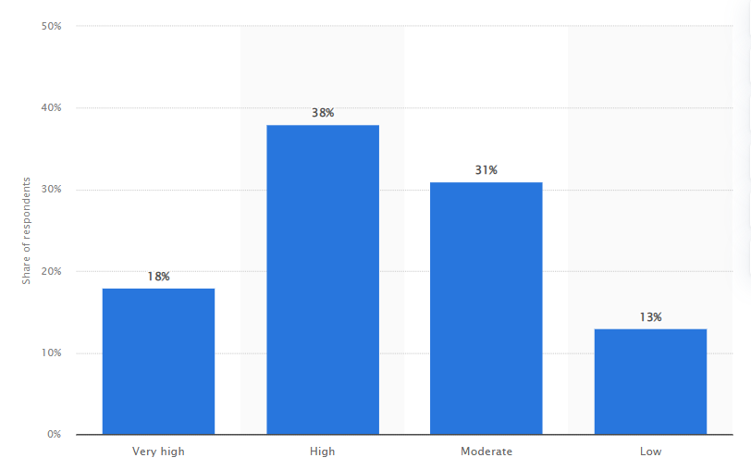
Figure 1: Entrepreneurial spirit index as of 2018
(Source: Statista.com, 2021)
This statistic represents the outcome of the entrepreneurial spirit index in 2018 where around 18 per cent of respondents has an "extremely high" entrepreneurial spirit (Statista.com, 2021). They must balance the need to promote economic growth and job creation with the need to protect consumers, workers, and the environment. Policymakers should focus on creating a supportive regulatory environment for entrepreneurs, providing access to funding and resources, and promoting education and training programs that prepare individuals for careers in entrepreneurship and enterprise.
Therefore, enterprise and entrepreneurship are complex topics that require a multi-faceted approach. By understanding the perspectives of different stakeholders, including entrepreneurs, intrapreneurs, support providers, and policymakers, developing more effective strategies to promote innovation, job creation, and economic growth (Khalil, and Khalil, 2020). Different software development companies specialize in developing and delivering software applications, systems, and platforms for businesses, governments, and consumers. Examples of software development companies include Microsoft and Adobe. Some Hardware manufacturers produce and distribute computer hardware components and devices, such as laptops, desktops, servers, and mobile devices. Examples of hardware manufacturers include HP and Lenovo.
Critically evaluate attributes and characteristics of entrepreneurs
Entrepreneurship is a complicated phenomenon that has been studied from different theoretical perspectives. One of the most influential theories in the field is trait theory, which argues with entrepreneurs possess absolute personal differentiae and traits that distinguish them from non-entrepreneurs. This theory has been widely criticized for oversimplifying the complexity of entrepreneurship and for neglecting the role of context and environment in shaping entrepreneurial behaviour (Boudreaux et al. 2019). Nevertheless, it still provides a useful framework for understanding some of the traits, characteristics, attributes, and motivations of entrepreneurs. According to trait theory, entrepreneurs have a set of inherent traits and characteristics that predispose them to engage in entrepreneurial activities. For example, Social media companies provide online platforms and services for social networking, content sharing, and communication. Examples of social media companies include Facebook, Twitter, and LinkedIn.
These traits include high levels of self-confidence, risk-taking propensity, innovativeness, proactiveness, and persistence. For instance, entrepreneurs are often described as individuals who are willing to take risks and pursue innovative ideas, even in the face of uncertainty and failure. They are also known for their proactive approach to problem-solving, their ability to persist in the face of challenges, and their high levels of self-confidence and self-efficacy (Bazkiaei et al. 2020). However, while these traits may be common among many successful entrepreneurs, they are not necessarily sufficient or necessary for entrepreneurial success. For example, some successful entrepreneurs may not possess all of these traits, while others may possess them but still fail in their ventures due to external factors such as market conditions or competition.
Another limitation of the trait theory tends to overlook the role of context and environment in shaping entrepreneurial behaviour. In reality, a wide range of factors, including cultural, social, economic, and political factors, as well as personal circumstances and experiences (Wartiovaara et al. 2019), influences entrepreneurship. For instance, the level of support and resources available to an entrepreneur, the regulatory environment, and the cultural attitudes towards entrepreneurship can all play a significant role in shaping their behaviour and outcomes. Moreover, the trait theory fails to account for the diverse motivations and goals of entrepreneurs (Bazkiaei et al. 2020). While some entrepreneurs may be motivated by the desire for financial gain or personal achievement, others may be driven by a sense of social or environmental responsibility, or by a desire to make a positive impact on their communities. William B. Stevenson was a pioneer in the field of entrepreneurship and is known for his contributions to the development of grounded theory research in entrepreneurship. It is focused on developed a framework for studying entrepreneurial behaviour based on grounded theory methodology. Grounded theory research is an approach to qualitative research that emphasizes developing theories and concepts based on data of decision-making processes, and strategies (Zamani and Babaei, 2021). These theories are focused on understanding these different motivations and goals is crucial for designing effective policies and interventions to support entrepreneurship. while the trait theory provides a useful framework for understanding some of the traits, characteristics, attributes, and motivations of entrepreneurs, it should be viewed as only one of many perspectives on entrepreneurship. To fully understand the complex nature of entrepreneurship, it is important to consider a wide range of factors, including personal traits, contextual factors, and diverse motivations and goals. E-commerce companies operate online marketplaces, retail websites, and other digital channels for buying and selling goods and services. Examples of e-commerce companies include Amazon, eBay, and Alibaba. These are just a few examples of the many types of businesses and organizations that make up the IT industry. The industry is constantly evolving and expanding, driven by advances in technology and changing consumer and business needs. One model of entrepreneurship is the opportunity-based model, which suggests that entrepreneurs are motivated by the identification and exploitation of opportunities in the marketplace (He et al. 2020). This model proposes that entrepreneurship is a process of discovering and creating new opportunities, and then taking action to exploit them. This model is beneficial for opportunity identification because it can identify potential opportunities through using new products as well as services. Here, entrepreneurs can assess the feasibility as well as potential profitability of identified opportunities to meet resource requirements of an organisation.

Role of entrepreneur, intrapreneur, support provider or policymaker in business
An entrepreneur is an individual who can start a business venture, by taking on financial risk and making huge profits in business. Entrepreneurs play a vital role in the UK business landscape by creating new jobs, introducing innovative products and services, and contributing to economic growth. As an entrepreneur in the UK, one would need to navigate the legal and regulatory environment, secure funding, build a team, and establish a customer base to be successful. For example, one example of a famous entrepreneur in the UK is Richard Branson, the founder of Virgin Group. Branson started his entrepreneurial journey with a student magazine at the age of 16 and later founded Virgin Records, which became a leading music label in the 1970s and 1980s. Branson expanded his business ventures into other industries, including airline, telecommunications, and banking, among others. On the other hand, an intrapreneur is an employee within a company who acts like an entrepreneur, taking on new challenges and initiatives to drive innovation and growth within the organization. Intrapreneurs can help established businesses stay competitive by identifying new opportunities, improving processes, and developing new products and services. As an intrapreneur, one would need to have strong communication and leadership skills, be able to identify areas for improvement and have a passion for innovation. Hence, support providers are organizations or individuals that offer services and resources to help entrepreneurs and small businesses succeed. These can include business incubators, accelerators, mentors, coaches, and professional service providers such as accountants, lawyers, and marketers. Support providers can play a vital role in the success of businesses by providing guidance, networking opportunities, and access to funding and other resources (Wartiovaara et al. 2019). Policymakers at the local, regional, and national levels play an important role in creating a supportive environment for businesses to thrive.
The opportunity theory suggests that entrepreneurship arises when individuals identify and act on opportunities that others have overlooked (Wilcox et al. 2018). This theory emphasizes the importance of environmental factors in creating entrepreneurial opportunities, such as changes in technology, shifts in market demand, or changes in government regulations. They can do this by developing policies and regulations that foster innovation, encouraging investment in infrastructure and education, and providing financial support and incentives to businesses. The social capital theory emphasizes the importance of social networks and relationships in entrepreneurship (Wilcox et al. 2018). According to this theory, entrepreneurs who have strong relationships with other individuals and organizations are more likely to succeed because they have access to valuable information, resources, and support. Policymakers can help create a favourable business environment by reducing red tape, creating tax incentives, and improving access to funding and other resources. Overall, each of these roles can contribute to the success of businesses in the UK, and a combination of efforts from all of these actors is often necessary for a healthy and thriving business ecosystem.

Distinguishes between 'for profit' and 'not for small profit organisations based on entrepreneurs' values
Differentiates between ‘for profit’ and ‘not for small profit organisations
"For-profit" organizations are businesses or companies that operate intending to make a profit for their owners or shareholders. These organizations exist to generate revenue and profits, which are distributed to owners or reinvested to gain future growth (Siqueira et al. 2018). Examples of for-profit organizations include publicly traded corporations, privately held companies, and sole proprietorships. For example, Tesco and amazon are multinational retail companies.

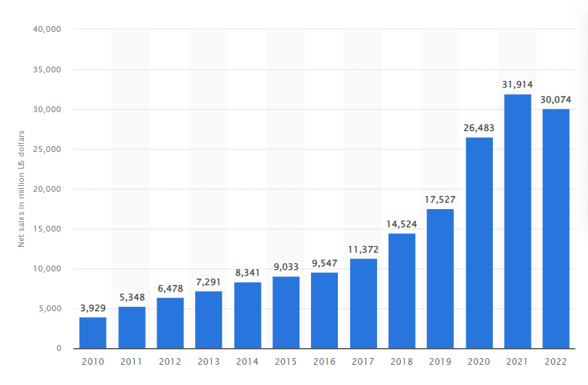
Figure 2: Net sales of Amazon in the UK
(Source: Statista.com, 2023)
Amazon enjoyed sales growth by taking net sales of around "32 billion U.S. dollars" in the UK as of 2021, and net sales have increased by 2022 (Statista.com, 2022). On the other hand, "not-for-profit" organizations, also known as non-profit organizations or charities, operate for a social or humanitarian cause rather than for profit. These organizations are generally set up to provide services or support to specific communities or causes and are funded by donations, grants, or other sources of non-commercial revenue.
Non-profit organizations are often governed by a board of directors or trustees and are typically tax-exempt. Examples of non-profit organizations include charitable foundations, educational institutions, religious organizations, and social service agencies (Stall et al. 2018). For example, the British Heart Foundation funds hearts and furnishes support for those affected. Furthermore, Oxfam is an international charity that focuses on poverty alleviation, disaster relief, and advocacy. While both for-profit and non-profit organizations exist to achieve specific goals, they differ in terms of their primary objectives, funding sources, and legal structures. For-profit organizations prioritize generating profits for their owners or shareholders, while non-profit organizations prioritize social impact and typically rely on donations and grants to fund their activities. Additionally, non-profit organizations are typically structured as tax-exempt entities, while for-profit organizations are subject to taxation on their profits.
Identify differences in drawing on entrepreneurs' values and beliefs
The primary difference between for-profit and not-for-profit organizations lies in their goals and motivations. For-profit organizations are driven by the desire to generate profits and create value for their shareholders or owners. on the other hand, not-for-profit organizations are guided by a desire to concoct social value or promote a specific cause (Cherrier et al. 2018). Entrepreneurs who start for-profit organizations may be motivated by a desire for financial success, independence, or the opportunity to create wealth. They may see business ownership as a means of achieving personal or professional goals, such as being their boss, creating innovative products or services, or achieving financial security. Entrepreneurs who start not-for-profit organizations, on the other hand, may be motivated by a desire to create social change, improve the lives of others, or advance a particular cause.
They may be driven by a sense of social responsibility, altruism, or a desire to address a particular social or environmental challenge. The values and beliefs of entrepreneurs can also influence the way they approach business and organizational management. For-profit entrepreneurs may place a strong emphasis on profitability, market share, and shareholder value, while not-for-profit entrepreneurs may prioritize social impact, community engagement, and stakeholder value (Cherrier et al. 2018). In terms of organizational structure and management, for-profit organizations are typically more hierarchical and focused on achieving specific business goals, such as increasing revenue, market share, or profitability. Not-for-profit organizations, by contrast, may be more decentralized, collaborative, and focused on building relationships with stakeholders and the community.
The main difference between these two organizations is their primary objectives. For-profit organizations exist to generate profits for their owners or shareholders, while not-for-profit organizations exist to achieve a social or humanitarian mission (Crawford et al. 2018). For example, Tesco, Rolls-Royce, and Dyson are all for-profit organizations that are navigated to generate profits. They focus on developing products or services that will appeal to customers and generate revenue, and their success is measured by their profitability and market share. In contrast, the British Heart Foundation, Oxfam, and RNLI are all not-for-profit organizations that are driven by a social or humanitarian mission. They focus on delivering services or support that will benefit their target beneficiaries, and their success is measured by their ability to make a positive impact on society.
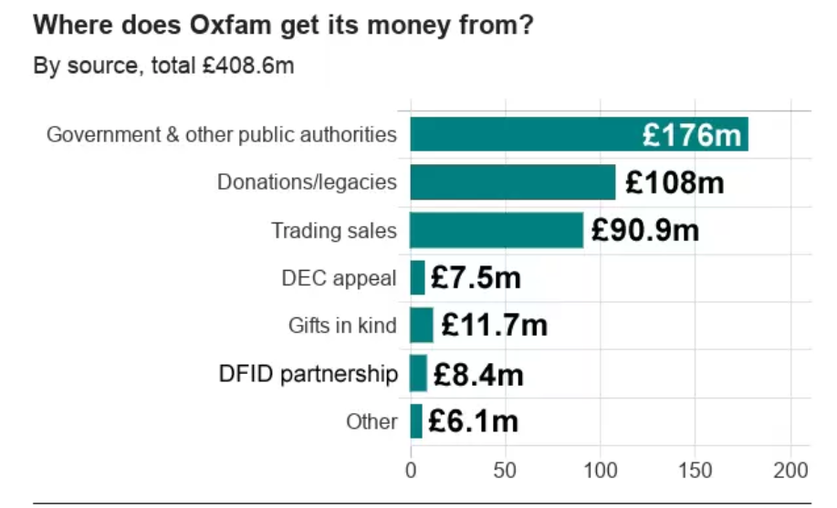
Figure 3: Oxfam non-profit business in the UK
(Source: Bbc.com, 2018)
They rely on donations, grants, or other sources of non-commercial revenue to fund their activities, and any profits generated are typically reinvested in the organization to further its social mission. Overall, while both for-profit and not-for-profit organizations play important roles in the UK economy and society, they differ in terms of their objectives, management, and funding sources. while both for-profit and not-for-profit organizations require entrepreneurial skills and vision to succeed, they differ in terms of their goals, motivations, and organizational values. Entrepreneurs who are clear about their values and motivations can choose the organizational structure that aligns best with their goals and personal beliefs.

Conclusion
In conclusion, this report has explored several topics related to entrepreneurship and organizational structures. It is concentrated on various theories of entrepreneurship, which provide insights into the traits, characteristics, and motivations of successful entrepreneurs. proper differentiation between for-profit and not-for-profit organizations has been also discussed along with highlighting their primary objectives, funding sources, and management structures. role of entrepreneurs in the UK business ecosystem and examined how they can contribute as entrepreneurs, intrapreneurs, support providers, or policymakers. Finally, values and beliefs have been explored here that underpin the decisions and actions of entrepreneurs, and how these can influence the organizational structure and management of their businesses. Overall, this report provides a broad overview of the key concepts and issues related to entrepreneurship and organizational structures. By understanding these concepts, entrepreneurs can make informed decisions about the type of business they want to start and the organizational structure that aligns with their values and goals.

References

Bazkiaei, H.A., Heng, L.H., Khan, N.U., Saufi, R.B.A. and Kasim, R.S.R., 2020. Do entrepreneurial education and big-five personality traits predict entrepreneurial intention among university students?. Cogent business & management, 7(1), p.1801217.
Bbc.com, 2018. Available at: Oxfam Haiti allegations: How the scandal unfolded. https://www.bbc.com/news/uk-43112200. Accessed on: 27.03.2023
Boudreaux, C.J., Nikolaev, B.N. and Klein, P., 2019. Socio-cognitive traits and entrepreneurship: The moderating role of economic institutions. Journal of Business Venturing, 34(1), pp.178-196.
Cherrier, H., Goswami, P. and Ray, S., 2018. Social entrepreneurship: Creating value in the context of institutional complexity. Journal of Business Research, 86, pp.245-258.
Crawford, L., Morgan, G.G. and Cordery, C.J., 2018. Accountability and not‐for‐profit organisations: Implications for developing international financial reporting standards. Financial accountability & management, 34(2), pp.181-205.
Fayolle, A., 2018. Personal views on the future of entrepreneurship education. In A research agenda for entrepreneurship education (pp. 127-138). Edward Elgar Publishing.
He, C., Shi, F., Peng, Q. and Tan, R., 2020. Identification of Technology Opportunity Based on a Three-Dimensional Technology Effect Model. Computer-Aided Design and Applications, 18(1), pp.97-116.
Khalil, C. and Khalil, S., 2020. Exploring knowledge management in agile software development organizations. International Entrepreneurship and Management Journal, 16(2), pp.555-569.
Kucharčíková, A., Mičiak, M. and Hitka, M., 2018. Evaluating the effectiveness of investment in human capital in e-business enterprise in the context of sustainability. Sustainability, 10(9), p.3211.
Siqueira, A.C.O., Guenster, N., Vanacker, T. and Crucke, S., 2018. A longitudinal comparison of capital structure between young for-profit social and commercial enterprises. Journal of Business Venturing, 33(2), pp.225-240.
Stall, N.M., Jones, A., Brown, K.A., Rochon, P.A. and Costa, A.P., 2020. For-profit long-term care homes and the risk of COVID-19 outbreaks and resident deaths. CMAJ: Canadian Medical Association Journal, 192(33), p.E946.
Statista.com, 2021.Entrepreneurial spirit index in Great Britain in 2018. Available at: https://www.statista.com/statistics/947961/entrepreneurial-spirit-index-in-great-britain/. Accessed on: 27.03.2023
Statista.com, 2023. Available at: Amazon annual net sales in the United Kingdom (UK) from 2010 to 2022. https://www.statista.com/statistics/1035592/net-sales-amazon-united-kingdom-uk/ Accessed on: 27.03.2023
Wartiovaara, M., Lahti, T. and Wincent, J., 2019. The role of inspiration in entrepreneurship: Theory and the future research agenda. Journal of Business Research, 101, pp.548-554.
Wilcox, P., Land, K. and Hunt, S.A., 2018. Criminal circumstance: A dynamic multi-contextual criminal opportunity theory. Routledge.
Wilcox, P., Land, K. and Hunt, S.A., 2018. Criminal circumstance: A dynamic multi-contextual criminal opportunity theory. Routledge.
Zamani, B. and Babaei, E., 2021. A critical review of grounded theory research in urban planning and design. Planning Practice & Research, 36(1), pp.77-90.

