Title：Graphic Design in Public Space

Communication, Surveillance and Power

Student Number：2405595 Ai Zhang
BA course title：Graphic design
Word count：2527
Lecturer's name: Donna

For this assessment, I confirm that I have NOT used Generative AI to support me in structuring my submission, including creating a draft argument structure, identifying parts and headings.
I confirm that I have not used Generative AI to create text for my submission. I confirm that I have not used Generative AI for creative materials, such as images
Table of Contents
List of Illustrations .................................................................................. pg. 4
List of Supporting Illustrations............................................................ pg. 4-5
Introduction............................................................................................pg. 6-8
1.0 Public Space........................................................................................pg. 8
1.1 Navigation, Communication and Social Production.............................pg. 8
1.2 Wayfinding and Accessibility..........................................................pg. 8-10

1.3 Universal Symbols and Cultural Assumptions..............................pg. 10-12

1.4 Commercial Interests and Visual Dominance...............................pg. 12-13

2.0 Surveillance: Visual Communication & Behavioural Regulation..pg. 13

2.1 Safety and Practical Benefits........................................................pg. 13-14

2.2 The Panopticon and Self-Regulation............................................pg. 14-15

2.3 Critical Responses to Surveillance...............................................pg. 15-16

3.0 Power: Authority, Economic Influence & Critical Resistance..pg. 16-17

3.1 Visual Markers of Authority...........................................................pg. 17-18

3.2 Corporate Power and Consumer Culture.....................................pg. 18-19

3.3 Design as Activism and Counter-Visuality.........................................pg. 20

Conclusion.........................................................................................pg. 20-22
Bibliography.......................................................................................pg. 23-24
Supporting imagery...........................................................................pg. 25-28

List of Illustrations：
Figure 1. Harry Beck, London Underground Map, 1933. Diagram. London Transport.
Figure 2. AIGA and Wolff Olins, London 2012 Olympic Pictograms, 2012. Graphic design. London Organising Committee of the Olympic Games.
Figure 3. International Organization for Standardization, ISO 7001: Graphical symbols — Public information symbols, 2024. Symbol set. Geneva: ISO.
Figure 4. Transport for London, "Mind the Gap" Platform Signage, 2024. Photograph. London Underground.
Figure 5. Experimental Jetset, SMCS Brochure, 2004. Graphic design. Amsterdam: SMCS Gallery. Source: Museum of Modern Art, New York.

List of Supporting Illustrations：
Figure 6. BOB Design, Chapel Market Wayfinding System, 2025. Photograph of installation. London. Source: Dezeen.
Figure 7. Davidson, M., Times Square Illuminated, 2023. Photograph. New York.
Figure 8. Greenspace, On the Dot Placemaking Project, 2025. Photograph of installation. Boston. Source: Communication Arts.
Figure 9. British Transport Police, CCTV Warning Sign, 2023. Photograph. London.
Figure 10. Birnbaum, D., Rio Videowall, 1989. Video installation. Atlanta. Source: Media Art Net.
Figure 11. Experimental Jetset, SMCS Gallery Identity, 2022. Graphic design. Amsterdam.
Figure 12. University of the Pacific, Voices in Red & Black Exhibition, 2025. Photograph of exhibition. Reynolds Gallery.

Introduction
Graphic design plays a significant role in shaping how people experience public environments. From transportation systems to city streets, visual communication such as signage, symbols and wayfinding systems helps individuals navigate complex spaces. While these systems appear to function simply as tools for information, they also operate on deeper social and political levels, influencing behaviour, structuring movement and reflecting authority.
Public environments rely heavily on visual communication to maintain order and accessibility. As David Gibson explains in The Wayfinding Handbook, wayfinding design helps users orient themselves and move effectively through physical environments (Gibson, 2009, p.15).
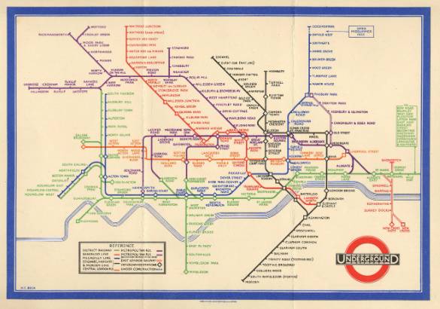
Figure 1. London Underground map, designed by Harry Beck, 1933. Diagram, London Transport.
The London Underground map, designed by Harry Beck in 1933, exemplifies this principle, prioritising clarity over geographical accuracy and demonstrating how design transforms complex spatial information into accessible tools (Figure 1).
However, public space is not neutral. Urban environments are shaped by political institutions and social structures. As Henri Lefebvre argues, urban space is socially produced rather than naturally neutral (Lefebvre, 1991, p.26). Visual communication within these spaces may therefore reflect underlying power relations. Lefebvre's triadic conception—spatial practice (how space is used), representations of space (how space is conceived), and representational spaces (how space is lived)—provides a useful framework (Lefebvre, 1991, p.33).
This essay explores graphic design in public environments through three concepts: public space, surveillance and power. It will examine how visual systems influence behaviour through subtle surveillance, and how visual communication reflects institutional authority.
This essay argues that graphic design in public environments functions as more than a neutral tool for communication. Instead, it actively participates in the production of social order, the regulation of behaviour and the reinforcement of institutional power. Through the critical examination of wayfinding systems, surveillance signage and institutional visual communications, this analysis demonstrates how design shapes spatial experience while reflecting broader political and economic structures. Understanding these dynamics is essential for designers to practise with critical awareness of their work's social implications within contemporary urban contexts.
1.0 Public Space

1.1 Navigation, Communication and Social Production
Public space plays a crucial role in everyday urban life. Spaces such as streets, transportation systems, parks and public buildings are designed to accommodate large numbers of people from different backgrounds. In these environments, graphic design helps structure movement and provide information that allows individuals to navigate efficiently. The relationship between graphic design and public space is reciprocal: design responds to spatial conditions while simultaneously shaping how those spaces are perceived and used. When designers intervene in public space, they are not simply adding information but actively participating in the production of spatial experience. Every sign, map or symbol carries implicit assumptions about how space should be used and to whom it is accessible.

1.2 Wayfinding and Accessibility
Graphic design fundamentally influences how people navigate urban environments. Successful graphic design is often so subtle that it becomes almost imperceptible; users can navigate with ease, often without realising they are following designed cues. Harry Beck's 1933 London Underground map is a prime example of this principle (see Figure 1).
By prioritising clarity over geographical accuracy, Beck transformed complex spatial information into an accessible cognitive tool. This approach has influenced wayfinding systems globally, from transport networks to the London 2012 Olympics pictograms (Figure 2).
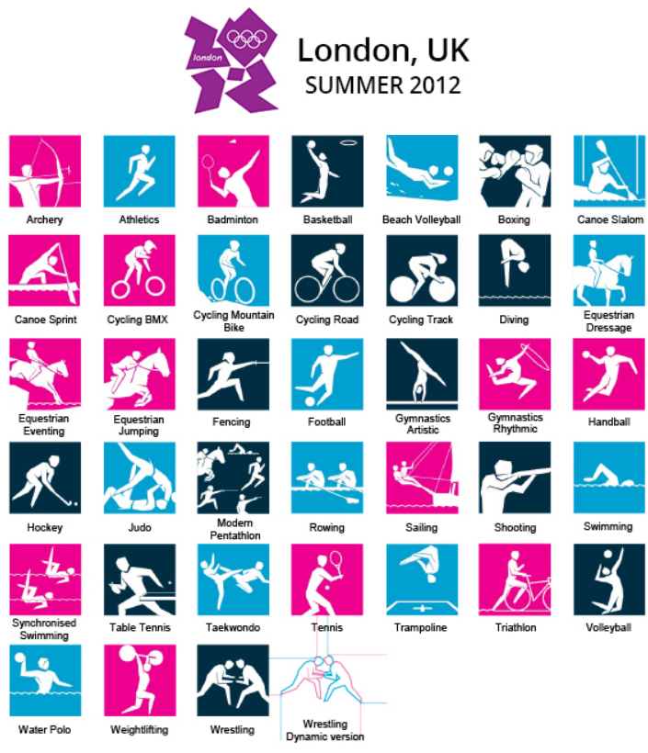
Figure 2. AIGA and Wolff Olins, London 2012 Olympic Pictograms, 2012. Graphic design. London Organising Committee of the Olympic Games.
Beck's approach exemplifies what Gibson (2009, p.20) identifies as effective wayfinding: reducing confusion and allowing users to move through spaces with confidence. Yet what makes these systems successful is not technical precision but human-centred thinking—design that anticipates how people actually perceive and navigate space. Good wayfinding does not simply direct; it empowers users to make their own choices, transforming anxiety into agency in unfamiliar environments. However, this empowerment is structured within predefined systems, meaning users are guided within limits rather than given complete freedom. This suggests that navigation in public space is never entirely free, but subtly shaped through design decisions. Accessibility, in this sense, is not just about physical access but about cognitive ease—the freedom to move without fear of getting lost.

1.3 Universal Symbols and Cultural Assumptions
In increasingly diverse cities, visual communication must transcend language barriers. Pictograms and symbols serve this function, enabling restroom identification, exit location and transportation navigation without words. At first glance, these symbols appear universally legible. However, their apparent neutrality masks cultural specificity.
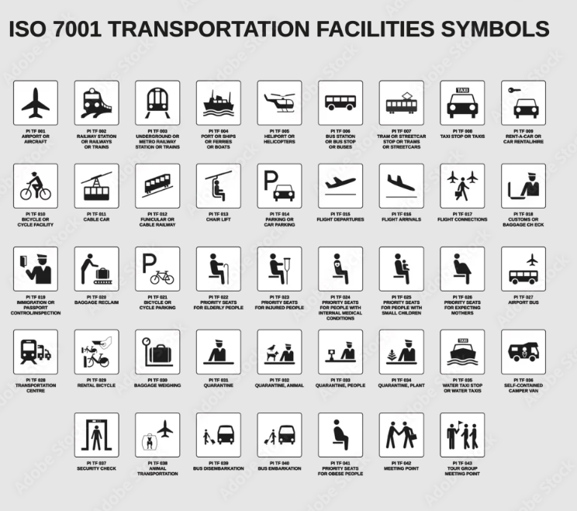
Figure 3. International Organization for Standardization, ISO 7001: Graphical symbols — Public information symbols, 2024. Symbol set. Geneva: ISO.

The International Organization for Standardization (ISO) has developed hundreds of symbols intended for global use (Figure 3), yet the standard bathroom icon depicts a figure in Western dress—a design choice that may not translate effectively across all cultural contexts. Designers increasingly recognise that universal symbols carry cultural assumptions (Pater, 2016, p.45). Lupton (2014, p.112) argues that visual communication simplifies complex information, but simplification inevitably involves selection—and selection reflects cultural bias. The challenge for contemporary designers is not to eliminate cultural specificity but to acknowledge it, creating systems flexible enough to accommodate diverse perspectives while maintaining clarity. Universal design, therefore, is an aspiration rather than an achievement, a goal to work towards rather than a finished product.

1.4 Commercial Interests and Visual Dominance
Public space is not a neutral backdrop for visual communication. Walking through any city centre, one observes this reality: advertising dominates. Large billboards and digital screens occupy the most prominent positions, while public information such as signs, maps and civic messaging recedes into the background. This visual hierarchy reflects a deeper imbalance: corporate interests increasingly shape how public space looks and feels. When a subway station displays twenty advertisements for every one piece of wayfinding, the message is clear: commerce comes first.
Urban space is actively produced through economic and political forces, as Lefebvre (1991, p.38) argues. Graphic design participates in this production, giving visual form to spatial meanings and hierarchies. The screens of Piccadilly Circus and Times Square do not simply carry advertisements; they transform public space into a surface for commercial messaging, normalising the presence of corporate voices in civic environments.
Yet designers have choices. They can reinforce existing power structures by accepting commercial dominance as inevitable, or they can work towards more equitable spatial experiences. The question is not whether design serves commercial interests, but whose interests designers prioritise when conflicts arise.

2.0 Surveillance: Visual Communication & Behavioural Regulation
Another important aspect of graphic design in public space is its role in influencing behaviour. Visual communication systems do more than provide information—they actively guide how people act. Signs asking us to "Mind the Gap", "Keep Left" or "No Smoking" appear neutral, yet each functions as an instruction that shapes behaviour. These everyday messages participate in what might be termed the micro-physics of spatial control: the subtle ways environments shape conduct without obvious force.

2.1 Safety and Practical Benefits
Safety signage exemplifies how this regulatory function serves clear practical purposes. In busy transport hubs, safety signage prevents accidents and maintains order. When a platform edge displays "Mind the Gap", it protects passengers from harm. The London Underground's "Mind the Gap" signage, introduced in 1968, has become so familiar that it transcends its original function, appearing on platform edges, recorded announcements and even merchandise (Figure 4).
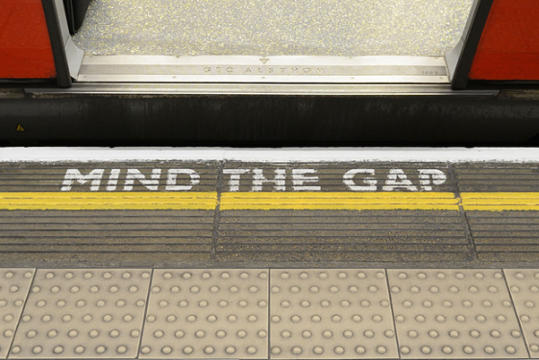
Figure 4. Transport for London, "Mind the Gap" Platform Signage, 2024. Photograph. London Underground.
A regulatory message has become cultural symbol. As Johnson (2017, p.63) notes, effective design communicates clearly and encourages appropriate responses. Yet this is only one side of the story.

2.2 The Panopticon and Self-Regulation
Beyond safety, visual communication subtly shapes behaviour through less visible mechanisms. Consider signs announcing CCTV surveillance. Even when no one actively monitors, these warnings influence conduct. People become more cautious, more rule-abiding, simply because they believe they might be watched. This is design as social control: subtle, indirect, yet remarkably effective.
Philosopher Michel Foucault's concept of the Panopticon—a prison design where inmates self-regulate because they might be watched at any time—helps explain this dynamic (Foucault, 1977, p.201). CCTV signage functions similarly: the possibility of surveillance, not its actual occurrence, produces compliance. The graphic representation of surveillance, such as a camera icon or an eye symbol, activates psychological self-regulation independent of actual monitoring. Design, in this sense, becomes an instrument of governance.
Directional systems operate similarly. Arrows, barriers and designated pathways encourage certain routes while discouraging others. These visual cues appear neutral, yet they carry authority. As Pater (2016, p.92) argues, the apparently neutral arrow implies particular forms of movement and excludes alternatives. Design shapes not only where we go but how we behave along the way.

2.3 Critical Responses to Surveillance
If design can regulate, can it also resist? This question becomes increasingly urgent as surveillance technologies expand across public space. While much graphic design serves institutional interests, directing behaviour, enabling observation and reinforcing control, some practitioners use visual communication to critique these very systems.
The rise of "nudge theory" from behavioural economics adds further complexity to this landscape (Thaler & Sunstein, 2008). Small changes in choice architecture can significantly influence behaviour without restricting freedom. A cafeteria that places fruit at eye level and junk food on lower shelves uses design to encourage healthier choices while leaving consumers free to choose otherwise. Yet the same mechanism can be deployed for competing objectives. A supermarket that positions premium brands at eye level and budget options on bottom shelves uses identical design principles, but here the goal is profit rather than public welfare. When visual systems influence behaviour without explicit awareness, the line between helpful guidance and commercial manipulation becomes difficult to draw.
Therefore, graphic design in public space does more than communicate. It organises, regulates and shapes behaviour through mechanisms both visible and invisible. From safety signage to surveillance warnings, visual communication participates in systems of social control. Designers cannot avoid shaping behaviour: every sign, map or symbol does this in some way. The critical task for designers, therefore, is to make visible the power relations embedded in seemingly neutral visual cues.

3.0 Power: Authority, Economic Influence & Critical Resistance
The final concept explored in this essay is power. Graphic design in public environments often reflects who controls space and whose voices are prioritised. Public visual systems are typically commissioned by governments, transport authorities or large corporations. The messages they carry therefore tend to serve institutional interests rather than public expression. This section examines how design both reinforces and sometimes challenges these power structures.

3.1 Visual Markers of Authority
Walk through any city and you encounter signs that define who belongs where. "Authorised Personnel Only", "Restricted Area" or "Private Property" do more than inform—they control. These visual markers create boundaries, telling people where they can and cannot go. As Fry (2009, p.41) argues, design plays an important role in shaping social systems and defining relationships between individuals and institutions. When designers create such signs, they help decide who gets access and who doesn't.
Even the design details matter. Government buildings often use traditional fonts and bronze plaques that feel formal and serious. Transport systems develop their own typefaces that appear on every sign, creating a sense of order and authority. A courthouse sign carved in stone feels permanent and serious, while a community centre sign in bright colours feels welcoming and casual. Design here is not just about looking good, it's about projecting an image and shaping public perception.

3.2 Corporate Power and Consumer Culture
Advertising further demonstrates how economic power shapes public space. Large commercial campaigns occupy the most visible positions in cities, including billboards, digital screens and transport hubs, while public information often takes second place. This visual dominance reflects what Debord (1967, p.12) describes as a society saturated by images of consumer culture. When a subway station displays twenty advertisements for every one piece of wayfinding, it shows that commercial interests come first.
Yet some designers resist this commercial dominance by choosing not to participate in its language. The Dutch group Experimental Jetset's work takes a quieter approach. Their poster for Stedelijk Museum CS uses simple Helvetica type and straightforward information—"next to the Central Station" in two languages (Figure 5).
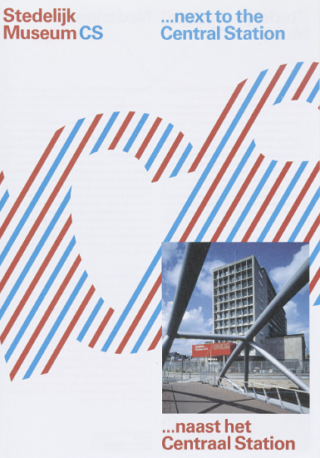
Figure 5. Experimental Jetset, SMCS Brochure, 2004. Graphic design. Amsterdam: SMCS Gallery.

In a world where public space is filled with advertisements shouting for attention, this refusal to sell feels quietly political. Design here serves information, not persuasion. McQuiston (2015) notes that visual communication can become a powerful form of protest. Experimental Jetset's work, while not protest in the traditional sense, quietly challenges the assumption that public space must be commercial. It suggests that visual communication does not always have to be loud or sell something; it can simply communicate necessary information.

3.3 Design as Activism and Counter-Visuality
Despite its ties to power, graphic design also offers possibilities for resistance. Posters, street art and protest graphics challenge dominant narratives and amplify marginalised voices. McQuiston (2015) documents how design has served political movements from the suffragettes to contemporary activism, giving visual form to dissent when words alone are not enough.
Mirzoeff (2011, p.15) argues that visuality (the ways we see and are seen) is always entangled with power. He describes counter-visuality as the practice of resisting dominant visual regimes and proposing alternative ways of seeing. When designers create posters for climate strikes or Black Lives Matter demonstrations, they contribute to alternative visual publics that challenge institutional authority. Graphic design in public space is therefore not limited to serving those in power. It can also provide tools for critical expression and social engagement. Yet this potential depends on practitioners' choices: whether they reinforce existing hierarchies or create space for alternative voices. The question is not whether design participates in power relations, because it inevitably does. The real question is how designers choose to navigate this reality and whose interests their work ultimately serves.

Conclusion

As this essay has demonstrated, graphic design plays a complex role in public environments—simultaneously enabling navigation, regulating behaviour, and mediating power. While often seen as a simple tool for communication, it also operates within broader social, political and economic systems. This essay has explored how visual communication shapes the way people interact with urban spaces through the concepts of public space, surveillance and power.
Design improves accessibility through wayfinding systems that help people navigate complex environments. At the same time, visual communication can subtly influence behaviour through surveillance mechanisms such as CCTV warnings and directional signage. Design here becomes a form of social control, regulating conduct without obvious force.
Public visual systems also reflect institutional and economic power. Governments and corporations control much of what we see in cities, from government signage to commercial advertising. Yet design also offers possibilities for resistance. Protest graphics and activist interventions show that visual communication can challenge dominant power structures rather than simply reinforce them.

Understanding these dynamics matters for designers. Every sign, map or symbol carries consequences beyond its surface function. Rather than asking whether design influences people, we must examine the social and political conditions under which it operates—and whose interests it ultimately legitimises. Designing for public space means considering not just how things look, but how they shape behaviour, perception and power relations within society.

Bibliography:
Barthes, R. (1972) Mythologies. Translated by A. Lavers. London: Jonathan Cape.
Chandler, D. (2017) Semiotics: The Basics. London: Routledge.
Debord, G. (1967) The Society of the Spectacle. Paris: Buchet-Chastel.
Foucault, M. (1977) Discipline and Punish: The Birth of the Prison. Translated by A. Sheridan. London: Penguin.
Fry, T. (2009) Design Futuring: Sustainability, Ethics and New Practice. Oxford: Berg.
Gibson, D. (2009) The Wayfinding Handbook: Information Design for Public Places. New York: Princeton Architectural Press.
Hall, S. (1997) Representation: Cultural Representations and Signifying Practices. London: Sage.
Johnson, M. (2017) Problem Solved: A Primer in Design and Communication. 3rd edn. London: Phaidon.
Lefebvre, H. (1991) The Production of Space. Translated by D. Nicholson-Smith. Oxford: Blackwell.
Lupton, E. (2014) Thinking with Type. 2nd edn. New York: Princeton Architectural Press.
McQuiston, L. (2015) Protest! A History of Social and Political Protest Graphics. London: I.B. Tauris.
Merleau-Ponty, M. (1962) Phenomenology of Perception. London: Routledge.
Mirzoeff, N. (2011) The Right to Look: A Counterhistory of Visuality. Durham, NC: Duke University Press.
Norman, D. (2004) Emotional Design: Why We Love (or Hate) Everyday Things. New York: Basic Books.
Papanek, V. (1971) Design for the Real World. London: Thames & Hudson.
Pater, R. (2016) The Politics of Design: A (Not So) Global Manual for Visual Communication. Amsterdam: BIS Publishers.
Thaler, R. H. and Sunstein, C. R. (2008) Nudge: Improving Decisions About Health, Wealth and Happiness. New Haven: Yale University Press.

Supporting imagery:
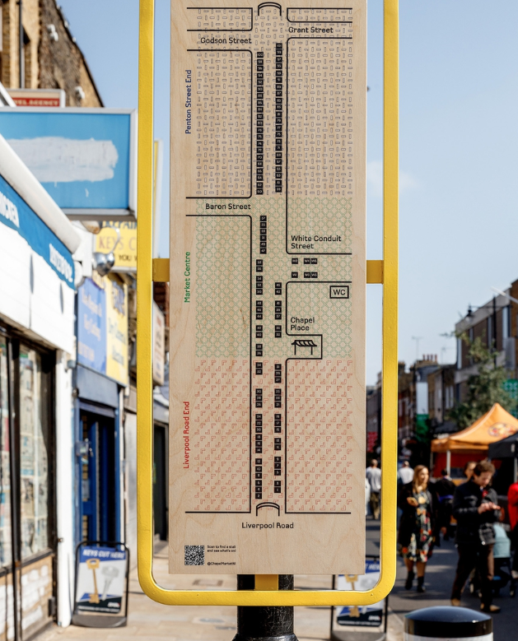
Figure 6. BOB Design, Chapel Market Wayfinding System, 2025. Photograph of installation. London. Source: Dezeen.
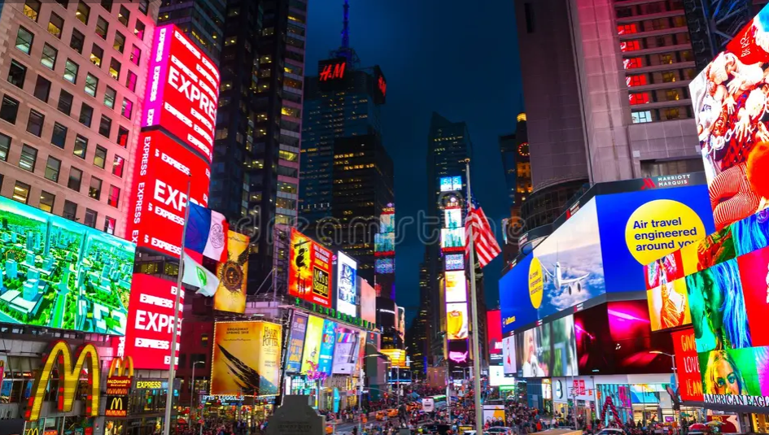
Figure 7. Davidson, M., Times Square Illuminated, 2023. Photograph. New York.

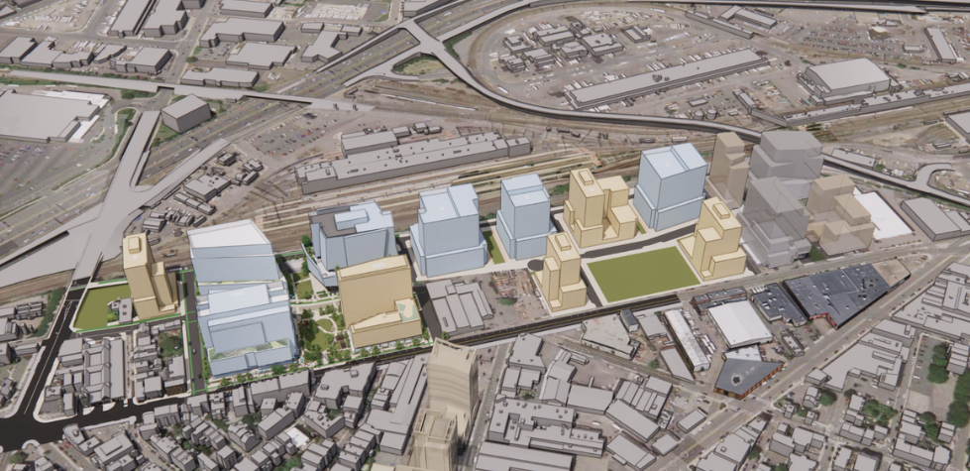
Figure 8. Greenspace, On the Dot Placemaking Project, 2025. Photograph of installation. Boston. Source: Communication Arts.
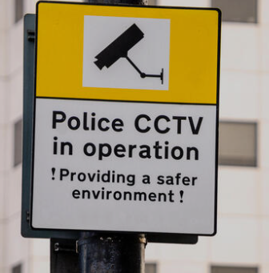
Figure 9. British Transport Police, CCTV Warning Sign, 2023. Photograph. London.


Figure 10. Birnbaum, D., Rio Videowall, 1989. Video installation. Atlanta. Source: Media Art Net.

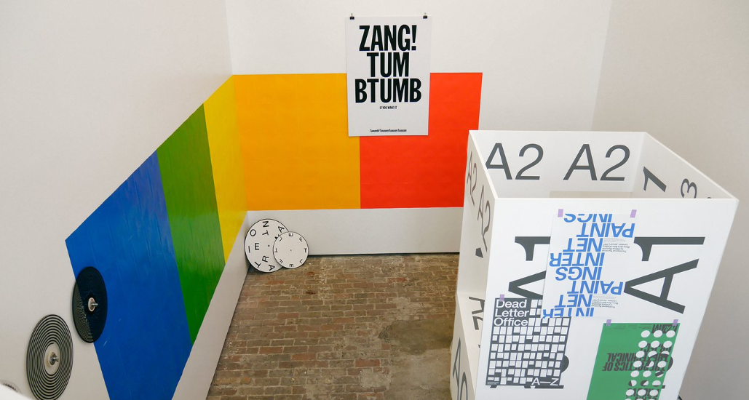
Figure 11. Experimental Jetset, SMCS Gallery Identity, 2022. Graphic design. Amsterdam.

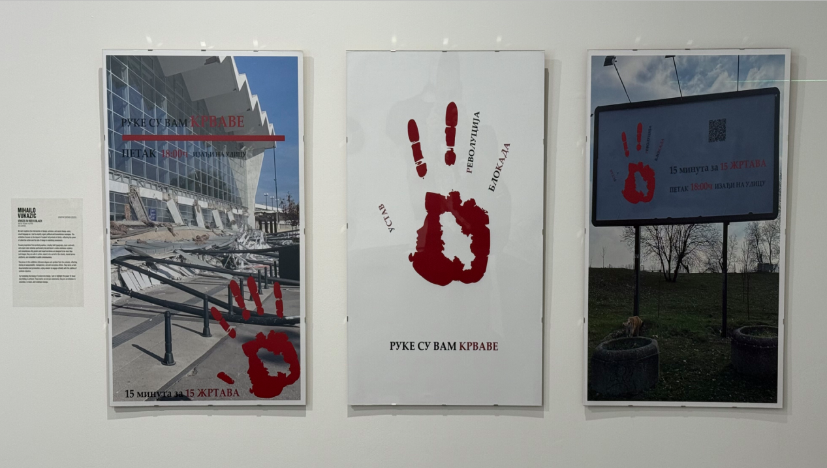
Figure 12. University of the Pacific, Voices in Red & Black Exhibition, 2025. Photograph of exhibition. Reynolds Gallery.

