

LEVEL 4 ASSESSMENT SPECIFICATION

Student name: | Liam Pugh | Student ID number: | 2420528
Programme: | HNC Electrical/Electronic Engineering & Instrumentation Engineering
Module: | Embedded Systems

STUDENT FEEDBACK FORM

This section details the extent to which the assessment criteria are demonstrated by you, which in turn determines your mark. The marks available for each category of skill are shown. Lecturers will use the space provided to comment on the achievement of the task(s), including those areas in which you have performed well and areas that would benefit from development/improvement.
Generic Assessment Criteria |  | Marks available |  | Marks  awarded
1. Engagement with Literature Skills
.
 |  | 0
2. Knowledge and Understanding Skills

Hardware: You have considered how the components work and alternatives extremely thoroughly , but would have benefited by clearly indicating how they will be used in the system. The justification for using an Arduino could have also considered the specific board selected, for example why use the Uno as oppose the Mega. Don't forget the resistors and button also make up part of the circuit given, however you do not mention these. Both circuit diagram and breadboard diagram included.  Software: Blind is either up or down, a single Boolean variable would work here, called for example blindUp, which is set to true for up and false for down. You have also oversimplified the process of determining when the blind is in position, this requires signals being sent and received from the sonic sensors. There is a button in the hardware design, however there is no pseudocode to suggest you are going to use it. In general, you should indicate where IF statements terminate with END IF, along with where the SETUP finishes. Final code contains a function which is omitted from pseudocode |  | 30 |  | 17
3. Cognitive and Intellectual Skills

Excellent discussion about the usefullness of C in the system. You give further detail about your investigation into the issues with the LED and have also realised the efficiency issues mentioned earlier. I would suggest that taking the light level every 30mins would be more than sufficient. Here would be a good place to discuss why the button was not functional/ implemented. |  | 15 |  | 9
4. Practical Application Skills

Good use of constants for naming pins and values that determine the responses from the system. You are continually sending signals to the sonic sensors which are not needed. You only need to read in from these sensors when the blind motor is turning, when it is stationary then sending signals when the servo is not moving will drain the power and is inefficient. You are also writing to the serial monitor which is useful for testing, but not needed when the system is in operation. Consider commenting this code out, as you may reuse this if you make any additional changes to the program. In general comments are quite sparse, consider comments more fully in future. However you have explained how the code functions in the report. Good use of functions. No code evident for the button. LED not operation  Testing: you have considered tests in normal conditions, but not about unexpected events. For example, once the blind has rolled down as it is dark and the sonic sensor picks up the blind and the servo motor is switched off. Whilst it is still dark, what happens if the blind is then moved (eg a gust of wind has moved it away from the sonic sensors range)? |  | 50 |  | 31
5. Transferable Skills for Life and Professional Practice

Missing introduction. Have included a front page taken from original assignment brief and contents page with clear section headings but should include page number in future. Have demonstrated where further reading and research has come from. Give more meaningful section headings such as Hardware Design rather than Task 1. |  | 5 |  | 3
Assessment Mark (Assessment marks are subject to ratification at the Exam Board. These comments and marks are to give feedback on module work and are for guidance only until they are confirmed. ) | Late Submission Penalties (tick if appropriate) |  |  | 60%
 | Up to 1 week late (40% Max) |  |  | 60%
 | Over 1 week late (0%) |  |  | 60%

Contents
Task 1 3
Task 2 7
Task 3 10
Task 4 16
Task 5 20
Bibliography 22
References 22
Appendix 23

Task 1

Ultrasonic sensor

An ultrasonic sensor is able to detect the distance of the closest object in front of the sensor. This is done by outputting a burst of ultrasound and listening for the echo when it bounces off an object. A short pulse is sent from the Arduino board to trigger the detection, it then listens for a pulse on the same pin. This second pulse will have a duration equal to the time taken for the ultrasound to travel to the object and back to the sensor. Then using the speed of sound, this time taken can be converted to distance. An alternative to the use of an Ultrasonic sensor is a laser sensor, laser sensors can measure up to a much further distance than an ultrasonic sensor approximately up to 3000 metres. However for this application our sensor is not required to measure a large distance and an ultrasonic sensor is far cheaper than a laser sensor, therefore an ultrasonic sensor is more than suitable for this application.

Servo motor
Typically, a standard servo motor rotates between 0-90° or 0-180° and they provide feedback of their position to the controller. Servo motors are commonly employed in conveyor systems as they provide precise control of conveyor belt speed and position. They allow you to move to a specific point on their arc of rotation and the servo will report its position back. You can also get continuous servo motors, these motors behave more like a standard DC motor, unlike a standard servo motor instead of controlling the position of the servo, the speed and direction is set by the controller instead. One other option we considered instead of a servo motor was a stepper motor as these too provide a simple rotation and have simple control capabilities, however we chose to use the servo motor as they provide far more precise control and provide high speeds and high torque if needed.

LED
‘’An LED (Light Emitting Diode) is a semiconductor device that emits light when an electrical current passes through it. The light is produced by the recombination of electrons and holes in the semiconductor material, which releases energy in the form of photons.’’ (Yuan, S., Li, X., & Lu, X. (2020). Light-emitting diode (LED) technology: Principles, applications, and future developments. Elsevier.) LED’s are popularly used in lighting, indication displays and television displays. This is because of their long lifespan, energy efficiency and also they have a great ability to produce light in different colours without the requirement for a filter. There are many other options that can be used instead of an LED such as halogen bulbs and incandescent bulbs however, LED’s are by far the most efficient and cost effective, they have far longer lifespan and produce minimal heat making hem far safer to use.

LDR
A light dependent resistor is typically used to detect light level, for example they are a common component in the construction of streetlights. When the LDR detects that it is dark it will trigger the streetlights to turn on. An LDR functions by when the light intensity increases the resistance of the LDR decreases. In turn this means that when the LDR is in a dark environment the resistance of the LDR is high and little current is able to flow through it. Therefore when placed in a light environment the resistance is low and current will flow easily. In a system an LDR will work by taking readings of the currents at different light levels to know when to activate the system or not. Another option we could have used instead of an LDR is a phototransistor, these work in a similar way to an LDR as their primary function is to convert light energy to electrical energy. However we went for the LDR overall as they are a far cheaper alternative and are less complex to setup compared to a phototransistor.

Breadboard
A breadboard is a rectangular board with small holes going into it allowing you to insert several electrical components to create a circuit. A big advantage of these boards is that the connection is not permanent so they can be easily removed or be changed. Because the connections within the breadboard are not permanent they are known as solderless boards, this is because each connection is a pin connection as there is a little terminal inside the board that the pin will go into. Due to the nature of us building this system we do not want permanent connections, this is because we want to be able to test and dismantle our circuit when needed. This is why the breadboard was chosen over any other component, proto boards are also a popular choice but they have more permanent fixings such as solder, this gives breadboards an advantage because if there is a fault in the construction of the circuit it is far easier to fault find on a breadboard than it is a protoboard.

Arduino
Arduino's have many advantages in terms of their capabilities, they are an open source microcontroller with an ability to be easily programmed, erased and reprogrammed at any given time. The board is used for programming and constructing electronic devices, it is based on based on simple microcontroller boards. The typical programming languages used for this board are C and C++. Due to Arduino being an open-source programme the software does not need to be purchased so it is only the cost of the board that needs to be paid for, making it far cheaper than any other option.

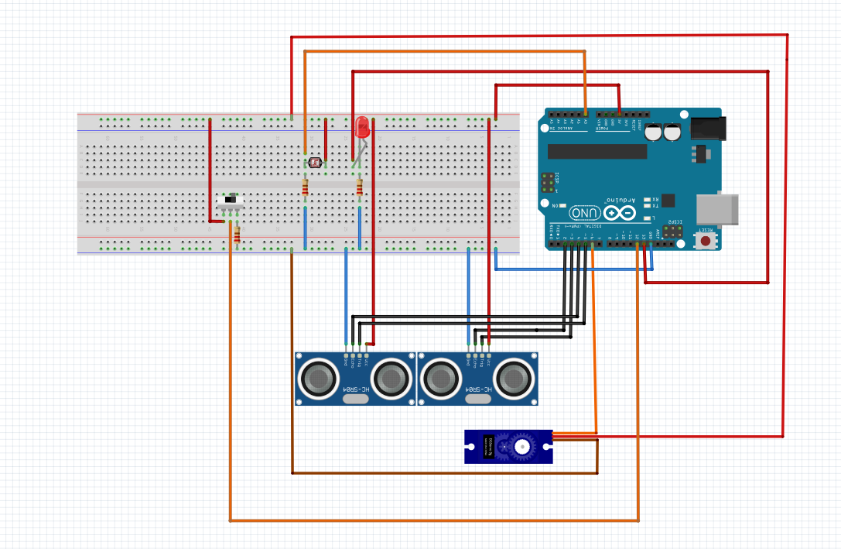
Figure 1

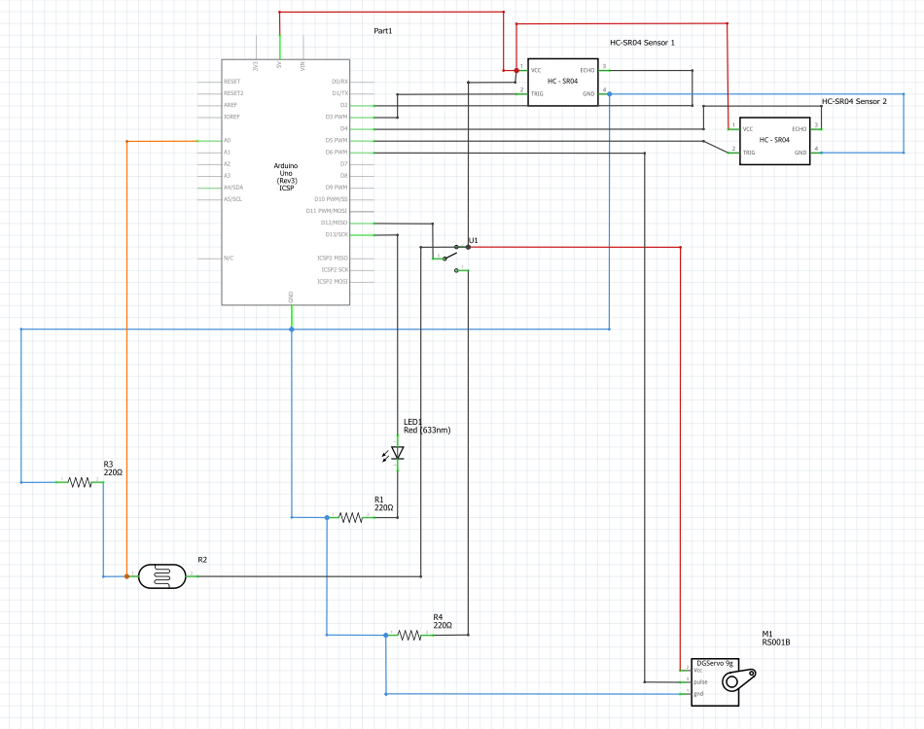
Figure 2

Task 2
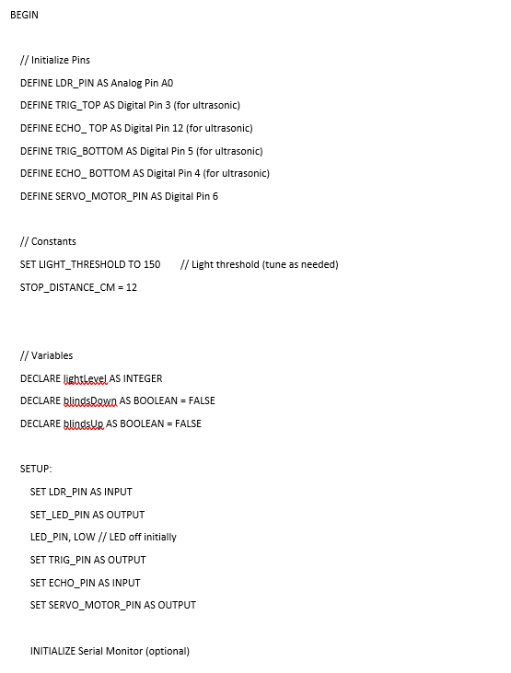
To give me a better understanding and visualisation of the various commands that are needed, I created a PSEUDO code to give me an outline of my programme. I then created a C++ programme which is the language required by the Arduino board. It is important to define all the input and output devices at the start of the sequence.
Figure 3
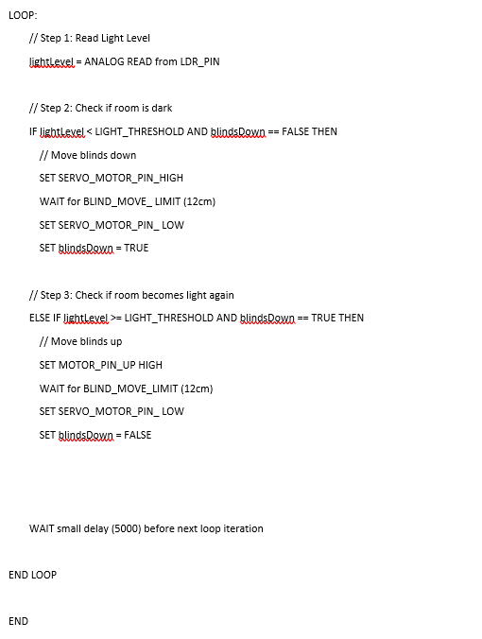
Figure 4

Task 3
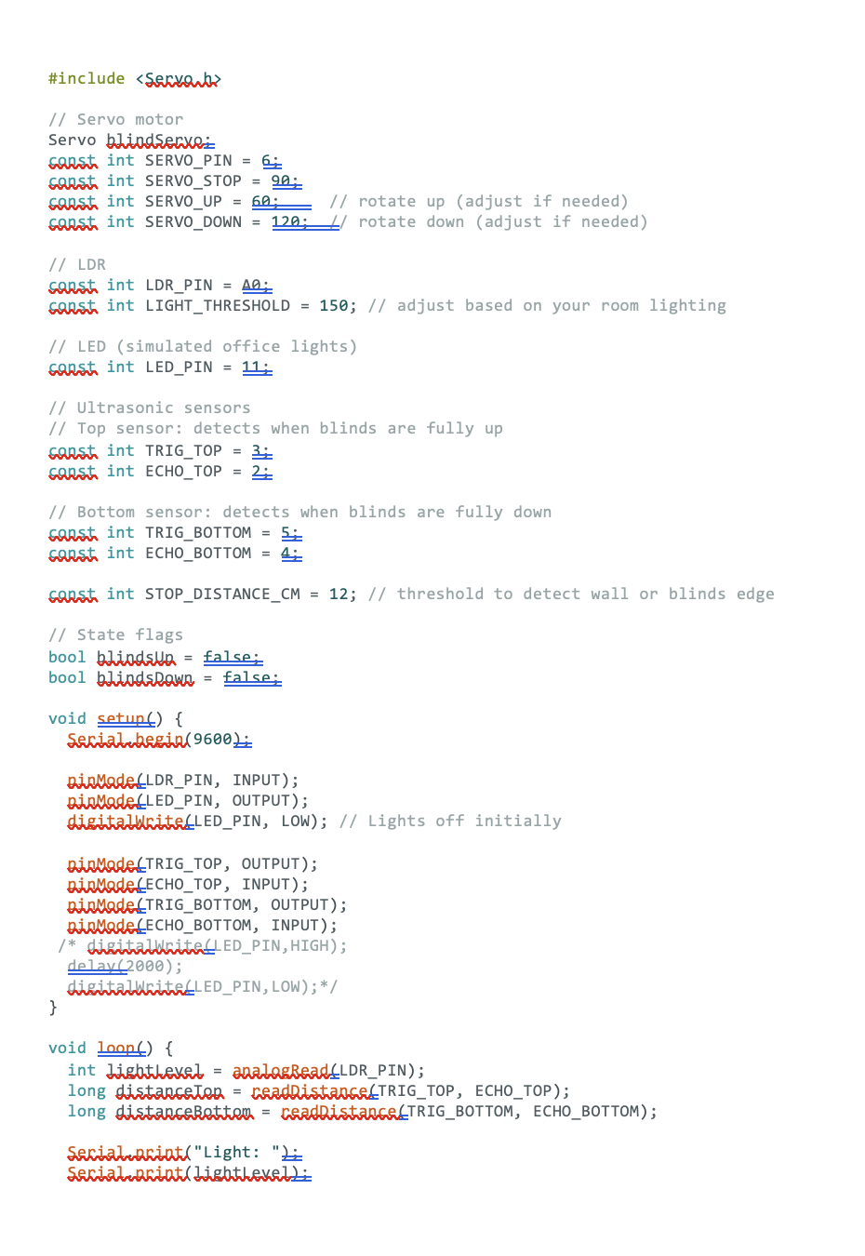
I created a C++ programme reflecting the functions that were in my flow diagram. Once I was happy with the code I had written, I downloaded it to the Arduino board.

Figure 5
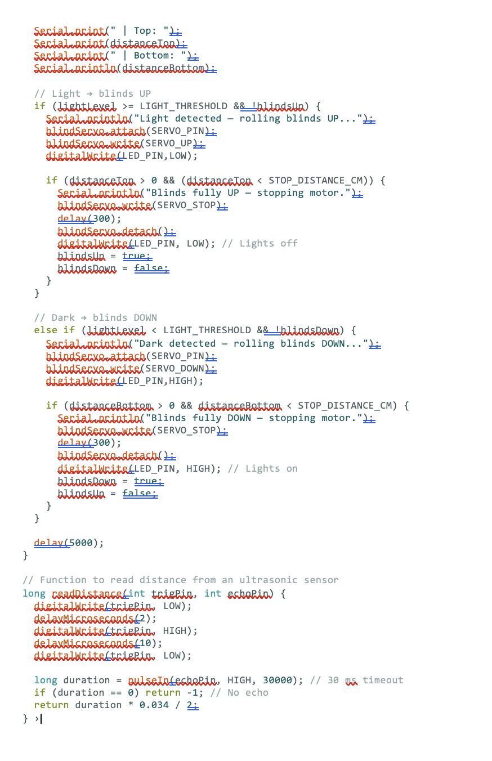
Figure 6
Breakdown of C code

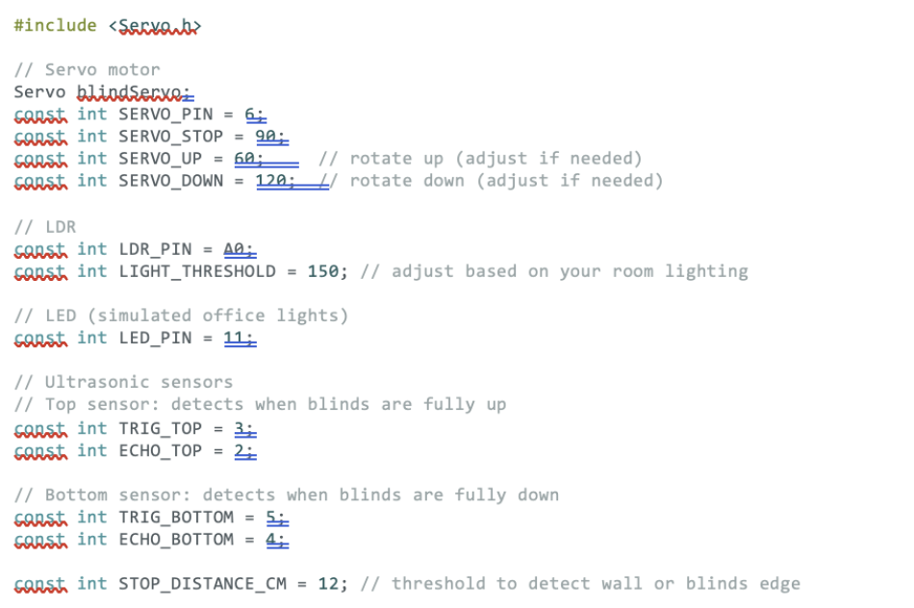
Figure 7

This part of my programming is where I defined my pins for each component connected into my Arduino circuit. In the // Servo motor section I defined the pin, set the stop position at 90° I then set the opening blind position to rotate to 60° and the closing position to rotate to 120°. For the // LDR section I defined the Pin and then set the light threshold to 150, this determined whether to open or close the blind depending on light intensity. For the // LED I simply had to define the pin. This was also the case for the top and bottom ultrasonic sensors. I then set a distance for both sensors as 12cm for the stop distance. This would then stop the motor when the sensor detected that the blind was either at its top limit or bottom limit.

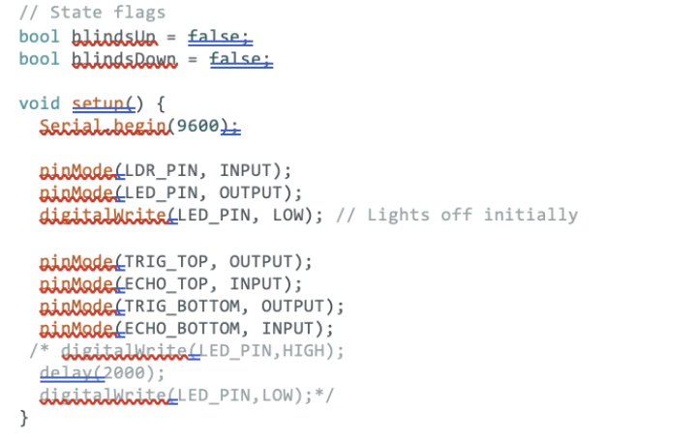
Figure 8
This part of the programme is the setup section, the first section is used to determine the position of the flags, they are both set to false because when the system is first turned on, it will not have yet determined the position of the blind to know whether it is fully open, fully closed or in travel. The LDR pin is set to input so that when the system is activated, it will immediately read the light intensity. For the set up of the ultrasonic sensors i have the TRIG_ as the output, this is the sending out of the electronic pulse and then ECHO_ as the input, thus is the receive of the reflected pulse which is how the distance is measured. Lastly I had a LED flash function for it to come on for 2 seconds, this was to test my LED as i had trouble with it working.

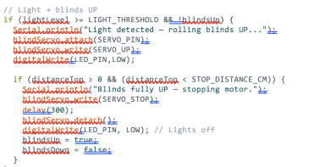
Figure 9

This section of C code has a main function of measuring the light level and making a judgement on whether it needs to move. The code if (lightLevel >= LIGHT_THRESHOLD && blindsDown) this measures to see if the light level is above the threshold, blindsDown ensures the blinds are currenty lowered, if both are true it will proceed to raise the Blinds.

Serial.println("Light detected – rolling blinds UP...");
blindServo.attach(SERVO_PIN);
blindServo.write(SERVO_UP);
digitalWrite(LED_PIN, LOW);
This piece of code will send the signal to the motor pin to raise the blind and also turn off the LED once the blinds are raised
if (distanceTop > 0 && distanceTop < STOP_DISTANCE_CM) { Serial.println("Blinds fully UP – stopping motor."); blindServo.write(SERVO_STOP);
delay(300);
blindServo.detach();
digitalWrite(LED_PIN, LOW); // Lights off
This piece then checks that the blinds have met the stopping distance, the servo motor will then stop, and the system will delay itself before measuring again.

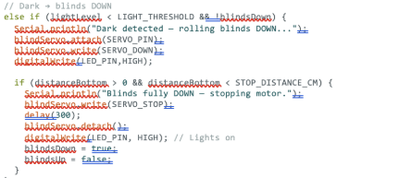
Figure 10
This section of C code has a main function of measuring the light level and making a judgement on whether it needs to move. The code if (lightLevel <= LIGHT_THRESHOLD && blindsDown) this measures to see if the light level is above the threshold, blindsUp ensures the blinds are currently up, if both are true it will proceed to lower the blinds..
Serial.println("Dark detected – rolling blinds DOWN...");
blindServo.attach(SERVO_PIN);
blindServo.write(SERVO_DOWN);
digitalWrite(LED_PIN, HIGH);
This sends a message to the servo motor to lower the blinds and turn on the LED once the binds are lowered.
if (distanceBottom > 0 && distanceBottom < STOP_DISTANCE_CM) { Serial.println("Blinds fully DOWN – stopping motor."); blindServo.write(SERVO_STOP); delay(300); blindServo.detach(); digitalWrite(LED_PIN, HIGH); // Lights on
This uses the ultrasonic sensor to ensure the stopping distance is reached, the servo motor will then be stopped. A short delay will occur to ensure stability and the blinds will remain down.

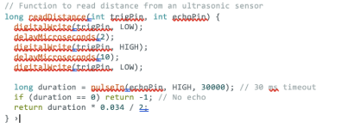
Figure 11
The function of this code is to ensure the Ultrasonic sensor is reading the distance.
digitalWrite(trigPin, LOW);
delayMicroseconds(2);
digitalWrite(trigPin, HIGH);
delayMicroseconds(10);
digitalWrite(trigPin, LOW);
This part of the code sends a 10 microsecond pulse out on the trigPin,
long duration = pulseIn(echoPin, HIGH, 30000);
It will then listen for the echo if the echo is not recieved in 30ms it will timeout, this prevents hanging.
return duration * 0.034 / 2;
This part of code will then convert time into distance in cm.

Task 4
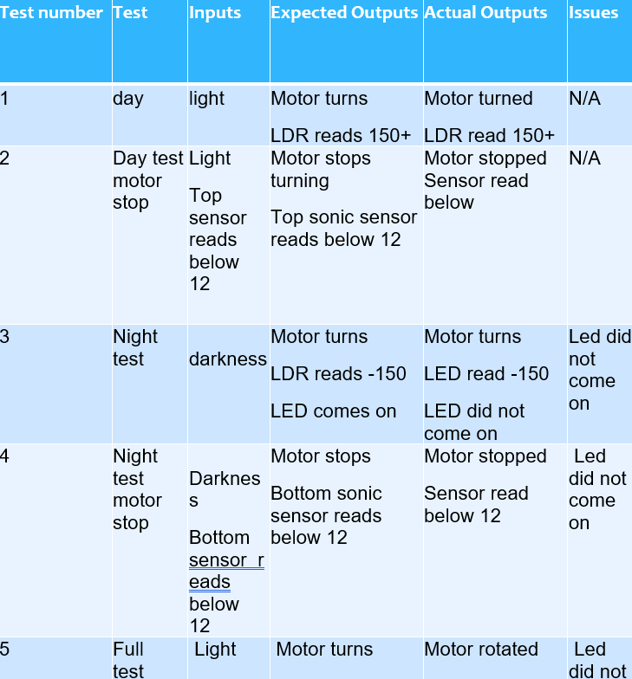
Figure 12
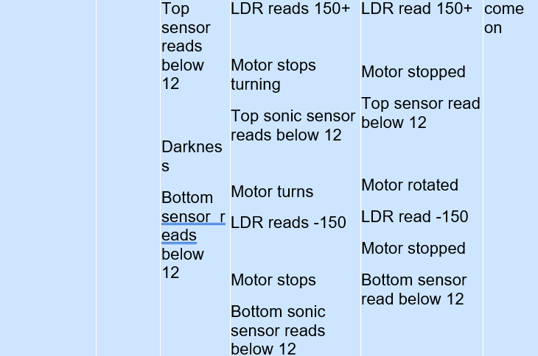
Figure 13
You can view the video of me carrying out my tests in the attached link IMG_9619.MOV

During my testing I found that my LED was not functioning correctly, to test this further I added to my code to as you can see in figure 11, this was to energise my LED for 2 seconds to test to see it will come on. However the LED failed to energise, therefore I think there was a fundamental issue with my LED. Other that the LED failing to energise, my testing proved successful with every other function working.
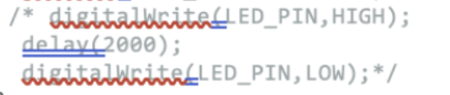
Figure 14

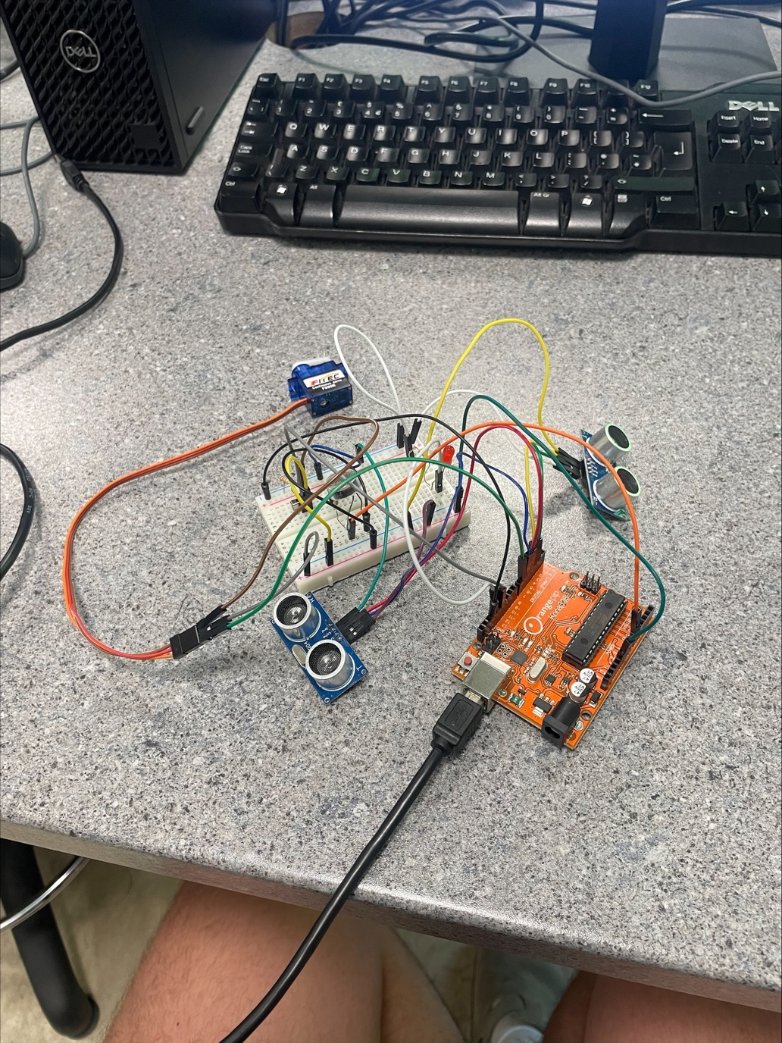
Figure 15

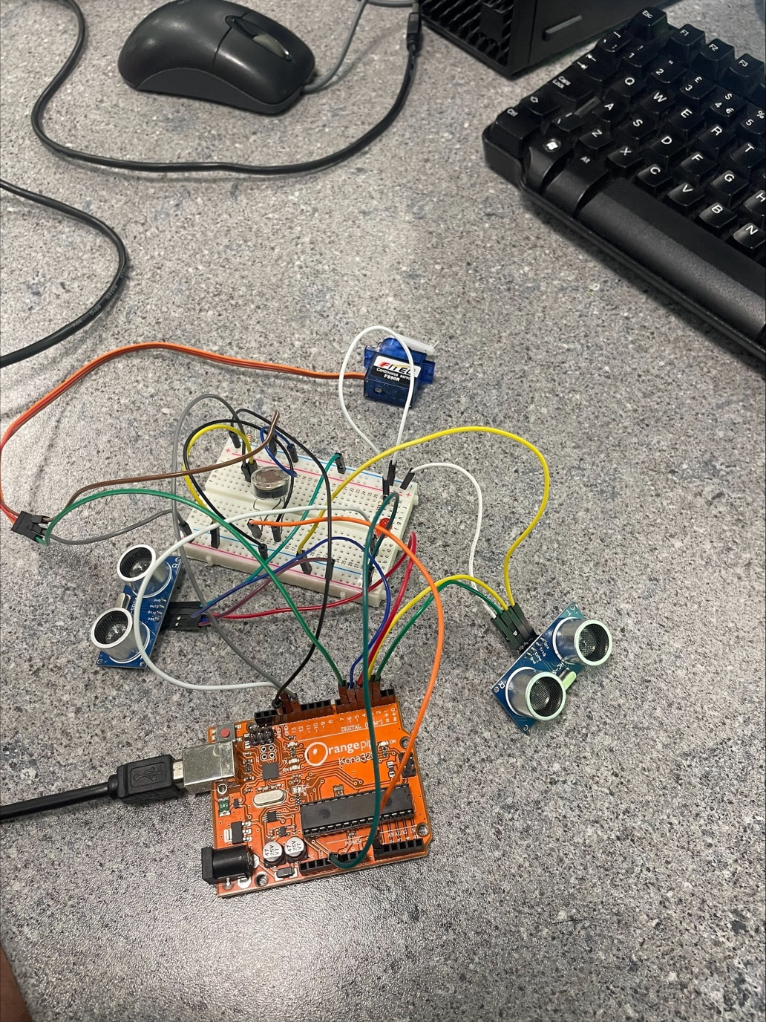
Figure 16

Task 5

Discussion
Overall I think the programming language C proved itself very useful. It offers a tight control of the system you are operating and proves to be relatively efficient in doing so. Due to the limits of embedded systems where processing power and memory can be limited, the C language helps counter this and offers a huge range of possibilities within the limitations it is provided. When researching about C language as a whole, many extracts mentioned how C was a very portable and transferrable language between the systems, with minor adjustments it can be quite simply transferred to another microcontroller with minimal to no changes to performance. I personally found C very useful in the fact that there was a large number of examples and documentations of other people using C code and there set ups. This along side what we learnt in class helped me massively in writing my code. The simplicity in the design of the code is what I found most useful, compared to other programming languages I would class C code as on the easier side of the spectrum to understand, the language used is relatively simple once used a few times.

Evaluation
The first and main modification I would make to my system would be to carry out more tests to get to the bottom of my LED issue. As you can see in the testing element of my assignment my LED failed to light up. I am in belief that it is more of a fundamental issue rather than a coding issue, I proved this by putting a step into my programme for the LED to come on for 2 seconds as soon as the system was activated, to which when tested did not come on. Therefore, I am particularly confident in saying that it is not a programming issue and it may be an issue with the LED itself or a faulty power supply to the LED. The only other modification I would make is one to make my system more efficient, at this moment in time my system is constantly sending outputs on both ultrasonic sensors measuring the distance from each stopping position and the LDR is also constantly reading light. Therefore, it would be more efficient to add a piece to the programming to only measure the stop distance on the sensor that is required E.g., if the blind is closing only the bottom ultrasonic sensor needs to be active and vice versa. It would also be more efficient to only take a reading of the light level every 10-15 seconds. Of course, this change does not change the way my system would fundamentally function, it would just be making it more efficient.

Conclusion
To conclude I believe my system meets the requirements for an office security system. The basic system itself functions and tests as it should. However, the additional LED I added is causing issues with turning on, as I have previously explained, I do however believe this is a fundamental issue and does not present as a fault with my code. Therefore, I believe my C code is correct and is meeting the requirements of the task, having the blinds roll up and down when the LDR detects the light going above or below the threshold.

Bibliography

Ultrasonic sensors - Koval, L., Vaňuš, J. and Bilík, P., 2016. Distance measuring by ultrasonic sensor. IFAC-PapersOnLine, 49(25), pp.153-158.

sciencebuddies. (2020). How to Use a Breadboard for Electronics and Circuit. [Online]. sciencebuddies.org. Available at: https://www.sciencebuddies.org/science-fair-projects/references/how-to-use-a-breadboard [Accessed 13 May 2025].

References

‘’An LED (Light Emitting Diode) is a semiconductor device that emits light when an electrical current passes through it. The light is produced by the recombination of electrons and holes in the semiconductor material, which releases energy in the form of photons.’’ - Yuan, S., Li, X., & Lu, X. (2020). Light-emitting diode (LED) technology: Principles, applications, and future developments. Elsevier.

Appendix

C code

#include <Servo.h>

// Servo motor
Servo blindServo;
const int SERVO_PIN = 6;
const int SERVO_STOP = 90;
const int SERVO_UP = 60; // rotate up (adjust if needed)
const int SERVO_DOWN = 120; // rotate down (adjust if needed)

// LDR
const int LDR_PIN = A0;
const int LIGHT_THRESHOLD = 150; // adjust based on your room lighting

// LED (simulated office lights)
const int LED_PIN = 11;

// Ultrasonic sensors
// Top sensor: detects when blinds are fully up
const int TRIG_TOP = 3;
const int ECHO_TOP = 2;

// Bottom sensor: detects when blinds are fully down
const int TRIG_BOTTOM = 5;
const int ECHO_BOTTOM = 4;

const int STOP_DISTANCE_CM = 12; // threshold to detect wall or blinds edge

// State flags
bool blindsUp = false;
bool blindsDown = false;

void setup() {
Serial.begin(9600);

pinMode(LDR_PIN, INPUT);
pinMode(LED_PIN, OUTPUT);
digitalWrite(LED_PIN, LOW); // Lights off initially

pinMode(TRIG_TOP, OUTPUT);
pinMode(ECHO_TOP, INPUT);
pinMode(TRIG_BOTTOM, OUTPUT);
pinMode(ECHO_BOTTOM, INPUT);
/* digitalWrite(LED_PIN,HIGH);
delay(2000);
digitalWrite(LED_PIN,LOW);*/
}

void loop() {
int lightLevel = analogRead(LDR_PIN);
long distanceTop = readDistance(TRIG_TOP, ECHO_TOP);
long distanceBottom = readDistance(TRIG_BOTTOM, ECHO_BOTTOM);

Serial.print("Light: ");
Serial.print(lightLevel);
Serial.print(" | Top: ");
Serial.print(distanceTop);
Serial.print(" | Bottom: ");
Serial.println(distanceBottom);

// Light → blinds UP
if (lightLevel >= LIGHT_THRESHOLD && !blindsUp) {
Serial.println("Light detected — rolling blinds UP...");
blindServo.attach(SERVO_PIN);
blindServo.write(SERVO_UP);
digitalWrite(LED_PIN,LOW);

if (distanceTop > 0 && (distanceTop < STOP_DISTANCE_CM)) {
Serial.println("Blinds fully UP — stopping motor.");
blindServo.write(SERVO_STOP);
delay(300);
blindServo.detach();
digitalWrite(LED_PIN, LOW); // Lights off
blindsUp = true;
blindsDown = false;
}
}

// Dark → blinds DOWN
else if (lightLevel < LIGHT_THRESHOLD && !blindsDown) {
Serial.println("Dark detected — rolling blinds DOWN...");
blindServo.attach(SERVO_PIN);
blindServo.write(SERVO_DOWN);
digitalWrite(LED_PIN,HIGH);

if (distanceBottom > 0 && distanceBottom < STOP_DISTANCE_CM) {
Serial.println("Blinds fully DOWN — stopping motor.");
blindServo.write(SERVO_STOP);
delay(300);
blindServo.detach();
digitalWrite(LED_PIN, HIGH); // Lights on
blindsDown = true;
blindsUp = false;
}
}

delay(5000);
}

// Function to read distance from an ultrasonic sensor
long readDistance(int trigPin, int echoPin) {
digitalWrite(trigPin, LOW);
delayMicroseconds(2);
digitalWrite(trigPin, HIGH);
delayMicroseconds(10);
digitalWrite(trigPin, LOW);

long duration = pulseIn(echoPin, HIGH, 30000); // 30 ms timeout
if (duration == 0) return -1; // No echo
return duration * 0.034 / 2;
}

