Marketing Fundamentals

Assessment 2: Marketing Fundamentals Analysis and Evaluation

Galina Rais ID: (2020307)

Contents
1. Introduction 3
2. Process of Marketing and Roll of Marketing Mix 3
2.1 Mission Statement 3
2.2 Market Research 4
2.3 Setting Objectives 4
2.4 Strategy 4
2.5 Implementation 5
2.6 Control 5
3. PESTLE Analysis 6
4. Porters 5 Forces Analysis 9
5. SWOT Analysis 11
6. The 4ps of Marketing 12
7. Role of Marketing in Creating Value 13
7.1 Marketing Concept 13
7.2 Branding 13
7.3 Branding Strategy of Rolls Royce 14
8. Stakeholder engagement and their impact on marketing activities 14
9. Conclusion 15
10. References 16

Introduction
Marketing is an important part of any organization. It is way of how organizations exhibit their product or service to their respective consumers. It includes all those activities which companies adopt to promote, distribute or sell their product in market (Jones and Chartered Institute of Marketing, 2006). Marketing ensures that the product must reach its consumer at proper time and demanded. Marketing manager of any organization must understand its importance in order to properly execute its duties.
Rolls Royce is a leading automobile manufacturer offering premium vehicles to its customers worldwide. Its headquarters is in based in UK having more than 1300 employees currently working. Rolls Royce is a subsidiary of German automobile company BMW. Company sells almost 4000 vehicles annually because it deals in luxuries and niche category of automobiles. Buyers of Rolls Royce are not only from China and US, but the middle east countries, India and Europe are one of the leading buyers of this unique car (Rolls-Royce, 2018).

Process of Marketing and Roll of Marketing Mix
Marketing is a tool adopted by companies to make sure that their product reaches its consumers without any hurdle, exhibiting company’s strong position (Harris and Ogbonna, 2003). There are various steps that are needed to be followed in order to make sure marketing has been conducted. This includes planning, developing key figures, executions and making relationship with customers and stakeholders. Overall purpose of marketing is to identify key consumers and exhibit them merits and quality of product which organization is selling.

2.1 Mission Statement
A mission statement of any organization focuses on customers’ needs and preferences. It is part of marketing process which includes focus on customers desires and they shape their product according to the need of customer. It also includes perception of product which company wants their consumers to have. Entire process of marketing revolves around it (Contributor, 2020).

2.2 Market Research
Market research involves gathering information regarding the marketing in which the product is going to be launched. It is also a process of marketing which is used to study target market of consumers in which company is going to launch products. It allows organization to get reviews from customers regarding their product or service. Research is not only limited to getting information about customers’ needs and product, but it includes competitors plans, their way of working and how they are positioning themselves in market. In depth marketing research report includes working of suppliers too and how customers preferences are. Based on all these findings a product is developed (Twin, 2020).

2.3 Setting Objectives
Plans and objectives are important for any marketing plan. If the layout of plan has no targets to be achieved then there is no point of achieving targets. Objectives can differ according to the nature of targets to be achieved. For example, if an organization is offering service to their employees then their objective will be to stay with consumers and build a stronger relationship so that they will keep providing services to the consumers. If company is offering a product which is needed to be sold then market objectives will be setting an appropriate price and increase number of sales.

2.4 Strategy
Strategy is a detailed set of frameworks which is used by manager to execute operations of an organization. Once mission and objectives of market research has elaborated “what” or “why” of the operation. Strategy reveals “how” part (Jones and Chartered Institute of Marketing, 2006). During pandemic many retail stores like Aldi has to adopt online platform to sell their product because of closure of physical stores due to Covid-19 restrictions. Indeed their sells surged during pandemic because they offered delivery system through online and product will be delivered to people’s home.

2.5 Implementation
It mostly includes logistics and HR. Once managers are done with strategizing, next step is to implement that strategy and it will be done by managing how many people will work in this project and how to finance operations (Jones and Chartered Institute of Marketing, 2006). Considering same case of Aldi, once they are aware of pandemic situation next step is to make online platform and put all products of Aldi on their online store. Implementation in this example includes how many people will work on this project and how much it will cost.

2.6 Control
After completion of implementation it is important to observe that our desired objectives are met or not. If there is no assessment after implementation then there would be no improvement. Control also means identifying threats and hurdles ahead of operation and finish it before it creates any effect.

PESTLE Analysis
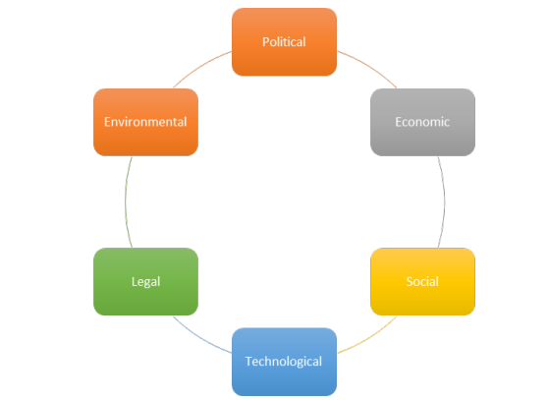
Figure 1 PESTLE Analysis (Reznowski, 2020)
- Political: Political environment is related to governmental bodies. Recently regulations have been imposed by government of UK and EU on fossil fuel cars and has serious implications on automobile manufacturers in UK, like wise it has effect on Rolls Royce as well. Company has also stated that it is investing in R&D technology to cope with government regulations which means new cars established by company will use green fuel. Moreover, after pandemic manufacturing options are not stable in EU and UK as compared to Asian countries so it has direct affect on sales of company. After No Brexit deal company also faced issues like reduce cost and ease in operation. One benefit is in favor of Rolls Royce it is its projects with Army and Airforce while working for armed forces it can bend any political situation according to it (Rolls Royce, 2019).
- Economical: Due to pandemic world has gone through immense changes. Covid-19 has imposed lockdowns worldwide and factories needed to be shut down due no physical labor. Many people had to lose jobs or decrement in their wages which means buying attribute of people has shifted towards necessary goods. Since Rolls Royce deals in luxury category and it faced declines in their sales volume in year 2020.
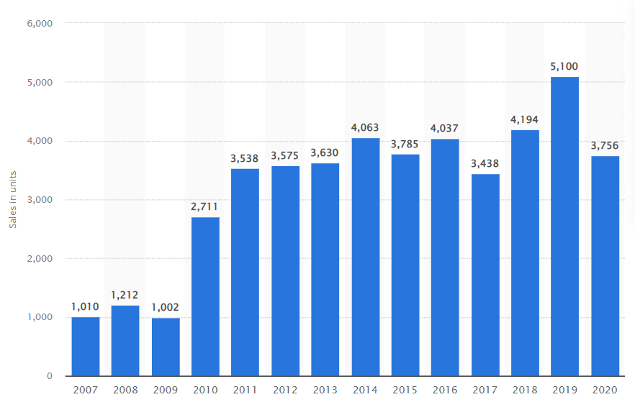
Figure 2 Sales of RR year 2020 (Statistica, 2021)

It can be seen from above graph that company sold 3750 vehicles worldwide in year 2020 which means 26% decline in sales as compared to previous year (Statistica, 2021).
- Social: This comparison is done in developed and underdeveloped countries. Social factors like demographics, education, GDP of country matters a lot. Since Rolls Royce deals premium cars which are expensive so very small percentage of people are able to afford it. But pandemic has turned tables it has turned buying attribute of every class towards necessary goods.
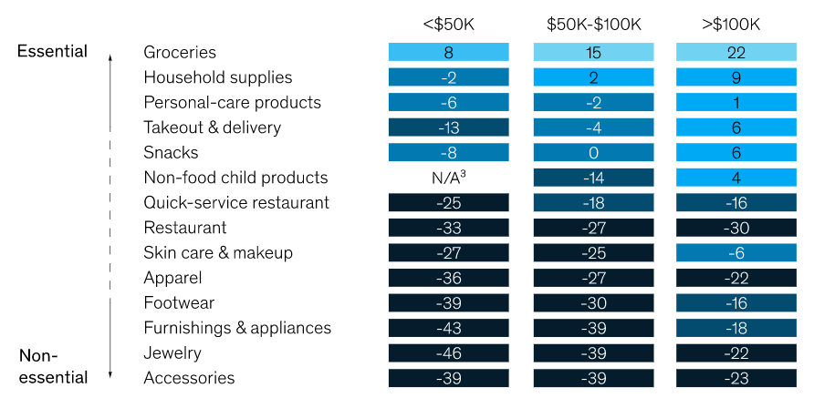
Figure 3 Buying attribute of people (Charm et al., 2020)

As we can see in above diagram buying shift of people from non-essential goods towards essential goods is significant in pandemic. Rolls Royce operates in top notch segment so its buyers are already limited across world like people in developed countries are able to afford such a product like RR (Charm et al., 2020).

- Technological: Due to issues regarding global warming there is immense competition going on in automobile industry regarding electric technology for this purpose every industry is investing heavily in R&D to produce electric vehicles and win in future race. Likewise, RR is also investing heavily in technology to go hybrid or completely CO2 less emission in their vehicles. Company is working on cars from future and has launched a prototype 103-EX which is a mixture of present technology and coming technology (Rolls Royce, 2019).
- Legal: Since RR has customers worldwide and company respect its customers and consider laws and regulations from other country and UK as well. To avoid being sued by agencies around the world company must ensures its quality and design according to the country in which the product is being sent. Recent example can be CBI from India booked RR for bribery against a private contractor which damaged company’s reputation a lot (Alen, 2019).
- Environmental: UK and EU have announced to go carbon free by 2040 (Overton, 2021). Many automobile companies like Ford, Honda, MG, Toyota has also announced that they will completely product electric vehicles by 2040 or 50. This is done environmental regulation imposed by governments on automobile companies. With others being in the race Rolls Royce is also going to produce its future products with green technology.

Porters 5 Forces Analysis
This model is used to access competitive business environment of Roll Royce Motors.
- Competitive in Industry: Rolls Royce also do contractual work with British Air Force. Aerospace and defense industry are growing increasing. For RR, its rival companies are General Electric Aviation, CFM International and Pratt & Whitney. CFM holds 39% shares, PW holds 35% while RR holds 12% (Statistica, 2021). This sector is growing rapidly due to development in Asian countries. Company is enjoying monopoly at this time however competition is high.
- Threat of Substitutes: Because of security threats around the world, aerospace and defence industry is increasing. This industry is highly competitive and advance in technology. Threat of substitution to this industry is low because there are only few companies who are working in this sector and are efficient. Rolls Royce ranks 27th in world defence market (Defence news, 2020). It is also one of the top engine manufacturers in the world (Statistica, 2021). Threat is low to as long as they are moving according to the requirements.
- Threat of New Entrants: Threats of new entrants to this market is low because there are many factors associated with it. In case of automobile market, huge investment is required. Since Rolls Royce work in aerospace and automobile sector both sectors are impenetrable because of huge amount of money required to invest in it. The outbreak of pandemic, almost all automobile companies have suffered decrease sale volume.
- Bargaining power of buyers: In this category bargaining power of customer cannot be specified easily. Because each automobile has its own unique features and brand image. Rolls Royce operates in ultra-luxury category. There are other options like super sports car but there is no alternate to British Royalty and this is only given by Rolls Royce itself. So bargaining power of consumers is low (Rolls Royce, 2019).
- Bargaining Power of Suppliers: Power of suppliers in automobile industry is low because there a lot of substitutes available. If one supplier is not providing enough quality company shift to another. Many automobile companies are building their own suppliers. Rolls Royce contribute a lot towards their suppliers. RR contributes 7 Billion £ annually on their suppliers and ensure that their supply chain remains smooth (Rolls Royce, 2019).

SWOT Analysis
Strengths:
- Rolls Royce has the most global reach with its business over 50 countries.
- According Statistica, market capitalization of Rolls Royce was 8 Billion dollars in 2020 showing its brand value.
- In 2020 Rolls Royce committed a budget of 1.25 billion pounds for its R&D, collaborating with 29 university technology centers (Shaw, 2021).
- RR adoption with latest technology with robotics allowing it make immense changes in aerospace and aviation industry (Shaw, 2021).
Weaknesses
- In 2020, company had high debt equity ratio of -0.7888.
- RR was accused of giving bribe to win contracts for itself. However, it paid 671 million pounds to avoid persecution.
- High negative debt-equity ratio indicates its weak risk management systems. Its projects are not safe.
Opportunities
- Alliance with other companies like Allison Engine Company or Daimler AG.
- Strategic partnership with other manufacturing groups to stable debt equity ratio.
- Launching sustainable engines like other automobile companies.
Threats
- Brexit deal has badly affected RR in terms of employees, taxes, shift in production facilities and many other issues.
- Pandemic has affected its sales volume declining of 26% in sales as compared to 2019.
- UK has announced to go fully carbon free by 2040. It means company has to invest large amount into R&D for green technology.
Segmentation
Based on segmentation automobile industry can be split into three segments which are income, age and country. RR buyers are usually from developed countries and are a part from normal people. People with old age are looking for vehicles of their time, younger people likes to have brand new cars with extra features and give good mileage. Average customers prefer cars that can be only be used for conventional driving. People in developed countries like Middle East countries and European countries can be seen purchasing RR in huge amount and there most buyers are from these countries. Otherwise salary-based person even high salary will not buy RR and will go for another choice (Ronald Edward Frank, Massy and Yoram Wind, 1972).
Targeting
Once the organization has figured its segmented market then it is for organization know which customers are needed to target and build their product around that segment. That segment will be then called as target market (Hooley, 2017).
Positioning
It means how organization wants to position itself in eyes of customer (Russell, 2018). Does organization want to be reputed or does it want to be price conscious. Does it want to deliver only product or it wants to deliver service as well. RR operates based on its quality, huge brand reputation and deals in premium category.

The 4ps of Marketing
Product: What organization is selling in exchange for consumers money is the product (Ronald Edward Frank, Massy and Yoram Wind, 1972). RR deals in variety of products not only in automobile but it also deals in aerospace engines manufacturing and also world’s top manufacturer in engine category (Rolls Royce, 2019).
Place: Place refers to the area from where organization sells their product. RR sells their product usually from dealership platform and their corporate offices which are situation around the world (Rolls Royce, 2019).
Promotion: Rolls Royce deals in luxury and niche category. Rolls Royce promotes itself through high paid promotional ads shown in television. They also conduct exhibition of their cars in 5-star hotels worldwide. As well as they also run promotional videos on different social media platforms.
Price: Since RR offers premium products so they do not provide relaxation in terms money. They sell premium manufactured luxury vehicles which came at cost.

Role of Marketing in Creating Value

7.1 Marketing Concept
Concept of marketing has changed over decade which means it was not something which was 5 or 10 years ago. Concept of marketing states that organization must gather information regarding their customers need, area of operation, what product they want? How they want? in what form and charges related to it. It also suggests that a product which fulfils customers’ needs is the most valuable product for the organization (Cateora and Graham, 2016).

7.2 Branding
To offer something unique and exclude oneself from current market competitors branding is necessary (Cateora and Graham, 2016). Branding needs to be unique and special but it also means to offer something which is unique does not available in market. In case of RR it has built immense reputation among its consumers. Wealthy people worldwide know that RR does not compromise on quality and luxuries features it has. RR Logo is one the most extensive features of this organization which is recognized worldwide as brand recognition symbol.

7.3 Branding Strategy of Rolls Royce

RR follows High Premium Pricing Strategy for all of its items because they all came in luxury category. It has well-known brands such Phantom, Ghost, Dawn and Wraith. Customers can also order customize RR but it is not operated by RR company but another company with same name provides these customizations such as bonnet metallic finish exteriors and hand tailors’ interiors are one of the features they offer.

Stakeholder engagement and their impact on marketing activities

Employees: They are most important stakeholders because who productivity of company depends on them. They are the most affected by any changes of the organization such as opportunities and threats. Any organization is made up because of its employees because every decision made by company affects its working employees. Reason of huge reputation of Rolls Royce is because of hard working employees. RR carries itself with skillful workers which specialized in making these products.
Managers: Manager are the ultimate decision maker of an organization which means any decision made by upper manager will be followed by lower management. One bad decision can destroy company’s reputation and one good decision can make its way to glory. Managers at RR are ones which build unique relationship of RR with its consumers.
Owners: Owners are those who had invested in every operation of organization and hence are the most valuable ones. Organization must always work to keep their owners or stakeholders happy because they are the ones holding assets of company. RR motors owners have invested their money, time, sweat and blood to this organization and brought a legacy for the world.
Suppliers: Suppliers are the external stakeholders which also affect organization. RR treats its suppliers with equity and care they spend almost 7Billion$ annually for their suppliers so that their supply chain system remains smooth.
Government: Rules and regulations of government has direct effect on companies operating in UK. RR makes compliance with every policy issue by the government. For example, UK’s decision on Brexit has already made many businesses vulnerable and many are waiting because they cannot trade in EU now (Contributor, 2020).
Customers: A profound and excellent organization always work to fulfil needs of its customers. It is no doubt that customers are important stakeholders of any organization. RR always treats customers with great care. RR maintains a professional relationship with its customers which is based on trust, expertise and outstanding service. RR serves their customers throughout their operational life (Rolls Royce, 2019b).

Conclusion
It is concluded that marketing is an essential part of any leading organization. Companies who present their product in form of good marketing always make their place among competitors. From identifying customers needs and developing a product which can fulfil their needs are fundamentals which a good market campaign involves. How marketing plants are executed and how lead towards a healthy bond between organization and customers. This is all shown in context world’s luxurious automobile manufacturing company “Rolls Royce”. Organizational view of Rolls Royce Plc was done in the actual market context. Segmentation on the basis different categories are explored and explained in context with Rolls Royce.

References

Alen (2019). Rolls-Royce Holdings Plc PESTEL / PEST & Environment Analysis[Strategy]. [online] Fern Fort University. Available at: http://fernfortuniversity.com/term-papers/pestel/nyse4/7986-rolls-royce-holdings-plc.php.
Cateora, P.R. and Graham, J.L. (2016). International marketing. New York, Ny Mcgrawhill Education.
Charm, T., Coggins, B., Robinson, K. and Wilkie, J. (2020). The great consumer shift: Ten charts that show how US shopping behavior is changing. [online] Mckinsey. Available at: https://www.mckinsey.com/business-functions/marketing-and-sales/our-insights/the-great-consumer-shift-ten-charts-that-show-how-us-shopping-behavior-is-changing.
Contributor, C. (2020). Defining a Market-Oriented Mission. [online] smallbusiness.chron.com. Available at: https://smallbusiness.chron.com/defining-marketoriented-mission-34797.html.
Harris, L.C. and Ogbonna, E. (2003). The Organization of Marketing: A Study of Decentralized, Devolved and Dispersed Marketing Activity*. Journal of Management Studies, 40(2), pp.483–512.
Jones, M. and Chartered Institute Of Marketing (2006). Marketing fundamentals. Oxford: Elsevier Butterworth-Heinemann.
Overton, S. (2021). UK and EU Greenhouse Gas Emissions Trading Schemes. [online] UK in a changing Europe. Available at: https://ukandeu.ac.uk/explainers/uk-eu-emissions-trading-schemes/.
Reznowski, G. (2020). LibGuides: Industry Research: PESTEL Analysis. [online] libguides.libraries.wsu.edu. Available at: https://libguides.libraries.wsu.edu/c.php?g=294263&p=4358409#:~:text=A%20PESTEL%20analysis%20is%20a.
Rolls Royce (2019a). Home. [online] Rolls-roycemotorcars.com. Available at: https://www.rolls-roycemotorcars.com/en_GB/home.html.
Rolls Royce, R. (2019b). Customers. [online] Rolls-royce.com. Available at: https://www.rolls-royce.com/country-sites/uk/our-uk-story/customers.aspx.
Rolls-Royce (2018). Our History. [online] Rolls-royce.com. Available at: https://www.rolls-royce.com/about/our-history.aspx.
Ronald Edward Frank, Massy, W.F. and Yoram Wind (1972). Market segmentation. Englewood Cliffs, N.J., Prentice-Hall.
Shaw, A.A. (2021). SWOT Analysis of Rolls Royce. [online] SWOT & PESTLE Analysis. Available at: https://swotandpestleanalysis.com/swot-analysis-of-rolls-royce/.
Statistica (2021). Worldwide sales volume of Rolls-Royce automobiles 2020. [online] Statista. Available at: https://www.statista.com/statistics/267243/worldwide-sales-volume-of-rolls-royce-automobiles/#:~:text=Rolls%2DRoyce%20Motor%20Cars%20delivered [Accessed 21 Dec. 2021].
Twin, A. (2020). Market Research: A Direct Report From the Customer on New Products or Services. [online] Investopedia. Available at: https://www.investopedia.com/terms/m/market-research.asp.

