An Early Years Practitioners Handbook


(Source: parent2parent.org.nz)

A guide supporting young children through transitions

Contents

Page
Introduction: Aims and What are Transitions? 3

The Needs of the Child 4

The Role of the Adult 6

Partnerships 8

Interventions 10

Proposed Outcomes 11

References 12

Introduction
Aims of the booklet
The aim of the booklet is to guide and support early years practitioners through the transition period of a new child starting at an early year setting. The importance of providing the best practice to achieve a positive experience for the practitioner, the new child, parents, and carers.
The booklet will give an insight into the meaning of transition, the role of the practitioner, parents and carers, the needs of the child, the impact of the importance of partnership working, explanation of interventions and theories used for a smooth transition and the proposed outcomes expected for a child.
What are Transitions?
“Transitions are key events or process of change over the life course” (Welsh Government, 2017)
It is the process of change and adjustment. Children will experience many transitions from birth and a major transition is when the child starts at a new setting. This is a journey and a process that is different for each child.
Most children in familiar surrounding like the home are happy and can feel confident and secure. Transitions can have a major impact on children. It can be a life changing event which has an impact, sometimes, happy, and positive but can also be difficult, unhappy, and negative experience.
These changes can have an overwhelming emotional impact on a child’s confidence and development. Preparation in welcoming a new child into the setting is paramount, communication between child, parent/ carer and practitioner is important. These may include spoken, written or through picture aids. Listening, observing, and respecting everybody’s thoughts and views gives everybody the confidence to feel valued and to make choices best for the child, parents, and practitioner. Building positive relationships and reducing the overwhelming feeling of the unknown, minimising the disruption and the many emotions felt by all involved is important. (Trodd, 2013).
When a transition occurs, practitioners must approach the situation holistically. This means involving all the people involved in the child’s life. This includes the child, parents, any carers, and the practitioners. (Brooke, 2008).
A new child at the setting will encounter many new transitional experiences, this includes the environment, the staff, and the other children. It can sometimes be overwhelming. The practitioners will encourage the process to run as smoothly as possible. This transition could shape the way the child deals with transitions in the future. (Dowling, 2010).

The Needs of the Child
All children have the right to a happy life and are given opportunities to develop to the highest capability standard as set out in Article 6 of the UN Convention on the rights of the Child. (UNICEF, 2019).
(Aubrey and Riley,2022) and (Conkbayir and Pascal, 2014) both agree the best practice in meeting a child’s needs is to respond to each child individually. Every child has different needs and the right to learn. The Montessori method reflects this by giving the child independence, careful observations by following the child, correcting the child by showing them rather that telling them and appropriate environment. (Conkbayir and Pascal, 2014) also explains that Rousseau saw children as individuals and capable of exploring and developing knowledge and experiences independently. Children should be allowed to mature and grow naturally and not dictated by society.
Maslow’s Hierarchy of Needs (1943) model shows that a child’s basic needs must be met before a child can move on to the next step and achieve a successful transition. If a child does not feel secure, safe, loved, or happy they are unlikely to form successful relationships.

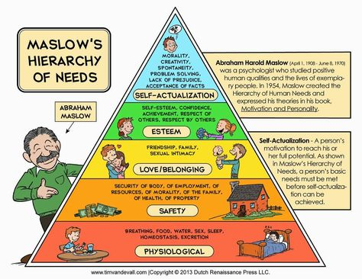
Source: Pinterest.com

When a child transitions from home or from another setting this should be seen as a journey, a settling in period may be needed. Some children settle in quickly, but others may take longer. A few visits to the setting may be useful. Shorter sessions until the child is comfortable to stay for the duration of the session.
Winnicott (1964) and Bowbly (1978) both believed that the mother is a significant figure in a child’s life and placed a great importance in forming a loving bond. Lindon (2012) explains a child starting in a new setting can experience an emotional transition and a successful attachment will only be formed between a child and a practitioner if the child becomes to think of the practitioner as a substitute mother figure in the setting. Article 12 of the UNCRC states that the child’s feelings and views must be considered. (UNICEF, 2019) For example, when a child visits the setting and shows interest in the Peppa pig figures, the practitioner could spend time by sitting and playing with the child. This process is important in building a relationship with the child.
Piaget (1932) believed that multiple attachment of love and care can increase the quality of care of the child. Forming positive friendships with other children can be important as it places the child in a more equal environment and can learn to compromise. (Keenan, Evans and Crowley, 2016).
Piaget (1932) also believed that observations are very important. Aubrey and Riley (2022) agree, observations will allow the keyworker to gather the evidence needed to help with planning for the needs of the child and to help the child in the development process. Preparing activities best suited to the development stage of the child, monitoring, evaluating, and reflecting. Making changes and improvements to the next activity if needed and allowing a smoother transition on to the next stage of the child’s development.
A child’s brain evolves from positive learning experiences which are age appropriate and encourages stimulation. These enhances child development. Positive and loving attachment with adults and supportive settings are essential to encourage positive emotions. Children learn from adults’ behaviour by mirroring and modelling their actions. When parents and practitioner show respect to each other the children will learn to respect themselves and others. (Pound, 2005).

The Role of the Adult
Early years practitioners are important in the smooth transition into a new setting. The practitioner must use the wealth of knowledge and skills to ensure a successful outcome is achieved. A practitioner could be the secondary attachment person after the parents therefore a positive relationship is essential and good communication is vital. The parents know the child best and by communicating and receiving information of the child’s likes, dislikes, and ways it can help with a positive transition for the child, parents, and practitioner.
All practitioners need to be aware of how important their roles are for a smooth transition. Montessori recognised this, stating that all practitioners should be accurately qualified to be able to deliver a successful and effective experience for the children that is well planned. (Aubrey and Riley, 2022).
It is important that National Minimum Standards (NMS), guidelines, and procedures set out by Care Inspectorate Wales, are always met. All practitioners in a registered setting must be kept up to date with any changes immediately. These changes can help with decisions on any transitions taking place.
It is the responsibility of a practitioner to make a new child’s experience of a transition as stress and trouble free as possible. Children should be part of any decision making and should always be listened to as stated in Article 12 of the United Nations Convention on the Rights of the Child. (Welsh Government, 2017).
Practitioners need to be able to communicate with the children. (Lindon, 2012) explains this is not always an easy task if a child feels scared, overwhelmed, or anxious. If a child is non-verbal other methods other than verbal need to be explored. These methods could be a variation in tone, using a softer quieter voice and using non-verbal techniques such as using facial expressions when speaking, hand gestures, whole-body movements or using pictures. The practitioner needs to recognise the signs when a child is concerned, unhappy or anxious. Becoming a key worker to a child will enable the practitioner to get to know the child and to inspire to become a role model and will come to recognise any signs if the child has any issues or concerns. The practitioner can intervene before the issue becomes a bigger problem.

Source: Nursery world

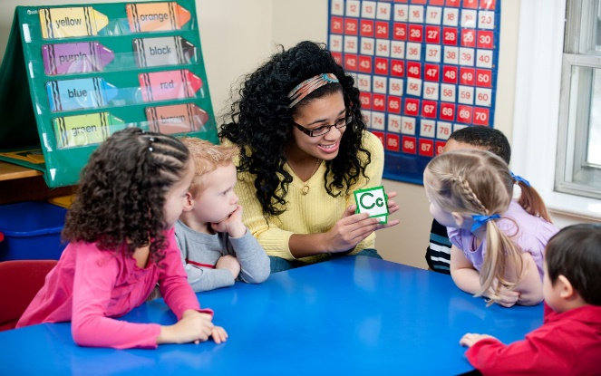
Source: Socialmettle.com

When a child transitions from home or from another setting, a settling in period is needed. Some children settle in quickly, but others may take longer. A few visits to the setting may be useful. Shorter sessions until the child is comfortable to stay for the duration of the session. The practitioner will assess this situation and adjust accordingly by discussing with parents and colleagues if needed in staff meetings or arranged meetings, over the phone, during drop off or pick up times, whichever is the most convenient, with the parents.

Partnerships
(Tovey, 2016) suggests the Froebel approach is essential for a smooth transition. It encourages partnerships between parents and practitioners and effective communication are essential in achieving this positively and to encourage development. (Pound, 2005) also agrees that the Froebel approach through play has a significant place in a child’s development. It helps to foster enjoyment and well-being through not only play but through songs and music. It also encourages to take play to an outdoor environment, experiencing nature and to enhance real life experiences.
Bronfenbrenner’s Ecology Model known as ‘systems theory’ explains that a child is placed in the middle of an ecological system. This means that the link between home and the setting and parents and practitioner has a positive effect on the child’s social and cognitive development. A holistic approach to a child’s development is beneficial. (Conkbayir and Pascal, 2014).
Bronfenbenner’s model has four parts and many of these elements may have an impact on a child directly and indirectly.
The Microsysytem – the environment the child spends most of it time, normally the home where they are happy, confident, and active.
The Mesosystem – this is the extended environment for example, other family members, neighbours, friends, nursery, or school.
The Exosystem – this is the environment which does not directly involve the child but can have an impact on their development. These include health services, local economy, and local government.
The Macrosystem – this is the wider environment which includes, laws and policies, pollution, and climate.
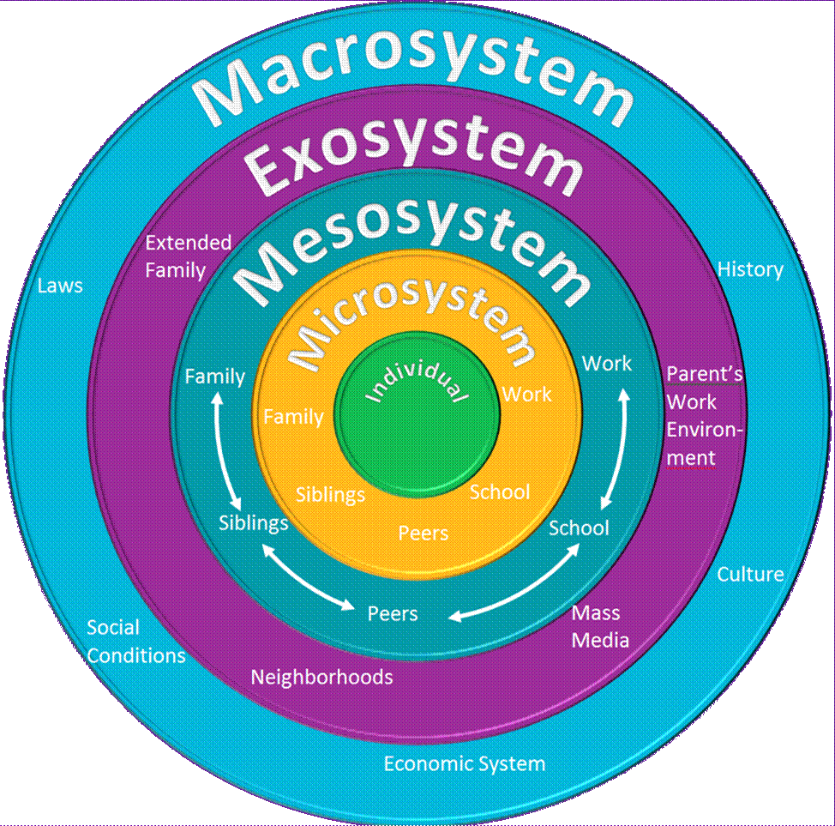
Source: mapoolcampus.com (2019)
Although a transition period can be a stressful time it can also be a way of getting to know the parents by asking questions regarding their background, occupation, hobbies, or skills they can share in the setting for example a physiotherapist could come and discuss the human body, a keen gardener could come and discuss and plant some seeds or flowers with the children.
(Conkbayir and Pascal, 2014) explains that children learn through explorative play and Piaget theory reflects this. He believed children learn through action and experimenting and allowing plenty of time for thinking. This can be achieved by observations and planning for the child’s ability. Identifying different schematic behaviours along the way. (Tovey, 2020) also believes that the Froebel approach to explorative play is important as the practitioner also learns in the process, working closely by observing and then reflecting on the child’s likes, dislikes, and abilities. This information can be shared with colleagues in staff meetings and can be used to improve the children’s transition experience of new children joining the setting.
Identifying any additional needs that a child has is important. Early intervention and seeking help from other agencies for example, a speech therapist can improve a development outcome for the child. Discussing any concerns and observations with parents allows a holistic approach to gain the extra support needed at the setting and at home. Health visitors and The Family Information Services are both excellent services that can help to achieve this.
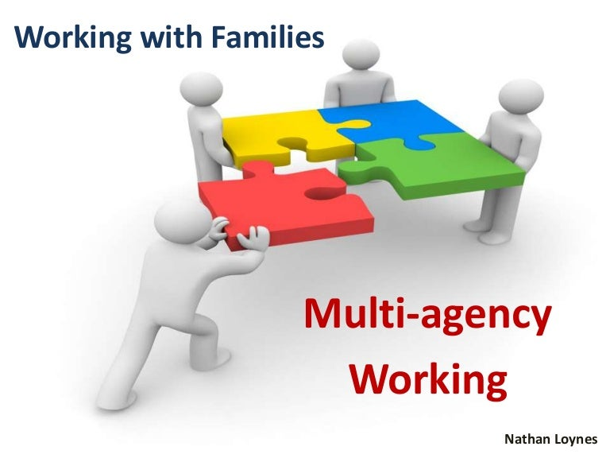

Interventions
It is important that the setting is always professional, organised, welcoming, consistent, and inclusive to be able to give the support needed when a new child starts in the setting.
A close link is the key factor. This is achieved by a home visit if needed, where a practitioner meets the child and their family in their own environment. This is outlined in Bronfrenbrenner’s approach, observing in a natural environment allowing a true reflection of the child and building a professional trustworthy relationship with the whole family. (Keenan, Evans and Crowley, 2016) This is helpful before the child starts in the setting to encourage a smoother transition into the setting. It encourages trust and familiarity between all involved.
A welcome pack will be completed at the time of the first visit this includes the settings Statement of Purpose and policies this outlines information regarding the setting and the commitment to providing an excellent service. It also includes a child record form providing the setting all the information regarding the child and family. Forms giving the setting the consents needed to safeguard staff and the child.
The setting must follow the National Minimum Standards set out by CIW. These can be adapted and developed to best suit the individual settings. Settings can take inspirations from other practices locally, nationally, and internationally. The Te Whariki approach from New Zealand is a positive inspiration and (Lee et al, 2012) explains that it is the importance of family and a community shared relationship that helps a child to be healthy in mind and body and encourages a sense of belonging. The Reggio Emilia approach as explained by (Kinney, 2007) also involves family and the wider community, this encourages involvement and all contributing to the learning process.
The New curriculum for Wales is a curriculum which we adapt here in the setting. It ensures all children have equal opportunities, excellent quality of care and the best education the setting can provide. (Welsh Government, 2022)
Once the child is ready to start in the setting the practitioner must always make themselves available so parents can ask questions about any concerns they have regarding the transition. Arranging a visit to the setting and maybe additional visits if needed. Allow the child to engage and play in activities during their visit. Explaining routines of the setting, where to drop off and to pick up the child, registration, snack-times, what snack to bring and lunchtimes encouraging familiarity.
The transition period has no set period. Planning for a successful transition is important. Some children will need more support than others, Practitioners need to be patient and allow time for the transition.

Proposed Outcomes
Every child is unique, from the rate they development, their personalities, their abilities and skills, their backgrounds, and the experiences they have already experienced in life. All these different factors must be taken into consideration when a child starts in the setting.
The practitioner must provide emotional and practical support throughout the transition period. This encourages continual care for the child, increasing their confidence to develop, encourages learning, improve their well-being and hopefully leaving an impact of a positive experience. Helping them to settle in and be at the setting. (Welsh Government, 2017)
The New Curriculum for Wales (2020) and its framework is important to raising standards throughout the educational sector. The aim is to encourage all children in Wales to become:
- Ambitious and capable learners. Encouraged to learn throughout their lives.
- Enterprising and creative contributors. Problem solving, sharing ideas and take measured risks.
- Ethical, informed citizens of Wales and the World, Respect the needs and the rights of others.
- Healthy and confident individuals. To be able to lead fulfilled lives as valued members if society,
The New curriculum for Wales will give the setting and practitioners the guidance needed to improve opportunities in the setting for the children and encourage a successful transition to all involved. Practitioners will further their confidence and will help to achieve a successful outcome for each individual child.
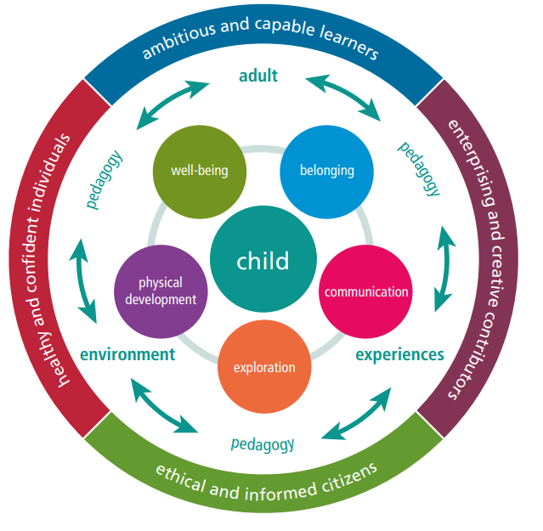
Source: ndna.org.uk

The desired outcome is for every child to be happy, to build positive relationships with the practitioners and the other children, to become curious and confident, to settle and enjoy their time at the setting and for parents to be confident to approach the staff with any concerns and questions, to feel valued and included in their child’s learning, development and for them to be happy sending their child to the setting.

References

Aubrey. K. and Riley, A. (2022) Understanding Educational Theories. 3rd edn. London: SAGE. Accessed 12th November 2022)
Brooker, L. (2008) Supporting Transitions in the Early Years. Maidenhead: Open University Press. (Accessed 16th November 2022)
Conkbayir, M. and Pascal, C. (2014) Early Childhood Theories and Contemporary Issues: An introduction. London: Bloomsbury. (Accessed 12th November 2022)
Dowling, M. (2010) Young children’s personal, social and emotional development. 3rd ed. London: SAGE. (Accessed 8th November)
Keenan, T., Evans, S. and Crowley, K. (2016) An introduction to child development. 3rd edn. London: SAGE. (Accessed 16th November 2022)
Kinney, L. (2007) An Encounter with Reggio Emilia: Children’s early learning made visible. London: Routledge. (Accessed 27th November 2022)
Lee, W. et a.l (2012) Understanding the Te Whariki Approach: Early years education in practice, London: Routledge. (Accessed 27th November 2022)
Lindon, J. (2012) Linking Theory to Practice: Understanding Child Development 0-8 years. 3rd edn. London: Hodder Education. (Accessed 13th November 2022)
Mapoolcampus.com (2019) Bronfenbrenner’s Ecology Model [image] Available at: https://i.pinimg.com/originals/2a/6b/4a/2a6b4aeeca16b2426f5566a0a241bfba.gif (Accessed 25th November 2022)
Ndna.org.uk (2022) Curriculum for Wales [image] Available at: https://ndna.org.uk/wp-content/uploads/2022/07/four-purposes.png (Accessed on 27th November 2022)
Nursery World (no date): Early years in School: Communication & Language – speaking parts [image] Available at: https://www.nurseryworld.co.uk/features/article/early-years-in-school-communication-language-speaking-parts (Accessed 13th November 2022)
Parent2parent.org.nz [Image] Available at: https://parent2parent.org.nz/wp-content/uploads/2020/05/backtoschool-1025x480.jpg (Accessed 7th November 2022)
Pinterest (no date): Maslow’s Hierarchy of Needs [image] Available at: https://www.pinterest.co.uk/pin/289708188503651718 (Accessed 12th November 2022)
Pound, L. (2005) How children learn: From Montessori to Vygotsky – Educational Theories and Approaches made easy. London: Practical Pre School Books. (Accessed 16th November 2022)
Slideshare no date. Working with families: Multi-Agency working [image] Available at: https://cdn.slidesharecdn.com/ss_thumbnails/multi-agencyworking-131128025000-phpapp01-thumbnail-4.jpg?cb=1385607129 (Accessed 25th November 2022)
Socialmettle.com (no date): Communication [image] Available at: https://socialmettle,com/verbal-communication-styles (Accessed 13th November 2022)
Teaching Expertise (no date) The transition from home to nursery or playgroup. Available at: https://www.teachingexpertise.com/articles/the-transition-from-home-to-nursery-or-playroup/ (Accessed 7th November 2022)
Tovey, H. (2016) Bringing the Froebel Approach to your Early Years Practice. 2nd edn. London: Routledge. (Accessed 25th November 2022)
Trodd, L. (2013) Transition in the early years: working with children and families. London: SAGE. (Accessed 8th November)
UNICEF (2019) A Summary of the UN Convention on the Rights of the Child. Available at: https://www.unicef.org.uk/wp-content/uploads/2019/10/uncrc-summary-1_1.pdf (Accessed 12th November 2022)
Welsh Government (2017) Flying Start – Annex Transition Guidance. Available at: https://gov.wales/sites/default/files/publications/2019-07/flying-start-transition-guidance-for-professionals.pdf. (Accessed 7th November 2022)
Welsh Government (2022) Curriculum for Wales Available at: https://hwb.gov.wales/curriculum-for-wales (Accessed 27th November 2022)

