Blaenavon Town
Field report

DISTINCTIVENESS AND REGENERATION BMSP 4005

Tutors: Dr Louise Emanuel, Anthony Burns and Davina Evans
Due date: 13th March 2018

Honorata Sieczych
Student no. 1708007

Abstract

The students from Carmarthen Business School of University Saint David Trinity were assigned to create a field report after visit at Blaenavon Town. The purpose of its visit was to understand and become familiar with industrial site of town.
Blaenavon had significant impact on its community and industrial revolution.

Town
Blaenavon town is situated between Abergavenny and Pontypool in south eastern region of Wales with a population of six thousand people. Since year 2000 Blaenavon is on UNESCO list of Heritage Site for Industrial Landscape (Unesco, United Nation, 2018). Blaenavon is well known for industrial revolution and had a significant impact on steel and iron production worldwide. In 1921 Blaenavon was lived by 13.000 people in 1921 (Taylor- Davies, 2018).

Ironworks
The development of this town started from ironworks in 1787 established by Thomas Hill, Benjamin Pratt and Thomas Hopkins (Wakelin, 2006). The ironworks have had six furnaces and the white houses beside ironworks were classified as posh houses at the beginning of industrial revolution. Moreover, only iron masters lived close to ironworks. However, after approximately 60 years those houses became as a lowest standard of living in Blaenavon and were shared by 2 to 3 families. Fumes from furnaces had major impact on health of its residents and workers. Those cottages were lived until 1960. Next to the white house front to Stack Square is a high tower which in fact was an iron’s elevator for an export. Furthermore, beside a lift there are two horse’s sculptures which I have thought were real. Just beside me there were very impressive metal sculptures – signs of Blaenavon. It gives a welcome feeling for tourist to explore more in its town. From 1860 steel production was introduced in Blaenavon (Taylor- Davies, 2018).

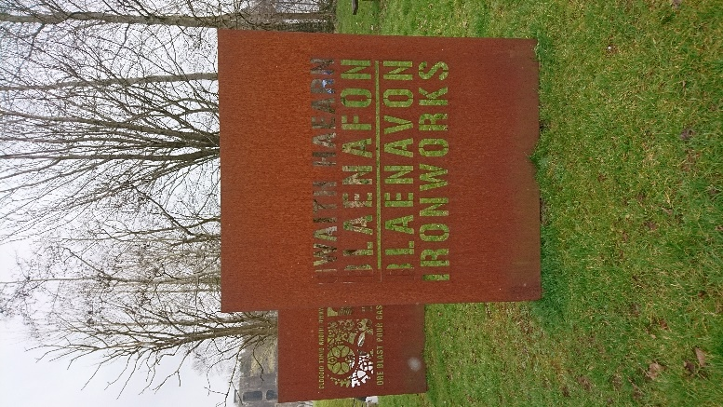
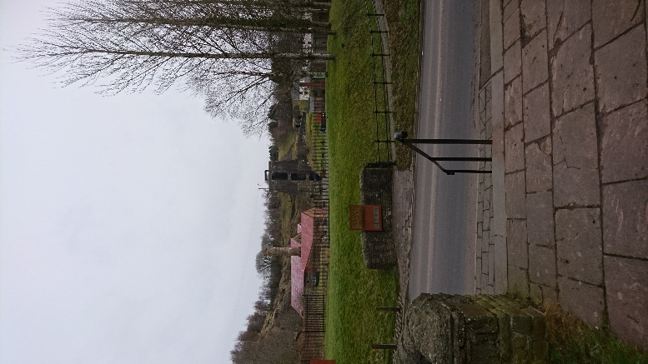 Photos by H. Sieczych

World Heritage Centre
World Heritage Centre is in the middle of town. It used to be Blaenavon Endowed School established by Sarah Hopkins. Through my observation this museum doesn’t share a passion for history of its town as much as Ironworks or different places that I have seen. A museum consists of exhibition of art and videos about Blaenavon history as well as souvenir shop and coffee shop (Welsh Goverment, 2018).
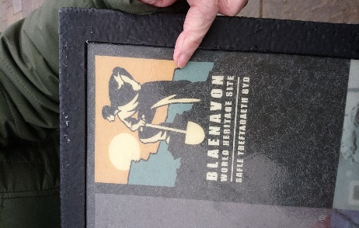
Photo by H. Sieczych

Workmen Hall and Institute
Blaenavon Workmen's Hall and Institute was built by its workers and it was opened in 1895 provided social and educational facilities for community (Royal Commission on the Ancient and Historical Monuments of Wales, 2018). The money was deducted from their wages according to Workmen’s Hall employees (Taylor- Davies, 2018). As you enter to the building you can feel a passion and a pride for Blaenavon history and industrial revolution. The hall consists of big conference theatre style hall upstairs with a balcony. Downstairs its consist of new and modern 4D Sony cinema and museum of Alexander Cordell as well as museum of heroes from the wars and significant people from its town and important people for Blaenavon society. It’s a beautiful place. Alexander Cordell was a writer fascinated about Blaenavon people and its region (Taylor- Davies, 2018).

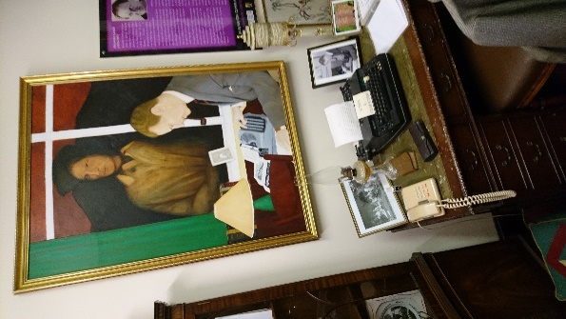
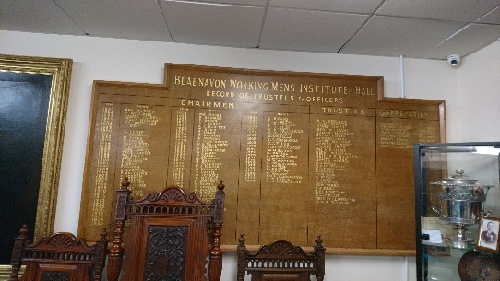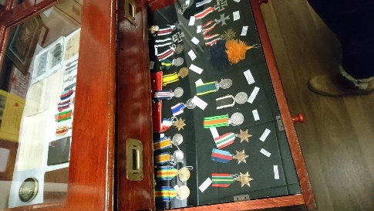

Photos by H.Sieczych

St Peter’s Church
St Peter’s church was built in 1804 by Samuel Hopkins and Thomas Hill of Dennis. It’s an impressive and remarkable memorial for Blaenavon society. An iron features are inside a church such as “cast iron baptismal font, cast iron pillars and cast-iron doors” (Welsh Goverment, 2018) Beside a church there is a grave yard where Samuel Hopkins great ironmaster is buried. His grave included “an iron top tomb” (Welsh Goverment, 2018).
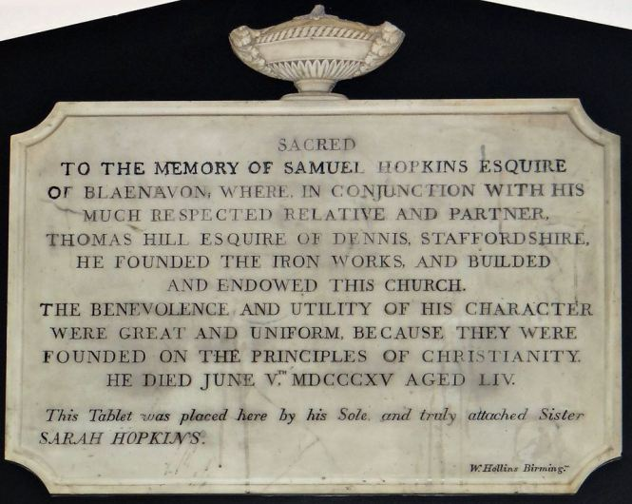
Inside St Peter’s Church there is memorial plaque dedicated to ironmaster by his sister Sarah Hopkins (Word Press Blog, 2015). Between 1840 and 1850 Blaenavon had 18 places of worships and 41 pubs (Taylor- Davies, 2018) .

Photo from Word Press Blog.

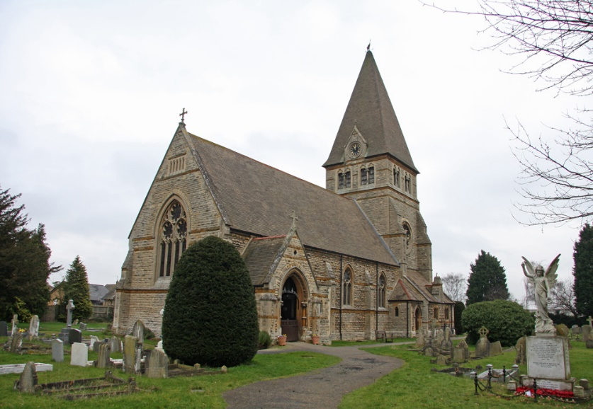
St. Peter’s Church
This Photo by Unknown Author is licensed under CC BY-NC-SA

Big Pit
Big Pit Museum is one of the two museums in Great Britain that takes tourist underground. Big Pit shares remarkable memory of the industrial revolution. Big Pit is operational preservation from the Welsh Heritage of coal production and is deep as 90 meters (Fawr, 2018). The coal was exported across the globe. A museum is divided by sections where tourists can contemplate about its past. Each room consist of tools, instruments and machinery of coal mining. It is impressive tourism attraction, furthermore an employee’s shown passion and pride of its place. Big Pit operated from 1880 until closure in 1980. According to our guide in Big Pit (Fawr, 2018)miners were accompanied by boy’s workers as small as 10 years old and horses which carried coal. The conditions of job itself were very dangerous and hard. Everyday miners and the rest workers risked their lives for black diamonds- coal. Its amaze me how well a goods are preserved. From one room to another we were seen step by step shift pattern of miners. In the Lamp Room it was explained and shown to us how miners carried heavy lamps underground. What astonished me it was importance of rats underground because they warned miners about roof collapsing underground. As well as rat’s canaries were important underground because they detected level of carbon monoxide underground which helped miners to prevent explosions. The Pit Heads Bath is a big building with showers cubicle, lockers and a place with automated boot brushers where miners cleaned their shoes. Also, The Pit Heads Bath have a medical room and canteen which at present is a coffee shop for visitors (Glamorgan-Gwent Archaelogical Trust, 2018). Miners preferred female doctor and nurse as a mining job was occupied only by males. This building also consists many of souvenirs of miners which makes its place unique.

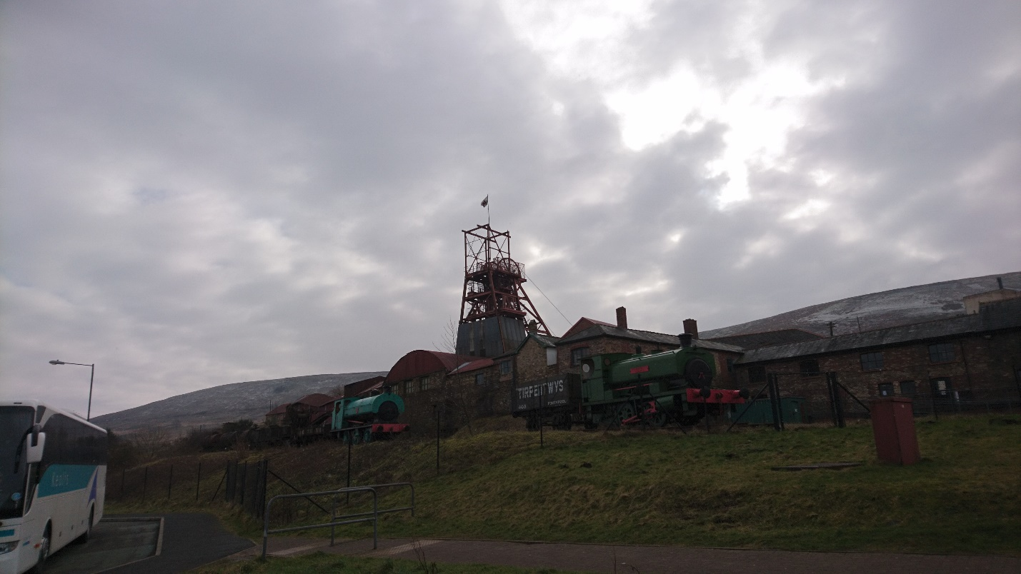
Big Pit Museum; photo by H. Sieczych

Old lamps in Lamp Room. Photo by H. Sieczych
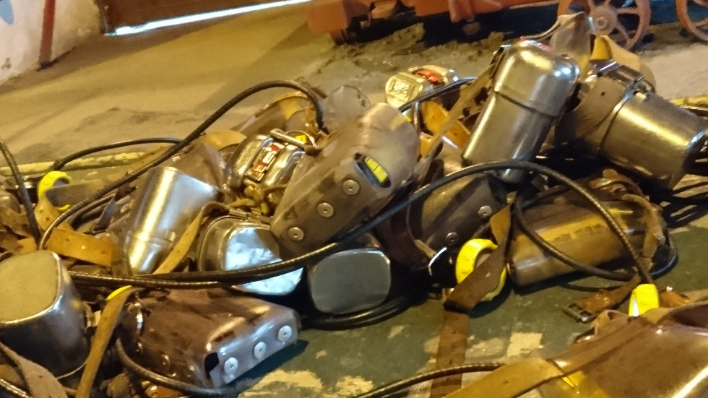

Automated boot brushers, photo by H. Sieczych
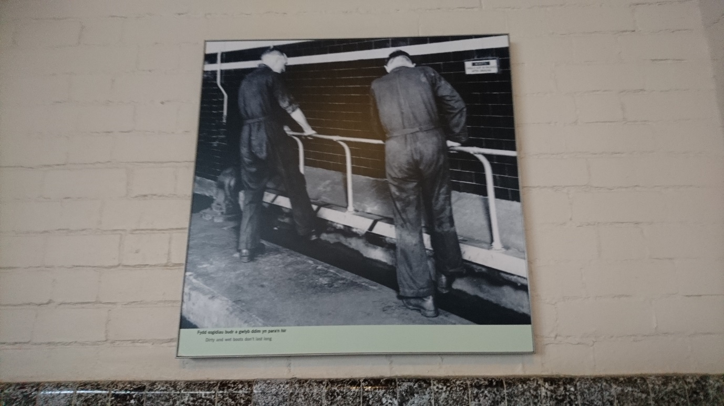

The Lockers, photo by H. Sieczych
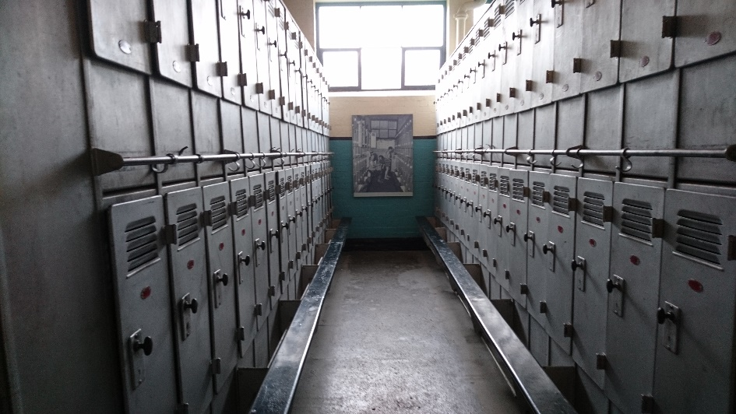

The showers, photo by H. Sieczych
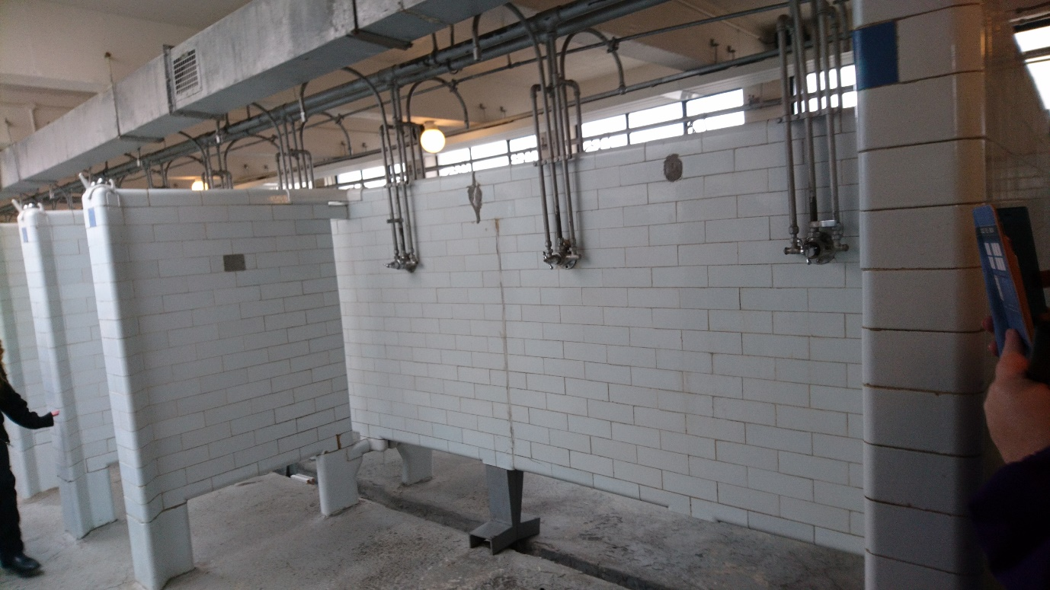

Blaenavon Heritage Landscape is important for present and future generations because of significant impact on our history of Wales. A field trip underlines importance of coal mining and industrial revolution.

References
Fawr, R. (2018, February 6). Guide of Big Pit. Blaenavon, Wales.
Glamorgan-Gwent Archaelogical Trust. (2018, n.d. n.d.). www.ggat.org.uk. Retrieved from www.ggat.org.uk: http://www.ggat.org.uk/cadw/historic_landscape/blaenavon/english/Blaenavon_Features.htm
Royal Commission on the Ancient and Historical Monuments of Wales. (2018, n.d. n.d.). Coflein. Retrieved from www.coflein.gov.uk: http://www.coflein.gov.uk/en/site/31951/details/blaenavon-workmens-hall-and-institute
Taylor- Davies, R. (2018, February 6). The guide of Blaenavon trip. Blaenavon, Wales.
Unesco, United Nation. (2018, n.d. n.d.). World Heritage Centre. Retrieved from www.whc.unesco.org: http://whc.unesco.org/en/list/984
Wakelin, P. (2006). Blaenavon Ironworks and World Heritage Landscape. Cadw.
Welsh Goverment. (2018, n.d. n.d.). Visit Blaenavon. Retrieved from www.visitblaenavon.co.uk: http://www.visitblaenavon.co.uk/en/VisitBlaenavon/ThingsToDo/SaintPetersChurch.aspx
Welsh Goverment. (2018, n.d. n.d.). World Heritage Site Blaenavon. Retrieved from www.visitblaenavon.co.uk: http://www.visitblaenavon.co.uk/en/VisitBlaenavon/Visit-other-Wales-World-Heritage-Sites/Visit-other-Wales-World-Heritage-Sites.aspx
Word Press Blog. (2015, June 4). Blaenavon blog. Retrieved from www.blaenavon.wordpress.com: https://blaenavon.wordpress.com/2015/06/04/remembering-samuel-hopkins/

