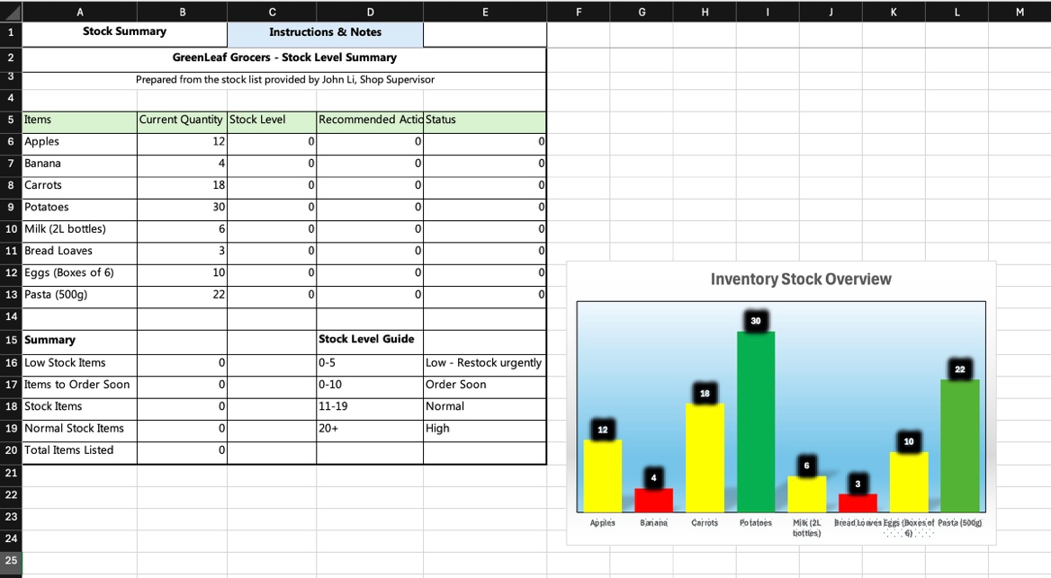
In this step, I formatted the spreadsheet for professionalism and usability.
Here’s what I did:
- I added clear title at the top to define the document’s purpose.
- I have also added labelled column headings. Each column has a clear heading. This helps us know what the data represents.

- I then made the heading bold, so they stand out and easy to find.
- I added borders around the table. This creates a distinct area for the data.
- I ensured the columns were wide enough to display all data clearly. This keeps the information readable.

- I froze the top row so users can see the headings while strolling through the data.

- I applied a filter to the stock table. This makes it easy for users to sort and
find information quickly.

- I included a summary section that highlight key metrics. This allows users
to get an overview immediately.

9. I created a separate sheet for instructions and notes. This helps users
understand how to navigate the spreadsheet effectively.

10. I created a bar chart and included colours for stock levels – green for
the sufficient stock, yellow for caution, and red for low stock. Placed the Lavel value to outside end with a black border, I then made the background horizontal category bold, and the port area is gradient filled to enhance visibility. These applications allow for a quick assessment.

