ECIE5002

Numbers Count

Portfolio

Susan Bowers-Roblin

Student Number: 2313941

Contents

VIDEO LINK:
Sue BR ECIE5002 Video.mp4

Element 1:
Essay - Why is good numeracy important?
Reference List

Element 2:
Blog – What can schools do to encourage numeracy?
Reference List

Element 3:
Resource – Information Sheet for professionals about a numeracy resource of your choice which aims to support numeracy development in pupils with ALN.
Reference List

Element 4:
Video of the resource in action 3 mins
Link Above.

Element 5:
Evaluation of the resource
Reference List

Why is numeracy important?
This essay will explore why numeracy is important to the younger generations of today’s world. Looking at research from around the world, it is apparent that maths/numeracy skills vary from country to country depending on the advantages and disadvantages that occur in the country (OECD, 2024). The social disadvantages that may affect people's numeracy skills are unemployment, low wages, poor health and well-being and poor education, all of which play a major role in how people perceive themselves and their attitudes to numeracy in everyday life (National Numeracy, 2025). Evidence suggests that good numeracy can in turn resolve many of these social disadvantages, for example, good numeracy leads to better employment options (Welsh Government, 2023).

Before we ask why numeracy is important, what we should look at is, what is numeracy. The Numeracy Framework includes four strands, these
are, developing numerical reasoning, using number skills, using measuring skills and using data skills (Hwb, Welsh Government, 2025).
We use numeracy in all aspects of our daily life without realising it, from getting up in the morning to going shopping. Having good numeracy skills allows people to be confident in their life decisions, it allows them to get a good-paying job and progress to being promoted (Indeed, 2025). These skills start at school, as early as the Flying Start, Early Years Foundation stage and reception classes, with the children being able to explore their opportunities to develop and improve on their maths/numeracy skills within their environment (National Children’s Bureau, 2019). These skills start at school, as early as the Flying Start, Early Years Foundation Phase and Reception classes, with the children being able to explore their opportunities to develop and improve on their maths/numeracy skills within their environment (National Children’s Bureau, 2019). At this early stage, children can establish a secure foundation in mental maths and recall of numbers. This is through counting and learning and understanding the differences in numbers (Haley, 2022).

The PISA (Programme for International Student Assessment) assessments are a worldwide set of exams that countries take part in every three years. The exams evaluate the ability of 15-year-old students in maths, reading and science (UK Government, 2024). These assessments have shown that the scores in Wales have declined slightly since 2018, however, the rest of the UK also achieved lower scores as well. It is stated that the decline could be due to the impact of the COVID-19 pandemic and the disproportionate impact on the areas that have higher levels of deprivation (Welsh Parliament, 2023). Sibieta (2024) Research Fellow at the Institute for Fiscal Studies and the Education Policy Institute, has stated in their report that the PISA scores do matter as it gives educators an indication of students' numeracy, reading and science skills. It also showed how skills and educational qualifications provide a better chance of employment, higher earnings, and higher productivity.

Therefore, without basic core numeracy skills going into adult life, people will struggle, creating a barrier to engaging in the mathematical aspects of life (NCFE, 2025). Children need to be prepared with the skills that will help them in the future, these include numeracy for life skills. This includes dealing with money and sorting out simple data, having the skills and confidence to deal with these will be more rewarding and creates security (NatWest, 2025).
When it comes to applying for jobs in the world of employment, you will be more than likely to complete a numeracy test where the employer can see what actual skills you have regarding numeracy. This is a way for them to see if you have the right skills for the job, namely good decision making, confidence with money, productivity and efficiency (Mistry, 2018).
Possessing the significant numeracy skills also benefits people, who will have better economic prospects in their employment. Once in the employment world, skill levels will play a vital role in determining the level of pay that people can achieve (UK Parliament, 2024).

Reviewing other research into why numeracy is important on a more global scale, it has been discovered that over the decade, we as citizens have witnessed an intensification of disruptive phenomena. This means that issues of global warming and changes to the environment, wars that have caused huge waves of refugees and migration issues, together with the disruption to energy supplies and that of food, have forced citizens to rethink the world around them (Gal, Geiger, and Graven, 2023). Meaning that when receiving information from the media regarding such world issues, with the range of different statistics and mathematical products, a greater understanding is needed to be able to interpret the information that is given. Therefore, without good numeracy skills, this information can be confusing and cause misunderstandings.

On conclusion with the varying numeracy skills in each country and the social disadvantages, it is fair to say that yes, numeracy skills are very important and being able to have students in a position where they can say they understand the maths that is all around them is vital. It’s a complex world that we live in today and we need to encourage people to be more critical in their thinking and question why things are happening in the way that they are. For that to happen they need the numeracy skills more than ever to be able to make a change, even if just for themselves. For that to happen, the teachings must include an approach that focuses on critical numeracy (O’Keeffe and Paige, 2019). Changes need to happen.

Reference List
Gal. I., Geiger. V., and Graven. M., (2023). SURVEY PAPER, The connections between citizenship education and mathematics education. Available at The connections between citizenship education and mathematics education | ZDM – Mathematics Education. (Accessed 8th March 2025).

Haley, (2022). The importance of Numeracy. Available at The importance of numeracy #NationalNumeracyDay - NHS Resolution. (Accessed 28th February 2025).

Hwb, Welsh Government, (2025). Literacy and Numeracy Framework. Available at Literacy and Numeracy Framework - Hwb. (Accessed 28th February 2025).

Indeed, (2025). Numeracy skills: examples and jobs that require them. Available at Numeracy skills: examples and jobs that require them | Indeed.com UK. (Accessed 25th February 2025).

Mistry, L., (2018). Numeracy Skills: How it all adds up. Available at Numeracy skills : How it all adds up. (Accessed 6th March 2025).

NatWest, (2025). Teaching kids about money. Available at Teaching kids about money | Banking for kids | NatWest. (Accessed 1st March 2025).

NCFE, (2025). The importance of numeracy skills for all. Available at Maths Week England: The importance of numeracy skills for all | NCFE. (Accessed 27th February 2025).

National Children’s Bureau, (2019). Early Mathematical Development. Available at Maths Brief MAR19.pdf. (Accessed 25th February 2025).

National Numeracy, (2025). Available at Why is Numeracy Important? - The Effects of Poor Numeracy. (Accessed 25th February 2025).

OECD, (2024). Available at Students in high-performing education systems record top scores in new international creative thinking assessment | OECD. (Accessed 23rd February 2025).

O’Keeffe, L., and Paige, K., (2019). Re-highlighting the potential of critical numeracy. Available at Re-highlighting the potential of critical numeracy | Mathematics Education Research Journal. (Accessed 8th March 2025).

Sibieta, L., (2024). Major challenges for education in Wales, Institute for Fiscal Studies and the Education Policy Institute. Available at Major challenges for education in Wales. (Accessed 7th March 2025).

UK Government, (2024). Available at What is PISA data and how does it measure students’ success at school? – The Education Hub. (Accessed 23rd February 2025).

UK Parliament, (2024). House of Lords Library, Importance of skills: Economic and social benefits. Available at Importance of skills: Economic and social benefits - House of Lords Library. (Accessed 6th March 2025).

Welsh Government, (2023). Mathematics and numeracy plan 2023. Available at Mathematics and numeracy plan 2023 [HTML] | GOV.WALES. (Accessed 25th February 2025).

Welsh Parliament, (2023). Available at How did Wales perform in PISA 2022?. (Accessed, 25th February 2025).
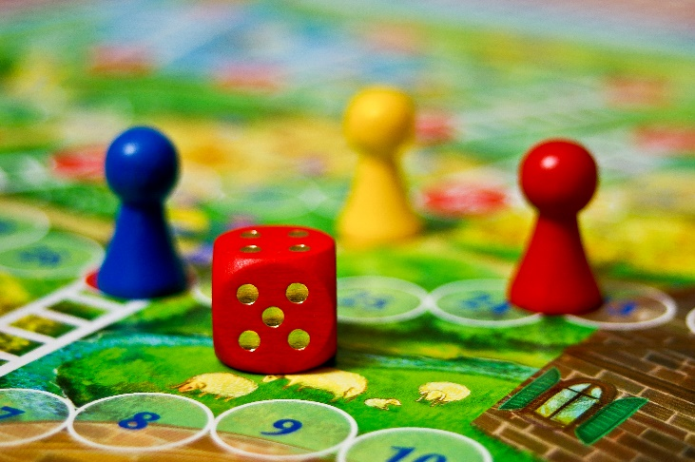
Numbers are everywhere; you can't get away from them!
Stock Image

Did you enjoy maths at school?
There will be many different answers to this question and a mixture of yes and no.
Everyone has different experiences when thinking about maths or numeracy (Huston, 2024). We need to start making the experiences more positive for all and encourage the confidence needed to say “Yes, I can do this”.

For this to happen, though, surely the education in schools needs to be looked at and improved, maybe?
From an early age, everyone learns in different ways. At times this is not noticed until later in one's school years. Does this count towards the development of our numeracy skills, I think it does, why?

We need to look at why someone's skills are not as good as others. The Cockcroft report (Cockcroft, 1982) suggested that some primary teachers are not that good at maths, therefore their methods of teaching it would not be the best. This report still stands today and is still referred to in schools and policies. The suggestions from this report are still being implemented in education today, surely this should have been done already, it’s been 43 years since it was presented to the world.

So, what can schools do differently you ask?
Schools already have a lot of strategies that they use to help pupils with their numeracy skills. However, they don’t always work for everyone. The new Curriculum for Wales (Welsh Government, 2020) has given Wales a new way of doing things with only four strands that concentrate on the following: -
- Developing Numerical Reasoning
- Using Number Skills
- Using Measuring Skills
- Using Data Skills
Did you know the new curriculum was designed by teachers and built for children in the fast-changing world? It gives educators the chance to change the way they can teach, supporting them through the creative side of lessons and allowing connections to the real-world (Welsh Government, 2021).
With the new curriculum, the educators have a lot more freedom with planning and can actively adapt and challenge students with new ways of learning.

Have you ever heard of VAK (Visual, Auditory and Kinaesthetic)?
If not, it is the way we use various senses to learn, this is with new information and experiences. There is usually a dominant sense that is different in all of us, but that sense defines the way we learn (UK Educational Furniture, 2016).

- Visual Learners – learn by absorbing information by sight.
- Auditory Learners – learn by absorbing information by sound.
- Kinaesthetic Learners - learn by absorbing information through movement.

How can this technique help in schools?
With VAKT, you can easily change the classroom environment to be adaptable to the students' needs. Whether it be visual, where you can create more visual displays, have charts, diagrams and even books available to them. For auditory learners, the tone of voices and pitch will enhance their learning, having written information or tasks read aloud would also be a benefit to them. Exploring the physical world around them is the best way for kinaesthetic learners to expand their knowledge and understanding through imitation and practice (Glinicka, 2025).

I wonder what you’re learning style is. Why not give the quiz link a go and find out. It might not be what you think.
VAK Test: What Is Your Visual, Auditory, And Kinesthetic Type? | Attempts: 340295 - ProProfs Quiz
Other ways that schools can encourage numeracy are by relating the lessons to real life problems or issues that they will come across later in life. What I mean by this is understanding of money, time, timetables, bills, statements, directions, recipes, all these categories involve numeracy in some way. Activities need to also be fun for the students to engage in the learning, take a trip to the shop to buy the ingredients for a cake (everyone loves cake), how many numeracy skills are in this simple activity. You’ve got directions, quantities, prices and total cost, bang, you got a whole lesson without even knowing it.

A hands-on approach to learning numeracy is also a good way to engage students in lessons. Dr Maria Montessori (1949) created an innovative pedagogy that prioritizes hands-on, experiential learning, giving students a cultivating foundation for understanding numeracy concepts (Gupta, 2023). Montessori’s teaching is from a young age, where students are introduced to numeracy concepts through touch, shapes and feel. She believed that everyone is naturally drawn to order, observations and patterns (La Prima Casa, 2020).

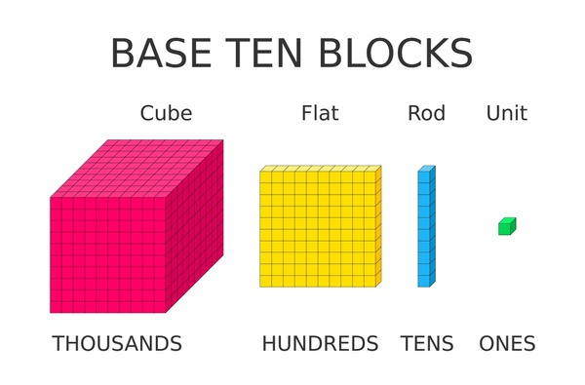
Another approach to learning the skills of numeracy would be through the Dienes method of teaching, where he believed that mathematics is defined by patterns and structures. Taking advantage of students' natural tendency for game-based learning, Dienes would invent game rules to match rules of mathematical systems. One game he created was Base 10 Blocks that help students to see and learn the underlying system of maths (Mclver, 2022).
Shutterstock - Base Ten Block, (2025)

Rounding up this information to a final note, we need students to see numbers as real and meaningful in every context for them to have those real-life moments, and they also need to be able to repeat these experiences for the learning to stick and be remembered. Notice what the students are doing in play and relate it to numbers in context, together with resources that engage their creativity. Make it FUN! (Department for Education, 2024).

Reference List
Cockcroft, W.H., (1982). The Cockcroft Report - Mathematics counts. Available at Cockcroft Report (1982). (Accessed 5th March 2025).

Department of Education, (2024). Numbers, Ways to support children’s maths understand from a very young age. Available at Help for early years providers : Numbers. (Accessed 8th March 2025).

Glinicka, M., (2025). The Visual Auditory and Kinaesthetic (VAK) Approach to learning and teaching, Language Services Direct. Available at https://www.languageservicesdirect.co.uk/. (Accessed 8th March 2025).

Gupta, S., (2023). Montessori Math: Hands-On Learning & More, Austin Children’s Academy. Available at Montessori Math: Hands-On Learning & More | ACA Blog. (Accessed 8th March 2025).

Huston, M., (2024). If you think you are ‘just not a math person’ then think again. Available at If you think you are ‘just not a math person’ then think again | Psyche Ideas. (Accessed 6th March 2025).

Image – Shutterstock - Base Ten Block, (2025). Available at Base Ten Blocks Math Learning Ones Stock Vector (Royalty Free) 2419341865 | Shutterstock. (Accessed 8th March 2025).

La Prima Casa, (2020). Add it Up: The Montessori method's unique approach to math. Available at https://laprimacasa.com/add-it-up-the-montessori-methods-unique-approach-to-math/. (Accessed 8th March 2025).

McIver, E., (2022). Zoltan Dienes and teaching mathematics through games. Maths No Problem. Available at Zoltan Dienes teaching mathematics with games lead to maths mastery. (Accessed 8th March 2025).

UK Educational Furniture, (2016). See, Hear, Speak, Touch - The Main Categories of Learning. Available at See, Hear, Speak, Touch - The Main Categories of Learning. (Accessed 8th March 2025).

Welsh Government, (2020). Area of learning and experience. Mathematics and Numeracy. Available at Mathematics and Numeracy: Introduction - Hwb. (Accessed 5th March 2025).

Welsh Government, 2021. Let’s get started. A new curriculum in Wales. Available at a-new-curriculum-in-wales-a-guide-for-children-young-people-and-families.pdf. (Accessed 6th March 2025).

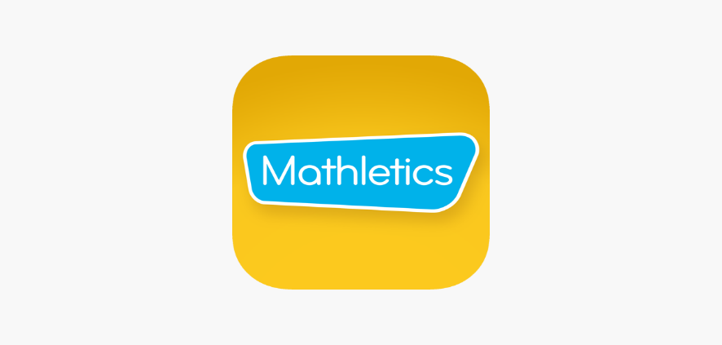
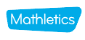
Mathletics What is it and is it any good?
Mathletics Students on the App Store (2025).
www.mathletics.com (2025).
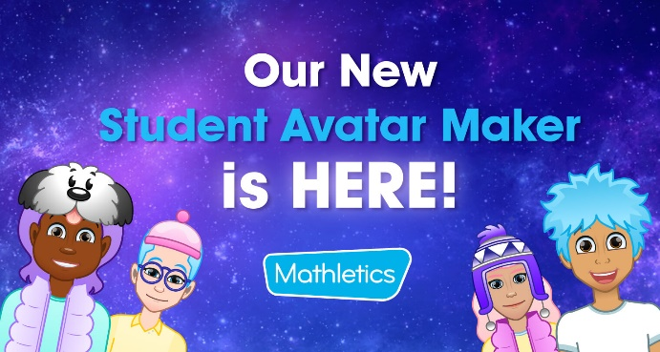
“Mathletics is the world's leading online maths program for children” (Mathletics.com, 2025).
The Mathletics program offers children, parents and teachers the opportunity to have a fun and engaging experience. In contrast, the children can actively learn the processes of how to solve mathematical problems.

Introducing Our NEW Student Avatar Maker (2025).
Avatars
Students can create a unique avatar that represents themselves while online. To develop and get new items for their avatar, students will need to earn Mathletics points otherwise known as M coins, one point is converted to one M coin. This is achieved through completing the activities, skill quests, games and the Live Mathletics. So, the more M coins they have the more choices they get to pick for their avatar (Student Avatar Maker, 2025).

Program Overview
This program was created for students aged 5 - 16 to help build confidence within their maths and to be able to master the core mathematical concepts that they are learning in their classrooms.
Students can work at their own pace and level through the extensive courses in the program. This enables them to have more confidence in their abilities to work within their personalised lessons and activities before moving on to the next challenges and tasks (Main, 2022).
There are games that the students can unlock as they progress through the program that motivates them to be engaged (Mathletics.com, 2025).

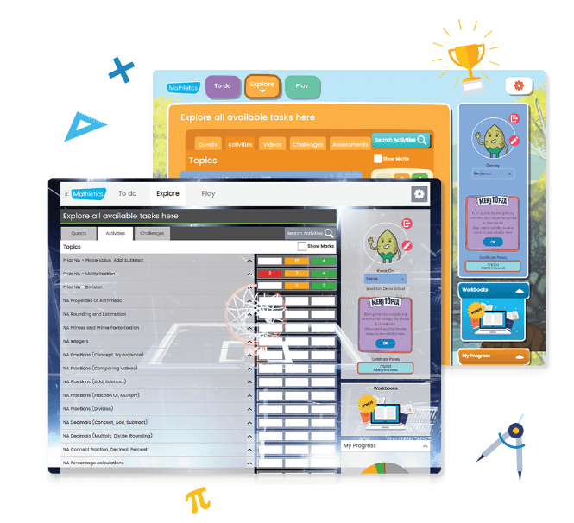
Mathletics | Empowering Mathematics Learning Online (2025).

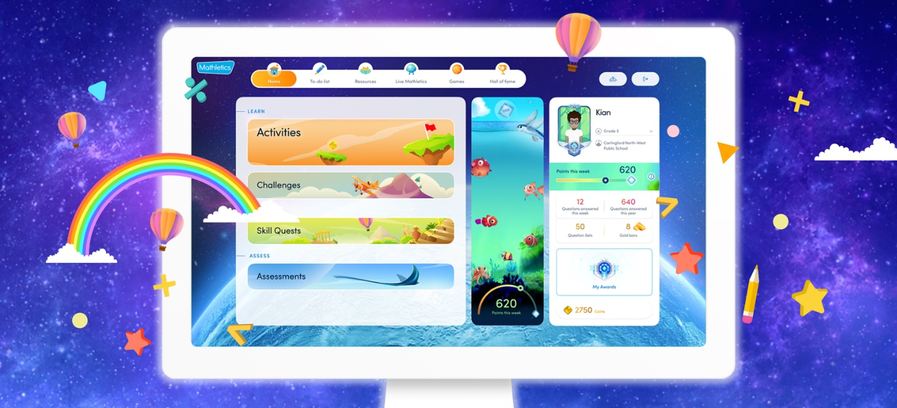
Mathletics United Kingdom | Empowering Maths Learning Online
Mathletics has been designed to “Boost students' engagement and achieve better maths results!”.

Mathletics Students on the App Store (2025).
Mathletics What is it and is it any good?
Learner Progress
Students are motivated by rewards, certificates, and gamified activities that all engage them and keep them on track as well as entertained and educated (Mana Education, 2024).
Educators can check on the student's progress, making changes if needed.
It can be to make it more challenging or slightly easier, depending on the level the student is currently at.
The program can produce reports of all the student's progress, giving a detailed account of where each student is at with each category of the lessons.
www.mathletics.com (2025).
Self-assessment
Students can use the program to see how they are getting on.
When handing in work online for the educator to mark, they will be able to see if they have answered the questions correctly. This means they have regular feedback on their work (University of Oxford, 2024).

Developing Skills
Mathletics caters for a wide range of ages from primary to secondary.
The program will mature with the students with updated visuals, challenges and activities (EdTech hub, 2025).
All activities are supported by online eBooks and resources, together with printable workbooks and assessments.

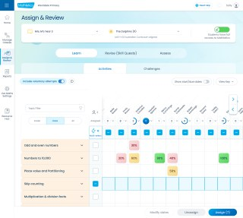
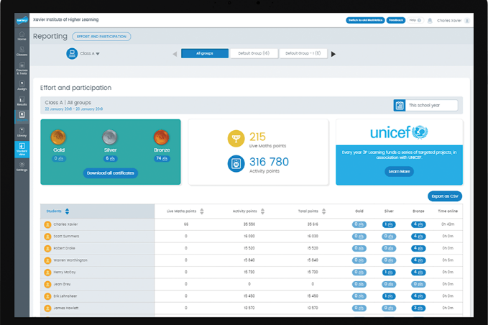
For a more in-depth look, why not visit the website for more information:
Mathletics United Kingdom | Empowering Maths Learning Online

Reference List
EdTech hub, (2025). Digital Personalised Learning. Available at EdTech for Digital Personalised Learning. (Accessed 1st March 2025).

Image – Mathletics, (2025). Available at www.mathletics.com. (Accessed 2nd February 2025).

Image – Mathletics App, (2025). Available at Mathletics Students on the App Store. (Accessed 2nd February 2025).

Image – Student Avatar, (2025). Available at Introducing Our NEW Student Avatar Maker. (Accessed 2nd February 2025).

Image – Student Pages, (2025). Available at Mathletics | Empowering Mathematics Learning Online. (Accessed 2nd February 2025).

Main. P, (2022). Personalised Learning: A teacher's guide. Available at https://www.structural-learning.com/post/personalised-learning-a-teachers-guide (Accessed, 27th February 2025).

Mana Education, (2024). Gamification in Education. Available at Gamification in Education. (Accessed 27th February 2025).

Mathletics.com, (2025). Available at Mathletics United Kingdom | Empowering Maths Learning Online. (Accessed 10th February 2025).

Mathletics.com, (2025). Available at https://www.mathletics.com/uk/for-schools/sats/free-trial/. (Accessed 11th February 2025).

Student Avatar maker, (2025). Available at https://www.mathletics.com/blog/mathletics-updates/new-student-avatar-maker/. (Accessed 11th February 2025).

University of Oxford, (2024). Making feedback inclusive. Available at Making feedback inclusive | Centre for Teaching and Learning. (Accessed 1st March 2025).

An Evaluation of Mathletics

This is an evaluation of the online Mathletics program aimed at learners aged 5-16 years old. Firstly, what is Mathletics? It’s an online platform for teaching, learning and reporting for students and educators. It is a tool that enables students to build their confidence in a personalised learning environment with tasks, games, and challenges. From an educational perspective, it is used to engage students with a view to diagnose their weaknesses and give targets for improvement together with the ability to assess and produce reports (Carlson, 2025).

I created a video of the online maths platform to give an example of what the program looks like and what it can do.
As you can see from the video, the platform is very inviting and colourful, which will of course catch your attention. Rounded edges also make it more appealing to look at, together with cartoon-like characters for the avatars the pupils can create that represent themselves.

Mathletics claims to be the world's leading online maths platform, being used by over 120,000 education sectors and over 3 million pupils across the world.
The program's effectiveness all depends on whether pupils use the platform enough and are monitored to gain any benefit from the activities that the educators have assigned to them. 30 minutes a week of using Mathletics has been said to give pupils an advantage over pupils who do not use the platform in national standardisation tests (EdTech Impact, 2025).

The usefulness of the platform is very good in that it is engaging with all the activities, games and challenges that give a natural boost to pupils' confidence within maths. They have a personalised learning area which gives them the support and challenges they need to achieve the best they can. The work is set to the individual pupil at the appropriate level, giving them the control over their learning, whether that be in school or at home with easy access to the program.
The automated marking system and the pupil progress reports are an essential tool to save teachers time in providing the formative assessment tools and information. Teachers can also plan, provide homework and revision all in one place, which to educators is very positive (3P Learning, 2025).

The creators of the program have created courses in line with the new requirements for the curriculum of Wales. The program has 1200+ adaptive activities for both primary and secondary schools. The pupils will be able to have access to all the relevant content to advance their knowledge and get them to the next stage. Together with access to all the eBooks, workbooks and other resources that will enhance their learning (Mathletics for Schools, 2025).

Regarding measuring your pupil's progress, there are several methods that you can use to gather the information you need. Educators can view the strengths and weaknesses of the one pupil or the whole class. You're also able to check how long pupils have been online each week, together with their points/rewards, and printing out reports. When checking course results, the use of the traffic light systems enables a quick and easy summary of the pupils' progress in each subject. Giving the teachers an idea of where the pupils are struggling (3P Learning Product, 2025).

The disadvantage of using Mathletics is that it can never replace traditional learning and teaching. The drawbacks can be that pupils have way too much screen time, which is time-consuming as they want to complete the tasks or game that they are on, making it a distraction. Some pupils and educators could have a bad experience with the program, which in effect will use users (Nisbet, 2024).
Schools also have to pay for the use of the platform at £5.40 per pupil if the whole school signs up, this is an annual cost to the school (LendED, 2025).

Does Mathletics work for everyone, they say it does, as it caters for all levels and abilities. It has a meticulous and variable approach to differentiated learning, with the capacity to have each pupil's work set to their individual learning level. This can also be done through a secret setting by the teachers that allows lower ability pupils to work on the correct level for them without knocking their confidence (Teachwire, 2025).

The practices behind the Mathletics platform are linked to many different learning theorists. Whilst we could name them all, there are a few that we can link to the teaching and strategies of learning with Mathletics.
Setting goals with the program comes in line with Dweck’s (2006) promotion of a growth mindset. This focuses on goals on learning and mastering certain skills, which links to a growth mindset, this then encourages pupils to accept challenges and continue even when they hit setbacks. Another theorist that comes up is Vygotsky (1978) and his Zone of Proximal Development theory, this relates to the challenges that are presented by the Mathletics program to the pupils. Pupils are given challenges that are just beyond their existing level, this in turn improves their focus to complete the task and heightens their learning to the next level (Bradshaw, Innes, Pike and Trimboli, 2024).

Coming to a conclusion on whether Mathletics is an effective resource for schools, I would say yes, it is as there are a lot of ways in which teachers can adapt the program for all pupils, making it a universal tool for individualised learning throughout the pupils' years at school. The ability for pupils to level up and compete with peers is also a motivator for them to improve on their numeracy skills, both at school and home in the real world.

Reference List

3P Learning, (2025). Meet the world’s most engaging evidence-based maths program for ages 5–16. Available at Mathletics | The World's Most Engaging Mathematics Program. (Accessed 9th March 2025).

3P Learning Product, (2025). Quick Guide to Viewing Progress with Mathletics. Available at GLOBAL_MX_QuickGuide_viewing-progress_A4.pdf. (Accessed 9th March 2025).

Bradshaw, M., Innes, D., Pike, K., and Trimboli, M., (2024). Teaching Mathematics with High Impact, 3P Better ways to Learn. Available at AU-Mathletics-White-Paper-Jan-2024.pdf. (Accessed 9th March 2025).

Carlson, E., (2025). What is Mathletics? Available at What is Mathletics? - Mathletics. (Accessed 8th March 2025).

EdTech Impact, (2025). What is Mathletics. Available at Mathletics | Reviews 2025: Features, Price, Alternatives. (Accessed 9th March 2025).

LendED, (2025). 3P Learning – Mathletics. 3P Learning - Mathletics - BESA LendED. Available at 3P Learning - Mathletics - BESA LendED. (Accessed 9th March 2025).

Mathletics for Schools, (2025). Mathletics courses are developed to align with curricula across the United Kingdom. Available at https://www.mathletics.com/uk/for-schools/united-kingdom-curriculum/ (Accessed 9th March 2025).

Nisbet, J., (2024). Prodigy - Game-Based Learning: Pros, Cons & Implementation Tips for Educators. Available at Game-Based Learning: Pros, Cons & Implementation Tips for Educators. (Accessed 9th March 2025).

Teachwire, (2025). Review – Mathletics. Available at Review – Mathletics - Teachwire. (Accessed 9th March 2025).

