
University of Wales Trinity Saint David
School of Computing
ACCA7005
Web Services
By Nathan Morris (2222137)

Contents
1. Introduction 3
2. Main Report 3
Design 3
Authorisation 5
Functional Tests 5
Reflection 8
3. Conclusion 8
List of Appendix 8

Introduction

This report sets out to outline and describe the design and implementation choices made when constructing a car tax API. The report is split out into a number of sections, being the design, authorisation, functional testing and reflection.

Main Report

Design

The RESTful web service has been designed to meet the requirements of a number of consumers that would need to interact with the web service. The users identified are staff working for a tax department, staff working for a vehicles department, customers who need to tax a vehicle and general customers who own vehicles. Two customer classes have been defined in the api, as a person who pays vehicle taxation is not always the owner of a particular vehicle. Appendix 1 outlines a high-level view of entity relationships and the interaction that a user has with those entities. From the left, a staff member from the vehicles department would require access to the car owner, car type and car registration information to maintain the vehicles and vehicle owner registers. A general customer requires information on the vehicle they own, as well as tax information for that vehicle. Staff from the tax department require interaction with the tax payments, tax payee information, tax information and vehicle information to ensure tax payments are made for the correct vehicle. Finally, a tax paying customer requires interaction with tax payments, tax payee information and has a requirement for vehicle information. Each user has been given the required access rights to the relevant entity, to be able to perform the CRUD operations required (see authorization section for more details).
The overlap in requirements for users between each of the entities has been fulfilled with a number of DTO’s that provide a user with information from multiple entities, as information provided from one entity alone would not meet the requirements of the users.
Three DTO’s have been created as follows:
- Untaxed cars
- Car details and status
- Payment summary
Untaxed cars DTO has been created for staff working in the tax department to obtain a list of cars that are not currently taxed. The list can be used by the tax department to generate reminder emails or letters as well as being used to contact customers about vehicles where tax is due. The below code snipped shows a response from the untaxed cars endpoint when a GET request is sent.

{
"currentlytaxed": false,
"taxyearly": 90.0,
"taxhalfyearly": 50.0,
"registrtation": "DC21XZN",
"cartype": "Electric",
"taxclass": "Rate 1",
"owneremailaddress": "lgarrand1x@blinklist.com",
"owneraddress": "2 Oakridge Crossing",
"ownerfirstname": "Ly",
"ownersecondname": "Garrand"
}

The car details and status DTO has been created so that ‘general customers’ or car owners can view the current details of their car as well as the tax status. The idea behind the implementation is that a customer portal or email would consume the information to display it to a logged in customer.
{
"currentowneremail": "tubsy@plusnet.com",
"curentownerfirstname": "Chris",
"currentownerlastname": "Tub",
"registration": "1DEV",
"vehicletype": "Large diesel",
"taxband": "Rate 8",
"iscurrentlytaxed": true,
"taxexpiry": "2024-02-29"
}

The final DTO created was created to fulfil the requirements of a paying customer. The information would be consumed by a summary email or customer payment portal to display the information of a payment, what it relates to and the cars tax expiry date.

{
"paymentid": 3,
"emailaddress": "fsporton2@foxnews.com",
"firstname": "Fancy",
"lastname": "Sporton",
"address": "8131 Mifflin Court",
"vehicleregistration": "WE01WXN",
"paymentamount": 370.0,
"taxedfrom": "2022-10-03",
"taxexpiry": "2023-10-02"
}

Authorisation

The authorisation structure of each entity and endpoint has been driven by balancing the requirements of the consumer with the security and integrity of the data held. Appendix 2 -Authorisation Matrix has been used to map out the authorisation requirements of each endpoint request for each of the users. A relevant role to serve the authorisation has then been created to allow OAuth to implement the relevant level of security. The matrix also contains information on functional test coverage, which will be covered in the Functional test section of this report.
Each user in the Matrix has relevant access to an endpoint request, where X denotes that access is required. The access varies depending on the needs of the user. The staff tax department naturally has more access the tax related entities whereas the vehicles staff have access to the car and car owner entities. The Customer have only been given limited access to a few requests, the specific reasoning and justification behind the access has been noted in a justification column.

Functional Tests

The functional tests have been completed within a postman test collection. The test pack has been split into two sections, being ‘Authorisation tests’ and ‘Endpoint tests’. The authorisation tests have been complied to ensure that each request tested has the correct authorisation level in line with the authorisation matrix. For example, only the tax department should have access to a get request on the taxinformation entity. Within the Staff Tax department test folder the get request to the taxinformation endpoint has an assertion that the response should contain the response code of 200;
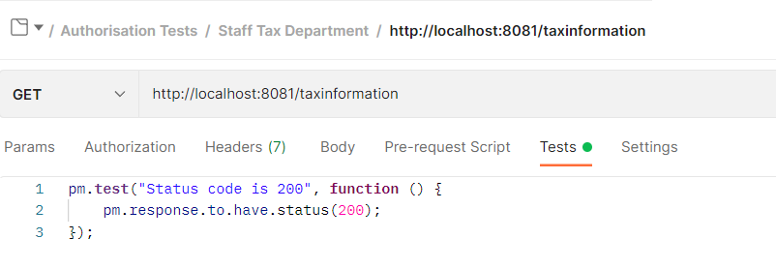

Whereas all the other users have an assertion that the response code should be 403 as they should not have access to the GET request on that endpoint.
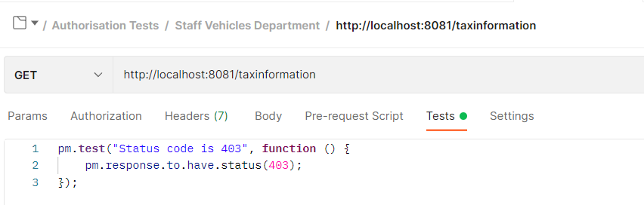

The Endpoint tests have been conducted to ensure that information input/request for each request is occurring correctly. As an example, on a car owner post test there are a number of assertions that the response body should contain based on the request information when making a POST entry to validate that the request is working correctly.
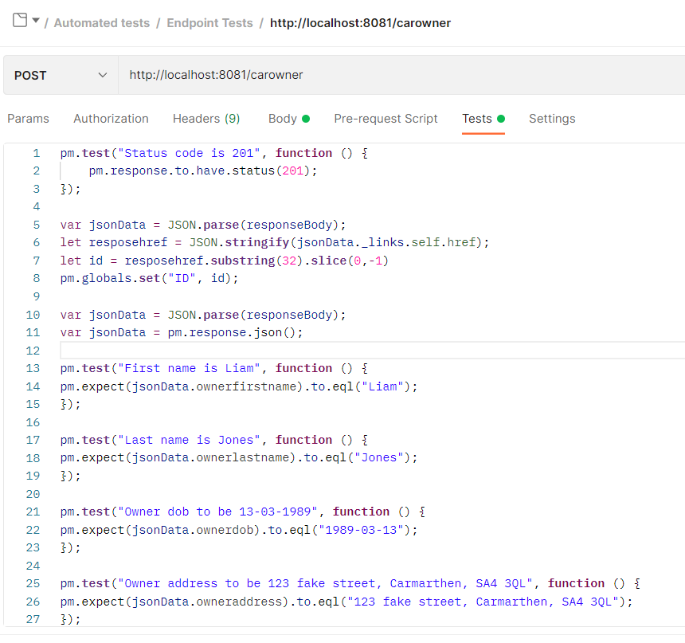

A similar test is then conducted with a PATCH request to ensure only the information changed in the request is changed when a PATCH request is made. Only the last name has been changed so the assertions expect that only the last name has changed in the response body.
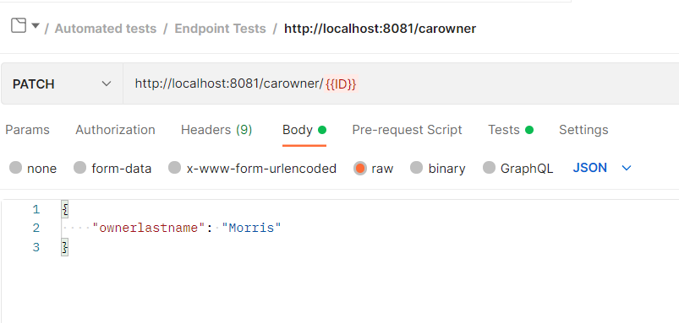

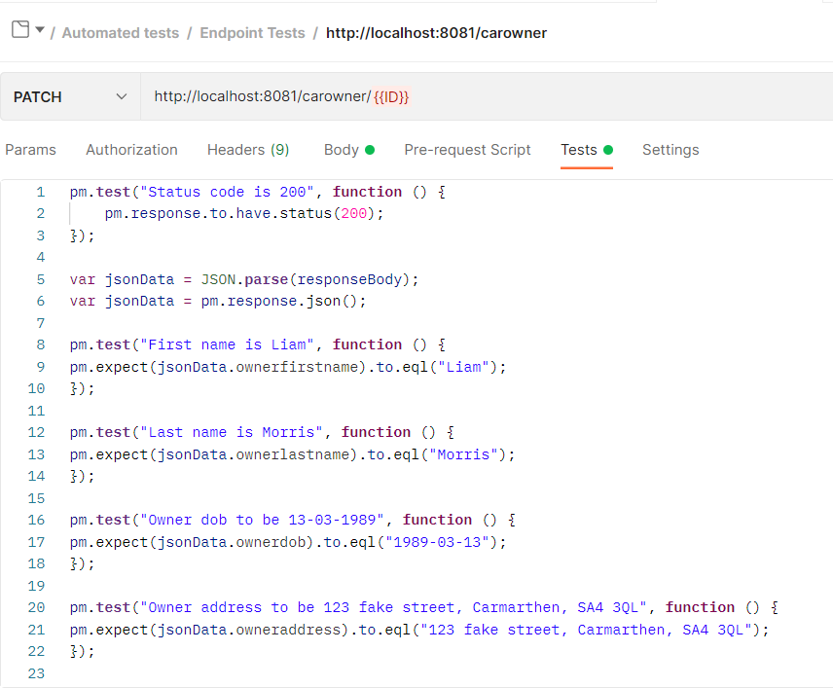

Reflection

Post project completion there are several areas that could be improved to make the API more robust. One of the design areas that could be improved is the design of the database/entities. The tax expiry of a vehicle is created at the time of payment, the system could have been designed to include an entity with tax expiry dates mapped to each car registered. That way each car would have a set expiry date that could easily be obtained and updated as required. The current design only provides a list of vehicles where the tax has already expired. This list would be used to send reminders etc. to customers within a set period of the expiration.
The Functional testing of the API could also have been improved to obtain more test coverage of the endpoints and more in-depth tests could have been performed. Most of the requests on each endpoint have been tested, however, there are still a few requests that are not covered. The Authorisation tests could have included more assertions to assert more detailed information on each test, given further confidence in the API.
The API also assumes that validation will occur at the point before a request has been made. To further improve the API, validation could also occur after a request has been made and return the relevant response message. For example, when an email address is provided, validation could occur to ensure the data entered is valid before it is posted to the database.

Conclusion

The report concludes that the API designed meets the requirements of the specification where design and implantation are considered. There are however several items listed in the report under the refection section that could be implemented to improve the functionality and test coverage of the API such as expanding testing assertions and a re-evaluation of the initial design regarding the tax expiry dates.

List of Appendix

All appendices have been included in file Appendix in the submission folder.
Appendix 1 - Initial design (available as image or draw.io file)
Appendix 2 – Authorisation Matrix

