
University of Wales
Trinity Saint David

BSc Bachelor of Science
Applied Computing

Providing an Optimal Algorithm for Extracting P, Q, R, S, T Points from the ECG Signal

Mehran Pouzesh Azar (2218967)

Supervisor:
Dr. Suresh Shanmugasundaram

Table of Contents
Abstract 3
1-1- Introduction 4
1-1- Electrical charge of heart cells 5
1-2- Pacemaker 6
1-3- ECG Signal 7
1-4- ECG Electrodes 8
1-5- Heart Rate 10
1-6- Components of the ECG signal 11
1-6-1- P Waveform 13
1-6-2- PR interval 14
1-6-3- QRS Complex 15
1-6-4- ST interval 16
1-6-5- T wave 16
1-6-6- QT interval 16
1-6-7- U Waveform 17
1-7- Recording an electrocardiogram (ECG) 18
1-8- Understanding the Functionality of an EKG 19
1-9- Noisy Heart Signal 21
1-10- Interferences in the recorded ECG signal 21
1-10-1- Power Interference 22
1-10-2- Contact noise of recording electrodes 22
1-10-3- Motion Artifacts 22
1-10-4- Muscle contractions (EMG signal) 23
1-10-5- Instrument noise 23
1-10-6- Baseline Deviations and Amplitude Modulation 23
Research 24
2-1- Introduction 24
2-2- ECG Analysis Techniques 25
2-3- Summary 30
Principles and techniques 30
3-1- The proposed methodology 30
Testing 33
4-1- Introduction 33
Conclusion and suggestions 42
5-1- Introduction 42
5-2- Conclusion and Suggestions 42
Coding 43
References 49

Abstract

The signal generated by the heart, which can currently be detected by devices placed on the surface of human skin, is referred to as an electrocardiogram (ECG). The ECG is composed of five essential waves: P, Q, R, S, and T waves. The time intervals that exist between these waves hold significant importance, as even the slightest alteration in these intervals can signify abnormal heart function. The initial time interval represented on the horizontal axis is known as the P-R interval, which denotes the duration from the beginning of the P wave to the QRS complex. In this study, two phases of signal smoothing utilizing two distinct windows have been implemented to extract these points, thereby enhancing signal quality and eliminating extraneous noise. Given that noise is inherently random and averaging tends to eliminate a substantial amount of noise with a mean of zero, two phases of noise reduction employing a mean filter have been applied. The methodology is predicated on identifying the R point as the peak signal value, with the other significant points (P, Q, S, T) being derived from this reference point. The findings indicate a high level of accuracy for the proposed technique. The data utilized are sourced from various individuals.

Keywords: Electrocardiogram, Heart Waves, ECG, QRS, Filter

Introduction

This section offers a comprehensive overview of the cases examined in this research. Subsequently, the existing literature in this domain is reviewed and discussed. One of the most straightforward and suitable techniques for assessing cardiac activity in the medical field is the utilization of an electrocardiogram, commonly referred to as an ECG. Its primary function lies in the exploration of conditions such as angina pectoris and myocardial infarction. In these conditions, the electrocardiogram exhibits distinct alterations that can even indicate the site and intensity of the cardiac event. Furthermore, the precise diagnosis of cardiac arrhythmias is a critical issue that can solely be achieved through the administration of an electrocardiogram. Given that the ECG serves as an examination of the heart's electrical state or contraction, it effectively illustrates the conduction and muscular variations of the heart. This recording not only reflects the heart's condition but also plays a significant role in assessing the overall health of the body. The ECG has gained widespread acceptance due to its efficacy and vital contribution to the diagnosis of heart diseases, its affordability, its accessibility in most cardiovascular facilities, and its significance in the lives of patients with heart conditions. Physicians are able to identify heart diseases by analyzing the ECG. However, challenges exist concerning ECG signals. Noise and interference represent some of these challenges. Such noise renders these signals difficult to interpret. This interference arises from both biological and environmental factors.

  - Electrical charge of heart cells
Cardiac cells exhibit a negative polarization when at rest. This means that the internal charge of the cell is negative in comparison to the external environment. The state of electrical polarization is established and sustained by the pumps located in the cell membrane. These pumps facilitate the necessary ion exchange to preserve the negative charge within the cell, particularly involving potassium, sodium, and calcium chloride ions. These ions traverse the cell membrane via specific ion channels. Heart cells experience a loss of their negative charge during a process referred to as depolarization. Depolarization represents the most essential electrical phenomenon within the heart. In certain cells, identified as pacemaker cells, which account for approximately one percent of heart cells, this event occurs spontaneously. In contrast, in other cells, depolarization is triggered by the arrival of an electrical impulse, which is generated by positively charged ions, at the cell membrane. The process of depolarization is communicated from one cell to another, resulting in a wave of depolarization that can spread throughout the heart. Once depolarization has concluded, the heart cells are able to restore their resting polarity through a process known as repolarization. This repolarization is facilitated by membrane pumps that reverse the ion flow.

  - Pacemaker
The heart contracts in response to electrical impulses. The frequency of these impulses dictates the heart rate. The cells responsible for generating these rhythmic impulses are known as pacemaker cells. The pacemaker is situated within the wall of the right atrium. A specific region of the heart, referred to as the sinus node, is tasked with the transmission of the pulse (action potential) throughout the atrium. Typically, the sinus node paces at a frequency of 60 to 100 beats per minute. Due to its role in regulating the electrical activity of the heart, it is often termed the primary pacemaker. Should the sinus node malfunction, a cluster of cells located between the right atrium and the right ventricle assumes the pacemaking role. This cluster, known as the atrioventricular group, can maintain a pacing rate of 40 to 60 beats per minute. The atrioventricular group is also referred to as the secondary pacemaker. Moving from the AV node, located in the lower section of the heart's electrical system, one encounters the bundle of His, its left and right bundle branches, and ultimately the Purkinje fibers. These components can also generate action potentials at a rate of 30 to 40 beats per minute if necessary (in cases where the SA and AV groups are unable to produce a pulse). The SA node is considered the primary source of heartbeat generation due to the rapidity of the impulses it transmits, allowing its action potentials to reach the heart's other components before they can initiate their own pulses. The electrical system of the heart is illustrated in Figure (1-1) [1].
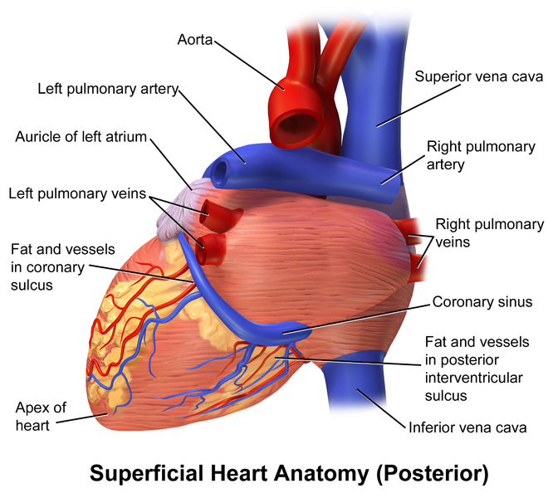
Figure 1-1: The cardiac electrical system [1]

  - ECG Signal
The electrocardiograph has been the most significant medical diagnostic instrument since 1901, enabling the identification of numerous cardiac conditions. An electrocardiogram is a non-invasive procedure that captures the heart's electrical activity and utilizes these electrical impulses to assess an individual's physical state and potential heart ailments. Employing an electrocardiogram is among the safest and most straightforward methods that furnish the physician with critical insights regarding the heart. This apparatus is also referred to by various other terms, including: electrocardiograph, electrocardiogram.[2]
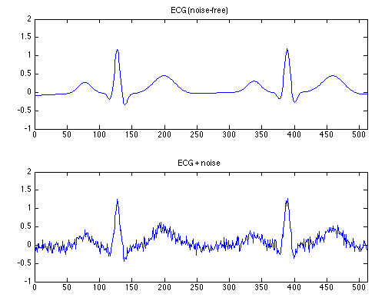
Figure 1-2: ECG signal [2]

Among the various biomedical signals, the ECG signal warrants particular attention owing to its significant role in assessing an individual's health. The electrocardiogram is generated by measuring the electrical potential across various points of the body with the aid of a biomedical amplifier. Each lead captures the heart's electrical signal from a distinct arrangement of recording electrodes positioned at different locations on the patient's body.

  - ECG Electrodes
Any contraction of muscle results in an electrical alteration known as depolarization. These alterations can be identified by a pair of electrodes positioned on the surface of the body utilizing ECG electrodes. These electrodes are arranged along an imaginary line connecting the two ECG electrodes and comprise a total of 12 electrodes, each of which captures the electrical activity from a distinct perspective of the heart muscle. Consequently, this configuration yields 12 unique electrical representations that vary in shape and amplitude based on the placement of the electrodes on the body surface, thereby enabling the heart to be examined from multiple angles.
The 12 standard ECG electrodes are categorized into two groups. The first group, referred to as limb electrodes, includes three bipolar limb electrodes (I, II, and III). Electrode I is formed between the negative and positive electrodes, with the negative electrode located on the right arm and the positive electrode on the left arm. Electrode II is created between the negative electrode on the right arm and the positive electrode on the left leg. Electrode III is established between the negative electrode on the left arm and the positive electrode on the left leg. Additionally, there are unipolar limb electrodes (AVR, AVL, AVF). The second group of electrodes is known as chest electrodes, also referred to as precordial or V electrodes (V1, V2, V3, V4, V5, V6). A detailed description of the 12 ECG electrodes along with a diagram of the lead placements is illustrated in Figure (1-3).[3]
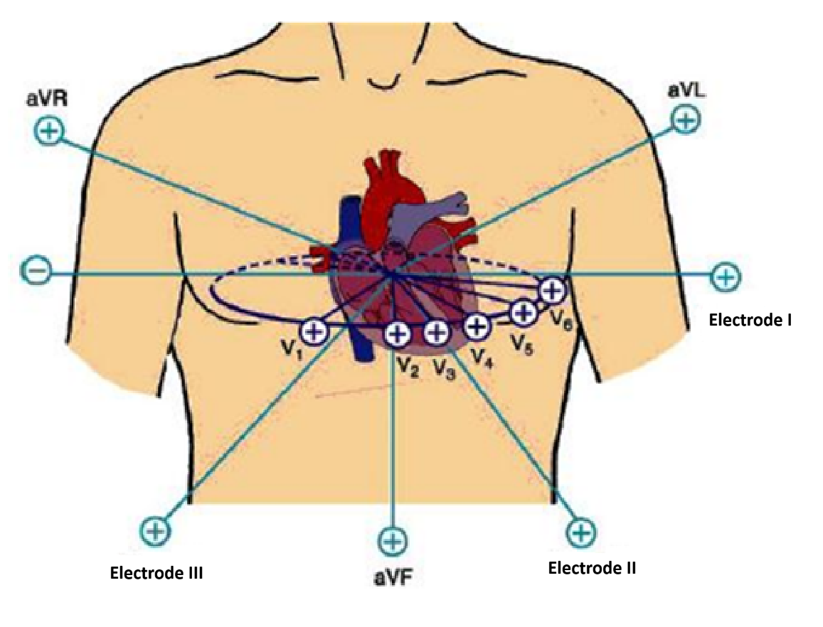
Figure 1-3: Standard limb leads [3]

A standard ECG is composed of 12 leads. Each lead is designated by a particular orientation on the body, and each lead observes the heart from a distinct angle. Organ leads: The six organ leads comprise three standard leads and three augmented leads. These organ leads examine the heart within a vertical plane known as the frontal plane. To establish the six leads in the frontal plane, each electrode is configured to be either positive or negative. The angle of each lead is established by a line drawn from the negative electrode to the positive electrode. The three standard organ leads are described below. Figure (1-4) illustrates the electrical axis of the heart [4].
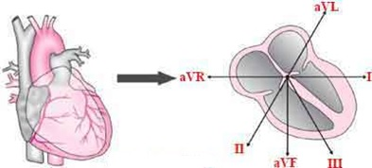
Figure 1-4: Electrical axis of the heart [4]

- Lead I: This lead is established by positioning the left hand as positive and the right hand as negative, with an orientation angle of 0 degrees.
- Lead II: This lead is created by placing the legs as positive and the right hand as negative, with an orientation angle of 60 degrees.
- Lead III: This lead is formed by positioning the legs as positive and the left hand as negative, with an orientation angle of 120 degrees In the case of amplified limb leads, there exists a single positive electrode alongside multiple negative electrodes, necessitating the amplification of these leads' voltage within the ECG device.
- Lead aVL: This lead is established by placing the left hand as positive while the other limbs are negative, with an orientation of -30 degrees.
- Lead aVR: This lead is formed by positioning the right hand as positive and the other limbs as negative, with an orientation of -150 degrees.
- Lead aVF: This lead is created by placing the legs as positive and the other limbs as negative, with an orientation angle of +90 degrees.
- Precordial leads: The precordial or thoracic leads are situated in a horizontal plane in relation to the heart and are designated as V1 through V6. Lead V1 is positioned directly above the right ventricle, V2 and V3 are located over the interventricular septum, V4 is situated over the apex of the left ventricle, while V5 and V6 are positioned over the lateral aspect of the left ventricle [4].

  - Heart Rate
Heart rate refers to the frequency of heartbeats, quantified by the number of beats occurring within a specified time frame, typically represented as beats per minute (bpm). For a healthy individual, the standard heart rate falls between 60 and 100 beats per minute; however, this range can fluctuate based on factors such as age and gender. A heart rate below 60 bpm is classified as bradycardia, while a heart rate exceeding 100 bpm is termed tachycardia. Various techniques exist for determining heart rate, primarily relying on the ECG waveform and the R-R interval. The initial step in the conventional method involves counting the R waves present in a 6-second rhythm strip, followed by multiplying this count by 10. The subsequent step entails counting the number of small boxes (representing the R-R interval in millimeters) within the selected R-R interval, which is then divided by 1500 to ascertain the heart rate. Finally, the count of large boxes (located between successive R-waves) for the chosen R-R interval is recorded, and this figure is divided by 300 to yield the heart rate.[5]

1-6- Components of the ECG signal
The sinus nodes, located in the wall of the right atrium, regulate the rate and rhythm of cardiac contractions. Electrical impulses originate from the SA node and proceed to a chamber situated between the atrium and the ventricle. This segment is depicted in the ECG signal as a P wave. Subsequently, these impulses arrive at the AV node, and after a brief delay, they continue to the AV bundles and then to the Purkinje network. The initial segment is represented in the ECG waveform as the P_Q interval, while the subsequent segment is illustrated as the QRS in the ECG waveform. Table (1-1) presents the electrical events occurring during a cardiac cycle alongside the corresponding waveform generated from these events in the ECG complex. A cardiac complex is comprised of six waveforms, denoted by the letters P, Q, R, S, T, and U. Additionally, Table (1-2) outlines the normal amplitude range of the ECG wave [5].

Table 1-1: Basic ECG characteristics [5]
Source | Section of electrocardiogram
Atria Excitation | P_Wave
Atria repolarization + ventricle depolarization | QRS_Complex
Ventricle repolarization | T_Wave
Excitation timing delay | P_Q Interval

Table 1-2: Normal ECG Wave Amplitude Range [5]
Wave | Domain range
 | Electrode I  Potential (millivolts) | Electrode II  Potential (millivolts) | Electrode III  Potential (millivolts)
p | 0.015 to 0.12 | 0.00 to 0.19 | -0.073 to 0.13
Q | 0.00 to 0.16 | 0.00 to 0.18 | 0.00 to 0.28
R | 0.02 to 0.13 | 0.18 to 1.68 | 0.03 to 1.31
S | 0.00 to 0.36 | 0.00 to 0.49 | 0.00 to 0.55
T | 0.06 to 0.42 | 0.06 to 0.55 | 0.06 to 0.3
 | aVR electrode  Potential (millivolts) | aVL electrode  Potential (millivolts) | aVF electrode  Potential (millivolts)
P | -0.179 to 0.01 | -0.085 to 0.140 | -0.06 to 0.16
Q | 0.00 to0.90 | 0.00 to 0.22 | 0.00 to 0.19
R | 0.00 to 0.33 | 0.00 to 0.75 | 0 . 02 to 0.15
S | 0.00 to 0.15 | 0.00 to 0.90 | 0.00 to 0.71
T | -0.00 to 0.00 | -0 .16 to 0.27 | 0 . 04 to 0.46
 | Electrode V1  Potential (millivolts) | Electrode V2  Potential (millivolts) | Electrode V3  Potential (millivolts)
P | -0.08 to 0.18 | 0.15 to 0.16 | 0 . 00 to 0.18
Q | - | - | 0.00 to 0.05
R | 0.00 to o.49 | 0.04 to 1.52 | 0 . 06 to 2.24
S | 0.08 to 2.13 | 0.19 to 2.74 | 0 . 09 to 2.22
T | 0.03 to 1.22 | -0.14 to 1.44 | 0 . 00 to 1.60
 | Electrode V4  Potential (millivolts) | Electrode V5  Potential (millivolts) | Electrode V6  Potential (millivolts)
P | 0.01 to 0.23 | 0.00 to 0.24 | 0.00 to 0.19
Q | 0.00 to 0.16 | 0.00 to 0.21 | 0.00 to 0.27
R | 0.18 to 3.20 | 0.42 to 2.42 | 0 . 2 5 to 2.60
S | 0.02 to 2.09 | 0.00 to 0.97 | 0 . 00 to 0.84
T | 0.05 to1.31 | 0.00 to 0.96 | - o 0.67

1-6-1- P Waveform
The initial segment of the ECG signal is identified as the P wave, which signifies the depolarization of the atria (the transmission of impulses throughout the atria). Figure (1-5) illustrates the P, Q, R, S, and T waves [5].

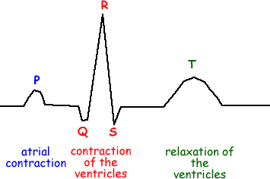

Figure 1-5: The p-wave and its components [5]

The primary characteristics of the P wave are as follows:
Location: preceding the QRS complex
Amplitude: ranging from 2 to 3 mm
Duration: between 0.06 and 0.12 seconds
A normal P wave indicates that its electrical impulses originate from the sinus node (SAnode). In contrast, variable P waves that fluctuate within a complex suggest that the impulses are generated from an alternative source. Furthermore, the presence of a specific P wave signifies the emission of impulses from a focus distinct from the sinus node, which may be due to nodal rhythm or atrial fibrillation. Additionally, the occurrence of the P wave before the QRS complex serves as an indicator of complete heart block [5].

1-6-2- PR interval
The PR interval serves as an indicator of the transmission of the electrical impulse from the atria to the atrioventricular (AV) node and subsequently through the bundle of His. In assessing the PR interval, particular emphasis is placed on its duration, as variations in this interval arise from either a disruption in the waveform formation or a delay in impulse transmission. Several characteristics can be evaluated concerning the PR interval:
Location: From the onset of the P wave to the onset of the QRS complex
Duration: 0.12 to 0.20 seconds
A duration of less than 0.12 seconds suggests that the electrical impulse originates from a site other than the SA node. Such alterations may be linked to arrhythmias of the atrioventricular node or premature excitation syndromes. Conversely, if the PR interval exceeds 0.20 seconds, it may signify a delay in conduction through the atrium or atrioventricular junction, potentially due to heart block interference [6].

1-6-3- QRS Complex
The QRS complex follows the P wave and signifies the depolarization of the ventricles through the conduction of electrical impulses. Following the depolarization of the ventricles, the QRS complex is generated, leading to the contraction of the ventricles. This contraction results in the ejection of blood from the ventricles into the body's arteries, which generates the pulse. The QRS complex has several characteristics:
Position after the PR
Range: 5 to 30 mm (though it varies across different leads)
Duration: 0.07 to 0.10 seconds, typically about half the duration of the PR interval, commencing from the Q wave and extending to the conclusion of the S wave. The duration of the QRS complex reflects the internal conduction time within the ventricles. Consequently, analyzing the QRS complex is crucial. The absence of a P wave alongside the QRS complex indicates the presence of arrhythmia. A lack of a QRS complex may result from atrioventricular block or ventricular arrest [6].

1-6-4- ST interval
The ST segment signifies the concluding phase of ventricular depolarization or conduction, marking the onset of ventricular polarization or the resting phase. Below are several characteristics of this segment:
Location: It begins at the S wave and continues to the start of the T wave.
Duration: Ranges from 0.05 to 0.15 seconds.
Range: Between 0.15 to 1 mm (can be either positive or negative based on the lead being analyzed).
Alterations in the ST interval may suggest myocardial injury, and the ST segment can exhibit either an ascending or descending pattern [6].

1-6-5- T wave
The T wave signifies the phase of ventricular replication, characterized by the following features.
Location: It occurs after the S wave.
Amplitude: Approximately 0.5 mm in leads I, II, and III, and exceeding 1 mm in the anterior chest leads. The T wave exhibits a smooth, rounded shape that is oriented upwards in some leads and downwards in others. Should an abnormal bulge appear in its contour, it is represented by the afterwave shape. This alteration indicates the atrial depolarization resulting from an impulse originating from a site above the ventricles. Various conditions can be inferred from the morphology of the T wave, including myocardial damage (indicated by a long wave and sharp T wave shape), myocardial ischemia (evidenced by an inverted T wave shape in leads I, II, and V3 to V6), and pericarditis (characterized by an extremely sharp and serrated T wave shape) [6].

1-6-6- QT interval
The QT interval depicted in the waveform indicates the time taken for ventricular depolarization. The length of the QT interval is influenced by heart rate; specifically, as the heart rate rises, the QT interval tends to shorten. A normal QT interval is characterized by the following features:
Position: It spans from the onset of the QRS complex to the conclusion of the T wave.
Duration: The duration of the QT interval is subject to variations based on age, sex, physical activity, and heart rate, typically ranging from 0.36 to 0.44 seconds [6].

1-6-7- U Waveform
The U waveform signifies the resting phase of the ventricular conduction fibers. It is important to note that the U waveform is not consistently observable in the ECG signal, as it is considered an atypical waveform that does not manifest in every individual within the population. Furthermore, the presence of this waveform may indicate a potential health issue in the individual. Figure (1-6) illustrates the U wave.

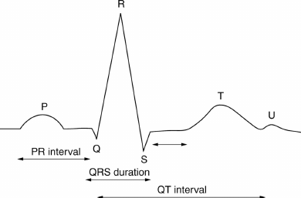
Figure 1-6: U-wave and other points [6]

Its prominent characteristics are as follows:
Location: Occurs subsequent to the T wave.
Shape: Rounded, directed upwards, and positive.
The aforementioned offers a concise summary of the elements of the standard ECG complex. We encapsulate them in Table (1-3) below [6].

Table 1-3: Normal ECG parameters [6]
Duration | EKG Interval | Amplitude | EKG wave
Sec 20/0-12/0 | P-R | mv 025/0 | p
sec 44/0-35/0 | Q-T | mv 60/1 | R
sec 15/05-0/0 | S-T | oFR 025 /0 | Q
sec 09/0 | Q-R-S | mv 05/0-1/0 | T

  - Recording an electrocardiogram (ECG)
The heart's electrical activity generates a current that flows through the surrounding tissues to the skin. By placing the electrodes of the electrocardiograph on the skin, the device captures this electrical current and relays it to the recording apparatus. This directed electrical current manifests as waves that illustrate the cardiac depolarization-repolarization cycle. The resulting waves are referred to as an electrocardiogram (ECG), commonly known in everyday language as a heartbeat. There are two primary types of ECG recorders: 12-lead recorders and single-lead recorders. Both types yield valuable insights into the heart's electrical activity. The 12-lead recorder presents data from 12 distinct perspectives of the heart's function. In a 12-lead configuration, six electrodes are positioned on the chest (referred to as six chest leads), while six electrodes are attached to the limbs (known as six limb leads). The limb leads are designated as leads I, II, and III, along with the right arm lead (aVR), left arm lead (aVL), and left leg lead (aVF). Leads I, II, and III are characterized by having a negative electrode, thus they are termed bipolar leads. The chest leads, labeled V1 through V6, are affixed to the chest and require only a single electrode, with the opposing pole situated at the heart's center, as interpreted by the electrocardiograph. Limb leads can facilitate the acquisition of leads I, II, and III. These leads possess two poles, one consistently positive and the other negative, which is why they are occasionally referred to as bipolar leads.
In lead I: the electrode attached to the left hand is designated as positive, while the electrode linked to the right hand is classified as negative.
In lead II: the electrode associated with the right hand is negative, and the electrode connected to the left leg is positive.
In lead III: the electrode linked to the left hand is negative, whereas the electrode connected to the left leg is positive.
Each complex in lead II corresponds to the total of the respective complexes found in leads I and III. This principle proves beneficial in situations where technicians may have improperly connected the electrodes. Figure (1-7) illustrates the ECG waveform across 12 leads [7].

I=aV_{L} – aV_{R}
II=aV_{F} _ aV_{R}
III=aV_{F} _ aV_{L}
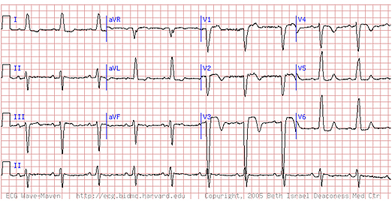
Figure 1-7: View of a 12-lead waveform [8]

When the limb leads are connected through a resistor and yield a single output, this configuration is referred to as a unipolar lead. Due to their low amplitude, these signals are amplified, as denoted by the coefficient a. The indices R (right hand), L (left hand), and F (left leg) are assigned based on the respective limb names.
Derivation of aVF: In this case, the left leg serves as the positive pole, while the other two limbs act as negative poles.
Derivation of aVL: This derivation employs the left hand as the positive pole, with the other limb functioning as the negative pole.
Derivation of aVR: Here, the right hand is designated as the positive pole, and the remaining two limbs are treated as negative poles. These derivations underscore the significance of the positive electrodes. Analyzing the interrelations among the leads allows for the inference of the remaining leads by utilizing only two leads. For convenience, it is advisable to use leads I and aVF. Additionally, chest leads are positioned on the chest, and these electrodes consistently serve as positive [8].

  - Understanding the Functionality of an EKG
An electrocardiogram (ECG) is a graphical representation of the variations in electrical potential resulting from the stimulation of the heart muscle. It is commonly referred to as ECG or EKG. The electrocardiograph continuously captures this graph on a specialized lined paper strip. The data recorded on the electrocardiogram reflects the electrical waves that activate the heart. These waves signify the various phases of cardiac stimulation. Ten wires extend from the electrocardiogram, with four connecting to the arms and legs, and six leading to the anterior part of the heart. These wires are attached to their respective locations after their ends are coated with a lubricant gel. Small metal electrodes are affixed to the wrist, ankle, and chest of the individual, allowing electrical signals to be transmitted from the electrodes through these wires to the electrocardiogram machine, which visualizes the signals as waves. An electrocardiogram is invaluable for assessing heart pain and diagnosing heart attacks, and it is routinely performed on individuals experiencing acute heart issues. The ECG comprises an ST segment and four primary intervals: QRS, P.R, R-R, and Q.R, with alterations in each indicating specific medical conditions. One of the critical changes monitored in the electrocardiogram of patients is the signs and symptoms of a heart attack or myocardial infarction (M.I.), which, depending on the affected area of the heart, manifests as T or ST and QRS changes across different cardiac leads. This information aids the physician in assessing the extent, severity, and type of heart attack. Electrical currents facilitate the contraction and expansion of the heart muscle. The P wave signifies the electrical activity occurring in the heart's upper chambers, known as the atria. Conversely, the QRS complex indicates the electrical activity in the heart's lower chambers, referred to as the ventricles. The T wave denotes the brief resting phase of the heart, during which it replenishes itself between beats. Electrical waves are depicted on the ECG as alternating peaks and troughs. Each cycle of the heart's electrical activity comprises several segments, commencing with a P wave and extending until the subsequent P wave. The P wave is relatively small and signifies the contraction of the atria. Following a brief interval, the QRS complex emerges, characterized by a rapid downward, upward, and downward movement of the ECG line. This complex results from the contraction of the ventricles, and after a more extended pause, the T wave appears, indicating the sudden filling of the ventricles. The ECG loop is a paper-based recording mechanism housed within the device, which, when the device's needle is slightly heated, inscribes lines onto the paper. Naturally, more sophisticated ECG devices have been developed that can capture the heart's activity from multiple angles simultaneously and acquire all necessary leads in a brief period. The wave pattern offers significant insights into potential damage to the heart muscle or inflammation of the pericardium, the membrane surrounding the heart. Typically, a standard ECG takes between 5 to 10 minutes and can be conducted in a physician's office, laboratory, or hospital [9].

  - Noisy Heart Signal
Electrical interference from sources other than the power supply lines can also impact the electrocardiograph. Electromagnetic interference from nearby high-wattage devices such as radios, televisions, and radars can be mitigated and corrected by the p-n junctions of transistors within the electrocardiograph, and at times even by the electrode-electrolyte interface on the patient. The lead wires and the patient function as antennas. Once the signal is identified, the demodulated signal manifests as interference on the electrocardiograph. Additionally, electromagnetic interference may be generated by high-frequency generators present within the hospital. Surgical and diathermy equipment consistently pose a risk. Furthermore, there exists a source of electrical interference originating from the body itself that can influence the ECG. A muscle consistently lies between the two electrodes that constitute the leads of the electrocardiograph. Whenever this muscle contracts, it generates an electromyographic signal that can be detected by the ECG lead, resulting in interference in the ECG [9].

  - Interferences in the recorded ECG signal
ECG signals, similar to other biological signals, are affected by a range of noise sources. The following are some of the most prevalent noise sources and interferences:
- Interference from urban electrical systems.
- Contact noise generated by the electrodes used for signal recording.
- Artifacts caused by movement.
- Muscle contractions, which are interpreted as electromyogram signals.
- Instrumental noise associated with electronic devices utilized in processing.
- Deviations in baseline and amplitude modulation [9]

1-10-1- Power Interference
Power interference presents challenges for the majority of recordings of physiological signals, particularly ECG signals. This interference is characterized by frequency components of 50 Hz and 60 Hz, along with their respective harmonics. It can be represented as a combination of sinusoidal waveforms. Typically, these interferences exhibit the following properties:
Frequency content: Frequencies of 50 Hz and 60 Hz, along with their harmonics.
Amplitude: Reaching up to 50% of the peak-to-peak amplitude of the ECG signal.
It is important to note that most contemporary ECG signal recording devices are equipped with filters designed to mitigate this interference [9].

1-10-2- Contact noise of recording electrodes
Electrode connection noise represents a transient disturbance that arises from a temporary disconnection between the electrodes and the skin surface. This disconnection may be either permanent or temporary. The separation between the electrodes and the skin can result from the relative movements of both the individual and the electrodes. Such disconnection can lead to the generation of various artifacts. Contact noise is characterized by a swift alteration in the baseline, which subsequently returns to its original value in an exponential manner. Consequently, the elements of this interference encompass the magnitude of change and the time constant for exponential decay. The standard parameters associated with this interference are outlined as follows.
Duration: 1 second.
Amplitude: equivalent to the maximum output of the recording device.
Time constant: 1 second [9].

1-10-3- Motion Artifacts
Motion artifacts lead to temporary fluctuations in the baseline, which arise from variations in the electrode-skin impedance of the patient. This change in impedance is also influenced by the patient's movements. The resulting interference pattern from this impedance alteration is represented as a biphasic signal resembling a sine wave. The characteristics of this artifact can vary, but typical parameters include the following:
Duration: 100 to 500 milliseconds
Amplitude: Up to 500% of the peak-to-peak amplitude of the ECG signal.
If motion artifacts persist for extended durations, they can significantly complicate the interpretation of the ECG signal, even for seasoned experts [9].

1-10-4- Muscle contractions (EMG signal)
Muscle contractions produce artificial potentials within the millivolt range. These contractions lead to interference with the electromyogram, which occurs in the microvolt range and is thus considered negligible. The signals generated by muscle contractions can be regarded as transient sequences of zero-mean Gaussian noise. The typical specifications for these arc descriptions are as follows:
Standard deviation: 10% peak-to-peak of the ECG signal.
Duration: 50 milliseconds.
The impact of this interference is mitigated by employing low-pass filtering techniques [9].

1-10-5- Instrument noise
An illustration of this interference is the saturation of electronic devices. When the input of the amplifier becomes saturated, no data pertaining to the ECG signal will be transmitted to the signal processor. This type of interference cannot be rectified by depending on signal processing block diagrams; instead, it must be managed through an alarm system.[9]

1-10-6- Baseline Deviations and Amplitude Modulation
Baseline deviations represent artifacts that generate misleading information. This information, produced during the capture of ECG signal parameters, particularly during the ST segment recording, complicates the recording process significantly. In the majority of ECG recordings, variations in electrode impedance, caused by factors such as perspiration or physical movements, are the primary contributors to baseline deviation [9].

Research

2-1- Introduction
The electrocardiogram, commonly referred to as the ECG, is the most prevalent diagnostic tool utilized for assessing cardiac function. The ECG is extensively employed due to its ability to reveal a range of cardiac abnormalities. ECG devices are widely accessible in nearly all healthcare settings, and the procedure is straightforward (characterized by safety and cost-effectiveness). The ECG signal provides the following critical information:
  - Heart rate
  - Heart rhythm
  - Assessment of potential abnormal thickening of the heart muscle
  - Determination of whether a myocardial infarction has occurred
  - Evaluation for the presence of coronary artery disease
  - Identification of conduction disorders (deficiencies in the transmission of electrical impulses throughout the heart) [10]
All of these features can hold significant importance. When an ECG indicates a heart attack or potential coronary artery disease, additional testing is typically conducted to accurately ascertain the nature of the issue and to establish the most effective treatment plan (these tests frequently include cardiac catheterization and stress testing). An electrocardiogram is often performed when the heart muscle exhibits thickening to evaluate the heart for potential valve disease or other irregularities. Variations in the electrical pattern of the electrocardiogram can be readily utilized to ascertain the cause of fainting or to detect possible heart disease. An electrocardiogram serves as a graphical representation of the bioelectrical signals generated by the human body throughout the cardiac cycle. It may be feasible to extract valuable and critical information from a chart that correlates the ECG with heart function through baseline and waveforms, which illustrate fluctuations in the heart's voltage over time. The ECG is of great significance and features specific waveforms associated with various clinical conditions:
  - Myocardial infarction (heart attack)
  - Pericarditis (inflammation of the pericardium)
  - Electrolyte imbalances
  - Atrial and ventricular hypertrophy
  - Irregularities
  - Effects of cardiac medications, particularly digitalis and quinidine (heart medications)
  - General discomfort impacting the heart and blood pressure [10].

2-2- ECG Analysis Techniques
The precise identification of the P, Q, R, S, and T points within the ECG signal is crucial for the automated diagnosis of cardiac conditions. The initial phase in the automatic diagnosis of heart disease involves recording the electrocardiogram (ECG) signal, which is subsequently analyzed by digital devices such as computers or microcontrollers. Through the analysis of ECG, we can derive metrics regarding the heart rate and rhythm, as well as the dimensions and locations of the heart valves and ventricles, any existing cardiac damage, and the impact of medications and devices employed to manage heart function. The diagnosis of cardiovascular diseases is conducted through decision-making techniques or more sophisticated algorithms. In recent years, numerous mathematical approaches and analyses have been developed for ECG signal evaluation; these encompass various studies, methods, and algorithms introduced over the past decades, including artificial neural networks, fuzzy logic techniques, digital signal processing, genetic algorithms, support vector machines, hidden Markov models, self-organizing maps, Bayesian methods, slope vector wavelet (SVW), discrete wavelet transforms (DWT), and difference operation methods (DOM). All these methodologies focus on the detection of the QRS complex in ECG signals. For instance, the slope vector wavelet (SVW) method proposes an algorithm for detecting the QRS complex in ECG and evaluating the R-R interval.
Through this approach, we attain a rapid and precise identification of the R location, R-R interval, and QRS complex length, yielding highly favorable outcomes in the domain of ECG feature extraction. The difference operation method (DOM) is employed to identify the QRS complex within the electrocardiogram signal. This technique encompasses two main processes: the difference operation process (DOM) and the wave detection process. The overall framework of this method is comprised of two stages. The initial stage involves locating the R point to identify the QRS complex. Additionally, an alternative system for extracting features from ECG signals utilizing neural networks is introduced, which integrates the cepstral coefficient method for feature extraction from long-term ECG signals alongside artificial neural network (ANN) models for classification purposes. Features are derived from the intensity wavelet decomposition of ECG images and subsequently processed through artificial neural networks. The extracted features encompass the following: mean, median, maximum, minimum, range, standard deviation, variance, and absolute mean deviation. Another approach involves employing artificial neural networks to identify critical points by utilizing the derivative, wherein the search focuses on the minimum and maximum derivatives of the wave. The highest peak (R wave) is expected to correspond to the zero crossing point between the minimum and maximum derivatives [11].
Using a neural network methodology, noise is mitigated from cardiac signals. In this framework, by training on the original signal with noise, the original input and output of the system are simulated, thereby facilitating the elimination of system noise [12].
A threshold-based filtering technique is also utilized to remove noise. In this system, peaks within a signal are detected, and if the input signal falls outside the filter range, they are discarded. The design of this filter is predicated on the ability to process several distinct signals devoid of noise [13].
Employing a hybrid online denoising technique, noise is effectively eliminated by extracting the average noise present in the signal. To achieve this, at each phase, the average noise is removed, and new noise is computed, continuing this process until all noise is eradicated. A notable limitation of this approach is its lack of intelligence [14].
A denoising technique grounded in chaos theory is utilized to eliminate noise. This method represents one of the latest advancements in noise removal, possessing the capability to adjust the noise levels within the signal. The process involves encoding each input signal into a matrix, allowing for comparisons between the input signals and this matrix. Ultimately, all noisy signals are organized within a matrix, facilitating their identification. This matrix functions as a robust encryption system, previously employed for encrypting image systems, among others; however, a significant drawback of this method is its time-intensive natur. [15]
A noise estimation technique based on signal scanning has been implemented to mitigate noise. This approach identifies signal locations that closely resemble the original signal by creating a small window around the signals, subsequently comparing the target signal with the faulty one to remove the noise. This method effectively denoises the system by analyzing all signals within the designated window. The primary disadvantages of this technique are its time consumption and higher power requirements compared to the previously mentioned methods [16].

A genetic evolutionary algorithm has been applied to classify noise in cardiac signals. The objective of this research is to utilize various types of noise for learning purposes. The genetic algorithm functions similarly to a support vector machine, capable of storing and reconstructing input signals into two distinct categories: noisy and noise-free [17].
Employing a linear approach that distinguishes signal components through wavelet transformation, signals undergo compression while extraneous system information, identified as noise, is filtered out. This process involves the elimination of insignificant data from the input signals. In accordance with the feature extraction technique, critical information is represented as a vector that is orthogonal to the data, with any information lying on this vector deemed significant; conversely, if the signal deviates from this vector, it is classified as noise [18].
Using a wavelet technique founded on the Hamming window, the signal undergoes denoising. This technique operates by moving the window across the signal, and if the oscillations within this window are rapid or sparse, they are classified as noise.[19]
An analysis has been conducted on segments of signals originating from the human heart. These signals exhibit randomness, necessitating the application of filters that do not depend on a predetermined initial input. Consequently, adaptive filter structures featuring an appropriate recursive algorithm have been employed. The findings indicate that this filtering method is effective in mitigating various environmental and biological noise, identifying critical points (QRS), and analyzing heart signals to detect different forms of cardiac arrhythmias. The adaptive filters discussed in this paper align with the process of identifying cardiac arrhythmias, which must ultimately possess the capability to detect the majority of these arrhythmias and be implementable in microprocessors, cardiac arrhythmia detection monitors, and comprehensive ECG signal analysis. It is important to note that the noise present in these signals closely resembles cardiac arrhythmias, and adaptive filtering offers a potent means to differentiate between these two phenomena, thereby enhancing the diagnosis of heart diseases [20].
The Kalman filter, which has numerous applications in addressing contemporary real-world challenges, has been thoroughly examined. This filter serves as an efficient recursive tool that estimates the state of a dynamic system based on a series of intricate measurements, with applications that include signal processing. In this study, the Kalman filter has been employed to eliminate noise from the electrocardiogram (ECG) signal and identify its critical points. Based on the T test results and the lower mean squared error (MSE) value associated with the Kalman filter, it has been determined that the Kalman filter outperforms the FIR filter in effectively removing low-pass noise from cardiac signals [21].
Cardiovascular diseases rank among the most prevalent health issues globally and are one of the leading causes of mortality. The ECG signal (electrocardiogram) is utilized to evaluate the condition of the heart and blood vessels. However, the real-time transmission of the ECG signal introduces significant noise. To process the ECG signal, various algorithms are implemented to optimally reduce noise and eliminate high-frequency disturbances. This paper employs noise reduction techniques based on the Violent algorithm. In this approach, the patient's cardiac signal is processed directly on their mobile device. The achieved signal-to-noise ratio (SNR) of 15-19 dB reflects the effective noise reduction, which is beneficial for medical diagnostics. Subsequently, the ECG signal is transmitted to the telemedicine center using the TCP/IP protocol. Recent advancements in technology, particularly in mobile devices, have facilitated the development of mobile healthcare systems aimed at monitoring patients' health statuses. This paper presents software designed to receive, process, and transmit cardiac signals in real-time to the telemedicine center. The SNR values obtained confirm the effective noise reduction of the signal. Patients can install this application on their Windows mobile phones to continuously monitor their cardiac health. Figure (2-1) illustrates the cardiac signal displayed on the mobile device.[22]
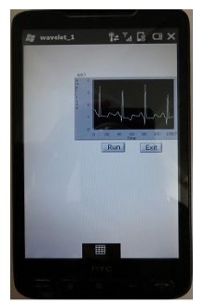
Figure 2-1: Displaying the heart signal on a mobile phone [22]

The electrocardiogram (ECG) signal, which records the electrical activity of the heart, serves as a crucial instrument in diagnosing cardiac conditions. This signal operates by detecting and amplifying the minor electrical fluctuations that occur on the skin during each depolarization of the heart muscle. However, noise or artifacts can hinder the efficacy of the electrocardiogram signal, necessitating their removal. In this study, we employ discrete wavelet transform to eliminate or mitigate noise within the ECG signal. The wavelet transform is recognized as a highly effective method for time-frequency analysis and is particularly adept at enhancing the signal-to-noise ratio. In this context, the wavelet operator is utilized at four levels of decomposition and is applied to the noisy ECG signal to assess the validity of this approach. The findings indicate that the discrete-time wavelet process was analyzed for soft thresholding, hard thresholding, and hard thresholding, all of which maintain the original signal's characteristics. The proposed method relies on selecting the threshold value that minimizes the error of the denoised signal and the wavelet coefficient. The performance of the denoising process is directly related to the type of signal being analyzed. The standard DVT demonstrates greater efficiency compared to the entropy-based wavelet transform. Furthermore, DWT offers superior evaluation through hard thresholding. While extending the filter length enhances the denoising process via hard thresholding, it simultaneously degrades the SNR and MSE values when soft thresholding is applied [23].
Numerous studies have been conducted in the area of estimating the positions of critical points within the ECG signal. In the majority of these investigations, the QRS complex is prominently utilized due to its easily identifiable location, which has been the focus of research [24]. In contrast, the identification of the P and T points presents certain challenges and complexities, resulting in a limited number of studies, and those that exist often lack sufficient accuracy. Addressing these aforementioned challenges, this thesis endeavors to resolve the identified issues and accurately ascertain the precise locations of all five points: T, S, R, Q, and P, utilizing the proposed methodology.

2-3- Summary
The electrocardiogram (ECG) signal is derived from electrodes positioned at various locations on the body. The conventional setup for these electrodes comprises 12 leads. These leads are categorized into two types: limb leads and pericardial leads, which assess the heart from vertical and horizontal perspectives, respectively. The ECG signal primarily represents the electrical activities of the heart, making it the most reliable reference for detecting abnormalities in the heart's electrical system. Additionally, this signal can reveal non-electrical issues such as stenosis or blockage of the heart valves, as well as thickening of the heart wall. The process of preparing the ECG signal is straightforward and cost-effective, contributing to its extensive use. In this chapter, we have explored several characteristics of the ECG electrocardiogram signal, introduced the complexes that constitute the ECG, and elucidated the origins of their formation. Finally, we review the research conducted by scholars in this domain.

Principles and techniques

3-1- The proposed methodology
In this study, a more straightforward, quicker, and more precise algorithm has been developed, which incorporates only a limited number of filters and a few uncomplicated steps to smooth the signal levels. Ultimately, by analyzing the fluctuations of the signal, the points P, Q, R, S, and T are identified. Among these, points T and P present the greatest challenges and complexities. The signals were gathered and documented through two distinct methods. Initially, the electrocardiographic signals from thirty volunteers were captured using the BSA device, which is designed to record vital signals at a specified sampling rate, and subsequently processed with MATLAB software to create a database. For enhanced accuracy and comparison, an additional twenty signals were sourced from various internet platforms and integrated into the existing database. Following the compilation of the database, the proposed algorithm was employed to identify critical points within the signals.
Considering the variability in heart rhythm, frequency, and noise, it is impractical to assign a specific frequency to the signals, as previous studies have relied on intricate algorithms for this purpose. Consequently, Fourier expansion has been utilized to ascertain the precise dominant frequency present in each signal. A summary of this
Process is illustrated in Figure (3-1)
Read dataset

(zeros cross )

Normalize data

Smoothing Signal
Filter type 1
Smoothing Signal
Filter type 1

Searching Minmax
Remove Invalid Minmax
Search Max points that value of them > R
Mark P,Q before Max
Mark S,T after Max

Show Results

Figure 3-1: Flowchart of the proposed algorithm

Initially, the data undergoes normalization within the interval [1 and -1]. To mitigate the impact of noise, a two-stage average filter and a two-stage noise removal filter are applied. The objective of this process is to entirely eliminate the noise. Subsequently, the data points are normalized once more, ensuring that the values altered by the filtering process reside within the range of (0 and 1). The point R serves as the reference for detection, with the maximum and minimum points calculated before and after it designated as P, Q, S, and T. Initially, the data is normalized. Formula (3-1)
(3-1)$∀ i∋X :X\left(i\right)=\frac{X\left(i\right)-X min}{X max-X min} i≥1 , i≤N$

Subsequently, the filter formula (3-1) is utilized on the data. In this formula, the average surrounding each point is replaced.

(3-2) $∀ i∋X :X\left(i\right)=\frac{\sum_{j=i}^{i+h}{X\left(j\right)}}{h+1} , i≥1 , i≤N-h$

In equation (3-2), h represents the size of the signal window, X(i) denotes the signal value, I indicates the signal index, and N signifies the total number of signal points.
The overall procedure is outlined below.
- Initially, the data undergoes normalization, meaning that each data point is divided by the maximum value of the entire dataset.
- Given that the majority of the data is positive while some values are negative, the average of all data points is subtracted from each data point to ensure a symmetrical distribution around the axes (zero cross).
- Two smoothing steps for the signal level are executed using formulas 3-1 and 3-2.
- The minimum and maximum signal points are computed and serve as criteria for identifying the maximum signal value.
- The maximum signal value is observed at point R.
- By assessing the signal against the threshold level, R points are identified and extracted.
- Based on the position of R, additional points are located both before and after it, and these points are also extracted.

Testing

4-1- Introduction
In this study, the points P, Q, R, S, and T are identified through a novel approach.
To evaluate the effectiveness of the proposed method, the developed algorithm was implemented on 50 distinct signals collected from 50 individuals. For instance, five signals are illustrated in Figures (4-1), (4-4), (4-7), (4-10), and (4-13). These figures demonstrate that the signals derived from each individual exhibit certain variations. Notably, the levels of noise and the fundamental frequency of each signal differ to some extent from one another. The Fourier transform has been employed to more accurately ascertain the fundamental frequency and the noise present in the signal. Figures (4-2), (4-5), (4-8), (4-11), and (4-14) display the signals post-filter application. As evidenced in the figures, particularly in Figure (4-2), the application of the filter has substantially reduced the noise, allowing for the critical points (P, Q, R, S, T) to be identified in a clear and precise manner.
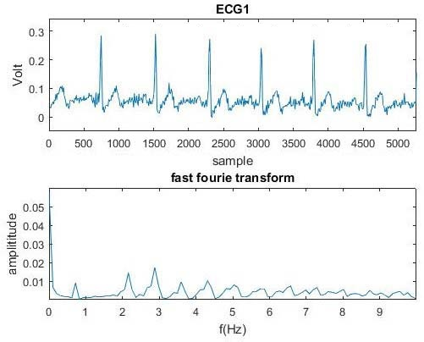
Figure 4-1: Signal number 1 and the Fourier transform of the signal
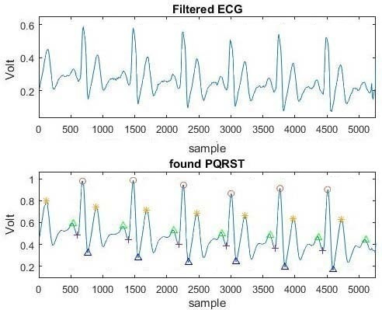
Figure 4-2: Signal number 1 and the filter performed on it and the diagnostic points

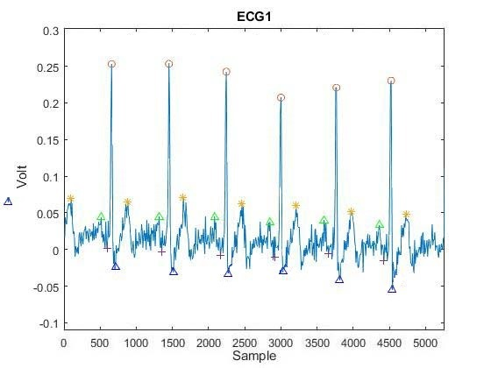
Figure 4-3: Points P,Q,R,S,T found and matching points on them

In Figure 4-3, the points identified on the original shape of signal number 1 are aligned. The findings demonstrate the high precision of the proposed method.
Signal number 2 exhibits some noise; however, the peak distance of the signals is significant. This suggests a frequency difference between this signal and the original signal. Nevertheless, as illustrated in Figure (4-5), the detection has been executed accurately.
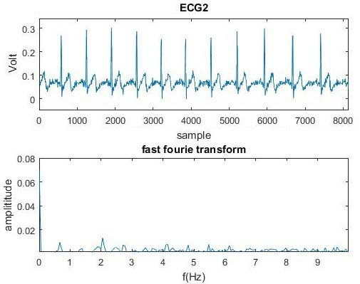
Figure 4-4: Signal number 2 and the Fourier transform of the signal

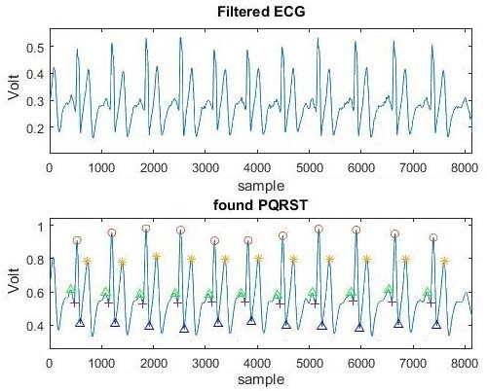
Figure 4-5: Signal number 2 and the filter performed on it and the diagnostic points
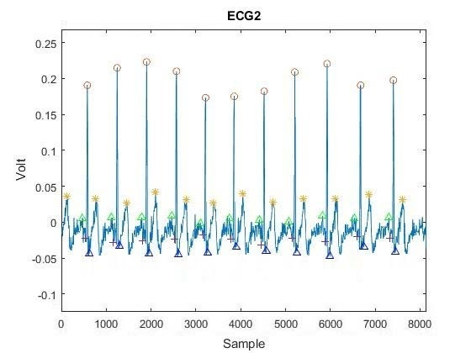
Figure 4-6: Points P,Q,R,S,T found and matching points on it

Following two stages of filtering, the outcomes are presented in Figure 4-5 for signal number 2.
In Figure 4-6, the identified points are positioned according to the original configuration of signal number 2. The findings demonstrate the high precision of the suggested approach.
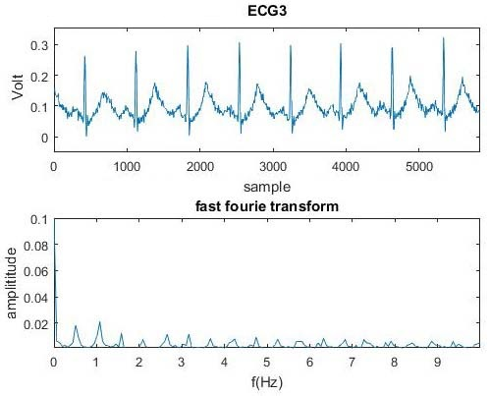
Figure 4-7: Signal number 3 and the Fourier transform of the signal
Signal number 3 exhibits a significant level of heterogeneity when contrasted with the typical heart signal of a healthy individual. The outcomes following the filtering process indicate that the T peak value of the heart signal is abnormally elevated.

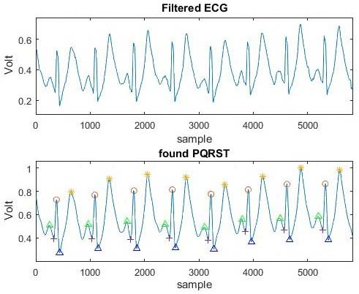
Figure 4-8: Signal number 3 and the filter performed on it and the diagnostic points
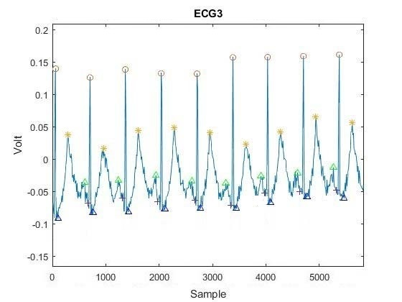
Figure 4-9: Points P,Q,R,S,T found and matching points on it

In Figure 4-9, the identified points are positioned according to the original configuration of signal number 3. The findings demonstrate the high precision of the suggested approach.

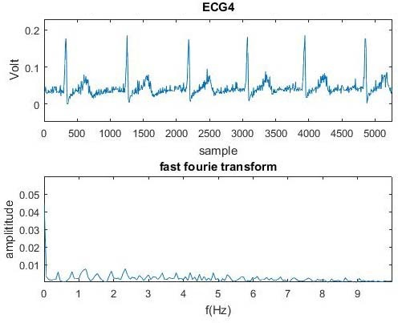
Figure 4-10: Signal number 4 and the Fourier transform of the signal

Signal number 4 exhibits minimal noise when compared to the heart signal depicted in the detection. This particular signal is fairly consistent.
After undergoing two stages of filtering, the outcomes are illustrated in Figure 4-11.

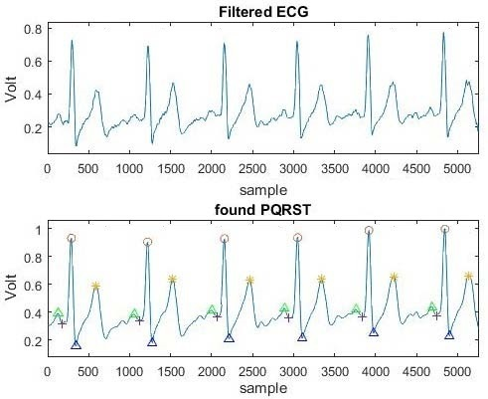
Figure 4-11: Signal number 4 and the filter performed on it and the diagnostic points
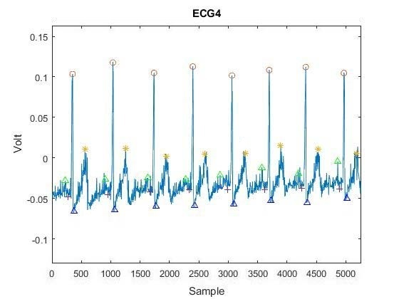
Figure 4-12: Points P,Q,R,S,T found and matching points on them

In signal number 5, there is a significantly elevated noise level, and the distance between the peak points is quite substantial. The algorithm proposed is capable of detecting this phenomenon.
The initial phase of the filter employs a small window filter. At each subsequent stage, the size of the window is expanded to accumulate a greater number of points, ensuring that at the peak points of the actual signal, the filtered signal achieves a higher value and exhibits increased smoothness. This maximum filtered point acts as a crucial reference for identifying the remaining points.
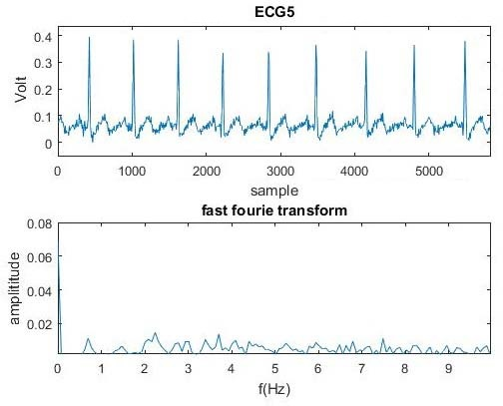
Figure 4-13: Signal number 5 and the Fourier transform of the signal

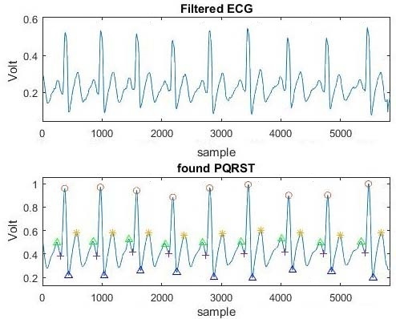
Figure 4-14: Signal number 5 and the filter performed on it and the diagnostic points
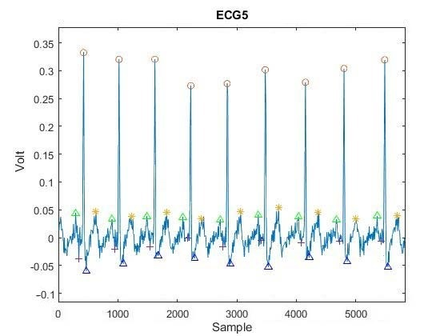
Figure 4-15: Points P,Q,R,S,T found and matching points on it

For signal number 5, the outcomes following two stages of filtering are illustrated in Figure 4-14.
Taking into account the signals and the filters applied, it can be concluded that the accuracy of the method presented is satisfactory and can be utilized as a system for identifying points P, Q, R, S, and T.

Table 4-1: Comparison of extracted and standard time intervals
Time intervals extracted from the signal (seconds) | Standard time intervals for a healthy person (seconds) | Distance between points | Signals
17/0 | 20/0-12/0 | P-R | ECG 1
33/0 | 44/0-35/0 | Q-T | ECG 1
15/0 | 15/05-0/0 | S-T | ECG 1
08/0 | 09/0 | Q-R-S | ECG 1
13/0 | 20/0-12/0 | P-R | ECG 2
39/0 | 44/0-35/0 | Q-T | ECG 2
15/0 | 15/05-0/0 | S-T | ECG 2
08/0 | 09/0 | Q-R-S | ECG 2
15/0 | 20/0-12/0 | P-R | ECG 3
39/0 | 44/0-35/0 | Q-T | ECG 3
15/0 | 15/05-0/0 | S-T | ECG 3
09/0 | 09/0 | Q-R-S | ECG 3
17/0 | 20/0-12/0 | P-R | ECG 4
40/0 | 44/0-35/0 | Q-T | ECG 4
15/0 | 15/05-0/0 | S-T | ECG 4
08/0 | 09/0 | Q-R-S | ECG 4
13/0 | 20/0-12/0 | P-R | ECG 5
35/0 | 44/0-35/0 | Q-T | ECG 5
15/0 | 15/05-0/0 | S-T | ECG 5
08/0 | 09/0 | Q-R-S | ECG 5

Based on Figures 4-3, 4-6, 4-9, 4-12, and 4-15, the points identified on the initial configuration of each signal correspond accurately. The findings demonstrate the significant precision of the suggested approach.

Conclusion and suggestions

5-1- Introduction
Continuous monitoring of heart rate and other vital signs in a general hospital setting serves as a crucial indicator of physiological deterioration, particularly during the initial 62 hours preceding critical events like cardiac arrest.
The approach outlined in this thesis aids in identifying these critical points, specifically the P, Q, R, S, and T points. By analyzing the time intervals between these points, it is possible to ascertain the patient's medical condition.

5-2- Conclusion and Suggestions
The objective of this project was to identify T and P points, which are inherently challenging and intricate critical points. Previous research, including methods such as wavelet transform, neural networks, and denoising techniques, demonstrated limited accuracy and employed complex algorithms that prolonged detection times. To address this issue, a more straightforward, rapid, and precise algorithm was proposed, incorporating only a few filters, such as a low-pass filter, interpolation, thresholding, and several other uncomplicated steps. For this study, ECG signals were gathered from two distinct sources. Firstly, signals were experimentally obtained from various individuals using the BSA device. Secondly, additional ECG signals were sourced from various internet platforms to enhance accuracy and were incorporated into the database. Subsequently, the proposed algorithm was applied to these signals, leading to the extraction of their critical points. The findings indicated a high level of accuracy in detecting critical points, including T and P, through the application of the proposed algorithm.
Furthermore, the implementation of an adaptive filter may enhance the quality of the noise-free signal, while utilizing multiple filters with varying windows could further improve signal quality. It is suggested that future work should involve the application of neural network algorithms to detect critical points in the signal with improved quality, speed, accuracy, and minimal time expenditure.

Coding
clc
clear all

x1 = load('ECG1.dat');%har noe ecg ke darim
x1=x1(1:400,1);
x1=x1/max(x1);
% subplot(2,1,1)
% plot(x1)

x2=x1;

% smooth
for i=1:numel(x1)-10
x1(i)=sum(x1(i:(i+10)))/11;
end
subplot(2,1,2)
plot(x1)
pause(.5)

% find Max
findMaxMin(x1',x2)
……………………………………………………………………………………………………………………………………
function ret=findMaxMin(x1,base)
x1=x1/max(x1);

for i=1:numel(x1)-8
x2(i)=sum(x1(i:(i+8)))/9;
end
x1=x2;
% star = 1
% green circle = 2
% red circle = 3
% red triangle = 4
% + = 5

before=-1;

Mx=[];
Mn=[];
for i=2:numel(x2)-7
if(x1(i)>x1(i-1) && before==-1)

Mn=[Mn i];
before=1;
elseif(x1(i)<x1(i-1) && before==-1)

elseif(x1(i)>x1(i-1) && before==1)

elseif(x1(i)<x1(i-1) && before==1)
Mx=[Mx i];
before=-1;
end

end
% fake list
BMx=[];
BMn=[];
for i=1:numel(Mx)
for j=1:numel(Mn)
if(abs(Mx(i)-Mn(j))<8 && abs(x1(Mx(i))-x1(Mn(j)))<8)
BMx=[BMx Mx(i)];
BMn=[BMn Mn(j)];

end
end
end

LMx=[];
for i=1:numel(Mx)
OK=1;
for j=1:numel(BMx)
if(BMx(j)==Mx(i))
OK=0;

break;
end
end
if(OK==1)
LMx=[LMx Mx(i)];
end
end

LMn=[];
for i=1:numel(Mn)
OK=1;
for j=1:numel(BMn)
if(BMn(j)==Mn(i))
OK=0;
break;
end
end
if(OK==1)
LMn=[LMn Mn(i)];
end
end

% generate R

subplot(3,1,1)
plot(base)

R=[];
for i=1:numel(LMx)
p=max(base(LMx(i)-10:LMx(i)+10))
if(p>.9)
R=[R LMx(i)];
end
end
R

S=[];
for i=1:numel(R)

for j=1:numel(LMn)

if(LMn(j)>R(i))
S=[S LMn(j)];
break;
end
end
end
S

T=[];
for i=1:numel(S)
for j=1:numel(LMx)
if(LMx(j)>S(i))
T=[T LMx(j)];
break;
end
end
end
T

Q=[];
for i=1:numel(R)
for j=1:numel(LMn)
if(LMn(j)>R(i))
Q=[Q LMn(j-1)];
break;
end
end
end
Q
P=[];
for i=1:numel(Q)
for j=1:numel(LMx)
if(LMx(j)>Q(i))
P=[P LMx(j-1)];
break;
end
end
end
P

R=R-1;
S=S-1;
T=T-1;
Q=Q-1;

subplot(3,1,2)
plot (1:numel(x1),x1 ,R,x1(R),'o',S,x1(S),'b^',T,x1(T),'*',Q,x1(Q),'+',P,x1(P),'g^');

% R=R+10;
% S=S+5;
% T=T+5;
% Q=Q+5;
% P=P+5
% subplot(3,1,3)
% plot (1:numel(base),base ,R,base(R),'o',S,base(S),'r^',T,base(T),'*',Q,base(Q),'+',P,base(P),'g^');

References
- N. Strodthoff, P. Wagner, T. Schaeffter, and W. Samek, “Deep Learning for ECG Analysis: Benchmarks and Insights from PTB-XL,” IEEE J. Biomed. Health Inform., vol. 25, no. 5, pp. 1519–1528, May 2021. (PubMed)
- M. S. Haleem, A. S. Khan, and M. A. Syed, “A Deep Learning Based ECG Segmentation Tool for Weak Supervision using Conv–BiLSTM,” in Proc. IEEE Int. Symp. Circuits and Systems (ISCAS), 2022, pp. 1–4. (IEEE Computer Society)
- C. Joung, J. Lee, and K. Lee, “Deep Learning based ECG segmentation for delineation with arrhythmia adaptation,” IEEE Access, vol. 12, pp. 1–14, 2024. (online) (PMC)
- S. M. I. Niroshana, S. Kuroda, K. Tanaka, and W. Chen, “Beat-wise segmentation of electrocardiogram using adaptive windowing and deep neural network,” Sci. Rep., vol. 13, Art. no. 11039, 2023. (Nature)
- Z. Wu and C. Guo, “Deep learning and electrocardiography: systematic review of current techniques in cardiovascular disease diagnosis and management,” BioMedical Engineering OnLine, vol. 24, Art. no. 23, Feb. 2025. (BioMed Central)
- C. Plaza-Seco, et al., “Detection of intra-beat waves on ambulatory ECG using deep learning,” Int. J. Biomed. Eng. Technol. (or relevant journal), 2025. (to appear) (ScienceDirect)
- G. Petmezas, L. Stefanopoulos, V. Kilintzis, A. Tzavelis, J. Rogers, and A. K. Katsaggelos, “State-of-the-Art Deep Learning Methods on Electrocardiogram Data: Systematic Review,” JMIR Med. Inform., vol. 10, no. 8, e38454, 2022. (medinform.jmir.org)
- H. Narotamo, et al., “Deep learning for ECG classification: A comparative study,” Comput. Methods Programs Biomed., vol. 260, 2024. (ScienceDirect)
- G. Jimenez-Perez, J. Acosta, A. Alcaine, and O. Camara, “Generalizing electrocardiogram delineation — Training convolutional neural networks with synthetic data augmentation,” in arXiv preprint arXiv:2111.12996, 2021. (arXiv)
- A. Raza, K. P. Tran, L. Koehl, and S. Li, “Designing ECG Monitoring Healthcare System with Federated Transfer Learning and Explainable AI,” in arXiv preprint arXiv:2105.12497, 2021. (arXiv)
- Z. Wang, S. Stavrakis, and B. Yao, “Hierarchical Deep Learning with Generative Adversarial Network for Automatic Cardiac Diagnosis from ECG Signals,” in arXiv preprint arXiv:2210.11408, 2022. (arXiv)
- E. Zvuloni, J. Read, A. H. Ribeiro, A. L. P. Ribeiro, and J. A. Behar, “On Merging Feature Engineering and Deep Learning for Diagnosis, Risk-Prediction and Age Estimation Based on the 12-Lead ECG,” in arXiv preprint arXiv:2207.06096, 2022. (arXiv)
- K. G. R. Silva, et al., “ECGNet: an efficient network for detecting premature ventricular complexes based on ECG images,” IEEE Trans. Biomed. Eng., vol. 70, pp. 446–458, 2023. (BioMed Central)
- D. Wouters, P. C. van de Leur, M. B. Vessies, et al., “Electrocardiogram-based deep learning improves outcome prediction following cardiac resynchronization therapy,” Eur. Heart J., vol. 44, pp. 680–689, 2023. (BioMed Central)
- L. Liu, G. Huang, X. Zhao, L. Wu, M. Wang, and X. He, “Deep learning assessment of left ventricular hypertrophy based on electrocardiogram,” Front. Cardiovasc. Med., vol. 9, Art. no. 952089, 2022. (BioMed Central)
- J.-M. Jo, Kwon J., Jeon K.-H., Cho Y.-H., Shin J.-H., and Lee Y.-J., “Detection and classification of arrhythmia using an explainable deep learning model,” J. Electrocardiol., vol. 67, pp. 124–132, 2021. (BioMed Central)
- B. Gustafsson, D. Gedon, E. Lampa, A. H. Ribeiro, M. J. Holzmann, T. B. Schön, et al., “Development and validation of deep learning ECG-based prediction of myocardial infarction in emergency department patients,” Sci. Rep., vol. 12, 2022. (BioMed Central)
- X. Xiao, C. Ding, X. Hu, G. D. Clifford, D. W. Wright, A. J. Shah, et al., “Transfer learning enables prediction of myocardial injury from continuous single-lead electrocardiography,” J. Am. Med. Inform. Assoc., vol. 29, no. 10, pp. 1908–1918, 2022. (BioMed Central)
- M. Tadesse, H. Javed, K. Weldemariam, Y. Liu, J. Liu, and J. Chen, “DeepMI: Deep multi-lead ECG fusion for identifying myocardial infarction and its occurrence-time,” Artif. Intell. Med., vol. 121, 2021. (BioMed Central)
- K. S. Kavak, X.-D. Chiu, S.-J. Yen, and M.-Y. Chen, “Application of CNN for Detection and Localization of STEMI Using 12-Lead ECG Images,” IEEE Access, vol. 10, pp. 38923–38932, 2022. (BioMed Central)
- L. Tseng, C.-Y. Chuang, S.-K. Chua, and V. S. Tseng, “Identification of coronary culprit lesion in ST elevation myocardial infarction by using deep learning,” IEEE J. Transl. Eng. Health Med., vol. 11, 2023. (BioMed Central)
- C.-M. Liu, C.-S. Lin, C.-C. Tsai, T.-P. Tsao, C.-C. Cheng, J.-T. Liou, et al., “A deep learning algorithm for detecting acute myocardial infarction,” EuroIntervention, vol. 17, pp. 765–772, 2021. (BioMed Central)
- M. Diaw, S. Papelier, A. Durand-Salmon, J. Felblinger, and J. Oster, “AI-Assisted QT measurements for highly automated drug safety studies,” IEEE Trans. Biomed. Eng., vol. 70, pp. 1504–1515, 2023. (BioMed Central)
- Y.-S. Baek, S.-C. Lee, W. Choi, and D.-H. Kim, “A new deep learning algorithm of 12-lead electrocardiogram for identifying atrial fibrillation during sinus rhythm,” Sci. Rep., vol. 11, Art. no. 12818, 2021. (BioMed Central)

