

Name: Greg Thompson
Number: 1705753
University of wales Trinity Saint David
Date: 04/12/20

Course: Built Environment Programmes – Level 5 Construction Management
Module: Project Planning for Construction
Module Code: ACBA5001
Date: 04/12/2020

Index

- Work Breakdown Structure
- Method statements
2.1) Roofing
2.2) Tarmac road / carpark
2.3) Curtain Wall

3) Project report

Appendix
A) Gannt Chart

Work Breakdown Structure

Site Set Up

- Site set up including all welfare and plant delivery
- Clean and prepare site for construction works
- Ensure all COVID Procedures are in place
- Materials Delivered to site

Substructure

- Reduced Level preparing for dig
- Excavation for foundations
- Reinforcement installed
- Concrete pouring
- Blockwork
- Install below ground ducting. drainage, services etc.
- Install ground floor slab

Superstructure

- Erect steel frame superstructure
- Install steel deck floor and pour
- Formwork to first floor slab and concrete pour
- Install internal precast staircases
- Install Pre-cast lift shaft
- Erect scaffolding
- Install roof purlins, decking, fascia’s, soffits, guttering.
- Install access hatch and safety line
- Alter scaffolding as required by cladders.
- Install curtain walls including all glazing systems.
- Install external doors and windows

Internal

- Install stud walls including plastering
- First fix carpentry
- First fix mechanical
- First fix electrical
- Install all plastering including any taping.
- Install tiles throughout
- Install floors
- Second fix carpentry
- Install internal doors and windows
- Second fix mechanical
- Second fix electrical
- Final Decoration
- Sign off all internals.

External Works

- Construct car park

Deliverable work-based Structure

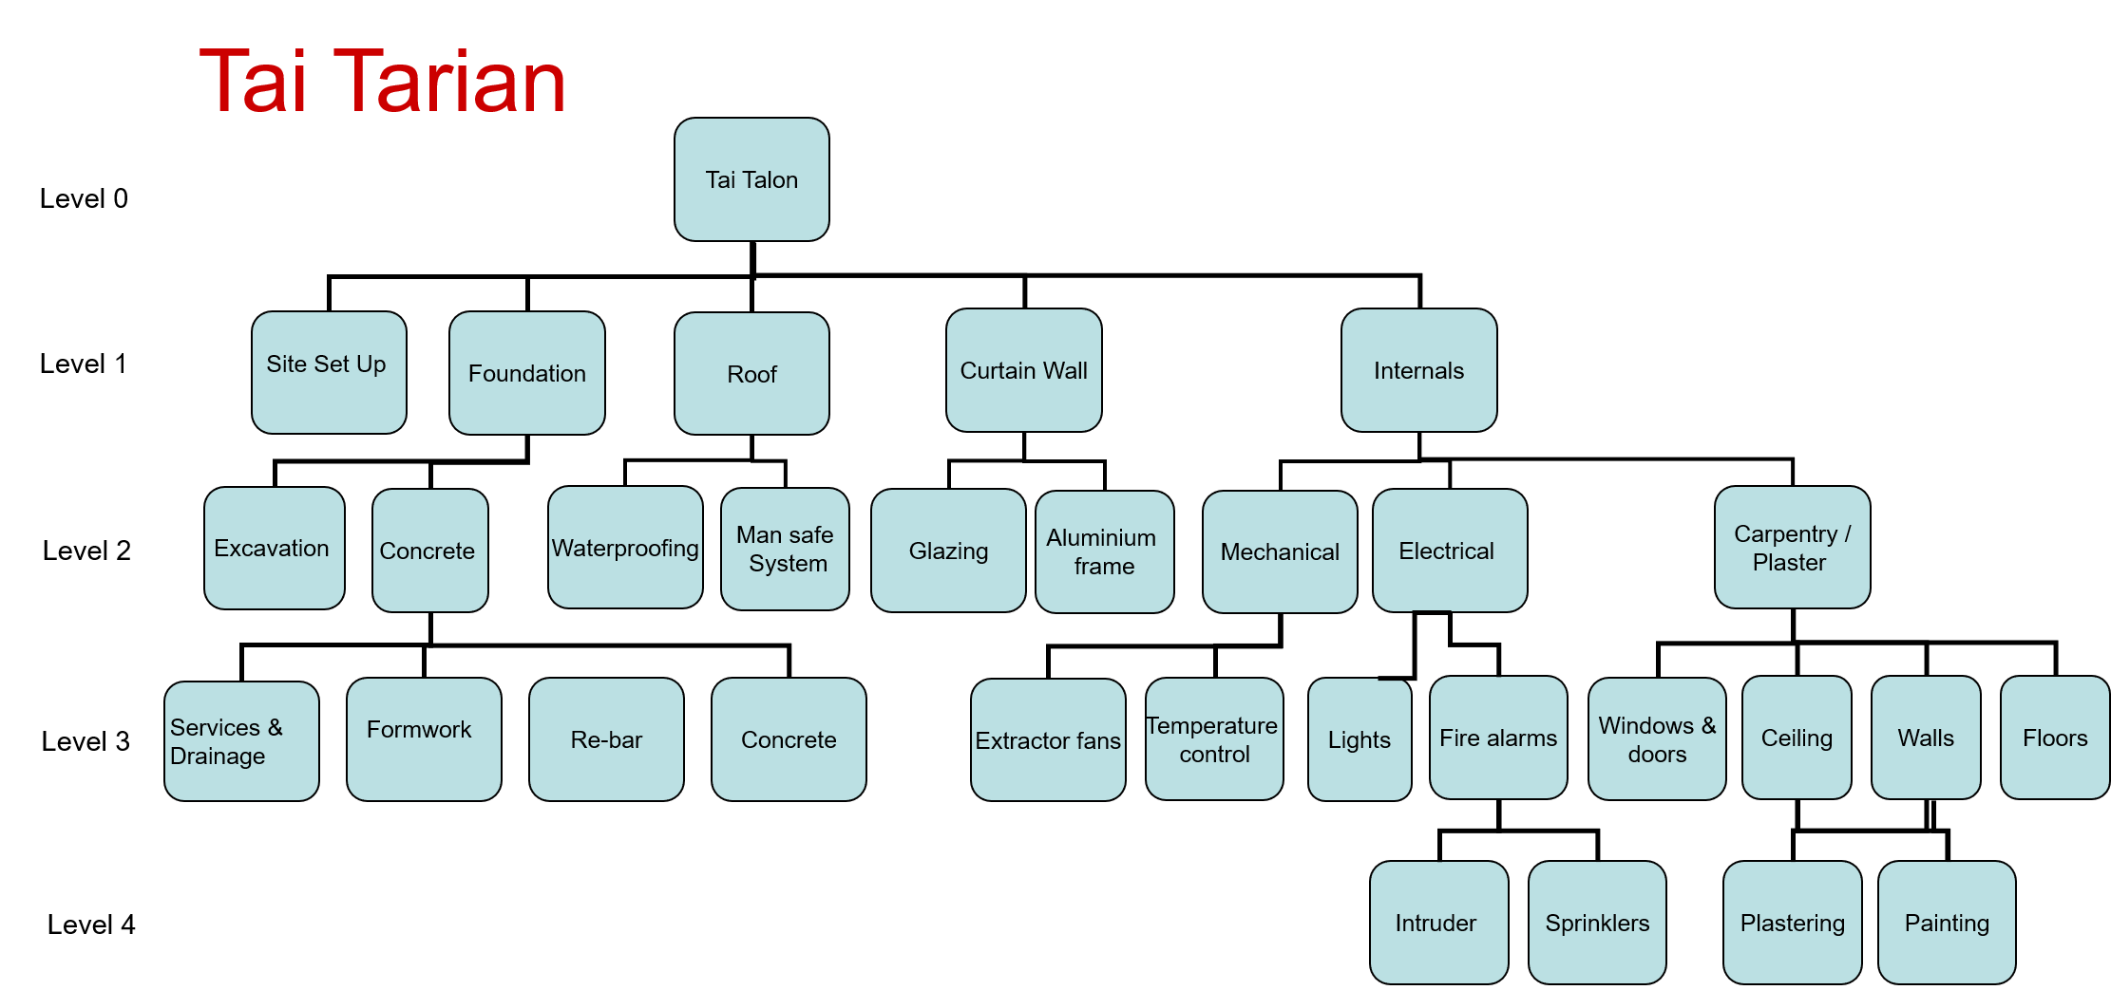

Work Breakdown Structure

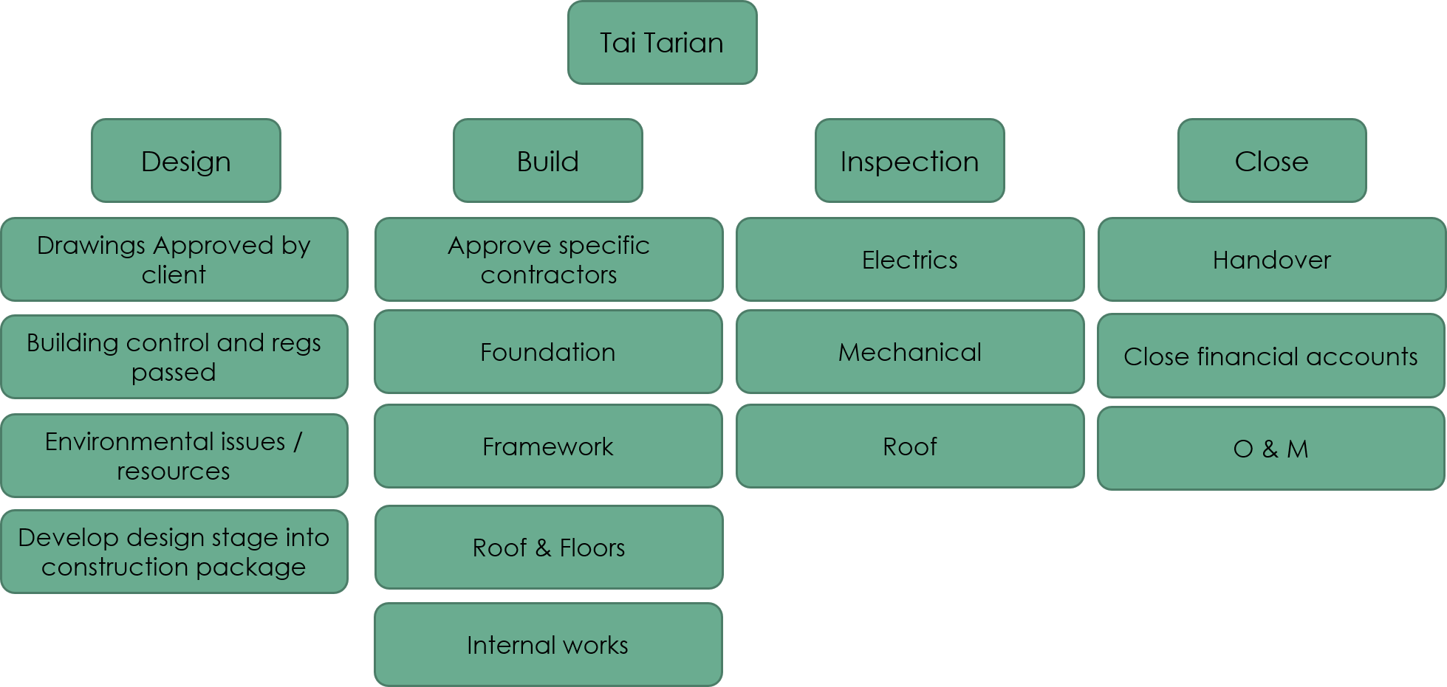

Risk Assessment and Method Statement
Tai Tarian – Baglan Enery Park
Address: Tŷ Gwyn, Brunel Way,, Baglan Energy Park,, Neath Port Talbot SA11 2FP
Version: 01
Issue Date: 05/12/20
Time: 10:00

SECTION 4.1 – METHOD 1 – Roof Waterproofing
4.1 Method to be followed
4.1.1 Outline of works
- Arrive at location
- Undertake daily routine
- Leave location
4.1.2 Detail of works (STEP BY STEP)
- Arrive on site and make communication with the PCs site manager, where they are to receive a site safety induction.
- Familiarise themselves with the work area and ensure that there are no hazards and are able to work safely.
- Construct a timber upstand, for the access hatch, the hatch is to be build a minimum of 150mm above finished roof level.
- The hatch is to be temporary sealed in until the hatched is ready for installation.
- All field areas of the roof are to be primed, this is to be applied using rollers and brushes.
- Once the primer has had time to dry, Install the VCL, the is to be installed using a hot air welding torch and by heating up the underside allowing full adhesion to the primed surfaces. (a hot works permit is to be in place for all hot work activities).
- The VCL barrier is to be overlapped by 75mm with each other a head lap of 100mm.
- Apply the PU insulation adhesive to the newly installed VCL, it is to be applied in a zig zag patterns with beads of approx. 20mm across the roof.
- Install the 130mm insulation boards to the adhesive ensuring all boards are fitted tightly together with no gaps, ensuring no cold spots are in the roofing system.
- The Single ply membrane is now ready to be installed using glue and then hot air welded the laps with an overlap of 100mm.
- Unroll the membrane onto the substrate without ripples and rolled back to expose the underside.
- Apply a coat of adhesion to the substrate and to the back of the membrane in a full and continuous coat.
- Roll back the membrane onto the adhesive approximately 5 to 10 minutes after application. After initial contact, the surface of the membrane is rolled and pressed to ensure full contact.
- Install the access hatch and access ladder to the manufacture’s instruction.
- Install detail flashings around the skylight timber using metal details.
- Instruct sub-contractor to install the mansafe system as per their method of working.
- All work areas are to be cleared of surplus materials and all rubbish removed to complete the project.

SECTION 5.1 – METHOD 2 – Road construction
5.1 Method to be followed
5.1.1 Outline of works
- Arrive at location
- Undertake daily routine
- Leave location
5.1.2 Detail of works (STEP BY STEP)
Pre-construction
- Arrive on site and make communication with the PCs site manager, where they are to receive a site safety induction.
- Familiarise themselves with the work area and ensure that there are no hazards and are able to work safely.
- Ensure all permits to dig have been completed.
- Evacuation to be clearly marked out prior to works
Lifting
- All lifts are to be pre-planned, to be produced by an appointed person.
- All lifts to be conducted utilising 360° with attached lifting eye on quick hitch.
- Competent banks man to be present at all times during lifts and excavations
Excavations – Site clearance / Topsoil Strip
- Utilise 25T on 360° excavator, topsoil to be stripped to the required levels started by the engineer
- Topsoil to be loaded into dump truck utilising 25T excavator
- Topsoil to be transported and tipped at onsite temporary stockpile, pile to be sealed at the end of every day.
Excavation General Bulk
- Excavation laser level to be set up to the correct level and fall.
- Site engineer to mark out all onsite services, utilising cable avoidance tool and site service plans.
- Trail holes must be excavated to determine exact depth of services underground
- All manhole / inspection chamber covers are to be lifted to estimate the line and level of pipes
- All overhead cables will clearly be identified with suitable barriers erected at least 6m distance from the power lines to prevent access, this complies with HSE guidance Note GS6.
- Permit to works to be issued for all works underneath or within 6m of overhead lines.
- All excavation movements are to be supervised by a trained banksman.
- Staff numbers in excavation areas to be kept to a minimum to avoid collision.
Road Construction
- Geotextile membrane to be laid at the bottom of the excavation.
- Granular material to be spread at bottom of the excavation using the excavator and the compacted in 100mm layers utilising rider on roller.
- Final thickness of material should be 200mm thick.
- Granular Type 1 subbase material will be spread over the road area in 100mm layers, using the 360 excavator.
- Final thickness of Type 1 layer to be 150mm.
Plot footings
- All trenches are to be cleared and marked out by site engineer, along with correct laser level.
- 360 excavators to be used to dig the trench with the bucket, the trench will be excavated in layers.
- All excavated materials to be stock piled at the on-site mound. Onsite mound to be sealed up at the end of every day.
- Mound must be kept separate to all other materials that are stored to prevent cross contaminations.
- Excavator to continue excavation of trench until required depth is achieved. Bottom of excavation is to be regularly checked by specific person with laser.
- Bottom of excavation is to be well compacted using the compactor plate / trench compactor. Specific RA will be provided for this machinery.
- When the trench exceeds 1.5m in depth the 360 excavators with the compaction attachment will be used to compact the bottom of the excavation.
- Building inspector is to then inspect the footing trench prior to concrete being poured.
- Concrete to be delivered by others in concrete mix wagons
- Concrete to be directly poured from wagon by use of shoots.
- Concrete to be spread to required levels by use of concrete poker and rakes.
- Final concrete level to be checked by Site Manager

Excavation for pipe trench
- All standard procedures as per previous events needs to be carried out, for example, checking pipe works, confirming the depth of the trench, locating overhead wires and ensuring all permits are in place.
- No movement of excavators can take place without the checks carried out and passed.
- 360 excavator to dig 600mm wide trench, this will be excavated in layers to avoid any contact with buried services.
- All excavated material to be dumped into the dumper.
- Once the trench is to the required depth with it being compacted after it reaches the 1.5m depth, trench boxes will be constructed on level hard ground by competent and experienced personnel and lifted into excavation.
- Boxes will be lifted into the excavation using the lifting point on the excavator, D Shackle and 4 arm chain. All equipment is to be checked and dated.
- All excavated materials are to be stock piled as per previous excavations.
Pile Laying and Backfilling
- Granular material / concrete will be spread at bottom of the excavation to create 150mm bed for the pipe. Bed to be well compacted utilising compaction plate on the excavator.
- Pipes will be lifted and placed in the trench utilising 360 excavator with lifting equipment.
- Additional granular material will be spread around and over the pipe to create 150mm surrounding granular material around the pipe.
- Remaining excavation to be backfilled in layers with suitable backfilling material (as specified by client)
- Backfilling to be done at 150mm layers and well compacted using the compaction plate, until matching ground level.
- When using concrete to backfill, concrete to be poured into excavated trench and spread using concrete poker, this to be installed as per clients specification.
Installation of precast concrete chambers and Gullies
- Manhole location to be set out by engineer, area will be excavated using the 25T 360 excavator to formation level, laser level will be required.
- Where ground conditions are poor, material from soft area to be excavated and sub-base to be spread and compacted in excavation area.
- Excavation will be battered to a 45 degree angle or less, the ground will be stepped where necessary or chamber boxes will be used.
- Access in and out of excavation via ladder.
- 350mm deep C20 concrete slab will be cast below the invert of pipe.
- Manhole ring to be installed with a minimum of 100mm embedment into the base. Ring to be lifted into position using the 360 excavator.
- Inlets and outlets will then be marked in the ring and cut out using the disc cutter, impact resistant goggles and FFPS face mask must be worn and water suppressions to be used. Only trained operatives with abrasive wheels are to use this.
- The inlet and outlet pipes will then be installed, each line will comprise of a stub and rocket pipe.
- the pipes will be protruded into the chamber by 100mm and 300mm out of the concrete surround.
- Pipes will then be sealed using sika product.
- The manhole will be positioned as per specification.
- Second ring to then be installed. Will need to be installed onto a bed of mortar.
- The precast concrete cover slab will then be lifted into place using the 8 ton 360 excavator.
- 2-4 courses of brickwork will then be installed – double skin
- Cover and frame to be installed with concrete surround.
New Highway construction
- 200mm thick layer of Type 1 granular material to be spread at bottom of excavation
- Granular material to be delivered to and tipped into excavation
- Final thickness of 6F5 fill to be 300mm thick
- Granular material to be trimmed to require levels and falls as per specification.
- Final layer of Tarmac to be 150mm thick
- 60mm thick binder course of 20mm aggregate tarmac to be spread by tarmac paving machine and compacted by ride on roller.
- 40mm thick surface course layer of 14mm aggregate tarmac to be spread by tarmac paving machine and compacted on ride on roller.

SECTION 6.1 – METHOD 3 – Curtain Wall
6.1 Method to be followed
6.1.1 Outline of works
- Arrive at location
- Undertake daily routine
- Leave location
6.1.2 Detail of works (STEP BY STEP)
- Arrive on site and make communication with the PCs site manager, where they are to
- Ensure all ground surfacing is clear and adequately levelled to allow for MEWP’s safe working access and storage of materials.
- Before any works to any elevation, all other works must be fully completed to enable us to continue with the works. This is to allow us to accurately set out the whole elevation from the outset.
- Any scaffold ties that penetrate openings where glazing is to be positioned are to be moved where practical and reinstated through areas which are to receive panels as they are lighter and easier to fix once the scaffolding has been strike.
- It is envisaged that the majority of the curtain wall/window will be installed via MEWP or scissor lift (operative must be IPAF trained) Full body harness and restraint lanyards will be worn and will be attached to a secure anchor point.
- All MEWP’s and access equipment will be operated within the IPAF/PASMA guidelines.
- The area around the works must be cordoned off (including signage) to prevent unauthorised access either with barrier or Heras fencing.
- All Glazing will be carried out via a “four-in-line” dual circuit vacuum lifter attached to site crane.
- Dependant on the elevation work will commence in the direction of left to right; right to left or from the corners.
- The frame for each related window opening will be built in the room.
- 1no operative will be harnessed to the internal structural metsec.
- 1no operative will be within an articulated boom with cage up tight to the opening.
- The operative internally will proceed to remove the safety barrier and move the built frame into the opening with additional support being given during this operation by the external operative.
- Once fully supported within the opening the safety barrier will be reinstated.
- Using a podium hard up against the safety barrier, the internal operative will proceed to fix the head as per details.
- Once complete the internal operative will proceed to fix the head as per details.
- Any perimeter EPDM’s are to be sealed and secure as per details.
- The above process will be completed on all elevations.
Glass installation
- Once the grid is in place and has been inspected the glazing can then commence.
- The glass will be lifted into position direct from the stillage using a certified vacuum lifter.
- the Vacuum lifter must be inspected everyday before use.
- Once the glass unit has be inspected and passed for installation the Vacuum lifter will be applied and lifting begins.
- There will always be a banksman on the ground when the glass is being lifted.
- Extreme care will be taken for each unit which are being lifted over and above the building to ensure they are restrained via suckers/straps to prevent spin/damage due to the high winds.
- Once the unit has been lifted to the related opening, operatives from inside the MEWP will guide the glass into the aperture of the grid and retained via full height vertical gasket pressure plates to the perimeter, to secure it before the vacuum lifter is removed.
- This sequence will repeat until the required area has been glazed.
- Operatives will then revisit each opening apply the full width gasket horizontal pressure plates.
- All pressure plates to be retained via the correct number of pressure plate screws to the correct torque as per design details.
- Fascia caps will then be fitted which are pressure applied and snap in to place.
- Ensure all labels are removed.
- Operatives are to ensure all installation zones are cordoned off at all times, to create an exclusion zone around the working area.

Project report

