STUDENT NAME AND ID:
WIOLETA TERESA KNYSZ | 1919631

MODULE:
LEADERSHIP AND MANAGEMENT IN SKILLS FOR THE WORKPLACE

ASSIGMENT:
MANAGING PROJECTS IN THE ORGANISATION
BMSW5104_LON

LECTURER:
YAJESH KUMAR

TASK No.1/2

LONDON LASH
PROJECT MANAGEMENT PLAN

LONGTERM ONLINE LASH EXTENSION ACADEMY

EXECUTIVE SUMMARY

The coronavirus era has shaken businesses hard. Only those with good strong strategies could survive the worst time of the pandemic.

From now on, as never before, every decision made to introduce or put aside project plans, has irreversible consequences. It either allows the company to survive, move forward or to simply bring the organisation down. From March 2020, businesses do not have time for the slightest mistakes, therefore the key is conscious and meticulous management of each project.

TABLE OF CONTENT

- Introduction.
- Longterm Online Lash Extension Academy as a Project of Quality - Benefits.
- Vision, Mission and Core Competencies – Kotter's Model.
- Maximum Control of Project Performing - Work Breakdown Structure Chart, Project Communication Method and Time Management.
- Other Stakeholders Mapping and Communication Between Them.
- Transformation Process - Significant Changes.
- Costs Resources.
- Conclusion.
- References.

INTRODUCTION

This report presents a brilliant online education forecast that turned out to be an advantage in the world of beauty industry.

The project will be based on Royal Award winner, an international lash extension company located in Great Britain- London Lash (London Lash, 2022). The organisation is famous for selling high-quality lash extension products of its own brand and conducting live training for eyelash technicians. All this with worldwide coverage thanks to the cooperation the company has established.
London Lash coped perfectly with the threats posed by epidemic. And the online learning implementation, which revolutionized the world in the time of COVID, will take the organization to an even higher level, guaranteeing its irreplaceability.

For this project to be successful, it must be planned down to the smallest detail, strictly controlled, and monitored. Therefore, the report will go through all the necessary aspects of design management, starting with the step-by-step scope, using various tools and techniques to create Lash Extension Online Academy, ending up with the costs and resources of the entire plan.

The output of the whole idea is London Lash core competencies, which are also fundamentals for the application of the Kotter’s Model.
Thanks to Work Breakdown System procedure, the work will be reliably divided between departments and sub-departments and fully supervise using Belbin Model and Time Management supporting practices.
The topic of all communication with stakeholders will also be covered, as well as inseparable parts of the entire project transformation.

LONGTERM ONLINE LASH ETENSION ACADEMY
AS A PROJECT OF QUALITY – BENEFITS

Although the times of the pandemic are sad and difficult for the society and businesses, they have drawn innovation and created the possibility to translate features into online mode, especially education.

And thus, online teaching has become bottomless topic (Saha, 2021), as brands adapted the level of knowledge transmitted by the media of technology so that a potential student could achieve the given abilities and education. It is amazing opportunity to be up to date with the industry trends (Saha, 2021), contact beauty trainers, other beginner or already qualified students because moreover support groups for studying and taking the first steps in the new career are the addition/ bonus to online purchases.

To the strong main advantages of the project, which is Longterm Online Lash Extension Academy, not to be confused with simply distance certified program, bellows are included:

- The certificates are issued in the same way as for students learning in the campus - there is no information on the diploma that the education has been completed online. The benefit of that approach is the fact that the type of the certificate issued is important for the future employer. Online training is often associated with poorly reliable and non-professional teaching, in one word... you are buying only the PAPER. Qualifications without underlining online achievement will be more desired.

- Comfort learning environment (Saha, 2021) – this is the first thing that the tutor should pay attention to. Students will be more focused, relaxed, and eager to learn through the material in the comfort of their own homes. And because practicing new skills can be often frustrating, while practicing at preferred chosen place the learners could postpone activities and return to them at a peace appropriate for them. This will not be guaranteed by a few days course in the facility and well-educated individual is the showpiece of the trainer.

- No travel costs (Saha, 2021) - and thus, students are not limited by the choice of trainings based on location. This in turn, also benefits the brand that provides the beauty education, in that case London Lash, as it can attract tutees from across the globe.

Thanks to this London Lash has massive chances to function effectively, regardless of the epidemiological level, providing employment to hundreds of people (trainers, IT, administration, accountants, depot workers), and most importantly, conquering the world.

VISON, MISSION AND CORE COMPETENCIES - KOTTER'S MODEL.

The revolutionary change in the organization must base on the strong structure (Athuraliya, 2021), otherwise it can fail.

John Kotter, tutor at Business School in Harvard, has developed eight steps that will allow any kind of business to successfully bring the project to life (Athuraliya, 2021).

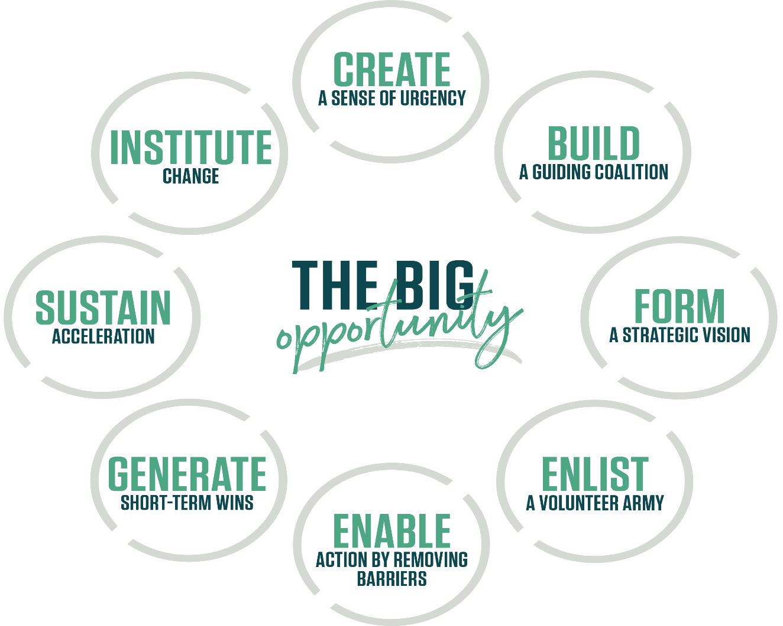
Pic: Kotter, <https://www.kotterinc.com/8-step-process-for-leading-change/>.

HOW DOES IT REALTE TO LONODN LASH?

- SENCE OF URGENCY.
The spectrum of the project implementation must be communicated to the entire crew - this is where the company will need a lot of support (Athuraliya, 2021).
Already at this stage superiors should clearly explain cases so that everyone is aware of various threats and demands (Athuraliya, 2021). The SWOT chart may be extremely helpful (Athuraliya, 2021).

STRNEGHTS
- highly qualified international trainers (London Lash, 2022) = source
- released Volume Lash Extension online course (London Lash, 2021) = experience
- social media webinars provided by the company have been extremely popular
- lash extension trainers become famous
- possibility to competently teach techniques for lash treatments via internet

WEAKNESSES
- IT team may need extensions
- the attitude of trainers to work online

OPPORTUNITIES
- an opportunity to stand out from the competition
- classroom's rental cost will be reduced
- revenue will increase – the academy will be more expensive than standard courses but worth the money
- reaching potential students all over the world
- expanding the London Lash community – each student is a potential client of London Lash’s product

THREATS
- connection and educational platform issues
- complaints made is someone is unable to perform online lash extension education

- GUIDING COALITION.
When entering the mode of broad online education, London Lash must complete appropriate crew. That applied to the above- mentioned expansion of the IT team.

An extra department (with additional lawyer's support) need to create a policy that excludes complaints of online education at the academy and will be on guard in matters of potential problems arising in the project.

Besides, the system and media of communication between the teams should be determined in detail, same as procedures of making decisions and resolving disagreements (Athuraliya, 2021).

- VISION AND STRATEGIES.
The basis of that project is the transformation of the company from the brand that distributes lash treatment tools and products with the addition of education in the world-famous eyelash extension educator with product distribution.

The vision and mission, the core competencies and strategies determine the future of the company after the project is performed (Athuraliya, 2021).

- ARMY OF CHANGE.
Every suggestion of staff members is taking under consideration (Athuraliya, 2021). The golden rule in project implementation according to Keller’s model says to unite ‘hearts and minds’ (Athuraliya, 2021), however this is not a new motto in London Lash culture.

- REMOVING BARRIERS.
To support team motivation, the compensation must increase, and each spotted skill gap should lead to further training and support (Athuraliya, 2021). This includes English language and diction improvement or copying with stressful clients and situation.

Anything taht delays or blocks the implementation of the project must be reported to CEO and removed immediately (Athuraliya, 2021)

- STEP BY STEP ACHIVMENT’S CELEBRATIONS.
The entire project should be broken down to sub-project, and every sub-project completion should be rewarded with a moment of respite and enjoyment (Athuraliya, 2021).

London Lash build the Academy as a whole team, and as a whole team must celebrate... recognition belongs to everyone. Corporate dinners in top London restaurants or vouchers for relaxing SPA treatments, in context of the entire project, will not affect the company’s budget, but will significantly increase the commitment of employees.

- CONSTANT CONTROL OF THE PROCESS.
Project may require slight corrections, so it is so important to look at each step in order to draw conclusions, collect feedbacks, and introduce improvements (Athuraliya, 2021).

- CHANGE IS CHANGE.
The eight step is a time for last fixes that will match the big change (Athuraliya, 2021). Perhaps, the organizational culture, salaries or employee's education need an extra attention (Athuraliya).
Everything in London lash must form a coherent whole. Values must be clearly defined, responsibilities precisely divided between departments and communication facilitated in order to work smoothly. Everything must work, without exemption, and there must always be an alternative to not stand still.
MAXIMUM CONTROL OF PROJECT PERFORMING - WORK BREAKDOWN STRUCTURE, PROJECT COMMUNICATION METHODS AND TIME MANAGEMENT.

The most important thing in the project, apart from the resources of people and tools, is appropriate framework guidelines planned in time with various control techniques, so there is no need to deal with all difficulties at the same time (Egeland, 2019).
Thanks to the controlling mode of the entire project, the forecast can move forward freely all the time (Egeland, 2019).
The control in creating London Lash academy should concern the following:

WORK BREAKDOWN STRUCTURE (WBS)
When looking at the entire project, coordinators may lose sight of the details that are necessary and yet not so obvious (DiFranza, 2019). Therefore, the use of WBS is the key to success. Dividing the project into smaller missions is a guarantee that every aspect will be considered, which will translate into a precise closure of the forecast (DiFranza, 2019).
Work Breakdown Structure allows to save time, competently implement the project where all divisions take care of the separate tasks entrusted to them (Difranza, 2019).
And so, lash trainers participate in photo sessions and recordings, and take part in the transformation of training material adapted to the online version.
IT teams creates the platform, and everything related to it – uploading content, photos, and videos.
Subcontractors (photographers and video makers) in addition to service performed, assemble the entire digital material to perfection.

TIME MANAGMENT
Time management is a scope that allows the organization to visualize the speed of the work on the project in a wisely and realistically thought-out manner (DiFranza, 2019).
However, for time management to serve as a perfect thorough tool to control the project process, it must ensure the following conditions (DiFranza, 2019):
- avoiding meetings which are unnecessary in the design (DiFranza, 2019)
- no brainstorming sessions but the strict definition of set of goals that are necessary in project’s implementation (DiFranza, 2019)
- avoiding misunderstanding and delays – departments have strictly defined objectives and deadlines, and coordinator should flexibly work between the teams to control the standards (DiFranza, 2019)
Preparation of the London Lash academy should not exceed the period of six months. The company already has great educators, excellent training manuals, and administration/ IT team, which means they already save time and money. Under such conditions, the steps are divided as follows:
- photo session of eyelash trainers and activities during eyelash extension treatments - 1 month
- preparation of training description and written exams = updating according to online mode – 2 weeks
- building an educational online platform - 3 months (in the time of other procedures)
- shooting lessons - 2 month
- assembly of lessons - 1 month
- allocating the training material online - 1 month
- opening the support groups for students on social media and communicator (WhatsApp) - 2 weeks

PROJECT COMMUNICATION METHODS
Effective communication perfectly oversees the project timeframe (DiFranza, 2019). And to control the deadlines by using interpersonal connection, the employee’s commitment must be cleverly and ethically maintained (DiFranza, 2019). That is what managers should focus on, because that approach strengthens relationships, keeps the spirit in the workplace and control the project at the same time (DiFranza, 2019).
Regular emails or even short meetings will fit perfectly in that structure (DiFranza, 2019).
The needs picked up when communicating with the crew should be automatically covered (DiFranza, 2019).
OTHER STAKEHOLDERS MAPPING AND COMMUNICATION BEETWEEN THEM.

To understand the stakeholders, around whom the whole project will be going on, it is to exclude any threats (Lucid Software Inc, 2022).
Stakeholder mapping is a precise tool that shows with clarity the entire environment of the organization so visualized communication between contributors, which leads to smooth implementation of the project and overall performance (Lucid Software, 2022).

LASH TRAINERS
The first group of stakeholders plays the key role in the success of the project. Their needs, observations, ideas, and wellbeing are on the first place. It is from them that the target group will feel the energies and the mission that the London Lash academy goes with.
When the project will be LIFE, their duty will be constant contact with students, supervising the progress of their work, evaluating assessments, and answering questions. The working environment provided to lash educator, should not cause any discomfort or claims.

LASH STUDENTS OVER THE WORLD
This stakeholder group is the main source of revenue.
Each stage of the project should be sensitive to the need and expectations of lash extension students. It must be characterized by transparency, wide content and rich visualization.
The Longterm Lash Extension Academy by London Lash is designed to ensure that students have enough TIME. The time needed to acquire the modules, to practice and to finally achieve professional perfection. Therefor the trainers need to be patient and prioritize an important level of teaching.

COMMUNICATION BETWEEN STAKEHOLDERS
Emails will be a channel for communication between stakeholders due the possibility to control and create students' files.
WhatsApp communicator will be a form of urgent contact as well as a place to set up a support group united all London Lash students.
Stakeholders will be informed of about the designated contact hours (daytime online academy working hours).
TRANSFORMATION PROCESS - SIGNIFICIANT CHANGES.

When introducing changes, organizations should strive to transfer the greatest possible benefit from this change process to their target group (Adesuko, 2019).
The process of transformation is the introduction of an order of action and the change of quality offered by the company to produce a profit (Adesuko, 2019), on both sides.

London Lash has a chance with a small input (investment), which requires only an online platform and preparation of recordings, to produce the amazing output to generate organizational profits and convey unbeatable value for lash extension students.
COSTS RESOURCES.

WBS in nothing without CBS (Cost Breakdown Structure) support which allow to control the costs of the project (Editorial Team, 2020). The project acquires an image that can be measured from a financial angle, which gives the forecast a new, in that case satisfactory, dimension.

LABOUR BUDGETE COST
Total work planned to perform by each member of staff, divided into hours, multiplied by the rate (Bear, 2021).
This applies to lash educators, IT staff and administration team in at London lash headquarters.

SERVICE RATE
This applies to ‘PAY FOR THE JOB DONE’ (photo shoots, lessons recordings and external IT stakeholders).

PRODUCT COST
The costs of the project must include devices in which the trainer will be equipped – laptops, professional lightning, cameras, and microphones.

CONCLUSION

Thanks to the achievements of London Lash so far, and with the full involvement of all stakeholders in the project as well as step by step control of performance, the lash academy will be fully operational in six months.
Longterm education will be a revolution in the lash industry. Students will not jump from course to course, from brand to brand, with constant sense of deficiency anymore. They will get all complete and desired knowledge in one place, module by module. Errors will be noticed an ongoing basis during the practicing and supported with reliable feedbacks of tutors. The Certified Eyelash Extension Technician will take on a new, exclusive meaning.

LIST OF REFERENCES

Adesuko B., (29 April 2019), “OPERATIONS MANAGEMENT TRANSFORMATION PROCESS”, LinkedIn, accessed 15 December 2021, <https://www.linkedin.com/pulse/operations-management-transformation-process-adesuko-babatunde>.
Athuraliya A., (23 September 2021), “The Easy Guide to Kotter's 8 Step Change Model”, Cinergix Pty. Ltd., accessed 15 December 2021, <https://creately.com/blog/diagrams/kotters-8-step-change-model/>.
Bear L., (20 May 2021), “Project Financials: Resource Costs and Price Rates”, Clarizen Inc, accessed 15 December 2021, <https://success.clarizen.com/hc/en-us/articles/360018195953-Project-Financials-Resource-Costs-and-Price-Rates>.
DiFranza A., (27 June 2019), “5 Time Management Strategies for Managers”, Northeastern University, accessed 15 December 2021, <https://www.northeastern.edu/graduate/blog/time-management-project-management/>.
Editorial Team, (1 May 2020), “What is a Cost Breakdown Structure?”, Adeaca Corp., accessed 15 December 2021, <https://www.adeaca.com/blog/faq-items/what-is-a-cost-breakdown-structure/>.
London Lash, (2022), “MEET OUR TRAINERS”, London Lash, accessed 15 December 2021, <https://www.londonlashpro.com/pages/meet-our-trainers>.
London Lash, (2022), “ONLINE LASH COURSE – RUSSIAN VOLUME LASH TRAINING”, London Lash, accessed 15 December 2021, <https://www.londonlashpro.com/products/online-russian-volume-course>.
Lucid Software Inc., (n. d), “A quick and dirty guide to stakeholder mapping,” Lucid Software Inc, accessed 15 December 2021, <https://lucidspark.com/blog/a-guide-to-stakeholder-mapping>.

TASK No.2/2

SPEAKER NOTES FOR PP PRESENTATION

INTRODUCTION
Longterm Lash Academy project is a forcast worth introducing in such an exclusive brand as London Lash.
The times of epidemic have shown that technology has once again proven that is able to keep busninesses alive. So why not bet on this business environment?
The company is distinguesh by a high sense of aesthetic, accuracy and high level of shared content.
The truth is that London Lash is already highly adapted to that mode. In order do educate online and stand out from the competition... strong stakeholders are needed - knowledge desired target group, and highly specialized tutors. If we add an extended IT team that will supervise and intervene in times of crisis vagaries of technology, and a supplier that equips London Lash warehouse with branded eyelash extension products, the business is doomed to success.

BENEFITS
Creating an educational platform which, instead of selling simply courses, will be an EDUCATIONAL CENTRE for potential lash technicians, leads to leadership in lash industry.
Except of benefits that the London Lash has a chance to gain, the company must focus on the attractiveness that will bring the innovation for the clients. Students will not only save valuable time that they will be able to spend on practicing new skills, but the comfort of education. Moreover, they will never be ashamed of diplomas completed online. London Lash academy’s certficates will not contain information about this type of teaching, and all modules full of knowledge and practice will be sheduled to be completed in one year. Learning a profession over a year, not just a few days, wil be an amazing investment in a student carieer and an enormous source of systematic income for the organization. And I would like to point out that the online academy will be able to obtain students all over the world. Hand with hand with that project is the promise of fame.

STAKEHOLDERS MAPPING
The success of London Lash is already builded and excellent team of trainers and focusing on transfering reliable knowledge in smallest detail, so that highly qualified lash technicians enter the market, rather than girls who only ‘glue' eyelashes.
These two groups of stakeholders create wonderful and beneficial synergy. Therefore, the entire project pays attention to the needs and expectations of lash tutors and students. They determinate the quality of London Lash Academy.
Using resources of fantastic educators, it is neccessary to create relationship between stakeholders and also the module program in such a way that students will have a sense of knowledge saturation. No other lash brand works with this schame as they are based on the number of courses sold, not on their quality. So the training follows the training to gain the mastery needed to perform lash treatments, but stylists still lack many skills. This is not what the 21st century market should be like.

The Longterm Academy Project will rely on the team controlling the technological aspect of the venture, that is why that devision required expansion. The company should work closely with an IT service representing a high standard, because by accepting and challenging situations independent of the human beeing, other enhancements are not acceptable. The online platform is the London Lash a command centre - that is where the future is.

RISK MANAGEMENT
Thanks to taking the risk management into account, the potential threat cannot shake the project hard because the company will be prepared for those blows (Egeland, 2019). Of course, no one can predict everything, but it is worth having a plan B in hand for emergencies.
First, London Lash should get strict promise (legally documented) from their trainers to fully committed online work. They must therefore thing carefully and openly agree to this huge change. All hands on board, not only during the project, but most of all after its implementation.
Secondly, in addition of providing positions of IT staff, London Lash must establish close cooperation with a reliable external IT service that will always be available when problem occur, and because technology is unpredictable, the company must be ready to face this situation.

CONCLUSION

The transition to longterm online learning is not a massive challenge for the organization but the promise of success.
London Lash has a chance to use the opportunity which brings the technology of XXI century and their own achievements to be ONE STEP AHEAD of the competition because the company has UNIQUE STAKEHOLDERS and CORE COMPETENCIES. This seals the entire project.
I hope you will feel the same energy flowing from this venture, just as much as I do.

