Programme: Master of Business Administration
Module Title: Strategic Management
Module Code: LCMB7003
Submission Title: Assessment component - Individual report
Assignment Title: Strategic Management Report on Unilever's Home Care Segment within UK
Lecturer Name: Amare Desta, Ghulam Mujtaba
Student Name: Niral Popatbhai Ranavaya
Student ID: 2530032

Table of Contents
Introduction 3
Section 1 3
1. Organisational Context and Overview 3
2. External and Internal Analysis 6
2.1 PESTEL Analysis 6
2.2 VRIO Analysis 12
2.3 SWOT Analysis 16
3. Comprehensive and holistic view of the organisation 18
4. Strategic Choices and Implementation 23
Section 2 26
Reflective Account Using Kolb's Reflective Cycle 26
Conclusion 29
References 30

Introduction
This report is mainly a strategic assessment of Unilever PLC Home care business in the United Kingdom (UK) approached from the perspective of strategic management consultant acting as a consultant to the Board of Directors. The strategic position of the organisation is properly analysed by integrating the appropriate and justified theories of strategic management with contemporary business evidence. It also examines the external and also internal business environment, looks into the corporate social responsibility, organisational performance as well as makes strategic hypothesis to boost and upgrade the sustainable competitive advantage and also long term growth in the changing the UK Home Care sector.

Section 1

1. Organisational Context and Overview
1.1 Organisation Overview
Unilever PLC was established in the year 1929 and has grown into one of the world's fastest-moving products (FMCG) companies (EBSCO Information Services, 2025). The report mainly looks at only Unilever's Home Care business in the United Kingdom which consists of laundry care, fabric enhancers, household cleaning and home hygiene products sold under brands such as Persil, Comfort, Surf, Cif and also Domestos (Unilever, 2025a). Unilever's corporate purpose is there to make sustainable living commonplace by giving such products and services for better living for all with a long-term value for stakeholders (Nurhidayah et al., 2025). It is also on achieving a better and faster, simpler and even more competitive organisation through science-led innovation, operational excellence as well as sustainable growth that its vision focuses.
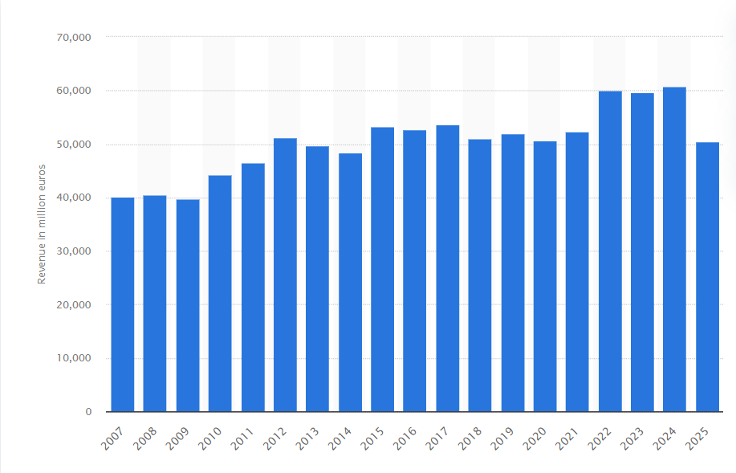Figure 1: Revenue of Unilever from 2007 to 2025
(Source: Statista, 2026a)
This figure displays the trend in Unilever's revenues over the last eight years (2007-2025), pointing that overall the company has performed well. The Home Care business model mainly combines of consumer insight, research and development, responsible sourcing, advanced manufacturing, digital technologies as well as some good retail relationships to provide imaginative cleaning solutions (Huynh et al., 2025). With the Group turnover of around €60.8 billion in the year 2024 the Home Care business accounted for around 20% of total group turnover (Unilever, 2025b). The company also reported that nearly 2.9% fundamental sales growth and 4.0% underlying volume growth pointing that the company's ability to withstand inflationary pressures and shifting the consumer demand (Unilever, 2025c).

1.2 Industry, Competitors and Market Position
Unilever's Home Care business is mainly a part of the UK global home care market that’s size was valued at USD 172.33 billion in the year 2025 (Fortune Business Insights, 2026). The market is also projected to grow from USD 183.78 billion in 2026 to USD 280.03 billion by 2034 exhibiting a CAGR of 5.41% during the forecast period (Fortune Business Insights, 2026). Asia Pacific dominated the home care market with a market share of 31.40% in 2025 (Fortune Business Insights, 2026). Higher demand for sustainable products and also more targeted formulations expand the premium cleaning performance and also increasing such online channels are mainly accountable for market growth.
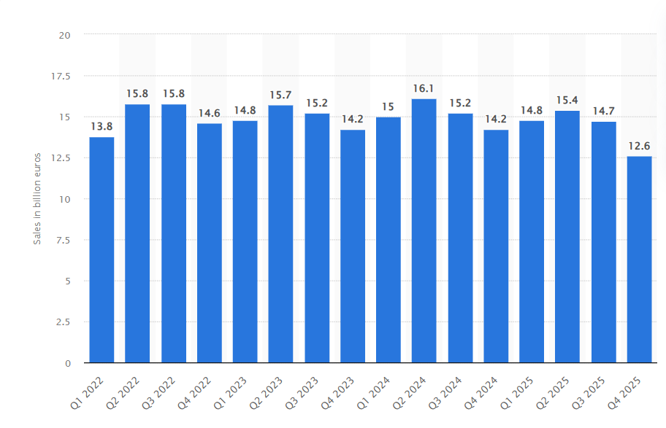Figure 2: Quarterly sales of Unilever worldwide from 1st quarter 2022 to 1st quarter 2026 in billion euros
(Source: Statista, 2026b)
This figure shows Unilever's quarterly sales across the globe from Q1 2022 through Q4 2025 where the figures are relatively stable but with some minor variations. With ever-rising operating expenses and the pressures of inflation companies have found themselves in a more sensitive to price which also makes it even more significant to consider the innovation. Unilever faces a direct competition from Procter & Gamble, Reckitt Benckiser Group plc, Colgate-Palmolive (CL) company offering a strong competitive rivalry for the whole UK market (Koalagains, 2025). In addition continued investment in some new ideas, well-known brands, sustainability efforts and a wide distribution system mainly help the company to hold its competitive ground and to meet changing consumer requirements and regulatory requirements in the UK Home Care market (Michalski et al., 2024).

2. External and Internal Analysis

2.1 PESTEL Analysis
Factors | Critical Analysis | Opportunity and Threat
Political | The political environment in the UK is considered as a stable democratic environment by which long term investment and operational continuity has been supported.  In UK Brexit as per Jozepa (2026) has introduced additional custom procedures and trade regulations between UK and EU and for that procurement costs have been increased.  Government in the UK through Extended Producer Responsibility that began in 2025 for that as per GOV.UK (2025) it promotes sustainable packaging and through investment in recyclable packaging have been encouraged that aligns with Unilever’s sustainability strategy.  Geopolitical tensions and global trade uncertainties in current era contributes to fluctuations in transportation costs which requires Unilever to mitigate procurement risks with the help of their supplier diversification. | Opportunity: A stable political environment in UK helps for sustainable manufacturing and with the help of that Unilever maintain its competitive position.  Threat: Post-Brexit regulatory changes and geopolitical uncertainties most of times increases compliance, logistics and raw materials costs and thereby reduce operational efficiency.
Economic | The UK economy in this current era shows a slow growth as per Stewart (2026) where a rise of 0.1% month by month and 1.0% growth was expected for 2026.  In UK Consumer Price Inflation (CPI) although is stable around 2.8% but due to underlying services and supply chain pressures the IMF because of energy volatility projects inflation about 3.5% towards the end of 2026 (Brien, 2026).  Supermarkets like Tesco and Sainsbury’s they maintains aggressive price war with small stores like Aldi and Lidl that makes hard for Unilever to raise their prices. | Opportunity: Despite of moderate economic conditions in UK consumers in UK prefers premium and sustainable Home Care products that supports Unilever’s revenue growth.  Threat: Slow growth in salary and supermarket price wars stops Unilever to raise their product’s prices as their production costs goes up.
Social | Households in UK has greater emphasis on cleanliness which results in demand for household cleaning products after the COVID-19 period.  Approximately 73% of UK consumers as highlighted in Deloitte (2024) have report that sustainability influences their purchase decisions and because of that it increases demand for environment friendly Home Care products such as Persil Wonder Wash and Cif EcoRefill.  Public awareness regarding and plastic waste and ethical sourcing as per Gerassimidou et al. (2021) also encourages recyclable packaging for which it requires sustainability to be integrated within product development. | Opportunity: Unilever’s market position is strengthen by UK consumers preference for sustainable and premium Home Care products.  Threat: consumer expectations in the current era is going towards premium products and for that Unilever need to meet that expectations.
Technology | Statista (2025) reports that e-commerce sales in UK accounts for approximately 26.8% of total retail sales in 2025 therefore Unilever need to invest in in digital marketing.  As per report of Unilever PLC (2024) €100 million of investment in in-house digital capabilities by Unilever includes AI, data analytics and product innovation.  Adoption of AI-driven demand forecasting, automated manufacturing and refill packaging by Unilever in current digital era may help in production efficiency. | Opportunity: Operational efficiency of Unilever is enhanced by their AI, automation and digital retail channels.  Threat: Rapid advancements in technologies and continuous investment also increases capital expenditure and it can intensify competitive pressure.
Environmental | The UK government is committed to achieve net zero greenhouse gas emissions by 2050 and for that UK government imposed strict environmental regulation and sustainability standards on FMCG manufacturers (GOV.UK, 2022).  Under Unilever’s sustainability commitment 100% of plastic packaging has been designed for reusability, recyclable and compostable. Unilever reduces the usage of virgin plastic with method like refill and concentrated product innovations (Unilever, 2024).  Increasing consumer awareness regarding climate change and plastic pollution as per Alamsyah et al. (2021) has increase the demand of environmentally responsible Home Care products which includes solutions like Cif EcoRefill and concentrated detergents.  Expectations in carbon emissions, waste management requires continuous investment is sustainable manufacturing and packaging technologies that maintains regulatory compliance. | Opportunity: Demand for sustainable Home Care products strengthen reputation of Unilever in UK and helps in Unilever’s Long-term competitive advantage.  Threat: Environmental regulations in UK is strict for that increase in sustainability investments can rise compliance costs and operational costs.
Legal | UK’s Extended Producer Responsibility (EPR) regulation increases producer accountability for packaging waste and the regulation requires investment in recyclable packaging and in waste management.  The UK REACH Regulation as highlighted in HSE (2021) has acquired chemical substances that are used in detergents and in cleaning products to be registered and reassessed and this is important for product formulation to comply with safety standards.  The Consumer Protection from Unfair Trading Regulations 2008 and the Competition and Markets Authority (CMA) Green Claims Code have strengthen scrutiny of misleading environmental claims and it requires communications to be transparent and based on evidences (CMA, 2021). | Opportunity: Unilever need to comply UK’s environmental and consumer legislation which will strengthen its brand credibility, consumer trust.  Threat: Regulatory requirements and compliance costs in cases of non-compliance often may expose Unilever to financial penalties and reputational risks.
Table 1: PESTLE Analysis
(Source: Self-Created)
The Home Care macro-environment in UK as described in this table experiences legislative requirements and rapidly changing consumer preferences. The implementation of the UK REACH framework and the introduction of Extended Producer Responsibility (EPR) regulation with added financial and compliance have been imposed on manufacturing sectors. Manufacturing sectors as remain dependent on virgin plastics and conventional chemical substances therefore UK impose these above regulations. Post inflationary economic pressures also was observed as inflation is projected to reach approximately 3.5% in 2026. Households in UK increases the adoption of energy efficient consumption practices which includes cold water laundering and as limited pricing flexibility is imposed by price competition within major UK’s supermarkets.

2.2 VRIO Analysis
Capability | Valuable (V) | Rare (R) | Inimitable (I) | Organised (O) | Competitive Implication | Strategic Implications
Strong Home Care Brand Portfolio (Persil, Domestos, Cif, Comfort) | Yes | Yes | Yes | Yes | Sustained Competitive Advantage (SCA) | Unilever has a well-established portfolio in Home Care brands which enables a premium positioning, consumer trust and strong market penetration within UK thereby it creates a competitive advantage (Unilever Global, 2026).
Sustainability and Product innovation | Yes | Yes | Yes | Yes | Sustained Competitive Advantage (SCA) | Unilever makes significant investments in refill packaging, concentrated formulations and in low market product innovation as highlighted by Jessen (2024) that aligns with UK’s environmental regulations and with consumer preferences.
Advanced Global Supply chain and Distribution Network | Yes | Yes | No | Yes | Temporary Competitive Advantage (TCA) | A £150 million investment has been made by Unilever at Port Sunlight to improve their Home Care manufacturing operations and they establishes an automated distribution center which is connected to three factories (Cosmetics Business, 2026).
Research and Development Capability | Yes | Yes | Yes | Yes | Sustained Competitive Advantage (SCA) | Continuous investment made by Unilever in research and development as per Jain et al. (2021) make sure product performance, packaging innovation and improvements in formulas that strengthen long term competitiveness.
Dependence on Third-Party Retailers | Yes | No | No | Yes | Competitive Disadvantage | Unilever as highlighted by GOV.UK (2023) is heavily dependent on retailers like Tesco, Sainsbury’s, Aldi and Lidl that reduces pricing flexibility as retail price competition influences profitability.
Expose to Global Raw Material Prices | Yes | No | No | Yes | Competitive Disadvantage | Dependence on globally sourced chemicals, packaging materials and vegetable oils expose Unilever to inflation, exchange rate volatility and towards geopolitical disruptions by which cost pressures are created across Home Care supply chain (Unilever Annual Report, 2026).
Table 2: VRIO Analysis
(Source: Self-Created)
The VRIO analysis in Table 2 indicates that Unilever’s position in UK has supported by valuable and well-organized capabilities. This table also shows certain limitation of Unilever’s operations. Sustained Competitive Advantage has created by Unilever’s strong Home Care portfolio that includes products like Persil, Domestos, Cif and Comfort. A £150 million investment has been made by Unilever as the Port Sunlight manufacturing hub where a 10000 m² automated distribution center has been integrated with three production facilities. Manufacturing efficiency and supply chain resilience have been enhanced and logistics movements has reduced up to 27%. As investments in manufacturing automation also be undertaken by competitors like Procter & Gamble (P&G) and Reckitt therefore Unilever generates only a Temporary Competitive Advantage with this capability. Strategic disadvantages also can be experienced as Unilever is dependent on UK retailers such as Tesco, Sainsbury’s, Aldi and Lidl which had constrained price flexibility. In addition expose to raw material volatility and exchange rate fluctuations that increases procurement costs had reinforce the demand of sustained innovation and premium product differentiation.

2.3 SWOT Analysis
Strength | Weaknesses
Unilever gets ahead of competitors in its innovations associated to the Home Care Industry within the UK. 75% of capital investments in the Home Care area in the year 2024 have been directed at developing growing market categories while the investment in the new European facilities amounts to EUR 150 million (Unilever, 2025b and May, 2026). Unilever completes £150 million investment in Port Sunlight facility in the UK aimed at making of liquid detergents and capsules and also supports the process of logistics development of some various brands such as Persil, Comfort, Cif and also Domestos (Unilever, 2026a). | Despite the apparent familiarity of the Home Care market for Unilever in the UK there is a significant load that is imposed by expenses related to innovations such as R&D costs (Dube and Dube, 2023). Additionally the process of improvement and boosting in the area of manufacturing needs a significant expenditure because of high complexity consisting of digitalisation and adding such high quality of products to the production process.
Opportunity | Threats
The market for cleaners is evolving quickly with the rise in awareness about eco-friendly and also high-end cleaning products among consumers. Unilever is answering to this changing trend and with the introduction of its new washing cycle called “Wonder Wash” and also focusing on the making of AI-ecosystem (Unilever, 2024). Some significant changes in the market create some new opportunities for the company and its products to become even more effective. | The UK market for home care products is also highly competitive where brands such as Procter & Gamble, Reckitt Benckiser Group plc, Colgate-Palmolive (CL) fight strenuously for their shares of the market using the innovation and aggressive pricing (Koalagains, 2025). What is more troubling for the players in the UK home care market is that the prevailing market conditions are usually favourable for some private label products and also due fluctuations in prices and inflation, the market remains unstable and undetermined.
Table 3: SWOT Analysis of Unilever PLC
(Source: Self-made)

3. Comprehensive and holistic view of the organisation
3.1 Corporate Social Responsibility (CSR) Strategy and Alignment with Business Objectives
Unilever uses the Corporate Social Responsibility (CSR) in its decision-making process in the Home Care market by executing sustainability in the processes of product innovation, production as well as distribution (Macassa et al., 2022). They view CSR as a strategy to be more competitive, efficient and also profitable instead of only complying with regulations. This approach is very much similar to its goal of giving innovative home care solutions while making environmental benefits and earning profit in the UK (Hagedoorn et al., 2023).
An instance of an investment is the €150 million investment made by Unilever in Port Sunlight manufacturing and research facility which will be able to increase production capacity, boost the logistics as well as help to develop environmentally friendly Home Care products (Unilever, 2026). The introduction of Persil Wonder Wash which is effective in cleaning clothes within 15 minutes in cold water is another evidence of Unilever's ability to supply consumers with convenience (Unilever, 2024). It also contributes to the reduction of household energy consumption which line up with the sustainability agenda while at the same time enhancing its premium products.
CSR is such a concept that requires some businesses and also that need to be mindful of the way they source, package as well as produce goods. CSR programs able to be enable companies to link sustainability with positive outcomes for the organisation and its brand image (Srivastava, 2024). The use of CSR ensures that the organisation achieves positive outcomes in terms of sustainable production which make results in increased efficiency in competing for customers (Padilla-Lozano and Collazzo, 2022).
Although these are the good methods that can be implemented by Unilever to become more sustainable they will require the continuous investment in such use of new technologies, better research, production studies as well as increased costs of operations that are taking place in the short term as the strategy is implemented. Apart from new green laws and the pressure of competitors require Unilever to prove the effectiveness of its sustainability efforts through the performance indicators without any kind of compromising the quality of products and costs of production (Hu and Zeng, 2024). Overall it can be stated that the current CSR strategy in the area of sustainability coincide with Unilever's business goals.

3.2 Balanced Scorecard Analysis (Kaplan and Norton, 1992)
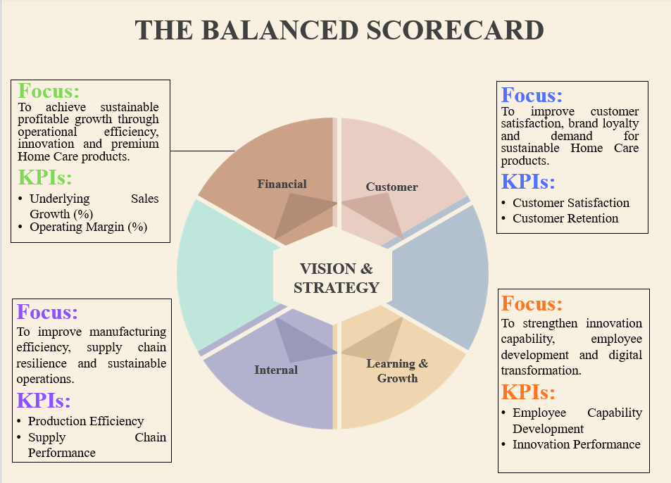Figure 3: The Balance Scorecard
(Source: Canva)
The Balanced Scorecard depicted in the image suggests how Unilever’s Home Care unit is segmented into some measurable operational goals which are connected and also comprise the four perspectives with the four perspectives of Financial, Customer, Internal Business Processes and Learning & Growth. The structure mainly represents financial and non-financial indicators that aim to make sure that strategic implementation and organisational efficiency are estimated not only based on the financial results. Each perspective entails precise subjects along with the relevant KPIs to enable tracking of performance and assessment of progress with regards to accomplishing strategic targets providing the basis for evidence-based decision-making.
Financial Perspective
Objectives
To achieve the significant and sustainable development of business within the Home Care segment while giving added value through innovations in this industry allowing for such long-term value creation for shareholders and make sure effective business operations.
Key Performance Indicators (KPIs):
Sale increase, improvement of operating profits, ROI, effectiveness of production and cost efficiency.
Targets:
Further improvement of obtained revenue through some innovations at the products and decreasing the costs of the operation with effective use of resources.
Initiatives:
The business financial performance is also boosted through investments in new manufacturing plants, modern digital supply chain technologies as well as premium Home Care innovations (Chen et al., 2025). The analysis of indicators through management also permits checking how well the investments increase profitability and resource utilisation of Home Care.
Customer Perspective
Objectives
To enhance the Customer Satisfaction & brand loyalty and also boost the demand for innovative & sustainable Home Care products.
Key Performance Indicators (KPIs):
Operate profits, ROI, effectiveness of production, cost efficiency as well as increase of sale.
Targets:
Further growing of the income achieved with some of the innovations in the products and also lowering the cost of operation with the proper successful utilisation of resources.
Initiatives
Current as well as ongoing product innovation, product performance improvement and also the solutions with sustainability orientation add some value for customers (Ortiz‐Avram et al., 2022). Managers are able to be monitor the customer KPIs to watch if there are any strategic actions that are successful in creating customer trust, positioning the brand better in the market as well as having some contribution to the companies premiumisation and also sustainable growth strategy for the UK Home Care sector.
Internal Business Processes Perspective
Objectives
To expand the operational resilience, boost the production processes while keeping environment in mind to enhance production efficiency.
Key Performance Indicators (KPIs):
Efficiency of production, quality of the product, logistics performance, reliability of the supply chain as well as innovation cycle time.
Targets:
Upgrade and enhance the operational performance and also able to decrease the waste and upgrade productivity as well as supply chain resilience.
Initiatives
Modernisation of the manufacturing process, digital technologies and process optimisation are the key elements of investment in operational excellence (Gomaa, 2025). All these operational KPIs are mainly used by the managers to find the process improvements, efficient use of resources. It also ensuring internal processes are always helping the company to achieve its strategic aim of sustainable and innovative Home Care products.
Learning and Growth Perspective
Objectives
To enhance the organisational capability through continuous learning, research excellence, digital transformation and also workforce development.
Key Performance Indicators (KPIs):
Capability of employee, innovation performance, productivity on research, workforce engagement as well as such digital adoption.
Targets
Improve the organisational learning to encourage innovation and organisational adaptability over time.
Initiatives
Ongoing R&D investments having some contributions towards the building of innovation capacity and organisational resilience as do investments in capability building and in digital the technologies (Nakandala et al., 2023). All these non-financial KPIs are observed by management to ensure that employee development and technological advances are successful in achieving Unilever's mission and long term objective in supporting the business to have sustainable competitive advantage in the UK market.

4. Strategic Choices and Implementation
4.1 Business-Level Strategic Choice: Differentiation
In order to achieve a sustainable competitive edge businesses use some strategies such as cost leadership, differentiation and also focus. The Home Care sector of Unilever can use some differentiation strategies in its quest for competitive advantage (Naqvi and Naqvi, 2023). A differentiation strategy allows the company to manufacture innovative and high-quality products that will be able to enable it to earn loyalty and also build brand equity (Zulfikar, 2025). However the UK Home Care industry is full of competitors mainly as consumers become more price sensitive and private label retailers are obtaining popularity.
Differentiation strategy is the most appropriate for Unilever since it can enable the company to reduce the operational costs while maintaining the quality of products. In this way the company can also manufactures such products at competitive prices by being efficient in production as well as through optimising the supply chain and its obtaining scale effect (Syed, 2025). Differentiation is the best strategic choice since it authorises enhancing profitability, flexibility of market demand as well as the long-term success of the company.
4.2 Validation of Differentiation Using Porter's Five Forces
Porter's Five Forces ensure the appropriateness of differentiation as it identifies the competitive forces in the UK Home Care industry.
Threat of New Entrants – Low
The competition is low since starting a Home Care business needs an extensive capital investment on manufacturing facilities, product development, distribution system, acquiring necessary permits as well as making the brand image. Furthermore because of the substantial loyalty of consumers to well-established brands the low threat of new such players entering the industry is reinforced. Therefore the ability of Unilever to compete in the market is boosted by the differentiation which is also achieved through upgrading the operating efficiency of the company making it more difficult for new entrants to effectively compete (Abbes, 2025).
Bargaining Power of Suppliers – Moderate
Supplier power is considered moderate since it relies on some raw materials, packaging and also chemicals whose prices might fluctuate. Effective procurement techniques, diversification of suppliers, supplier network and also successful establishment of long-lasting relationships with the suppliers can also help to reduce such risks in procurement and manage procurement costs (Dijmarescu, 2024).
Bargaining Power of Buyers – High
High buyer power is evident due to the availability of lot many branded products and affordable alternatives in the market. Retailers are very possessing high bargaining power that is based on their purchasing power and importance of shelf space (Taleizadeh et al., 2023). To stay competitive it becomes very much essential and important as well to keep prices low and maintain quality consistently making it an effective strategy to implement.
Threat of Substitute Products – High
In the marketplace there are numerous supermarket private label options and some other cleaning substitutes available which suggested that the threat of substitutes is high. Customers are usually look for a better deal before they purchase any specific item (Cakranegara et al., 2021). Through the differentiation Unilever has been able to ensure that the quality of their products is comparable to that of competition and at the same time keep the prices down. The customers are also offered some similar products but are not diverted to other brands.
Industry Rivalry – Very High
The Home Care sector in the UK is witnessing intense competition with companies competing on pricing, innovation, marketing and sustainability initiatives (Walker et al., 2022). Under such conditions organisations with a lower operating cost find it easier to lower their prices and also remain competitive. Porter's Five Forces mainly suggests that the firms in this market benefit from cost leadership.
4.3 Delivering Optimum Performance and Competitive Advantage
The implementation of differentiation strategy mainly authorises Unilever to improve and enhance its performance through operational the efficiency and also optimisation of productivity and profitability while keeping customer value. Execution of Porter’s generic strategies reflects that lower costs lead to greater pricing flexibility and better financial performance than that of competitors (Marfo-Yiadom et al., 2025). In the similar way Porter’s value chain also displays that increasing the cost in terms of procurement, production, logistics and also distribution able to improves the company’s costs in the long term basis.
According to the RBV theory having an efficient operation like supply chain, established brands, and innovation are also valuable resources which are hard to replicate by competitors (Komakecha et al., 2025). This will also lead to an effective and innovative operation allowing the company to keep competitive prices without compromising quality or sustainability. This also leads to higher satisfaction of customers, expand the profitability and also long-term competitive advantage for the company contributing to sustainable growth in the UK Home Care market (Hajar et al., 2022).
4.4 Implementation Challenges and Mitigation Strategies
Differentiation strategy having some challenges such as increases in raw material prices and energy costs, disruptions in supply chains as well as stringent environmental regulations. Excessive cost-cutting efforts can also compromise product quality, employee motivation or innovation (Ogbonnaya et al., 2022). To mitigate all these challenges Unilever needs to invest in the advanced technology such as automation and digital supply chain management to enhance the efficiency (Ameh, 2024). Additionally lasting supplier connections can also be built by making sufficient sourcing options as well as significant investments in research and development to support the required success of the business as they will allow Unilever to successfully balance between operational efficiency and also quality while making sure that sustainability and innovations stay an integral part of the organization.

Section 2

Reflective Account Using Kolb's Reflective Cycle
2.1 Concrete Experience
What happened?
In the course of preparing for this assessment I mainly have undertaken the research and analysis of Unilever's Home Care division in the UK leveraging strategic management theories in conjunction with data that are published by various organisations (Kang et al., 2023). The objective is to establish the strategic position of the organisation using appropriate and proper analytical tools as well as to come up with some feasible recommendations. Theory that are learnt has been applied to the organisation rather than merely giving such information.
What did you do?
I conducted a thoroughly literature search, industry data as well as I also corporate such documents prior to using the analytical models such as SWOT analysis, Balanced Scorecard and also Porter's Five Forces. I also consider and make some comparison with the other views on the topic, structured the information properly, logically and also edited it many times to make sure that the clarity of structure is present. I also paid such attention to making sure that all parts of the report corresponded with the evaluation criteria.
What did others do?
Theoretical knowledge and practical evidence were given by the academic researchers and by organisational publications. In their work they familiarised me with the application of strategic concepts effectively in a real life business environment.
2.2 Reflective Observation
What did you assume?
Initially I believed that possessing an overwhelming amount of information would automatically lead to the production of an exceptional strategic report. However I learned that presenting abundant descriptive material is in no way an essential for ensuring quality in an academic essay what is more important is to find out such relevant evidence and also assess it critically (Mallahi, 2024). I also thought it was quite enough just to talk about strategic models but I was mistaken in that opinion because strategic models should be utilised critically while making such decisions in the company.
What happened?
While writing I able to be realised that some of the parts were not analytical enough as I paid more attention to explaining theories rather than evaluating their relevance. Another challenge that was matching theory to the organisational examples. With all these shortcomings I understood that I must need to analyse my paper in a more critical manner.
What did you learn?
It is also my experience that there are some logical as well as some critical thinking are present that mainly reflecting which are always needed in strategic analysis. All of the arguments should properly justify the appropriateness of a strategic decision instead of just stating the theory generally.
2.3 Abstract Conceptualisation
What could have been done better or differently?
I could have also organised the planning of my research before composing it. I should have been more critical in evaluating alternative strategic options and also challenged my own supposition rather than of just taking my first impressions. This would have also enhanced the quality of my analysis in general.
How would you deal with similar situations in the future?
During the future assessments I will plan a proper structured research compare some theoretical point of view to make conclusions and will spend more time to review my own work. More emphasis will be given to the production of analytical discussions with the enhanced critical evaluation.
2.4 Active Experimentation
How did you put these new ideas into practice?
Once I had underlined all these improvements I made some changes to my work to shorten the factual information, enhance my critical evaluation and as well as incorporate the theory with organisational evidence.
What did you do differently next time?
I will also continue to look at my work in the upcoming days assignments as I mainly research and not just at the end. I will also reflect on my own opinions, I will properly back up all of the strategic suggestions with further evidence and make sure that there is a proper balance between theory and practice. The improvements will help to authorise me to write more cohesive, critical and academically sophisticated pieces as well as to develop my reflective and analytical abilities.

Conclusion
This report has shown that differentiation is the best business level strategy applicable to Unilever's Home Care business in the United Kingdom according to Porter's Five Forces analysis. The proposed approach mainly able to enhances the efficiency of operations, the competitive edge and also future performance of the organisation and address implementation challenges with such realistic mitigation measures. Moreover the reflective piece also underscored the significance of critical thinking, lifelong learning and decision making on which is based an effective strategic management competency.

References
Abbes, I., (2025). Strategic pathways for innovation and sustainability in digital transformation: Insights from leading global companies. Social Sciences & Humanities Open, 12, p.101906. https://doi.org/10.1016/j.ssaho.2025.101906
Alamsyah, D.P., Othman, N.A. and Indriana (2021). Consumer awareness towards eco-friendly product through green advertising: Environmentally friendly strategy. IOP conference series: Earth and environmental science, 824(1), p.012043. doi:10.1088/1755-1315/824/1/012043.
Ameh, B., (2024). Digital tools and AI: Using technology to monitor carbon emissions and waste at each stage of the supply chain, enabling real-time adjustments for sustainability improvements. International Journal of Science and Research Archive, 13(1), pp.2741-2754. https://doi.org/10.30574/ijsra.2024.13.1.1995
Brien, P. (2026). Economic update: Beating the forecasts, for now. House of Commons library. Available at: https://commonslibrary.parliament.uk/research-briefings/cbp-10857/ [Accessed 18 July 2026].
Cakranegara, P.A., Kurniadi, W., Sampe, F., Pangemanan, J. and Yusuf, M., (2022). The impact of goods product pricing strategies on consumer purchasing power: a review of the literature. Jurnal Ekonomi, 11(03), pp.1115-1120. https://www.ejournal.seaninstitute.or.id/index.php/Ekonomi/article/view/845
Chen, M., Tan, X., Zhu, J. and Dong, R.K., (2025). Can supply chain digital innovation policy improve the sustainable development performance of manufacturing companies?. Humanities and Social Sciences Communications, 12(1), pp.1-15. https://doi.org/10.1057/s41599-025-04601-9
CMA (2021). CMA guidance on environmental claims on goods and services helping businesses comply with their consumer protection law obligations. Available at: https://assets.publishing.service.gov.uk/media/61482fd4e90e070433f6c3ea/Guidance_for_businesses_on_making_environmental_claims_.pdf [Accessed 18 July 2026].
Cosmetics Business (2026). Unilever completes £150 million investment in Port sunlight to ‘strengthen’ UK supply chain. Cb_beautynews. Available at: https://cosmeticsbusiness.com/unilever-completes-150-million-investment-in-port-sunlight [Accessed 18 July 2026].
Deloitte (2024). The sustainable consumer. Deloitte united kingdom. Available at: https://www.deloitte.com/uk/en/Industries/consumer/perspectives/the-sustainable-consumer.html [Accessed 18 July 2026].
Dijmarescu, E., (2024). Supplier collaboration relationship: Essential role in building global supply chain resilience. Revista de Management Comparat Internațional, 25(4), pp.689-698. https://www.ceeol.com/search/article-detail?id=1318968
Dube, M. and Dube, S., (2023). Towards sustainable color cosmetics packaging. Cosmetics, 10(5), p.139. https://doi.org/10.3390/cosmetics10050139
EBSCO Information Services (2025) Unilever. Research Starters. Available at: https://www.ebsco.com/research-starters/business-and-management/unilever (Accessed: 18 July 2026).
Fortune Business Insights (2026) Home Care Market Size, Share & Industry Report, 2026–2034. Available at: https://www.fortunebusinessinsights.com/home-care-market-114624 (Accessed: 18 July 2026).
Gerassimidou, S., Lovat, E., Ebner, N., You, W., Martin, T.G.O.V. and Iacovidou, E. (2021). Unpacking the complexity of the UK plastic packaging value chain: A stakeholder perspective. Sustainable production and consumption, 30. https://doi.org/10.1016/j.spc.2021.11.005
Gomaa, A.H., (2025). Lean 4.0: A strategic roadmap for operational excellence and innovation in smart manufacturing. International Journal of Emerging Science and Engineering (IJESE), 13(4), pp.1-14. https://doi.org/10.35940/ijese.D2592.13050425
GOV.UK (2022). 1. Why net zero. GOV.UK. Available at: https://www.gov.uk/government/publications/net-zero-strategy/1-why-net-zero [Accessed 18 July 2026].
GOV.UK (2025). Extended producer responsibility for packaging announcements. GOV.UK. Available at: https://www.gov.uk/government/news/extended-producer-responsibility-for-packaging-announcements [Accessed 18 July 2026].
Hagedoorn, J., Haugh, H., Robson, P. and Sugar, K., (2023). Social innovation, goal orientation, and openness: Insights from social enterprise hybrids. Small Business Economics, 60(1), pp.173-198. https://doi.org/10.1007/s11187-022-00643-4
Hajar, M.A., Alkahtani, A.A., Ibrahim, D.N., Al-Sharafi, M.A., Alkawsi, G., Iahad, N.A., Darun, M.R. and Tiong, S.K., (2022). The effect of value innovation in the superior performance and sustainable growth of telecommunications sector: Mediation effect of customer satisfaction and loyalty. Sustainability, 14(10), p.6342. https://doi.org/10.3390/su14106342
HSE (2021). UK reach: UK reach explained. Www.hse.gov.uk. Available at: https://www.hse.gov.uk/reach/about.htm [Accessed 18 July 2026].
Hu, Y. and Zeng, Y., (2024). Achieving sustainable operations: Challenges, countermeasures, and the case of Unilever. In SHS Web of Conferences (Vol. 181, p. 01036). EDP Sciences. https://doi.org/10.1051/shsconf/202418101036
Huynh, P., Stöckli, S., Kowatsch, T. and Vinay, R., (2025). Business Models and Technologies of Leading Home Care Providers for Older Adults: A Multi-Country Comparative Study. medRxiv, pp.2025-11. https://doi.org/10.1101/2025.11.19.25340576
Jessen, J. (2024). Unilever’s innovations in sustainable packaging. Sustainabilitymag.com. Available at: https://sustainabilitymag.com/articles/how-unilever-is-making-its-packaging-more-sustainable [Accessed 18 July 2026].
Jozepa, I. (2026). Customs rules for trade with the EU. House of Commons library. Available at: https://commonslibrary.parliament.uk/research-briefings/cbp-10680/ [Accessed 18 July 2026].
Kang, J., Lee, S. and Choi, S., (2023). Asymmetric Vacillation in the FMCG Industry: A Case Comparison of Procter & Gamble and Unilever. Administrative Sciences, 13(8), p.187. https://doi.org/10.3390/admsci13080187
Koalagains (2025) Unilever competitors and alternatives. Available at: https://koalagains.com/stocks/NYSE/UL/competition (Accessed: 18 July 2026).
Komakecha, R.A., Ombatib, T.O., Kikwathab, R.W. and Wainainab, M.G., (2025). Resource-based view theory and its applications in supply chain management: A systematic. Management Science Letters, 15, pp.261-272. https://www.researchgate.net/profile/Robert-Komakech/publication/387946639_Resource-based_view_theory_and_its_applications_in_supply_chain_management_A_systematic_literature_review/links/67ba034a461fb56424e67120/Resource-based-view-theory-and-its-applications-in-supply-chain-management-A-systematic-literature-review.pdf
Macassa, G., Rashid, M., Rambaree, B.B. and Chowdhury, E.H., (2022). Corporate social responsibility reporting for stakeholders’ health and wellbeing in the food and beverage industry: a case study of a multinational company. Sustainability, 14(9), p.4879. https://doi.org/10.3390/su14094879
Mallahi, O., (2024). Exploring the status of argumentative essay writing strategies and problems of Iranian EFL learners. Asian-Pacific Journal of Second and Foreign Language Education, 9(1), p.19. https://doi.org/10.1186/s40862-023-00241-1
Marfo-Yiadom, E., Kusi, L.Y. and Nketsiah, I., (2025). Efficacy of the Porter’s generic strategies in achieving competitive advantage: The mediating roles of market ambidexterity and firm performance. Journal of Business and Enterprise Development (JOBED), 13(2). https://doi.org/10.47963/jobed.v13i.1753
May, A. (2026) Unilever completes £150 million investment in Port Sunlight to ‘strengthen’ UK supply chain. Cosmetics Business, 27 May. Available at: https://cosmeticsbusiness.com/unilever-completes-150-million-investment-in-port-sunlight (Accessed: 18 July 2026).
Michalski, D., (2024). Operationalization of ESG-integrated strategy through the balanced scorecard in FMCG companies. Sustainability, 16(21), p.9174. https://doi.org/10.3390/su16219174
Nakandala, D., Yang, R., Lau, H. and Weerabahu, S., (2023). Industry 4.0 technology capabilities, resilience and incremental innovation in Australian manufacturing firms: a serial mediation model. Supply Chain Management: An International Journal, 28(4), pp.760-772. http://dx.doi.org/10.1108/SCM-08-2022-0325
Naqvi, F. and Naqvi, A., (2023). A Study of what makes Organizations Successful in a VUCA World. Migration Letters, 20(S4), pp.143-158. https://www.academia.edu/download/108444386/3840_Article_Text_14210_1_10_20231123.pdf
Nurhidayah, F., Setyaningtyas, F.N. and Syakira, N.A., (2025). Exploring the Intersection of Profit and Social Responsibility: Analyzing Unilever's Approach to Sustainable Business Practices. SINOMIKA JOURNAL: Publikasi Ilmiah Bidang Ekonomi dan Akuntansi, 3(6), pp.393-406. https://publish.ojs-indonesia.com/index.php/SINOMIKA/article/view/2661
Ogbonnaya, C., Dhir, A., Maxwell-Cole, A. and Gorny, T., (2022). Cost-cutting actions, employment relations and workplace grievances: Lessons from the 2008 financial crisis. Journal of Business Research, 152, pp.265-275. https://doi.org/10.1016/j.jbusres.2022.07.055
Ortiz‐Avram, D., Ovcharova, N. and Engelmann, A., (2024). Dynamic capabilities for sustainability: Toward a typology based on dimensions of sustainability‐oriented innovation and stakeholder integration. Business Strategy and the Environment, 33(4), pp.2969-3004. https://onlinelibrary.wiley.com/doi/10.1002/bse.3630
Padilla-Lozano, C.P. and Collazzo, P., (2022). Corporate social responsibility, green innovation and competitiveness–causality in manufacturing. Competitiveness review: an international business journal, 32(7), pp.21-39. http://dx.doi.org/10.1108/CR-12-2020-0160
Srivastava, V.K., (2024). Impact of Corporate Social Responsibility (CSR) initiatives on brand reputation: A study on how CSR activities enhance brand reputation and consumer loyalty in the context of sustainable marketing practices. International Journal of Science and Research Archive, 13(1), pp.1910-1930. https://doi.org/10.30574/ijsra.2024.13.1.1869
Statista (2025). Internet retail sales share in great Britain 2021-2025, by sector. Statista. Available at: https://www.statista.com/statistics/1186167/internet-sales-share-by-retail-sector-uk/?srsltid=afmboor_2kmcezo6kvkl3xpn8sro2ygtlu8j_-obhjkf_u43bxwy8hy_[Accessed 18 July 2026].
Statista (2026a) Revenue of Unilever from 2007 to 2025 (in million euros) [Graph]. In: Statista. Available at: https://www.statista.com/statistics/269190/global-revenue-of-the-unilever-group-since-2007/?srsltid=AfmBOopOWfTIU9cybJ8OGC7iVMnBeZ4JBN5Thi0eLsnYQviNnU8ELrWj Accessed: 18 July 2026).
Statista (2026b) Quarterly sales of Unilever worldwide from 1st quarter 2022 to 1st quarter 2026 (in billion euros) [Graph]. In: Statista. Available at: https://www.statista.com/statistics/1381490/unilever-s-quarterly-sales-globally/?srsltid=AfmBOoq1kf3gc0ggUfNoR_jnNdMoxUyC8YY7yQj-0VXBF3JZeabyGgOq (Accessed: 18 July 2026).
Stewart, H. (2026). UK economy grew by 0.1% In May despite impact of Iran war. The guardian. Available at: https://www.theguardian.com/business/2026/jul/16/uk-economy-grew-gdp-despite-iran-war [Accessed 18 July 2026].
Syed, S.A., (2025). Critical and Analytical Evaluation of the Relationship between Supply Chain Characteristics and Manufacturing Strategies: Case of Unilever. Innovative Journal of Applied Science, pp.43-43. https://doi.org/10.70844/ijas.2025.2.43
Taleizadeh, A.A., Aboutorabian, F., Moradi, R., Moon, I. and Mohamadi, N., (2023). Pricing, warranty, and shelf space decisions for the supply chain with non-symmetric market and warranty-period dependent demand. Operational Research, 23(4), p.61. https://doi.org/10.1007/s12351-023-00803-8
Unilever (2024) 15-minute Wonder Wash innovation taps into changing laundry habits. Available at: https://www.unilever.com/news/news-search/2024/15minute-wonder-wash-innovation-taps-into-changing-laundry-habits/ (Accessed: 18 July 2026).
Unilever (2024). Our ambition is an end to plastic pollution through reduction, circulation and collaboration. Unilever. Available at: https://www.unilever.com/sustainability/plastics/ [Accessed 18 July 2026].
Unilever (2025 a) Four innovations driving growth for our Home Care brands. Available at: https://www.unilever.co.uk/news/2025/four-innovations-driving-growth-for-our-home-care-brands/ (Accessed: 18 July 2026).
Unilever (2025 b) Improved performance led by volume growth and gross margin expansion. Press release, 13 February. Available at: https://www.unilever.com/news/press-and-media/press-releases/2025/improved-performance-led-by-volume-growth-and-gross-margin-expansion/ (Accessed: 18 July 2026).
Unilever (2025c) What’s behind Unilever’s full-year results? Available at: https://www.unilever.com/news/news-search/2025/whats-behind-unilevers-full-year-results/ (Accessed: 18 July 2026).
Unilever (2026) Unilever completes £150 million investment in Port Sunlight. Available at: https://www.unilever.co.uk/news/press-releases/2026/unilever-completes-150-million-investment-in-port-sunlight/ (Accessed: 18 July 2026).
Unilever Global (2026). Unilever home care q1: Growth driven by innovation | unilever. Unilever. Available at: https://www.unilever.com/news/news-search/2026/categoryshaping-innovations-drive-strong-q1-performance-in-home-care/ [Accessed 18 July 2026].
Unilever PLC (2024). Unilever invests to build world-class fragrance expertise in-house. Unilever. Available at: https://www.unilever.com/news/news-search/2024/unilever-invests-to-build-world-class-fragrance-expertise-in-house/ [Accessed 18 July 2026].
Walker, C.C., Druckman, A. and Jackson, T., (2022). A critique of the marketisation of long-term residential and nursing home care. The Lancet Healthy Longevity, 3(4), pp.e298-e306. https://doi.org/10.1016/
Zulfikar, I., (2025). Product Marketing: Building a Strong and Sustainable Brand. Jurnal Multidisiplin Sahombu, 5(04), pp.1059-1068. https://ejournal.seaninstitute.or.id/index.php/JMS/article/view/7250

