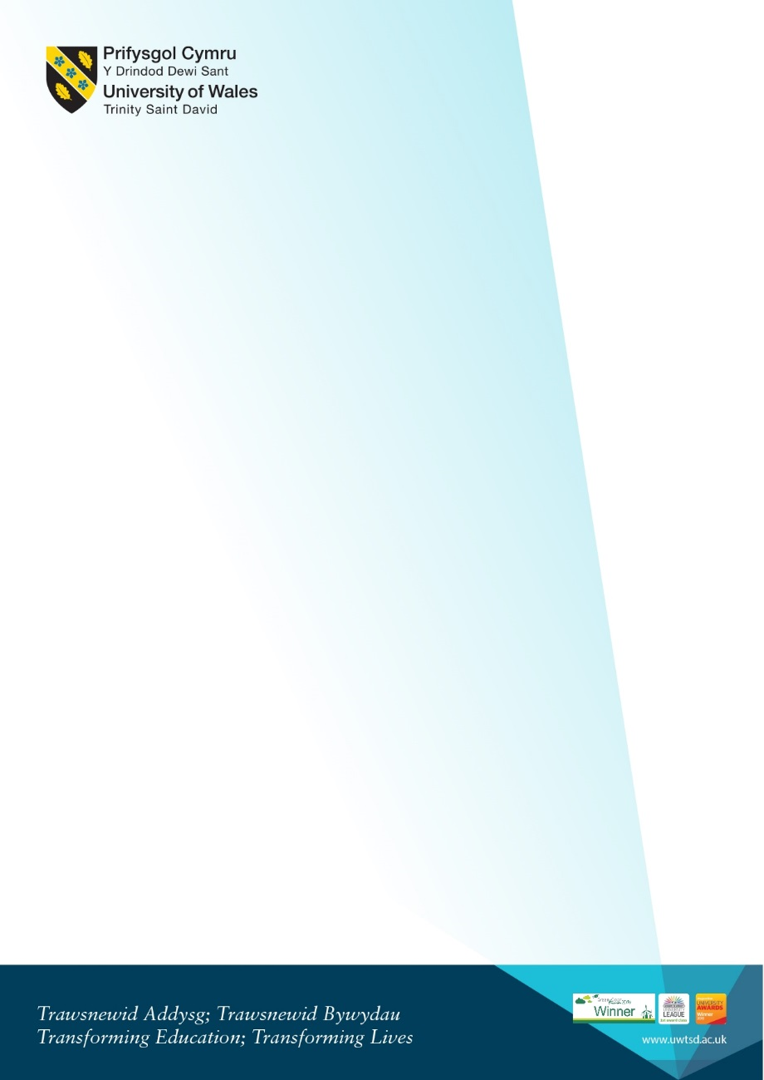
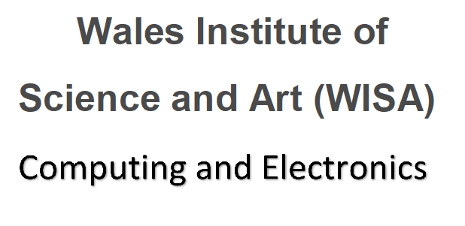
Online welcome for returning level 4/5 DDA students
Sept 2020 and Jan 2021 cohorts
DDA Students Tuesday 21st September 2021 1PM
Microsoft Teams link: Click here or https://bit.ly/3k0eUqo

1pm-1.30pm | Meeting with the team Kapilan, Beverley, Gaynor and Bridget | - Welcome back.  - Exam board results and feedback  - Overview of course structure
1.30-2pm | Liaison officer team feedback. | - Feedback session from ALOs.
2-3pm | Beverley and Gaynor Course overview Q and A | - Introduction to the course pathway for this academic year and overview of the modules  - Moodle and where to find information on Moodle  - Student services and procedures to follow  - Hwb what’s new  - Opportunity to ask any question
3pm-4pm | Team Q and A session | - Opportunity to ask any question about enrolment.  - ID Cards  - IT requirements where to find software
4pm | Self-guided:  Welcome videos and Campus safety presentations link.  Pre-recorded videos please see links Please take some time to watch the videos if you have any questions, please e-mail the team. | Including  - Welcome from the VC  - Welcome from Provost  - Your Campus: COVID Safety on Campus  - Campus Virtual Tour  - Parking  - Enrolment  Link to resources in Hwb:  https://uwtsd.myday.cloud/pages/student/resources_welcomeandinduction

