MODULE CODE: BMSW4002
EFFECTIVE TEAM WORKING AND COMMUNICATION
STUDENT NAME: ALEXANDRU-MARIAN BALSANU
STUDENT ID: 1713839

Table of Contents
Introduction 3
Application of the main theories of group dynamics, teamwork and communication in the workplace 3
Tuckman model of team Building 3
Belbin Model of Team Role 4
Aristotle Model of Communication 6
Shannon and Weaver Model of Communication 7
Impact of the theories in the personal workplace 9
Conclusion 10
References 11

Introduction
This assignment is based on the necessity as well as the requirements for teamwork and group dynamics as well as Communication within an organisational mainframe as a whole, as an effective team is required in every organization in order to achieve their relative goals and targets. Thus, through the utilisation of the Tuckman model, this assignment will highlight the phases of group dynamics and through the Belbin model will highlight the teamwork, and through the Aristotle model as well as the Shannon and Weaver Model of communication, the necessity and basic framework of communication will also be presented.

Application of the main theories of group dynamics, teamwork and communication in the workplace
Group Dynamics, teamwork and communication are the key necessity and requirement in any organizational mainframe, as they ensure that the firm can divert its human resources as well as assets towards achieving its goals and targets as a whole, which requires optimum teamwork and group dynamic which all depends on communication (Pollack and Matousm, 2019). Thus the key theories of teamwork, group dynamic and communication are discussed as follows:

Tuckman model of team Building
The Tuckman model for team building is one of the rudimentary models that are utilised in the creation of a team or group dynamics, from the very inception or formation of the group within the organisational mainframe (Kiweewa et al., 2018).
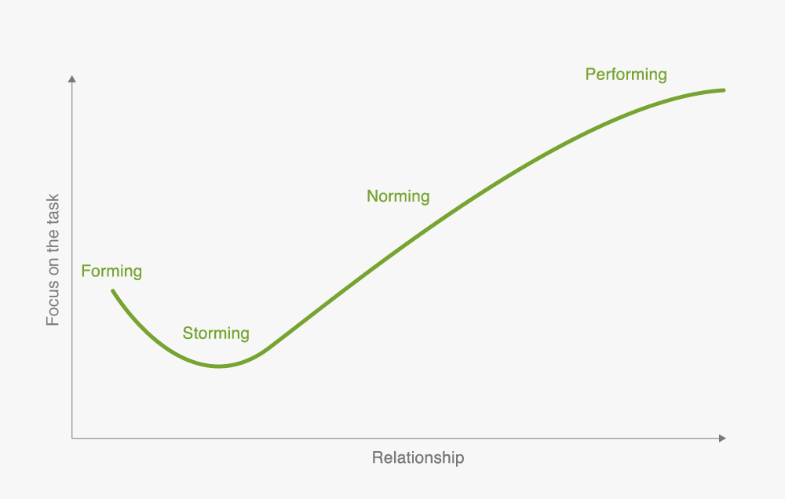
Figure: Tuckman model of team Building
Source: (Kiweewa et al., 2018)
The Tuckman theory or model of team building was established in the mid-1960s by Bruce Tuckman which highlight five major steps that are involved in the formation of a team, which are in the form of Forming, which is followed by Storming and leads to Norming along with Performing as well as Adjourning respectively, wherein each stage serves a special function or role in the formation of an effective team that can undertake any given task or objective tactfully (Nativug and Stark, 2016).
The Stages of the formation of the team are described as follows:
Forming: This is the first step in the creation of an effective team, wherein a new team is formed, in this stage all the members are unknown and new to each other and try to establish some set of rules as well as transparency for undertaking the allocated tasks that are entrusted to them.
Storming: This is the turbulent stage in the formation of steam wherein each and every member tries to find his roles as well as their identity in the team, along with establishing the leadership position as a whole, along with establishing the routes of communication amongst the team members.
Norming: In this stage, the team members start bonding with each other and the team, along with setting the formal means of communication within the team members for resolving any conflict as well as establishing the leading figure in order to discharge their duties as well as tasks that are entrusted to them.
Performing: In this stage the team members after setting in the means of communication and identifying their respective roles and function within the teamwork towards establishing their respective goals and targets as well as the tasks that are allocated to them within the organisational mainframe as a whole.
Adjourning: This is the final stage, wherein the team after undertaking their allocated tasks is disbanded and adjourned as a whole (Putro et al., 2020).

Belbin Model of Team Role
The Belbin Model of Team roles is one of the core team dynamic concepts that are utilised within the organisational mainframe and aims to establish the perfect team based on the roles as well as the behaviour pattern of the individual forming part of the team as a whole (Ferky et al. 2019).
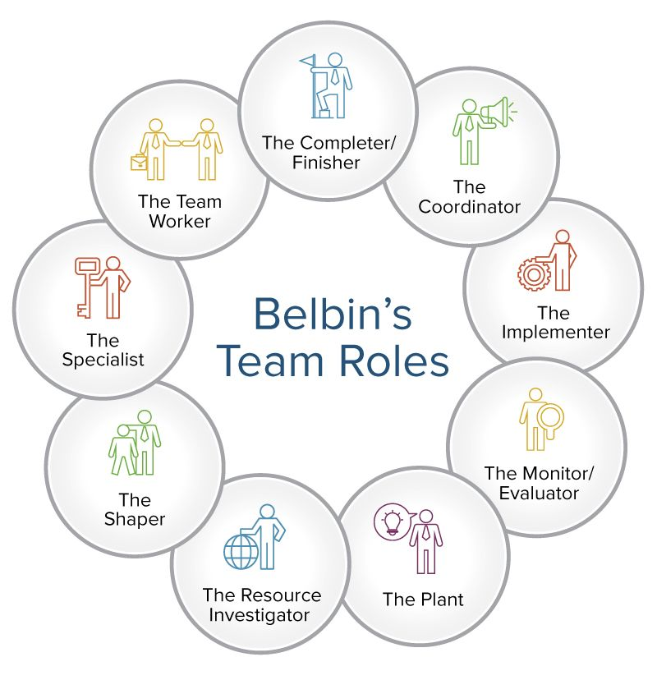
Figure: Belbin Model of Team
Source: (Gutiérrez et al. 2020)
The Belbin model of team building identifies three major team roles which are Action oriented team roles, thought oriented team roles, as well as People, oriented team roles, which are further subdivided into three different and specific team roles which are further discussed as follows:
Action-Oriented Team Roles
Shaper: The team member is responsible for challenging the pre-established norms as well as taking the lead and pushing the team towards the goals and objectives of the firm as a whole.
Implementer: The team member is responsible for executing and implementing the plans and strategies.
Finisher: The team member is responsible for looking after and paying attention to the finer details of the task (Gutiérrez et al. 2020).
Thought-Oriented Team Roles
Plant: The team member is responsible for scourging of valid ideas as well as procedures and establishing tactics and strategies that can help the team to achieve its goals and targets.
Specialist: The team member is responsible for providing his expertise in a particular job or designation that he is skilled in.
Monitor: The team member is responsible for separating and analysing the plans and strategies that can be utilised by the team.
People-Oriented Team Roles
Co-Ordinator: The team member is responsible for coordinating the efforts of the teak towards common objectives, and unifying their efforts as the leaders.
Team Worker: The team member is responsible for coordinating the efforts of the team and resolving any issues within the team.
Resource Investigator: The team member is responsible for establishing and evaluating any external resources that the team can utilise for reaching its goals and targets (Florovskiy and Guseva, 2019).

Aristotle Model of Communication
The Aristotle model of communication is one of the core models of communication that was established by the philosopher and polymath of the ancient period and is based around the concept of mass speaking or mass communication as a whole. It is a speaker centric model that highlights five key elements which are in the form of the “Speaker, Speech, Occasion, Audience and Effect” (Umeozor, 2020).
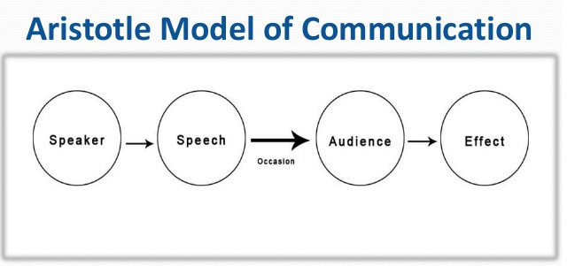
Figure: Aristotle model of communication
Source: (Umeozor, 2020)
This is a linear model of communication, wherein instead of normal communication methods, this is utilised for relaying important announcements as well as influencing people through the use of the speech that is prepared based on the occasion in which it is being related by the speaker (Knepper et al. 2019).
In this type of model, the listener has only one functions, that is to be the audience of the speaker, where the speaker has to prepare a speech based on the occasion as well as the target audience based on the occasion as well, in order to gain a favourable or a desirable outcome as a whole at the end of the speech or the intended communication from the audience are in the form of being motivated or inspired in the current mainframe or relaying important information.
Therein the result of the communication or the effects depends on ethos and pathos of the speaker, wherein ethos can be directly translated to the credibility that the speaker holds, along with the authority and the topic or the occasion on which the speech is made. Whereas, the Pathos can be described as feelings or emotions, wherein the speaker has to relay the message of the speech in a manner that resonates with the emotions and the feelings of the audience in order to get the expected response or result from them (Shaw, 2020).

Shannon and Weaver Model of Communication
The Shannon and Weaver Model of Communication is one of the finest models of Communication that was established by Shannon and Weaver when they were working under a Telephone company, wherein they had to ensure that the customers were getting the optimum quality of services and were able to communicate with each other. This model effectively highlights and establishes five basic components or concepts of communication which are in the form of “sender, encoder, channel, noise, decoder, and receiver as well as Feedback”, herein the sender encodes and sends the receiver an encoded message, which only he can decode and sends an appropriate reply (Talukdar, 2017).
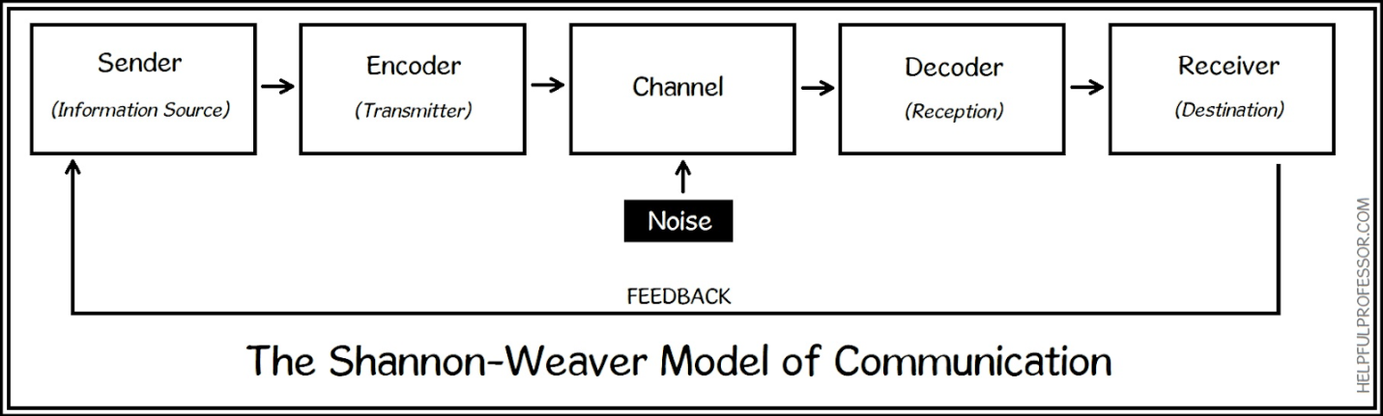
Figure: Shannon and Weaver Model of Communication
Source: (Talukdar, 2017)
In the Shannon and Weaver model of communication, the explanation of the various components of communication is in the form of:
Sender: The sender is the first step in the Shannon and Weaver model, wherein the sender decides the intended audience, as well as the channel or means of communication along with the message or information that is to be transmitted through this model.
Encoder: The encoder can be a human or machine that transmits the message or the information that is to be transmitted to the receiver of the communication so that the information can only be understood by the intended receiver.
Channel: The channel is alternatively known as the modem and is the connection between the sender and the receiver as well as the encoder and decoder (Elleström, 2020).
Noise: The Noise can be referred to as the interruption or the barrier in communication, which can be internal or external and affects the quality of communication.
Decoder: The decoder just like the encoder can be a machine or a human being, and the primary function of the decoder is to transmit the message to the receiver in terms that can be easily understood by the receiver (Daylight, 2017).
Receiver: The receiver is the result or the destination of the message to which the sender intended to send the information through the process.
Feedback: The feedback is the response that is transmitted back to the sender, where the roles of the intermediaries are reversed, as the sender becomes the receiver in order to keep the communication process moving or in a loop (Konstantinov, 2017).

Impact of the theories in the personal workplace
The impact of the team building theories particularly the Tuckman and Belbin model have been diverse in my workspace, as previously according to my experience with working in teams were haphazard with ego clashes, and fights as well as the controversy that has brought down the efficiency of our work. This model has helped me to understand the different phases of the team building, wherein through the Tuckman model, we can identify the phase of team building in which we are for minimising the fights and the clashes and in order to effectively utilise our time and resources which are pretty limited.
In addition to that with the Belbin model of team roles, I have also understood the need of diversifying work and the allocation of tasks based on the characteristics of the team models that can help them to focus on their strength while other team members can cover up for their weaknesses. Furthermore, the integration of both of these models simultaneously can lead to the creation of a perfect team that can undertake any task and overcome any challenges through cooperation as well as teamwork, wherein each and every team member focus in their strength and cover the weakness of other team members.
Thereafter, in the realm of communication, I was pretty sure that my communication skills are top-notch, but with the application of the Aristotle model of communication, I reflected upon my communication skills and came to the conclusion of the use of emotions in speeches as well normal day to day communication. As the feelings and emotions play a major part in conveying the message and impacting the overall message that is received by the audience and it also helps the speaker to stimulate the audience as well, through just his speech and the use of emotions.
Thereby, the Shannon and Weaver model of communication helped me to reflect on the needs and basic things that are involved in communication, whether by email, calls, video calls and other means, which requires encoding and decoding the message in a manner that can only be understood by the receiver. This allows for the loss of information to third parties as well as the spillage and manipulation of information by the third parties involved or parties that are eavesdropping, and reduce the chances of any misuse of information or data as a whole, along with the need of selecting an appropriate means or channel as well.

Conclusion
Thus, conclusively brings forth the concepts and model of team building, roles as well as group dynamic along with communication in diverse environments, wherein the team building models like Belbin and Tuckman model, highlights the bare necessities of the development of an effective team wherein the team members are aware of their roles, and the Aristotle as well as Shannon model of communication for ensuring the optimum flow of communication.

References
Daylight, R., 2017. Saussure and the model of communication. Semiotica, 2017(217), pp.173-194.
Elleström, L., 2018. A medium-centered model of communication. Semiotica, 2018(224), pp.269-293.
Fekry, A., Dafoulas, G.A. and Ismail, M., 2019. The Relation between Student Behaviours in Group Presentations and their Teamwork Modalities Using Belbin and MBTI Analysis. Procedia Computer Science, 164, pp.292-300.
Florovskiy, S. and Guseva, L., 2019. Personality values and role preferences in teamwork: an experience of empirical research. Scientific Notes Journal of St. Petersburg State Institute of Psychology and Social Work, 31(1), pp.49-58.
Gutiérrez, L., Flores, V., Keith, B. and Quelopana, A., 2019. Using the Belbin method and models for predicting the academic performance of engineering students. Computer Applications in Engineering Education, 27(2), pp.500-509.
Kiweewa, J.M., Gilbride, D., Luke, M. and Clingerman, T., 2018. Tracking growth factors in experiential training groups through Tuckman’s conceptual model. The Journal for Specialists in Group Work, 43(3), pp.274-296.
Knepper, R., Mehringer, S., Brazier, A., Barker, B. and Reynolds, R., 2019. Red Cloud and Aristotle: campus clouds and federations. In Proceedings of the Humans in the Loop: Enabling and Facilitating Research on Cloud Computing (pp. 1-6).
Konstantinov, M., 2017. MODEL OF COMMUNICATION ACT IN ART BY JU. M. LOTMAN. European Philosophical and Historical Discourse, 3(1), pp.98-104.
Natvig, D. and Stark, N.L., 2016. A project team analysis using Tuckman's model of small-group development. Journal of Nursing Education, 55(12), pp.675-681.
Pollack, J. and Matous, P., 2019. Testing the impact of targeted team building on project team communication using social network analysis. International Journal of Project Management, 37(3), pp.473-484.
Putro, B.L., Rosmansyah, Y. and Suhardi, S., 2020. An intelligent agent model for learning group development in the digital learning environment: A systematic literature review. Bulletin of Electrical Engineering and Informatics, 9(3), pp.1159-1166.
Shaw, P., 2019. Sadharanikaran Model vs Mathematical Model: Analyzing their Relevance in Context of Social Media. Bodhi: An Interdisciplinary Journal, 7, pp.105-126.
Talukdar, H., 2017. The Different Models of Communication-Their Differences, Lacks and Integrity, and their Association to Real Life Communication. Asian Journal of Research in Social Sciences and Humanities, 7(8), pp.36-50.
Umeozor, S.N., 2020. Information Retrieval: A Communication Process in the 21st Century Library. International Journal of Knowledge Content Development & Technology, 10(2), pp.7-18.

