


  - Book before- 13 Feb
Phone: 029 2038 2810

Valentine’s Day – Menu
Live Music from 5pm Tue-14 Feb- 2023 £45 per person
Starters & nibbles at choice

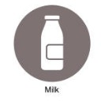
CRISPY FRIED CHICKEN WINGS / soy & bourbon glaze, pineapple kimchi dressing.
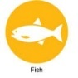
CORNISH MUSSELS / local cider, leeks, smoked bacon, cream & sourdough.
CRISPY SQUID / roasted garlic aioli, lemon.
CARAMEL PORK BELLY / competition BBQ sauce, apple remoulade.
Main course at choice
RUMP 300g // packed full of flavour, a lean juicy steak…
SIRLOIN 250g // nicely marbled with a good layer of top fat…
RIBEYE 300g // highly marbled with lots of fat, full on beefy flavour…
FILLET 200g // the most tender cut of beef, very buttery & exceptionally lean… Sauces: CLASSIC PEPPERCORN / GARLIC BUTTER / CHIMICHURRI / BEARNAISE
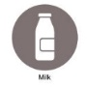
Sides at choice: DRIPPING CHIPS / sea salt, malt vinegar.
TRUFFLE CHIPS / Cornish gouda cheese.
GRILLED PORTOBELLO MUSHROOMS / confit garlic, chives.
GREEN SALAD / soft lettuce, gouda, buttermilk & preserved lemon dressing.
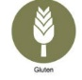

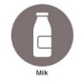
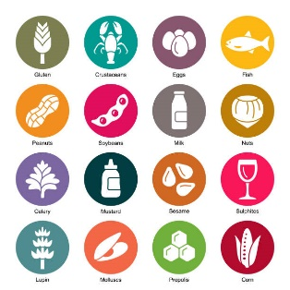
Desert: CHOCOLATE DOME // warm chocolate brownie, hazelnut shortbread.
Most of our dishes can be tailored to cater for any allergens, please ask for guidance.
Drinks at choice by the bottle

2019 Esencia Divina Albarino, Rias Baixas, Spain 13% (White Wine) 2012 Cahors Malbec Authentique Cahors, France 13% (Red Wine) Domaine Coste Rose NV, France 12.5% (Rose)

Drinks
White Wine
2019 Esencia Divina Albarino, Rias Baixas, Spain 13% // 175ml £6.50 // BTL £27
Kotuku Sauvignon Blanc, Marlborough, New Zealand 13% // 175ml £6.50 // BTL £27
2019 Esencia Divina Albarino, Rias Baixas, Spain 13% // 175ml £6.50 // BTL £27
Red Wine
2012 Cahors Malbec Authentique Cahors, France 13%// 175ml £6.50 // BTL £29
2016 Torres Purgatori, Syrah, Carinena, Garnacha Costers Del Segre, Spain 14.5% // 175ml £6.50 // BTL £29
2018 Grapillon D’or, Gigondas Cote du Rhone, France 15%// 175ml £6.50 // BTL £29
Rose
Rose D’Anjou, France 12% // 175ml £4.95 // BTL £19
Domaine Coste Rose NV, France 12.5% // 175ml £5.2 // BTL £24
2019 Château Minuty et Or, Côtes de Provence, France 12.5% // BTL £36
Fizz
Prosecco,DOC,Italy //125ml £6 // BTL £24
Drappier Carte d’Or Brut NV Champagne //125ml £10 // BTL £58
Drappier Rose Brut NV Champagne // BTL £75
Bollinger,NV Special Cuvée // BTL £80 Dom Perignon 2010 // BTL £195
Draught
Clwb Tropica // £4.95 Tropical IPA ABV 5.5%
Stay Puft // £5.25 Dark Stout ABV 5.2%
Easy Living // £4.95 Pale ale ABV 4.3%
LOST & GROUND E D Keller Pils // £4.95 Hopped lager ABV 4.8%
Wanna Go To The Sun // £4.95 Pale Ale ABV 4.6%
THATCHERS // Rascal // £4.95 Medium Dry ABV 4.5%
Rose // £4.95 Sweet & sparkling ABV 4%

Reference: www.istockphoto.com/illustrations/allergens
https://pasturerestaurant.com/wp-content/uploads/2020/08/PASTURE-MAIN-CARDIFF-TERRACE.
Les Croupiers Casino Cardiff - Poker, Roulette, & More (les-croupiers.co.uk)

