Network Operating Systems and Security
Assignment 1
Observational Tasks Lecturer: Terry Walcott
Ralitsa Nikolova (Student ID: 1806089) BSc Cloud Computing – term 4
Table of Contents
Introduction 1
Observational Tasks 1
WS 1: Building the NOS infrastructure using Active Directory (AD) 1
Task A 1
Task B 2
Task C 2
Task D 2
WS 2: Resource Management in AD: Users, Computers and Groups 3
Task 1 3
Task 2 3
WS 3: Resource Management in AD: Managing Access to Files and Folders, and Controlling Domain User Environments 3
Task A 3
Task B 3
Task C 3
Task D 4
WS 4: Network Administration Using DHCP 4
Task A 4
Task B 4
Task C 4
WS 5: Planning and Deploying DNS in the Network Infrastructure 5
Task 1 5
Task 2 5
Task 3 5
Task 4 6
References 7

Introduction
The following paper is concerned with completing the Assignment Worksheets of Assignment 1 for Network Operating Systems and Security module. It contains detailed answers to the Observational Tasks of the assignment, supported by graphical presentation of some main concepts in NOS.

Observational Tasks

WS 1: Building the NOS infrastructure using Active Directory (AD)

Task A
A hypervisor is a software whose main purpose is to host and manage virtual machines on a workstation. It allows multiple guest OS to run on one physical host or server. There are 2 types of hypervisors.
Type 1 hypervisor is the one installed straight on the workstation hardware. It is located between the hardware and the operating system. Where type-two hypervisor is deployed on top of an already existing operating system and is referred to as a hosted approach hypervisor (Singh, 2018). Some of the advantages of type 2 hypervisors are:
- Allows I/O and memory management
- Does not need specific hardware components
- Allows the installation of an OS on top of another OS, providing more flexibility and ease of running multiple systems at a time.
For the purposes of this assignment a type 2 hypervisor is used, in particular – Oracle’s VirtualBox. It carries all the advantages of a type 2 hypervisor. It is an open source and easy to update application. It supports a wide range of operating systems and has a simple user-friendly interface. On the other hand, VirtualBox shows a small weakness in the utilisation of CPU and memory, leading to the occasional low performance issues (TrustRadius, 2020).

Task B
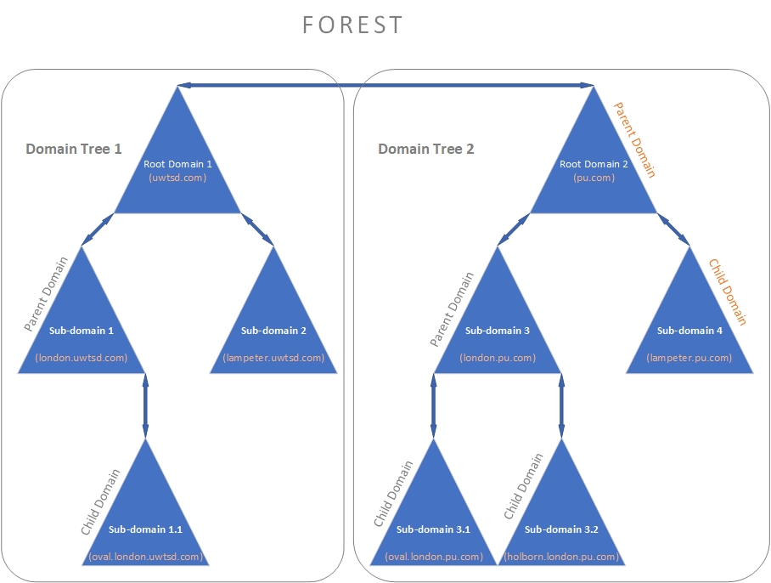
Figure 1. Active Directory Structure (Source: Author)
The above diagram explains the structure of the Active Directory Domain Services (AD DS) and some basic terms, like forest, domain tree, child and parent domains (Figure 1).

Task C
A Domain Controller can be referred to as an authentication server. It is a software module that provides specific functionalities to a server, such as handling and responding to authentication requests. For Windows Server 2008 it is a built-in functionality which can be activated. The Domain Controller is the tool that routs network resources, group policies and permissions to user accounts.

Task D
If the Domain Controller (DC) fails, the system is left completely unprotected in terms of authentication. To prevent a major risk like this, a good practice is to create at least one replication of the Domain Controller which would be used in case the primary DC fails. This is used for increasing the fault tolerance of the network.

WS 2: Resource Management in AD: Users, Computers and Groups

Task 1
As a part of a modern network operating system, some requirements are implemented regarding password complexity. This includes number of characters, what kind of symbols should it include or not. These requirements are enforced when a password is initially created or being modified. In Windows Server 2008 some minimum password complexity requirements are determined, such as:
- The password should not contain the account username in it.
- It should contain uppercase and lowercase letters, nonalphanumeric symbols.
- It should contain digits from the range: 0 to 9. etc (Microsoft, 2017).

Task 2
AD is a system that makes managing user and computer accounts easy and creating Groups is one way to do this. Groups are containers that unite user accounts, computer accounts or even other Groups with the same permissions, privileges and access to network resources. The main advantage is the ease of managing numerous accounts by assigning and configuring security policies to a whole group, instead of dealing with each account individually.

WS 3: Resource Management in AD: Managing Access to Files and Folders, and Controlling Domain User Environments

Task A
Permissions in a Windows network environment are separated in two key types.
- Share Permissions – they apply for folders shared over a network. They are not enforced on users that log on locally. Share permissions can be applied to folders in FAT and FAT32 file systems, and the access for its content - objects and subfolders is managed by NTFS Permissions.
- NTFS Permissions – they apply to users who are logged on locally or remotely to the network. They manage access to data in NTFS file systems and are enforced at the Windows logon.
When trying to restrict unauthorised access it is a good practice to use both types of permissions together. If an overlap occurs, the more restrictive permission takes effect (Ng, 2020).

Task B
NTFS (New Technology File System) is the most recent system introduced by Windows, for storing and retrieving files. Compared to the earlier file system (FAT), NTFS supports larger disks and file sizes and is much more secure (Ng, 2020).

Task C
As mentioned above, the main advantage of using Groups in AD DS is the capability to manage security permissions and access levels by organizing large numbers of accounts in groups and nested groups, thus saving time and resources in the process.

Task D
Very similar to Groups, Organizational Units (OU) can be used to manage objects in the AD efficiently. If Groups are used to delegate permissions, OUs are used to delegate different security and system configuration and levels of access to the system’s resources. This is done by linking Group Policy Objects (GPO) to a specific OU. GPO is a set of configurations to a user or a computer which allows or restricts access to given functionalities.
Another fundamental role of an OU is delegating administrative authorities to a user or group of users, without the need to give them full administrator access level (Zoho Corporation Pvt. Ltd, 2020).

WS 4: Network Administration Using DHCP

Task A
Using DHCP service in a network infrastructure is a way of an automated assignment of IP configuration to a client upon a request from that client. This reduces the risks of manual configuration errors and duplications of IP addresses. The time needed for network administration is also significantly reduced and simplified (Oracle, 2012).

Task B
The distribution of IP configuration from a DHCP server to a DHCP client can be represented as a 4-stage process, known as a DHCP transaction (Computer Networking Notes and Study Guides, 2020). The following diagram illustrates this process in detail.
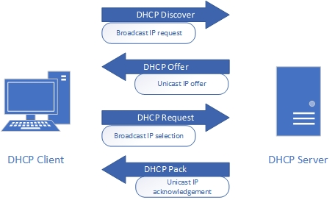
Figure 2. DHCP Process (Source: Author)

Task C
Some of the disadvantages of a DHCP service are:
- If there is only one DHCP server configured for the network there is a risk of failure in the whole network if the server crashes. Without the DHCP server the clients are not able to access the network.
- DHCP service is not routable.
- Security risks, because of inability to authenticate clients.

WS 5: Planning and Deploying DNS in the Network Infrastructure

Task 1
Depending on the configuration of the DNS server, when a DNS client makes a enquiry to the server (in the shape of a domain name) and it does not find the correct corresponding IP address in its local database and cache memory, there are two main ways for processing this query – recursive and iterative.
If the query is recursive, the DNS server forwards the request to another available DNS server on behalf of the client until a response is recovered. When this happens it directly provides the result to the client.
When the query is iterative, the DNS server will return a referral to the client containing information about other available DNS servers and the process of retrieving the right IP address from them would be a responsibility of the client (Pillai, 2013).

Task 2
When a DNS server cannot resolve a query by using its local cache, it forwards the request to other DNS servers - forwarders. If it does not find the correct answer there, then the query is being forwarded to other authoritative DNS servers for the root DNS names on the internet. The information about these servers is stored in the root hints.

Task 3
- The exact FQDN (Full Qualified Domain Name) is Server1.subcontA.nwtraders.msft.
- The following diagram illustrates how a FQDN is broken down by the DNS:
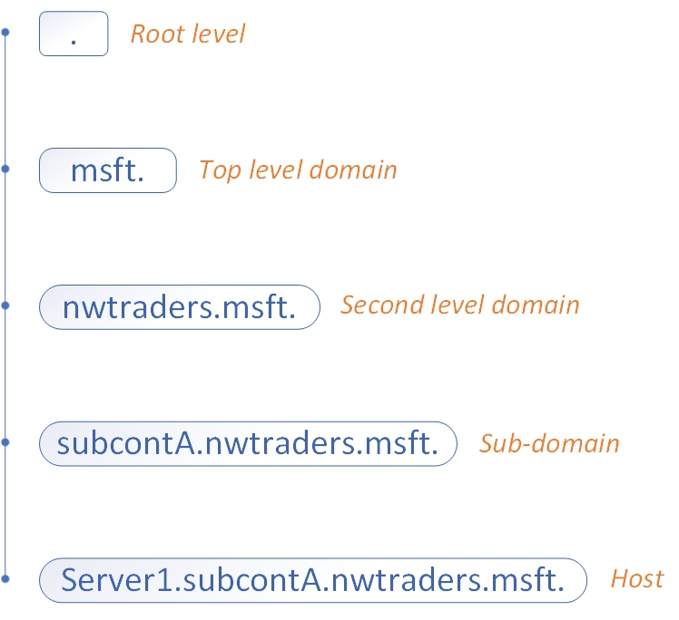
Figure 3. Break down of the FQDN (Source: author)

Task 4
DNS zones are administrative outlined areas of the DNS namespace which allow for more controlled management of DNS components. It is a way to delegate administrative control. A DNS zone begins to expand from a single domain and can contain multiple subdomains in itself. Also, one DNS server can hold multiple DNS zones (Cloudflare, Inc., 2020).

References
Cloudflare, Inc. (2020). What is a DNS Zone? Retrieved April 27, 2020, from CloudFlare: https://www.cloudflare.com/learning/dns/glossary/dns-zone/
Computer Networking Notes and Study Guides. (2020). How DHCP Server works Explained with Examples. Retrieved April 26, 2020, from ComputerNetworkingNotes: https://www.computernetworkingnotes.com/networking-tutorials/how-dhcp-server-works-explained-with-examples.html
Microsoft. (2017). Password must meet complexity requirements. Retrieved April 26, 2020, from Microsoft Docs: https://docs.microsoft.com/en-us/previous-versions/windows/it-pro/windows-server-2012-r2-and-2012/hh994562(v%3Dws.11)
Ng, C. (2020). NTFS Permissions vs Share: Everything You Need to Know. Retrieved April 26, 2020, from Varonis: https://www.varonis.com/blog/ntfs-permissions-vs-share/
Oracle. (2012). Advantages of Using DHCP. Retrieved April 26, 2020, from Oracle Solaris Administration: IP Services: https://docs.oracle.com/cd/E23824_01/html/821-1453/dhcp-overview-12a.html
Pillai, S. (2013). difference between iterative and recursive dns query. Retrieved April 27, 2020, from SlashRoot.in: https://www.slashroot.in/difference-between-iterative-and-recursive-dns-query
Singh, B. (2018). A Study on Virtualization and Hypervisor in Cloud Computing. International Journal of Computer Science and Mobile Applications, 6(1), 17-22. Retrieved April 25, 2020, from http://ijcsma.com/publications/january2018/V6I102.pdf
TrustRadius. (2020). Oracle VM VirtualBox Reviews. Retrieved April 25, 2020, from TrustRadius: https://www.trustradius.com/products/oracle-vm-virtualbox/reviews?qs=pros-and-cons
Zoho Corporation Pvt. Ltd. (2020). The structures and benefits of organizational units. Retrieved April 26, 2020, from Active Directory 360: https://www.windows-active-directory.com/the-structures-and-benefits-of-organizational-units.html

