Application Development Assignment

Name: Scott Mainwaring
Student Number: 1701633
Module: L5 Application Development (ACCA5012)
Lecturer: Dr Kemi Ademoye

Table of Contents

Section 1: Introduction
The following report will contain documented information on how the website provided was designed and created using HTML, CSS for styling, JavaScript for client-side functionality and the help of [1]Bootstrap framework to build responsive, mobile friendly websites. The report will also contain the importance of application development concepts such as the Design Principles and the Usability and User Experience for web applications. Documentation of the main requirements and features for the web application will be included in this report along with the main scripts and classes that have been implemented to provide the core functionality of the website. A set of test cases will also be included in this report to verify and validate the requirements and features implemented into the web application.

Section 2: Application Development Concepts
Effective website designs are judged by the people who use the website, not by the website creator. Many factors are taken into count when it comes to the usability of the website being affected and it isn’t just the way the website looks, it’s also the functionality of the website.
One design principle that is important for a good website design is purpose. Every page on a website needs to have a clear purpose that will cater to the users needs. Another important design factor is the way in which the website displays its information. It is important for the information being displayed on a website is easy to read and to take in. Users browsing websites want to be able to find answers to their questions fast so using things like large, clear headings and bullet pointed answers is much preferred. Font and font size also play a factor in a websites design and usability. According to [2]WebsiteBuilderExpert,
“16px is the ideal font size for your main body text. It is not too small or too big, so it really helps improve your paragraph's readability.”
16px font size will easily make the content being displayed readable. For website fonts, Arial seems to be the most commonly used sans-serif font for web design according to [3]WebsiteSetup. Colours scheme a website chooses can enhance the users experience massively. Contrasting colours for the website background and text will make reading the content on the website easier on the eye. Tools such as [4]WebAIM’s contrast checker should be considered when choosing a colour scheme as this tool will help you find what colours work well together and pass the [5]WCAG guidelines. Vibrant colours should be used sparingly throughout a website as they create emotion. These colours are most commonly used on buttons and call to actions. The navigation section on a website should be very accessible. It is important for the navigation section to be very clear and accessible as this is what users will use to navigate through your website. For effective navigation [6]Usability.gov suggest using the ‘three-click-rule’. This rule suggests that the user should be able to navigate the website and find the relevant information with no more than three mouse clicks. Laying out content in the grid format can help a lot with the design and usability of a website. Grids bring order to a website layout making it a lot easier for users to navigate a website and find information.

Section 3: Requirements
The website provided in this report is a video games website that provides news, reviews and any other relevant information on the newest video games. The website also includes a section that reviews the latest gaming peripherals such as keyboards, headsets and gaming mice. The gaming peripherals section also includes lists of the top-rated gaming products for a certain calendar year allowing the user to have a good idea of what to purchase if they’re looking for new peripherals. In addition to the information already provided by the website staff, users have the option to post their own reviews for user interaction. The purpose of this website is to allow users to easily find reviews for the latest video games and have the ability to express their own thoughts on games they have played to let other users know whether or not a game is worth purchasing. The website also makes searching for good gaming peripherals a lot easier by providing a list of the top-rated gaming equipment for that calendar year. The target audience for this website is broad as it covers anyone who likes video games and are searching for game reviews or new gaming peripherals.
When approaching a responsive website design, it is best to create the website for mobile first as it allows for the content that is most important to be laid out in a clear and logical way on the smallest screen. Once that has been done, all that needs doing is for the content to scale to fit all other devices. This is the approach that was taken when creating this video games website. The first breakpoint that was encountered was for a ‘min-width’ of 480px and this was to set the minimum height of the two jumbotrons on the website to have a minimum height of 230px. The next breakpoint was at a ‘min-width’ of 500px and this was to set the content within a ‘div’ with the class name ‘.game-reviews’ for a width to be set at 100%. The next breakpoint on the website was set at a minimum width of 767px and this was to change the jumbotrons minimum height to 480px and the content that uses a ‘div’ with the class ‘.card-home-advert’, to set there minimum and maximum width to ‘initial’. This means that the values of these properties will be set back to there default value. The next two breakpoints are at the ‘min-width’ of 979px and these two breakpoints are used to hide content on the website that shouldn’t be displayed either on the desktop version of the website or the tablet version of the website. These both have a display either set to ‘flex’ which means show or ‘none’ which means not to be displayed.
As said previously, the website was created using the grid layout design principle as this will help making the website responsive. Rows and columns were used to separate the content on the website. [1]Bootstrap have a limit up to 12 columns per row and the more columns a row has, the less space there is for content. Every page on the website contained a main content section but some pages were built with a small sidebar. This was done by splitting the columns using the ‘col’ attribute. Nine columns were dedicated to the main content section and the three column spaces remaining were used as the website’s sidebar.

Section 4: Design
The design principles and patterns that have been used in the creation of this website consist of clear navigation, high quality images, good colour scheme, grid and column layout. The navigation bar is clearly visible at the top of the screen with the navigation options being spaced out and capitalised, so they can easily be read. High quality images have been used throughout the entire website to give the website a professional feel. The website overall has a good colour scheme with colours consisting of dark greys for the navigation bar, background and footer of the website, white for the navigation links, website headings and content and then the colours pink and purple to give the website a vibrant look.
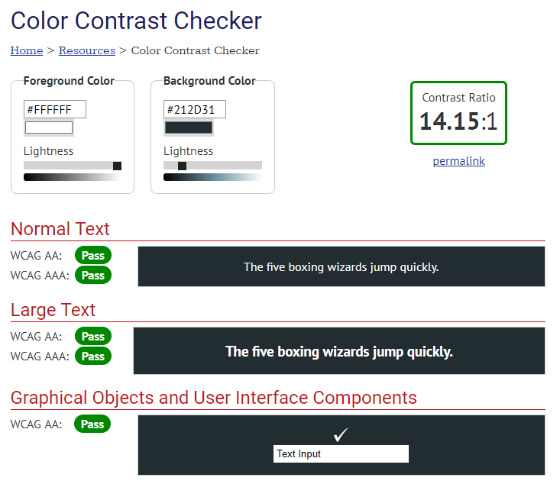
Above is a screenshot taken from the [4]WebAIM’s colour contrast checker and from the results, the colours used on the website pass the [5]WCAG 2.0 accessibility check. The website also follows the grid layout design principle which allows for the content of the website to be organised and nicely laid out. The grid layout also helps with the responsiveness of the website.

Section 5: Implementation
Some JavaScript has been implemented into this website to allow for user interactions and to improve the functionality of the website. The first JS function that was added was a button that allows the user to hide an advertisement on the website when clicked. This is an option on most pages as a lot of pages on the website include advertisements. This would reset if the page was refreshed or if the user left the page.
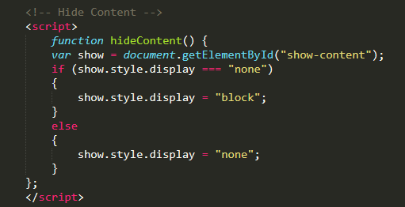
This website addition was done using an ‘if’ statement. The statement states that if the ‘div’ with the ID ‘show-content’ was visible then it would run the ‘block’ command in JS.

Below is a screenshot of the homepage of the website.
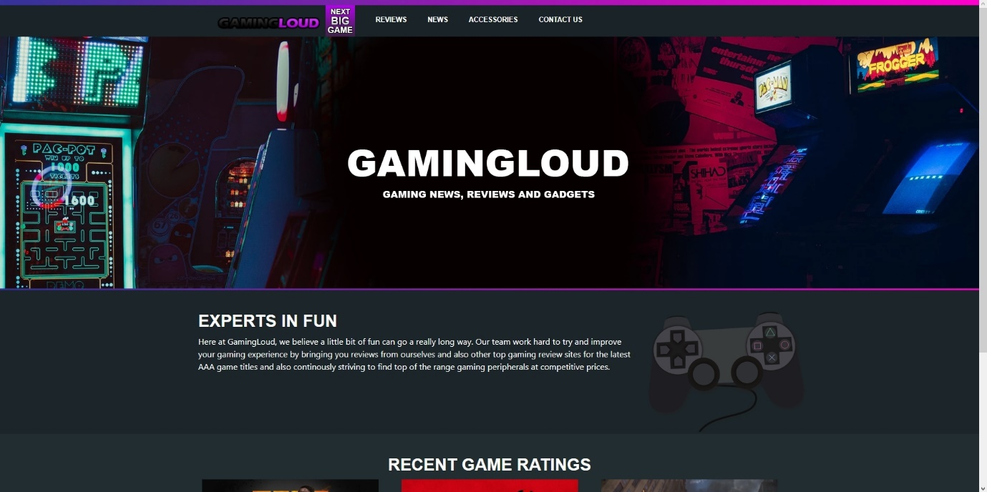

Below is a screenshot of the ‘Next Big Game’ page on the website.
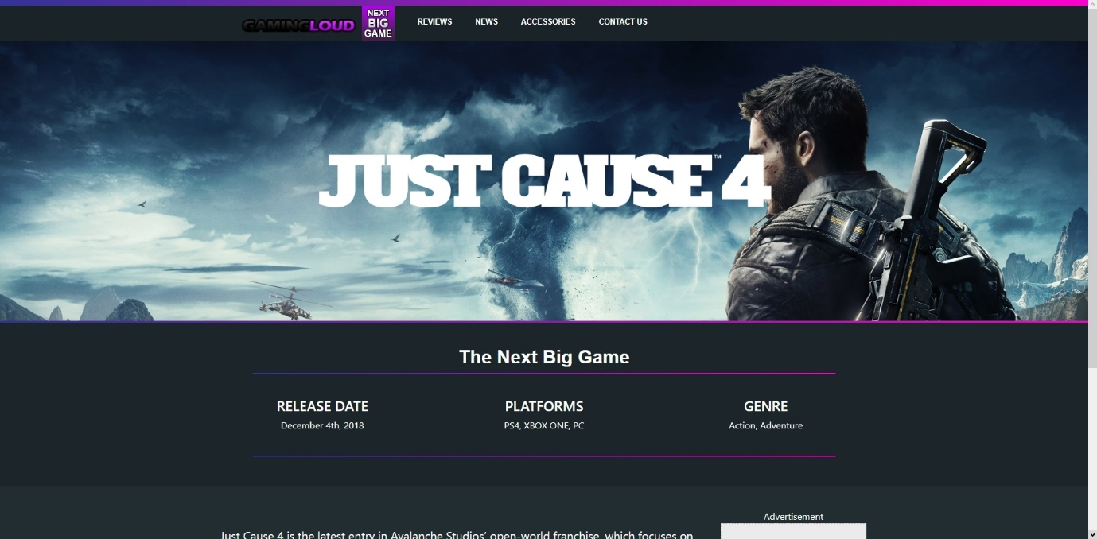

Below is a screenshot of the ‘Reviews’ page on the website.
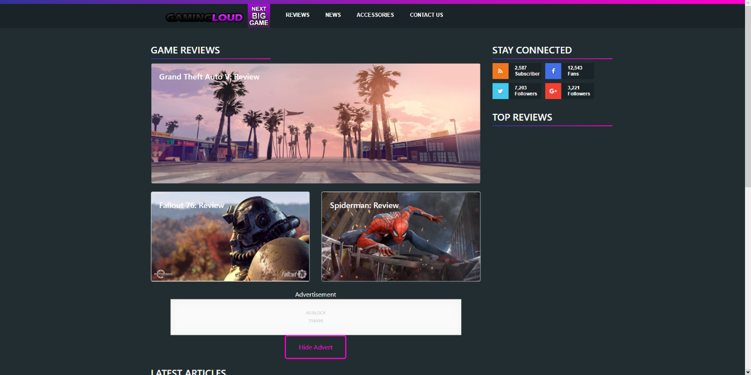
Below is a screenshot of the ‘Gaming News’ page on the website.
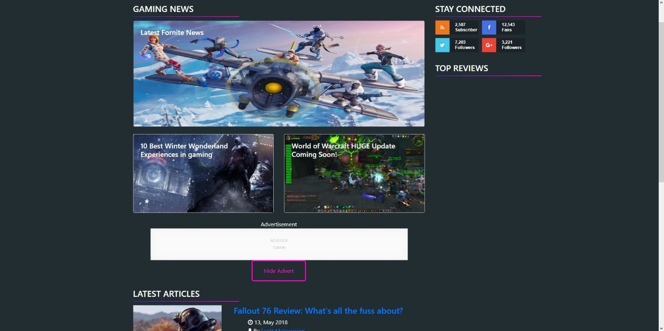

Below is a screenshot of the ‘Accessories’ page on the website.
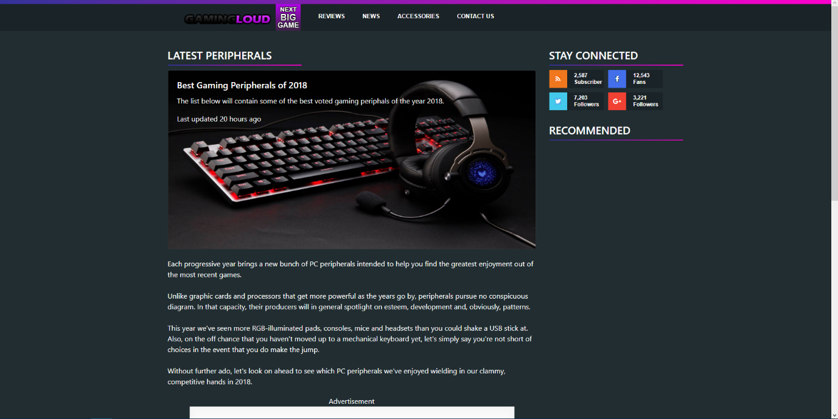
Below is a screenshot of the ‘Contact Us’ page on the website.
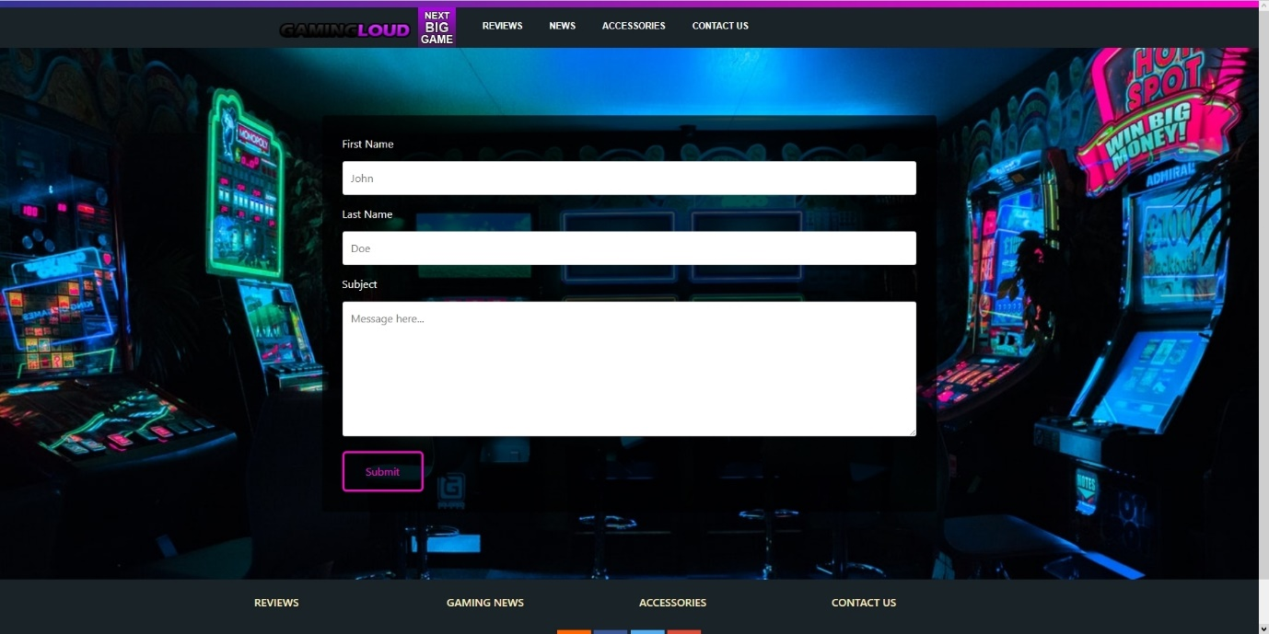

Section 6: Evaluation
Application verification and validation plays an important part of the development process. This section will contain a set of test cases to validate features that have been implemented into the website and will also contain screenshots of CSS validation. [7]Jigsaw was used to validate the CSS in the website and the results came back with zero errors as shown from the screenshot below.
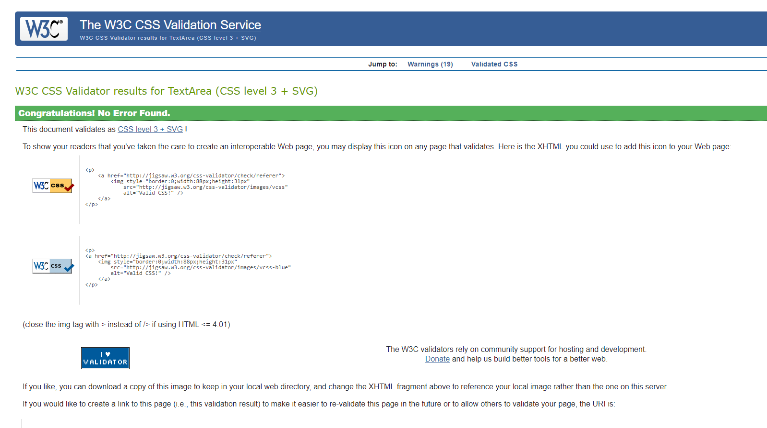
Below are screenshots of tests being carried out on certain features implemented into this website. The first screenshot is of the navigation bar to test its responsiveness and to see if the logo still shows whilst being in mobile view. The test succeeded.
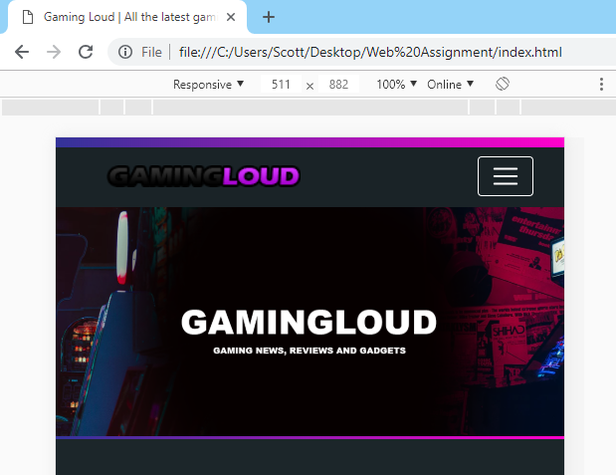
The second test is to see if the game review content boxes will stack on top of each other if the screen is in mobile view. This test succeeded.
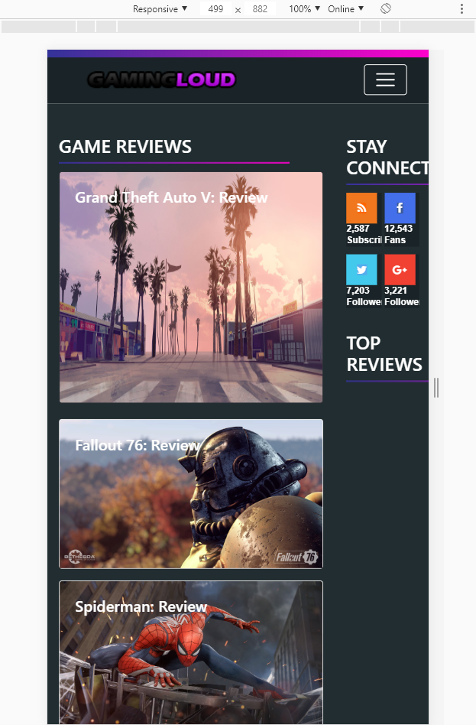
This final test is to see if the ‘Hide Advert’ button hides the advertisement above it if the button is pressed. This test also succeeded.
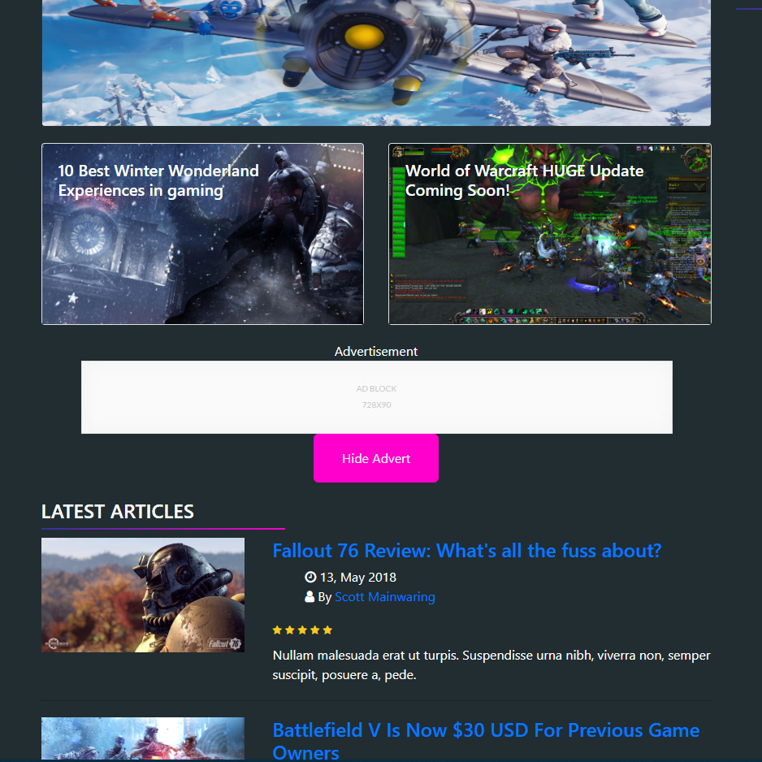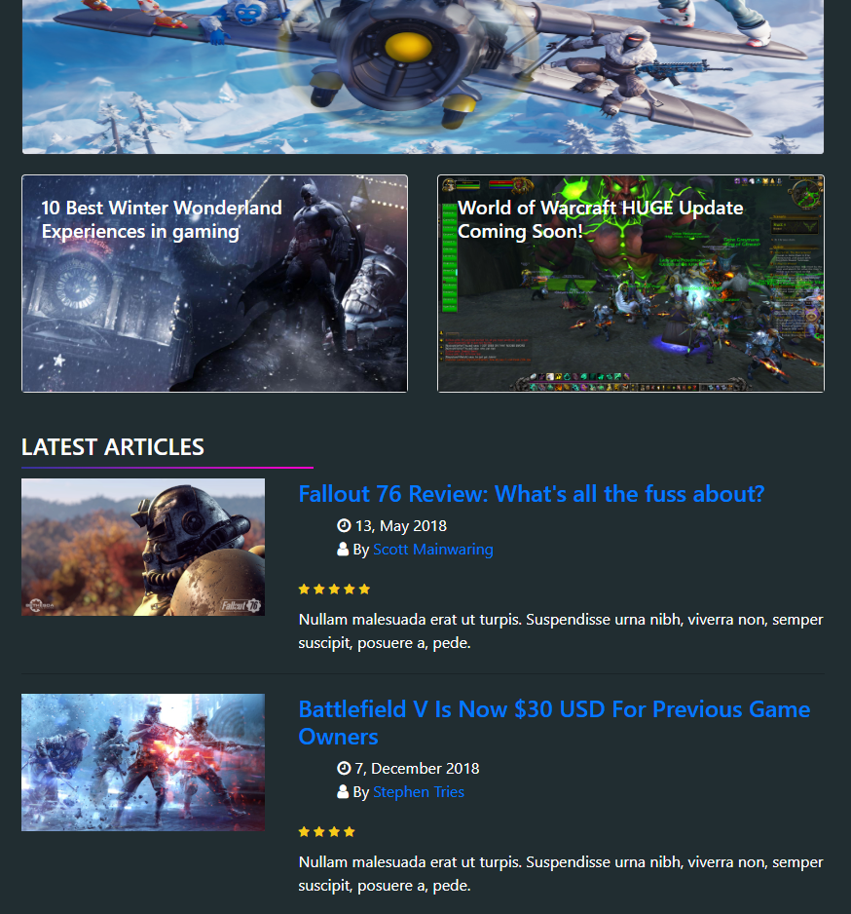

Overall, the final website is very accessible. The design of the website is very simple and modern and that is key when it comes to creating websites as it allows the user to navigate and read content on the website with ease. The website has a very good colour combination as mention previously in this report scoring a ‘AAA’ by [4]WebAIM’s colour contrast checker. Also, the colours seem to fit well with the video games scene which is a bonus. The navigation section of the website is very visible and can easily be accessed on every device because of its responsiveness. Different sections on pages were easily identifiable by the use of heading tags ranging from <h1> to <h5> being used and also the content being displayed in a grid layout. However, there are some features on the website that will be removed and some that will be added in a future update. Pages that included the sidebar felt as if they didn’t have much information to offer within the sidebar so in the near future more content will be added. Also, with JS functions more could’ve been implemented to improve with the website’s functionality such as ‘onclick’ functions when using buttons can speed up the load time of the page being accessed.

References

[1] | "Bootstrap · The most popular HTML, CSS, and JS library in the world.," Bootstrap, 19 August 2011. [Online]. Available: https://getbootstrap.com. [Accessed 4 December 2018].
[2] | "How To Pick The Best Font For Your Website (Dec 2018)," Website Builder Expert, 17 July 2018. [Online]. Available: https://www.websitebuilderexpert.com/designing-websites/pick-best-font-style-for-website/. [Accessed 5 December 2018].
[3] | "15 Best Web Safe HTML & CSS Fonts," Website Setup, 2017 March 7. [Online]. Available: https://websitesetup.org/web-safe-fonts-html-css/. [Accessed 2018 December 7].
[4] | "WebAIM: Color Contrast Checker," WebAIM, 1999. [Online]. Available: https://webaim.org/resources/contrastchecker/. [Accessed 7 December 2018].
[5] | "Web Content Accessibility Guidelines (WCAG)," W3, 11 December 2008. [Online]. Available: https://www.w3.org/WAI/standards-guidelines/wcag/. [Accessed 7 December 2018].
[6] | "3-click rule | Usability.gov," Usability, 5 July 2014. [Online]. Available: https://www.usability.gov/what-and-why/glossary/3-click-rule.html. [Accessed 7 December 2018].
[7] | "The W3C CSS Validation Service," Jigsaw, 1994. [Online]. Available: http://jigsaw.w3.org/css-validator. [Accessed 8 December 2018].

