Understanding and Engaging Stakeholders
LCLM5001
Student ID: 2408444
Student name: Mihaela-Andreea Rusu

Executive Summary
This report critically evaluated the launch plan of a new wearable health device named Pulsewave that can monitor heart rates, oxygen levels and sleep patterns, developed by the medical device manufacturing organisation Penlon. This company was founded in 1943 and specialises in manufacturing and designing various medical devices. The report focused on the strengths, weaknesses, opportunities and threats faced by this company. The PESTLE analysis explored how the Pulsewave launch may influence key external factors affecting the organisation. of Pulsewave sells its products and services in over 90 countries, giving the organisation a strong global presence in the industry market. The Chief Executive Officer, Gavin Gao, is one of the primary internal stakeholders of the company. Medcaptain Medical Technology LTD is the parent company of this medical device organisation and one of the key stakeholders of this company. Penlon was sold to BPL Medical Technologies by the previous owners, making BPL one of the major stakeholders of this company. As one of the business-to-business suppliers, Penlon offers components such as vaporisers and ventilators to other medical device manufacturing companies. The report finds that stakeholder engagement plays a key role in resolving disputes. Furthermore, it helps in the management of risks effectively. To overcome challenges during project management, Penlon should establish a multi-faceted ROI framework that goes beyond simple financial metrics to involve clinical and operational outcomes. The goals must be clearly defined, measurable and communicated across all external and internal stakeholders to ensure transparency. To ensure the company meet regulatory compliance in an effective manner, transparent roles and responsibilities required defining and assigning clear understanding of responsibilities across the project management team.

Table of Contents
Introduction 4
SWOT and PESTLE analysis of Penlon 4
SWOT 4
Key internal and external stakeholders 7
Role and responsibilities of the stakeholders along with the benefits brought by them and the challenges they face 8
Theories 9
Critical explanation of the process to engage the stakeholders and the ways of managing conflicts 10
Process of Engaging stakeholders 10
Managing the conflicts with the help of the 4C’s model 14
Evaluation of the impacts of stakeholder engagement on business performance, along with recommendations 15
Conclusion 17
Reference List 18

Introduction
Penlon is a British medical device-based company founded in 1943, specialising in designing, manufacturing and exporting anaesthesia, airway management and medical gas products. This company is well-reputed for developing high-quality products such as laryngoscopes and anaesthesia machines. This company comprises 131 total employees and generated revenue of around 17.8M GBP for the financial year ending on 31 March 2022. Apart from this, the total net profit of this company was estimated at nearly 603K GBP in 2022.
The medical device-based organisation is currently planning to release a new wearable device that would be named Pulsewave, associated with health, which would help track oxygen saturation levels as well as patterns of sleep. The major objective is to release the product to the customers within 6 months. As a project manager, the task is to get the product available on the date of launch. As project manager, your responsibility is to engage stakeholders of all potential stakeholders in achieving the advantages that could be brought to the new project, as well as keeping every stakeholder satisfied during the time of the ongoing project.

SWOT and PESTLE analysis of Penlon

SWOT
Strength | Weakness
- Strong brand reputation and history.  - Diverse product portfolio.  - Stro  - Strong international disruption. | - Potential supply chain and manufacturing challenges.  - Slower integration into new product areas.  - Dependence on the parent company for strategic direction.
Opportunities | Threats
- Expansion in the emerging business market.  - Technological advancements.  - Diversification into related medical device markets. | - Intense competition in the business market.  - Evolving medical device regulations.  - Global supply chain disruption.
Table 1: SWOT analysis
Analysis
Penlon has a long-standing brand reputation for quality and reliability in the medical business market. The company has received four Queen’s Awards for producing high-quality medication in the UK business market (Penlon.com, 2025b). For instance, the organisation sells its products and services in over 90 countries, giving the organisation a strong global presence in the industry market (Penlon.com, 2025a). The management of this company faces issues regarding quality control and the shortage of production with the component suppliers. While Penlon is expanding into new areas such as endoscopy the company may require time to build the same brand recognition it has in anaesthesia (Penlon.com, 2025c). The management of this company has the opportunity to expand into the emerging markets by leveraging the extensive distribution networks of the parent companies. With this help, the company can focus on different cost-effective solutions and expand its presence in the developing business regions. The business market of medical devices is highly competitive with established global players such as GE Healthcare, Dräger and Midray providing comprehensive solutions. Penlon has to compete with these organisations on both cost and technology (Forbes.com, 2025). Situations such as the COVID-19 pandemic demonstrated how supply chains were disrupted while impacting the production process and product availability.
PESTLE
Political Factor | - Government health initiatives.  - Political stability in the business market.
Economic Factor | - Spending habits of the potential customers.  - There is intense competition in the business market.
Social Factor | - Health consciousness among the customers.  - Shift in customer preference toward preventive care.
Technological Factor | - Integrating connectivity and infrastructure.  - Digital health platform integration.
Legal Factor | - Using technologies to protect intellectual properties.  - Following the customer protection law.
Environmental Factor | - Maintaining sustainability and ethics.  - Using ethical data practices to build trust.
Table 2: PESTLE analysis
Analysis
Health initiatives taken by the government create opportunities with the help of funding, partnerships and tax incentives. Political stability in the targeted markets impacts the investment risk and market viability (Yang, Amin and Shihada, 2024). The economic downturns can impact the willingness of customers to spend on non-essential, premium health tech while the growth period can create opportunities in the market. The market is crowded with different competitors including both specialised startups and tech giants impacting the market share and pricing strategy (Ghadi et al., 2025). The rapidly changing trends of personal fitness and health tracking present a major opportunity for a device that provides comprehensive health data. Growing public interest in proactive health management aligns perfectly with a device that offers continuous insights regarding health. Integration of a reliable app, cloud storage and robust connectivity are essential for the process of real-time monitoring and transfer (Channa et al., 2021). Successful market adoption will need seamless integration with the existing health platforms and electronic health records to create a valuable ecosystem. Securing patents for any unique technology is critical for the dependence of the system against the competitors. Marketing claims have to be transparent and evidence-based to comply with the regulations of customer protection (Yang, Amin and Shihada, 2024). The customers and the regulators increasingly expect companies to address their environmental impact including the ethical sourcing and waste disposal. Beyond the legal compliance the customers are concerned with the ethical use of their personal health data needing a clear and trustworthy approach to the process of data handling.

Key internal and external stakeholders
Internal stakeholders of Penlon
Internal stakeholders of the medical device organisation Penlon include its employees, management team and the parent company. The stakeholders with an internal-facing role such as the director of innovation, regulatory affairs and technology are also core internal stakeholders. As the Chief Executive Officer Gavin Gao is one of the primary internal stakeholders of this company (Penlon.com, 2025e). He is responsible for the overall strategic direction, expansion and development of the organisation. The Director of Innovation Mary Ryan is also one of the core stakeholders. She focuses on strategic development, regulatory compliance and innovation. Penlon also considers the employees of this company to be a crucial internal stakeholder group while emphasising teamwork and open communication and respect. The workforce of over 100 employees is included in the manufacturing and development of products such as anaesthesia systems, surgical instruments and ventilators (Penlon.com, 2025f). Medcaptain Medical Technology LTD is the parent company of this medical device organisation and also one of the key stakeholders of this company. Penlon was acquired by its parent company in January 2022 (Penlon.com, 2025d). Now Penlon operates as part of their larger organisation. Medcaptain has a significant influence over the strategic direction and finances of this organisation.
External stakeholders of Penlon
The external stakeholders of Penlon include customers, the clinical advisory panel, investors, suppliers and regulatory bodies. The direct clients of this company who use the anaesthesia machines and ventilators along with other medical products are one of the stakeholders of this company. Doctors, technicians, anesthesiologists, and a panel of external physicians are also key stakeholders of this company (Fearne et al., 2021). The businesses that provide materials and components for Penlon to manufacture its medical devices also play huge roles and responsibilities as the stakeholders of this organisation. Businesses such as Medical systems help the company to export and import the products manufactured by the company in different markets globally (Phillips et al., 2022). Organisations such as Workroom, which have partnered with Penlon on rebranding projects, are also one of the essential stakeholders of this company. Penlon was sold to the BPL Medical Technologies by the previous owners making BPL one of the major stakeholders of this company (Lincolninternational.com, 2025). Anyone whose medical health can be affected by the corporate practices or products of this company is a potential stakeholder of this company.

Role and responsibilities of the stakeholders along with the benefits brought by them and the challenges they face
Roles and responsibilities of the stakeholders
The employees of this company are responsible for manufacturing, developing, selling, and supporting Penlon’s products. The management team of this company led by the CEO is responsible for the overall strategy, economic performance and operational efficiency of the company (Torre et al., 2021). The owner of Penlon provides the capital and holds the ultimate responsibility for the financial and long-term strategic success of the company. Customers are expected to provide feedback on the products as most of the customers of this organisation rely on the products and services offered by Penlon for patient care (Ashcroft et al., 2017). As one of the business-to-business suppliers, Penlon offers components such as vaporisers and ventilators to other medical device manufacturing companies. Penlon relies on an international network of distributors to sell its manufactured products. The company must comply with the medical device regulations in every country where the products of this company are sold (Torre et al., 2021). The scientific and clinical communities of this company include expert practising physicians on the clinical advisory panel of this company and in a larger medical field. The organisation depends on its suppliers for the components and materials required to manufacture its medical devices.
Benefits
Penlon’s intuitive design helps clinicians concentrate on patient well-being of the patients. The commitment of this company to long-term partnerships ensures reliable service and support. The company receives high-quality and reliable components that meet its manufacturing standards. Working with various trusted suppliers decreases the risks and ensures a smooth production and manufacturing workflow (Riso et al., 2024). The management of this organisation prioritises its staff and invests in them. This helps the company to foster a work environment built on shared values and mutual respect. Penlon’s profitability and growth, especially following major acquisitions to have yielded visible benefits (Bocean et al., 2021). Using various systems offers the company visibility into its forecasts and sales while leading to more efficient capacity planning. The proven ability of this company to ramp up its production can be crucial during different health crises.
Challenges
Penlon sells its medical devices in numerous countries requiring it to navigate a web of constantly changing regulations including CE marking and FDA approval (Varadarajan, Koh and Daniel, 2023). Ensuring compliance for every product in the global business market is a time-consuming and expensive process that can delay the launches of new products and consume significant resources. Failure to meet the regulatory standards of a country can led to penalties, costly production recalls, reputational damage and even legal consequences. Investors demand a return on the investments which can create challenges with the requirements to offer healthcare institutions competitive pricing especially in the emerging markets with a lower profit margin (Williamson and Prybutok, 2024). While new technologies are critical for staying competitive the rigorous testing and the documentation required to ensure regulatory and quality compliance can slow down the development process.

Theories
Stakeholder’s Matrix:
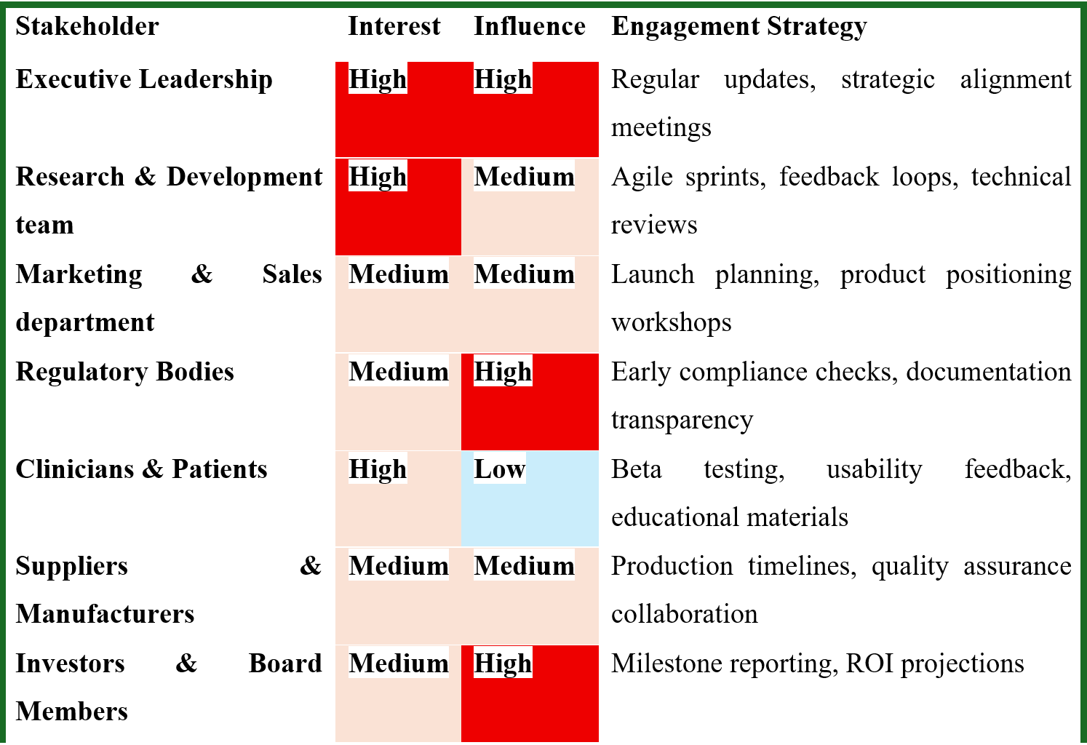
Figure 1: Stakeholder Matrix
The matrix associated with stakeholder identification is a tool that is broadly utilised in the field of project management as well as planning related to strategic initiatives. The matrix has been designed by multiple scholars of management. Through the application of the Stakeholder’s Matrix, the impact and interest of all the stakeholders associated with the project of implementing Pulsewave would be analysed. This would facilitate prioritisation of all the stakeholders and result in the creation of strategies associated with engagement. This can be achieved by categorising stakeholders based on their impact and interest. Through the application of the framework, the interested stakeholders would be listed, and their level of impact would be efficiently evaluated. Furthermore, strategies of engagement would be tailored depending on the categories of stakeholders so that communication of higher quality and support is ensured. The targeted practice would help in making sure that the allocation of resources is performed to increase engagement of stakeholders who are extremely important for the progress of the project.
Engagement Plan:
The stakeholder engagement plan could be utilised during the management of the project so that the stakeholders may have access to all the information regarding the aims and scope of the project. Through fostering an engagement among the stakeholders, there would be a greater possibility for improvement of communication, thereby leading to the enhancement of operational clarity (Christopher, Payne and Ballantyne, 2013). Through the application of the theory, the level of engagement could be enhanced so that the groups of stakeholders are analysed (Maqbool, Rashid and Ashfaq, 2022). It is highly crucial for all stakeholders with decision-making powers to be involved in the implementation of the project. An assessment of stakeholders’ needs must be conducted, which is associated with the identification of the level of interest possessed by all the stakeholders. Their levels of engagement can also be evaluated through an analysis of their interests. Limitations of the project need to be defined, which might result in the determination of the strength and impact of all stakeholders. Appropriate communication tools must be selected for a successful outcome.
Communication Plan:
Through the use of the communication plan model, knowledge and understanding could be gained regarding the process of communication and its impact on the results of the project. This would help in the delivery of a systematic method for analysis of effective communication and collaboration within the team, as well as with external stakeholders, thereby resulting in the improvement of overall communication. The utilisation of communication models would cause an explanation of the procedures and all the associated stakeholders in the quality transmission of data and information. Conversely, theories associated with communication enhance interactions that are professional, thereby facilitating the sharing of complex thoughts and ideas more transparently.
RACI Matrix:
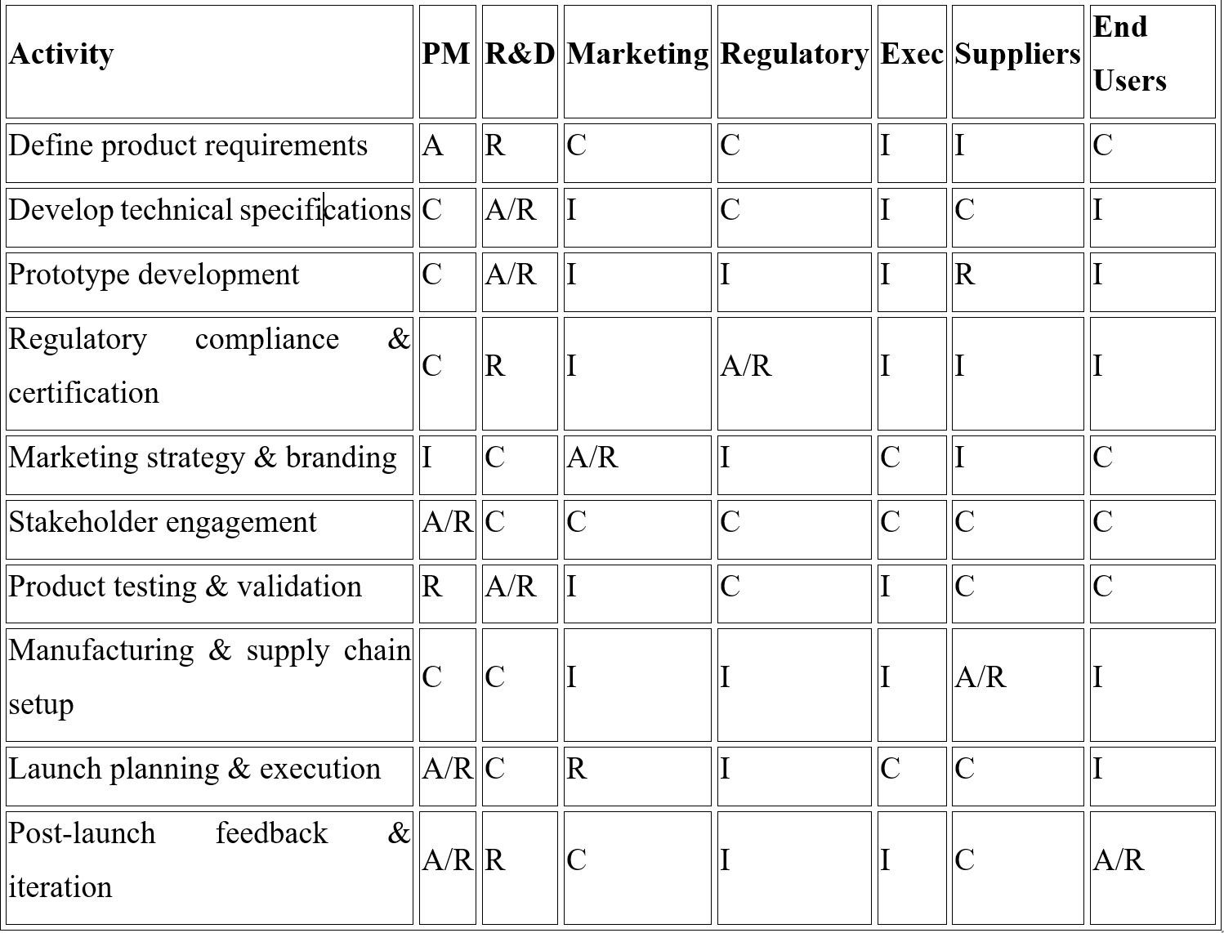
Figure 2: RACI Matrix
The Responsibility Assignment Matrix is a framework used in project management through which the project manager would be able to define and clarify functions within the team of stakeholders (Ma'arif et al., 2023). Due to its utilisation, transparent communication would be established, thereby bringing about an improvement in the process of decision-making and greatly ensuring responsibility for activities and deliverables. The matrix describes the collaboration of multiple functions in the completion of activities for the management of the project through responsible, accountable, consulted and informed.

Critical explanation of the process to engage the stakeholders and the ways of managing conflicts

Process of Engaging stakeholders
Step 1: identify and analyse stakeholders
The company can focus on commercial success, return on investment and market share, which will attract the attention of the company leadership and investors. Identifying the current product development team, such as engineers, software developers and designers, is also required as they need to meet the technical specifications and usability standards as well (Woudstra et al., 2022). The regulatory and quality assurance team will be responsible for ensuring compliance with the medical device regulations, such as the CE or FDA regulations. The marketing and sales teams need to understand the unique value proposition of the product to position as well as promote it efficiently and effectively in the business market (Ellis, Gibbs and Rein, 1991). The external stakeholders, including the doctors, cardiologists and nurses, will integrate or recommend the device into the patient care.
Step 2: Planning and Strategic Engagement
Stakeholder Group | Objective of Engagement | Engagement Tactics
Internal Teams | Align all departments towards a shared goal and timeline | - To establish a clear product vision and strategy, the management has to arrange kickoff meetings.  - Therefore, with the help of cross-functional workshops, the company can use a central communication platform to track the milestones and progress of the new product.  - By updating the status of the product regularly, the company can ensure a consistent understanding of different features and requirements (Woudstra et al., 2022).
Healthcare Professionals (HCPs) | Gain clinical validation while building trust and secure professional endorsement. | - Through an advisory board, the company can convene panels of medical experts to offer input on the design of the new product and clinical utility.  - By collaborating with research hospitals, the organisation will be able to test the accuracy of the product against clinical-grade equipment (Bird et al., 2021)  - Arranging medical conferences will help the production team to present various study results and showcase the device to the medical community.
Table 3: Plan and Strategic Engagement
Step 3: implement, execute and iterate
The planned engagement strategies are put into action across the lifecycle of the device from starting long before the official product launch. Creating early-stage versions of the device is used for testing in the workshops with both internal and external stakeholders. The company can run clinical and usability studies while incorporating feedback from the HCPs and the patients to refine the product (Bird et al., 2021). By securing the regulatory approvals the company will be able to finalise the submissions of the product and gain necessary approvals for the market clearance from the required stakeholders. Coordinating marketing campaigns, public relations, and sales training activities according to the planned timeline will help execute the launch plan.

Managing the conflicts with the help of the 4C’s model
Communication
Poor communication is one of the major drivers of conflicts during a new product creation and launch. A proactive and transparent communication plan is essential for the new product launch. The engineering team may feel the need to prioritise the clinical-grade accuracy over the consumer-friendly features or the cost of the product. Meanwhile, marketing will prioritise marketability and the consumer experience the most (Abhinav et al., 2025). Facilitating a series of workshops between these two teams early in the manufacturing process to agree on a minimum viable product that balances accuracy along with the market appeal and cost will help solve this conflict.
Collaboration
The medical community can be hesitant to recommend the Pulsewave due to different concerns about the data liability and quality. Partnering with core opinion leaders in cardiology, general practice and sleep medicine to get their feedback and secure endorsements can build credibility. It will also help the company to address the concerns of the HCPs (Duan et al., 2025). The launch will attract the attention of the regulatory bodies such as the FDA especially if the device makes medical claims. Engaging with regulators early in the development process will ensure the device is compliant and does not overstate its capabilities.
Commitment
Commitment involves aligning a shared vision and working together to gain a common goal. If company leadership is not fully committed to the consumer wearable, internal teams may resist the change (Abhinav et al., 2025). Developing a new customer product will draw resources away from the existing B2B product lines. This could create friction between product lines due to resource competition.
Control or Correction
Correction or control refers to managing emotions and staying focused on finding a solution while correcting confusion as it arises. This is particularly significant for managing feedback and negative reactions post-launch. Post-launch issues such as technical bugs, feature gaps or unexpected market feedback can cause internal frustration among the stakeholders (Duan et al., 2025). Establishing a post-launch review process that objectively analyses issues and assigns responsibilities without blame is essential. It helps the company to focus on creating a clear plan for corrective action and improvement.

Evaluation of the impacts of stakeholder engagement on business performance, along with recommendations
Impact
Stakeholder engagement typically has a significant impact on business performance, influencing trust and perception. Collaboration with multiple stakeholders helps organisations encourage greater innovation and creativity in the decision-making process. Penlon will engage a diverse stakeholder base, including internal and external participants. The participation of multiple stakeholders from diverse backgrounds and with diverse knowledge will lead to diverse perspectives and accelerate innovation (Ashcroft et al., 2017). This will enable greater business differentiation for Penlon and assist in the attainment of a viable competitive edge. Based on the above analysis, the current UK healthcare market is largely threatened by economic uncertainties and a highly competitive rivalry. In such a dynamic business context, differentiation will be a critical component to foster sustainability and competitiveness. Therefore, stakeholder engagement will be crucial for Penlon to positively influence its market performance.
Management of Risks
The contemporary and rapidly evolving corporate environment of the UK demonstrates a number of unpredictable trends, such as fluctuation in consumer demand, regulatory changes, and geopolitical tensions and so on. The organisation can experience a severe setback due to these unpredictable situations. Such a scenario underscores the critical need for strategic planning to maintain a sustainable competitive advantage (Amaral et al., 2024). Additionally, data-driven decisions can also be an effective approach for the brand to generate informed decisions based on accurate forecasts about future industrial trends and the behavioural evolution of consumers (Bird et al., 2021). Here, the enterprise can undertake the advancement of digital tools such as predictive analytics to project potential industrial evolution. Proactive risk mitigation will be facilitated by increased organisational and supply chain resilience of Penlon. Regular changes have been identified as potential risks for Penlon. The organisation can minimise such threats through proactive risk mitigation and predictive maintenance.
Avoidance of disputes
Quality engagement of stakeholders helps in the promotion of inclusivity within project management, thereby ensuring efficient collaboration of every relevant party. This helps stakeholders attain a better understanding of the underlying causes of disputes as well as complexities in a comprehensive manner. Furthermore, diverse points of view and expertise are often enhanced, leading to innovative, sustainable and holistic solutions to issues (Senarath, Udawatta and Karunasen, 2023). In addition, as a result of engagement among the stakeholders, a sense of ownership is accelerated further strengthening support and legitimacy for the resolution process, enhancing the chances of greater progress. Through addressing the interests and considerations of stakeholders, hostility could be mitigated, trust and loyalty could be built, and situations of conflict could be de-escalated.
Recommendations
Need for awareness regarding regulatory compliance
In order to meet regulatory compliance in an effective manner, transparent roles and responsibilities need to be defined, further defining responsibility for compliance across the project management team. This would help ensure oversight and sponsorship are highly executive. Regulations of compliance that are applicable must be analysed regularly. This defines a baseline against which the performance of the new device can be measured. The entire organization from R&D to sales, customer support, and marketing, must understand the objectives of the launch process. Regular and transparent communication keeps everyone aligned and committed to the same goals.
ROI goals need to be transparent and measurable
While launching a new device successfully, Penlon should establish a multi-faceted ROI framework that goes beyond simple financial metrics to involve clinical and operational outcomes. The goals must be clearly defined, measurable and communicated across all external and internal stakeholders to ensure transparency. The company should state upfront what the product is intended to achieve. Medical device ROI is not purely monetary. It also includes enhanced clinical efficacy and operational efficiency for the healthcare providers. Transparently defining both upfront is crucial for justifying the investment to all stakeholders. Before the process of launch starts, determine the current state of clinical results and costs within the target market. An ROI strategy is not a one-time calculation which uses real-time data and analytics to track progress against KPIs and make strategic adjustments based on actual performance and market feedback (Li and Wang, 2024). The company can track the total marketing and sales costs required to acquire each new hospital or clinical customer. The company should estimate the total revenue a customer will generate over the entire relationship, including repeat purchases and service contracts.

Conclusion
This report finds that Penlon is a British medical device company is a British medical device-based company specialises in designing, manufacturing, and exporting anaesthesia, airway management and medical gas products. The company has received four Queen’s Awards for producing high-quality medication in the UK business market. The study highlighted that the management of this company faces issues regarding quality control and the s production shortages due to component suppliers. Economic downturns can affect customer willingness to spend can impact the willingness of customers to spend on non-essential, premium health tech while the growth period can create opportunities in the market. Penlon’s workforce of over 100 employees is involved in manufacturing and development of products such as anaesthesia systems, surgical instruments and ventilators.
It has also been highlighted that organisations such as Workroom, which have partnered with Penlon on rebranding projects, are also one of the essential stakeholders of this company. The management of this organisation prioritises its staff and invests in them. Using various systems offers the company visibility into its forecasts and sales while leading to more efficient capacity planning. Penlon sells its medical devices in numerous countries requiring it to navigate complex and evolving regulations including CE marking and FDA approval. The matrix associated with stakeholder identification is a tool that is broadly utilised in the field of project management as well as planning related to strategic initiatives. Through the application of the engagement plan the level of engagement could be enhanced so that the groups of stakeholders are analysed. While engaging the stakeholders in the launch process of the new product the company can focus on commercial success, return on investment and market share, which will attract the attention of the company leadership and investors. Stakeholder engagement followed three key steps following three steps such as identifying and analysing the key stakeholders, creating a strategic and well-planned engagement, and implementing the plan to engage more stakeholders. With the help of the 4Cs model, Penlon can mitigate the post-launch issues.

Reference List
Abhinav, V., Basu, P., Verma, S.S., Verma, J., Das, A., Kumari, S., Yadav, P.R. and Kumar, V., (2025) Advancements in Wearable and Implantable BioMEMS Devices: Transforming Healthcare Through Technology. Micromachines, 16(5), p.522. DOI: https://doi.org/10.3390/mi16050522
Amaral, C., Paiva, M., Rodrigues, A.R., Veiga, F. and Bell, V., (2024) Global regulatory challenges for medical devices: impact on innovation and market access. Applied Sciences, 14(20), p.9304. DOI: https://doi.org/10.3390/app14209304
Ashcroft, J., Childs, R., Myers, A. and Schluter, M., (2017) The relational lens: Understanding, managing and measuring stakeholder relationships.
Bird, M., McGillion, M., Chambers, E.M., Dix, J., Fajardo, C.J., Gilmour, M., Levesque, K., Lim, A., Mierdel, S., Ouellette, C. and Polanski, A.N., (2021). A generative co-design framework for healthcare innovation: development and application of an end-user engagement framework. Research involvement and engagement, 7(1), p.12. DOI: https://doi.org/10.1186/s40900-021-00252-7
Bocean, C.G., Nicolescu, M.M., Cazacu, M. and Dumitriu, S., (2022). The role of social responsibility and ethics in employees’ wellbeing. International Journal of Environmental Research and Public Health, 19(14), p.8838. DOI: https://doi.org/10.3390/ijerph19148838
Channa, A., Popescu, N., Skibinska, J. and Burget, R., (2021) The rise of wearable devices during the COVID-19 pandemic: A systematic review. Sensors, 21(17), p.5787. DOI: https://doi.org/10.3390/s21175787
Christopher, M., Payne, A., and Ballantyne, D. (2013) Relationship Marketing: Creating Stakeholder Value. Saint Louis: Taylor and Francis
Duan, H., Peng, S., He, S., Tang, S.Y., Goda, K., Wang, C.H. and Li, M., (2025). Wearable electrochemical biosensors for advanced healthcare monitoring. Advanced Science, 12(2), p.2411433. DOI: https://doi.org/10.1002/advs.202411433
Ellis, C.A., Gibbs, S.J. and Rein, G., (1991) Groupware: some issues and experiences. Communications of the ACM, 34(1), pp.39-58.
Fearne, A., Wagner, B., McDougall, N. and Loseby, D., (2021) The power of purpose–lessons in agility from the Ventilator Challenge. Supply Chain Management: An International Journal, 26(6), pp.753-766. DOI: https://doi.org/10.1108/SCM-09-2020-0468
Forbes.com, (2025) The Era Of Corporate Healthcare: How Medical Device Sales Professionals Can Face The Challenges. Available at: https://www.forbes.com/councils/forbesbusinesscouncil/2024/09/23/the-era-of-corporate-healthcare-how-medical-device-sales-professionals-can-face-the-challenges/ [Accessed 1 October 2025].
Ghadi, Y.Y., Shah, S.F.A., Waheed, W., Mazhar, T., Ahmad, W., Saeed, M.M. and Hamam, H. (2025) Integration of wearable technology and artificial intelligence in digital health for remote patient care. Journal of Cloud Computing, 14(1), p.39. DOI: https://doi.org/10.1186/s13677-025-00759-4
Li, M. and Wang, T., (2024). Optimizing learning return on investment: Identifying learning strategies based on user behavior characteristic in language learning applications. Education and Information Technologies, 29(6), pp.6651-6681. DOI: https://doi.org/10.1007/s10639-023-12078-9
Lincolninternational.com, (2025) Altaris has sold Penlon to BPL Medical Technologies. Available at: https://www.lincolninternational.com/transactions/penlon-sold-to-bpl-medical-technologies-private/ [Accessed 3 October 2025].
Ma'arif, S., Putrianti, F.G., Indraswari, N.M., Nhu, D.Q., Pujianingsih, E.D., Marsinta, A.K. and Ardianti, P., (2023). Stakeholder Management in Developing a Sustainable Tourism Village Based on Renewable Energy Using RACI Matrix. Journal of Industrial System Engineering and Management, 2(2), pp.73-82. DOI: https://doi.org/10.56882/jisem.v2i2.25
Maqbool, R., Rashid, Y. and Ashfaq, S., (2022). Renewable energy project success: Internal versus external stakeholders' satisfaction and influences of power‐interest matrix. Sustainable Development, 30(6), pp.1542-1561. DOI: 10.1002/sd.2327
Penlon.com (2025a) Producers Of World-Renowned Medical Devices. Available at: https://www.penlon.com/ [Accessed 1 October 2025].
Penlon.com, (2025b) Penlon's success in the 2019 GHP Technology Awards. Available at: https://www.penlon.com/news/penlon-success-in-2019-ghp-technology-awards/ [Accessed 1 October 2025].
Penlon.com, (2025c) Penlon Continues to Expand Endoscopic Accessories Range. Available at: https://www.penlon.com/news/penlon-continues-to-expand-endoscopic-accessories-range/ [Accessed 1 October 2025].
Penlon.com, (2025d) A brief history of Penlon. Available at: https://www.penlon.com/about/company-history/# [Accessed 2 October 2025].
Penlon.com, (2025e) New CEO for Penlon. Available at: https://www.penlon.com/news/new-ceo-for-penlon/ [Accessed 2 October 2025].
Penlon.com, (2025f) Mary Ryan Named Among Top 50 Women Leaders in Healthcare. Available at: https://www.penlon.com/news/mary-ryan-named-among-top-50-women-leaders-in-healthcare/ [Accessed 3 October 2025].
Phillips, W., Roehrich, J.K., Kapletia, D. and Alexander, E., (2022) Global value chain reconfiguration and COVID-19: Investigating the case for more resilient redistributed models of production. California Management Review, 64(2), pp.71-96. DOI:https://doi.org/10.1177/00081256211068545
Riso, V., Tallaki, M., Bracci, E. and Cantele, S., (2024) The transition towards benefit corporations: What are the roles for stakeholders?. Business Strategy and the Environment, 33(2), pp.904-916. DOI: https://doi.org/10.1002/bse.3525
Senarath, N.B., Udawatta, N. and Karunasena, G., (2023), November. A conceptual model to manage intragroup conflicts in construction projects: The role of stakeholder engagement. In Australasian Universities Building Education Association Conference (pp. 413-423). Singapore: Springer Nature Singapore. DOI: https://doi.org/10.1007/978-981-96-1181-2_33
Torre, I., López-Baucells, A., Stefanescu, C., Freixas, L., Flaquer, C., Bartrina, C., Coronado,
Varadarajan, S., Koh, J.H.L. and Daniel, B.K., (2023) A systematic review of the opportunities and challenges of micro-credentials for multiple stakeholders: learners, employers, higher education institutions and government. International Journal of Educational Technology in Higher Education, 20(1), p.13. DOI: https://doi.org/10.1186/s41239-023-00381-x
Williamson, S.M. and Prybutok, V., (2024) Balancing privacy and progress: a review of privacy challenges, systemic oversight, and patient perceptions in AI-driven healthcare. Applied Sciences, 14(2), p.675. DOI: https://doi.org/10.3390/app14020675
Woudstra, K., Reuzel, R., Rovers, M. and Tummers, M., (2022) An overview of stakeholders, methods, topics, and challenges in participatory approaches used in the development of medical devices: a scoping review. International Journal of Health Policy and Management, 12, p.6839. DOI: https://doi.org/10.34172/ijhpm.2022.6839
Yang, L., Amin, O. and Shihada, B. (2024). Intelligent wearable systems: Opportunities and challenges in health and sports. ACM Computing Surveys, 56(7), pp.1-42. DOI: https://doi.org/10.1145/3648469

