The future of hospitality, and is it profitable to be green?

Student name:Andreea Boscornea 2122612
Module title and nr: Sustainable Hospitality&Tourism Management
Lecturer name: Ruth Taylor-Davies

Table of Contents
Introduction 2.
Discussion 3
Elkington’s Triple Bottom Line 4
Financial resilience 5
Greener- hospitality industry 5
Business Responsibility 5
Doxey’s Irridex model 6
Butler’s Life Cycle Model 8
Conclusion 10
References 11

Introduction
Green practises, and efforts are seen as giving competitive merit as the customer base is used to increase eco-awareness. Sustainable activities like energy-efficient constructions, trash deductions, and eco-friendly activities not only attain the increasing need for accountable travel but also quickly lead to longer-term cost merits (Das et al., 2021). The hospitality sector holds the unique chance to aid the SDG, as it attains upon several elements of human well-being, like health, education, cultures, employment, and the community. The hospitality sector is the most lively and varied segment in the UK, contributing to various customer services and experiences, from pubs and restaurants to hotels and nightclubs (Boella and Goss-Turner, 2019). The report aims to explain the future of hospitality with sustainability in hospitality. This will involve Doxey’s Irridex model and Butler’s life cycle model with industry-based examples.

Discussion
Milton Friedman’s statement of relevancy
Friedman gave the theory in a 1970 article for The New York Times titled "A Friedman Doctrine: The Social Responsibility of Business is to Increase Its Profits". In the article, it is seen that the author has explained that the firm holds no social responsibility to the public or community; the only accountability is to the stakeholders (Musiał and Lubszczyk, 2022).
Friedman's posture is simple: “There involves the one social responsibility of businesses that involve using the resource and interacts in practices made to increase the profit.” The view holds the longer impacted management thoughts and corporate governance with the strategic steps (Shapiro, 2021).
Future of hospitality and green practises.
Sustainability in hospitality with eco-friendly activities is seen as the main of the future of hospitality. Even the prior expenditure could be essential; being green could leverage the profitability by declining the operating expense, leveraging the hotel’s loyalty, and levelling up the hotel’s perceptions. For hospitality businesses to be effective in a socially and environmentally sensitive market, accepting green activities would not be profitable; however, it is too important. The UK’s Hospitality sector is seen at 19.77 billion pounds sterling in 2023. It is likely to attain 22.40 billion pounds sterling by 2028, developing at the CAGR of 2.53% during the forecast period (2023-2028) (Mordorintelligence.com, 2023). The hospitality business, with an environmental strategy on reducing, reusing, and recycling (the 3Rs), increases the business's profitability. The 3R’s plan in the hospitality industry concerns water, energy, and waste efficiency to reduce emissions and resource use. Reducing removes the need for reducing and recycling. These are a few examples of reduction practices: improved insulation, healthier energy management, food, packaging, or paper waste; like most hotels, nowadays introduce the digital room key on the phone app. Reusing a product or part of it is still part of the reduction. These are a few examples of reusing practices, including reusing linens/towels and reusing furniture. Recycling converts materials into new products. Recycling practices like recycling shampoo and soap and their bottles and food as Hilton created a staff canteen for free and the food left is taken in the staff canteen.

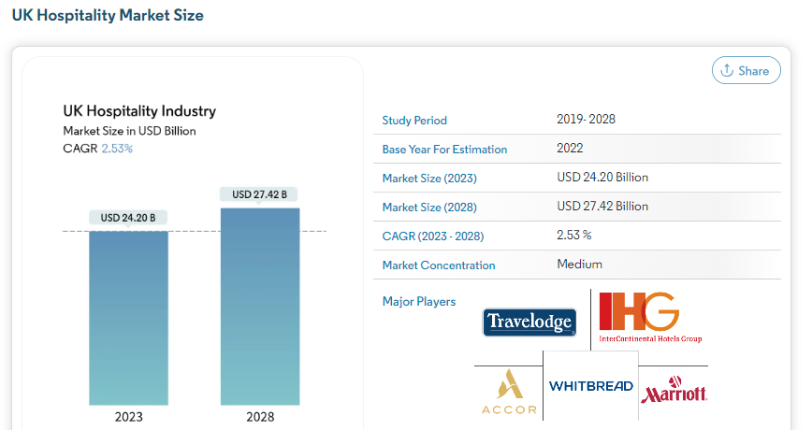
Source:(Mordorintelligence.com, 2023)

Elkington’s Triple Bottom Line
Triple bottom line theory is used to make the expansion of the conventional business’s success metric involve the firm’s contribution to social well-being, environmental health, and the just economy. The bottom line segments are seen to be the 3 “P's”, namely people, planet, and prosperity (Sarkis, 2020). The Triple Bottom Line approach could give a series of merits to firms involving a better brand reputation, better social with the environmental influence, enhanced talent acquisitions and retention, making the higher level of the sustainable supply chain, with enlightening profit through cost-saving.
The assertion by Milton Friedman has come under scrutiny lately. While growing profit is yet the top priority, contemporary perspectives execute the more considerable stress upon CSR. Firms are highly aware of the value of moral behaviours, ecological sustainability abilities, and social well-being. Consumers, stakeholders, and other shareholders anticipate firms to handle social and environmental problems. Hence, in the globalised as well as communally mindful community, contemporary businesses regularly hold the higher all-inclusive plan that combines profits with ethical business exercises, displaying the change for the understanding of the interdependencies of financial success with social responsibility (Muldoon et al., 2022).
An example involves Accor’s sustainability strategy, making the business leverage its effectiveness and efficiency. It will lead to net zero carbon emissions by the year 2050. It would, too, interact in lowering the greenhouse gases. It also saves the natural resource at large (Accor.com, 2023).

Financial resilience
It could be considered that the secret to CSR is monetary strength. It stretches the corporation to endure economic downturns, make sustainable investments, and regulate fluctuating market conditions. The hospitality business could struggle to overcome the social and ecological hurdles without monetary constancy. Being monetarily resilient aids the company in being involved in communally accountable events, marking a longer-term investment in sustainability and weakening the environmental influences. Economic resilience fundamentally upsurges the business's attitude to bear and flourish, safeguarding that sustainability struggles can be effectively accepted and continued over time (Brin and Nehme, 2019).

Greener- hospitality industry
Through applying sustainable activities, the hospitality industry can work to be sincerely green. Though whole environmental impartiality can be hard to attain, the business can significantly diminish the ecological influence in hospitality. This requires activities similar to renewable energy sources, energy-effective building, falling trash, preserving water, and obtaining locally. Moreover, encouraging accountable travel, humanising guests, and helping conservation edges could aid the corporation in being highly ecologically friendly. While sustainability can be the moral aim, ongoing initiative and technology can meaningfully decrease the ecological result of a hospitality business. Example- 1 Hotel is seen as LEED Certified. The hotel also offsets CO2. It uniformly safeguards nature and culture (1hotels.com, 2023).

Business Responsibility
Not only emphasising increasing the profitability, but firms in hospitality shall also take care of the social duties. While profits are indisputably the main aim of every firm in hospitality, contemporary firms are highly aware of the broader social obligation (Vicente, 2021). These involve:
Monetary responsibility of firms: The firm holds to make the profits seen as the most essential and foremost priority in hospitality. It aids the firms in developing new offerings. It makes investments in R and D, with the assistance of economic expansions, all of which merit the society by making employment with the other possibility in hospitality.
Law responsibility: It is considered that the firms have to do the operation within the bounds of law. The main element of social responsibility is seen in law, which ensures the appropriate moral business activities that prevent the stakeholders and customers. Out of compliance with the law, firms must perform ethically in hospitality (Sheth & Parvatiyar, 2021). This takes care of the ethical worker's treatments and is accountable for the sourcing, with an ecologically friendly process. The firm's reputation is seen to be upgraded by ethical behaviours, which also raises the consumer's and partner's trust in hospitality.
Business communal and ecological accountabilities: Communal and ecological accountabilities involve being highly and highly demanded of firms. This is used to attain charitable endeavour and social engagement with the sustainability programme in hospitality (Wandosell et al., 2021).
The interest of shareholders: Firms has to consider the interest of the range of shareholders, including client, staff, and investor, as well as the societies where they do business. The vital element of social responsibility seems to be balancing several interests instead of stressing only the bottom lines in hospitality.

Doxey’s Irridex model
Doxey’s Irridex model is seen as the model set up through Doxey in 1975. Doxey’s Irridex model relies upon learning how the local people used to feel about the changing attitudes towards tourists and the growth of tourism in varied steps of the location’s life model (Cheung & Li, 2019). It has been given by Doxey, a name not certainly remembered by tourism academics. Doxey’s Irridex model is the theoretical structure for managing tourism and destination marketing. It was made by Stephen Doxey in 1970 to understand and predict the development of tourist destinations and the linked change in visitors’ attitudes and behaviour. It is considered that in the model Doxey’s Irridex, there are stages, namely, the exploration stage, involvement stage, and development stage, with the decline stage seeming to be the paradigm of Irridex. The unique aspect of the destination makes the traveller be there during the exploration stage (KILIÇ and Seçilmiş, 2022). The development of a place is seen as the outcome of leveraging the visitor’s interests and investments. However, the location’s appeal and contentment among the visitors can degrade as it develops highly populated grows.
The model stresses that tourism destinations seem cyclical and could face experienced developments and stagnation with the decline steps. Destination managers can make the appropriate decision to keep and raise the attraction of the destination by having careful knowledge of the steps (Kichin et al., 2021).

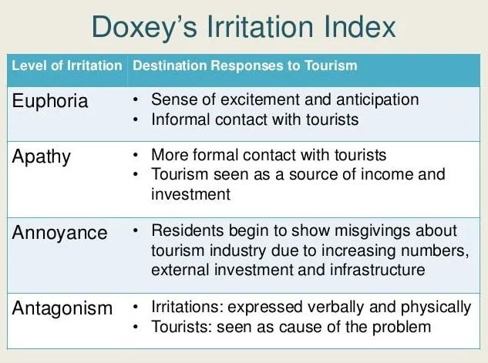
Source:( KILIÇ and Seçilmiş, 2022)
There are ways to promote environmental sustainability:
Exploration: This is the first and foremost stage where the traveller is seen to be drawn to lesser-travelled areas as of beauty as the unique aspects of landscapes. Getting to know the stage enables the destination manager to execute sustainable activities, like inspiring accountable travel, regulatory structure development, and caring about subtle ecologies.
Phases of Participation and Growth: The destinations advance by the stage, which involves the rise in traveller capacity and infrastructure building. As an outcome, the environment can be in strains that can drive problems comprising habitat destruction, pollution, and resource reduction (Milano & Koens, 2022). By recognising the phases, policymakers and businesses can execute sustainable tourism activities, like eco-friendly hotels, trash management, and conservation practices.
Declining: The time the destination attains the stage; the significance of extreme growth and environmental harm can adversely influence tourism. The stage has to be recognised to take remedial practices like rehabilitation and ecological restoration to sustainably refresh the location (Zmyślony et al., 2020).
Awareness of cyclic motion: The concept stresses the recurring feature of travel locations by emphasising the chance for regeneration to sustainable development. Stakeholders can plan for sustainable development by knowing the cycle and confirming that the locations pass the steps with fewer negative environmental influences.
Doxey’s Irridex model helps in decision-making processes for destination managers and decision-makers who want to encourage ecological sustainability in the destination. Doxey’s Irridex model is critical for shielding the natural miracles of the ecosphere while enhancing tourism's monetary advances (Khusairy & Ismail, 2022).

Butler’s life cycle model
Butler’s life cycle model is seen to be broadly used ideal to know the development of specific tourism destinations. The concept proposes that the tourism areas evolve the six foreseeable dissimilar steps: explorations, involvements, development stage, consolidation stage, stagnation stage and decline stage. The Model is seen as the manner of taking care of the tourist’s resort, how they change over time, and about altering demand of the tourism sector. The prediction could then contradict the change. Butler’s life cycle is a valuable device for comprehending the phases that tourist attractions go through in life. It aids tourism planners and developers in observing how tourist resorts could alter over time to the flexible demand of the tourism sector (Singh, 2021).
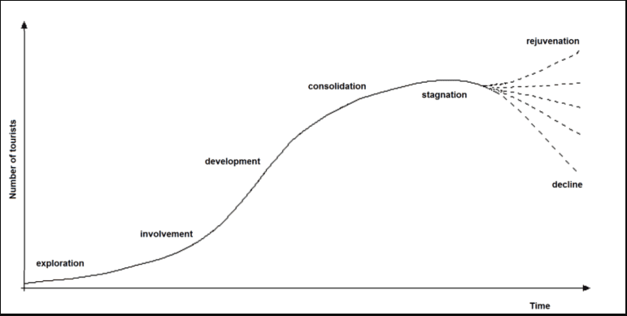

Source:( (Singh, 2021)
However, Butler’s life cycle includes disadvantages, like the generalisation of complicated tourist development procedures, the Western-centric perspective, and the lack of suggestions for how destinations can go from one phase to another. Moreover, it does not consider the outside variable that can significantly impact the destination’s development, involving the pandemic or economic shock (Dodds, 2020).
In the UK's hospitality sector, a scandic group of hotels engaged in CSR practice take care of the environment, community, and employees in business. Hotel is seen as the leader in sustainability in the industry. It is also seen that it is an excellent first employer. Scandic inculcates the business's value and culture (Scandichotelsgroup.com, 2020).

Conclusion
The report concludes that the hospitality sector is seen as the most lively and varied segment in the UK, contributing to various customer services and experiences, from pubs and restaurants to hotels and nightclubs. Sustainability in hospitality with eco-friendly activities is seen as the main of the future of hospitality. Doxey’s Irridex has stages, namely, the exploration, involvement, and development stages, with the decline stage seeming to be the paradigm of Irridex. Butler’s life cycle model is seen to be broadly used ideal to know the development of specific tourism destinations. In hospitality, trying to be green means that the company need to spend more money to implement the new strategy, and this means that the cost of holiday prices can raise
.

References
‌1.1hotels.com. (2023). Sustainability at 1 Hotel. [online] Available at: https://www.1hotels.com/sustainability [Accessed .2 November 2022].
2.Accor.com. (2023). Accor - Sustainability Strategy. [online] Available at: https://group.accor.com/en/commitment/approach/sustainability-strategy [Accessed 7 November. 2023].
3.Boella, M.J. and Goss-Turner, S., (2019). Human resource management in the hospitality industry: A guide to best practice. Routledge.
4.Brin, P.V. and Nehme, M.N., (2019). Corporate social responsibility: analysis of theories and models.
5.Cheung, K.S. and Li, L.H., (2019). Understanding visitor–resident relations in over-tourism: Developing resilience for sustainable tourism. Journal of Sustainable Tourism, 27(8), pp.1197-1216.
6.Das, J.K., Taneja, S. and Arora, H. eds., (2021). Corporate social responsibility and sustainable development: Strategies, practices and business models. Taylor & Francis.
7. Dodds, R., (2020). The tourist experience life cycle: a perspective article. Tourism Review, 75(1), 216-220.
8. Ioannidis (28. June 2021) Going green increases hospitality industry profitability [online] Available at: https://tyndall.ac.uk/news/going-green-increases-hospitality-industry-profitability [Accessed 9 November 2023]
9. Khusairy, N.M. and Ismail, H.N., (2022). Social Impact Assessment in Measuring Environmental Sustainability in Tourism Project Development: Trends in the Existing Literature. Journal of Advanced Research in Technology and Innovation Management, 3(1), pp.11-15.
10.Kichin, S., Ayob, N. and Kasuma, J., (2021). THE INITIAL DEVELOPMENT OF RURAL TOURISM DESTINATION IMAGE FROM RESIDENTS’PERCEPTIONS. Journal of Sustainability Science and Management, 16(5), pp.288-306.
11.KILIÇ, İ. and Seçilmiş, C.İ.H.A.N., (2022). Effects of exceeding social carrying capacity on residents’ support for tourism: The mediating role of community participation and quality of life. Turizm Akademik Dergisi, 9(1), pp.341-355.
12.Milano, C. and Koens, K., (2022). The paradox of tourism extremes. Excesses and restraints in times of COVID-19. Current Issues in Tourism, 25(2), pp.219-231.
13.Mordorintelligence.com. (2023). Hospitality Industry in UK - Statistics & Analysis & Market Share. [online] Available at: https://www.mordorintelligence.com/industry-reports/hospitality-industry-in-the-united-kingdom [Accessed 31 October. 2023].
14.Muldoon, J., Gould, A.M. and Yonai, D.K., (2022). Conjuring-up a lousy guy: The academy’s straw-manning of Milton Friedman’s perspective of corporate social responsibility and its consequences. The American Economist, p.05694345221145008.
15.Musiał, H.G. and Lubszczyk, M.M., (2022). The Issue of Corporate Social Responsibility in the Light of Milton Friedman's Views and Their Further Development.
16.Sarkis, J., (2020). Supply chain sustainability: learning from the COVID-19 pandemic. International Journal of Operations & Production Management, 41(1), pp.63-73.
17.Scandichotelsgroup.com. (2020). Sustainability | Scandic Hotels Group AB. [online] Available at: https://www.scandichotelsgroup.com/sustainability/ [Accessed 7 November. 2023].
18. Shapiro, S. J. (2021). Book Review: Milton Friedman Fifty Years Later. Journal of Macromarketing. https://doi.org/10.1177/0276146721994624
19.Sheth, J.N. and Parvatiyar, A., (2021). Sustainable marketing: Market-driving, not market-driven. Journal of macro marketing, 41(1), pp.150-165.
20. Singh, S., (2021). Time, tourism area ‘life-cycle,’evolution and heritage. Journal of Heritage Tourism, 16(2), pp.218-229.
21.Vicente, L., (2021). Corporate Social Responsibility in Developing and Emerging Markets: Institutions, Actors and Sustainable Development By Onyeka K. Osuji, Franklin N. Ngwu and Dima Jamali (eds), Cambridge and New York: Cambridge University Press, 2020. 447 pp. ISBN: 978-1-10847-211-1 99.00. International Journal of Law in Context, 17(4), pp.569-573.
22.Wandosell, G., Parra-Meroño, M.C., Alcayde, A. and Baños, R., (2021). Green packaging from consumer and business perspectives. Sustainability, 13(3), p.1356.
23.Zmyślony, P., Leszczyński, G., Waligóra, A. and Alejziak, W., (2020). The sharing economy and sustainability of urban destinations in the (over) tourism context: The social capital theory perspective. Sustainability, 12(6), p.2310.

‌

