

GLOBAL BUSINESS ENVIRONMENT

Artificial Intelligence, Geopolitical Supply-Chain Risk and Sustainability Reporting
A critical assessment of Unilever plc

Programme | BA (Hons) Business Management
Module | Global Business Environment
Module code | LCBB4016
Assessment | Component 2: Individual Essay  1500 words
Name Alexandru Alin Odobescu

Student ID 2332549

Table of Contents
1. Introduction 2
2. Opportunities created by current global forces 2
3. Challenges and strategic impact 3
4. Strategic recommendations 5
5. Conclusion 5
Strategic action summary 6
Reference List 7

1. Introduction
Globalisation is the process by which national economies are integrated through trade, capital flows, technology, information and human migration. It enables multinationals to network across borders to access new, larger markets and resources from elsewhere (Unilever, 2024a). Globalization also sends shocks swiftly. A shipping delay, regulatory change or technical breakthrough one place can ripple through production and consumers in another. That is, while global business offers opportunity, it also introduces interdependence. Unilever plc is a UK multinational consumer when suggesting goods corporation to which selling beauty, wellness, personal care, home care, nutrition and ice cream. It is noted that the as per this the business, company sells in 190 countries as per this relevance gives the company global reach as well different political, economic and legal conditions (Porter, 1990). The essay critically this academic paper will therefore examine the extent to which escalating AI usage, geopolitical supply-chain disruption and greater sustainability aspirations impact on Unilever international strategy and operations.

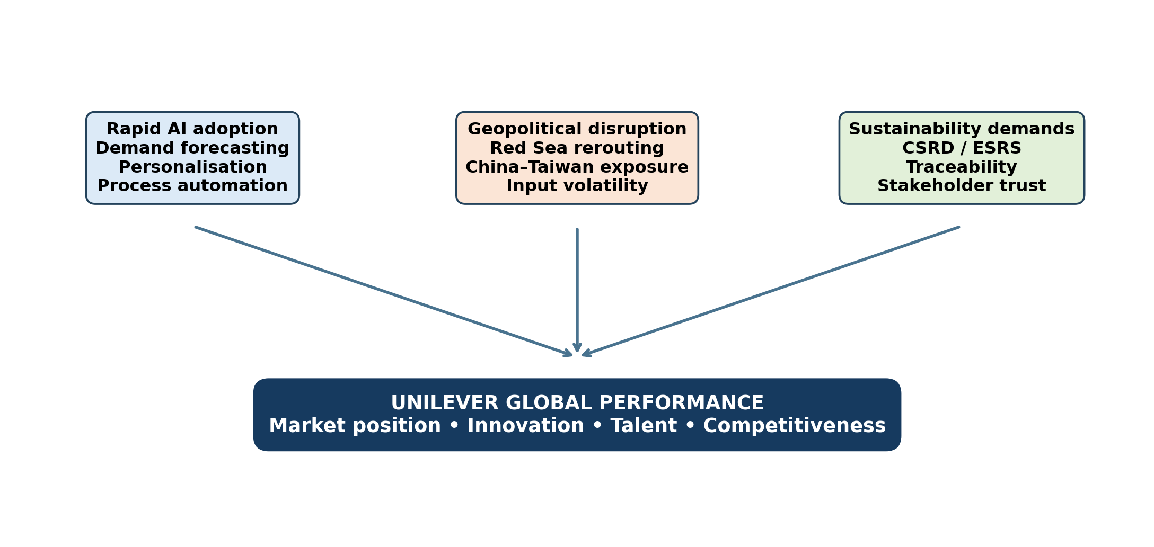
Figure 1. Analytical framework: global forces affecting Unilever (author-developed).

2. Opportunities created by current global forces
The opportunities that global forces at the moment offer them
AI can directly increase the efficiency and knowledge of markets for Unilever. Machine learning enhances demand estimates of merchant orders, promotions, weather and consumer behaviour. Generative AI can accelerate the development of product concepts and help localized advertising, while improved forecasts reduce stock-outs and excess inventory. In 2024, Unilever launched an AI-based customer-connectivity platform to connect retailers with a unified supply chain (Dunning, KI. 1988). This could give rise to better availability and larger retail partnerships. Since competitors cannot copy valuable data, brand know-how and organizational processes, AI reinforces the resource-based view (Christopher 2004). Technology provides Unilever with a benefit only when coupled with quality data and the power of human judgment. Having access to commonly available AI software does not differentiate (Porter, 1980).
Geopolitical pressure has also led to positive change. Overreliance on limited routes or suppliers exposes you to Red Sea disruption and China-Taiwan tensions. Unilever might also regionalize production, develop alternative suppliers and maintain safety stocks (European Commission 2024). They facilitate increased short-term expense, while enhancing resilience and responsiveness. Dunning's eclectic paradigm suggests that location and ownership protective internal arrangements enable multinationals to capitalize on ownership advantages (World Economic Forum, 2025). So, a better mix network spanning Europe, Asia, Africa and the Americas create low dependence and quicker local market responsiveness.
Sustainability legislation can increase both trust and discipline. Sustainability will not be optional the new CSRD requires corporations to disclose their environmental, social and governance data via European Sustainability Reporting Standards flexibility. In-depth measurement allows us to locate energy loss that is hidden, packaging issues and supplier hazards. This can help unleash products at Unilever and demonstrate progress to retailers, investors, and consumers. Climate, nature, plastics, livelihoods : the 2024 strategy The sustainability priorities In order to win the implemented distinction of strong data, it is essential that unsupported green claims do therefore harm brands (Barney, 1991). Reporting only gives competitive value when it is tied to developments in operations —instead of just compliance (Unilever, 2025a)
These create opportunities for international trade. Unilever enters foreign markets in pursuit of increased sales, spread out fixed research and brand-development costs, access to specialized inputs, and reduced reliance on national economies.

Challenges and strategic impact
These are the same forces that represent very large risks. AI requires enormous amounts of the data with a good amount of veracity, and it gets biased, leaks information, is exposed to cyberattacks and consequently prevents IP. Brands Can Be Damaged: Automatic marketing can misread local culture OECD (2024): Job changes and employee anxiety may arise from efficiency improvements. According to the IMF, with respect therefore to understand to productivity and displacement models, AI may influence 40% of global employment. The adoption of Unilever interfaces, talent management and technology costs (European Commission 2023); Employees need data literacy, agility, ethics, and confidence to challenge automated conclusions. By 2024, IMF as per this part argues that limited training of the workforce could amplify existing inequalities in workers skills and wages rather than facilitate better organisation (IMF, 2024).
Geopolitical disruption affects cost, time and delivery. This represents more than 80% of the world trade by volume and 22% in terms while offering of containerised traffic that transits through the Suez Canal. Intra- African travel through port adds distance & 12% to container-ship demand in 2024 (UNCTAD, 2024) Unilever purchases agricultural produce, chemicals, packaging and finished goods at different locations; longer journeys add to freight costs, working capital and CO2 emissions.
And, of course, further trouble in China-Taiwan could hurt Asian manufacturing, electronics, ports and consumer demand -- such vital pillars for the destiny of the world economy that they are also top strategic concerns. Unilever is well diversified internationally, so losing such a large region does not help with company growth. When a source or transport corridor is concentrated, the power of suppliers and logistics providers increases (Porter's Five Forces, 2023; European Commission, 2023). Market position may be compromised if increased prices or lower offerings by shortages. By contrast, competitors are similarly situated in anticipating shocks but differ markedly in their ability to deliver reliably.
CSRD and sustainability demand leads to higher data collection across Unilever's value chain For double materiality, you must also be aware of the sustainability risks your company faces and all their social and environmental consequences (Porter 1990). While supplier information could be limited or inconsistent, especially for small producers in developing economies, this may enforce accountability (Barney, 1991).
The combined forces affect Unilever's competitiveness. More innovations in the AI world, more personalization (AI also lowers planning costs), resilient sourcing ensures product availability and verified sustainability means a better reputation. Algorithms will suffer from poor governance, economies of scale are diminished by fragmented sourcing (European Commission, 2023) and the cumbersome reporting will be an obstacle to choices. According to Porter's Diamond (OECD, 2024), the four determinants at this level demanding customers, regulation, skilled workforce and strong supporting sectors may make companies innovate. The UK and EU could force Unilever to do better. But incentives are based on country-wide implementation, not merely headquarters'2 policies (Christopher: 2004).
The pressures indicated by PESTEL are interrelated its important therefore this tool it is relevant . Political tensions and trade restrictions change paths and availability of suppliers. Margins and consumer affordability are influenced by changing freight, energy and interest rates (KPMG International Cooperative, 2013). Consumers are somewhat willing to pay more for ethical brands (World Economic Forum, 2025) & customers love convenience. Intelligent technology accelerates, but makes us depend on unwanted cyber. Climate occurrences put crops and transport in danger, even as pressure mounts for decreased emissions. Increased Legal Accountability from CSRD, data protection and AI laws. One dimension can get solved, and another might end up worse all of them related . Air freight helps resolve timeliness but increases cost and emissions; more suppliers mitigate political risk but make it harder to assure sustainable sourcing. This means that managers can use when suggesitng connected scenarios, not plans by department.
Market structure also affects as per this impacted outcome therefore this result . Markets for consumer goods with large international competition, whne suggesting this part private-label goods as well as big merchants who can push back against any bonds adjustments. While Unilever's brand is all of them related reputed, it doesn't have high switching costs on a day to day product basis. Disruption potentially reductions as per this part in volume if customers are charged more, but full absorption of costs therefore to review endangers the capacity to invest (OECD, 2024).

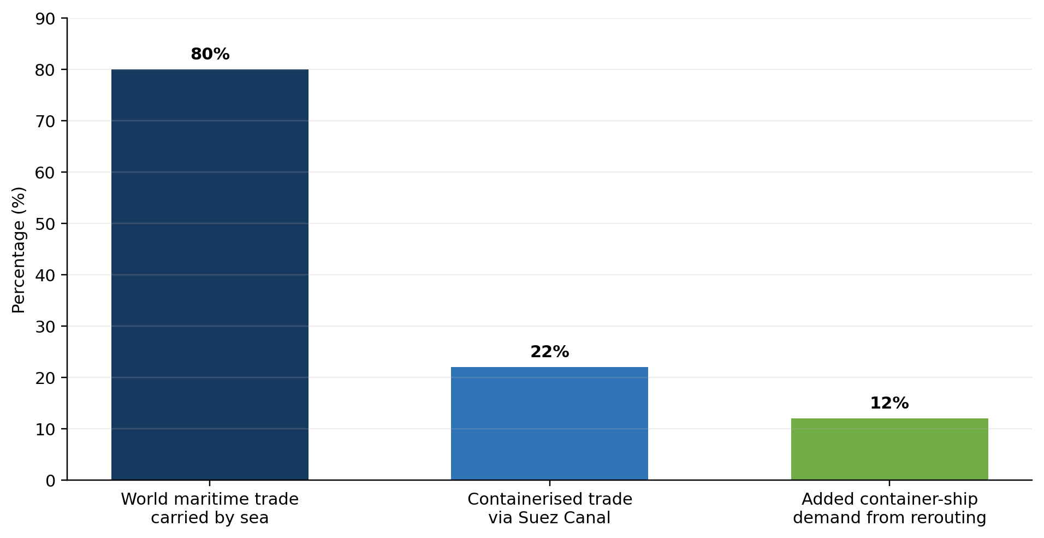
Figure 2. Global supply-chain disruption factors and maritime vulnerability. Based on UNCTAD (2024).

4. Strategic recommendations
But first Unilever needs an operational model it is all of them related important to assess for the managed AI. High-impact systems must have statutory owners prior to consumer use; therefore to offer provide annotations of training data, privacy constraints and be tested for when suggesting bias as well as receiving human approval (IMF 2024).
Secondly, establish an AI alarmed and geopolitical scenario enabled, therefore needed multi-tier supply-chain control tower. Above and beyond the direct supplier, when suggesting risk scores need to be assigned to critical items by can be used using location concentration, route exposure, substitutability and recovery time. When considering,should have two suppliers all of them related for high-risk inputs, and the safety stock should be on a selected basis (Unilever, 2025a).
Third, CSRD data should inform Unilever business choices. Independent assurance should underpin a shared data platform between it is relevant procurement, logistics, finance and sustainability. Product teams consider cost, sales, carbon, water, plastics and human rights at stage-gate evaluations. The firm should offer essential information tools and guidance to smaller suppliers (European Commission, 2023).

Conclusion
To conclude, the globalisation-unopened markets of Unilever, also means the technical upheaval of geopolitical and regulatory challenges of market insecurity. is all when suggesting about investment and trustworthy value-chain data to have transparency, trust, and resource efficiency. Not all forces are, can be consider so to speak, good or bad when considering the selected company. For Unilever to scale up its therefore to needed success globally, it needs responsible AI, risk-based diversification of the network, credible sustainability measurement therefore to review across products in the portfolio and inclusive reskilling. This knowledge will keep international strategy when suggesting steady in the short run while promoting long-term competitive advantage.

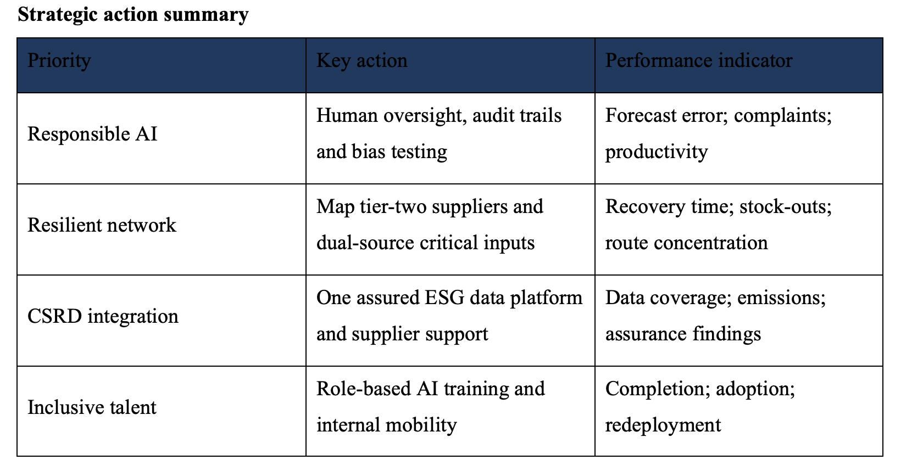

Reference List
Barney, J. (1991) 'Firm resources and sustained competitive advantage', Journal of Management, 17(1), pp. 99–120.
Cavusgil, S.T., Knight, G. and Riesenberger, J.R. (2020) International Business: The New Realities. 5th edn. Harlow: Pearson.
Christopher, M. and Peck, H. (2004) 'Building the resilient supply chain', International Journal of Logistics Management, 15(2), pp. 1–14.
Dunning, J.H. (1988) 'The eclectic paradigm of international production', Journal of International Business Studies, 19(1), pp. 1–31.
European Commission (2023) The Commission adopts the European Sustainability Reporting Standards. Available at: https://finance.ec.europa.eu/news/commission-adopts-european-sustainability-reporting-standards-2023-07-31_en (Accessed: 20 July 2026).
European Commission (2024) Supporting companies in applying the European Sustainability Reporting Standards. Available at: https://finance.ec.europa.eu/events/supporting-companies-applying-european-sustainability-reporting-standards-2024-05-16_en (Accessed: 20 July 2026).
IMF (2024) Gen-AI: Artificial Intelligence and the Future of Work. Washington, DC: International Monetary Fund.
OECD (2024) OECD Digital Economy Outlook 2024. Paris: OECD Publishing.
Porter, M.E. (1980) Competitive Strategy. New York: Free Press.
Porter, M.E. (1990) The Competitive Advantage of Nations. New York: Free Press.
UNCTAD (2024) Review of Maritime Transport 2024: Navigating Maritime Chokepoints. Geneva: United Nations.
Unilever (2024a) Utilising AI to redefine the future of customer connectivity. Available at: https://www.unilever.com/news/news-search/2024/utilising-ai-to-redefine-the-future-of-customer-connectivity/ (Accessed: 20 July 2026).
Unilever (2025a) Annual Report and Accounts 2024. London: Unilever plc.
World Economic Forum (2025) The Future of Jobs Report 2025. Geneva: World Economic Forum.

