Effective team working and communication
University of Wales Trinity Saint David
Mina Carmen Iacobescu
Student ID: 2010126
Tutor : Lloyd Beharry

Shannon and Weaver Model of Communication

The Shannon and Weaver Model of Communication can be defined as a mathematical theory of communication that emphasizes breaking the fundaments of human communication into 6 crucial components.
- Sender
- Encoder
- Channel
- Noise
- Decoder
- Receiver

Claude Shannon was the main mind behind the establishment of the model and therein it has been popularly known as the Shannon theory (Cargill 2019). The primary factor behind the formulation of the model was to explain how messages can potentially get lost and end up being distorted by the end of the communication process. This model of communication is linear, demonstrating how messages or information are sent and received in the process of communication. The Shannon and Weaver Model of Communication is best known for reflecting how significant messages end up being misinterpreted by the receiver at the end of a communication process (Petersons and Khalimzoda 2016). Claude Shannon asserted that the primary glitch arising in a communicational cycle is grounded on the reproduction of the message sent by the sender from one point, perhaps either exactly or somewhat approximately to the receiver to the endpoint.
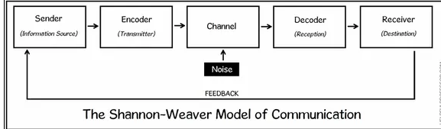
The Shannon Weaver Model begins with an information source, which can also be termed as the sender. It is any individual or object containing the information in the first place. The sender commences the communication process by sending across the message he/she wishes to, someone through which the message can be passed across, and lastly the communication channel via which the desired message is to be sent. Furthermore, the information source can pass across a message in numerous ways. This may include any message sent orally, in a written format, through music, or even body language. The encoder then plays its part of any machine or person who undertakes the function of converting the idea into signals that could be sent from the information source to the receiver (Mohorek and Webb 2015). Moreover, an encoder can be any person that converts the idea into written or spoken words, and sign languages for communicating the idea to the receiver. The presence of a channel in the Shannon Weaver Model of Communication refers to the infrastructure that plays a crucial role in terms of getting the initial information from the sender and transmitter through to the receiver and decoder. The channel has often been regarded as the medium. Next up is the relevance of noise in the communication process. Shannon and Weaver explain that noises interrupt a communication process while any message is on its way from the sender to the decoder. The noises can internal, external, or simply both. Internal noise occurs in a communication process particularly when the sender ends up making mistakes while encoding the message or when a receiver makes mistakes whilst decoding the sent message. On the other hand, external noise disrupts a communication process when external factors outside the control of both the sender and the receiver act as an inhibitor to the message (van Ruler 2018). Conversations around a busy road or highway can often distort a communication process by factors like the sound of cars. The decoder in the Shannon and Weaver model of communication is exactly the opposite of encoding. In a communication process involving two individuals devoid of any presence of technology, the receiver might as well have to decode a message or a piece of information by converting written words in a way that makes sense to the mind of the receiver, or the receiver might have to decode and interpret the underlying meaning of imagery or a picture that has been sent to the receiver. The receiver on the other hand happens to be the ultimate destination. A receiver is any person who is the end-point of any process of communication. This is when the receiver has finally received the initial message or has interpreted an approximate version of the same, after having accounted for the barriers of noise. In the case of Maria and Pedro, the barriers of external noise could have potentially distorted the communication process between the two of them. The external noises from the building site acted as a potential barrier reflecting the role of noise in a communication process. Considering the sound and the situation, it can very be said that it was the sound and noises from the building site that led to Pedro interpreting Maria's message as the kitchen, instead of chicken.
The Shannon Weaver Model as proposed in 1948 misses out on the important component of feedback. It was until Norbert Weiner introduced the feedback step into the model. Feedback ensures the receiver responds to the sender in order to close the communication loop (Van Ruler 2018). This helps them communicate with the sender ensuring whether they have received the message without any form of distortion or misinterpretation.
Based on my experiences at my workplace, there have been several instances when I had to communicate with my immediate boss over a telephonic conversation, wherein there occurred misinterpretation in terms of encoding the information I intended to pass across to my boss. I was having a conversation with my boss over the phone when my brother turned on the television, owing to which there occurred distorted communication between my boss and myself.
1.2 Schramm’s Model
Wilbur Schramm’s Model of Communication is somewhat of an improvement or an enhanced version of the Shannon-Weaver Model of Communication. Schramm's model is more often than not regarded as a way more comprehensive than that of the Shannon-Weaver model, owing to the missing significance of feedback in the latter. Besides, Schramm's model identifies the relevance of feedback in the communication process, furthermore cultivating a two-way process of communication (Elleström 2018). Schramm's model comprises three primary elements, that encoding, interpreting, and decoding, whereas the Shannon-Weaver model reflects the presence of a speaker, receiver, encoding, decoding, channel, and noise (McQuail and Windahl 2015).
Moreover, the Osgood-Schramm model of communication represents a circular model, instead of a linear model of communication. The model embodies a sender who takes on the role of encoding a message, followed by the recipient taking on the act of decoding the message sent. Both the sender and the receiver hold crucial roles in the communication model. Therein, the significance of interpretation stands imperative to the model. Going by Schramm's model of communication, factors like coding and decoding happen to be primary components contributing to effective and successful communication. He furthermore asserted that any successful communication would be left incomplete until the recipient delivers feedback back to the sender regarding the sent message (Popescu et al. 2015). In other words, Schramm’s model explains that communication undertakes between the sender or transmitter and the receiver or recipient. The recipient has the access to sending feedback to the sender on the message that has been sent. The feedback is sent with the aim to confirm whether the initial message has been received properly, understood appropriately, and interpreted without any distortion (Gopeni, Wayi and Flowerday 2016).
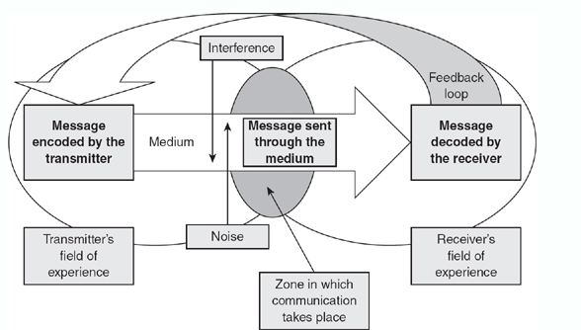
Schramm's model of communication views a communication process in a practical approach. The model explains that the communication place can take place within oneself or amongst two individuals, where each individual acts the role of both the sender and the receiver, therein making use of interpretation. This model introduced the concept of semantic noise. This concept furthermore explained that such interference of barriers arise when both the sender and the receiver draw differing meanings and interpretations to the same message (Liebers and Schramm 2019). Such interference of barriers is mostly evident owing to the use of certain words and phrases, such as the like of technical languages. These words and phrases lead to the deviation from the actual and original intended meaning of the message. Schramm added that decoding and interpretation become ineffective particularly when semantic noise takes over. Thus, it ends up causing individuals to deviate from the original message and the intended meaning. The greatest advantage of Schramm's model is that the model successfully shows how a situation can potentially change. Besides, the model of communication has no separate sender and receiver, rather both the sender and the receiver happen to be the same individual, while the presence and significance of feedback remain central to the model (McQuail and Windahl 2015).
Schramm’s model of communication insisted that communication processes cannot be reduced to the passing of information from one entity to another. Furthermore, he emphasized that semantic barriers or noises are nothing but the background knowledge, beliefs, and values impacting how an individual passes on a message and how a receiver chooses to interpret the same (Koptseva, Liia and Kirko 2015). With the presence of feedback and owing to its two-way communication attributes, it can be said that semantic noise can be minimized when the two communicators involved in the process come to terms with their respective interpretations by providing feedbacks or clarification regarding the underlying meaning of the message.
As in the case of Maria and Pedro, had Pedro made sure to call Maria back to clarify the confusion and ambiguity caused, by asking as to whether Maria meant "Kitchen", only then would the interference caused by the semantic barriers, generating from the building site be eliminated.
1.3 Berlo’s SMCR Model of Communication
Berlo’s model of communication is primarily outlined into six different stages. The six stages involve the communication source, followed by the encoding of the message, followed by the message, the method via which the message gets delivered, the decoding procedure of the sent message, and lastly the receiver receiving the message (Muyanga. and Phiri 2020). David Berlo has been highly credited for postulating his Sender-Message-Channel-Receiver model of communication. He explained in his model the various factors hindering the individual components in a communication cycle, therein causing inefficacy to the entire process of communication (Majithia 2018). Additionally, the SMCR model emphasized primarily the encoding and decoding aspects that take place before the sender transmits the message and before the receiving of the message by the receiver respectively.
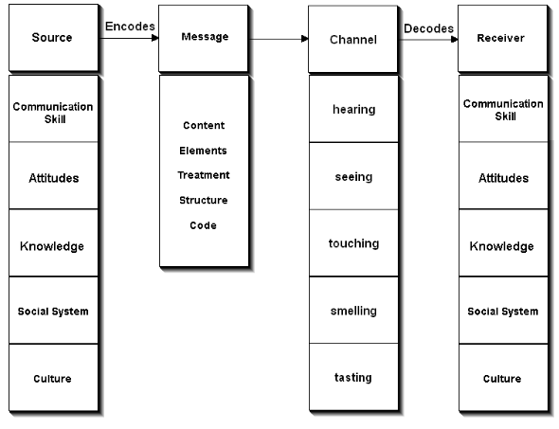
The sender plays the role of the source who initiates the message. Communication skills play a crucial part in terms of effective transmission of the message. When a sender possesses good communication skills, the message will be communicated in a much appropriate way. Likewise, the receiver ought to draw the message effectively in order to interpret its intended meaning. Good communication skills are central to successful communication processes, as it includes skills like an individual's ability to listen, speak, write, read, etc. Moreover, the attitude of both the sender and the receiver has an equally important role to play (Perugia 2015). The message on the other hand can be defined as the substance or information that has been sent to the receiver by the sender. Treatment is one of the most determining factors that suggest how the original message is being conveyed to the recipient. Moreover, treatment has significant effects on the receiver's drawn feedback. In the SMCR model of communication, the channel is any medium that has been made use of by the sender. This medium could either be a telephone or simply anything else. Lastly, the receiver is the person receiving the message at the end of the communication cycle. Additionally, Berlo’s SMCR model of communication has no presence of any feedback; neither does it include the concept of noise and barriers in the communication process. It is more of a linear model devoid of a two-way communication. Both the sender and the receiver are to be similar in accordance with the relevant factors.
The SMCR Model of communication stresses that factors like an individual's thinking patterns are supposed to be synchronized with the sender in order to yield a successful communication process. Besides, the original message may not impart the same or the intended effect in case both the sender and the receiver are not similar. The receiver ought to have equally good and effective listening skills to reap a successful communication cycle (Bergman 2019). These factors also include and involve both the sender’s and the receiver's communication skills, their knowledge of the subject or the context, their respective attitudes, culture, and the relevance of social systems.

References

Bergman, M., 2019. Towards a Pragmatistic Perspective on Models of Communication. Models of Communication: Theoretical and Philosophical Approaches, pp.47-63.
Cargill, S.S., 2019. How do we really communicate? Challenging the assumptions behind informed consent interventions. Ethics & human research, 41(4), pp.23-30.
Elleström, L., 2018. A medium-centered model of communication. Semiotica, 2018(224), pp.269-293.
Gopeni, A., Wayi, N. and Flowerday, S., 2016. A feedback loop model to facilitate communication between citizens and local government in Buffalo City. In International Conference on Information Resources Management (CONF-IRM). Association for Information Systems AIS Electronic Library (AISeL).
Koptseva, N.P., Liia, M. and Kirko, V.I., 2015. The Concept of “Communication” in Contemporary Research.
Liebers, N. and Schramm, H., 2019. Parasocial interactions and relationships with media characters–An inventory of 60 years of research. Communication Research Trends, 38(2), pp.4-31.
Majithia, R.K., 2018. CRAFTING CONTENT FOR INNOVATIVE LEARNING IN DESIGN EDUCATION. Makers, Crafters, Educators: Working for Cultural Change, p.39.
McQuail, D. and Windahl, S., 2015. Communication models for the study of mass communications. Routledge.
McQuail, D. and Windahl, S., 2015. Communication models for the study of mass communications. Routledge.
Mohorek, M. and Webb, T.P., 2015. Establishing a conceptual framework for handoffs using communication theory. Journal of surgical education, 72(3), pp.402-409.
Muyanga, C.C. and Phiri, J., 2020. Assessment of Effective Communication in International Schools in Developing Countries Based on the Berlo’s SMCR Model. Open Journal of Business and Management, 9(1), pp.448-459.
Perugia, L., 2015. Reflecting on a critical incident within the workplace. British Journal of Healthcare Assistants, 9(11), pp.566-569.
Petersons, A. and Khalimzoda, I., 2016, May. Communication models and common basis for multicultural communication in Latvia. In SOCIETY. INTEGRATION. EDUCATION. Proceedings of the International Scientific Conference (Vol. 4, pp. 423-433).
Popescu, D.M., Pârgaru, I., POPESCU, C. and Mihai, D., 2015. A multidisciplinary approach of communication. Theoretical & Applied Economics, 22(2).
van Ruler, B., 2018. Communication Theory. The International Encyclopedia of Strategic Communication, pp.1-7.
Van Ruler, B., 2018. Communication theory: An underrated pillar on which strategic communication rests. International Journal of Strategic Communication, 12(4), pp.367-381.

