BSc Computing Portfolio

Project Management

ACDA5004

Managing a Hardware/Software Project for Disaster Recovery

Lifeline

Helen Frey

P131560

Lecturer: Sue Maw

Table of Contents
Introduction 3
Risk Management 3
Identification: What Are the Risks? 3
Risk Evaluation Matrix 3
Strategy for High Risks 3
Code of Practice: Sustainability Issues 4
First Order: Direct 4
Second Order: Indirect 4
Third Order: Systemic 4
Code of Practice: The BCS and IEEE Code of Conduct 4
Ethical and Legal Issues for Project Lifeline 8
The Chartered Institute for IT: Digital Brexit Report 9
Lifeline Project Management and Brexit 9
Quality Assurance Issues 10
Usability 10
Reliability 10
Functionality 10
Efficiency 10
Power Point Presentation 11
Bibliography 13
Appendix 1: Project Management – Gantt Chart 15

Introduction
This report sets out the project management ramifications for the commission and deployment of an all-terrain truck to provide temporary internet connection to the residents of Kansas City in the aftermath of a tornado which has wiped out the network infrastructure.

Risk Management
“Risk is when an uncertain event or condition can occur and have an effect on the project outcome. That effect can be positive or negative.” [1]
Projects are based on assumptions and risk is the possibility that the assumption is incorrect, the following steps set out the risks associated with this project [2].

Identification: What Are the Risks?
R1 Brexit;
R2 Safety concerns of traversing a tornado swept area eg trees, infrastructures or power lines falling or burst gas, water or sewage pipes.
R3 Getting the internet (Worldwide Interoperability for Microwave Access, Inc. (“Wi-Max”)) to be effective with the number of particles of dust in the air which can cause scattering and refraction issues;
R4 Satellite coverage;
R5 Fuel and supplies for drivers and operators;
R6 Secondary weather issues, flooding, strong winds etc.

Risk Evaluation Matrix

High | R5 | R4 |  | R2, R6
Significant |  |  | R3
Moderate |  |  |  | R1
Low
 | Low | Moderate | Significant | High

Impact

Probability

Strategy for High Risks
Devise a set of rules and regulations so that if any of the above-mentioned risks occur the truck occupants would know how to react, for example R2: if there are burst gas or water pipes then the driver would have to leave the area and concentrate on a different area until it was safe to traverse that area. R6: find shelter until the weather condition had passed. R3, this has already been taken into consideration when designing the path that the truck would take. WiMax boasts a 30-mile radius [3], but due to the reflection and refraction issues of dust and other particles in the air, it was decided that if the truck was able to give internet access to both sides of the street that would be sufficient. If internet access was further than this, it would be a bonus.

Code of Practice: Sustainability Issues

First Order: Direct
As this is a new build there is no electronic waste when replacing hardware. However, there will be a need in the future for the electronic devices to be replaced so there will be some form of electronic waste. The truck will use fuel at low speeds in an urban terrain so that will also be a direct sustainability issue regarding fuel and emissions.

Second Order: Indirect
Transportation of the vehicle and training personnel to Kansas. As Cisco has a base in Kansas [4] the routers and switches could come directly from them to limit any transportation issues.

Third Order: Systemic
Should this system work then more trucks would be produced and could cause systemic changes to current practices. There would however be savings over costs of disaster recovery services randomly going around the city looking for survivors and call centres not having to answer so many enquiries about families’ loved ones.

Code of Practice: The BCS and IEEE Code of Conduct
The British Computer Society (BCS) Code of Conduct [5] and the Institute of Electrical and Electronics Engineers (IEEE) Code of Conduct [6] has been compared as follows:
No. | BCS | No. | IEEE
1a  1b | Public Interest  Due regard for:  Public health, privacy, security, wellbeing of others and environment.  And the legitimate rights of third parties. | 1 | Respect for others  We will be respectful of others, including IEEE members and IEEE employees, and will act in a professional manner while participating in IEEE activities.  We will be respectful of the privacy of others and the protection of their personal information and data.
1c | Non-discrimination regarding:  Sexual orientation, marital status, nationality, colour, race, ethnic origin, age, disability or any other condition. | 2 | Non-discrimination regarding:  Age, ancestry, colour, disability or handicap, national origin, race, religion, gender, sexual or affectional orientation, gender identity, gender expression, appearance, matriculation, political affiliation, marital status or veteran status.
1d | Promote equal access to IT and promote the inclusion of all sectors in society whenever possible.
2a  2b | Only undertake work within your professional competence.  NOT claim any level of competence that is not in your possession.
2c | Continuous professional development, maintaining awareness of technological developments, procedures and standards relevant to your discipline.
2d | Ensure that you have the knowledge and understanding of Legislation of the jurisdiction that you are under and that you comply with such Legislation, in carrying out your professional responsibilities. | 5 | Comply with applicable laws in all countries where IEEE does business and with the IEEE policies and procedures.
2e | Respect and value alternative viewpoints and, seek, accept and offer honest criticisms of work.
2f | Avoid injuring others, their property, reputation, or employment by false or malicious or negligent action or inaction. | 3 | We will avoid injuring others, their property, data, reputation, or employment by false or malicious action.  We will not engage in or participate in the spreading of any malicious rumours, defamation or any other verbal or physical abuses, against an IEEE member, employee or other person, whether on the Internet or otherwise.
2g | Reject and will not make any offer of bribery or unethical inducement. | 5a  5d | Rejecting bribery in all forms.  Not agreeing with competing persons to fix prices or reduce price competition through allocation of customers or markets, manipulate bids in any competitive bidding process, or engage in other acts that result in restraining trade.
3a | Carry out your professional responsibilities with due care and diligence in accordance with the Relevant Authority’s requirements whilst exercising your professional judgement at all times.
3b | Seek to avoid any situation that may give rise to a conflict of interest between you and your Relevant Authority. | 5b | Avoiding real or perceived conflicts of interest whenever possible and disclosing them to affected parties when they do exist.
3c | Accept professional responsibility for your work and for the work of colleagues who are defined in a given context as working under your supervision.
3d | NOT disclose or authorise to be disclosed or use for personal gain or to benefit a third party, confidential information except with the permission of your Relevant Authority, or as required by Legislation. | 5c  5e | Protecting confidential information belonging to IEEE and personal information belonging to IEEE members, employees and other persons.  Not misusing or infringing the intellectual property of others.
3e | NOT misrepresent or withhold information on the performance of products, systems or services (unless lawfully bound by a duty of confidentiality not to disclose such information) or take advantage of the lack of relevant knowledge or inexperience of others.
4a | Accept your personal duty to uphold the reputation of the profession and not take any action which could bring the profession into disrepute.
4b | Seek to improve professional standards through participation in their development, use and enforcement.
4c | Uphold the reputation and good standing of BCS, the Chartered Institute for IT.
4d | Act with integrity and respect in your professional relationships with all members of BCS and with members of other professions with whom you work in a professional capacity
4e | Notify BCS if convicted of a criminal offence or upon becoming bankrupt or disqualified as a Company Director and in each case give details of the relevant jurisdiction.
4f | Encourage and support fellow members in their professional development.
 |  | 2 | We will not engage in harassment of any kind, including sexual harassment, or bullying behaviour whether in person, via cybertechnology or otherwise.
 |  | 4 | We will not retaliate against any IEEE member, employee or other person who reports an act of misconduct, or who reports any violation of the IEEE Code of Ethics or this Code of Conduct.  We will not retaliate against any person who makes IEEE aware of the violation of any laws, rules or regulations in connection with IEEE activities.
 |  | 5d | Not agreeing with competing persons to fix prices or reduce price competition through allocation of customers or markets, manipulate bids in any competitive bidding process, or engage in other acts that result in restraining trade.

It can be seen from the above table that the British Computer Society’s Code of Conduct is far more comprehensive that the IEE’s Code. Also, the BSC appears to have more interest in members keeping up to date and making sure that the profession’s integrity is maintained, whilst the IEE appears more focused on the members themselves.

Ethical and Legal Issues for Project Lifeline
Working in Kansas, local legislation would need to be taken into consideration. The workforce would be monitored to ensure that working conditions were maintained to both BCS and IEE standards so that all ethical issues would be covered. However, as mentioned in smallbusiness.chron.com would all employees read these codes of conduct? Their answer to this is: “It's not enough to put it in the company handbook. Even supplying copies to everyone assumes they will read it cover to cover. At minimum, employers should send a memo marked "Important" to everyone spelling out common practices that the company considers unethical as well as the possible consequences for them. Ask each employee to send a reply email saying they received and read the memo. Better still, schedule a mandatory mini-training session where everyone hears the news, word for word. Take attendance, and record the session for those who were absent or anyone who wants to review the information at any time.” [7] which seems much more appropriate and would be considered good practice by project team leaders.

The Chartered Institute for IT: Digital Brexit Report
Brexit has so much uncertainty and speculation at this moment in time that it is difficult to predict anything with any certainty. However, the charity, The Chartered Institute for IT (BCS) has reacted to ensure that IT policies are taken into consideration at this pivotal moment in British politics [8]. The BCS has therefore called for the establishment of a Royal Commission on personal data and its protection [9].
Since May 2018, Britain is under the General Data Protection Regulations (GDPR) set out by the European Commission [10]. When Britain leaves the EU (29 March 2019) British citizens will have to use the GDPR when dealing with countries still within the EU. According to IT Pro the Regulations state that “the transfer of personal data to a non-EU country is prohibited unless that country has “an adequate level of data protection”” which is why Britain has replaced the Data Protection Act [11] with the Data Protection Bill. “The Bill is a complete data protection system, so as well as governing general data covered by the GDPR, it covers all other general data, law enforcement data and national security data. Furthermore, the Bill exercises a number of agreed modifications to the GDPR to make it work for the benefit of the UK in areas such as academic research, financial services and child protection.” [12]
Wider implications in this area is the Digital Single Market that Europe will create for which the GDPR was created. Britain will no longer be a part of this – how will this affect the IT sector post Brexit? [13]
A lot of focus on Brexit and IT is put on the GDPR. Little is said about the Universal Service Obligation (USO) which came in force on 23 April 2018 which is EU driven. Following Brexit, is this now going to continue or will it be left by the wayside as the EU will no longer force the issue? [14], [15] The author thinks that most of the EU driven issues will be ignored if Brexit takes place.

Lifeline Project Management and Brexit
This project would not have any issues with GDPR as any data generated on the Kansas citizens would be held in America by their emergency services. With Cisco Corporate HQ in California and a local office in Kansas, it would be more judicious to have all deliveries sent directly to our Kansas collaborators with the Project installation to be set up there rather than in Lifeline’s London HQ. This way, stockpiling parts would not be necessary as it may have been had the project taken place in Britain.
Although speculative, there is a possibility that Brexit could influence how British people can travel to the USA. Currently they are part of the US Visa Waiver Programme and benefit from travel to the USA using the Electronic System for Travel Authorisation (ESTA) and although there are some non-EU countries that benefit from this system there is no guarantee that Britain will become one of them. Also, current British passports have ‘European Union’ written on them, which once Brexit takes place would be deceitful at best and fraudulent at worst. The ESTA is directly linked to the passport and this could cause many problems in travel arrangements with the USA [16].

Quality Assurance Issues
Although Boehm’s Software model is often used for IT this does not really fit in with the scope of this report as Nick Hinder (team member responsible for software aspects of the project) would most likely cover this in his report.
Quality is quite a subjective term and totally dependent on the point of view: Usability, Reliability and Functionality and Efficiency have been used in this report to evaluate the quality of the project.

Usability
“Usability is the measure of a product's potential to accomplish the goals of the user. … Usability testing is a method by which users of a product are asked to perform certain tasks in an effort to measure the product's ease-of-use, task time, and the user's perception of the experience.” [17]
The project would use Cisco qualified network engineers to operate routers, switches and connect to the Internet whilst a driver navigated a city. The routers and switches would be pre-configured, and their task would be to monitor successful use by citizens. For a qualified engineer this would be a simple task as they would have been trained by Cisco and then shown the use of the system when trained by Lifeline. There would be a week for acceptance testing by the client and this would be reviewed after a tornado to see if any changes were required.

Reliability
Calls to the help-desk would be monitored for reliability issues with the equipment whether this is the truck or network infrastructure. Crash reports or downtime would need to be logged as well. No more than 10 calls on reliability per month would be acceptable.

Functionality
A questionnaire would be given out for feedback and this must be 75% acceptable as a minimum. The project would need to meet 100% of high priority features and 70% of medium priority features requested by Kansas City officials.

Efficiency
Efficiency would be measured over time as to whether the project worked or whether different parameters would need to be used as Lifeline is a new concept.

Power Point Presentation
A simulation of the project was made in Packet Tracer and a presentation made. Screenshots were taken of the presentation slides. Figure 1 shows a map of Kansas City with the rectangle representing the truck and the gridded circle surrounding it is the area of internet coverage. Whilst this shows coverage of more than one street, as mentioned above in the Risk Management Strategy, Internet access may be more or less and cannot be calculated before the event as each tornado debris left in the air will differ.
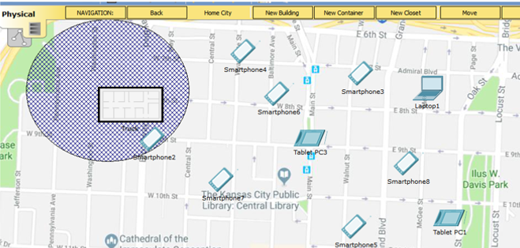
Figure 1: Packet Tracer showing Internet Access

Figure 2 is the logical view in Packet Tracer showing that only the smart device within the grid has a connection whilst the remaining smart devices were out of reach and cannot connect.
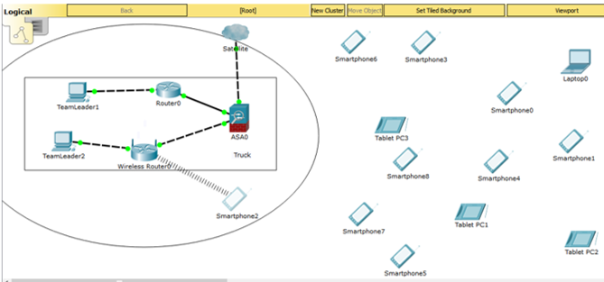
Figure 2: Logical view of Packet Tracer showing a connection
Figure 3 shows the physical view as the truck progresses down the street. It can be seen that the initial smart device no longer has connection and the 4 other devices within the grid are now within the coverage range and have Internet access.

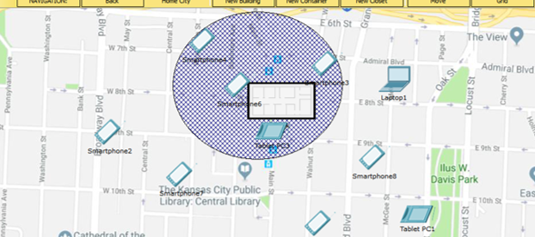
Figure 3: Packet Tracer continuation of truck's progress

Figure 4 shows the logical view of the truck’s passage down the street with the devices having access and the original smart device no longer able to connect.
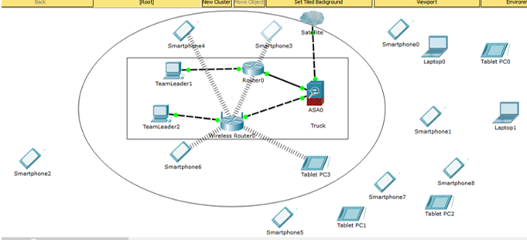
Figure 4: Packet Tracer logical view of truck's progress

Bibliography
[1] “What Is Project Risk? - ProjectManager.com.” [Online]. Available: https://www.projectmanager.com/training/what-is-project-risk. [Accessed: 27-Dec-2018].
[2] “Risk Management Approach - PRINCE2 2017 Primer - PRINCE2 Practitioner Self Study Tuition Exam Training Online.” [Online]. Available: https://www.prince2primer.com/risk-management-approach/. [Accessed: 28-Dec-2018].
[3] “WiMAX Coverage and Speed | HowStuffWorks.” [Online]. Available: https://computer.howstuffworks.com/wimax2.htm. [Accessed: 17-Jan-2019].
[4] “Cisco Global Contacts.” [Online]. Available: https://globalcontacts.cloudapps.cisco.com/contacts/officeLocation/en_US. [Accessed: 16-Jan-2019].
[5] “Trustee Board Regulations Schedule 3 v5-Code of Conduct for BCS Members BCS, THE CHARTERED INSTITUTE FOR IT TRUSTEE BOARD REGULATIONS-SCHEDULE 3 CODE OF CONDUCT FOR BCS MEMBERS.”
[6] “IEEE - Ethics and Compliance.” [Online]. Available: https://www.ieee.org/about/compliance.html. [Accessed: 17-Jan-2019].
[7] “Common Ethical Workplace Dilemmas | Chron.com.” [Online]. Available: https://smallbusiness.chron.com/common-ethical-workplace-dilemmas-748.html. [Accessed: 18-Jan-2019].
[8] “Digital Brexit Planning for a successful digital future outside of the EU.”
[9] “BCS Digital Brexit Report | BCS Policy Hub.” [Online]. Available: https://policy.bcs.org/position_statements/bcs-digital-brexit-report. [Accessed: 28-Dec-2018].
[10] “2018 reform of EU data protection rules | European Commission.” [Online]. Available: https://ec.europa.eu/commission/priorities/justice-and-fundamental-rights/data-protection/2018-reform-eu-data-protection-rules_en. [Accessed: 16-Jan-2019].
[11] “GDPR and Brexit: how will one affect the other? | IT PRO.” [Online]. Available: https://www.itpro.co.uk/policy-legislation/31772/gdpr-and-brexit-how-will-one-affect-the-other. [Accessed: 16-Jan-2019].
[12] “Data Protection Bill Factsheet-Overview.”
[13] “Navigating Brexit and GDPR | Blogs | Blogs and videos | Publishing and editorial | BCS - The Chartered Institute for IT.” [Online]. Available: https://www.bcs.org/content/conBlogPost/2612?utm_source=British Computer Society&utm_medium=email&utm_campaign=7611269_Brexit Bulletin. [Accessed: 16-Jan-2019].
[14] “The Electronic Communications (Universal Service) (Broadband) Order 2018.”
[15] “A Universal Service Obligation.” [Online]. Available: https://www.btplc.com/Thegroup/Policyandregulation/KeepingtheUKconnected/USO/index.htm. [Accessed: 16-Jan-2019].
[16] “The effect that Brexit could have on ESTA and the VWP.” [Online]. Available: https://www.application-esta.co.uk/brexit-effect-on-ESTA. [Accessed: 18-Jan-2019].
[17] “What is usability? - Definition from WhatIs.com.” [Online]. Available: https://searchmicroservices.techtarget.com/definition/usability. [Accessed: 17-Jan-2019].

Appendix 1: Project Management – Gantt Chart
There was only one delay and that was in the delivery of networking equipment. This did not impose any significant delays as there was sufficient leeway in the timings to allow for this.



