

Application Development
  - Assignment 2
  - Module Code: ACCA5012
  - LEcturer: Dr Kemi Ademoye
Ruzy Aktar | 1708215 | 08/06/2020
Contents
Introduction 3
Web Application / Purpose & Subject Matter 4
Target audience 5
Relevance 5
Design and implementation 6
Registering 6
Testing the registering 6
Login 7
Testing forgotten password feature 7
Adding a new record 8
Testing 9
Testing body function fields 9
9
Conrollers/ Views & Methods 10
Methods / classes / scripts 11
View models 12
Evaluation 13
Future improvements 14
Screenshots of the pages 15
Home 15
Register 17
Login 18
After login 18
Forgot password page 22

Introduction
Throughout this report the student has been asked to demonstrate their knowledge of understanding the visualization of technologies used with the development and building of applications. Part 1 is the implementation ; the student has been told to design and implement an ASP.NET MVC web application of their choice. Which incorporates with a SQL Server Express LocalDB, this is for storing and safe keeping managing the data. However, the student may use MVC Controllers or MVC Web API Controllers for the controller technology and razor and JavaScript or Blazor for the views. The student has been given instructions to follow and the scenario must be compatible to the real world.
Furthermore, the student must make the database to be properly normalized to 3NF and have minimum of 3 tables along with the standard user tables given by the .NET framework.
These are the requirements the application should showcase, the features including:
- Data display
- Interactively querying and displaying results
- Form validation
- Manipulating data using CRUD operations
- Main models
- Views/view models and controllers the student implemented.

However, part 2 is the student giving an explanation with a brief description about the web application. Defining the aim and subject matter as well as the target audience and the importance. This will be done throughout the report.

Web Application / Purpose & Subject Matter
Following the requirements and features the student created a website application. Using ASP.NET & MVC with the database being normalized to 3NF with the features added:
- Data display
- Interactively querying and displaying results
- Form validation
- Manipulating data using CRUD operations
- Main models
- Views/view models and controllers the student implemented.
The website application was made for a fitness website. The student chose fitness because the student believes fitness is important and more people should be leading a healthy lifestyle. The student looks up to this and thus as created a website on this topic. When loading the website up the features for the website is to get the target audience which are fitness enthusiast and individuals who would like to make their life healthier to gain knowledge. However, as well as that the website allows individuals to join the gym and sign up to get a membership. This is done by clicking ‘ Join Us’ or simply by registering.

The student has researched that turning digital has be profound to be good for helping individuals with real life problems. And by doing thorough research and understanding from students experience health is an issue. Thus, by having a website application online is helpful to those who may be scared to give fitness a chance. This not only helps individuals but business retailers to gain customers.
Online shopping is a growing business itself and has done a lot for industries through a lot of lifelong challenges e.g. a pandemic or if individuals are incapable of leaving their homes for self-matters.
‘ By 2021, there are expected to be 2.14 billion people shopping online. And yes, that includes gym related products and services.’[1]

Target audience
The student has created a fitness website application, a website application currently is important today. Individuals rely upon online support and furthermore are always using smartphones. It is why most businesses earn profit from online customers rather than customers who go to the shop or an actual gym. Individuals who may want to start a better future for themselves but have never been to a gym can be challenging.
Furthermore , individuals who have a busy schedule cannot always be at the gym when there are promotional discounts as well as being there to read information and join to carry out a membership.
Therefore, having an online platform not only allows them to join but it is possible to gain information see if the gym is capable of aiding disabled and elderly. With thorough research it has been said “ It also helps you get discovered and can set you apart from your competition”[2]. The student has understood not only is it good for individuals but gym businesses as well.
The target audience would be:
- Individuals concerned about fitness
- Want to gain knowledge on fitness
- Make a membership
- Curious about fitness workouts
- Want knowledge on gym membership prices
- Healthy living enthusiast
- Competitors vising the page for knowledge.

Relevance
The student has come to realise relevance is creating a website which is intriguing to individuals that will relate to them. A fitness website must have content which will entice and help individuals or be a value to them throughout. Such as introducing simple workouts and making content which will benefit them during any time of the day and any environment, they may be in.
Such as offering tips and information is cost free, this gives individuals a chance to browse the website and experience the real value of the website. This builds hope for the website and good traffic for the website to be relevant to them. This makes it interesting for individuals and comfortable to find many other features they may like for what the website offers.

Design and implementation
There many main design features for the fitness application called Gym X , such as the following:

Registering
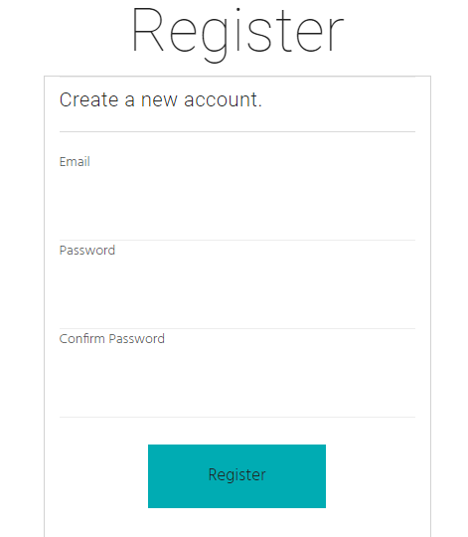
On the home page there is an active button. This button is called ‘New Member’, this button allows new individuals to connect to a new page which allows individuals to register for an account. The registering account wil ask for the simple requriments an email and password to be inputted twice.
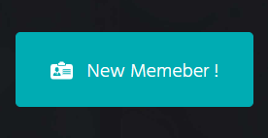

Figure 2

Figure 3

Testing the registering
The student tested to see if the registering process works , and it has been sucessful to be able to register which automatically then logins you in .
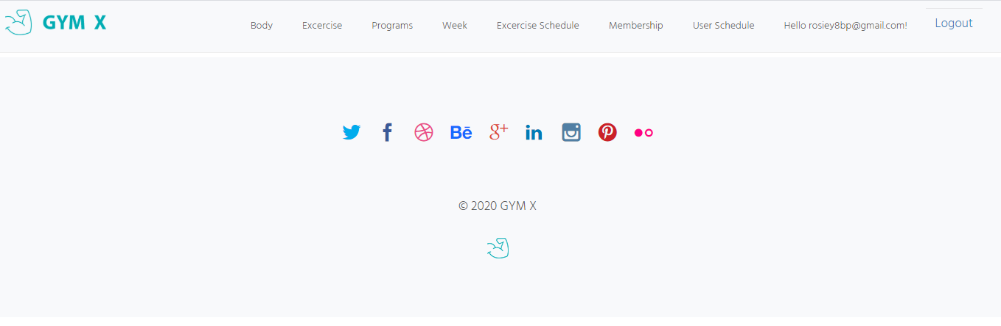

Login
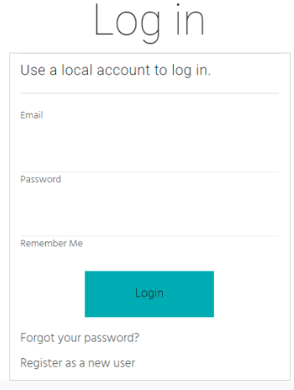
However, if there is an individual that is a member already amd they are browsing and sudfdenly want to login there is a option for it. This also opens a window for memebers to login easily.
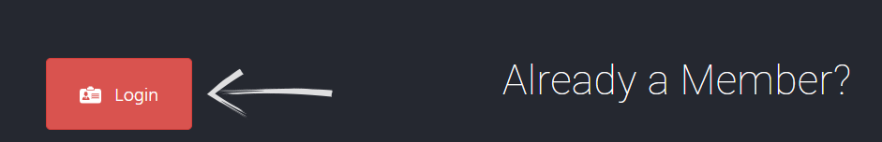
figure 5

Figure 4

Within this feature there are 2 other features such as . ‘ Forgot your password’ & ‘ Register as new member’. This enables users to create a new password if they want to change their old password . and if they have not created an account they have that option to register as a new member.
Below are screenshots the student has provided what promps open up when clicking ‘forgotten password’. The student has tested the features to know if they work.

Testing forgotten password feature
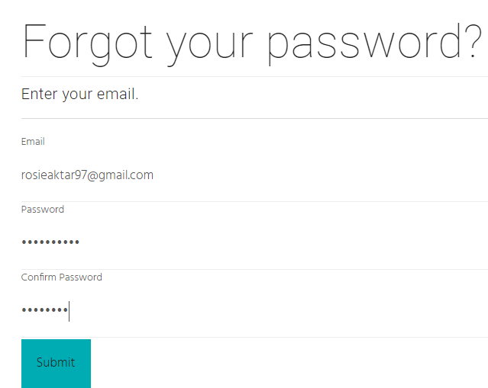
While testing this feature the student has realised. There is a problem , this feature may be difficult for those individuals who actually have forgotten their passwords then they wont be able to change it without knowing their old password.
But if they remember their old password and want to change it for their circumstances then this is possible.
Figure 6
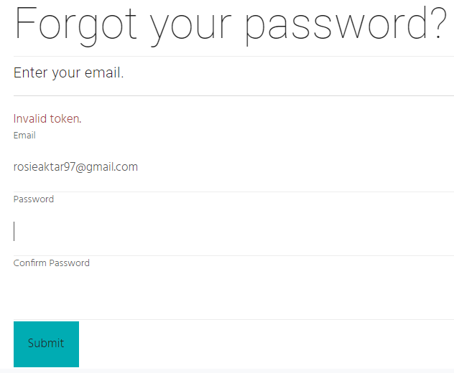
While testing if this works , the student has come to realise that if the passwords don’t match it will come up with a prompt to indicate filling in the boxes again. This message alert is required for login and resgistering when inputting passwords. However, if user inputs the exact same password and it is wrong it will give another message.
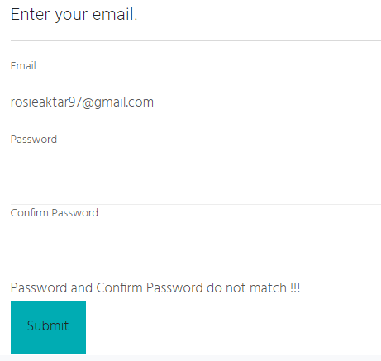

Figure 7 Figure 8

Adding a new record
The student has added in a feature that allows for different body workouts to be added , this is a main feature because being fitness webiste body workouts is one of the main elements.
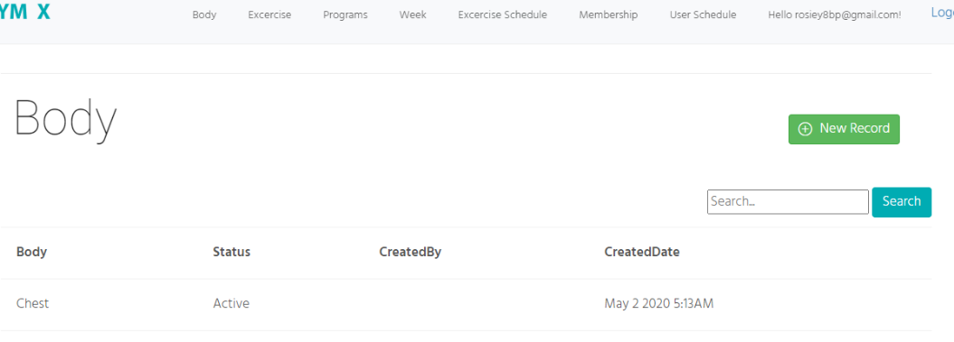

Figure 9

Testing
When the student clicks on the ‘ New Record’, it allows to input a new record, by testign this feature it has been found that it works sucesffuly by adding bicep as a body part.
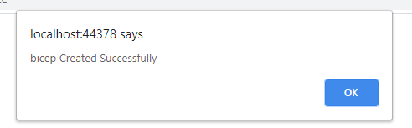

Figure 10

Testing body function fields
Another testing was carried out by the student, this testing was done to see what would happen if a blank field was to be submitted. The student implemented it for an error message to appear.
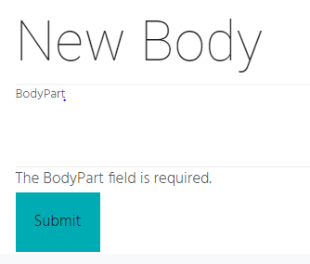

Figure 11
This has proven that the webiste application and databse is running as it should be , no input in the field will come with an error.

Conrollers/ Views & Methods
In programming controllers are used to send demands to the model. a controller is also known to communicate between a user and the application itself. The student has done research to find out that it ‘ handles business-related tasks triggered in ASP.NET pages’[3].
In MVC the controller is a normal class with public methods . the methods are linked with an action done by the user. ‘ The controller class methods process input data execute application logic and determine view’[3].
The controllers are the everything going into the databse. When the application starts it is home controller that’s the first one. When home controller starts it calls the home view / index page. This is the first page that shows. This is a main controller.
When you open the webiste login or register that is linked to the account controller, in the controller you have 3 views index , login and the register page the important ones are login and register. The account controllers deals with authentication the user is valid or not . this is found in the views . The menus on the top screen are the index pages linked to the account controller.
When you have logged in you will see body master linked to the home controllers , BodyMaster is for the body part workouts , when clicking new you can add in new body parts. In views you will see bodyMaster theres 2 pages create and index. This is the working on views.
Contollers are what the acting of the webiste. everything is comunicating with the views to display the interactive display .

Methods / classes / scripts
This is one of the main methods of loggin , this is the main functionality without this the webiste you wouldn’t be able to login. The LoginViewModel is a class this is a combination of methods as well.
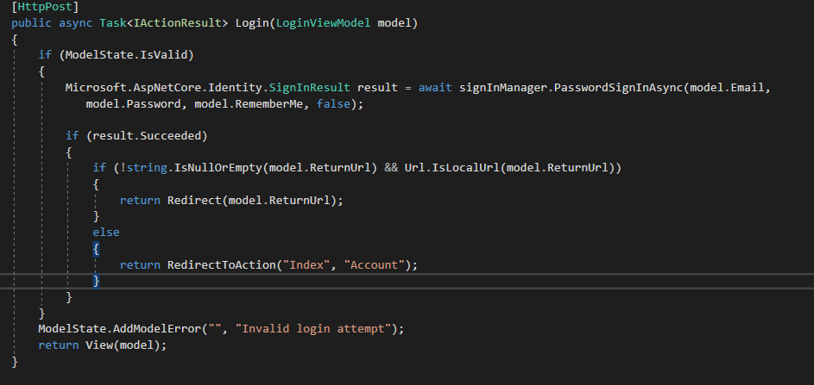
This is important because once opening the website this is the only way to login.
Figure 12
Try and catch method are used for exception handling, they catch errors of the run time so the application does not break. The spNewBody is stored procedure, the query is shown below, this shows when you go to bodymaster and create methods.
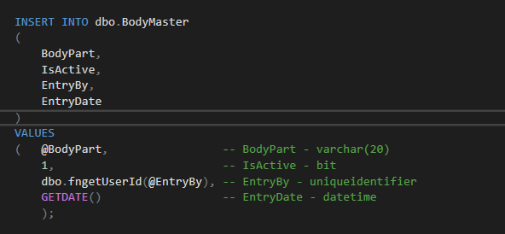
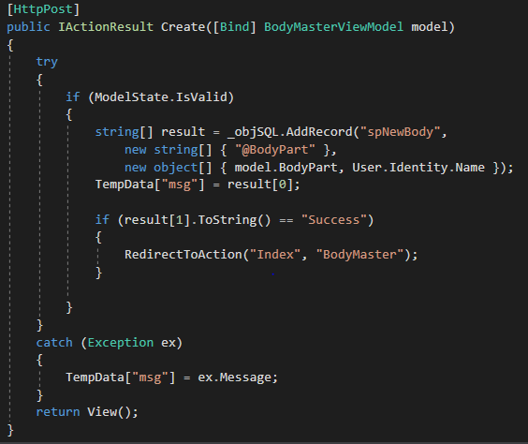
Figure 14
Figure 13

View models
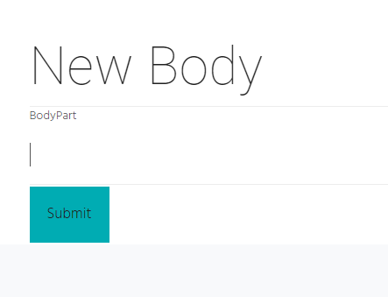
The student has used view models and implemented her own. She has made one for the body and called it BodyMasterViewModel to communicate with the controller and created it with views which is used in a public string part. This is to communicate with the controller. This is the implementation and the result.
Figure 15
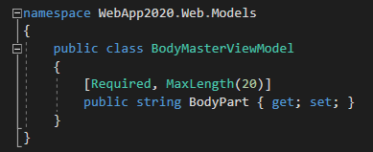
figure 16

Evaluation
Tests | Test case description | Pre -conditions | Test steps | Test data | Expected result | Actual result | Status
1 | Login | There should be already stored in database | Click login | The email rosiey8bp@gmail.com  And password | To auto after entering | Successful auto login | Passed
2 | Wrong details | There should be already the correct details | Attempt wrong password | Entering wrong password | Display error | Successfully displayed wrong error | passed
3 | Leaving fields empty | There should be already the correct details | Attempt to login without fields filled | Entering without credentials | Display error | Successfully displays 2 error messages | passed
4 | Testing new record | There should be already h the correct details | Attempt to add in a body part without entering a word | Submitting blank field | Should display error | Successfully displays error | Passed
Evaluation table

Future improvements
Throughout the start of creating the project to finishing and gaining the result, by looking at the result there can be future improvements that can be made, such as the design of the website application. The design is basic with basic information about fitness. If it were to be changed the student would add in more information about fitness to help users as well as add in features for disabled individuals to aid them.
However, another future improvements would be the login. Although the login works successfully and auto logs the student in. if it were going to be changed the student would not allow this feature. Simply because this can be a security issue that can allow hackers and thieves easily into the website without security authentication.
When being able to login however, the student has made it easy to login and then access the whole page system . but the features like e.g. Body, week they are supposed to be for the admin only. Another is being able to change the add new record. This feature is good but it is not required for all as the creator should have access to only the e.g. Body and week .
Another issue to change would be not being able to see other user’s data. below is a screenshot showing a field called ‘ created by’ for some features it is good again not all the categories need it . users should only see their part of the program and user schedule not any other user should see it apart from the creator of the website.
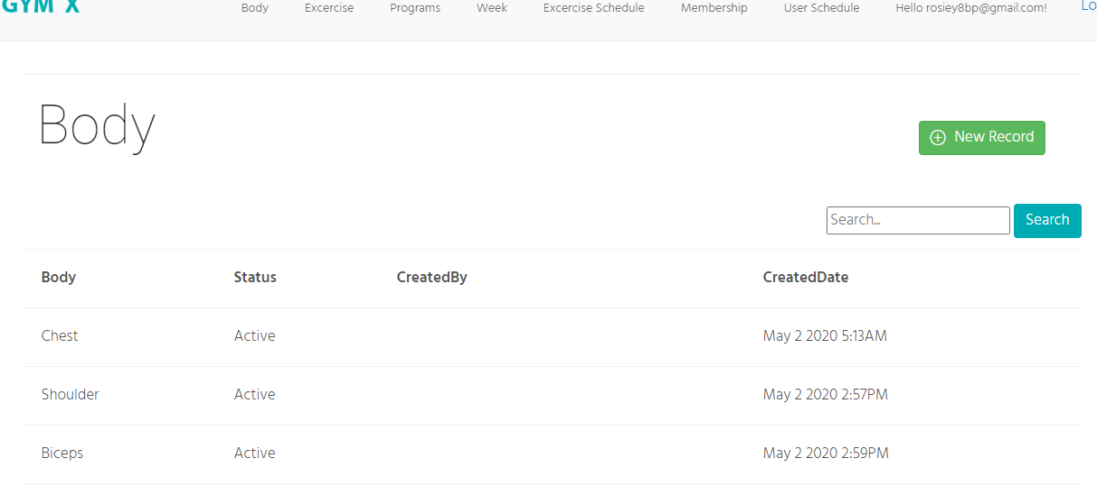
Some of the created by fields are empty this is because it was tested first and it did not work but afterwards the student was successfully adding a user. Therefore, some of the created y fields are empty but soon come to realise that it should not be shown for everyone to see they should see their own.

Figure 17

Screenshots of the pages

Home
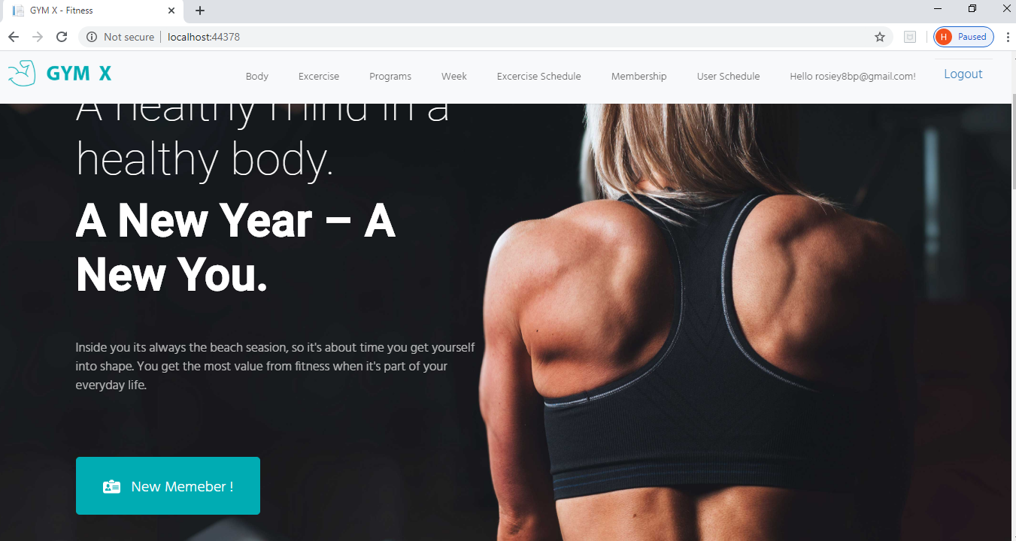

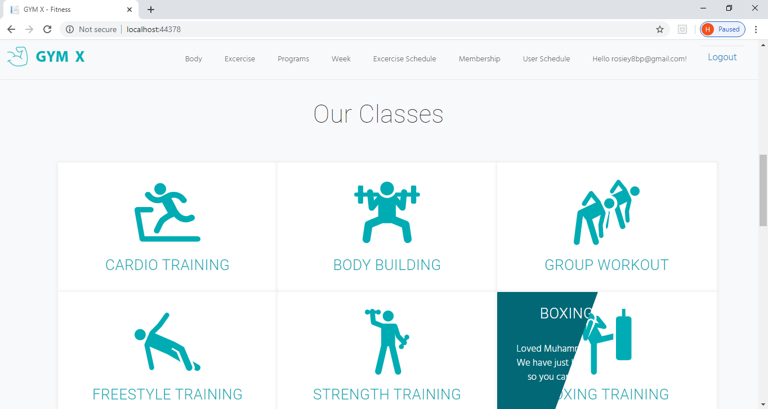

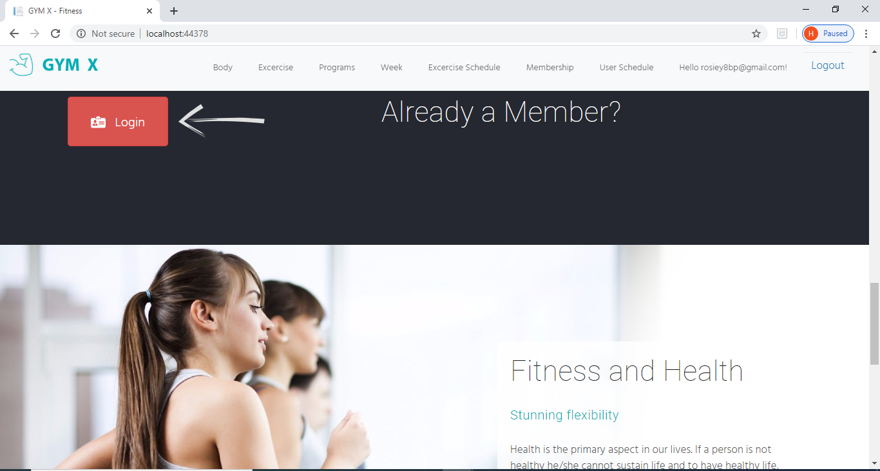

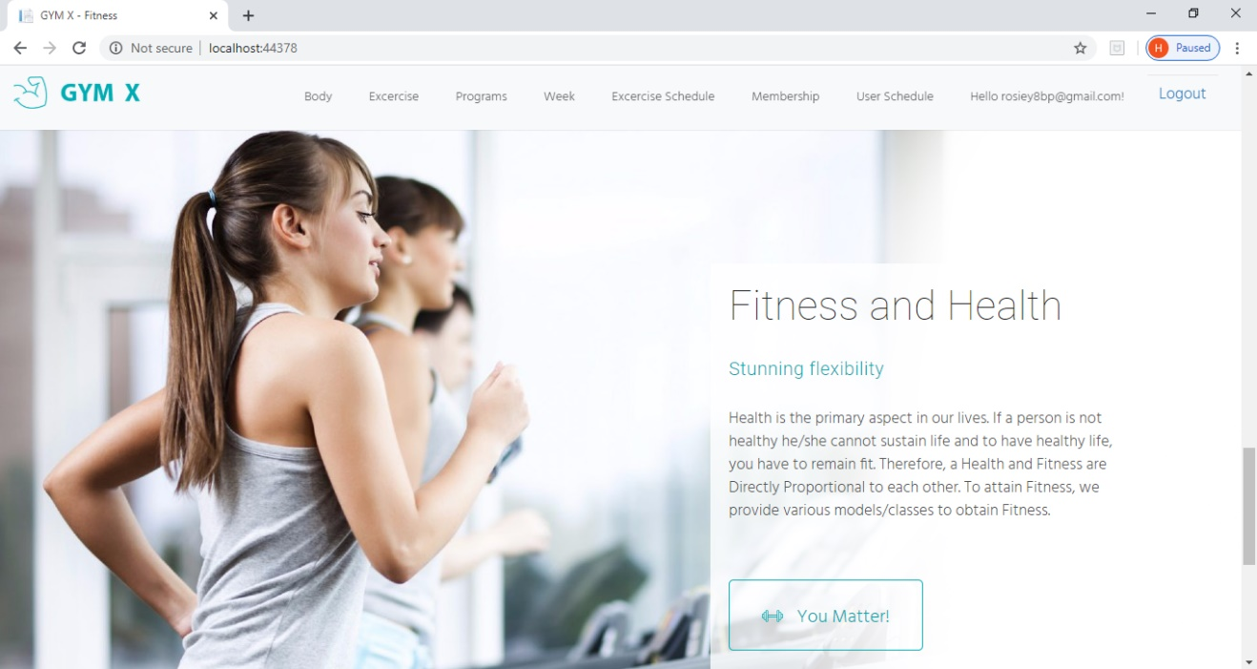

Register
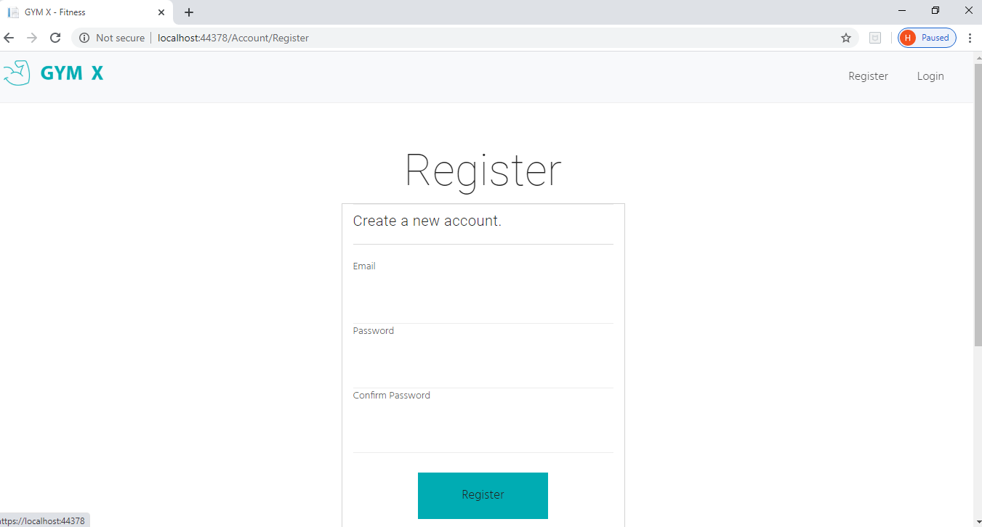

Login
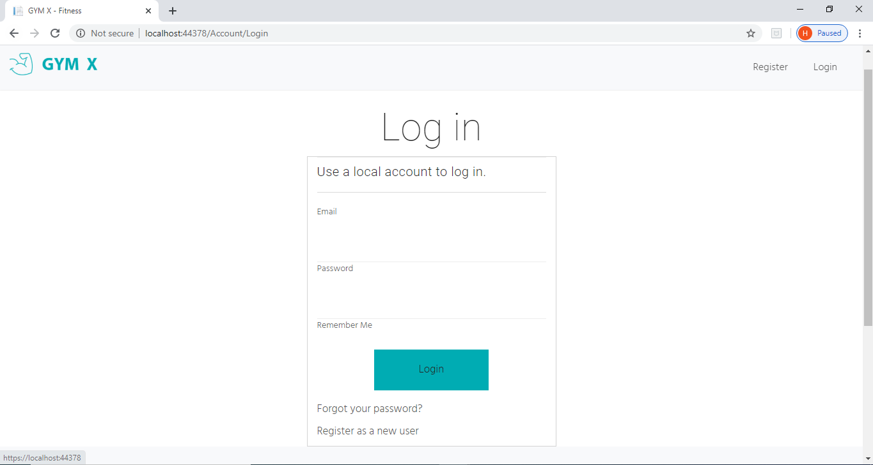

After login
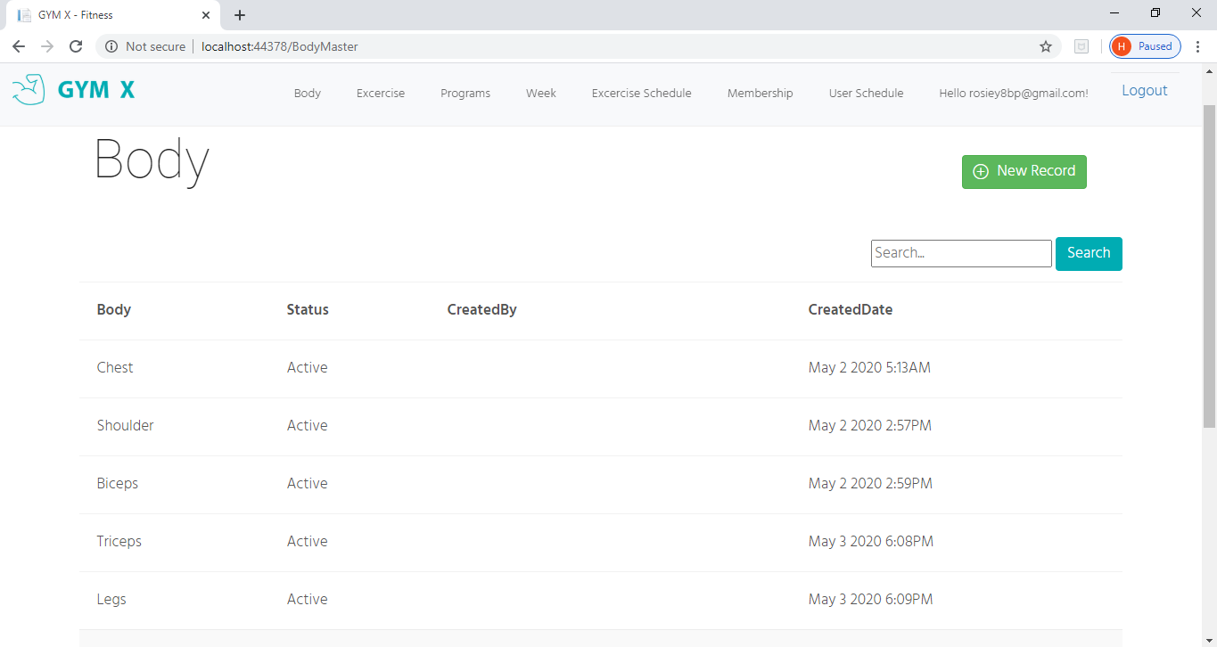

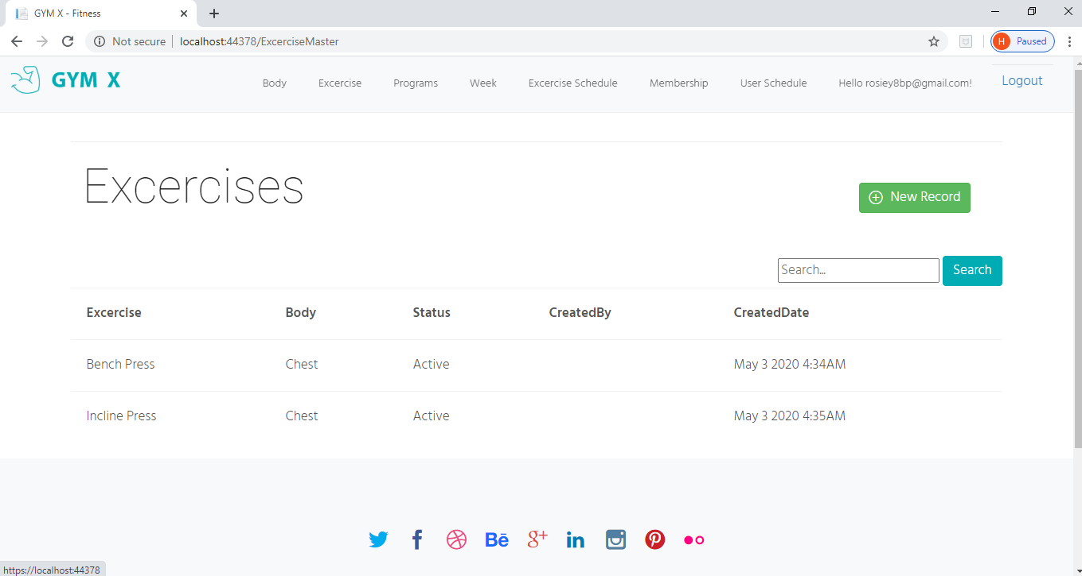

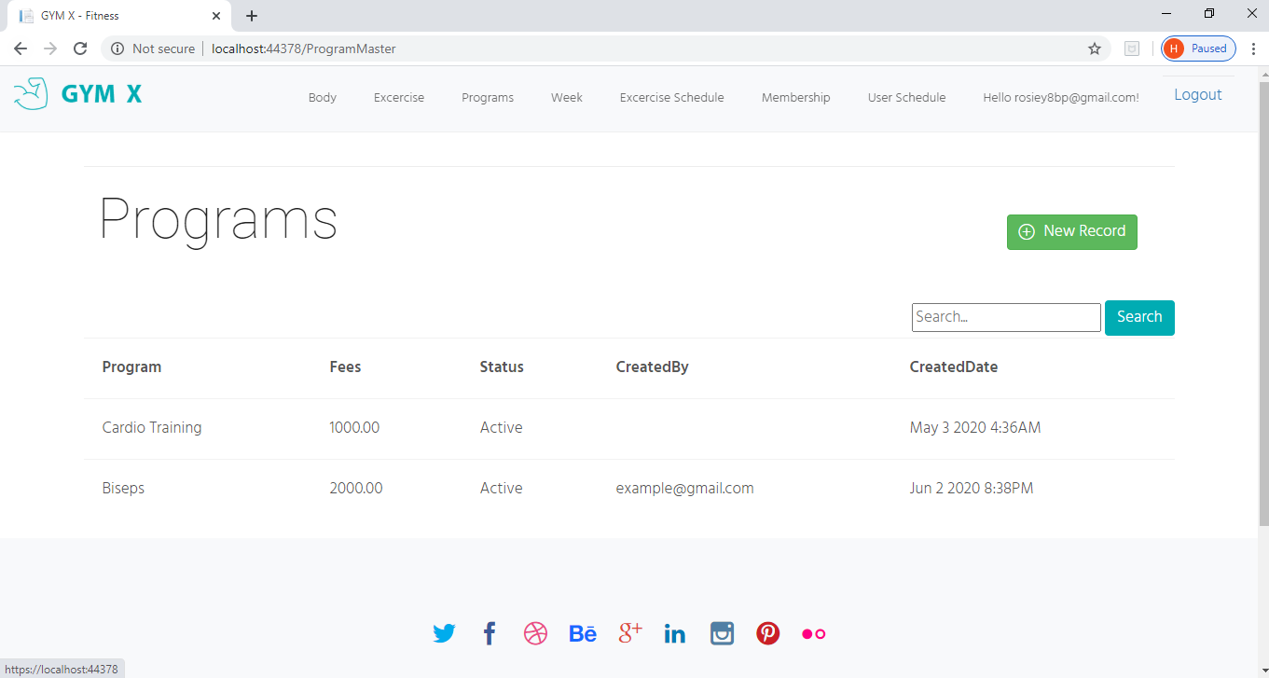

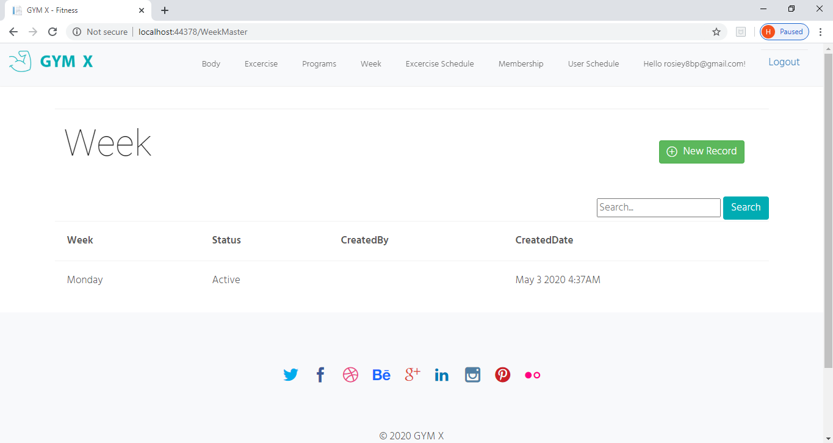

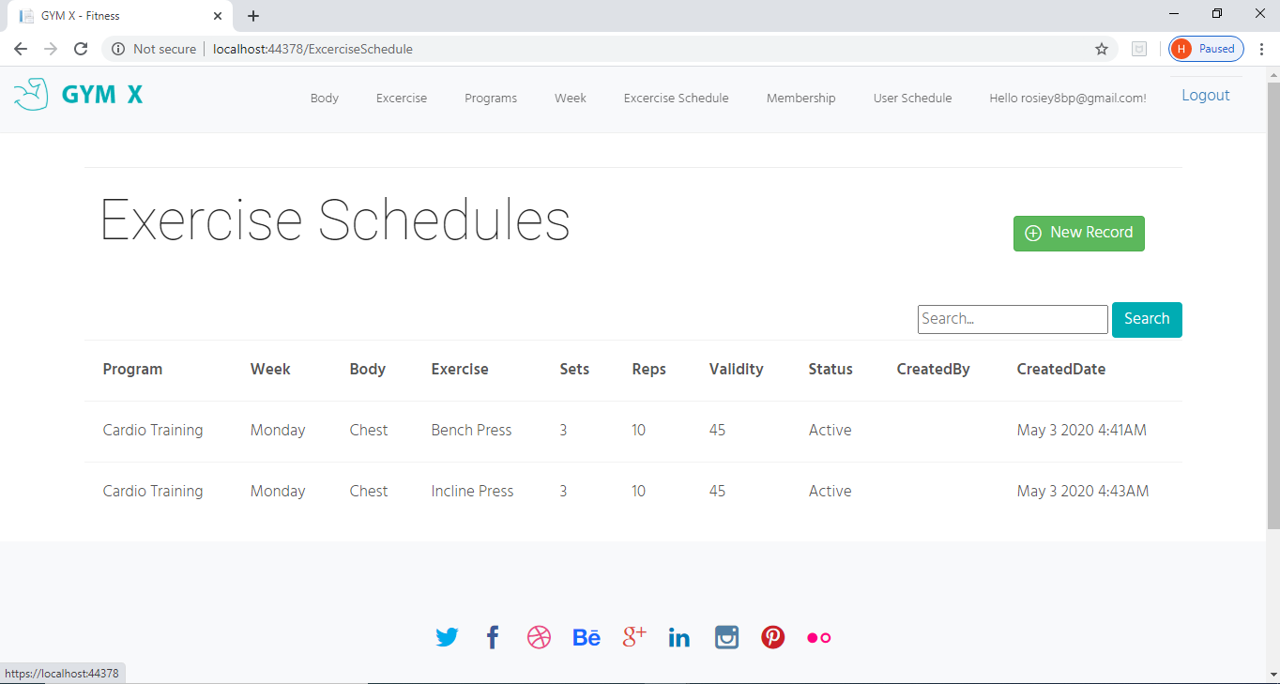

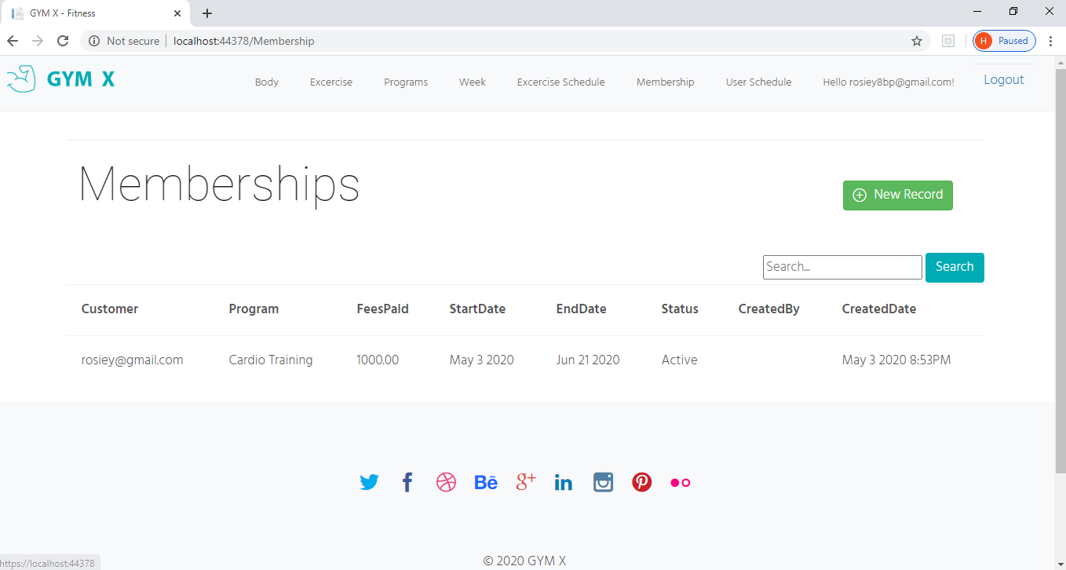

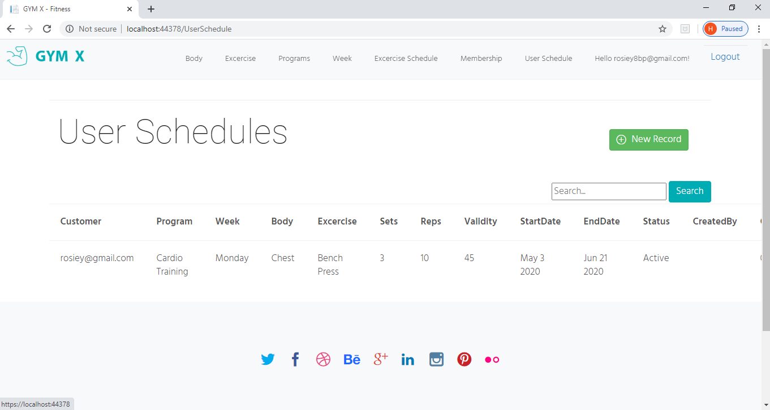

Forgot password page
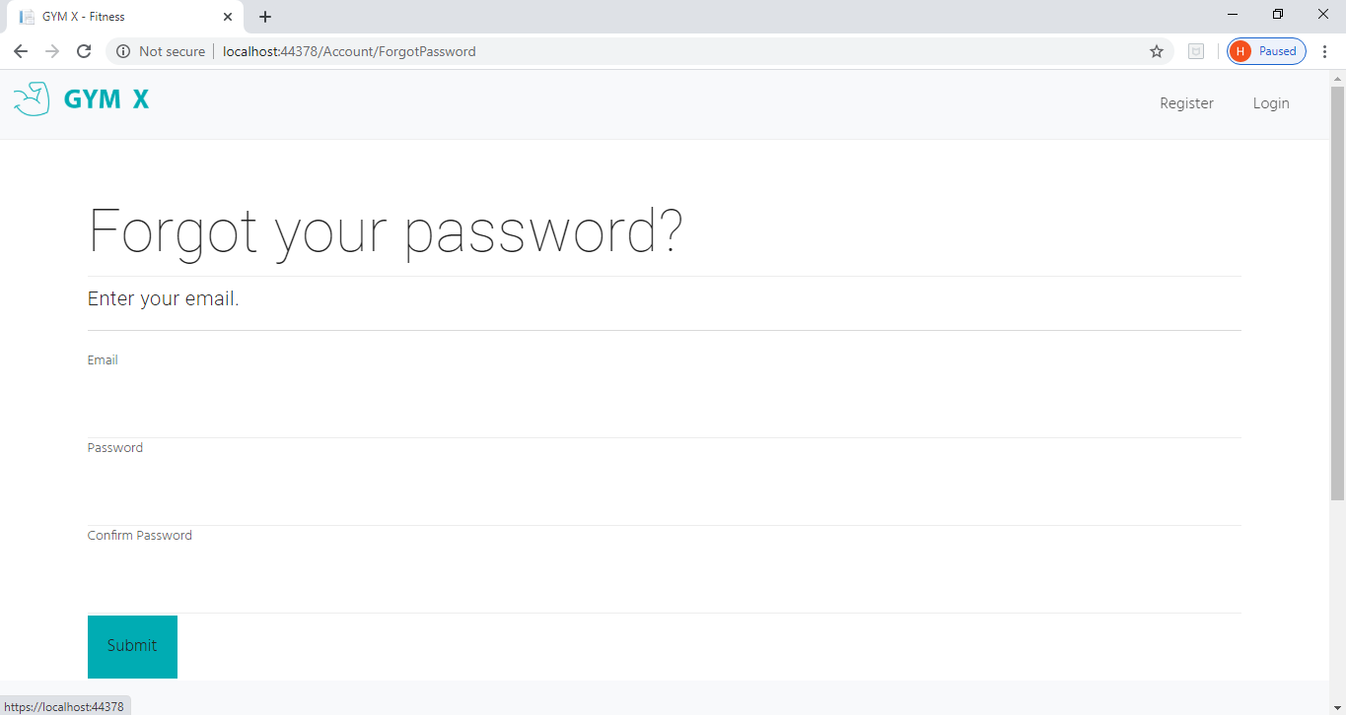

References
- https://www.perfectgym.com/en/blog/club-owners/why-your-fitness-club-needs-a-website?pg_nt=1
- https://zenplanner.com/gym-websites-101/
- https://www.techopedia.com/definition/2359/controller-aspnet

Discloser
when opening the file, the file path must be changed in order for the application to work.

marking criteria and Student FEEDBACK

This section details the extent to which the assessment criteria are demonstrated by you, which in turn determines your mark. The marks available for each category of skill are shown. Lecturers will use the space provided to comment on the achievement of the task(s), including those areas in which you have performed well and areas that would benefit from development/improvement.

Common Assessment Criteria Applied (Assignment 2) | Marks available | Marks  awarded
1. Engagement with Literature Skills

2. Knowledge and Understanding Skills

3. Cognitive and Intellectual Skills

A satisfactory set of test cases has been provided. The limitations of the submitted work has limited what test cases you can perform. The evaluation is basic and needs to be a more critical evaluation of the application, including its limitations. (Grade mark: 40.00%) | 30 | 12
4. Practical Application Skills

A basic attempt. The submitted web application does not work. Although you have submitted an application with models, views, and controllers, it does not work because you have taken code templates from another project and pasted them in to the template provided in class. For example, the menus in the screenshots displayed in your report, do not match the code in the submitted work. (Grade mark: 43.33%) | 60 | 26
5. Transferable Skills for Life and Professional Practice

The report is of a good standard but needs to contain more of the information required for the assignment instead. (Grade mark: 60.00%) | 10 | 6

Assignment Mark (Assessment marks are subject to ratification at the Exam Board. These comments and marks are to give feedback on module work and are for guidance only until they are confirmed. ) | Late Submission Penalties (tick if appropriate) |  | 44%
 | Up to 1 week late (40% Max) |  | 44%
 | Over 1 week late (0%) |  | 44%

