Developing Innovation and Creativity for Business Advantage

(BMSK6002_LON)

Student: Samsul Alom
Student ID: 1605852

Table of Contents
Introduction 1
1. Stockholm Gases’ approach to innovation 2
1.1 Approaches of innovation 2
1.2 Types of innovations 5
1.3 Leadership in Practice of Innovation 6
2. Role of Marketing Manager in the Teeth Whitening Project 7
3. Explain one open model and one closed model of innovation and analyse how they could be applied to the teeth whitening project. 9
3.1 Closed Innovation 9
3.2 Open Innovation 10
3.3 Linear Models – Technology Push and Market Pull 11
3.4 Elements and empowerment of innovation 13
4. Recommendation on making the investment of £10million 15
4.1 Porter 5 Forces Analysis 15
4.2 Internal issues 17
4.3 Market situation and customers 17
4.4 Final decision 18
Conclusion 18
Reference 20

Table of Figures:
Figure 1 4 types of innovations 3
Figure 2 Radical innovation approach 4
Figure 3 Closed innovation model 10
Figure 4 Open innovation model 11
Figure 5 Linear models of innovation 12
Figure 6 Porter's 5 forces model 16

Introduction
Business industries prefer to develop their reputation and brand value while working with the new product development (Balmer & Greyser, 2013). It takes the research and development process while managing the business innovation towards specific goals of the company. However, the creativity of the employees would benefit the industries for the development of the profit and operation. Each large industry cares for the innovation to increase competitive advantages in the market (Doganis and Christou, 2012). Stockholm products has already developed its brand name due to its service and innovation in the business. The company supplies liquid oxygen to health care markets. Also, the company sells the carbon dioxide to the drinks and beverages industry. The company has been depending on R&D for enhancing its dominant position. Also, the organization focuses on the new innovation to bring the effectiveness and competitive advantages of the company (Kotler & Lee, 2018). In the UK, most of the industries pretend to have the market positions where they highly need to invest into the new project for the development of the sustainability. However, the decision for the investment into the different projects requires the data analysis and proper market evaluation to succeed among the competitors. This assessment will represent the techniques Stockholm products uses for the innovation and the new project for making decisions whether to invest or not.

1. Stockholm Gases’ approach to innovation
It takes millions of the resource planning and strategic planning for the innovation in the business industries (Balmer et al., 2019). The high value and the reputation somehow depend on the business innovation with the new product development for managing the specific goals of the company. Stockholm products has been depending on R&D while supporting the innovation to bring the effectiveness and competitive advantages (Doganis and Christou, 2012). Around 32,000 people are employed in Stockholm products over 70 countries where in the year of 2018, the company has managed to increase the sale volume with revenue of£12.1billion, with its annual R&D budget of £100 million. When it comes to the innovation approach, the industries maintain the different innovation method and characteristics of the tools (Kotler & Lee, 2018). The company recently had to decide on whether to invest 10% of this budget to a new teeth whitening project. The company has taken the project of teeth whitening for their expansion of the new product category.

1.1 Approaches of innovation
Stockholm products has their own innovative approach while managing the research and development tools for the business and operation(Balmer & Greyser, 2013). Different approaches of business innovation are used in the organization for the business. Some of the industries use new technologies for the innovation to add value. Some companies would create a new product, service or business for the innovation and invention. According to the some researchers, the innovation can be broken into two dimensions including technology and market (Anastassova and Purcell, 2015). Under these dimension, following 4 types of innovations have been used in the companies and these are as follows:
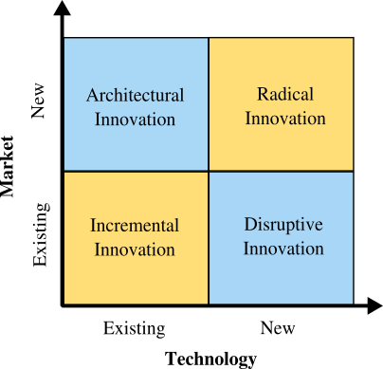
Figure 1 4 types of innovations
Source:(Balmer et al., 2019)

Incremental Innovation: Incremental Innovation has been the significant and most common innovation taken by the company for utilizing the existing technology(Balmer & Greyser, 2013). This innovation helps the company to increases value to the customer with the help of changing features, new design changes and so on in the existing market(Doganis and Christou, 2012). Stockholm products has been managing incremental innovation in their existing service to handle the competition and effectiveness of the existing products or services as well. However, this innovation approach used in Stockholm products is simple for the departments to engage the organization for improving the value of the existing products to create the better experience.
Disruptive Innovation: According to disruptive innovation, the company would focus on using and applying new technology or processes for the customers and the company’s current market. Some industries would develop the products while attracting the same customers with the existing market under the newer technology(Kotler & Lee, 2018).Stockholm products has not been used this innovation approach for the business. The disruptive innovation creates a new market displacing established market-leading firms(Anastassova and Purcell, 2015). However, Stockholm products has not been concerned of using new technologies for the same market or the current customers group as they always care for the quality of the service and product.
Architectural Innovation: Architectural innovation has been used by the large industries for focusing on the development of the skills and overall technology while managing and applying them within a complete new customer group and the different market. This type of innovation is amazing for the ventures and the industries for increasing new customers. However, Stockholm products has not chosen this approach as the new products may not match the demands of the new customers in the new market. But, Stockholm products prefers to handle the innovation while managing the research and development programs for the business innovation.
Radical innovation: Radical innovation is the main theme of the innovation while bringing the new industries for the customers(Balmer et al., 2019). This innovation helps the company to swallow the existing market while bringing and creating revolutionary technology for the development of the business innovation. Stockholm products has been using radical innovation approach while managing the effectiveness in the workplace.
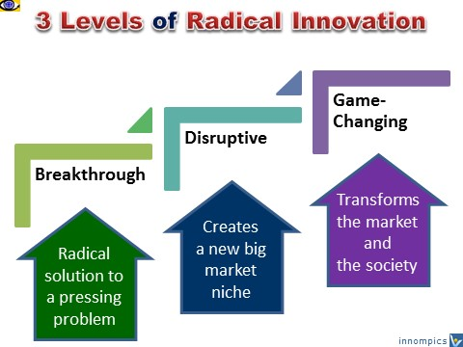
Figure 2 Radical innovation approach
Source:(Doganis and Christou, 2012)
According to the radical innovation approach, Stockholm products has been thinking about investing to the teeth whitening products while approaching new market and abolishing the existing industries as well. For managing the innovation approach, Stockholm products has been managing the different tools and methods(Evans and Weigl, 2011). These are as follows:

1.2 Types of innovations
Technological Innovation: Technologies have brought lots of impacts and issues in the industries where the companies first thinks about technological innovation(Balmer & Greyser, 2013). This the type of changes brought into the organization’s production process to enhance the production and to enable distinctive competence of the company. Stockholm products has not been used technological innovation in their company for the production process. However, the company did manage the changes in their knowledge and skills base, to have a more efficient production and operation in the market. According to this innovation, the technology helps the company to enhance the techniques and work methods, and work flow(Balmer et al., 2019). Stockholm products has focused on the bigger picture for the innovation.
Product and Service Innovation: Some companies would go for the product and service innovations to bring entirely new product lines(Kotler & Lee, 2018). Stockholm products has been focusing on this type of innovation as the company is looking for the new project to invest 10% of this budget. The company has taken the project of teeth whitening for the new product category to develop new markets and the new group of the customers. Stockholm products has been working for the profitability and market share while introducing new goods and services to the market. Most of the companies would not make risks for the new products as this connects to the risks of security in income and acceptance(Anastassova and Purcell, 2015). However, Stockholm products has chosen this innovation for the business.
Strategy and Structural Innovation: There is innovation that relates to the innovation in strategy and structural innovation for the development of the business. The management of the company cares for the development of the business innovation and profit. Stockholm products has not been focusing on this innovation as they have their effective management and supervision system, structure and reward systems for the employees.
Cultural Innovation: The business industry may focus on the cultural innovation that brings the changes for the employee’s attitudes, norms and beliefs, abilities and values, expectations and workplace actions and behaviour. Stockholm products has not decided to accept the culture innovation rather than using product and technology for the market.

1.3 Leadership in Practice of Innovation
Many organizations have accepted the innovation while managing changes(Balmer et al., 2019). But some of them are resistant in the market to changes and they had been operating without having any innovation or changes. The leaders are required for the development of the standard mode of operations with the innovative ways. To change the strategies and to create a competitive edge, the creative power of the leaders can be the greatest assets(Evans and Weigl, 2011). Stockholm products has focused on the development of these assets for the business and innovation.
Management of the Stockholm products has been working with the innovation involving technological innovation, product and service innovation, for the development of the business reputation (Kotler & Lee, 2018). The leaders of the company have brought the effectiveness towards the company. However, Stockholm products prefers to develop the skills and learning of the leaders. The organization has been managing the challenging and believable vision where the innovative leaders have accepted responsibility while managing the culture (Anastassova and Purcell, 2015). For the innovation approach, employee engagement and employee empowerment are necessary. The empowerment of the employees would help the leaders for making the changes and making right decision. Stockholm products prefers the empowerment of the employees. The purpose of empowering people and individual in the organization is to develop the new options and opportunities for the market. Stockholm products has been managing the skills of the employees while managing the system with radical innovations.

2. Role of Marketing Manager in the Teeth Whitening Project
The marketing activities of the project help the employees and related management team for handling the public relation to promote the brand issues and reputation of the products (Balmer & Greyser, 2013). Maria Klaus, the marketing manager of Stockholm products has been working towards the promotional activities. Regarding the teeth whitening project in Stockholm products, the manager had a different viewpoint for the effectiveness. Basically, the Marketing managers of the company are focused mainly on the representation or the practical application of the marketing operations (Evans and Weigl, 2011). The marketing managers should have excellent skills in their communication with analytical skills for formulating, directing and coordinating each promotion and marketing activities to influence the buyers and the customers to choose the organization's products. The roles of marketing manager in Stockholm products project are discussed below:
Conducting the Market Research
A marketing manager of the company carries out market research and data research to gain a clear understanding and information of what an organization’s customers really want and how the company can influence the customers as well (Balmer et al., 2019). The marketing manager of Stockholm products has done her marketing research to identify new market opportunities and to develop effectiveness of the products. According to the market research for the business plan and organization's competitors, the marketing manager of Stockholm products has proposed to use the efficient marketing techniques for managing the buying habits of consumers (Grugulis & Wilkinson, 2012). Even they would promote the products with the help of the mass production while targeting the customers market.
Developing the Marketing Strategy
Marketing managers of the company are responsible for generating and developing marketing strategies for their organizations towards the specific products development (Kotler & Lee, 2018). These strategies outline in the promotion and marketing activities clearly represent how an organization will promote its products. The marketing manager of Stockholm products has been managing promotion of their new project to target the market with an aim of increasing its sales volumes, profitability of the company while maintaining a competitive edge over its competitors in the market.

Customer Relationship Management
The marketing manager of the organization basically performs the actions with full set of responsibilities with the function of championing and managing the customer relationship management (Anastassova and Purcell, 2015). The marketing manager of Stockholm products has supported the customer relation management while engaging the customers for the sale volume. The managers propose to maintain the customer relation while collecting the information from the organization's customer’s purchase, repeat purchase and database to help create a customer satisfaction survey for the development of the business. Marketing managers of Stockholm products have worked with their operation where she managed to build lasting relationships of the customers with Stockholm products.
Employee Management
The marketing managers of Stockholm products are in charge of the marketing department while being responsible for the individual and employees. The management of Stockholm products has assigned the duties while setting the achievement and targets for the employees and departmental staff. The marketing managers of the company need to perform periodic objectives and performance evaluations of the staff. Even the manager in Stockholm products has been managing the employees while working with them for the project.
Identifying New Business Opportunities
The marketing managers of Stockholm products analyse future and current market trends with an aim of focusing on the changes and identifying unexploited market or new markets for the organization's products and services with the innovation in the market (Grugulis & Wilkinson, 2012). Stockholm products has supported its marketing managers for studying the purchasing patterns of consumers to handle the customer’s decision and business innovation. The managers can identify the peak and off-peak demands and seasons. The customers of the market would be influenced by the marketing activities while managing the new business opportunities (Kotler & Lee, 2018). Stockholm products has been employing sales forecasting while managing the market analysis to handle the new business opportunities.

3. Open and Closed model innovation and analyse and how they could be applied to the teeth whitening project.
When talking about innovation, the company must focus on its importance and types of innovation. The high value and the reputation of the company depend on the business innovation (Balmer & Greyser, 2013). Stockholm products has been depending on R&D while employing around 32,000 people to increase the sale volume. The company has taken the project of teeth whitening for their expansion of the new product category. Stockholm products has their own innovative approach to use new technologies for the innovation and to add value to the management. Stockholm products has been managing incremental innovation in their existing service for the development of the effectiveness and to handle the competition (Balmer et al., 2019). However, Stockholm products has not been used disruptive innovation approach for the business. Also, Stockholm products has not chosen architectural innovation approach to handle the innovation. Stockholm products has been using radical innovation approach while managing the effectiveness in the workplace. The demands on innovation management in the company have changed in the market dramatically (Anastassova and Purcell, 2015). The R&D department of the company helps the management to maintain the source of innovation. To meet the increased demands of the market would allow the company to maintain the open innovation and closed innovation.

3.1 Closed Innovation
Basically, the closed innovation developed by companies is managed for the company itself doe the development of the effectiveness within the company (Grugulis & Wilkinson, 2012). This innovation model represented the research for the project and development within the company while focusing on the development of the market position.
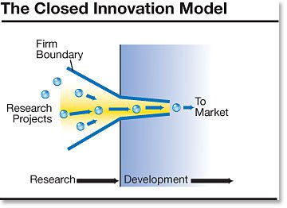
Figure 3 Closed innovation model
Source: (Balmer et al., 2019)
According to this innovation process, opening to the outside and managing the innovation are therefore impossible (Dharwadkar et al., 2011). Stockholm products has identified that this innovations are only developed within clearly set and defined company boundaries with the skills of the employees, technology and processes of the innovative company. According to close innovation, Stockholm products has been investing large sums for the internal research and development (R&D). Even the closed innovation allows the company to invest in order to establish R&D departments for the significant technological inventions to innovative products in the market (Kotler & Lee, 2018). The closed system has been already accepted in Stockholm products for the innovation process under internal R&D activities with the highly qualified employees.

3.2 Open Innovation
Open innovation is the system used by the company of opening up the innovation process in order to increase one's own innovation with the use of the environment (Balmer & Greyser, 2013). This innovation in the company arises through the interaction of both internal and external ideas, usages of the various technologies and processes, aim and the sales channels to develop promising innovative products for the company (Grugulis & Wilkinson, 2012). In this process, the innovation takes place in both inside and outside the company.
Stockholm products has been managing its closed innovation with the research and development programs. However, their marketing manager is insisting to manage the open innovation for the development of the new customers market and group.
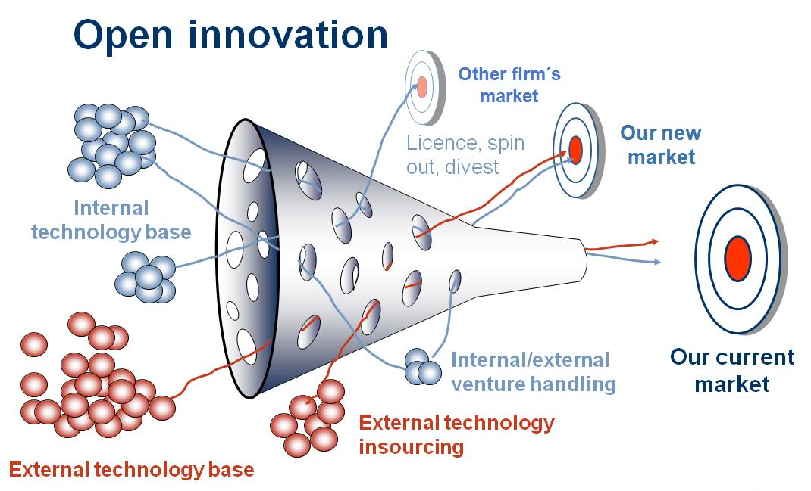
Figure 4 Open innovation model
Source: (Dharwadkar et al., 2011)
However, the open costs may increase the costs of the company (Kotler & Lee, 2018). In this situation, if the company is able to handle the situation with the tools and technologies under the innovation, the company can develop the effectiveness and make decision for the investment. Stockholm products has been focusing on their innovation while managing the close innovation approach. In this sense, the company can go for the technology push to manage the operation.

3.3 Linear Models – Technology Push and Market Pull
The models of innovation has focused on the idea representing that the specific processes can generate new technologies involved in technological change which can be the technology push (Dharwadkar et al., 2011). This innovation helps the company for the advancement of the technology because, while managing the rise of new products in the market. Stockholm products needs to focus on this approach in which the technology innovation would be pushed to the market. Even this supports the closed innovation starting from internal development to marketing function (Buick and Muthu, 2017). On the other hand, market pull innovation approach manages the development process starting from the expressed market need and the customers. Stockholm products has not focused on this approach yet.
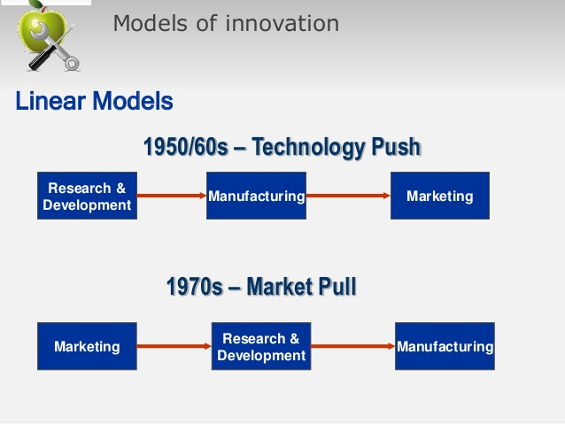
Figure 5 Linear models of innovation
Source: (Grugulis & Wilkinson, 2012)
Stockholm products should go for the technology push strategy in the innovation project of Teeth Whitening project. Stockholm products has been depending on R&D while supporting the innovation. Relying on the research and development for the innovation is known as closed innovation (Hoeffler & Keller, 2012). For the effectiveness and competitive advantages, the company has managed to increase the sale volume and has taken the project of teeth whitening. Stockholm products has their own innovative approach while managing the research and development. For the development of their new project, Stockholm has chosen technology push under the close innovation approach.
Stockholm products has been using radical innovation approach while managing the effectiveness in the workplace. Even Stockholm products has been thinking about investing to the teeth whitening products while approaching new market. Technologies have been given priority in the company (Kotler & Lee, 2018). Even every company focuses on the changes brought into the organization’s production process with the help of the technological innovation. Stockholm has been working new project for the expansion and operation in the market. According to this innovation, the technology helps the company to enhance the techniques (Buick and Muthu, 2017). Stockholm products has been working for the profitability and market share while introducing new goods and services to the market. Thus, technology push market with the closed innovation will be the right choice for Stockholm.

3.4 Elements and empowerment of innovation
The leaders of the company are required for the development of the operations with the innovative ways and approach (Balmer & Greyser, 2013). Stockholm products has focused on the development of business and innovation where the leaders are welcomed to enhance their learning and skills for the technological innovation, product and service innovation. However, Stockholm products prefers to develop the skills and learning of the leaders. For the innovation approach, employee engagement and employee empowerment are necessary (Dharwadkar et al., 2011). Stockholm products has engaged the employees for the empowerment of the employees while managing the system with radical innovations and closed model of the innovation as well. There are several tools and elements involved in handling the technology push market for the company. In the technology push market, the company needs to handle proper communication to build the right customer base with the customer loyalty and brand recognition (Buick and Muthu, 2017). Stockholm products is new in their teeth whitening market. Apart from the competitors, the company has not developed their brand recognition in this area. It would take time for the brand development and customer base. For the development of the brand value and brand positioning in the project under closed innovation, Stockholm products needs to handle the technological promotion and marketing activities while targeting mass market.
In this sense, most of the companies prefer to use technologies while handling the effectiveness of the market with cost effective tools (Hoeffler & Keller, 2012). The project regarding teeth whitening has already increased the costs of Stockholm products for the research area. Stockholm products has been managing its closed innovation with the research and development programs. However, their marketing manager in the new project is insisting to manage the technological innovation for the development of the new customers market and group (Kotler & Lee, 2018). However, the company can use technology push market except market pull factors for the development of the business and right decision for the investment in the project as well.

4. Recommendation on making the investment of £10million
Business industries depends on the research and development process while managing the business innovation for the development of the profit and operation (Buick and Muthu, 2017). Stockholm products has already focused on the effectiveness of the R&D to bring the effectiveness and competitive advantages of the company while making decision for the investment into the new project of teeth whitening (Gilbert and Guerrier, 2017). However, the decision for the investment in Stockholm products into the project required the data analysis. The company has taken the project of teeth whitening while having confusion whether to invest into this project as the competition is higher or not. If they invest, who to target in the market as well.

4.1 Porter 5 Forces Analysis
For making the decision regarding investment, Stockholm products has focused on the analysis of the market. This would represent the effectiveness of the product or the demand that Stockholm products can create in the market. Porter five forces analysis helps the company to identify related 5 factors affecting the business decision and the company’s strategy (Hoeffler & Keller, 2012). Porter’s 5 forces analysis of Stockholm products is as follows:
Power of Customers: Buyers and customers in the market can make things worse if the customers do not prefer the products that the company intends to produce (Kotler & Lee, 2018). In this case, Stockholm products has seen that the growing customers in the market have the higher power where only the quality products can manage their power over the company’s. Stockholm products has brought quality while managing the service and product’s effectiveness. This has always helped Stockholm products to maintain the power of the buyers.
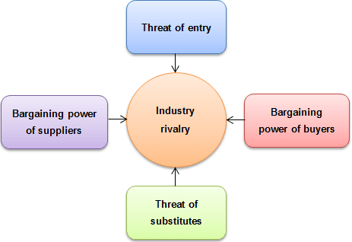
Figure 6 Porter's 5 forces model
Source: (Kotler & Lee, 2018)
Power of suppliers: The suppliers of the company may affect the operation and decision (Balmer et al., 2019). Stockholm products has maintained their higher value and market’s image which literally influence the strategy and perceptions of the suppliers while dealing with the company. Thus, Stockholm products can manage the attitude and service of suppliers that they are working with.
Rivalry competition: Over the period, the large industries and multinational companies working in teeth whitening products and service have already developed their existence and brand image. In this era, Stockholm products is thinking about stepping with their new products. Stockholm products has been using radical innovation approach under the R&D. Decision for the innovation also depends on the particular area. However, the manager of Stockholm products explained the attractiveness of this growing market but the competitors and multinationals including Colgate-Palmolive and Procter & Gamble had already managed their position. As Stockholm products has their brand image and higher power in the market, the company can handle the competition in the market regarding their new products.
Power of substitutes: The substitute products can increase the threats and risks to the company. Stockholm products has been managing the quality and image which cannot be provided by the other substitute products which is the advantage for Stockholm products.
Power of new entrance: New entry in the market brings lots of issues and barriers for the existing industries (Gilbert and Guerrier, 2017). Stockholm products has developed their own ability while building the shields. They have ability to manage the barriers for affecting the new entrants into the market. Most of the companies prefer technological innovations. Stockholm products has not been used technological innovation in their company for the production process. However, the company should focus on the technological innovation for more efficient production and operation in the market (Kotler & Lee, 2018). The technological innovation would help Stockholm products to maintain the new entrance for the production and operation.

4.2 Internal issues:
Investment in to the different projects depends on the innovation approach, market, customers and others as well (Dharwadkar et al., 2011). According to the internal environment, Stockholm products has invested into the research and development tools for getting data of the market for the business and operation. Some of the industries use new technologies for the innovation to add value (Hoeffler & Keller, 2012). Stockholm products prefers to work with the research and development tools while getting data for bringing and creating revolutionary technology for the development of the business innovation. The marketing manager of Stockholm products proposed to use the technology where Stockholm products has been working for the profitability and market share while managing the product innovation for the development of the business. Management of the Stockholm products has been working with the innovation involving technological innovation, product and service innovation. For the innovation approach, employee engagement and employee empowerment are necessary (Balmer & Greyser, 2013). Stockholm products has been managing the skills of the employees with the employee engagement and employee empowerment. Maria Klaus, the marketing manager of Stockholm products has done her marketing research to identify new market opportunities. She insisted to invest into the products while targeting mass market and developing the Marketing Strategy for the promotion and marketing activities.

4.3 Market situation and customers
R&D in the company would help them to identify the market data and analysis(Balmer et al., 2019). The R&D project leader in Stockholm products has represented the some convincing argument for the business. The product development manager produced estimation and the statistics representing the gap in the market for teeth whitening product. The multinational would develop the competitive advantage with the technology and Stockholm products can go for it. However, the confusion grows whether to invest or not or to target whom for the products(Weiss and Craft, 2014). Stockholm products has been managing incremental innovation in their existing service for the development of the effectiveness. According to close innovation, Stockholm products has been investing large sums for the internal research and development (R&D) of this project of teeth whitening. The closed system has been already accepted in Stockholm products for the innovation process and Stockholm products has been working for the profitability (Shafritz et al., 2015). Thus, the company has already accepted the technology push market with the closed innovation for targeting the right customers with the promotion and marketing activities.

4.4 Final decision
Based on the scenario and options available, every company needs to make the right choice of the investment in their projects (Hoeffler & Keller, 2012). According to the internal environment, Stockholm products has identified own effectiveness and power. The investment in this new project can be effective with lots of the competitors and multinationals with ability. Stockholm products can go for the investment in this project if the company chooses to use technology for the promotion and marketing activities to deliver the products to the mass market. It would take time for the brand development and customer base. However, the company can go for the investment in the market for the teeth whitening project.

Conclusion
Investment into the new project for the business innovation would help the company for managing the specific goals of the profit and operation (Balmer et al., 2019). Stockholm products has been focusing on the new project for the investment while depending on R&D for the right data and decision making analysis. The company has managed to use innovative approach, radical innovation approach and product and service innovation for the business. However, making the right decision in the company would require the right leadership in the workplace and employee engagement (Dharwadkar et al., 2011). Management of the Stockholm products has been working with the innovation involving the vision and the empowerment of the employees. Also, the marketing manager of Stockholm products has been managing promotion of their new project. However, according to close innovation, Stockholm products has been investing for the research and development (R&D) while accepting the technological push approach for the technology innovation in the market. Every company needs to make the final decision based on the data analysis (Doganis and Christou, 2012). Before making the investment, Stockholm products has focused on their innovation approach, internal environment and market. According to the market situation and the internal environment, Stockholm products has chosen to invest in this project while targeting mass market for the teeth whitening project and the high sale volume as well.

Reference
Anastassova, L. and Purcell, K. (2015). `Marketing management in hotel industry: from command to empowerment’. International Journal of Hospitality Management, Vol. 14, no. 2, 171-185.
Balmer, J. M., & Greyser, S. A. (Eds.). (2013). Revealing the corporation: perspectives on identity, image, reputation, corporate branding, and corporate-level marketing: an anthology. Psychology Press.
Balmer, J. M., Stuart, H., & Greyser, S. A. (2019). Aligning identity and strategy: Business Innovation. California Management Review, 51(3), pp.6-23.
Buick, I. and Muthu, G. (2017). `An investigation of the current practices of in-house employee training and development within hotels. Service Industries Journal, Vol. 17, no. 4, 652-668.
Dharwadkar, B., George, G., & Brandes, P. (2011). Privatization in emerging economies: An agency theory perspective through innovation. Academy of management review, 25(3), 650-669.
Doganis, R. and Christou, E., (2012). Innovation and Commercialization: The management of innovation. Psychology Press.
Evans, N. and Weigl, M., (2011). Collaborative strategy: an analysis of the changing world. Tourism management, 22(3), pp.229-243.
Ferrell, O.C. and Fraedrich, J., (2015). Business ethics: Ethical decision making & cases. Nelson Education.
Gilbert, D. and Guerrier, Y. (2017). `UK hospitality managers past and present’. Service Industries Journal, Vol. 17, no. 1, 115-132.
Grugulis, I., & Wilkinson, A. (2012). Managing culture of business innovation: hype, hope and reality. Long Range Planning, 35(2), pp.179-194.
Hoeffler, S., & Keller, K. L. (2012). Building brand equity through corporate societal marketing. Journal of Public Policy & Marketing, 21(1), pp.78-89.
Kotler, P., & Lee, N. (2018). Creativity and Innovation: Doing the most good for your company and your cause. John Wiley & Sons.
Shafritz, J.M., Ott, J.S. and Jang, Y.S., (2015). Classics of organization theory. Cengage Learning.
Weiss, J.W., and Craft, J.L., (2014). Business ethics: A stakeholder and issues management approach. Berrett-Koehler Publishers.
Werther Jr, W.B. and Chandler, D., (2011). Strategic corporate social responsibility: Stakeholders in a global environment. Sage.

