Referencing practice activity
In the following Activity you will find 9 different credible sources, comprising of books, journal articles and websites.

The actual websites are connected to the website image with a link, so you can access the original source to look around for information if needs be. To access this please right click on the image and open the link.

For each source, please provide the citation (both variations – eg (Cottrell, 2019) or Cottrell (2019)) and the full reference.

Once complete, make sure you are happy and confident with your answers before submitting to the Turn-It-In link.

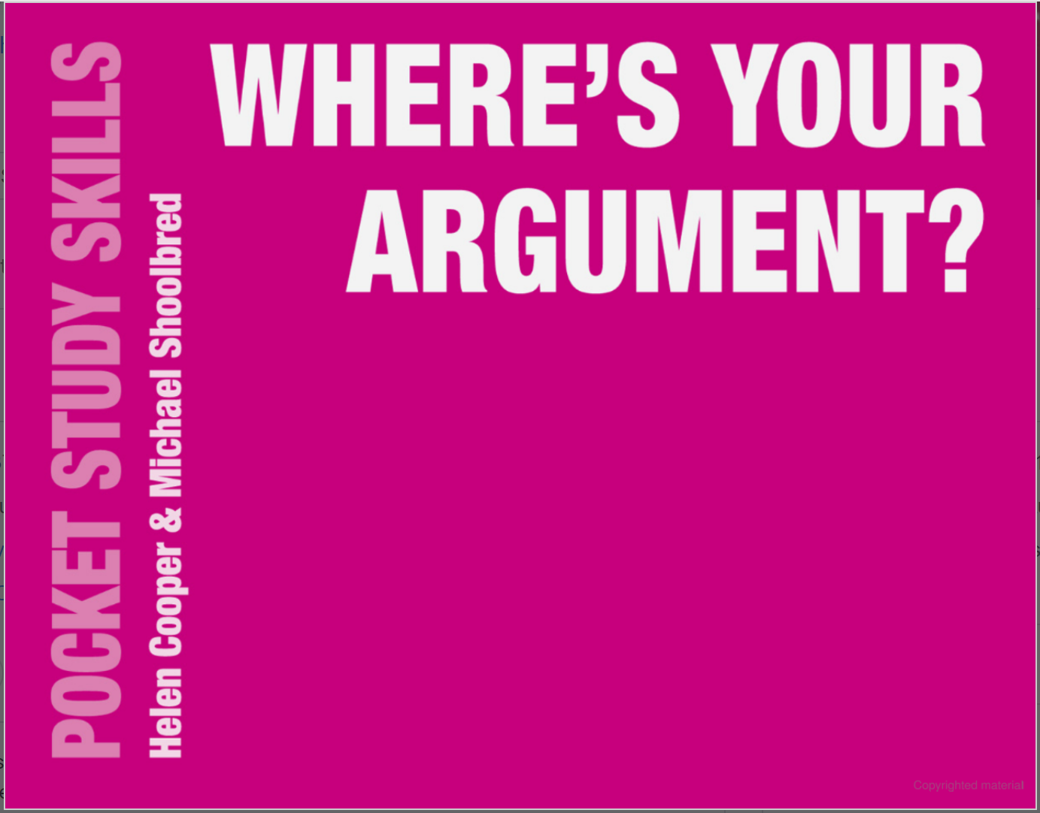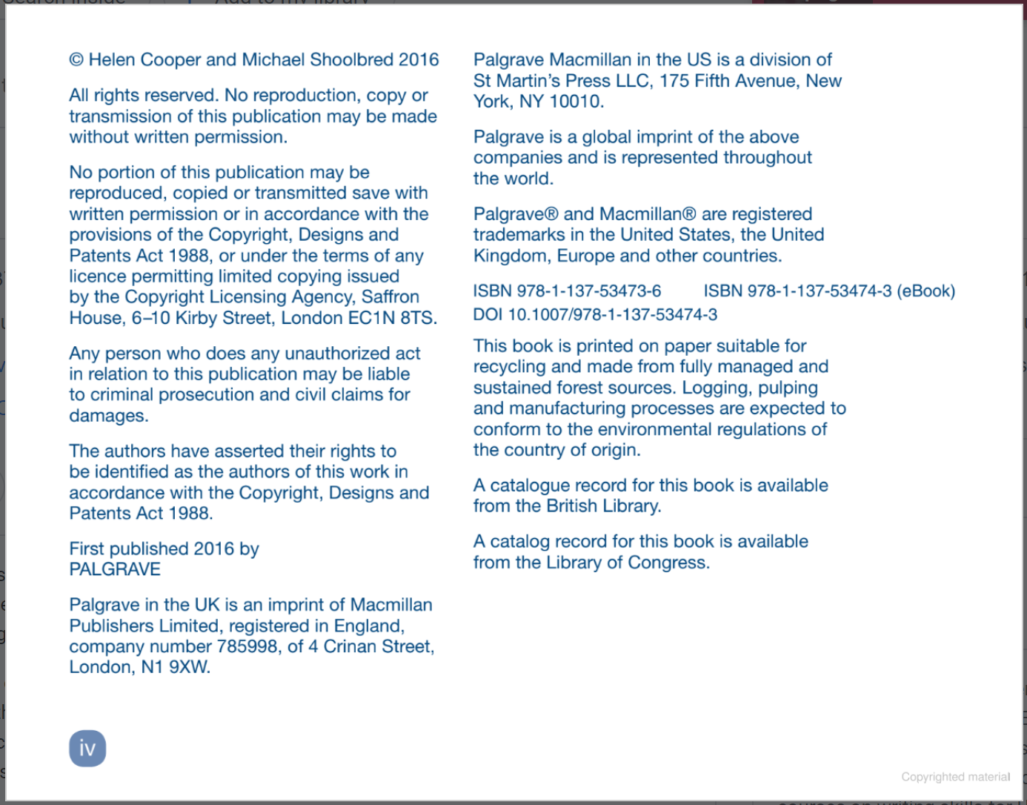

Citation: (Cooper and Schoolbred, 2016)
Reference: Cooper, H. and Schoolbred, M. (2016) WHERE’S YOUR ARGUMENT. London: PALGRAVE.
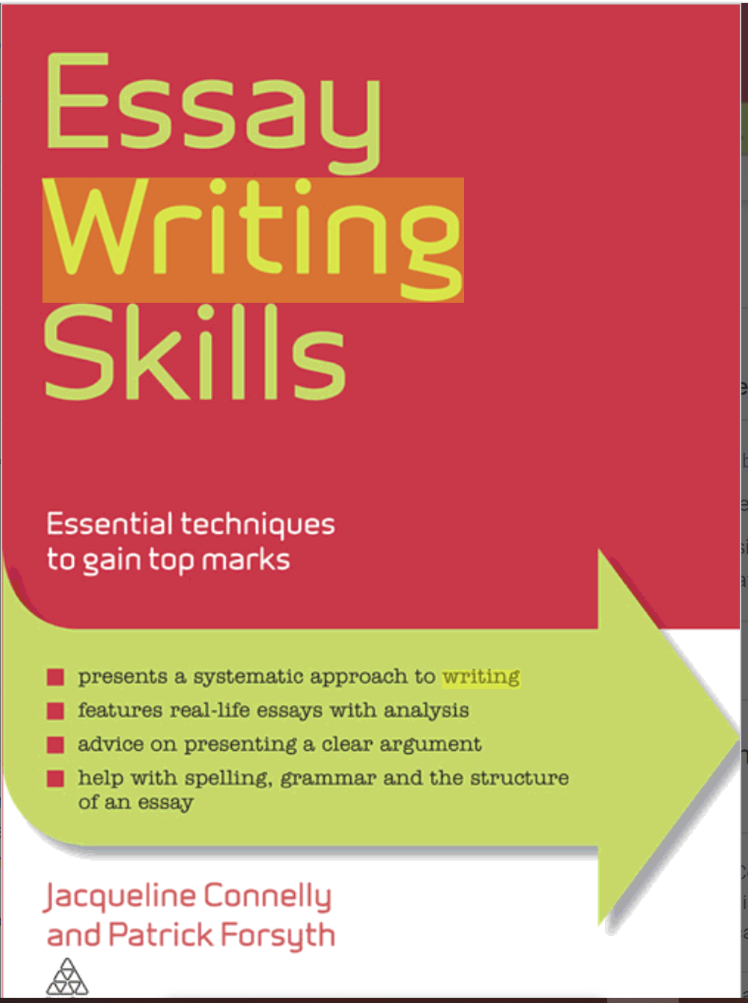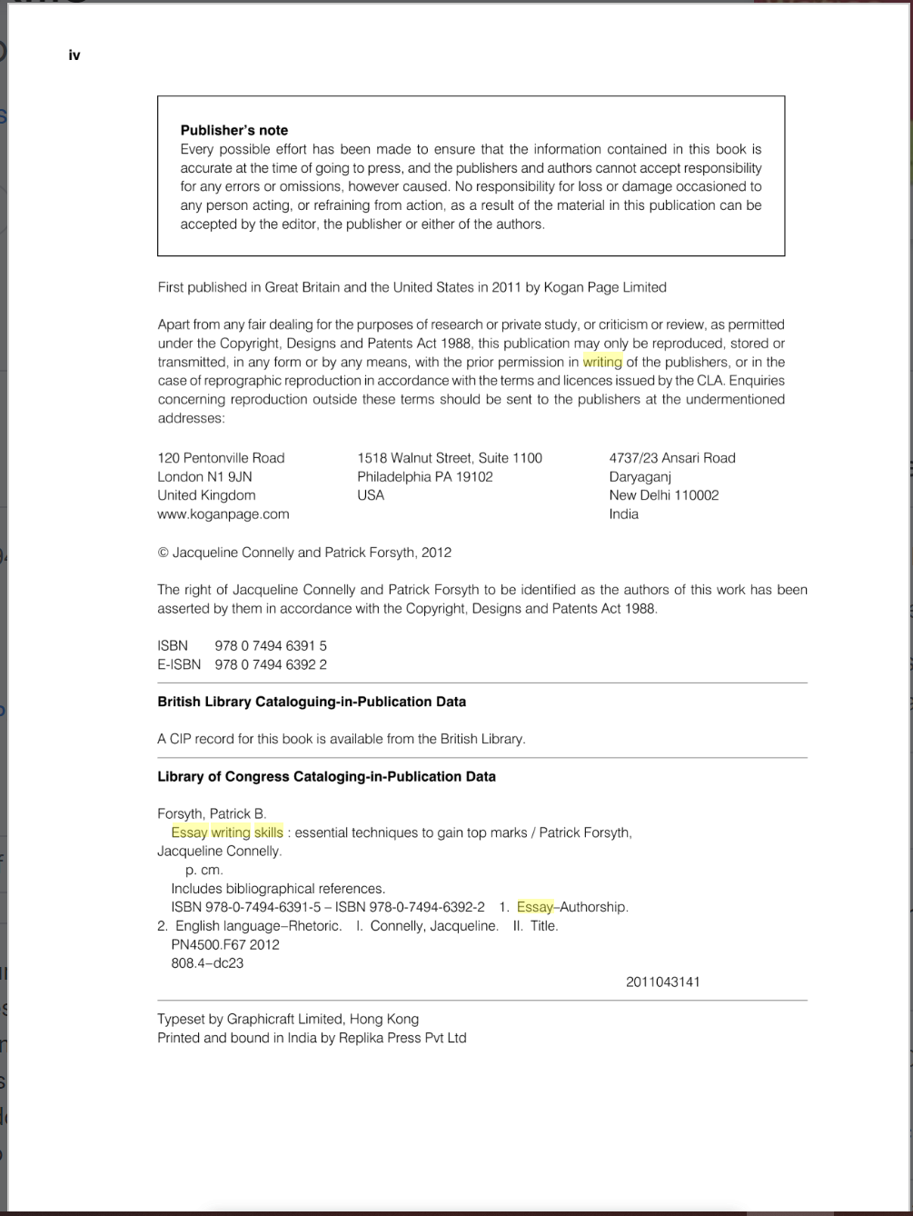
Citation: (Connelly and Forsyth, 2011)
Reference: Connelly, J. and Forsyth, P. (2011) Essay writing skills: Essential techniques to gain top marks. London: Kogan Page Limited.

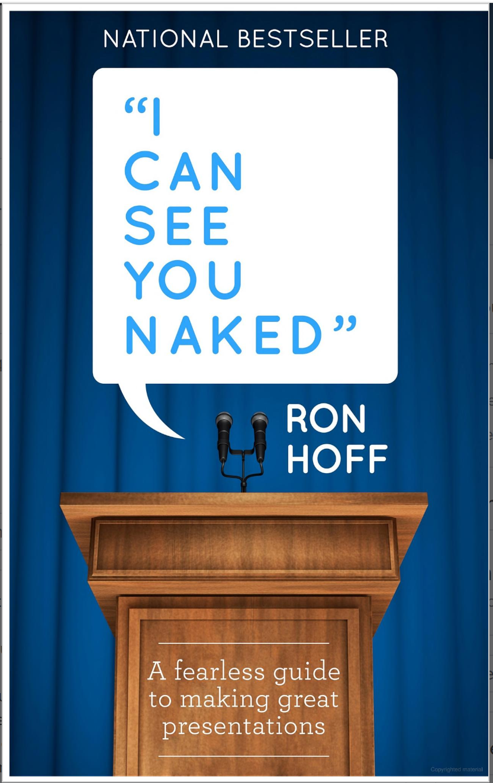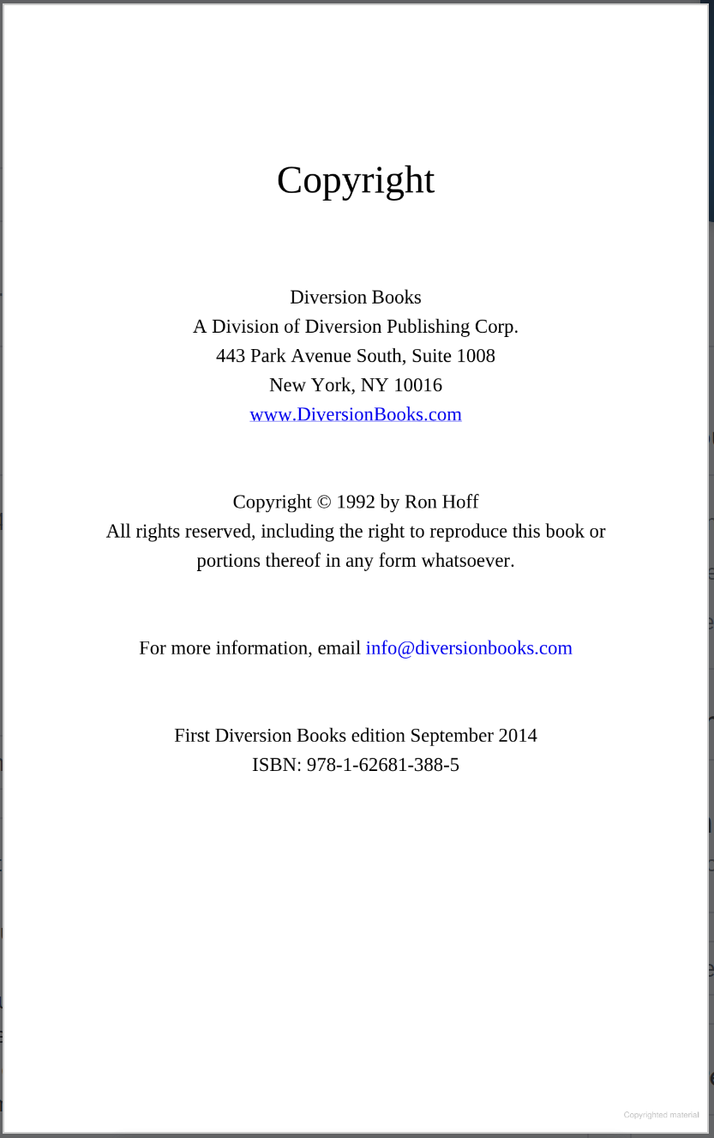
Citation: (Hoff, 2014)
Reference: Hoff, R. (2014) ‘I CAN SEE YOU NAKED’: A fearless guide to making great presentations. New York: Diversion Books.
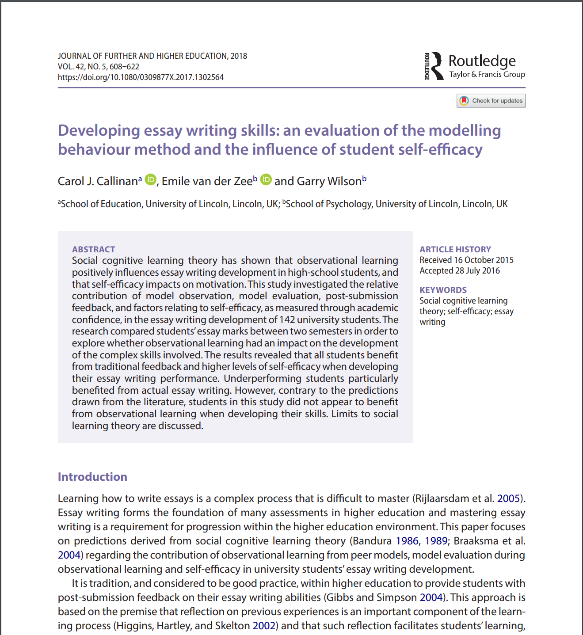
Citation: (Callinan, van der Zee and Wilson, 2016)
Reference: Callinan, CJ., van der Zee, E. and Wilson, G. (2016)’ Developing essay writing skills: an evaluation of the modelling behaviour method and the influence of student self-efficacy’, JOURNAL OF FURTHER AND HIGHER EDUCATION, 42(5), pp 608-622. Available at: https://doi.org/10.1080/0309877X.2017.1302564.

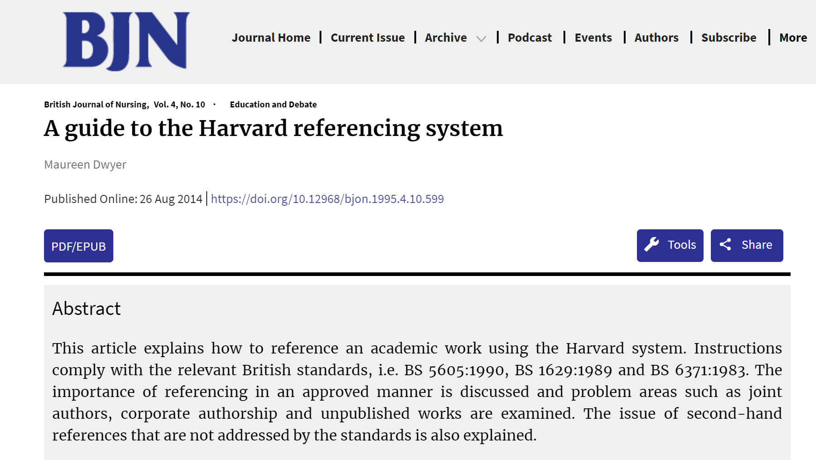
Citation: (Dwyer, 2014)
Reference: Dwyer, M. (2014) ‘A guide to the Harvard referencing system’, British Journal of Nursing, 4(10). Available at: https://doi.org/10.12968/bjon.1995.4.10.599.
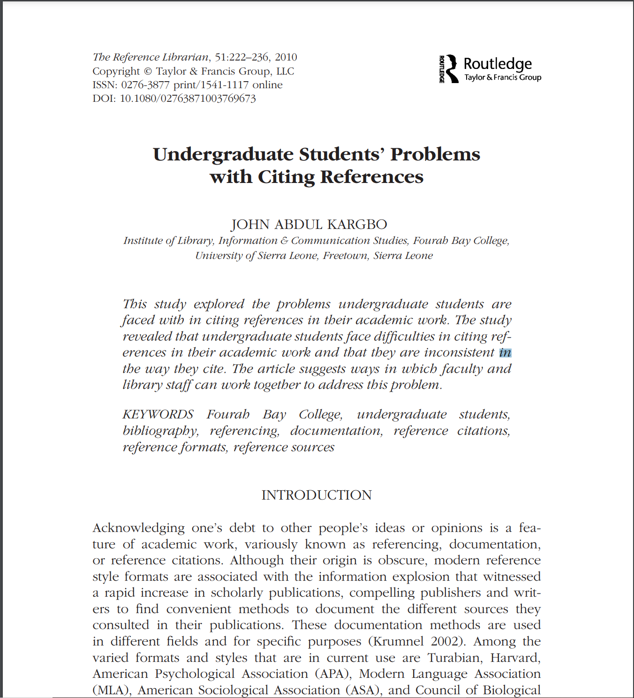
Citation:
Reference:

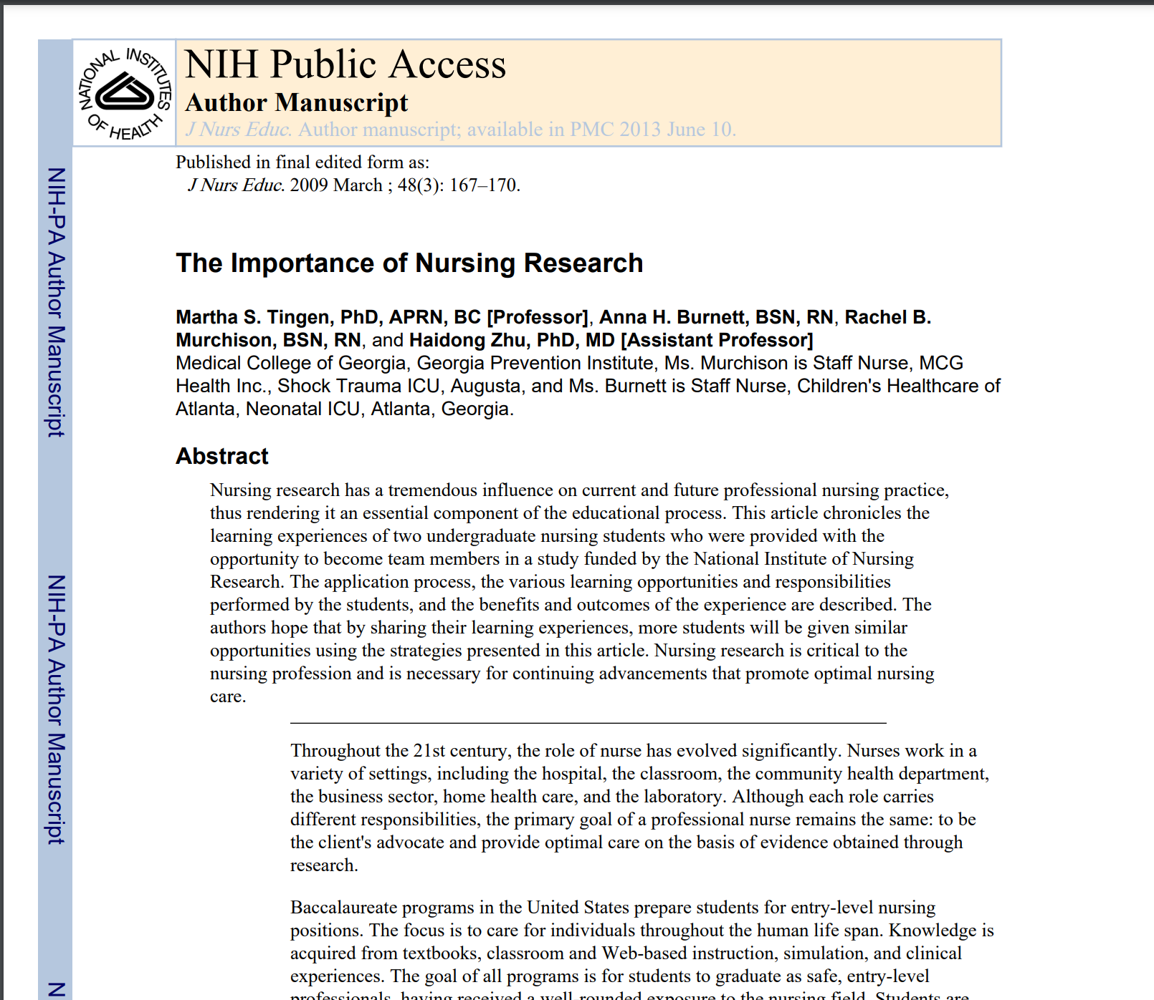
Citation:
Reference:
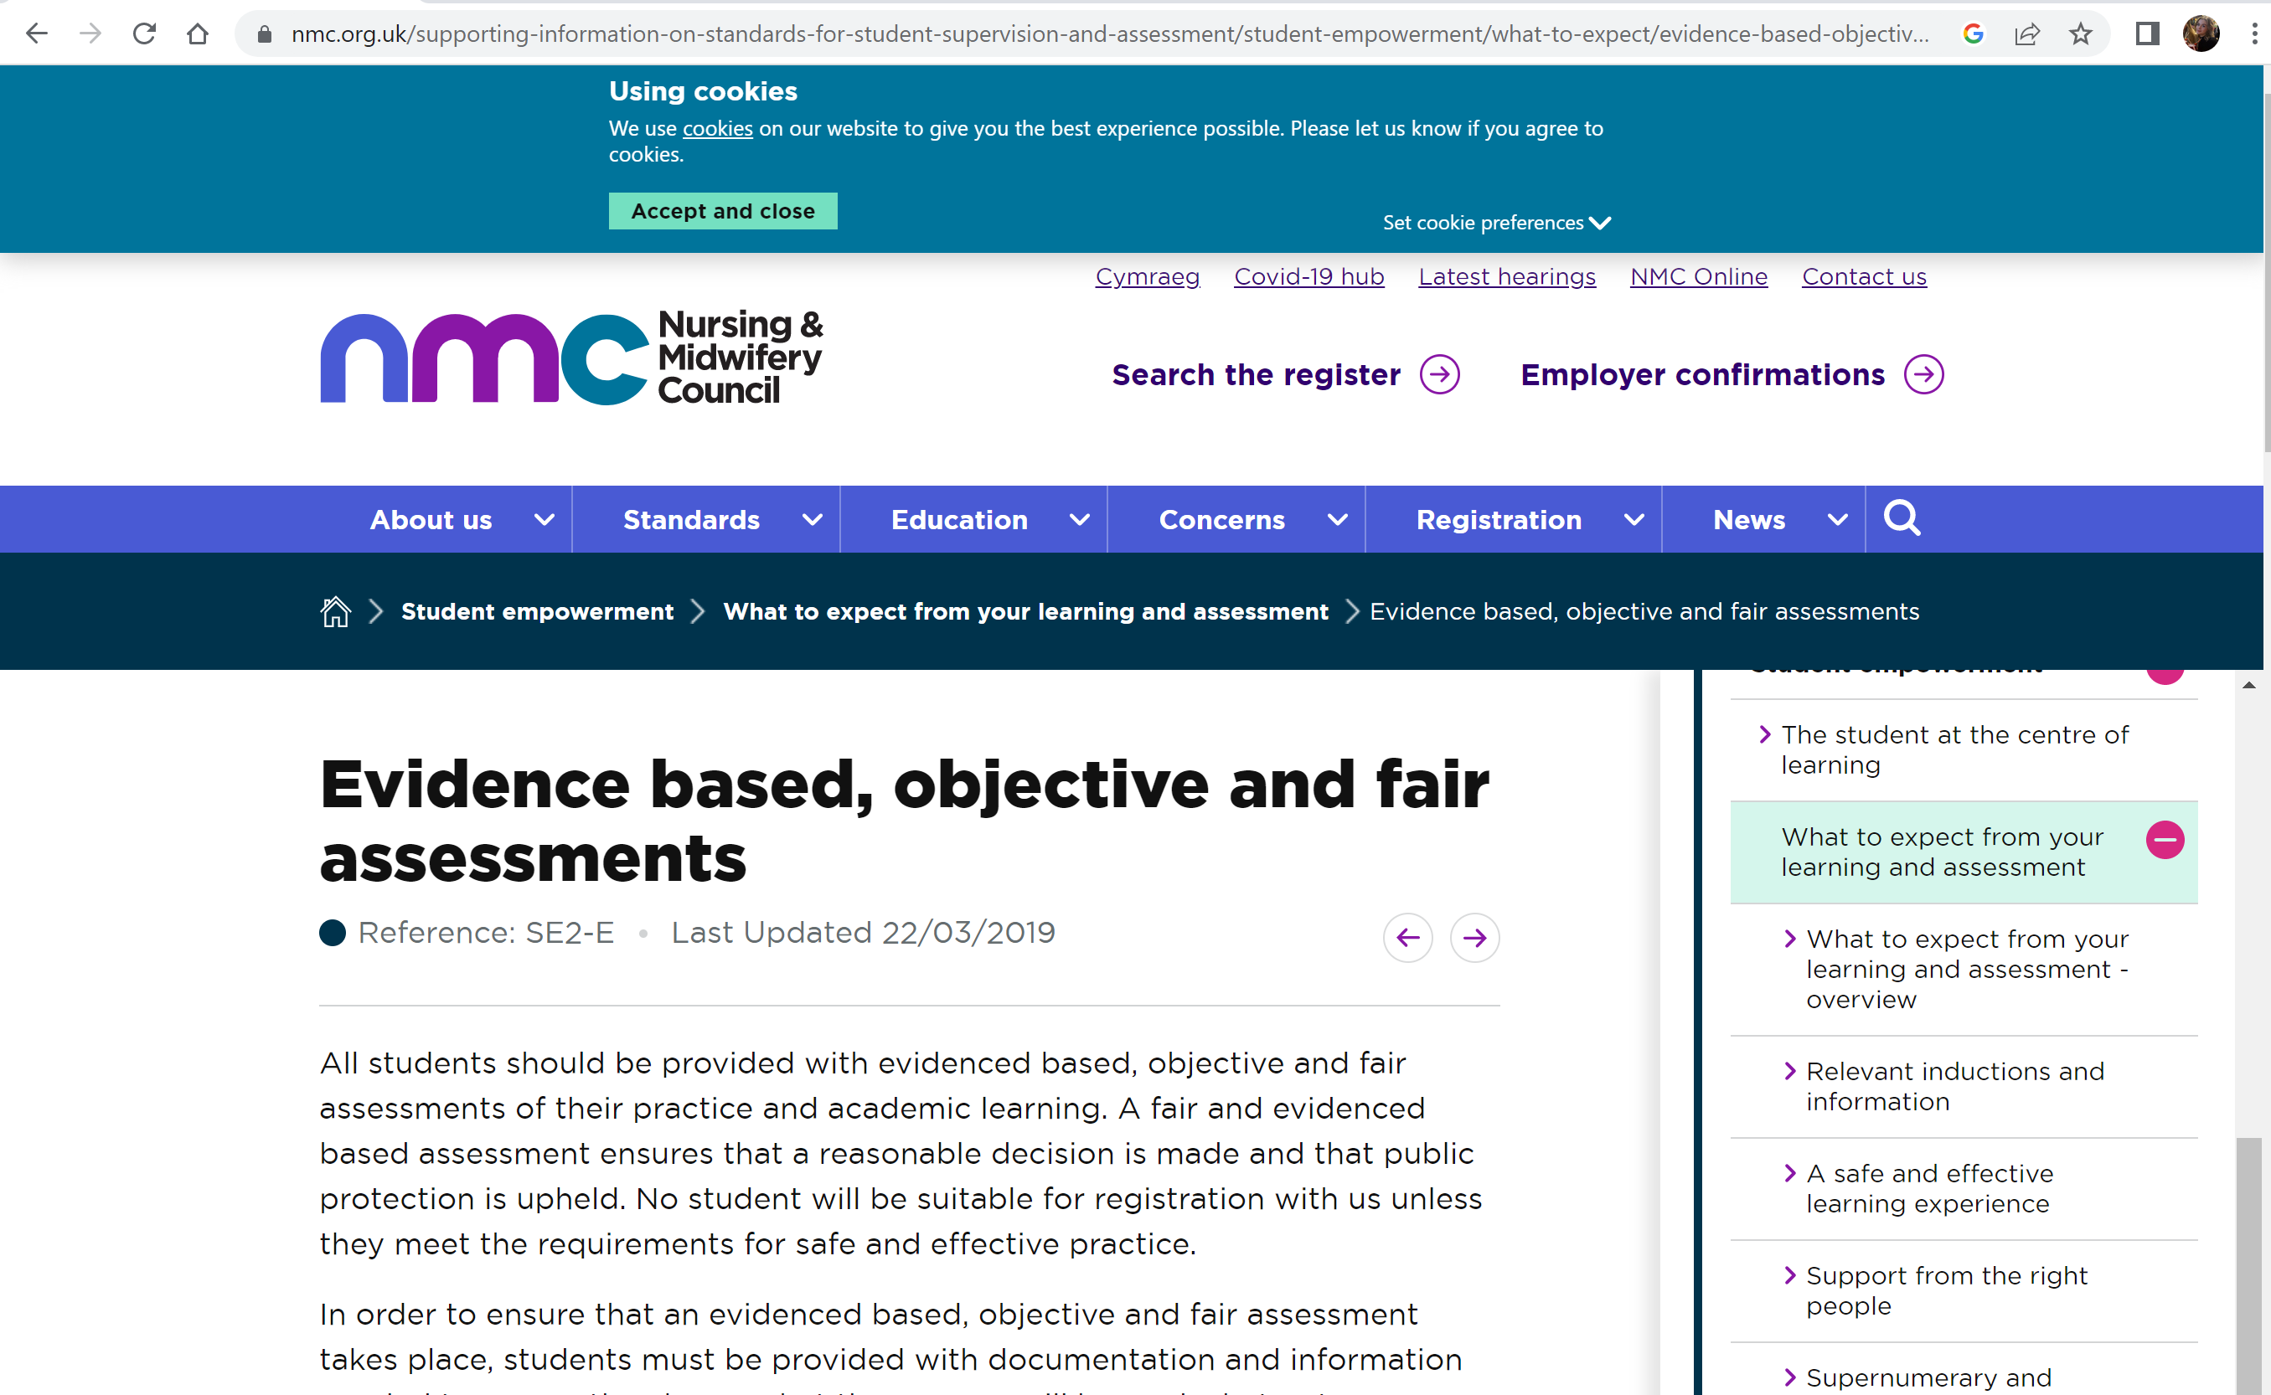
Citation: (NMC, 2019)
Reference: NMC (2019). Evidence based, objective and fair assessments. [online] Nmc.org.uk. Available at: https://www.nmc.org.uk/supporting-information-on-standards-for-student-supervision-and-assessment/student-empowerment/what-to-expect/evidence-based-objective-and-fair-assessments/ [Accessed 17 Oct. 2026].

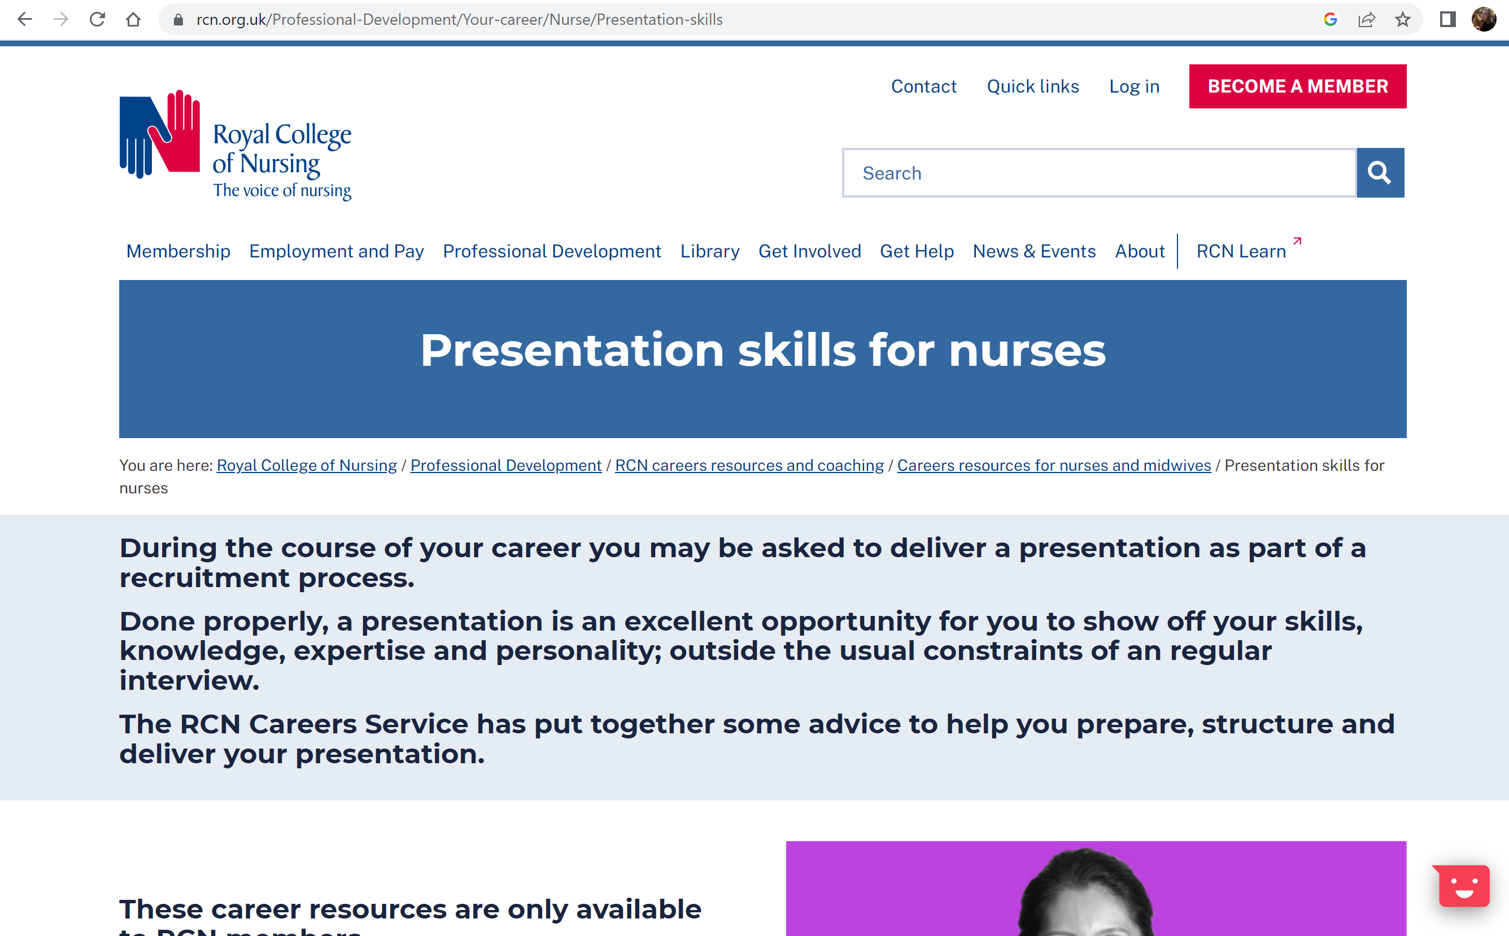
Citation: (The Royal College of Nursing, 2026)
Reference: The Royal College of Nursing. (2026). Presentation skills for nurses | Careers Resources | Royal College of nursing. [online] Available at: https://www.rcn.org.uk/Professional-Development/Your-career/Nurse/Presentation-skills [Accessed 17 Oct. 2026].

