

ENTREPRENEURSHIP (LCMB7004)
ASSESSMENT 2

SUBMITTED BY:
ERIKA MAE M. PAGADUAN
STUDENT NUMBER: 1604894

MODULE LECTURER:
DR. NANDISH PATEL

Table of Contents
Introduction 3
Entrepreneurial Motivation 3
Entrepreneurial Motivation in Start-Ups 5
Influence of Economic Environment in Start-Ups 6
Influence of Cultural Environment in Start-Ups 6
Conclusions and Recommendations 7
References 7

Figure 1 Entrepreneurs’ Goal Setting, Striving and Attainment Process 4

Introduction
To stay in control in the ever-changing world, people need to keep up with its demands. One of the key players in making this possible are entrepreneurs. According to Schumpeter (1934, cited in Mazzarol and Reboud, 2020), entrepreneurs are agents of the process wherein the economy moves forward through innovation. Filion (2021) noted that the definition of entrepreneurs revolves around the main components of it, such as innovation, recognition of opportunity, management of risks, action, management of resources and adding value. The challenging nature of entrepreneurship is worth some credits in managing the constant changes in the society. Creating opportunities, helping in maximisation of wealth and development of the economy is fuelled by their motivations. Entrepreneurial motivations are various factors which incites desire and stimulates enthusiasm in entrepreneurs for them to identify their strengths and opportunities leading them to achieve their goal of creating solutions to certain problems and creating values despite risks and threats (Trivikram, 2020).

Entrepreneurial Motivation
Motivation is an essential factor in the success of entrepreneurs because it acts as a driving force in order to materialise their goals and objectives. Alam et al (2019) cited goals and objectives as stimulators of motivation, which transform entrepreneurial intentions into actualisation. They also gave credits on the ability of individuals to adopt in the changing environment which stems from their capability transform motives and goals. Because of the changing motives and individuality of each entrepreneurs, there are number of theories analysing various entrepreneurial motivation. Schjoedt and Shaver (2019) developed a conceptual process model to better understand the reasons why individuals are motivated to become entrepreneurs. In their model, as shown in Figure 1 below, the authors cited that motivation starts as soon as entrepreneurs recognise the dimensions of their goals. These dimensions affect the goal progress which in turn impacts the attainment of the goal itself. Moreover, the dimension of goals, the progress as well as the attainment altogether are influenced by goal-specific self-efficacy.
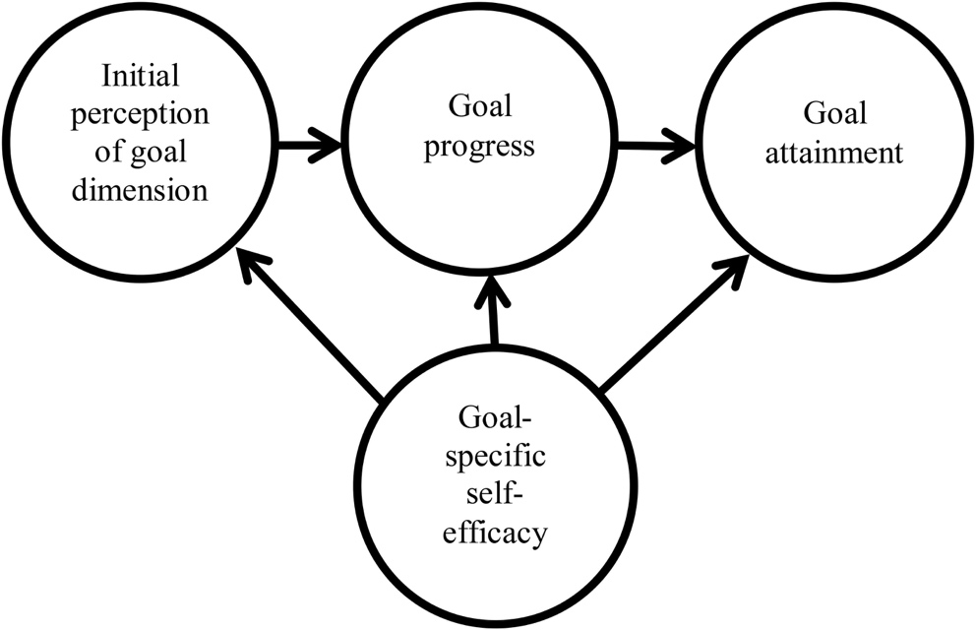
Figure 1 Entrepreneurs’ Goal Setting, Striving and Attainment Process

As defined by Wei et al (2020), self-efficacy in entrepreneurship is the level or degree to which entrepreneurs are confident, assertive and reliant on their own knowledge and skills to complete tasks. Bandura (1986, cited in Bayron, 2013) established in his Social Cognitive Theory that the environment affects an individual’s behaviour, but it also goes the other way around. This means that an individual’s behaviour can also impact the environment. Therefore, using Social Cognitive Theory, an entrepreneur’s sense of self-efficacy can be motivated by their environment such as proactive learning, persuasion by other people, role modelling, indirect experiences as well as self-assessment of psychological state. Moreover, self-efficacy stimulates entrepreneurs’ motivation as experiences or the environment gives an idea regarding desirability or feasibility of a certain project.

Goal dimension refers to an entrepreneur’s self-interpretation of his or her goals. Goal dimension includes goal content which is further divided into two categories: difficulty and specificity; and goal intensity, subdivided into: commitment and importance (Schjoedt and Shaver, 2019). This means that, upon setting themselves goals, entrepreneurs are motivated depending on their degree of proficiency which necessary to achieve those goals and the specifications of the goals. Furthermore, entrepreneurs are also motivated based on their commitment, dedication and drive to achieve their goals. This process can be supported by Vroom’s Theory of Expectancy which proposes that there are three motivating factors that push an individual to put efforts in order to achieve their goals, namely: expectancy, instrumentality and valence (Hsu et al (2014). This means that entrepreneurs are motivated to work on their craft if they believe that when they put in more efforts, achieving their goals will be more possible, feasible and attainable.

Goal striving progress involves feedback systems such “comparators” in order to assess whether the goal has been achieved. This process is advantageous for entrepreneurs especially when they are trying to achieve multiple goals at the same time. This means that entrepreneurs are motivated by the progress of their goal striving in the sense that they can rectify or improve any issues before actually completing their projects. On the other hand, goal attainment acts as a motivating factor because it refers to goal-directed performance (Klein and Kim, 1998 cited in Schjoedt and Shaver, 2019).

Entrepreneurial Motivation in Start-Ups

Becoming an entrepreneur is a challenging task and perhaps the hardest part is the initiation. This is why motivation is an important factor to succeed in this endeavour. Motivation can be entrepreneurs’ cutting edge because this will set them apart from the others. Moreover, motivation plays a crucial role in getting things done, inspiring others, sparking creativity and innovation and developing better ideas, products and/or services. According to Murnieks et al (2020), the most dominant motivations during start-up are of extrinsic and intrinsic nature. Extrinsic motivation includes economic motivations, financial motivations, social equity, ecological preservation and work-life balance. Meanwhile, intrinsic motivations include identity, moral values and emotional motivations.

Influence of Economic Environment in Start-Ups

Generally speaking, it is motivation which drives an individual to venture on an entrepreneurial path. Some scholars believe that financial gain is the primary motive of an individual to start-up an entrepreneurial career. However, there are also studies which shows that economic factors are not the main motivation of an entrepreneur. According to Amit et al. (2000, cited in Murnieks et al, 2020), non-economic factors are the top motivation of an entrepreneur to start-up. These includes achieving independence, making a contribution and being innovative. Although financial gains are not the primary motivating factor, it still plays an important role because entrepreneurs would need financial resources in order to fund their ventures. This means that economic motivations are still necessary, but entrepreneurs must not be limited to this motivator alone. Moreover, economic environment must be analysed even before the initialisation of an entrepreneurial activity. This is due to the reason that, changes in the economic condition or environment can increase or decrease an entrepreneur’s motivation to be involved in certain entrepreneurial activities. For example, circumstances affecting the entrepreneur’s income can influence his or her drive towards entrepreneurship. An individual who has been negatively impacted, in terms of financial standing, may mostly be motivated to engage in entrepreneurial activity to satisfy or balance out that negative effect.

Influence of Cultural Environment in Start-Ups

According to Hayton (2002, cited in Hechavarria and Reynolds, 2009), culture refers to the set of expected behaviours, values and beliefs. For some individuals, cultural environment influences them to venture in start-ups. An entrepreneur’s cultural value represents the extent to which the society considers his or her entrepreneurial behaviours to be acceptable. If he or she lives within an environment with a culture that promotes entrepreneurship, an entrepreneur has a potential in innovation. Some cultural values may be favourable to start-up entrepreneurs, while some has reservations and limitations.

Low and MacMillan (1988, cited in Hechavarria and Reynolds, 2009) stated that it is necessary to draw more attention and greater understanding on the role and relationship between culture and entrepreneurial activities. Entrepreneurship can be influences by cultural values, showing that contextual forces play a major role in motivating start-ups. Entrepreneurs’ perception on his or her cultural environment wherein he or she ventures a start-up is necessary in order to develop a framework to better understand various environmental conditions.

Conclusions and Recommendations

As established by many studies, motivation can be considered a foundation in every endeavour and most specifically entrepreneurship and start-ups. Motivation drives necessary performance and behaviour relating to start-ups. Therefore, entrepreneurs must keep in mind the importance of motivation in order to create solutions for certain problems and create value for greater benefits. Entrepreneurs must always find their purpose on why they started their entrepreneurial journey in the first place as this is the core of entrepreneurship. Developing smart, measurable, accountable, relevant and time-bound goals can also help in achieving goals as well as being surrounded with people with same goals

References

- Mazzarol, T. and Reboud, S. (2020) Entrepreneurship and Innovation: Theory, Practice and Context. 4th edn. Singapore: Springer.
- Filion, L.J. (2021) ‘Defining the entrepreneur’, in Dana, L.P. (ed.) World Encyclopedia of Entrepreneurship. Gloucestershire: Edward Elgar Publishing Limited.
- Trivikram, S. (2020) Entrepreneurial Motivation. Available at: https://myventurepad.com/entrepreneurial-motivation/#:~:text=Motivation%20makes%20entrepreneur%20by%20fulfilling,individual%20goals%20and%20society%20development. (Accessed: 9th May 2021).
- Alam, M.Z., Kousar, S. and Rehman, C.A. (2019) ‘Role of entrepreneurial motivation on entrepreneurial intentions and behaviour: theory of planned behaviour extension on engineering students in Pakistan’, Journal of Global Entrepreneurship Research, Vol. 9. Available at: https://journal-jger.springeropen.com/articles/10.1186/s40497-019-0175-1 (Accessed: 9th May 2021).
- Schjoedt, L. and Shaver, K.G. (2019) ‘Entrepreneurs’ Motivation: A Conceptual Process Theory’, Journal of Small Business & Entrepreneurship, Vol. 32, No. 4, pp. 333-353. DOI: 10.1080/08276331.2019.1596398. Available at: https://www.tandfonline.com/doi/full/10.1080/08276331.2019.1596398 (Accessed: 9th May 2021).
- Wei, J., Chen, Y. Zhang, Y. and Zhang, J. (2020) ‘How Does Entrepreneurial Self-Efficacy Influence Innovation Behavior? Exploring the Mechanism of Job Satisfaction and Zhongyong Thinking’, Frontiers in Psychology, Vol. 11, pp. 708-. DOI: 10.3389/fpsyg.2020.00708. Available at: https://www.frontiersin.org/articles/10.3389/fpsyg.2020.00708/full (Accessed: 9th May 2021).
- Bayron, C.E. (2013) ‘Social Cognitive Theory, Entrepreneurial Self-Efficacy and Entrepreneurial Intentions: Tools to Maximize the Effectiveness of Formal Entrepreneurship Education and Address the Decline in Entrepreneurial Activity’, Revista Griot, Vol. 6, No.1, pp. 66-77. Available at: http://scholar.google.co.uk/scholar_url?url=https://dialnet.unirioja.es/descarga/articulo/4769400.pdf&hl=en&sa=X&ei=z2eYYKWvErTGywSJ5IGgBQ&scisig=AAGBfm3dKC3FjNuqfmwSW3u82pT3Em68Gg&nossl=1&oi=scholarr (Accessed: 10th May 2021).
- Hsu, D.K., Shinnar, R.S. and Powell, B.C. (2014) ‘Expectancy Theory and Entrepreneurial Motivation: A Longitudinal Examination of the Role of Entrepreneurship Education’, Journal of Business and Entrepreneurship, Vol. 26, No. 1, pp.121-140. Available at: https://www.researchgate.net/profile/Thomas-Pittz/publication/268510441_A_Model_for_Experiential_Entrepreneurship_Education/links/54be890a0cf28ce312326bad/A-Model-for-Experiential-Entrepreneurship-Education.pdf#page=130 (Accessed: 10th May 2021).
- Murnieks, C., Klotz, A.C. and Shepherd, D.A. (2020) ‘Entrepreneurial motivation: A review of the literature and an agenda for future research’, Journal of Organizational Behavior, Vol. 41, No. 2, pp. 115-143. Available at: https://onlinelibrary.wiley.com/doi/10.1002/job.2374 (Accessed: 10th May 2021).
- Hechavarria, D.M. and Reynolds, P.D. (2009) ‘Cultural norms & business start-ups: the impact of national values on opportunity and necessity entrepreneurs’, International Entrepreneurship and Management Journal, Vol. 5, No. 4, pp. 417-437. Available at: https://www.researchgate.net/profile/Paul_Reynolds7/publication/225631174_Cultural_norms_business_start-ups_The_impact_of_national_values_on_opportunity_and_necessity_entrepreneurs/links/00b7d5269a97897b0e000000/Cultural-norms-business-start-ups-The-impact-of-national-values-on-opportunity-and-necessity-entrepreneurs.pdf (Accessed: 10th May 2021).

