Exploring the difference in anxiety before and after a CBT short-course

Introduction
It is frequently said that anxiety is a complex feeling that makes scientific research challenging or impossible. If there were a modal definition of anxiety, it might refer to an uncomfortable emotional state or situation that is characterised by apprehension. According to some studies, anxiety is a distressing emotional state or condition characterised by strain, dread, and concern as well as the activation or stimulation of the autonomic nervous system. Others claim that the term "anxiety" refers to a cognitive-affective reaction characterised by bodily arousal and apprehension regarding a possibly bad event that the person views as imminent (Sarason et al., 1990). There are various forms of anxiety, including social anxiety disorder, phobias of public places, obsessive-compulsive disorder, panic disorder, post-traumatic stress disorder, and generalised anxiety disorder (GAD). Here, only social anxiety disorder will be covered in more detail. Social anxiety disorder progresses in a chronic and crippling manner if left untreated. Patients with this condition appear to benefit from pharmaceutical, psychological and self-help interventions, according to a meta-analysis (Mayo-Wilson et al., 2014). The signs of social anxiety, which is defined as a significant and enduring fear of social or performance conditions, include sweating, heart palpitations, shaking, and respiratory difficulty. Social anxiety is a relatively common disorder that may be highly debilitating. It can be diagnosed using a scale-based questionnaire, which can be either specific or general. It's possible for social anxiety to coexist with other illnesses like depression. Among the disorders on the differential diagnosis for social anxiety are panic disorder, agoraphobia, atypical depression, and body dysmorphic disorder. Social anxiety can be treated with psychotherapy, medication, or a mix of the two. Social skill development, live exposure, cognitive therapy, and cognitive-behavioural therapy are some of the formal psychotherapies available for people with social anxiety disorder (individual and in groups). Finding qualified, experienced therapists may be challenging even though these treatments have a good chance of success. Social anxiety disorder is a common, persistent, frequently incapacitating, but unfortunately underdiagnosed illness. Additionally, this sickness is easily treatable with good pharmaceutical and psychiatric therapies. The results of treatment can be extremely beneficial even for individuals who have had the condition for a long period. (Jefferson, 2001a).
Cognitive-behavioural therapy (CBT) teaches patients the cognitive and behavioural competencies necessary to function adaptively in their inter- and intrapersonal environments. It is a time-restricted, present-focused approach to psychotherapy. In order to address the patient's concerns, the therapist and patient collaborate as a team. CBT is distinguished by an emphasis on controlled research that provide empirical evidence of effectiveness. The four basic CBT subtypes that have been utilised to treat social anxiety disorder are exposure, cognitive restructuring, relaxation training, and social skills training. The purpose of exposure treatments is to keep patients psychologically engaged as they confront the events, they are afraid of, allowing for the natural conditioning processes that lead to fear reduction to take place. The patient and the therapist create a list of anxiety-inducing circumstances in descending order as a first step. The patient begins by tackling their least-favourite scenario, gradually moving on to more challenging ones as they feel more in control of the simpler ones, all to keep anxiety within manageable bounds. The patient is instructed to actively engage the scenario until anxiety starts to naturally reduce, whether through role playing, imagination, or actual encounters with frightening circumstances outside of sessions (Heimberg,2002). The psychotherapy method for social anxiety disorder has been shown to be just as effective as social anxiety medications, and it may also improve the likelihood that the reaction will remain after the course of treatment. (Jefferson, 2001b).
It is hypothesised that levels of self-reported anxiety will be significantly lower following the completion of a six-week CBT short course.
Method
Participants
The number of participants that took part in the study (plus any information about how many were males/females if applicable). Range of ages of participants and the mean and SD of age. Demographic information of participants for your report: Twenty-four participants in total;11 males and 13 females Range of ages 19-63. M = 27.93, SD = 11.24 Seven of the 24 participants had been clinically diagnosed with an anxiety disorder while the other 17 had not.
Design
The design = within-subjects; all participants completed the Anxiety Symptoms Questionnaire (ASQ) before and after taking part in a six-week CBT short-course. The independent variable was the completion of the ASQ (before and after the CBT course) and the dependent variable was the intensity of anxiety symptoms reported. The test used to analyse data will be the Wilcoxon Signed Ranks Test.
Materials
The Anxiety Symptoms Questionnaire (ASQ; Baker et al., 2019) was used to collect data on participants self-reported intensity of anxiety symptoms. The full questionnaire aims to assess both intensity and frequency of symptoms however, for the purpose of this study, only intensity data was used within the analysis.
The Anxiety Symptoms Questionnaire (ASQ) contained 17 questions. There were specific instructions at the beginning of the questionnaire. The scoring mechanism for each question was 0-10. Problems with Concentration or Attention is an example of a question from ASQ. The possible range of total scores for intensity was from minimum 0 to maximum 170, where the highest scores represent extreme distress.
Procedure
A volunteer sample of members of the public were notified of the research study via a study advertisement poster placed within a self-help group for individuals experiencing symptoms of anxiety. Interested participants were prompted to contact the lead researcher to receive further information about the requirements of the study. Full study information was sent via email to each interested participant. Participants were informed that they would be required to take part in a six-week short-course of CBT aimed at helping them manage their anxiety symptoms, and that they would be asked to complete a short anxiety questionnaire before and after taking part in the CBT course. On the first day of their CBT sessions, each participant completed the ASQ to assess the intensity of their anxiety symptoms prior to taking part in the course. Following the completion of the final session after the six-week period, participants were again asked to complete the ASQ. Participants were thanked for their participation and provided with the opportunity to ask questions. A debrief form was provided outlining the aims of the study.
Results
A Wilcoxon Signed Ranks Test was conducted to determine whether the intensity of anxiety symptoms reported by participants reduced following the completion of a six-week shortcourse of CBT. The value of W was calculated as the smaller of W+ and W-, and therefore W was equal to 81.5. The critical value of W as indicated by the critical values table for 24 participants was 91, and so it has been observed that there is/is not a significant difference in participants anxiety symptom intensity.
The median scores indicate that intensity of symptoms was lower following the completion of the CBT short-course (median before = 52.5 and median after = 49).

References
Heimberg, R.G. (2002). Cognitive-Behavioral Therapy for Social Anxiety Disorder: Current Status and Future Directions.
Jefferson, J. W. (2001a). Social Anxiety Disorder: More Than Just a Little Shyness. Primary Care Companion to the Journal of Clinical Psychiatry, 03(01), 4–9. https://doi.org/10.4088/pcc.v03n0102
Jefferson, J. W. (2001b). Social Anxiety Disorder: More Than Just a Little Shyness. Primary Care Companion to the Journal of Clinical Psychiatry, 03(01), 4–9. https://doi.org/10.4088/pcc.v03n0102
Mayo-Wilson, E., Dias, S., Mavranezouli, I., Kew, K. M., Clark, D., Ades, A. E., & Pilling, S. (2014). Psychological and pharmacological interventions for social anxiety disorder in adults: a systematic review and network meta-analysis. The Lancet Psychiatry, 1(5), 368–376. https://doi.org/10.1016/s2215-0366(14)70329-3
Sarason, I. G., Sarason, B. R., & Pierce, G. (1990). Anxiety, cognitive interference, and performance. Journal of Social Behavior and Personality, 131–142. https://doi.org/10.4324/9781003163244-6

Appendices
- Consent form
- Debrief form
- Anxiety Symptoms Questionnaire
- Wilcoxon Signed Ranks Test


Centre for Psychology and Counselling

Study Debrief Sheet
(words underlined and in italics should be changed to fit your specific study)
Exploring differences in anxiety levels pre- and post-CBT short-course.

Thank you for taking part in the study.

The aim of this study was to assess the effectiveness of a six-week short course of CBT in assisting in the reduction of anxiety symptoms. We specifically aimed to find out whether self-reported anxiety symptoms, as recorded by participants at the beginning of their first CBT session, reduced when the same questionnaire was completed for a second time following the completion of the six weeks of CBT. We expect to find that taking part in the course of CBT significantly reduces symptoms of anxiety in participants.

If you wish to withdraw your data from the study, you must tell the researcher now. After this point, all of your data will be anonymised and we will not be able to trace it back to you.

If taking part in this study has raised any questions, please speak to the researcher on put your name and student email address here or contact the academic supervisor insert supervisor contact here, name and email.

Thank you once again for taking time to participate in this study.

Put your name here

Put your programme of study here
(BSc Applied Psychology, or BSc Psychology, or BSc Psychology and Counselling)

University of Wales Trinity Saint David
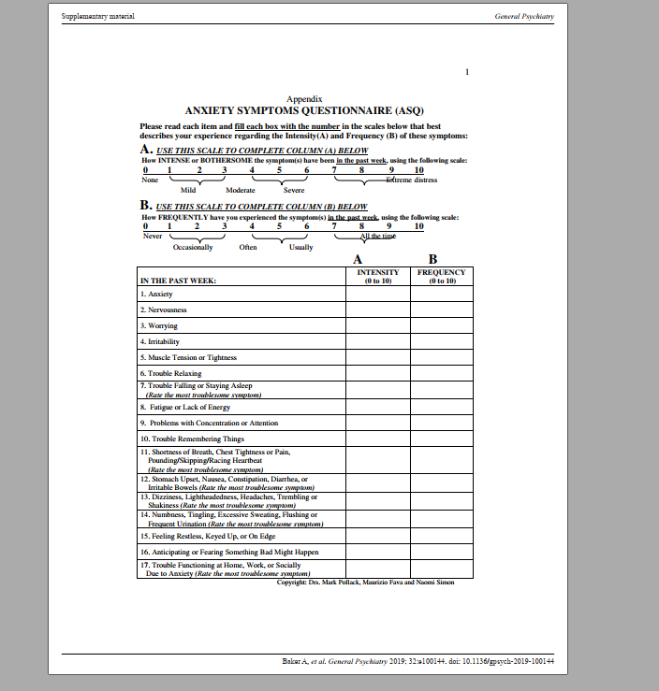

Report 1 Data: Wilcoxon Signed Ranks Test

P | Anxiety BEFORE CBT | Anxiety AFTER CBT | Difference | Order | Rank | Sign
1 | 100 | 80 | 20 | -1 | 3 | -3
2 | 56 | 46 | 10 | -1 | 3 | -3
3 | 111 | 110 | 1 | 1 | 3 | 3
4 | 80 | 84 | -4 | 1 | 3 | 3
5 | 54 | 50 | 4 | 1 | 3 | 3
6 | 40 | 41 | -1 | -2 | 7 | -7
7 | 21 | 23 | -2 | -2 | 7 | -7
8 | 35 | 29 | 6 | 2 | 7 | 7
9 | 34 | 30 | 4 | 3 | 9 | 9
10 | 45 | 25 | 20 | -4 | 12.5 | -12.5
11 | 81 | 74 | 7 | -4 | 12.5 | -12.5
12 | 64 | 60 | 4 | 4 | 12.5 | 12.5
13 | 27 | 31 | -4 | 4 | 12.5 | 12.5
14 | 58 | 60 | -2 | 4 | 12.5 | 12.5
15 | 51 | 50 | 1 | 4 | 12.5 | 12.5
16 | 101 | 81 | 20 | -5 | 16 | -16
17 | 49 | 48 | 1 | 6 | 17.5 | 17.5
18 | 84 | 80 | 4 | 6 | 17.5 | 17.5
19 | 29 | 39 | -10 | 7 | 19 | 19
20 | 40 | 45 | -5 | -10 | 20.5 | -20.5
21 | 68 | 65 | 3 | 10 | 20.5 | 20.5
22 | 27 | 28 | -1 | 20 | 23 | 23
23 | 12 | 10 | 2 | 20 | 23 | 23
24 | 56 | 50 | 6 | 20 | 23 | 23

W+ =218.5
W- =81.5

So W = -81.5
Critical value W =91

