Application Development

Name: Liam Salter.
Student Number: 1702256.
Course: Web Development.
Date: 04/12/18.
Table of Contents
1. Introduction [Task 3]. 2
2. Application Development Concepts [Task 1]. 2
2.1. Web Design Principles. 2
2.2. Usability and User Experience (UX). 3
3. Requirements. 4
3.1. Introduction to the website. 4
3.2. Breakpoints and content display strategy. 4
3.3. Primary requirements/features. 4
4. Design. 4
4.1. Design Principles Followed. 4
5. Implementation. 5
5.1. Script and class functionality. 5
5.2. Screenshots of all pages. 5
6. Evaluation. 9
6.1. Validation and Testing. 9
6.1.1. JavaScript Test. 9
6.1.2. Responsive Test. 10
6.1.3. Browser Support Test. 11
6.2. Evaluation of design and usability. 12
6.3. Reflection. 12
7. Conclusion. 12
8. Appendices. 13
8.1. Appendix 1. 13
8.2. Appendix 2. 13
8.3. Appendix 3. 13
8.4. Appendix 4. 14
References 15

Introduction
Within this report, the author will be researching into important application development concepts to implement in the application. Application requirements that have been followed during the production of the application will also be discussed. Important design principles that have been adhered shall be detailed. JavaScript and classes that have been implemented during the production of the site will be discussed and finally an evaluation of the completed site will take place.

Application Development Concepts [Task 1].

Web Design Principles.
There are many web design principles that are followed by web developers every day to keep websites and applications up to date to todays standards. One such principle being the K.I.S.S Principle. K.I.S.S stands for ‘Keep It Simple Stupid’ [1]. The principle itself is thought to be created by a man called Clarence Johnson, who was responsible for the design of the SR-71 Blackbird spy plane [2]. K.I.S.S is an important design principle as it prevents information overload, which can deter potential retention of visitors to a site. Also, by following K.I.S.S, most of the time, only key information or aspects are shown, which again relate to reducing information overload. However, K.I.S.S should not come before the functionality of the application, as some form of complexity (within reason) enhances the experience for visitors [3].
According to a conference paper conducted by ResearchGate[6], there are two groups of web design principles that should be followed to enhance the overall design of a website, these being “balance, harmony and unity” and “simplicity, consistency, clarity”.
Balance: According to the first set of design principles, objects and colours are needed to be balanced as it is visually appealing to the human eye [4]. If objects and colours are not balanced, it creates a feeling of tension, a feeling of the screen being off sided or tipped. Balance creates symmetry.
Harmony and Unity can be achieved by using similar fonts, colours, pictures that match the topic and feel of the site/application and graphics which use a similar tone. Creating a site without full harmony and unity breaks the flow of the site and cannot provide the site with the feeling of totality. Also, according to the second set of design principles, simplicity is key as superfluous graphics and information can interfere with visitors’ understanding and can also distract the user. Consistency refers to the placement of items on the page, an example of this would be if the logo is situated on the top left of the web page on page, it should still be placed on the top left on every other page on the site. Inconsistencies can cause cognitive overhead, which refers to the amount of logical connections the brain must take to make sense of the object or item the brain is looking at [5]. Finally, clarity, which is achieved by the user understanding the meaning of each item on the page. If clarity isn’t achieved, the user will find it difficult to interpret the page and will most likely cause them to leave. All information provided can be found in the conference paper [6].

Another important principle to adhere to is the Gestalt Theory aka Gestalt Principles[ref]. These principles were originally derived from 1920’s psychology where it was found that people typically view objects by grouping similar elements, simplifying intricate images and recognising patterns [7]. The principles are divided into four laws. The law of closure, where as the brain prefers complete shapes, the brain will automatically fill the gap [Appendix 1]. The law of Common Region, where the brain groups elements that are in the same closed region [Appendix 2]. The law of Figure/Ground, where the brain can perceive complex images as simple images [Appendix 3] and the Law of Proximity, where the brain seeks order, the brain will group elements into groups and seek balance/order, even in situations where it isn’t there.

Usability and User Experience (UX).
Usability and user experience are very important aspects of web and app design. As defined in a research paper by ResearchGate[ref], user experience can be summarised as a person’s attitude, response and subjective feeling towards a specific aspect of the site. While usability can be summarised as the indictor for interactivity of a site. It refers to how interactive a site is, how easy a site is to learn and how easy a site is to use [8].
Usability and User Experience can be subdivided into four elements each. Usability can be divided into functionality, learnability, flexibility and industry design. Functionality asks how the user can interact with the site, learnability asks how easy the site is to learn and/or navigate without extra learning, flexibility asks do more that its original intended use and industry design asks how professional does the site look [9]. User Experience on the other hand can be divided into usability, adoptability, desirability and value. Usability simply asks how easy the site is to use, adoptability asks how easy the site is to start using for new users, desirability asks how engaging the site to users and value is asks how useful the site is [10].
When all these elements are put together, four more topics are opened. These topics being how clear is the content on the page, colours, typefaces (fonts) and responsiveness. Content clarity on a page is vital as users only want to see relevant information in a clear order. User tend to read web pages in a F or E order, this is known within industry as the ‘F Pattern’ [11]. Also, elements with functions on the page should be clear and evident to their purpose, such as a navigation bar being a place to navigate the site. Colours are also very important as certain colours can trigger subconscious, emotional responses in our brains, such as the colour red can cause anger, intensity, love and warmth [12], whereas the colour blue incites the emotions of calmness, serenity, trustworthiness [13]. Fonts are important as they dictate the feel of the website and they also are important for readability for the user [14]. Finally, responsiveness is very important to web/app development as responsiveness allows the page to be seen on every device people use to browse the web, such TVs, laptops, computers and most importantly, mobile phones. As a recent research study by Pew Research Center, more than 95% of Americans own some sort of smart phone [15], and ….

Requirements.

Introduction to the website.
Luminance is a place where people can relax and enjoy by browsing many, high quality, watermark free images and be motivated by quotes from many icons of our generations. The goal of the website is to provide a sense of tranquillity and help boost creativity in people.

Breakpoints and content display strategy.
The web site was built with ‘Mobile First’ in mind [16]. This was done for two reasons. One being that it would it drastically decrease the amount of work needed if a problem was to occur. Another being that the design process could be changed slightly as the website was upscaled progressively. Bootstrap utilises a grid system that can be scaled to 5 different sizes, being extra small, small, medium, large and extra-large [17]. But the site was designed with extra small, medium and large for simplicity. Extra small to medium utilises all 12 columns, to maximise usage of screen real estate. Medium to large utilises 6 columns and 6 columns to display more content without sacrificing quality and for large and higher, the extra screen real estate allows the use of 4, 4 and 4 columns per row.

Primary requirements/features.
The primary requirements/features that the website must have followed were divided into technical specifications and non-functional requirements [18] [19].
Technical Specifications:
- User must be able to play/pause audio.
- User must have choice if they wish to play audio.
- User must be able to cosmetically interact with the website.
- User must be able to fill in a form.
- User must be able to navigate the website with ease.
Non-functional requirements:
- Website must be viewable on varying screen resolutions.
- Website must include high resolution images.
- Website must have easily readable typefaces that are readable on smaller devices.
- Website must use colours that don’t conflict and are pleasing to the eye.
- Website must load fast.

Design.

Design Principles Followed.
During the development of the website, the author primarily followed 2 design principles. These being the K.I.S.S principle and the Gestalt Theory. Rows and columns were placed in a form which follows the law of common region and the law of proximity. This was to keep the design familiar and inviting, yet professional. The content was kept in relevance to the site, then the content was divided up into sections, which the content inside the sections are relevant to each other. And superfluous information was kept to a minimum and removed where possible, as to adhere to K.I.S.S and to avoid information overload.

Implementation.

Script and class functionality.
The JavaScript functions created for website are:
- Header Placer – Places the header from the index page into any other page that the user loads. Avoids duplicated code.
- Footer Placer – Places the footer from the index page into any other page that the user loads. Avoids duplicated code.
- PageRedirect1 – Redirect from categories digital to gallery digital.
- PageRedirect2 - Redirect from categories gaming to gallery gaming.
- PageRedirect3 - Redirect from categories nature to gallery.
- PageRedirect4 - Redirect from categories urban to gallery urban.

Screenshots of all pages.
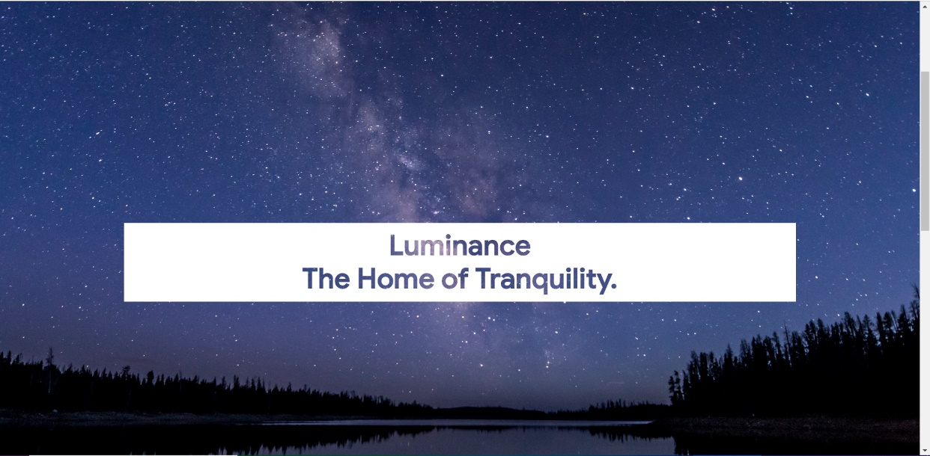
Home.
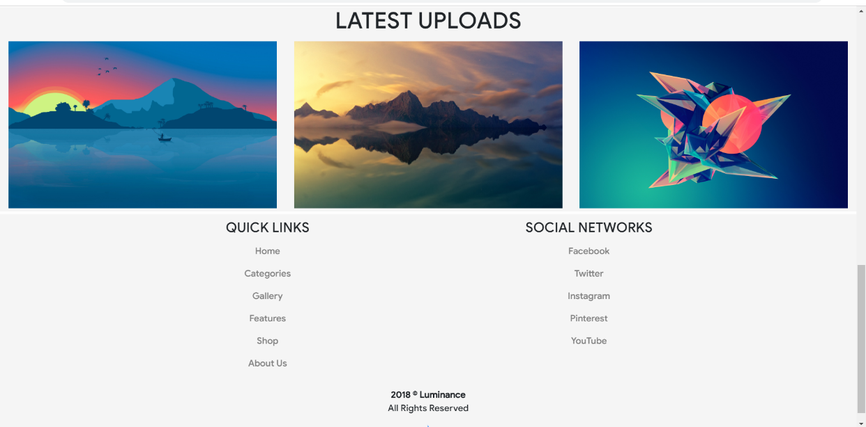

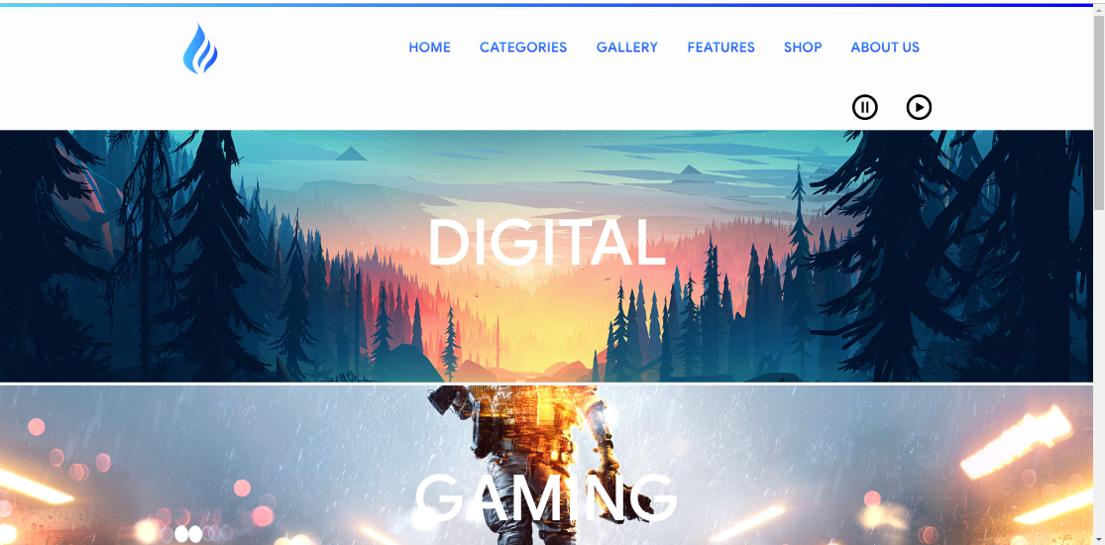
Categories.

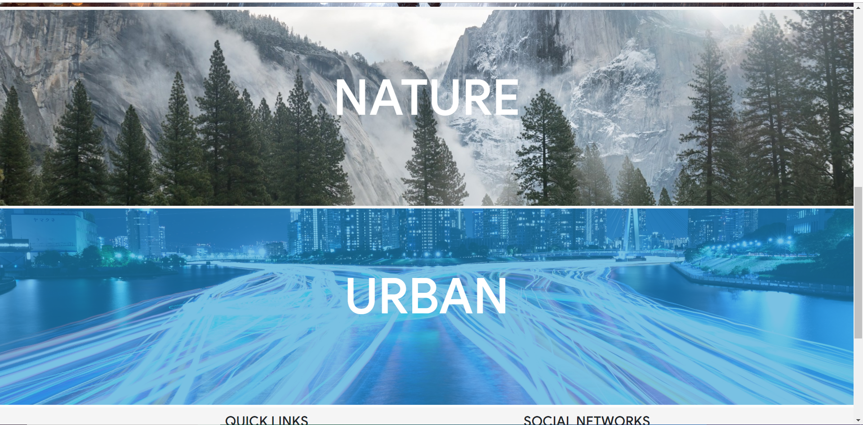

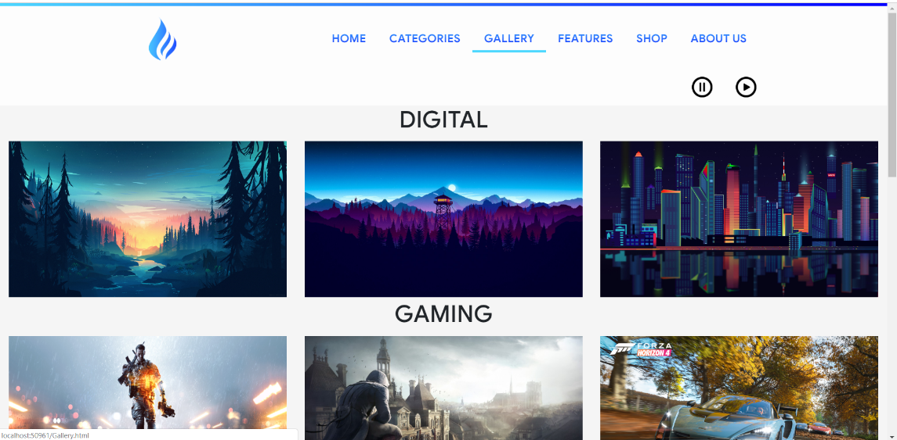
Gallery.

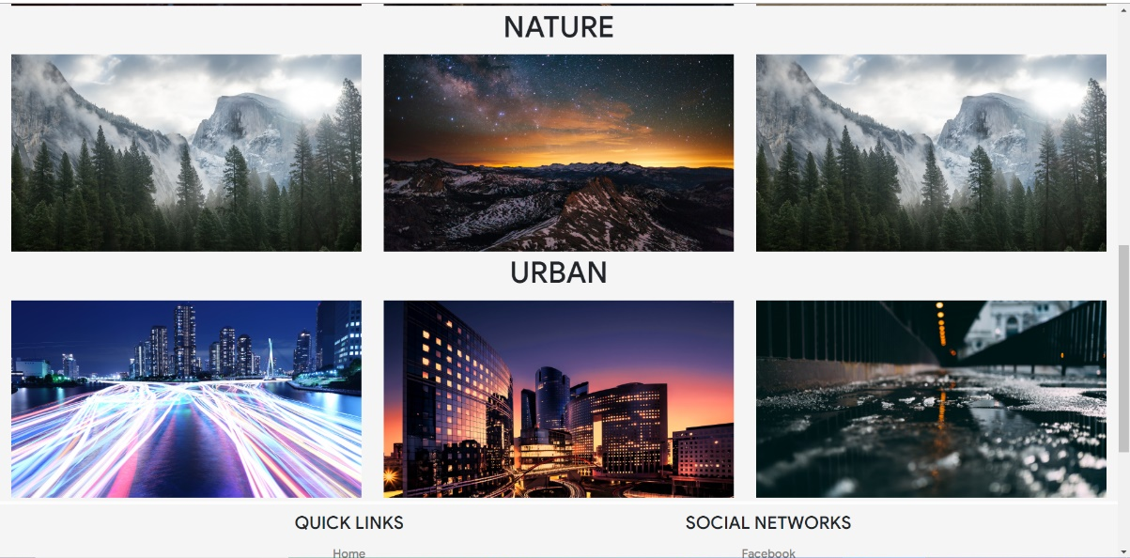
Features.
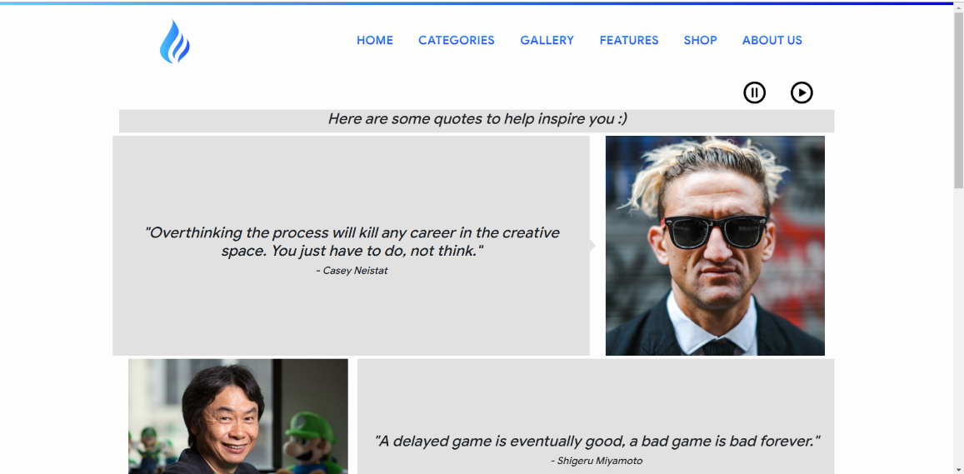
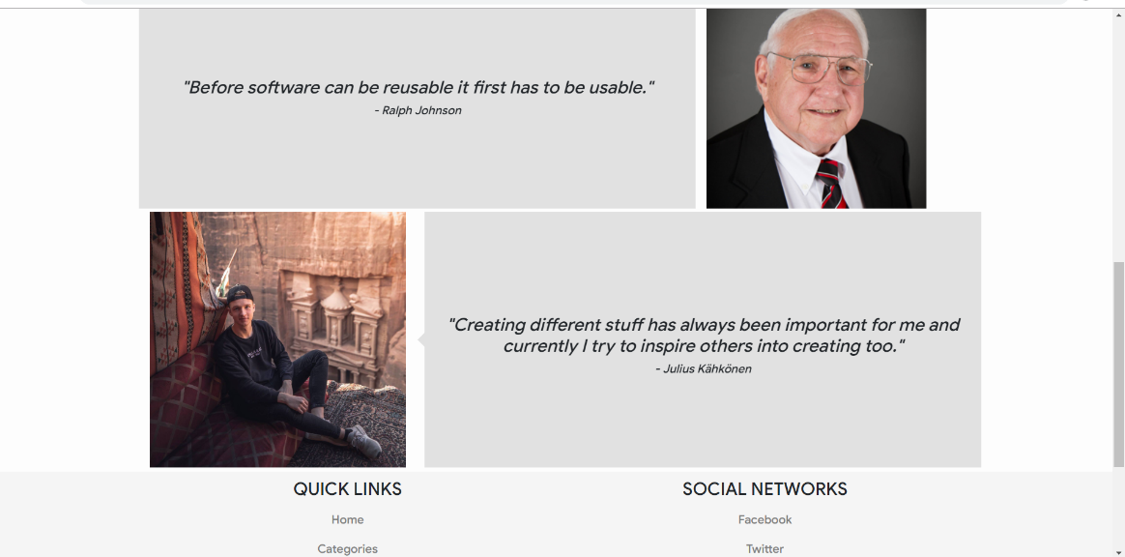

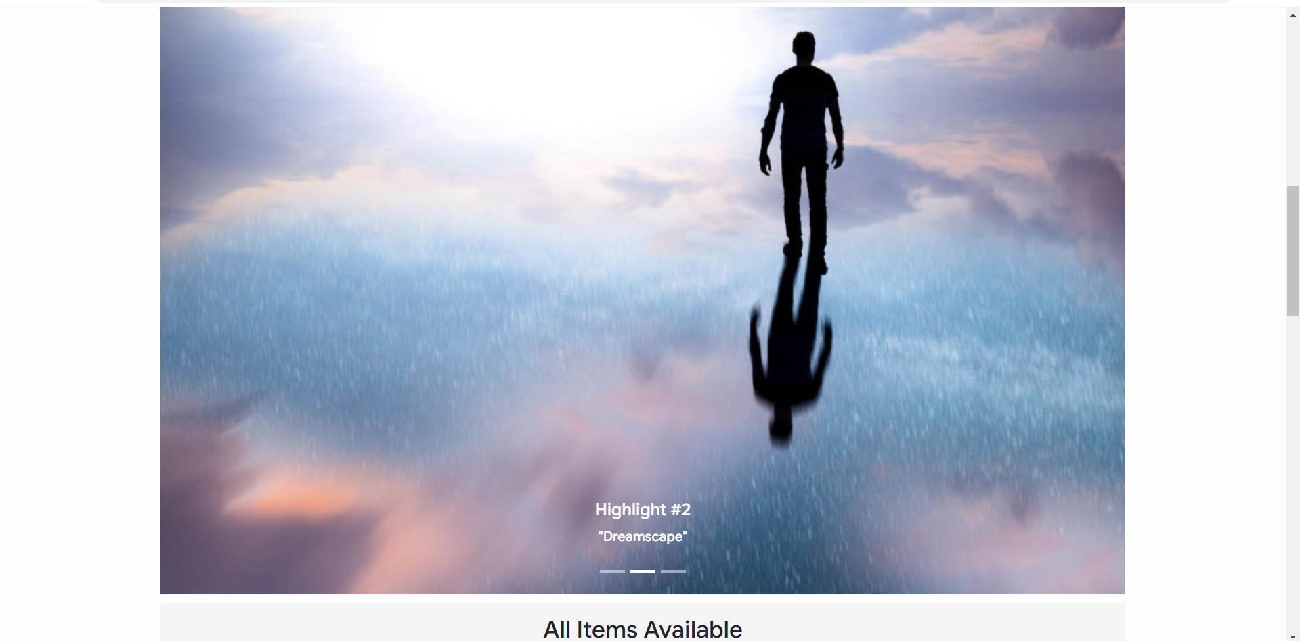
Shop.
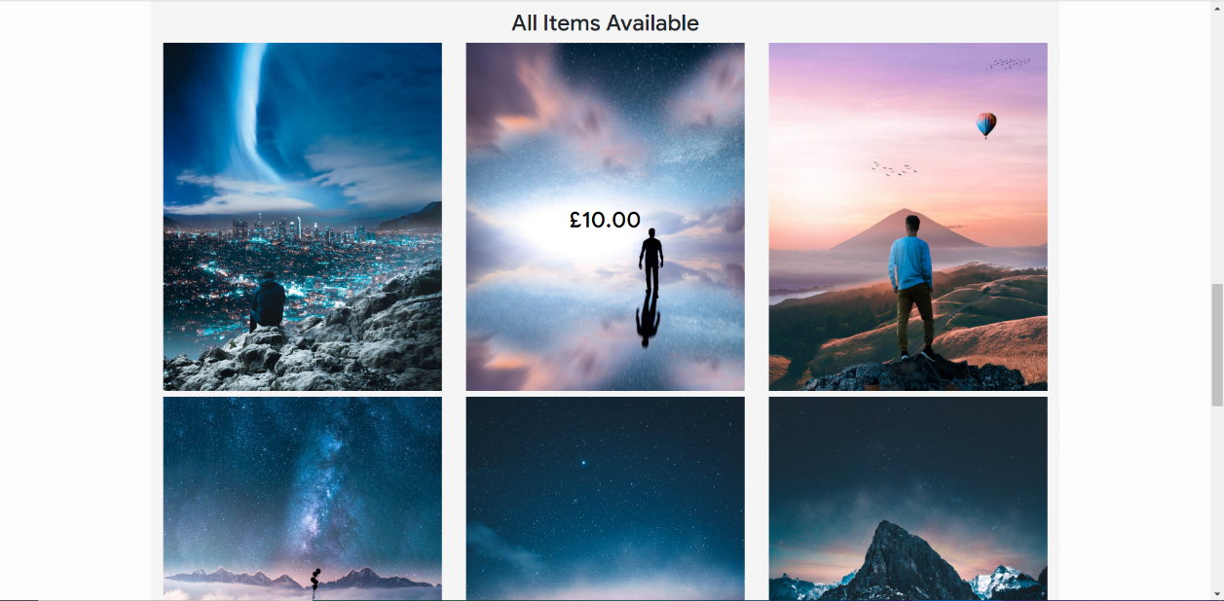

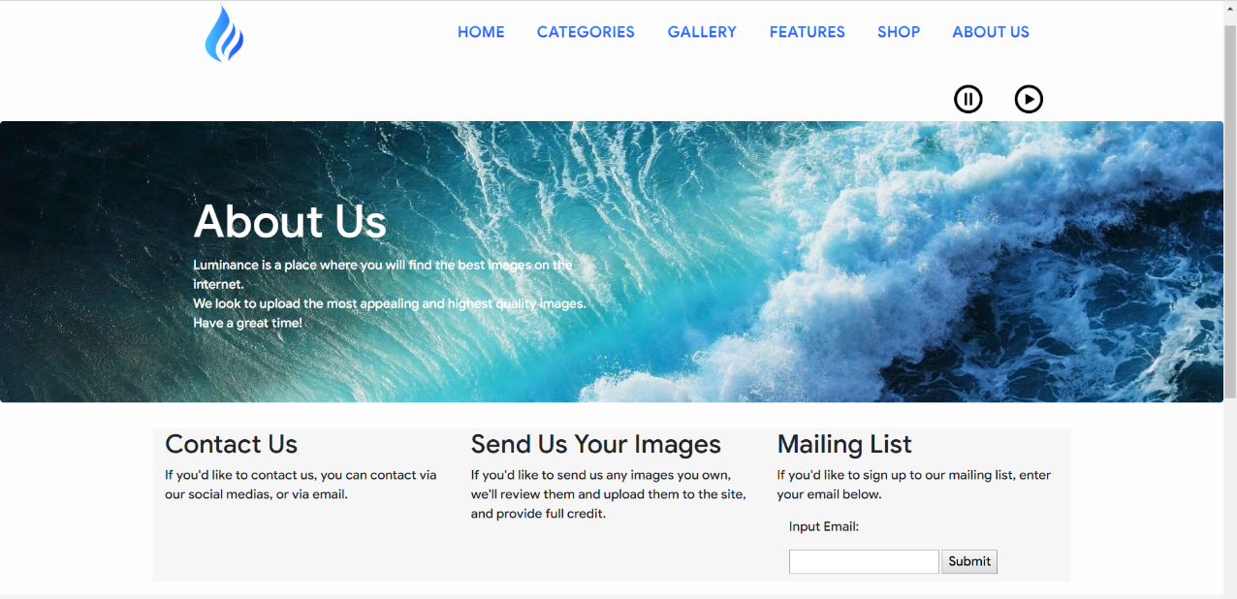
About Us.

Evaluation.

Validation and Testing.

JavaScript Test.
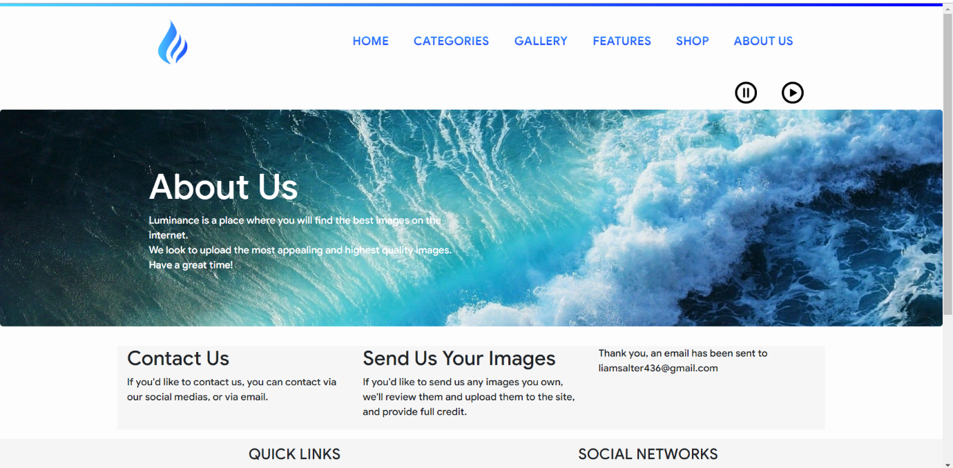
Example 1 – Mailing List.

As seen in the screenshot above, once the user has input their email, a message will display thanking them for their input.
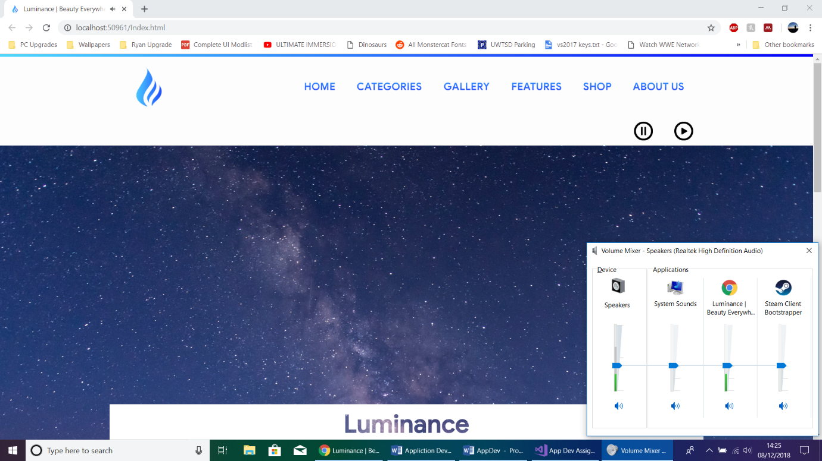
Example 2 – Audio.

As seen in the screenshot above, windows sound mixer demonstrates that audio is playing in the browser.

Responsive Test.
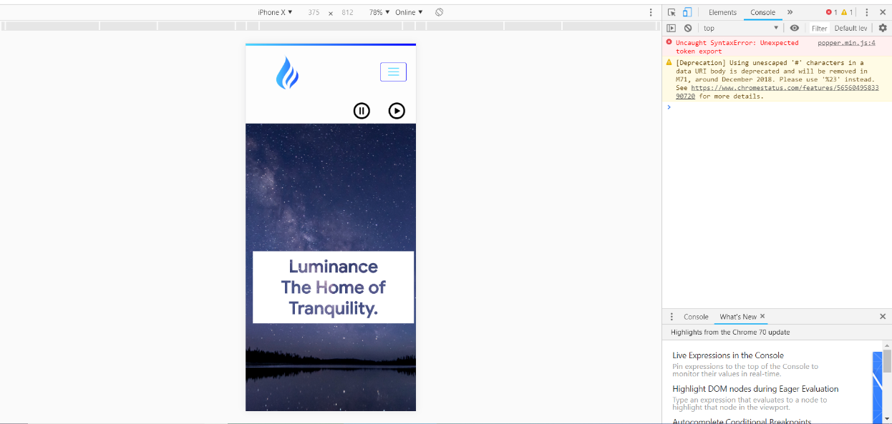
Responsive Home Page.

The home page was tested to be responsive on the iPhone X in the above screenshot.

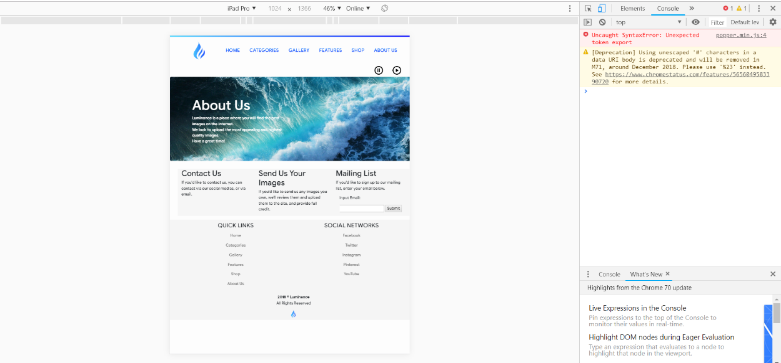
Responsive About Us Page.

The About Us page was tested to be responsive on iPad Pro in the above screenshot.

Browser Support Test.
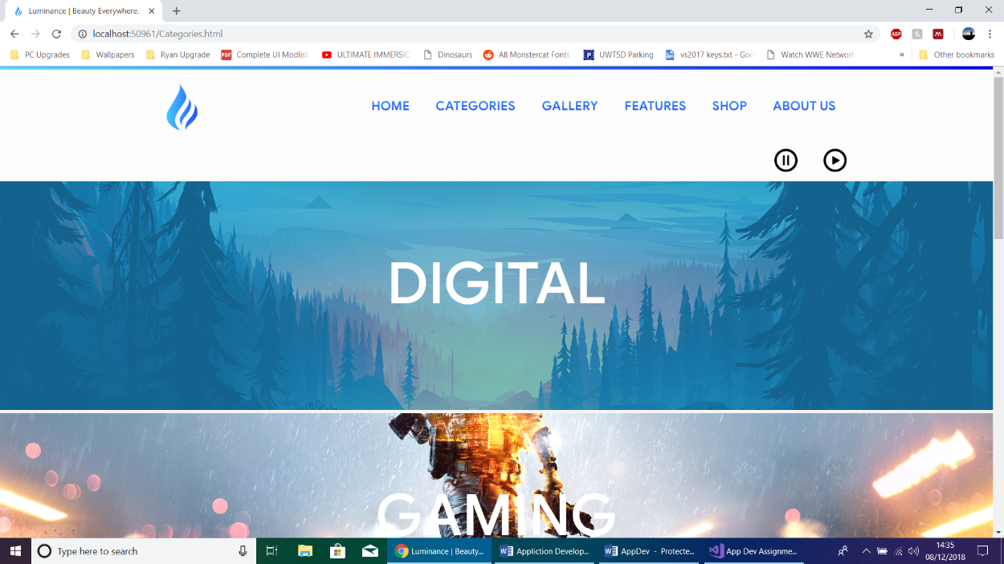
Test on Google Chrome.

The web page is demonstrated to be working on Google Chrome in the above screenshot.
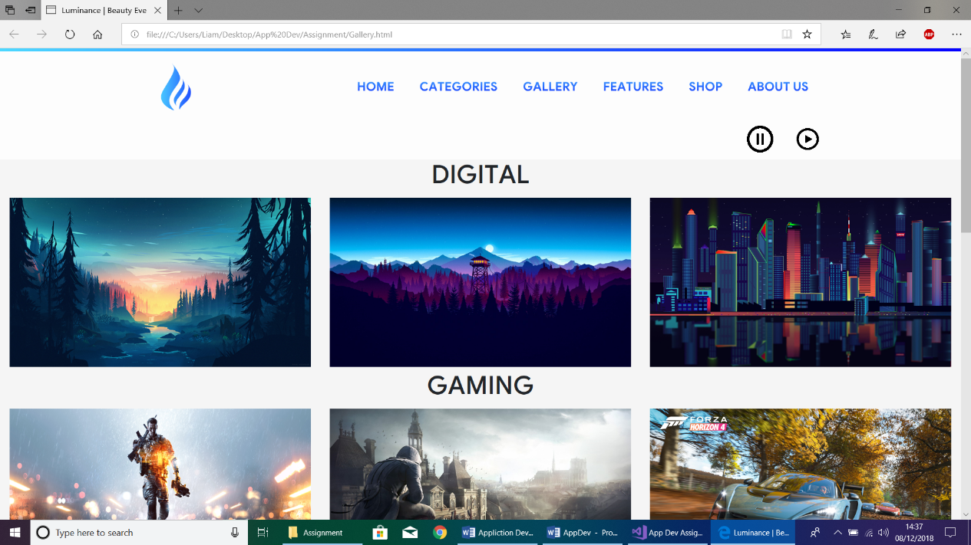
Test on Microsoft Edge.

The web page is demonstrated to be working on Microsoft Edge in the above screenshot.

Evaluation of design and usability.
The design of the site was built from the ground up, by following multiple design principles, to have a professional design, due to the nature of the site. The layout out of the site was designed with bootstrap and utilises the grid system to create a professional looking layout. The colours were chosen specifically as to make the site more inviting and eye pleasing to the viewer. As the colour blue, emotionally, makes the brain feel calm and invited. The typeface (Product Sans) was chosen as it is a professional typeface, utilised by Google. The functionally of the site was carefully considered to match the feel of the site, such as the peaceful audio, the mailing list functionality and more.

Reflection.
Further improvements that could be utilised in the future could be to utilise more of Bootstrap’s native tools, such as text sizing, container margins etc. Another recommendation could be to add a volume slider to the audio, to add further control to the user. Another recommendation would be to add a user comment section or a blog, as it would further increase site interactivity.

Conclusion.
In conclusion, the author has researched into principles correlating to web design, usability and user experience, created a website utilising the principles, outlined the primary requirements of the website by creating an SRS, outlined the design principles followed during the creation of the site, described the JavaScript functions used in the site and finally evaluated the site by recommending strategies to use in the future.

Appendices.

Appendix 1.
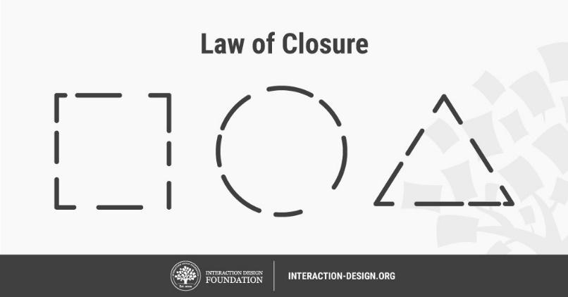

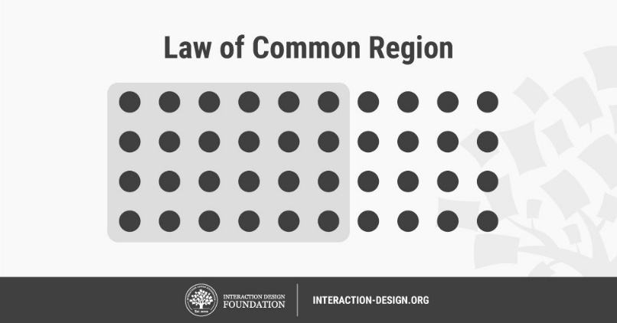
Appendix 2.

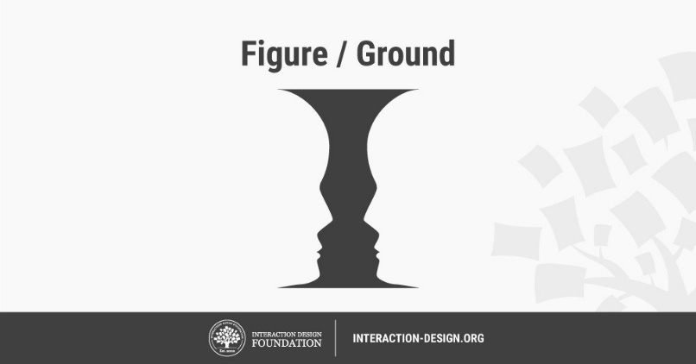
Appendix 3.

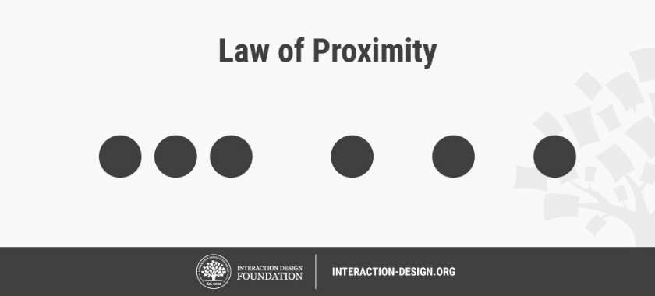
Appendix 4.

Note: Appendix 1, 2, 3 and 4 are derived from the same source [7].

References

[1] | Interaction Design Foundation, “KISS (Keep it Simple, Stupid) - A Design Principle,” Interaction Design Foundation, November 2018. [Online]. Available: https://www.interaction-design.org/literature/article/kiss-keep-it-simple-stupid-a-design-principle. [Accessed 7 December 2018].
[2] | Lockhead Martin, “Clarence “Kelly” Johnson: Architect of the Air,” Lockhead Martin, [Online]. Available: https://www.lockheedmartin.com/en-us/news/features/history/johnson.html. [Accessed 7 December 2018].
[3] | J. Dance, “UI/UX PRINCIPLE #53: MORE FLEXIBILITY CAN LEAD TO MORE COMPLEXITY,” Fresh Consulting, 23 August 2017. [Online]. Available: https://www.freshconsulting.com/uiux-principle-53-more-flexibility-can-lead-to-more-complexity/. [Accessed 7 December 2018].
[4] | T. Mastroeni, “Why Our Brains love Symmerty in Design,” FreshHome, 29 September 2014. [Online]. Available: https://freshome.com/2014/09/29/why-our-brains-love-symmetry-in-design/. [Accessed 7 December 2018].
[5] | S. Verhulst, “A new vocabulary for the 21st Century: Cognitive Overhead,” GovLab, 22 April 2013. [Online]. Available: http://thegovlab.org/a-new-vocabulary-for-the-21st-century-cognitive-overhead/. [Accessed 7 December 2018].
[6] | P. C. M. A. Carlos J. Costa, “PRINCIPLES FOR CREATING WEB SITES: A DESIGN PERSPECTIVE,” in PRINCIPLES FOR CREATING WEB SITES: A DESIGN PERSPECTIVE, 2004.
[7] | Interaction Design Foundation, “Gestalt Principles,” Interaction Design Foundation, [Online]. Available: https://www.interaction-design.org/literature/topics/gestalt-principles. [Accessed 7 December 2018].
[8] | N. Bevan, “What is the differnce between the purpose of the usability and user experience evaluation methods?,” What is the differnce between the purpose of the usability and user experience evaluation methods?, p. 4, 2009.
[9] | Mockplus, “The Ultimate Guide—Difference Between Usability and User Experience,” Mockplus, 28 December 2017. [Online]. Available: https://www.mockplus.com/blog/post/difference-between-usability-and-user-experience. [Accessed 7 December 2018].
[10] | F. Guo, “More Than Usability: The Four Elements of User Experience, Part I,” ELICITING DESIRED BEHAVIOR, vol. 1, p. 3, 2012.
[11] | N. Babich, “F-Shaped Pattern for Reading Content,” UXPlanet, 4 April 2017. [Online]. Available: https://uxplanet.org/f-shaped-pattern-for-reading-content-80af79cd3394. [Accessed 7 December 2018].
[12] | M. A. M. S. L. S. S. Vanessa L, “Red - Take a Closer Look,” German Research Foundation, 2014.
[13] | J. Cao, “12 colours and the emotions they evoke,” 27 September 2018. [Online]. Available: https://www.creativebloq.com/web-design/12-colours-and-emotions-they-evoke-61515112. [Accessed 7 December 2018].
[14] | Awebco, “WHY TYPOGRAPHY IS SO IMPORTANT TO YOUR WEBSITE DESIGN,” Awebco, 21 Augusr 2017. [Online]. Available: https://www.awebco.com/blog/why-typography-is-so-important-to-your-website-design/. [Accessed 7 December 2018].
[15] | Pew Research Center, “Mobile Fact Sheet,” Pew Research Center, 5 February 2018. [Online]. Available: http://www.pewinternet.org/fact-sheet/mobile/. [Accessed 7 December 2018].
[16] | V. Page, “Mobile First Strategy,” Investopedia, 6 April 2018. [Online]. Available: https://www.investopedia.com/terms/m/mobile-first-strategy.asp. [Accessed 8 December 2018].
[17] | Bootstrap, “Grid System,” Bootstrap, [Online]. Available: https://getbootstrap.com/docs/4.0/layout/grid/. [Accessed 8 December 2018].
[18] | We Make Websites, “HOW TO WRITE A WEBSITE SPECIFICATION,” We Make Secrets, 26 Febrruary 2018. [Online]. Available: https://wemakewebsites.com/blog/how-to-write-a-website-specification. [Accessed 8 December 2018].
[19] | A. P. M. T. S. A. Alican Güçlükol, “Software Requirement Specification For Web Based Integrated Development Invironment,” Middle East Technical University, Ankara.

Links to Images, fonts and libraries used.
Bootstrap -
getbootstrap.com

Hover -
http://ianlunn.github.io/Hover/

JQuery -
http://jquery.com/

Product Sans -
https://fonts.google.com/license/productsans

Audio -
EPIC Games - Used in Fortnite.

logo inspiration -
https://www.google.co.uk/url?sa=i&source=images&cd=&cad=rja&uact=8&ved=2ahUKEwjoqPTasbHeAhWBfywKHUS8DWEQjRx6BAgBEAU&url=http%3A%2F%2Fwww.clker.com%2Fclipart-blue-flame-simpleblueblack-6.html&psig=AOvVaw2uzDvRdulm0c5nCojObXsw&ust=1541099593255206

pictures used :
blue night -
https://wallpaperset.com/w/full/b/5/8/325185.jpg

new 1 -
https://wallpaperstudio10.com/wallpaper-download-198662-4096x2304.jpg

new 2 -
https://i1.wp.com/blog.pickyourtrail.com/wp-content/uploads/2017/12/johannes-plenio-266430.jpg?fit=4563%2C2567&ssl=1

new 3 -
https://hdqwalls.com/download/abstract-shapes-3840x2400.jpg

nature 1 -
https://wallpapershome.com/images/pages/pic_h/181.jpg

nature 2 -
https://i0.wp.com/wallpapersultra.net/wp-content/uploads/Yosemite-Full-Screen-HD-4K-Wallpaper.jpg

nature 3 -
https://wallpapershome.com/images/wallpapers/wave-3840x2160-5k-4k-wallpaper-8k-ocean-palms-sun-5490.jpg

digital 1 -
http://hdqwalls.com/wallpapers/small-memory-lp.jpg

digital 2 -
http://wallpaperping.com/wp-content/uploads/2018/05/firewatch-night-widescreen-wallpaper-1920x1080.jpg

digital 3 -
https://wallpaperstudio10.com/static/wpdb/wallpapers/3840x2160/185016.jpg

urban 1 -
https://wallpapershome.com/images/wallpapers/city-3840x2160-light-night-river-4k-8k-18452.jpg

urban 2 -
http://hdqwalls.com/wallpapers/france-paris-city-4k-im.jpg
urban 3 -
http://wall2born.com/data/out/646/image-45827241-4k-wallpaper-for-desktop.jpg

gaming 1 -
https://i.ytimg.com/vi/tOXWsyzsekw/maxresdefault.jpg

gaming 2 -
https://wallpapersite.com/images/pages/pic_w/261.jpg

gaming 3 -
http://hdqwalls.com/wallpapers/forza-horizon-4-2018-bj.jpg

about us background -
http://genchi.info/images/ultra-wide-hd-wallpaper-29.jpg

casey neistat -
https://yt3.ggpht.com/a-/AN66SAzRddjQW5e0W-H8H3fzhlI-z48SqNniAEik2w=s900-mo-c-c0xffffffff-rj-k-no

Shigeru Miyamoto -
https://www.thefamouspeople.com/profiles/images/shigeru-miyamoto-1.jpg

Visuals of Julius -
https://scontent.flhr3-1.fna.fbcdn.net/v/t1.0-9/46823836_1313795178758797_224325403135705088_o.jpg?_nc_cat=110&_nc_ht=scontent.flhr3-1.fna&oh=665df516cafd4145669eeadab9c67540&oe=5C671F0D

Ralph Johnson -
https://www.ngu.edu/myimages/ralph_johnson_2.jpg

marking criteria and Student FEEDBACK

This section details the extent to which the assessment criteria are demonstrated by you, which in turn determines your mark. The marks available for each category of skill are shown. Lecturers will use the space provided to comment on the achievement of the task(s), including those areas in which you have performed well and areas that would benefit from development/improvement.

Common Assessment Criteria Applied (Assignment 1) | Marks available | Marks  awarded
1. Engagement with Literature Skills

A wide range of appropriate reference sources have been consulted. (Grade mark: 100.00%) | 5 | 5
2. Knowledge and Understanding Skills

Excellent discussion of the application concepts demonstrating detailed knowledge and critical understanding of the concepts. (Grade mark: 84.00%) | 25 | 21
3. Cognitive and Intellectual Skills

A good evaluation of the implemented website has been provided. The documentary evidence of testing could be improved beyond screenshots to further demonstrate test cases for the interactive functionality. (Grade mark: 50.00%) | 20 | 10
4. Practical Application Skills

A very good attempt, but there is still room for improvement. Some things to note: learn how to create a single reusable function with a parameter to accept what varies - see your report. Note the correct URL reference for your images and consider reducing the size of your Jumbotrons and Slideshows so that users get to see relevant above-the-fold content. Very good use of JavaScript to define reusable header and footer content once and load into the different pages, but the use of JavaScript to load links was not necessary as simple HTML <a> links would have been ok in this case. Well done for working out how to let users decide if they wanted to listen to the music or not. See your report for additional comments and suggested corrections. Overall, a very good attempt. (Grade mark: 71.11%) | 45 | 32
5. Transferable Skills for Life and Professional Practice

The report is of a very good standard but see your report for some suggested improvements. (Grade mark: 70.00%) | 5 | 3.5

Assignment Mark (Assessment marks are subject to ratification at the Exam Board. These comments and marks are to give feedback on module work and are for guidance only until they are confirmed. ) | Late Submission Penalties (tick if appropriate) |  | 71.5%
 | Up to 1 week late (40% Max) |  | 71.5%
 | Over 1 week late (0%) |  | 71.5%

