Job Advertisement:

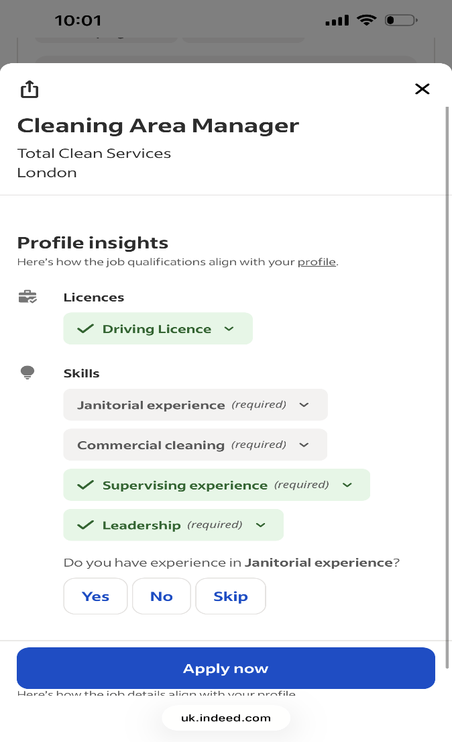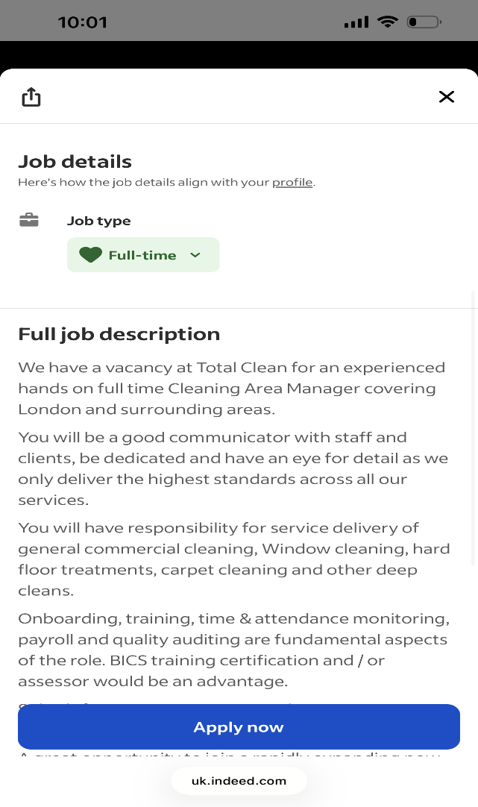
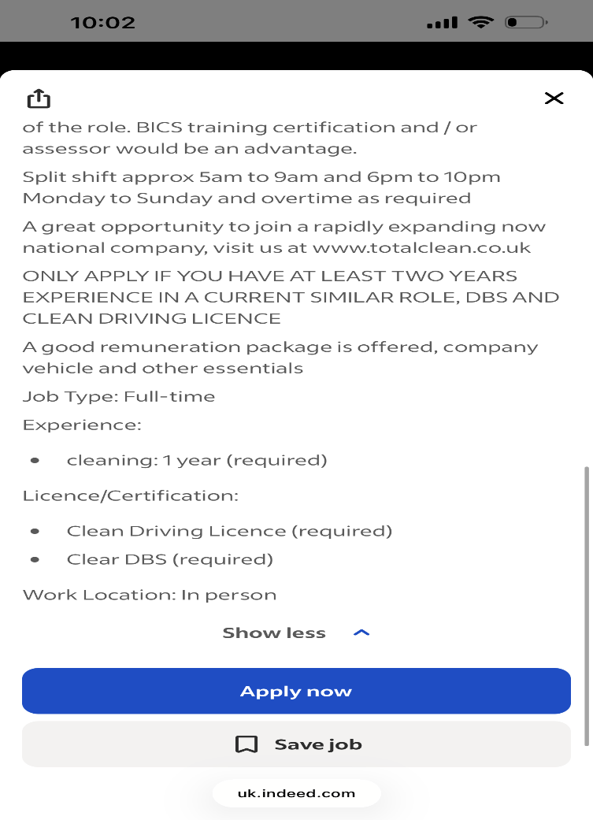

Galyna Zhenchuk
2513871@student.uwtsd.ac.uk
SUMMARY
Experienced cleaning operations professional with over four years with supervisory and management experience in the hospitality industry. Proven ability to lead cleaning teams, manage staff rotas, conduct quality inspections, maintain Health & Safety and COSHH compliance, and deliver outstanding customer service. Skilled in motivating teams, improving operational performance and maintaining excellent cleaning standards across busy environments. Currently seeking an Area Cleaning Manager position with Total Clean Services where I can apply my leadership and operational management experience.

EXPERIENCE
07/2026 – Present
Site Manager
Regular Cleaning Company – London
- Managed daily cleaning operations across the site.
- Supervised and supported cleaning team.
- Scheduled staff rotas and allocated workloads.
- Conducted site inspections and quality audits.
- Ensured Health & Safety and COHSS compliance.
- Maintained strong client relationships and resolved service issues.

09/2023-06/2026
Assistant Housekeeping Manager
Courtyard London City Airport Hotel – London
- Supervised daily operations.
- Managed staff rotas and workloads.
- Conducted quality inspections.
- Ensure Health & Safety and COSHH compliance.
- Resolved guest concerns and supported team performance.

06/2022 to 09/2023
Housekeeping Supervisor
JW Marriott Grosvenor House-London
- Supervised the housekeeping team.
- Allocated daily tasks and monitored performance.
- Inspected rooms to maintain quality standards.
- Trained and supported new employees
- Reported maintenance and safety issues.
09/2007-02/2022
Assistant English Teacher
Bortnyky School, Bortnyky, Ukraine
- Assisted in delivering English lessons.
- Supported students during classroom activities.
- Prepared teaching materials.
- Helped maintain an organised learning environment.
SKILLS
- Cleaning Operations Management
- Team Leadership & Staff Supervision
- Staff Training and Induction
- Quality Inspections & Audits
- Health & Safety Compliance
- COSHH Compliance
- Staff Rotas & Workforce Planning
- Problem Solving
- Time Management
- Customer Service Excellence
- Microsoft Office
- Communication Skills
Languages
Ukrainian – First Language; Russian- B2; Polish A2.
References available on request

`

Galyna Zhenchuk
Chelmsford
18th July 2026
Total Clean Services
16 St. Michaels Eve, Pitsea, Essex SS13 3DE

Dear Hiring Manager,
Thank you for taking time to read this letter. I am writing to express my interest in the Cleaning Area Manager position. With over four years of supervisory and management experience in the hospitality industry, I have developed strong leadership, organisational and operational management skills. In my current role I manage daily cleaning operations across the site. My responsibilities include supervising cleaning teams, planning staff rotas, conducting quality inspections, ensuring compliance with Health & Safety and COSHH regulations, and maintain excellent relationships with clients to deliver a high-quality service.
Previously, I worked as an Assistant Housekeeping Manager at Courtyard by Marriott London City Airport Hotel and as a housekeeping supervisor at JW Marriott Grosvenor House London. These roles strengthened my leadership, organisational and problem – solving skills while giving me extensive experience in managing teams and maintaining exceptional cleaning standards in fast-paced environments.
I am a reliable, organised and motivated professional who enjoys leading teams, improving operational performance and ensure customer satisfaction. I am also currently studying Business Skills for the Workplace at the University of Wales Trinity David, further developing my management and communicational skills.
I believe my experience in cleaning operations, staff management and client service makes me strong candidate for the Cleaning Area Manager position. I would welcome the opportunity to discuss how I can contribute to your team and add to your team’s successes as a top cleaning company in London. Thank you for considering my application. I look forward to hearing from you.

Yours faithfully,
Galyna Zhenchuk

