A critical analysis of the relationship between teacher subject knowledge and effective learning and teaching in the primary school.

4437 WORDS

Introduction
In this essay I am going to be researching the topic of teacher subject knowledge and the place it has in relation to effective teaching. I am going to produce a literature review synthesising any relevant books, articles and papers I find, comparing and contrasting ideas and concepts. I will then use this research to evaluate my own subject knowledge during my experience in my first placement block (PTE1).
This placement took place in a Pioneer primary school in South Wales. Pioneer schools are schools throughout Wales that are implementing suggestions for the new curriculum set out in Donaldson’s ‘Successful Futures’ (2015) report. The school’s 2017 Estyn report (Estyn.gov.wales, 2017) states that the school has 471 children on roll, with 31% recognised as having additional learning needs (ALN) and 36% receiving free school meals. The report gave the school a mixture of ‘good’ and ‘excellent’ judgements in each inspection area. I have omitted the school’s name from the reference for confidentiality reasons.
For the first part of PTE1 in this school, I was assigned to the Nursery. There are 68 children enrolled in the nursery, split between the morning and afternoon sessions. Each session is then further separated into 5 key worker groups of roughly 7 children per group. I planned and led the lessons for one key worker group during each session, with 6 children in the morning and 6 children in the afternoon. I will keep the name of the school, the teachers and all students, anonymous in accordance with the BERA guidelines (Bera.ac.uk, 2019).
Extracts from literature reviews
It is a widely held idea that teacher subject knowledge is important in order for students to learn effectively. In their journal ‘Subject Knowledge in Early Childhood Curriculum and Pedagogy: beliefs and practices’ (2005), Hedges and Cullen conclude that in order for teachers to extend their children’s desire for knowledge and understanding, an excellent level of subject knowledge is vital. This is also the case with Haylock and Cockburn (2008) who state that in order for teachers to teach in a way that promotes understanding, they must clearly understand the concepts that they are teaching. Harlen and Holroyd (1997) describe that a lack of subject knowledge can negatively impact a teacher’s confidence level and the coping techniques that some use to deal with their lack of confidence, such as avoiding topics that they are unsure of, can really limit children’s learning. Similarly, Shulman (1987) presents the case of Colleen who was a student teacher who had achieved a Master’s degree in English. When Colleen was teaching the literacy topics that she felt confident in, she showed some excellent teaching skills but when Colleen had to teach a subject she did not feel as confident in, all those unique and exceptional skills vanished and she was instead very controlled and the lesson was completely teacher-led. From this research, it is obvious that subject knowledge is key for students to receive effective teaching due to the huge impact a lack of such knowledge can have on the teacher’s confidence. The range of dates on these sources, from 1987 to 2008, shows that there has always been a consistent importance of subject knowledge in effective teaching.
Constructivism is a learning theory that holds that people learn through taking part in, and reflecting upon, active experiences (Fosnot and Perry, 2005). Vygotsky is a key advocate for constructivism and his social development theory is made up of three main features: social interaction, the more knowledgeable other, and the zone of proximal development (ZPD) (Aubrey and Riley, 2016). The latter two are important in this case. The more knowledgeable other, he maintains, is a person who has a superior amount of knowledge on a subject than another person – normally a teacher to a child. The ZPD is the gap between a person’s independent ability and their potential ability when coupled with the presence of this more knowledgeable other. This ‘gap’ is where Vygotsky states that the learning takes place. So in order for the pupils that we are teaching to learn effectively, we need to act as the more knowledgeable other. Therefore, our knowledge base has to be higher than theirs on the given subject, and this shows the importance of subject knowledge. Although, his theory only states that learning takes place in the ZPD with the help of a more knowledgeable other, it does not mention that this necessarily means that effective teaching is taking place. Effective teaching is not mentioned. This theory just shows the role that teacher subject knowledge has in learning, and also highlights that the need for good teacher subject knowledge increases as the age of the learner increases. As the pupil’s subject knowledge for each subject increases as they go through primary school, in order for the ZPD to exist and for learning to take place, the associated teacher subject knowledge must also increase.
There are some people who maintain that although subject knowledge is important, there are other components that are of more importance. John Bruer (1993) makes a strong point that in the past, schools have been focusing on subject knowledge where they should have focused on how that subject knowledge is taught. There are a lot of misconceptions that if someone has a very strong knowledge of a subject, that they can effectively convey that knowledge to others but that is not always the case. Shulman (1987) talks about how someone with a mathematics degree shows a good understanding of mathematics but that there is a difference between this person having the knowledge and being able to teach it. The art of teaching is to discover how different children will best understand a concept and teach it to them in that way.
In ‘Knowledge and ‘Teaching: Foundations of the New Reform’ (1987), Shulman highlights the difference between content knowledge (CK) and pedagogical knowledge (PK). CK, he explains, is the thorough understanding of what is being taught and PK is the tools and practices that are used in teaching. The latter is seen as the ‘heart of what it means to be an excellent teacher’ (Donaldson, 2015, pp.63). Shulman thinks teachers should aim to be where these two types of knowledge overlap, known as pedagogical content knowledge (PCK). He also maintains that the art of effective teaching, specifically pedagogic reasoning and action, moves through five steps: Comprehension, transformation, instruction, evaluation and reflection. Initially comes comprehension. This is the idea that in order for you to teach a subject or topic, you must first understand it. The second step, transformation, is the art of altering the knowledge that you have and adapting it in a way that can be easily learned by the recipient. Instruction is the third step and this involves the way that the knowledge is delivered, with a variety of teaching methods and pedagogical knowledge. The next step is evaluation which involves checking the children’s understanding and misunderstanding of the subject and assessing gaps in their knowledge, which is closely linked to the final step: reflection. Reflection involves looking back over lessons taught and teaching experiences, learning from any mistakes made and evaluating why some things worked well. This leads to the teacher having a new comprehension of the purposes and of the subject.
Similar to this, Rowland et al. talk about using ‘The Knowledge Quartet’ (Rowland, cited in Williams, 2003) as a tool for assessing how subject knowledge and pedagogical knowledge is presented in the classroom. They assessed 24 lessons carried out by trainee teachers, looking for evidence of subject and pedagogical knowledge and separated what they found into four units: foundation, transformation, connection and contingency. The paper described how the foundation category was the trainee teacher’s knowledge before entering the classroom. They then moved on to talk about the transformation of this knowledge into a form that the pupil can understand. This category is based on Shulman’s transformation step mentioned previously and involves the input of pedagogical knowledge in order to transform the knowledge in the correct way. The next category Rowland et al. talk about is connection which is the binding together of all aspects of the topic. Finally, contingency, which entails all the classroom activities that we cannot plan for, that will inevitably happen in a class full of children. It is the art of being able to ‘think on our feet’ and run with an idea that a child seems interested in or has questions about. (Williams, 2003, pp. 98)
Both Shulman (1987) and the Knowledge quartet (Rowland, cited in Williams, 2003) hold that subject knowledge is not enough on its own as there needs to be an element of adaptation and translation of the knowledge (be it by simplifying or altering) to make it easier to understand. The fact that these two papers are roughly 20 years apart shows how reliable and sustainable this idea is.
John Hattie (2012) talks about the importance of effective teaching. He claims that effective, or what he calls ‘high-impact’, teaching gives a student nearly a year’s advantage over other students who are not receiving as effective teaching (Hattie, 2012, p.26). He states that ‘high-impact’ teachers are categorised by their attitudes and beliefs around teaching. He highlights the importance of having teachers that are ’passionate and inspired’ (Hattie, 2012, pp. 27). Interestingly, he is not alone in this view, with Walberg and Paik (2000), and Brophy and Good (1986) also mentioning the importance of enthusiasm and passion. His overall point is that that there are lots of factors that affect student’s progress, many being factors that we as teachers have no control over, like the background of the child. However, one factor that teachers can control is their own ‘beliefs and commitments’ (Hattie, 2012, pp.25).
Hattie (2012) also goes on to suggest some characteristics common to what he calls ‘expert teachers’. He notes that they have the ability to create an effective learning environment, monitor progress and give the children feedback, have belief that the success criteria can be achieved by all children, they can adapt their teaching to best represent the knowledge they are trying to teach and they have an impressive influence on student outcomes, both academically and non-academically. A similar list of characteristics is also shown in Donaldson’s (2015) report (pp. 63). Through further research, I found three articles that agree with Hattie (2012) that subject knowledge is just a part of what makes up effective teaching and that suggest the key characteristics of an effective teacher. These articles were: A review of the underpinning research on what makes great teaching (Coe et al., 2015), Effective teaching (Education.wa.edu.au, 2019), and A Second Report of the Independent Review of Teachers’ Standards (Dera.ioe.ac.uk, 2011). I will refer to these three articles as Article A, Article B and Article C, respectively. There were similarities and differences between the papers themselves and with Hattie’s (2012) views, mentioned above, that I will thus discuss. All three articles mention that an effective teacher has good subject knowledge, a good knowledge of questioning and assessment methods and high expectations of the children and themselves. Professional development and teacher self-evaluation is present in all three articles, as well as, like Hattie (2012) says, the ability to provide a safe and appropriate environment for the age group of the children. Two of the articles (Article B and Article C) maintain that a good knowledge of the children’s background is important and mention that having respect for and from the pupils is important too, with Article C going further saying that teachers should hold respect from parents too. These two articles also mention that keeping records of the children’s achievements is important, with Article B going further saying providing them with feedback is essential, a characteristic also mentioned by Hattie (2012). Two articles (Article A and Article C) talk about the importance of the teacher having professionalism within the school, accepting advice readily and supporting colleagues. They also understand that behaviour management is key. The main thing I understood from all of these articles is that subject knowledge is part of what makes up the characteristics of an effective teacher but that it is not by any means the only important characteristic. It is instead one of many. The fact that there were quite a few characteristics that were common to all three articles, and John Hattie’s book, is evidence that there must be a link between these characteristics and effective teaching, again highlighting that subject knowledge alone is not enough. An effective teacher not only has the knowledge of the subject but also has a range of other skills that make them efficient, from behaviour management to professional development – a mixture of PK and CK, just as Hattie (2012) holds.

Extracts from Analysis and Evaluation of subject knowledge section
I am now going to reflect on my PTE experience in relation to the research I have carried out. For this, I will focus on four areas, or specific lessons, that I planned and taught: Numeracy, Welsh, Digital competency, and Literacy. I will first give a brief explanation of each lesson and then go on to evaluate it.
While on my placement, one lesson that I planned and taught was a numeracy lesson on applied counting (see appendix 1). The main part of the lesson consisted of them applying their knowledge of counting to a game. The game (Figure 1) was centred on the children rolling a colour dice and moving that far along the circle of dots to the colour that they had rolled. The Welsh topic this term focused on gaining a familiarity and understanding of the phrases ‘ble mae…?’ and ‘dyma’, and being able to use them in the correct context (see appendix 2). In Literacy, we were applying our topic of vehicles to listening and description activities (see appendix 3). Digital competency was linked in to other lessons and the lesson I will refer to below is a lesson where the children were to research their choice of vehicle using iPads. I will now apply the knowledge quartet (Rowland, cited in Williams, 2003) to my own teaching knowledge and experiences in these lessons in an effort to reflect and try and improve my future teaching.

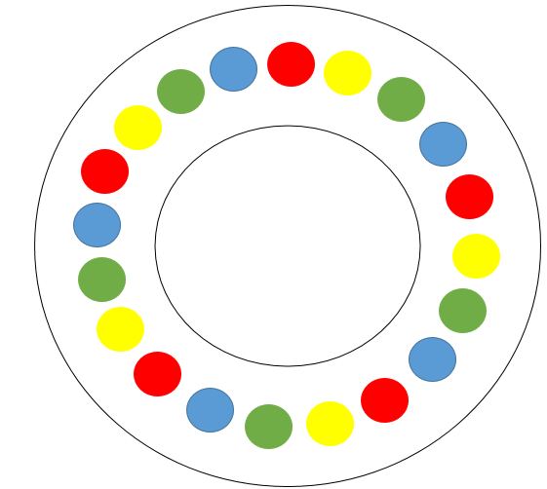
Figure 1

Foundation
I felt assured going into the numeracy lesson described above that my foundation knowledge was far above the lesson objective and I hence felt confident that it would go well. Similarly, I did a lesson involving digital competency, where the children were to research pictures of their chosen vehicle on iPads. Again, as I have an iPad myself and am familiar with how they work, I felt confident that my subject knowledge was of a high enough standard for the lesson to go well.
Conversely, I did a Welsh lesson on the sentence structure ‘dyma’ which included reading a Welsh story book called ‘Picnic’ which introduced all the items you might take on a picnic by saying ‘dyma afal’ etc. As Welsh is not my first language, this worried me since although they were simple words and sentences, the correct words and pronunciation had to be used in order for the children to learn efficiently. I did not feel confident that I would get the pronunciation correct and so took steps to improve my foundation knowledge before going into the lesson. I checked and practiced the pronunciations with a Welsh First Language speaker which made me feel happier about taking the lesson, however I was still worried that I may get confused and use inaccurate pronunciation so there is a possibility that this anxiety may have had an impact on the lesson.
I found that the difference in my subject knowledge in numeracy and digital competency compared to in Welsh also showed a correlation with my confidence and hence performance in teaching these subjects. This underpins what was discussed in my literature review that a lack of teacher subject knowledge has an impact on their confidence and therefore negatively impacts the children’s learning (Harlen and Holroyd, 1997) and how well the lesson is delivered (Shulman, 1987).
One area in which I feel my foundation knowledge is particularly lacking in is Literacy. For my second part of PTE1, I am in Key stage 2 (KS2) and I am conscious that my literacy subject knowledge may not be sufficient enough to allow for efficient learning. This is evidenced by Vygotsky’s idea of a ‘more knowledgeable other’ as discussed above (Aubrey and Riley, 2016).
Although I did not experience any problems with literacy during this placement as my subject knowledge was sufficient for the lessons that I was teaching, I am mindful that this is where my confidence will waver in KS2. This is highlighted by Vygotsky’s ‘more knowledgeable other’ concept (Aubrey and Riley, 2016). My subject knowledge only has to be superior to those that I am teaching and in nursery their literacy subject knowledge was significantly inferior to mine, whereas in KS2 their subject knowledge is increased.
One thing that has come across during this placement, is how essential cross-curricular subject knowledge is in order to be a consistent and confident teacher. This is especially important with the suggestions from Donaldson’s (2015) report, where he stresses the importance of cross-curricular lessons covering his 6 areas of learning. The main feedback I received from my observations was a lack of confidence in some areas. I believe that this was because I did not feel confident in the subject knowledge and so for this reason, I understand that I need to focus more on developing my foundation knowledge for subjects that I feel less confident in: Welsh and Literacy, in order to better my future practice.
Transformation
Overall, I felt that I showed an ability to transform the knowledge that I possessed into a more understandable form for a three year old. In the Numeracy lesson previously mentioned, I feel that I succeeded in translating my knowledge of counting into a more understandable form for the children. From my previous observational notes, I knew that the majority of the children could only confidently count one-to-one up to 5 so I made sure that the task was not too challenging by limiting the highest number that the children would have to move their counter along by was 5. I also believed that making it into a game would make the children enthusiastic about the learning as Hedges and Cullen (2005) hold that children learn best through experiences they deem meaningful, like play. This research was certainly evidenced in this particular lesson by the children’s excitement during the game.
I felt that I transformed my knowledge of the Welsh phrases ‘ble mae…?’ and ‘dyma’ appropriately as I used simple examples to aid in their understanding. I started by asking where each of the children were: ‘Ble mae…?’ and encouraging the children to use the reply ‘dyma…’ as they pointed to the person. I began the lesson by demonstrating the sentence pattern with the class teacher and also used a demonstration for the digital competency lesson, showing the children how to type in the letters of the vehicle they were searching for. I feel that using these visual and demonstrative examples really helped cement their learning. For my literacy lesson, I deliberately chose the sounds of vehicles that they knew and that they liked to spark interest and engagement in the activity. As with the Welsh and digital competency lessons above, I demonstrated how the task was to be performed before they started. I also played each sound twice to allow them efficient thinking time to complete the task to the best of their ability.
I believe that my ability to transform my foundation knowledge is due to having experience working in a nursery prior to this placement. I already had an idea of how 3 year olds learn best. I feel that as I have less experience in KS2, this step will not be as easy for me to accomplish in the second part of PTE1. To overcome this, I will search for effective and appropriate examples and demonstrations for the lessons that I am planning, and the year group that I am in, and I will double check them with my class teacher beforehand.
Connection
The area that I failed at in my numeracy lesson was in this phase (See appendix 4). My starting activity was a ‘blast off’ activity, I included it in my lesson because I felt it was a fun way to recap their number knowledge. However, I wrongly assumed that as the children knew how to count objects one-to-one, and knew their colours, that they would be able to use a die to move a counter forward by a certain number. I misunderstood the complexity of this task to a 3 or 4 year old child. They had full understanding of how to count the number of objects in front of them with their fingers, but got very confused moving a counter on ‘one more’. They started counting on the space that they were on, or did not understand that you counted on one more every time you moved the counter. Unfortunately, there was a gap in my pedagogical knowledge. With hindsight, what I needed to have done was to have a lesson in between this and the last, teaching them the skill of counting on ‘one more’ using a counter, cementing this knowledge before the lesson.
Each of my Welsh lessons, however, built upon the last, offering less support as their knowledge and confidence in the phrase increased. I found that the most efficient way for them to learn this knowledge was to keep returning to prior knowledge and slowly developing this knowledge once they understood what had come before. For example, only once we were certain that they understood ‘dyma’ did we introduce ‘dim yma’ alongside it.
I anticipated that the children may find the digital competency lesson difficult, particularly the spelling of the words they were searching for, and so I planned in support from both me and the class teacher. This meant that we could inform them of the letters so they could just find them on their keyboards. Similarly, in my literacy lesson, I anticipated that the children may get confused about which sounds they had already heard and so I planned to use counters so they could keep track.
I believe that this unit was the most difficult for me to achieve as I had to broaden my thinking to how all parts of the learning connected to each other. As I am new to planning, and how each lesson links to the previous, I feel that this is something I need to work on. I will overcome this by making sure to familiarise myself with what was done prior in the subject, in order to inform my future planning.

Contingency
Due to the fact that I had not anticipated the children finding the game as hard as they did, my numeracy lesson did not go as planned. I instead had to offer a lot of support, using my finger as the ‘counter’ and counting along with them. I did not want to lose the opportunity for the children to learn this skill however and so I thought about how I could transform the knowledge into a more understandable form and adapted a future lesson to have hula hoops as the ‘dots’ and the children themselves as the ‘counters’.
I believe I showed the ability to deviate from my plans if needed, as in one Welsh lesson where the children were doing a ‘vehicle hunt’, and saying ‘dyma …’ when they found a vehicle, the children wanted to hide the vehicles themselves. This was not in my plan but I saw how enthusiastic they were about this idea and so I adapted and encouraged them to instead ask ‘ble mae …?’ to their friends once they had hidden their vehicles instead. I believe that this change improved the lesson, and developed the children’s learning as in the past, I had been the only one asking ‘ble mae…?’. I knew that this was something that was going to be introduced in a lesson in the future but I thought that this provided the perfect opportunity to introduce it sooner.
The digital competency lesson in question did not go as planned (see appendix 5) as the WiFi in the Nursery was not working that day. I instead thought on my feet and got out a picture of a vehicle that I had for another lesson, and did an ‘I see, I think, I wonder’ activity instead. Likewise, my literacy lesson explained above did not go to plan either (see appendix 6). One of the children in my class was disruptive and so I diverged from my original plan in an effort to employ different behavioural techniques to calm him down. I tried to alter the way the activity was carried out so that the child in question could complete some of the task alone, however it did not work and I had to remove the child from the lesson.
These lessons highlighted the importance of this contingency step in an environment like a primary school. Being able to think on my feet helped improve all of my lessons mentioned above. For example, had I stuck to my original digital competency plan, the children would have had nothing to do that lesson, making it an inefficient lesson.
Conclusion
In conclusion, it is clear to me through research that teacher subject knowledge is essential to effective teaching, however it is not the only essential factor. Someone who is unrivalled in their knowledge of a subject is not necessarily an effective teacher. It has also become apparent to me through this essay that the importance of subject knowledge increases as you go through primary school due to, in Vygotsky’s terms, the size of the ZPD (reference). For this essay, I read a number of different texts on the topic of teacher subject knowledge and summarised a number of articles which listed characteristics that exist alongside subject knowledge to make up effective teaching. I also brought forward people with differing perspectives. I have then reflected on my PTE experience in relation to the research that I have done, in particular Rowland et al.’s (Rowland, cited in Williams, 2003) knowledge quartet, in order to develop and inform my future practice. Although in Nursery some subject knowledge was needed, through observation of the class teacher in the first week, it quickly came across that the pedagogical knowledge held more importance. This idea of the importance of PK, or indeed PCK, has been cemented through my research.

Appendices
Appendix 1: Numeracy lesson plan

Appendix 2: Welsh lesson plan
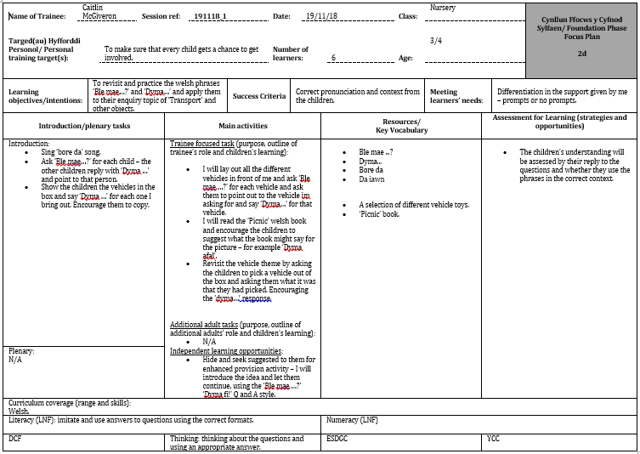

Appendix 3: Literacy lesson plan
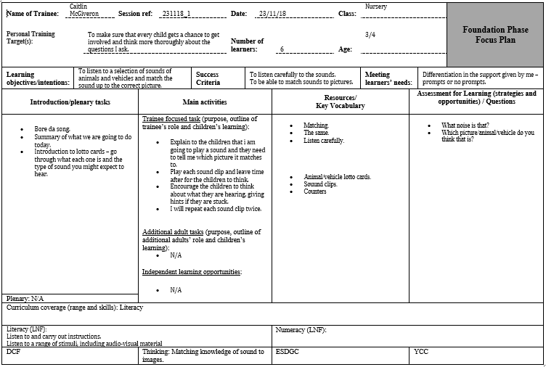

Appendix 4: Digital competency Reflection ARC
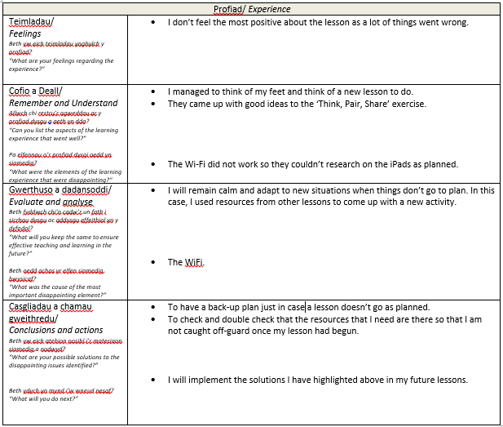

Appendix 5: Numeracy Reflection ARC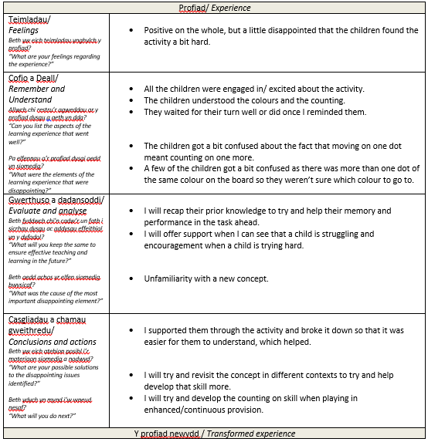

Appendix 6: Literacy Reflection ARC
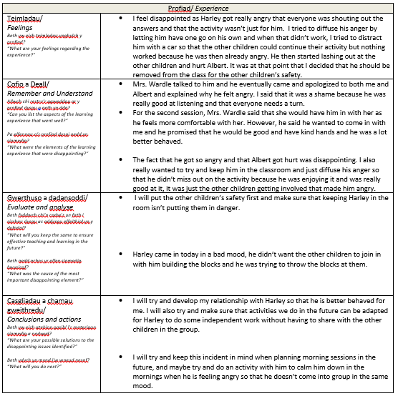

References
Aubrey, K. and Riley, A. (2016). Understanding & Using Educational Theories. London: SAGE Publications.
Bera.ac.uk. (2019). Ethical Guidelines for Educational Research, fourth edition (2018) | BERA. [online] Available at: https://www.bera.ac.uk/researchers-resources/publications/ethical-guidelines-for-educational-research-2018 [Accessed 1 Jan. 2019].
Brophy, J. E., & Good, T. L. (1986). Teacher behavior and student achievement. In M. Wittrock (Ed.), Handbook of research on teaching (3). New York: Macmillan.
Bruer, J. (1993). Schools for thought. Cambridge, Mass.: MIT Press.
Coe, R., Aloisi, C., Higgins, S. and Major, L. (2014). What makes great teaching? Review of the underpinning research. 1st ed. [online] Available at: http://www.suttontrust.com/wp-content/uploads/2014/10/What-makes-great-teaching-FINAL-4.11.14.pdf [Accessed 23 Dec 2018].
Dera.ioe.ac.uk. (2011). Second Report of the Independent Review of Teachers' Standards. [online] Available at: https://dera.ioe.ac.uk/13186/1/second%20and%20final%20report%20of%20the%20review%20of%20teachers%20standards%20%20%2012%20december%202011.pdf [Accessed 2 Jan. 2019].
Donaldson, G. (2015). Successful futures.
Education.wa.edu.au. (2019). Effective teaching. [online] Available at: https://www.education.wa.edu.au/documents/43634987/44524721/Effective+Teaching.pdf/5dcc8207-6057-3361-ade8-cf85e5a2c1ab [Accessed 1 Jan. 2019].
Estyn.gov.wales. (2017). Estyn. [online] Available at: https://www.estyn.gov.wales [Accessed 1 Jan. 2019].
Fosnot, C. and Perry, R. (2005). Constructivism: Theory, Perspectives, and Practice. 2nd ed. New York: Teachers College Press.
Harlen and Holroyd (1997) Primary teachers’ understanding of concepts of science: impact on confidence and teaching, International Journal of Science Education, 19:1, pp.93-105 [online] Available at: https://doi.org/10.1080/0950069970190107 [Accessed 23 Dec 2018]
Hattie, J. (2012). Visible Learning for Teachers. Oxon: Routledge, pp.25-38.
Haylock, D. and Cockburn, A. (2008). Understanding Mathematics for Young Children. London: SAGE Publications.
Hedges, H. and Cullen, J. (2005). Subject Knowledge in Early Childhood Curriculum and Pedagogy: Beliefs and Practices. Contemporary Issues in Early Childhood, 6(1), pp.66-79.
Shulman, L. S. (1987) ‘Knowledge and teaching: Foundations of the new reform’. Harvard Educational Review, 57(1), pp. 1-22.
Walberg, H. J., & Paik, S. J. (2000). Effective educational practices. Brussels: International Academy of Education
Williams, J. (Ed.) Proceedings of the British Society for Research into Learning Mathematics 23(3) November 2003

