UNIVERSITY OF WALES TRINITY SAINT DAVID
LONDON CAMPUS
Assignment 2
Learning in the Digital Era
Video Link: https://youtu.be/ivWEbOYd-wg
Module Name: Learning in the Digital Era
Module Code: ACCA 4025

Student Name: Dieudonne Mbah Owono
Student ID:2431071
Group:2

Lecturer’s Name: Koushi Modak

Table of Contents
Introduction 2
Main Body 2
Conclusion 9
References 9

Introduction
This word documentation contain a report of my PowerPoint based video presentation in which the focus was based on self -evaluation and self - development Plan. By using Gibbs Reflection model ,I have reflected on my current academic performance , identifying strengths and weaknesses and how I could improve ,in addition to this ,I have set some goals to achieve and outlined some strategies to make this achievable .Furthermore, It also contain a summary of my understanding of a topic Learning to Learn of Unit 4 including some references .

Main Body
Essential material on this document will be an video of PowerPoint presentation link which will cover all 3 Tasks of this Assignment 2 of the Module Learning in Digital Ara.
Task 1- A report of self -Evaluation including strengths and weaknesses
Task2-A report of Personal Development Plan , set goals to achieve and a mind map explaining what it takes to achieve them and how this will increase my career opportunity
Task3- a short analysis based on the study of topic Learning to Learn of Unit 4

Video Link: https://youtu.be/ivWEbOYd-wg

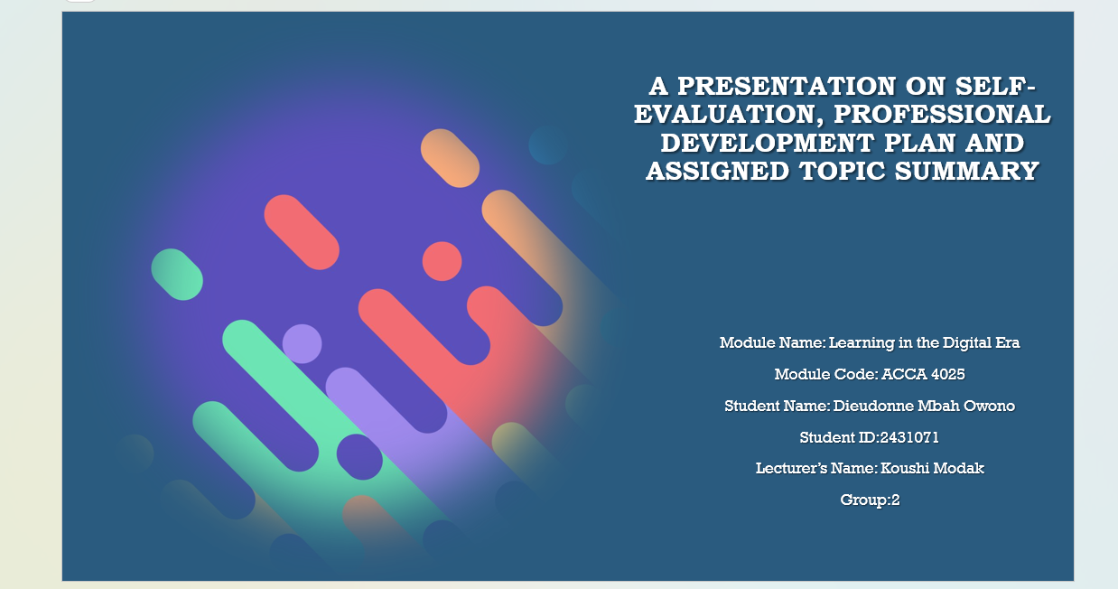

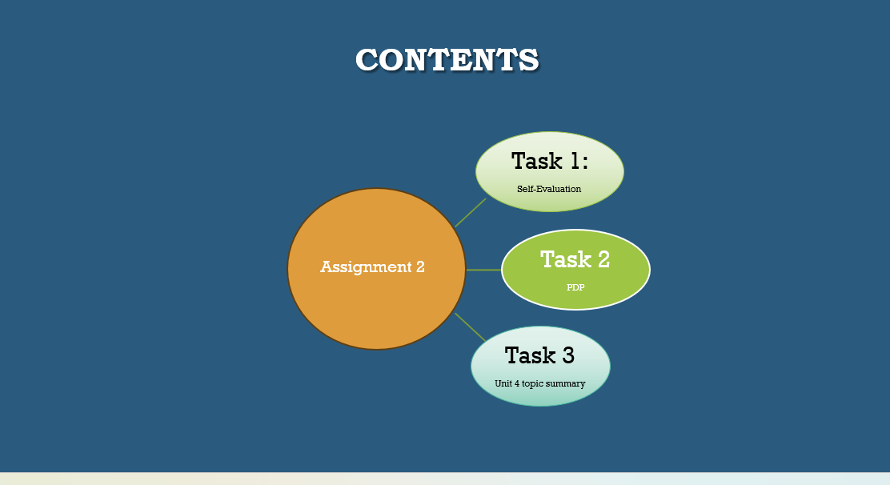
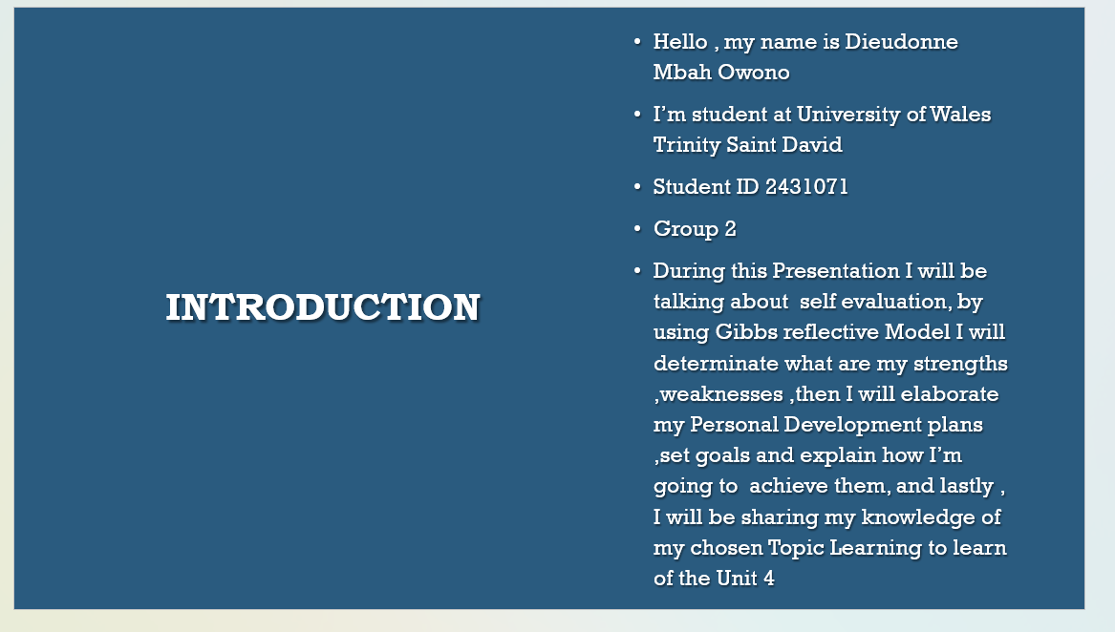

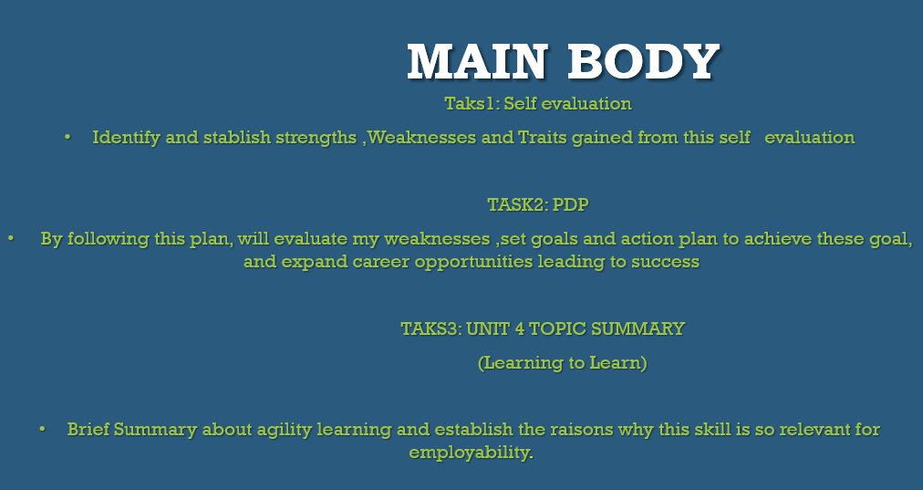
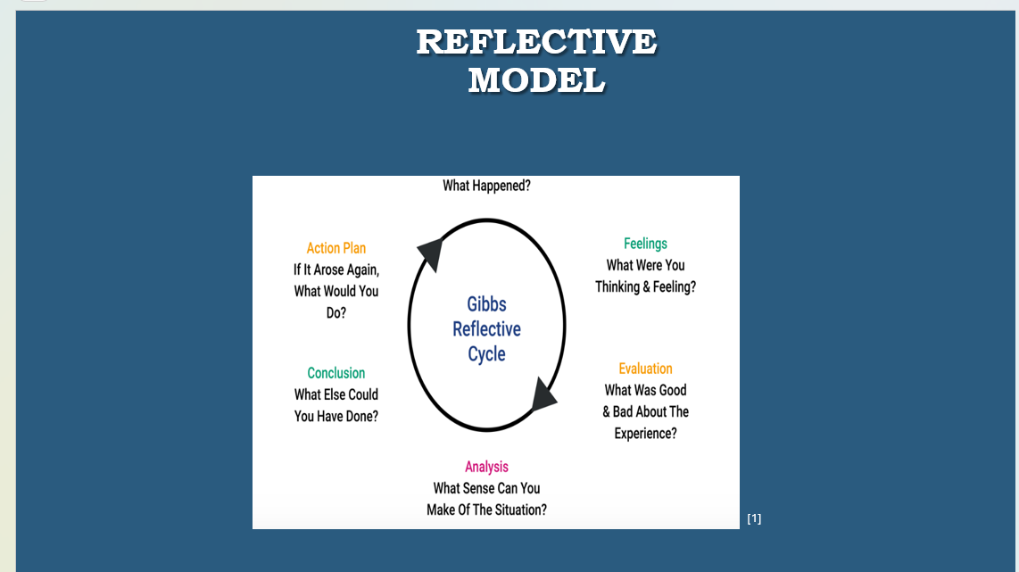
Brief explanation:
Gibbs’ reflective cycle is an structure of 6 stages enable student s to understand the process of learning from our experience about what we have done wrong or right and how to improve . This model will assist me in my self-evaluation process , to determine my strengths and weaknesses and set a personal development plan to improve and become better [1]

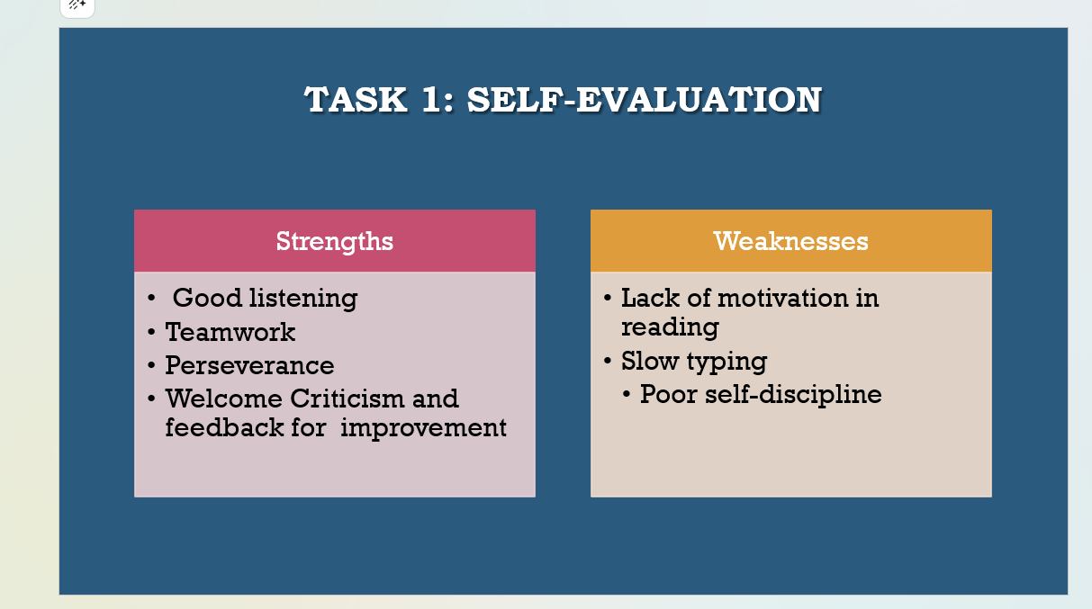Brief explanation: My strengths and weaknesses reflect the level of my academic performance after self -evaluation process,despide the difficulties and challenges I have demonstrated courage and bravely to contunue learning ,however, ackknowleging my weaknesses is an important part of my self-development.Recognising areas I need to improve and set goals help me become a better version of myself
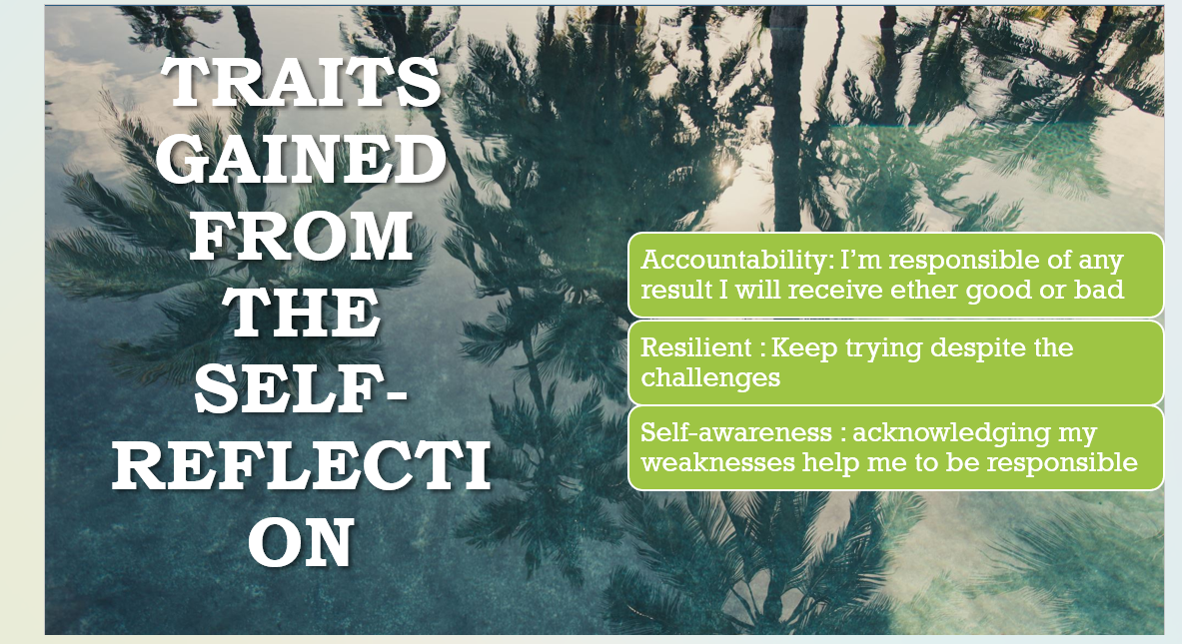

Brief explanation: Through this self-reflection, I have developed a significant traits such as accountability ,resiliency and self-awareness this traits allow me to understand my weaknesses and take action to improve.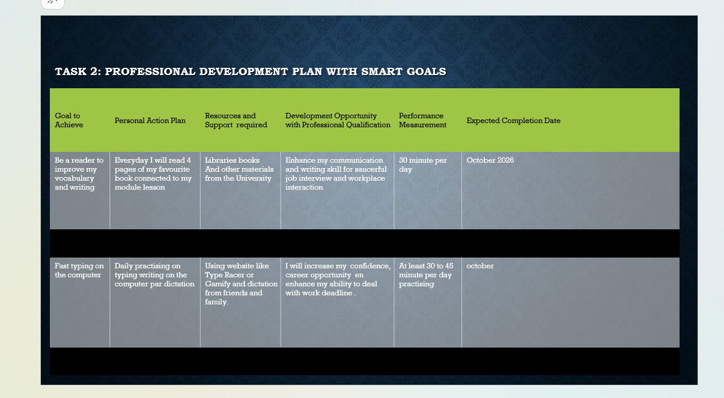

Brief explanation: This PDP has helped me to clearly identify areas for improvement , to tract my progress and keep focusing on developing my skills based on this structure

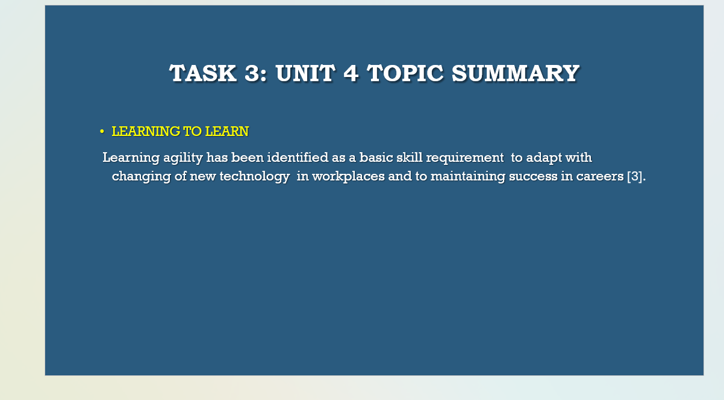
Brief explanation :The ability to learn and applying the principle of learning agility is an essential skill for future career success ,as innovation and internet are increasingly transforming the way we work , and to be able to adapt with this transformations, including meeting the demand of new skills in workplaces or enjoying success in careers , students will need to develop the skill of how to learn progressively. Learning agility has been identified as a basic skill required for maintaining success in careers [3].

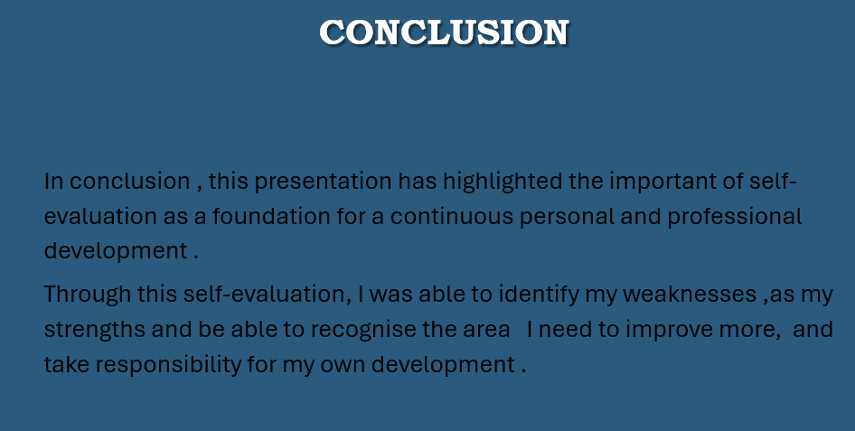

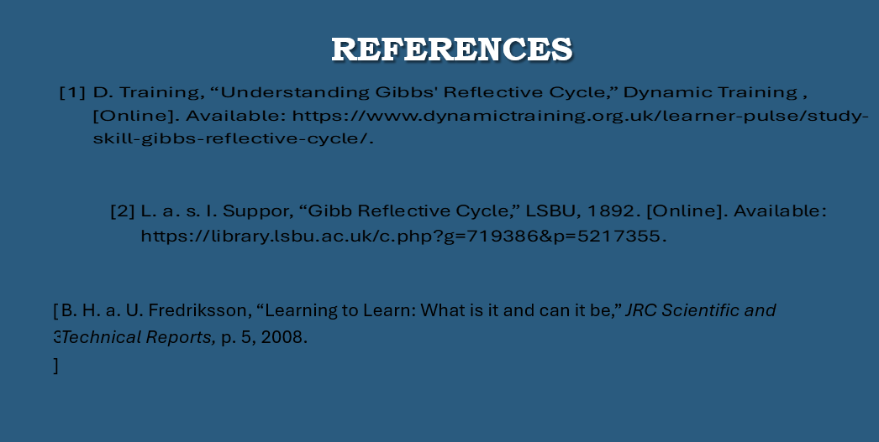

Conclusion
By completing this module LDE , I have gained an opportunity to reflect on my academic performance and personal development , this project have increased my confidence and realise the importance of learning new skills , setting goals and plans to achieve them and support my future academic and professional development .

References

[1] | D. Training, “Understanding Gibbs' Reflective Cycle,” Dynamic Training , [Online]. Available: https://www.dynamictraining.org.uk/learner-pulse/study-skill-gibbs-reflective-cycle/.
[2] | L. a. s. I. Suppor, “Gibb Reflective Cycle,” LSBU, 1892. [Online]. Available: https://library.lsbu.ac.uk/c.php?g=719386&p=5217355.
[3] | B. H. a. U. Fredriksson, “Learning to Learn: What is it and can it be,” JRC Scientific and Technical Reports, p. 5, 2008.

