University of Wales Trinity Saint David

Case study: ABC Technology Artificial Intelligence software project
Effective Team working and communications-(BMSW4002_SWAN)
Rasa Vilimaite-2020471
Lecturer: Helen Evans
Word count: 2158

Content page

Contents
Content page 1
Executive Summary 2
Introduction 3
Application of Theories 4
Effective communications 7
Theorical communication models 7
Effective virtual communication 8
Importance of effective virtual communications for success in business 8
Recommendations 8
Conclusion 10
References 11

Executive Summary

The report is written based on the given case study about ABC Technology company occurring problems. Company has two offices- one in Cardiff and another one in Glasgow. Due to global Pandemic regulations and traveling restrictions the company is six months behind their schedule. In these challenging times ABC Technology companies’ communications between two offices have suffered and their communications has broken down.
In this report will be discussed a couple of Effective Communication theories that may help to bring the two teams back and working together on the project.

Introduction

Communication is an exchange of the thoughts and ideas with the intention to conveying information. It is a two-way communication street that needs vocalization as well as gesticulation. Purpose of communication is to present one’s beliefs, ideas, and thoughts with the clarity so the consensus or mutual acceptance solution can be reached (Kashyap, 2021).
The teamworking theories shows and teaches how teams evolve, how individual behaviours can structure a team at the workplace. Also helps to understand different conflicts they may occur in different stages of their development. Applying effective communication theories may help to solve the issues teams are facing and help to evolve as a team.
The Tuckman’s (Tuckman, 1965) theory shows a simple way on how people interact in different team’s situations. Illustrates that teams go through the stages as they develop more and more. Shows that different aspects of team behaviours need to be managed at the different stages. Gives a good understanding of different team requirements at the different timing. Tuckman’s theory recognises that the group develop trough the five stages and ABC Technology teams problems could be addressed to each of them:
- Forming: people does not know their roles, so they need to be addressed to everyone.
- Storming: management and leadership roles must step up and lead their teams.
- Norming: the recognition of the team members will start to happen as more responsibilities will be addressed to everyone.
- Performing: strengths of each member will be used in the right roles, and each will be working individually.
- Adjourning: Recognition to the teams for their effective communications, their hard work and appreciation. Focus on the next goals.
Applying this theory will help for both and each group to navigate what to expect at each different stage. To become motivated and goal-focused team.

The Belbin’s (Belbin, 1993) theory states that there are nine roles in a team which needs to be occupied. That does not mean that it needs nine people to do so as usually one person can do a few roles and are good at it. Belbin team roles are used to identify the behavioural strengths and weaknesses within the team at the workplace. Theory provides and ensures the language the team works better, communicates, and understands each other. The nine team roles fall into the three broad categories: though- oriented role, action- oriented role, and people- oriented role. The roles are:
- Shaper (action- oriented)
- Coordinator (people- oriented)
- Plant (thought- oriented)
- Resource Investigator (people- oriented)
- Monitor Evaluator (thought- oriented)
- Specialist (thought- oriented)
- Team worker (people- oriented)
- Implementer (action- oriented)
- Completer Finisher (action- oriented)

Two Theories work well together as Tuckman’s (1965) theory working out dynamics in the team and different actions in different stages. Belbin’s (1993) theory to observe the behaviours of the individuals to work out who is suitable for nine different roles to work in different stages of the goal.
Applying both theories to the ABC Technology teams who are working on Artificial Intelligence project will lead them to set the roles every individual is best at and the times when they must action the most.

Application of Theories

Due to current Pandemic restrictions to travel and geographically dispersed teams the ABC Technologies are six months behind the schedule on their new software project. Teams were used to communicate through the face-to-face meetings to discuss the project, share their ideas and discuss the problems that are occurring. Since the face-to-face meetings are not available now. The teams have not been productive and the improvement on the project have been very poor. Teams need to learn a new communication way and make all out of it to succeed in the project.
Application of theories in the ABC Technology would help to build the structure of effective and successful teams within the company. As Belbin (1993) said that the same working styles behaviours in the team might become unbalanced. As if the team members have similar strengths, they might start competing for the roles, duties and projects in the team that will be easier to compliment with their skill set. Situation would be the same if the most of team members have similar weaknesses as it may came out as a reason why the goal have not been accomplished yet. Using Belbin’s (1993) theory of 9 Team Roles can help to create a balanced team. Can identify the opportunities for growth within the team role. Applying Belbin’s theory will help to understand individual’s role in the team, what contributions will be the most appreciated. Help to develop and manage the weaknesses. Knowing the role for everyone will set the duties and expectation boundaries.
Applying Tuckman’s (1965) theory would help to the management team to structure a plan of development at different stages. As ABC Technology the teams are not fully developed and fully functional, and they have lack of communications and productivity from both teams as the meetings have been moved to online. The Tuckman’s (1965) theory suggests that the teams grow in clearly defined stages from individuals in the team to cohesive and task- focused team. Applying Tuckman’s (1965) theories of group development the five stages below will show how important is to use it in the different stages to succeed:
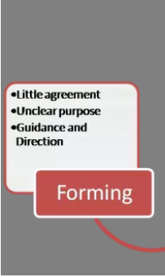
Forming stage
Management team needs to be in a dominant role as team’s roles are not clear to the team members. Management team must:
- Direct their team
- Establish clear objectives both as a whole team and as individual members
- Cautiously select the team members
- Keep the meetings smaller for better interactions.

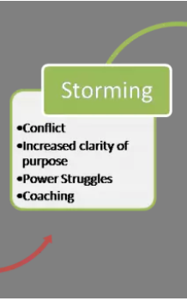
Storming Stage
Members in the team should not resist on taking the tasks on. Management should work on:
- Establishing structure and the process
- Build the trust between the two teams and within the teams
- Work and resolve on the conflicts

Norming Stage
Resolving the differences in the work ethics, combining the strengths in the workplace. Management team should:
- Help team members to take on responsibilities
- Plan bigger meetings so all the team members could interact with each other
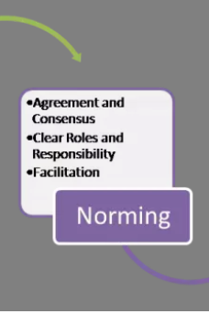
Performing stage
For group to get focused on a goal team members must be competent and motivated. The management team should:
- Delegate tasks and projects
- Let people work independently

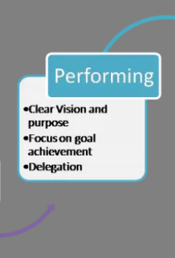
Adjourning stage
As the task gets completed management should:
- Show the appreciation for the hard work
- Pay the recognition to the team members
- Start focusing on another goals

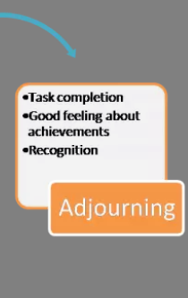
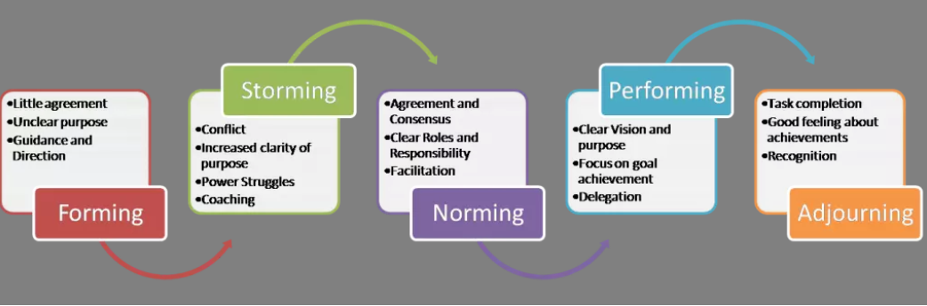
Okpalad, based on Tuckman and Jensen (1977)

Letting their employees to rotate in the responsibilities would lead them on finding out which strengths and which weaknesses they have, this would lead to create a well-balanced and effective team. Setting the clear goal and letting people to work individually on their tasks would let them work trough their differences. Setting the Ground rules in the team would make everyone feel treated and valued equally. Sorting out the “conflicts” would set the mindset that the differences are normal in the teams, and no one should be afraid to bring the new ideas. Communicating with each other have a big impact on teams’ productivity. Everyone should contribute to the goal (Robinson, 2020).

Effective communications

Theorical communication models
The Importance of two-way communication is a process that takes a place between the Sender and Receiver. According to Schramm’s (1954) communication model there is two essential processes to effective communication, and they are coding and decoding. He states that the communication is not completed until the sender receives a feedback from recipient. As Shannon and Weaver states in the Transmission model of Communication (1949) the message needs to be specific, the message source it is going to be sent through must be known. In the ABC Technology company for the team members who are working on the “Artificial Intelligence” software project the two-way communication would have to be only way team is communicating. Since the communication only happening online, trough the emails, messages, and social media due to Pandemic. For sender to send a message and receive a feedback from the recipient would be crucial. The sender must receive a feedback message from recipient as the communications performing online, sender must clearly see that the message sent receiver understands. The face-to-face communication is not possible now so the sender can not read the body language or the voice tone of the recipient.
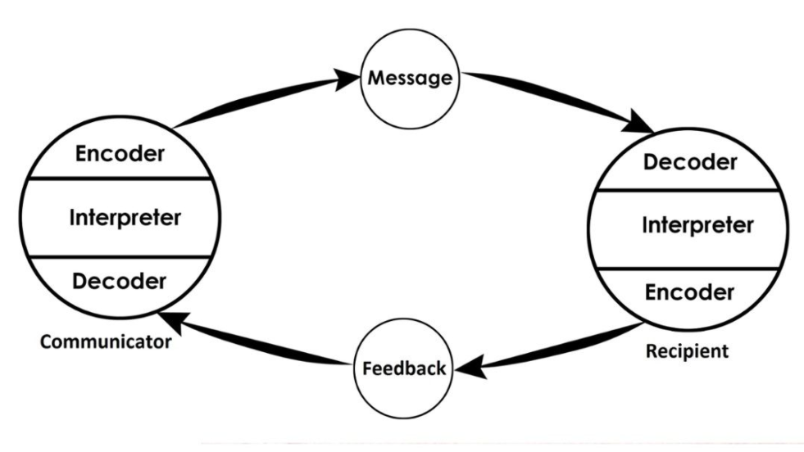

Effective virtual communication
Effective virtual connection is very important for the team as it has a big impact on everyone engagement, their productivity, and organizations success. To keep the team motivated with the virtual interaction might be not as easy as in the face-to-face interactions but is very important to (Bhandari, Deaves and Hassanein, 2009). To effectively communicate is important to send a clear message and receive a feedback that it has been understood correctly (Maley, 2020). Not being plain in the interactions is important too- the only way to bond and understand your colleagues for ABC Technology company with both offices is trough virtual platform.

Importance of effective virtual communications for success in business
Importance of effective communication for ABC Technology company is that both offices are far away, to keep the effective communications between the offices and team members will led the company to success as they will be able to take on more projects and still work with both offices on them together.

Recommendations
In the Pandemic times everyone must think from a different perspective, management must understand that the teams been affected, team members lives have been changed (Brower, 2020). Have to learn new skills, be efficient with all the technology and that employees had to learn a new virtual communication skill. To have an effective virtual communication with the teams is important that:
- There is given space and more latitude to everyone.
- Asked the right questions.
- Forgiving and not judgemental conversations.
- Time to build relationships in between the teams.

To have effective communication it is very important to make sure both- sender clearly explains their message and receiver understands a message. Management/ leadership teams listen to their team members. Effectiveness can only be achieved when the sender of the message pays attention to specific elements that might affect how the message is perceived and decoded by the receiver (Martelli, 2019). Management who creates a trusty atmosphere to the employees and welcomes two-way communication where the message receiver can explain their understanding of what has been said. To create effective communications at the workplace might be challenging as it requires time from both sides. Management team must create an idea friendly, transparent work atmosphere and employees must build trust in their leadership teams to be able to communicate their ideas. In Effective Public Relations (1952) Professor Scott M. Cutlip and Allen H. Center defined a set of principles, known today as the 7 C’s of communication:
1. Completeness- a receiver will get all the message, and this will reduce the need for follow up. Will fasten up the phase the team members are in right now.
2. Conciseness- keeping the message on the point, as it helps for the receiver to focus on what is important. Will set the right goals and boundaries to work in the team.
3. Consideration- effective communication will take into the account the receiver’s point of view. Messages must be tailored to suit the audience. Everyone’s different behaviours need to be dealt different in the team as everyone has different strengths and weaknesses.
4. Concreteness- message must be specific and vivid. Must be supported by facts. Will let the message receiver to get straight on the point, no confusions on what is expected from everyone.
5. Courtesy- respecting receivers’ culture, values, and beliefs. Messages must be polite.
6. Clearness- clearer the message – easier for the receiver to decode it. Reduces confusion and ambiguities.
7. Correctness- the formal errors might affect the clearness of the message. To show to the team that attention is paid both ways. That everything is being carefully looked at and that every little detail is important.

Conclusion

Applying effective communication theories to their teams helps to understand that there are many factors that needs to be considered in the different stages. That different actions from management teams needs to be taken a place. Communications is the tool that directly influences a team and their performance. Using this tool correctly will get the team communicating effectively and will bring a positive impact on their behaviours. Will build meaningful relationships in between colleagues which will lead to working and completing projects effectively.
Focusing on each stage of team’s development will help ABC Technology build their relationship and motivate their team members. Will help to follow the process and help to predict a few steps forward on what issues might appear in the process.

References

Bhandari, G., Deaves, R. and Hassanein, K., 2009. Corrigendum to “Debiasing investors with decision support systems: An experimental investigation” [Decision Support Systems Volume (46/1) 399–410]. Decision Support Systems, 47(1), p.74.
Biznewske.com. 2021. Wilbur Schramm Model of Communication (1954). [online] Available at: <https://biznewske.com/wilbur-schramm-model-of-communication/> [Accessed 26 June 2021].
Brower, T., 2020. Virtual Communication: The One Thing You Can Do to Be More Effective. [online] Forbes. Available at: <https://www.forbes.com/sites/tracybrower/2020/10/18/virtual-communication-the-one-thing-you-can-do-to-be-more-effective/?sh=7a4063d35e6f> [Accessed 26 June 2021].
Business Jargons. 2021. What is Effective Communication? definition and barriers - Business Jargons. [online] Available at: <https://businessjargons.com/effective-communication.html> [Accessed 29 June 2021].
Cellege, I., 2021. [online] Imperial.ac.uk. Available at: <https://www.imperial.ac.uk/media/imperial-college/administration-and-support-services/staff-development/public/impex/Belbin-Team-Roles.pdf> [Accessed 28 June 2021].
Deverge, N., 2021. How to Leverage Your Team’s Good Mood. [online] Team Mood, Morale & Health. Available at: <https://blog.teammood.com/2018/06/12/how-to-leverage-your-teams-good-mood.html> [Accessed 26 June 2021].
Kashyap, S., 2021. Here’s How Effective Communication is in the Hands of 73% of Professionals. [online] ProofHub. Available at: <https://www.proofhub.com/articles/effective-communication> [Accessed 28 June 2021].
Maley, M., 2020. 5 Rules for More Effective Virtual Communication - Articulate Persuasion. [online] Articulate Persuasion. Available at: <http://articulatepersuasion.com/5-rules-effective-virtual-communication/> [Accessed 28 June 2021].
Nauwelaers, J., 2020. Tuckman and Belbin go hand in hand | Stanwick. [online] Stanwick.be. Available at: <https://www.stanwick.be/en/blog/tuckman-and-belbin-go-hand-hand> [Accessed 26 June 2021].
Robinson, L., 2020. Effective Communication - HelpGuide.org. [online] HelpGuide.org. Available at: <https://www.helpguide.org/articles/relationships-communication/effective-communication.htm> [Accessed 28 June 2021].
Stein, J., 2018. Tuckman (forming, norming, storming, performing) | Multi-Stakeholder Partnerships. [online] Mspguide.org. Available at: <http://www.mspguide.org/tool/tuckman-forming-norming-storming-performing> [Accessed 28 June 2021].
Tuckman, B., 1965. Developmental sequence in small groups. Psychological Bulletin, [online] 63(6), pp.384-399. Available at: <https://the-happy-manager.com/wp-content/uploads/Tuckman_1965_Developmental_sequence_in_small_groups.pdf> [Accessed 26 June 2021].

