Assessment Component 1
Individual report
Student Name: Mariana Acris
Student Number: 2239619
Lecturer Name: Masud Ibrahim
Module Name: (LCBB6004_BIRM)
Strategic Management and Sustainability
“Strategic Management Analysis and Recommendations for Nissan UK”

Table of Contents
Executive Summary 3
1. Introduction 3
2. Strategy Analysis 4
2.1 External Environment Audit 4
2.1.1 PESTLE Analysis 4
2.1.2. Porter’s Five Forces Analysis 5
2.2 Internal Environment Audit 6
2.2.1 Value Chain Analysis (Porter, 1985) 6
2.2.2 Resource-Based View (RBV) and VRIO Analysis 7
2.3. Nissan UK: Strategic SWOT Matrix 9
3. Strategy Formulation 10
3.1 Strategic Priorities 11
3.2 Strategic Options 12
3.3 Recommended Strategic Direction 12
3.4 Strategic Outlook 12
4. Conclusion and Recommendations 13
References 14

Executive Summary
Nissan UK plays a pivotal role within the UK automotive sector, contributing substantially to employment, exports, and technological innovation. As the automotive industry faces transformative shifts-electrification, environmental regulation, geopolitical uncertainty, and evolving consumer preferences-strategic management becomes essential for Nissan to maintain competitiveness and ensure sustainable growth.
This report analyses Nissan UK’s strategic position using PESTLE, Porter’s Five Forces, Value Chain, Resource-Based View (RBV), VRIO, and SWOT frameworks. It identifies key external opportunities in green technology, digital transformation, and market diversification, while highlighting threats such as regulatory volatility and intense competition. Internal analysis reveals strong manufacturing capabilities and innovation capacity, but also structural weaknesses such as dependence on EU supply chains and limited agility in EV market adaptation.
Strategic options are proposed to strengthen Nissan’s market position, including expanding EV production, leveraging digital transformation, developing strategic partnerships, and enhancing supply chain resilience. The report concludes with actionable recommendations for sustainable long-term growth in an increasingly complex industry environment.

Introduction
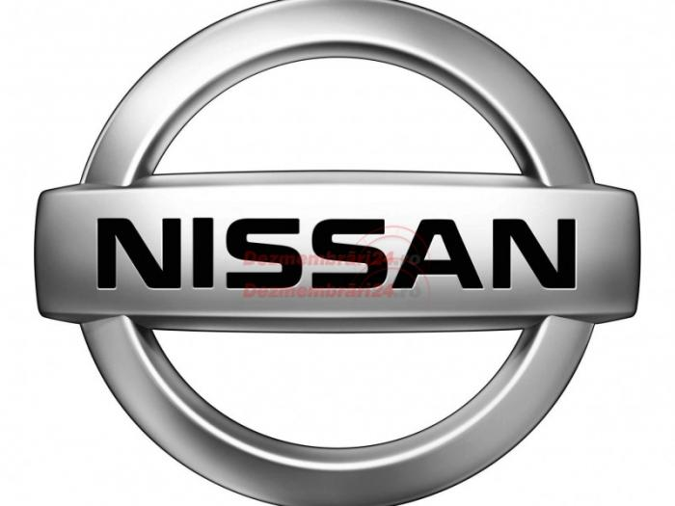
Strategic management plays a vital role in guiding organisations toward long-term success by aligning internal resources with external opportunities and threats (Johnson, Scholes and Whittington, 2020). It enables firms to anticipate market changes, respond to competition, and sustain performance through innovation and adaptability (Grant, 2021). In today’s volatile global business environment, particularly within the automotive sector, strategic management is essential for achieving resilience, efficiency, and sustainable growth.
This report focuses on Nissan Motor Manufacturing (UK) Ltd, commonly known as Nissan UK, a subsidiary of the Japanese multinational Nissan Motor Corporation. Established in 1986, the company operates its flagship manufacturing facility in Sunderland, which is recognised as one of Europe’s most productive car plants. Nissan UK produces several key models, counting the Qashqai, Juke, and Leaf, the latter being one of the world’s first mass-produced electric vehicles (Nissan, 2024). The company employs thousands of skilled workers and significantly contributes to the UK economy through exports and technological innovation.
Nissan’s vision is “to enrich people’s lives” through accessible and sustainable mobility, while its mission focuses on delivering innovative, high-quality vehicles that combine performance with environmental responsibility (Nissan, 2024). The firm goals to achieve carbon neutrality across its operations and product lifecycle by 2050.
The introduction sets the foundation for analysing the strategic influences impacting Nissan UK and developing forward-looking strategies to enhance its competitive advantage within the evolving automotive landscape. The following sections assess the company’s internal and external environments and propose strategic recommendations for sustainable growth.

2. Strategy Analysis

2.1 External Environment Audit

2.1.1 PESTLE Analysis

Factor | Key Issues | Strategic Implications
Political | Post-Brexit trade policies, government incentives for EVs, and global trade tensions influence production and export decisions. | Nissan benefits from UK government’s EV support (e.g., battery plant grants) but faces customs barriers with the EU.
Economic | Inflation, currency volatility, and supply chain disruptions impact costs. Global economic slowdown may affect consumer spending. | Need for cost efficiency and diversified sourcing strategies.
Social | Increasing environmental awareness and changing mobility preferences (car-sharing, urban transport). | Growing demand for EVs and sustainable products supports Nissan’s Leaf and upcoming EV models.
Technological | Rapid innovation in EV batteries, automation, and digital connectivity. | Continuous R&D investment required to stay competitive in technology and smart mobility.
Legal | Strict emission standards, employment laws, and data protection regulations. | Compliance requires innovation and potential cost increases.
Environmental | Climate change targets and sustainability pressures necessitate green production and energy-efficient processes. |  | Nissan’s EV strategy aligns with UK’s net-zero goals.

Tab. Nr. 1: (Sources: OICA, 2024; SMMT, 2024; UK Gov, 2023; Grant, 2021)

2.1.2. Porter’s Five Forces Analysis
Porter’s Five Forces framework provides a valuable lens for examining the competitive dynamics of the UK automotive industry in which Nissan operates (Porter, 2008). The model evaluates the competitive pressures that shape strategic behaviour, including the threat of new entrants, bargaining power of suppliers and buyers, the threat of substitutes, and the intensity of industry rivalry.
The threat of new entrants within the UK automotive market remains relatively moderate. High capital requirements, stringent safety and environmental regulations, and economies of scale act as substantial entry barriers (Grant, 2021). However, technological disruption-particularly in the electric vehicle (EV) segment-has reduced traditional entry barriers. Emerging firms such as Arrival and established global EV manufacturers like Tesla have entered the market with advanced digital and battery technologies, intensifying competition (SMMT, 2024). While these entrants may not yet match Nissan’s manufacturing scale, their innovation-driven strategies pose a credible long-term threat.
The bargaining power of suppliers is comparatively high, particularly given the current global shortages of semiconductors and battery materials. The UK’s departure from the European Union (EU) has further complicated supply chain logistics, increasing reliance on specific international suppliers (Christopher, 2020). Nissan’s operations in Sunderland are dependent on imported components, many of which are sourced from EU-based suppliers. Although the company’s strategic partnership with Envision AESC for local battery production partially mitigates this risk, supplier power remains a pressing strategic concern due to limited domestic alternatives and rising raw material costs (Nissan, 2024).
The bargaining power of buyers in the UK automotive market is moderate to high. Consumers today have extensive choice across price ranges and powertrains, while their preferences are shifting towards sustainability, digital integration, and affordability (Statista, 2024). The increasing transparency of online retailing enhances buyer information and price comparison, reducing brand loyalty. Consequently, Nissan must maintain competitive pricing and enhance product differentiation through technological innovation and customer experience improvements (Johnson et al., 2020).
The threat of substitutes is moderate. Although traditional car ownership remains dominant, the growing popularity of alternative mobility solutions-such as car-sharing, public transport, and ride-hailing services-has begun to influence urban markets (McKinsey & Company, 2024). Moreover, government initiatives promoting sustainable public transport could gradually erode demand for personal vehicles. To counter this, Nissan must continue investing in value-added EV features and connected mobility services to retain relevance in evolving mobility ecosystems.
Competitive rivalry in the automotive industry is particularly intense. The market is saturated with strong global competitors including Volkswagen, Toyota, Hyundai, and Tesla, each investing heavily in electrification, automation, and digitalisation (Deloitte, 2023). Price-based competition remains fierce, especially in the compact and SUV segments that dominate the UK market. Additionally, the transition towards EVs has levelled the technological playing field, reducing product differentiation. To sustain competitive advantage, Nissan must leverage its operational excellence, brand heritage, and alliance with Renault and Mitsubishi to achieve economies of scale and shared innovation benefits (Dyer, Kale and Singh, 2018).

2.2 Internal Environment Audit

2.2.1 Value Chain Analysis (Porter, 1985)
- Inbound Logistics: Efficient supply chain supported by just-in-time manufacturing; Brexit has complicated EU parts flow.
- Operations: Sunderland plant known for high productivity and automation; continuous improvement culture through Nissan Production Way (NPW).
- Outbound Logistics: Strong distribution network across Europe; exports account for over 70% of production.
- Marketing & Sales: Strong brand equity in affordability, reliability, and innovation; EV marketing requires further differentiation.
- Service: Well-established dealer network and after-sales service infrastructure.

Support Activities:
- Technology Development: Continuous R&D investment in EVs, AI, and automation.
- Human Resource Management: Skilled workforce, but needs retraining for digital and EV technologies.
- Procurement: Global sourcing efficiency but exposed to geopolitical risks.
- Infrastructure: Stable financial backing from parent company and alignment with global strategy.

2.2.2 Resource-Based View (RBV) and VRIO Analysis
The Resource-Based View (RBV) posits that enduring competitive advantage is achieved when firms deploy internally controlled resources that possess value, rarity, inimitability, and organisational support (Barney, 1991). The VRIO model below assesses Nissan UK’s key resources and capabilities using these four dimensions.
VRIO Framework for Nissan UK
Strategic Resource / Capability |  | Rare |  | Organised to Exploit |  | Explanation / Insight
  Valuable
  Inimitable
  Competitive Implication
Advanced Manufacturing Capability (Sunderland Plant) | ✔️ | ✔️ | ✔️ | ✔️ |  | Highly automated and efficient production system (Nissan Production Way) creates superior productivity and quality levels that are difficult for rivals to replicate.
  Sustained Competitive Advantage
Electric Vehicle (EV) Technology & Innovation | ✔️ | ✔️ | ⚪ | ✔️ | Temporary Advantage | Early leader with the Nissan Leaf; however, increasing competition in EV tech from Tesla, Hyundai, and VW reduces rarity over time.
Global Alliance with Renault & Mitsubishi | ✔️ | ✔️ | ✔️ | ✔️ | Sustained Competitive Advantage | Access to shared R&D, technology, and economies of scale through the Alliance structure; rare and organisationally embedded partnership.
Brand Reputation and Market Recognition | ✔️ | ⚪ | ⚪ | ✔️ | Temporary Advantage | Strong brand associated with reliability and innovation, though easily imitable and not unique among major automakers.
Skilled Workforce and Organisational Culture | ✔️ | ⚪ | ⚪ | ✔️ | Temporary Advantage | Skilled employees and training programmes enhance efficiency, but technical skills can be developed by competitors over time.
Supply Chain and Lean Logistics System | ✔️ | ⚪ | ⚪ | ✔️ | Competitive Parity | JIT production and supplier integration reduce costs but have become standard across the industry; exposed to Brexit-related disruptions.
R&D and Technological Collaboration | ✔️ | ✔️ | ✔️ | ✔️ | Sustained Advantage | Continuous innovation in EV and battery technologies, supported by global R&D network, is both valuable and organisationally embedded.
Tab. Nr. 2. Source of: (Barney, 1991; Peteraf, 1993)

2.3. Nissan UK: Strategic SWOT Matrix

STRENGTHS 🟩 | WEAKNESSES 🟥
✅ World-Class Manufacturing – Sunderland plant renowned for productivity and efficiency (SMMT, 2024). | ⚠️ Supply Chain Dependence – Heavy reliance on EU imports for components exposes Nissan to Brexit-related trade barriers.
✅ Strong EV Credentials – Early leadership with the Nissan Leaf reinforces brand position in the electric vehicle market (Nissan, 2024). | ⚠️ Limited EV Range – Narrow electric model line-up compared to competitors such as Hyundai and VW.
✅ Global Alliance (Renault–Mitsubishi) – Shared technology and R&D generate economies of scale (Dyer, Kale and Singh, 2018). | ⚠️ Slow Digital Transformation – Delayed adoption of Industry 4.0 technologies limits agility and efficiency.
OPPORTUNITIES 🟦 | THREATS 🟧
💡 EV Market Growth – Expanding demand for sustainable transport supports Nissan’s electrification strategy (UK Gov, 2023). | ⚡ Intensifying Competition – Major EV producers such as Tesla, BYD, and Volkswagen increase market rivalry.
💡 Green Manufacturing Incentives – UK government support for battery and EV production offers growth potential (SMMT, 2024). | ⚡ Economic Volatility – Inflation and currency fluctuations may suppress consumer demand.
💡 Digital Innovation – Adoption of AI and smart manufacturing can enhance efficiency and cost control (Deloitte, 2023). | ⚡ Supply Chain Risks – Semiconductor shortages and global logistics challenges threaten production continuity.

Tab. Nr 3. Source of: (Nissan Annual Report, 2024; SMMT, 2024; Grant, 2021)

Strategic Interpretation
Nissan UK’s strengths lie in operational excellence, EV expertise, and strategic alliances, which provide a solid base for competitive advantage. However, internal weaknesses-notably supply chain dependency and limited digitalisation-must be addressed to maintain leadership.
Externally, opportunities in EV expansion and digital transformation align with Nissan’s sustainability vision, while threats such as competition and economic instability require agility and innovation. Overall, success depends on aligning manufacturing strength with future mobility trends and accelerating technological adaptation.

3. Strategy Formulation
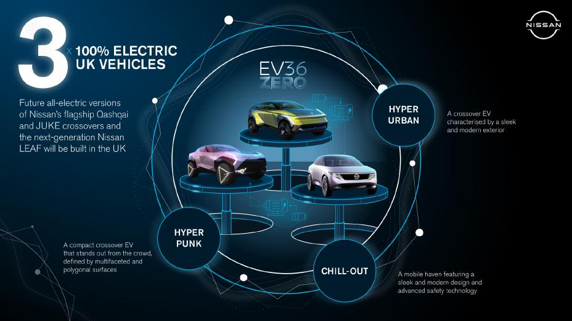
Image nr.2: source of https://europe.nissannews.com/en-GB/releases/three-is-the-magic-number-as-nissan-accelerates-the-switch-to-full-electric
Strategic formulation is the process through which an organisation determines the most effective approach to achieving a sustainable competitive advantage by aligning its internal strengths with external opportunities (Porter, 1985; Johnson, Scholes and Whittington, 2020). For Nissan UK, the formulation of forward-looking strategies must address the challenges identified in the environmental and internal analyses while capitalising on emerging opportunities in electrification, digitalisation, and sustainability.

3.1 Strategic Priorities
Based on the preceding PESTLE and SWOT analyses, several strategic priorities emerge for Nissan UK.
First, the company must accelerate its electrification and product innovation agenda. Expanding its electric vehicle (EV) range and investing in next-generation battery technologies will enable Nissan to remain competitive as the automotive industry transitions towards zero-emission mobility (UK Government, 2023).
Second, digital transformation should be central to Nissan’s operational strategy. Integrating artificial intelligence, robotics, and advanced data analytics into manufacturing and logistics processes can enhance efficiency, flexibility, and supply chain resilience (Deloitte, 2023).
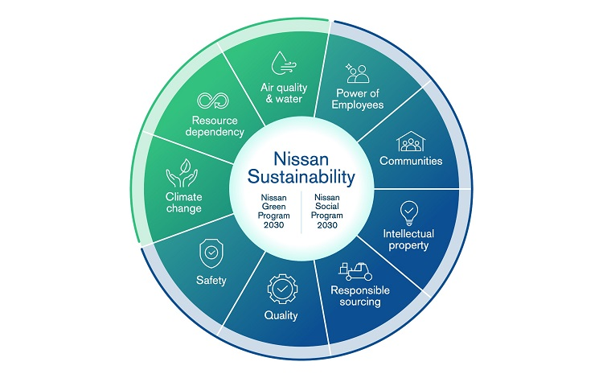
Third, the firm needs to strengthen localisation and supply chain resilience. The post-Brexit environment has highlighted the risks of over-reliance on imported components from the EU. By building stronger partnerships with UK-based suppliers and investing in local component manufacturing, Nissan can mitigate supply chain vulnerabilities and improve production continuity (SMMT, 2024).
Additionally, sustainability and circular economy principles should be embedded within Nissan’s operations. The company can enhance its environmental credentials by implementing closed-loop production systems and expanding battery recycling initiatives, which align with both consumer expectations and national carbon reduction targets (Nissan, 2024). Finally, a customer-centric innovation strategy focused on connected, autonomous, and intelligent mobility solutions will allow Nissan to address evolving consumer needs in a digitalised market (Grant, 2021).

3.2 Strategic Options
Using the TOWS framework (Weihrich, 1982), Nissan can develop strategic alternatives by aligning its internal capabilities and limitations with external opportunities and challenges. The company’s operational excellence and strong alliances can be leveraged to capitalise on opportunities in the EV and green technology markets. Similarly, its R&D and innovation capabilities can help counter threats such as rising competition and market volatility. To address weaknesses such as limited digital adoption, Nissan should pursue technology partnerships and invest in digital upskilling. Strengthening supplier networks and localisation can also reduce exposure to global disruptions.

3.3 Recommended Strategic Direction
Nissan UK should pursue a hybrid competitive strategy, combining differentiation through innovation with cost efficiency (Porter, 1985). This approach would allow the company to offer technologically advanced and sustainable vehicles while maintaining the productivity and cost advantages of its lean manufacturing system. Innovation-driven differentiation will be achieved through continual product development, enhanced battery technology, and customer-focused digital features. Operational excellence, meanwhile, will ensure that efficiency and quality remain key competitive levers.
Furthermore, collaboration within the Renault–Mitsubishi Alliance should be strengthened to share technological expertise, pool R&D resources, and achieve greater economies of scale. A deeper integration of environmental, social, and governance (ESG) principles will also enhance Nissan’s reputation and compliance with global sustainability standards.

3.4 Strategic Outlook
In summary, Nissan UK’s strategic direction should focus on innovation, localisation, and sustainability. The automotive sector is evolving rapidly, and success will depend on the company’s ability to adapt to regulatory, technological, and market shifts. By executing a hybrid strategy, Nissan can expand its presence in the EV market, enhance brand differentiation, and build long-term resilience. Effective implementation of these strategies will position the company not only as a leader in the UK automotive industry but also as a global innovator in sustainable mobility.

4. Conclusion and Recommendations
Nissan UK stands as a central figure within the British automotive industry, known for its strong manufacturing performance, innovation capability, and contribution to the UK economy. However, the sector is facing profound transformation driven by technological change, environmental regulation, and global market uncertainty. The strategic analysis in this report highlights that while Nissan UK benefits from strengths such as operational efficiency, skilled labour, and a strong brand, it also faces challenges including supply chain vulnerability, digitalisation gaps, and increasing competition within the electric vehicle (EV) market.
To secure long-term competitiveness, Nissan must adopt a strategic direction that balances cost efficiency with innovation-led differentiation. This hybrid approach enables the company to maintain its production advantage while advancing in electrification, sustainability, and digital transformation. Investment in next-generation battery technologies, expansion of EV offerings, and enhanced R&D collaboration within the Renault–Mitsubishi Alliance will be critical to achieving these goals.
Furthermore, Nissan should strengthen its local supply chain to mitigate post-Brexit trade risks and improve operational resilience. Embracing Industry 4.0 technologies, such as artificial intelligence, automation, and data analytics, can boost productivity and support evidence-based decision-making. At the same time, embedding sustainability and circular economy principles into operations—through initiatives like battery recycling and carbon reduction-will reinforce Nissan’s environmental reputation and compliance with national policies on green mobility.
In conclusion, Nissan UK’s future success depends on its ability to integrate innovation, sustainability, and operational excellence. By pursuing these strategies, Nissan will not only enhance its market position but also contribute significantly to the UK’s transition towards a competitive and sustainable automotive future.

References

Barney, J. (1991) ‘Firm resources and sustained competitive advantage’, Journal of Management, 17(1), pp. 99–120.
Christopher, M. (2020) Logistics & Supply Chain Management. 6th ed. Harlow: Pearson.
Deloitte (2023) Digital Transformation in Automotive Manufacturing. [Online] Available at: https://www.deloitte.com/ (Accessed: 10 October 2025).
Dyer, J., Kale, P. and Singh, H. (2018) Strategic Alliances: Managing the Networked Firm. Oxford: Oxford University Press.
Grant, R. (2021) Contemporary Strategy Analysis. 11th ed. Wiley.
Johnson, G., Scholes, K. and Whittington, R. (2020) Exploring Corporate Strategy. 12th ed. Pearson Education.
McKinsey & Company (2024) The Future of Electric Mobility: Europe Outlook. [Online] Available at: https://www.mckinsey.com/
Mintzberg, H. (2019) Strategy Safari: A Guided Tour Through the Wilds of Strategic Management. 3rd ed. Pearson.
Nissan Motor Corporation (2024) Annual Report 2024. [Online] Available at: https://www.nissan-global.com/
Nissan Motor Manufacturing UK (2024) Sustainability and Innovation Report. Sunderland: Nissan UK.
OICA (2024) Automotive Industry Data and Statistics. [Online] Available at: https://www.oica.net/
Peteraf, M. (1993) ‘The cornerstones of competitive advantage: A resource-based view’, Strategic Management Journal, 14(3), pp. 179–191.
Porter, M.E. (1985) Competitive Advantage: Creating and Sustaining Superior Performance. New York: Free Press.
Porter, M.E. (2008) The Five Competitive Forces that Shape Strategy, Harvard Business Review, 86(1), pp. 78–93.
Porter, M.E. and Heppelmann, J.E. (2014) ‘How smart, connected products are transforming competition’, Harvard Business Review, 92(11), pp. 64–88.
SMMT (2024) UK Automotive Industry Outlook 2024. London: Society of Motor Manufacturers and Traders.
UK Government (2023) Road to Zero Strategy: Clean Growth and Future Mobility. London: Department for Transport.
Statista (2024) UK Automotive Market Report 2024. [Online] Available at: https://www.statista.com/

