University of Wales
Trinity Saint David

MBA – HRM

Petya Slaveva
2014035

Marketing Management
Assessment 75%

LCMB7001

Tushara Balendran

Table of content

1.Introduction

2.Communication

3. Shannon and Weaver Model of communication

4.Integrated Marketing Communication

5.Current and new promotion

6.Marketing strategy of Zara

7.Brand and brand equity

8.Keller’s brand equity model

9.Customer journey and customer touchpoints

10 .Customer journey map

11.Total engagement model

12.Conclusion

13.References

1.Introduction
Zara is one of the world's most successful brands. With the dramatic introduction of the concept of fast fashion retail since its founding in Spain in 1975, Zara aims to create a responsible passion for fashion among a wide range of customers spread across different cultures and age differences. There are a lot of factors that have contributed to Zara's success, but one of its key strengths has played a strong role in becoming a global fashion powerhouse as it is today, because they put customers first. Zara is obsessed with its customers, and from the very beginning, they have defined the company and the culture of the brand.

2.Communication

Marketing communication refers to the means used by businesses to communicate with messages directly or implicitly to consumers regarding the goods and brands they sell, with the goal of persuading them to buy. In other words, the different mediums embraced by the organization to exchange consumers with knowledge about their products and services is called marketing communication.
The marketer uses marketing communication strategies to build brand interest among prospective buyers, which ensures that in their minds, some impression of the brand is generated that makes them make the purchase decision.

3. Shannon and Weaver Model of communication

Shannon was an American mathematician in 1948, an electrical engineer, and Weaver was an American scientist who both came together to write an article in "Bell System Scientific Journal called "A Mathematical Theory of Communication " and also called " Communicational Model of Shannon – Weaver.

This model is designed primarily to established efficient communication between the sender and the receiver. They also notice variables called ''noise “ that influence the communication process. The model was developed initially to facilitate technological collaboration. In the field of communication, it was later commonly applied.

The model deals with different topics, such as the source of information, transmitter, noise, channel, message, receiver, information, destination, encode, and decode.



4.Integrated Marketing Communication

IMC is a term in which an organization combines the many communicational networks carefully and coordinates them to produce a coherent and effective message. It seeks to ensure that the message and the complementary use of the media are compatible.

IMC is an interrogation within the organization with all marketing methods, techniques, and services that maximize the effect on the mind of the customer, resulting in optimum benefit at low cost.
It implements many creative approaches to ensure that the right message is heard by the consumer in the right place and at the right time.

Advertising
Sales Promotion
Public relations
Personal selling
Digital marketing

5.Zara – current Promotion

According to Forbes, the reason why Zara succeed is that it is focused on pulling people in, not pushing product out.
Spain-based Zara, the largest clothing retailer in the world and owned by Inditex, is introducing an increased reality experience in its stores. Shoppers can engage their phones to see models wearing selected fashions by clicking on the sensors in the store or viewing the AR-enabled shop windows. Originally launched in 120 stores all over the world, this technology is irresistible digital honey to bring millennials into the store and shop.
Zara is pulling customers into the brand, unlike its closest competitor H&M, which remains committed to pushing its brand and product out to the clients.

In studying these two often-compared brands, the main differences revolve around their overall marketing approach. H&M is still fixed on the old 4Ps of the marketing model—Product, Price, Promotion, and Place—where the company and the brand are the focus.
By contrast, Zara has evolved into a new 4Es marketing strategy—puts the customer at the heart of the company and the brand.
For Zara, it's all about the customer—experiences for the customer, exchanges with the customer, evangelism through the customer, and in every place for the customer. Shelley E. Kohan, Assistant Professor at the Fashion Institute of Technology, recently shared an analysis of the Zara difference based on the 4Es marketing concept.
Zara makes the King's customer experience.
The product used to be King, but it wasn't anymore. In the new retail economy, the experience is more important than the product in the mind of the shopper. This is what Zara understands.
"While Zara is an excellent purveyor of product, it also capitalizes on the store experience by continuously offering reasons for customers to visit the stores and catch the hottest trends at affordable prices," Kohan explains. Zara has cultivated a loyal customer who visits around six times a year, compared to other retailers in today's market, where two to three visits for the year are the standard.
The fast-fashion experience formula for success combines frictionless shopping in a highly curated product environment offering a scarce supply and new styles that rotate quickly." The more quickly and efficiently a customer can navigate through the store to explore and find hidden gems, the better the experience," she says. "Zara nails that."

The exchange dollars for the product no longer meets the needs of today's shoppers, as they seek deeper connections with the brand," Kohan states. "The shops must adapt to the changing consumer, where value is at the top of the list. Today, value is measured beyond price, but also in terms of time and convenience."
Zara has a deep understanding of the value proposition that is being exchanged with customers. Its quick-mode delivery is available in the quantity, format, and time that the customer needs the product. This translates into a great deal of value.
"Branded value aligns customer's needs with a brand deliverable," says Kohan. For example, retailers' most loyal customers typically account for 80 percent of sales. These brand loyalists are also less price-sensitive. "Appealing to the loyal segment of the target market, like Zara does, allows for higher profit margins and caters to customers who seek out branded value," she points out.
Zara masters the concept of exchange, as it is not the cheapest in the fast-fashion, but consistently delivers the branded value of the trend-right product at attractive prices.
Zara developed a brand of evangelists.
By making the experience of the brand meaningful and the exchange value, Zara draws on the potential of its customers to evaluate the brand. Instead of pushing out marketing, Zara attracts customers, cultivates them as brand influencers to improve operations, services, and products, and
encourages them.
"Zara's shopping frequency is 2x to 3x higher than traditional women's clothing, indicating super brand loyalty," says Kohan. These loyalists become brand evangelists who share the excitement of the brand with their networks. Zara, for example, has over 25 million Facebook followers, 16 million on Instagram, and more than one million on Twitter.
Zara has a highly-developed data infrastructure, Kohan also notes, which allows for a super-efficient analysis of what's selling and what's being said on social media platforms. These data are used to improve different aspects of the business, from product offers to service. "The two-way communication between the customer and Zara allows for continual improvement of product and services," she says.
Zara is everyplace the customer needs to be in.
Personal commerce is the place where the customers are, rather than the physical place where the brand is present. This is the new distribution model for retailers today: delivering brand experience and products when and where the customer needs it. That's what Zara does for them.
"Zara has devoted significant time, money, and resources to develop a synchronized strategy between online and offline commerce," Kohan explains. By means of this technology and mobile connectivity, it links the customer's shopping visit and provides access to inventory that is not present at a specific location. "It is a big win for both the customer and the company," she says.
Location strategy is another important factor. Currently, it operates in 2,213 stores across 93 markets and 39 online markets. The flagship locations are located in the most critical markets that attract to their most loyal shoppers."Zara has the courage to continuously strengthen its store portfolio by closing unprofitable stores, opening up new markets, and expanding sister brands in already existing markets (Zara Home, Massimo Dutti)," says Kohan.
Zara is all about the customer.
. "As the brand ethos is so embedded in the customers' mind, the customer becomes the brand manager," Kohan explains.
In 2016, the service agents responded to more than 17 million customer inquiries, Kohan found. “Zara actually listens and reacts to customer feedback as its most valuable brand asset to improve its products and services, ” she says.
With corporate policies on diversity, respect, equal opportunity, work-life equilibrium, and professional growth, Zara focuses on its own people. Zara encourages a highly engaged workforce that translates into highly engaging consumer experiences. In addition, over 60 percent of Inditex staff are 30 or younger, aligning themselves with the brand's target demographic.
"The result is the customer, and the company works cooperatively together so that the Zara customer becomes the Chief Customer Officer providing feedback on all aspects of the business," concludes Kohan. This is a radically different alignment than brands working using the 4Ps marketing approach. The client, not the corporation, is calling the shots today. In the decision-making process, Zara includes consumers interactively. That is the difference in Zara.

New promotion strategies

Collaboration
Partnering with other brands and/or businesses is one way to expand your reach and leverage others' resources and experiences. Retailers can communicate to execute unique sales promotions from a variety of angles. One such example is Adidas collaborating with Stella McCartney.

The loyalty programs are also one good way to bring more customers. The more they spend, the more they get.

Another interesting promotion idea is the so-called Bag sale. - Whatever-you-can-fit-in-this-bag-is-a-single-price sale .
The shop provides a shopping bag, cart for shoppers to use for their items while shopping. They can then purchase everything that is inside the container for a single flat price.
This promotion strategy is more popular in America and gives positive results for many years, and I think it will be good for Zara in the UK as well.

Another promotion idea is about recycling. Every woman has a lot of clothes which she doesn’t wear anymore. So they can bring them back to one of Zara's stores and, in exchange to have a discount for future purchases.

Also, the company can organize seasonal events for loyal customers. This type of action shows the customer's appreciation.

6. Marketing strategy of Zara
Zara uses demographic, geographic, and psychological segmentation strategies to meet the growing needs of its customers.

Zara has limited stores around the globe that use selective targeting strategies to make their products available on the market.

Usage-based positioning strategies are being used by Zara to highlight its customer-centric approach to meeting the changing needs of consumers around the world. The company knows that its customers want new and up-to-date trends and therefore target customers solely on the basis of their designs.

7. Brand and Brand equity

Branding is a method of bringing meaning to a particular entity, business, product, or service by creating and forming a brand in the minds of customers. It is a technique developed by companies to help consumers easily recognize and experience their brand and to give them a justification to select their brands over the competition by clarifying what the specific brand is and what is not.

The objective is to attract and retain loyal customers and other stakeholders by delivering a product that is always with what the brand promises.

Brand equity describes the level of sway a brand name has in the minds of consumers and the value of having a brand that is identifiable and well thought of. Organizations establish brand equity by creating positive experiences that entice consumers to continue purchasing from them over competitors who make similar products.

8.Keller ‘s Brand Equity model.
The Keller Brand Equity Model is known as the Customer-Based Brand Equity (CBBE) Model. Kevin Lane Keller is a marketing professor at the Tuck School of Business at Dartmouth College, has created the model and published it in his very used book, "Strategic Brand Management
". The structure behind the Brand Equity Model is simply easy: to make a strong brand which you need to shape how customers think about your product. You need to build the right kind of experience around the brand so that customers have specific, positive thoughts, feelings, beliefs,
opinions about it.

Figure 1 – Keller's Brand Equity Model
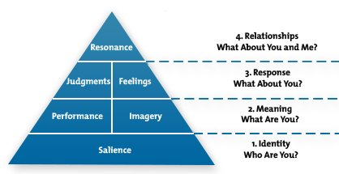
KELLER, KEVIN, STRATEGIC BRAND MANAGEMENT: GLOBAL EDITION, 4th, © 1901. It was reprinted by permission of Pearson Education, Inc., New York, New York.
The four stages of the pyramid raise four basic questions about the brand
that consumers will sometimes ask.

Within a pyramid, the model highlights four levels to create a successful brand. These four levels are:

1.Brand identity.
2.Brand meaning.
3.Brand responses.
4. Brand relationships.

Within these four levels are six building blocks that further help with brand development. These six building blocks are salience, performance, imagery, judgments, feelings, and resonance.

With over 2000 global stores, the company commenced operations in Australia during 2011 and now operates 12 stores throughout the country (Inditex, 2017).

Zara is a general example of a "global brand" (Li, Lecture 4 2017), a retailer that has remained the same name and same image throughout the world.

Zara's identity lies at the heart of its image as a trendy and affordable brand. Zara has maintained its image as "a brand that possesses high cultural capital and is competitive with today's luxury brands" (Cellner, 2013)

But perhaps the company's biggest asset is its reputation as a leader in "fast fashion" online fashion phenomena that dominate today's retail climate.

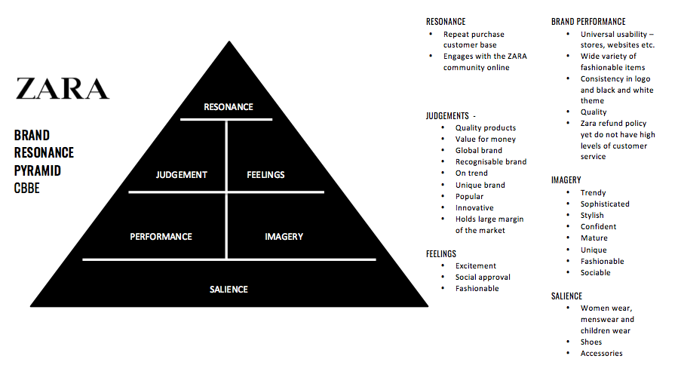
Zara.com

Salience

Indicator of Brand Awareness

Depth of brand awareness: when ZARA is mentioned, the black-and-white logo comes to mind, as well as the high-street fashion brand identity. Although ZARA rarely uses advertising, vivid brand images are known when consumers visit ZARA's physical stores and displays. Importantly, ZARA's location strategy is the main way to communicate with the public. In the minds of consumers, ZARA has already been one of the top high fashion retail outlets.

ZARA has different product categories that suit everyone, including women, men, children. When consumers need fashionable but affordable clothing, ZARA is their right choice. ZARA brings clients a concept that you don't need to buy luxury clothing just for wearing it once you can buy ZARA's stylish Design with a limited budget.

Imagery﻿
Meeting of customers' psychological and social needs

User Profile: Typical Zara customers are young, fashion-conscious, but budget-lower people. They care about their appearances and want to be stylish.
﻿
Purchase situations: Consumers may be passing through ZARA stores and attracted by their window display. Like the clothes in ZARA change very quickly, if you don't buy something that you love right now, they'll be sold out next time. Thus, ZARA creates psychological thoughts that allow clients to buy their clothes without considering too much.

Personality and values: Zara is modern, trendy, fashionable, and individualistic. The stylish personality of Zara appeals to the confident, young target.

Performance
Meeting of Customers' Functional Needs

Reliability & Durability: As ZARA's idea is to wear a disposable and fashionable design, the quality of the clothing is good but less than the luxury brands.
﻿
Style & Design: the latest Design is provided by ZARA. From Design to sale, the shortest time is only 15 days for ZARA. Thus, ZARA can always offer modern, up-to-date fashion to attract consumers who want to be voguish and unique. As fashion changes every moment, this fast fashion method ensures that ZARA is always ahead of its competitors and the first to deliver fashionable clothes.
﻿
Service Efficiency: ZARA satisfies customers with its fast pace of Design and up-to-date fashion. ZARA is also very concerned about the needs of consumers. If some products are not so popular with customers, ZARA will not hesitate to remove those stocks so that consumers can find out what they love and buy.
​
Price: The price is low compared to other luxury fashion brands. It's so affordable for those who want to keep up to date. With this price, consumers can buy clothing more often than not, instead of spending a lot of money on a piece of classic luxury clothing.

Feelings
Creating which type of emotion during consumption

Self-respect: ZARA creates less emotion about warmth, fun, safety; instead, ZARA builds more on self-respect. People who buy ZARA can feel that they are unique, different, cool, chic, superior, and individualistic. This atmosphere is also shape
d by the logo and modern decoration.

Judgments

Credibility: Having seen the value and satisfaction of ZARA consumers, ZARA is definitely a reliable brand. Since 1975, ZARA has been continuously offering fashion products. ZARA is an expert in the production of fast fashion clothing for males, females, and children. Although it copies the Design of other luxury brands, it truly satisfies consumers' needs for the pursuit of the latest fashion.

Resonance
Intensity of psychological bonds that consumers have with the brand

Behavioral Loyalty: Because ZARA delivers limited fast fashion products without being replenished many times, products can be sold out soon. Consumers know this, so they would like to visit the ZARA store to see the newly available products. Once they love the products, they can't refuse to buy them. Otherwise, the next time customers come, the products would be sold out.

Community Sense: ZARA manages its social community in a cool way. It only posts information such as the new Design of this season or the newly opened FB store. And ZARA does not post and communicate with its clients every day. It's the personality of ZARA, so there's no conflict in this way. And clients love ZARA and fashion to keep track of their information.

Active engagement: ZARA has 19.7 million Facebook fans. It communicates more with younger people who love fashion. ZARA rarely does marketing; instead, it saves money to design and optimize its supply chain so that customers can be happy with its products. That's how ZARA keeps the public
engaged.

9. Customer journey and customer touchpoints in Zara

The customer journey in marketing relates to the customer’s path, via touchpoints to their decision to buy a product. Common end -to -end customer journey represents all the interactions in between a customer being completely unaware of a company to become aware, investigating it and buying it, and telling friends that they should buy it too.

Thanks to its customer's experience, Zara is raising its sales. The. The target consumer is usually in the age range of 18-40. As part of his /her occupation, fashion trends usually demonstrate high importance.

The customer profile is a single working mum with two children of primary school age. After a hard day at work, taking care of the kids, household, she has little time for herself, which allows the consumer to scroll through to social media and some shopping platforms. According to the 2009 BSM Media survey, 71% of mums use social media to buy products (Linder & LaMotta, 2009). Online shopping, especially for this consumer whose job role requires her to stay up-to-date, is an essential tool for a single working mother who has no time to browse high street stores. The online shopping experience has to be as streamlined and friendly as possible, ensuring that products can be found quickly and easily.

In terms of the discounted price, seasonal bar sales, the brand does not offer any discount on their clothing. Products are priced compared with other fast fashion sites, but competitors generally offer a student discount, usually 10% off. The brand differs slightly from other 'high street' brands, as Zara follows high fashion trends more closely than New Look, so the products appear to be more expensive than the price paid.

When the consumer went online, they can see that the website offers as well some suggestions regarding outfits .this creates more interest from the consumer. The websites are divided between women, men, kids with their own accessories, and lately, they create a new department for the home.
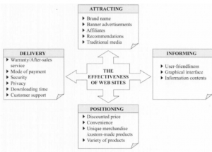

10. Customer journey diagram
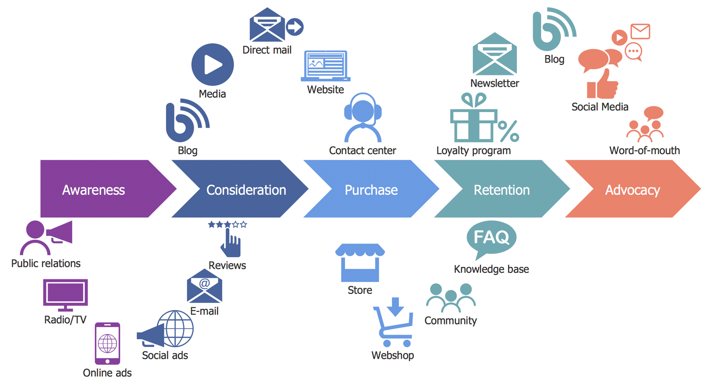www.conceptdraw.com

11.Total engagement model

They place the customer at the very center of our business model. They are knowing and delivering what their customers want-no matter where they are-requires attention to detail and industry-leading technological innovation in every part of their value chain.

Whether they're designing, manufacturing, or distributing our products, we're always looking at how our operations can improve customer service and the quality of customer experience – while honoring the sustainability commitments that customers expect. Listening to feedback, creating short production runs, and investing in state-of-the-art logistics allows us to identify and meet customer needs, refresh the stores and online systems with new styles twice a week. This guarantee
s total commitment.

12.Conclusion

This report of the Zara company analyzed the customer journey considering the promotion strategy, IMC and customer touchpoints, and it was disused Shannon – Weaver‘s communication model and Keller's brand equity model . . It can be stated the Zara company is succeeding very well with their strategy for fast fashion and focusing on the customer. It was said that they could improve the promotion strategy. One of the secrets behind Zara's global success is culture and respect for the fact that no one is a better, more authentic trendsetter than the customer itself – and this philosophy needs to be constantly reflected in all its forward-looking business strategies.

Reference:

Principles and Practice of Marketing , sixth edition , David Jobber,2010

Management Theory and Practice ,fifth edition ,G. A. Cole ,2003

Doyle, Peter, and Philip Stern. Marketing management and strategy. Pearson Education, 2006.

Kuhn, Kerri‐Ann L., Frank Alpert, and Nigel K. Ll Pope. "An application of Keller's brand equity model in a B2B context." Qualitative Market Research: An International Journal (2008).

Kranzbühler, Anne-Madeleine, Mirella HP Kleijnen, and Peeter WJ Verlegh. "Outsourcing the pain, keeping the pleasure: effects of outsourced touchpoints in the customer journey." Journal of the Academy of Marketing Science 47.2 (2019): 308-327.

Ritchie, D. (1986). Shannon and Weaver: Unravelling the paradox of information. Communication research, 13(2), 278-298.

Rowley, Jennifer. "Online branding." Online information review(2004).

Inditex.com

Forbes.com

Conceptdraw.com

