Assessment 1
Blogging to Communicate
WALMART
Student Name -Alice Ana-Maria Casota
Student ID -2117332

Table of Contents
What is Walmart? 3
What does Walmart do and why? 3
Why is it called Walmart? 3
What makes Walmart the largest retailer in the world 4
Why is Walmart known as world largest retailer? 4
When did Walmart become the largest retailer in the world? 4
What countries do Walmart operate in? 5
Does Walmart have stores in Europe? 5
Target vs Walmart: which is the best?!? 6
Is Walmart or target more successful? 6
But which is the CHEAPER one?? 6
Millionaires At Walmart! 7
What do rich people buy in Walmart? 7
Is Walmart for poor people? 7
discounts at Walmart!! 9
Do Walmart members get discount? 9
REFERENCES 10


What is Walmart?
The Walmart Corporation is a globally-recognized retail corporation that operates large chain stores, hypermarkets and grocery products. The company was founded by Sam Walton over 50 years ago with an annual revenue of more than $500 billion dollars as 2008 prices - making them the largest retailer in terms not only America but worldwide too! Walmart is headquartered in Bentonville, Arkansas. (Wang, 2016). The company began as a small chain of stores in rural communities and has since expanded to thousands of locations around the world.

What does Walmart do and why?


Walmart is known for low prices and its wide range of products, which include groceries, clothing, electronics, and home goods. The company also offers a lot of services, such as financial services, pharmacy services, and optical services. Walmart has come under fire for its business practices, including its treatment of employees and its impact on the environment. However, the company has also been praised for its philanthropic efforts, such as its support of education and disaster relief.

Why is it called Walmart?
A combination of the founder's last name and the initial letters of the word "market" gave rise to the moniker "Walmart," which means "worldwide market." Walmart operates under the name Walmart in the United States and Canada, in Mexico and Central America, it is known as Walmart de México y Centro América, the Seiyu Group in Japan, Asda in the United Kingdom, and in India as Best Price. Walmart de México y Centro América is the company's Mexican and Central American division. It has activities in Argentina, Canada, Chile, Brazil, and South Africa that are completely owned by the company. Sam's Club retail warehouses are also under the control of the firm. (Roberts, 2012).

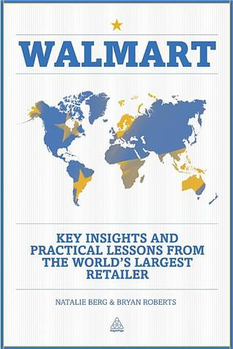
What makes Walmart the largest retailer in the world
Walmart is the biggest retailer in the world because it offers customers low prices, a large selection of products, and convenient locations. Walmart also invests in technology to improve the shopping experience for its customers. The company has developed a mobile app that allows customers to shop online and pick up their purchases in-store. Walmart is also testing a drone delivery system that could provide customers with even faster access to their purchases. Walmart's success is due to its focus on providing low prices, convenience, and selection. (list, 2017). The company has invested in technology to improve the shopping experience and is always looking for ways to improve its customer service. Walmart is the best place to shop for everything from groceries to electronics.

Why is Walmart known as world largest retailer?
- Walmart is the largest retailer in the world because it has a very large selection of products, it is very affordable, and it has a lot of locations. Walmart is also known for its low prices, which is why it is often referred to as the "king of retailers." Walmart is also a very convenient store because it is open 24 hours a day, 7 days a week.
- Another reason why Walmart is so popular is because it offers a variety of services that other stores do not offer. For example, Walmart has a pharmacy, a optometrist, a hair salon, and a portrait studio. Walmart also has a tire and lube center, a auto service center, and a garden center. These services make Walmart a one-stop-shop for many people. (haiven, 2013).
- Walmart also has a good return policy. If you are not satisfied with an item that you purchased at Walmart, you can return it within 90 days for a full refund.
Despite these positive aspects, there are some negative aspects of Walmart as well. For example,
- Some people complain that Walmart's customer service is not very good.
- Additionally, some people say that the store is often dirty and unorganized.
Overall, Walmart is a very popular store because it has a lot to offer its customers. It is convenient, affordable, and has a wide selection of products. However, there are some negative aspects of Walmart that one should be aware of before they shop there.

When did Walmart become the largest retailer in the world?
Walmart became the largest retailer in the world in 1989. In the years since, Walmart has continued to grow, both in terms of its physical presence and its reach. The company now operates more than 11,700 stores around the world, including more than 5,000 in the United States alone. Walmart also runs an e-commerce business that includes a handful of online stores, as well as a grocery delivery and pickup service.

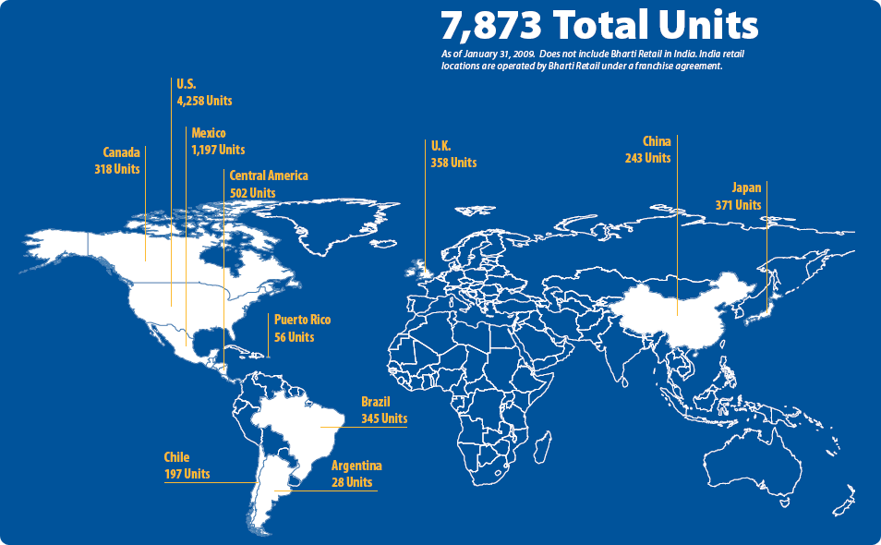
What countries do Walmart operate in?
Walmart operates in Argentina, Brazil, Canada, Chile, China, Colombia, Costa Rica, El Salvador, Guatemala, Honduras, India, Japan, Mexico, Nicaragua, Peru, Puerto Rico, South Korea, Taiwan and the United States. The company also operates in the United Kingdom, as Asda. Walmart has 11,695 stores and clubs in 27 countries, under a total of 63 banners.

Does Walmart have stores in Europe?
Walmart has stores in Europe. Walmart has stores in the United Kingdom, Germany, and Portugal. In addition, Walmart also owns ASDA, a major grocery chain in the UK. Walmart is expanding its reach in Europe, and it is looking to open more stores in the future.
Walmart first entered the European market in 1999, when it acquired a majority stake in ASDA, a UK-based grocery chain. Walmart has since expanded its operations in Europe, and now has stores in the UK, Germany, and Portugal. Walmart is looking to continue its expansion in Europe, and is planning to open more stores in the future. (Ellicson, 2018).
Walmart's European operations are a key part of the company's global strategy. Walmart is committed to growing its business in Europe, and is investing heavily in its expansion plans. Walmart is confident that its European operations will be successful, and is committed to providing customers with the best possible shopping experience.

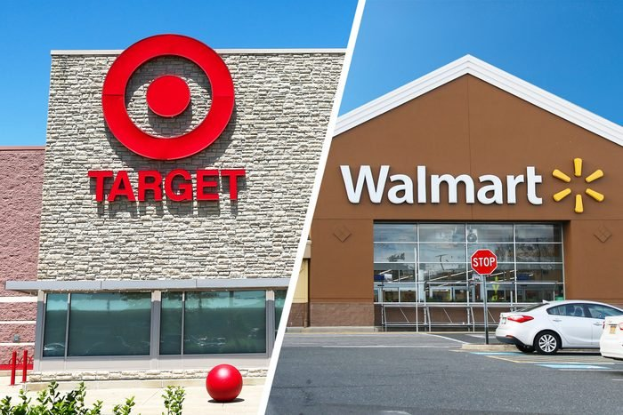
Target vs Walmart: which is the best?!?
There are many reasons that Walmart is better than Target. For starters, Walmart is cheaper than Target. Additionally, Walmart has a much larger selection of products than Target does. Finally, Walmart is more convenient than Target because it is open later and on Sundays. Target may have some advantages over Walmart, such as a nicer store environment and better customer service, but overall Walmart is the better store. Walmart is cheaper, has a greater selection of products, and is more convenient. For these reasons, Walmart is the better choice for most shoppers.
There are pros and cons to both stores, but ultimately it depends on what you are looking for. Target often has a wider variety of products, while Walmart is known for its low prices. So, it really depends on what you need. If you are looking for a specific item, Target is probably a better bet. But if you are just looking for the best deal on general items, Walmart is probably your best option. (Duff, 2016).

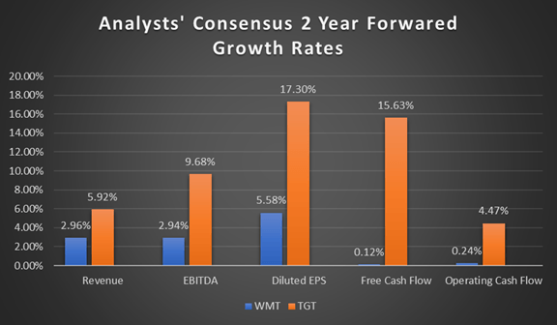
Is Walmart or target more successful?
There is no definitive answer to this question as it depends on a variety of factors. Some people may feel that Walmart is more successful because it is a larger chain and has a wider selection of products. Others may feel that Target is more successful because it offers a more unique shopping experience, with features like design studios and food courts. Ultimately, it is up to the individual shopper to decide which store they believe is more successful. Target may be seen as more successful because it offers a more unique shopping experience than Walmart. Target has features like design studios and food courts that Walmart does not have. This may make Target more appealing to some shoppers. However, Walmart is a larger chain and has a wider selection of products. This may make Walmart more appealing to other shoppers. Ultimately, it is up to the individual shopper to decide which store they believe is more successful.

But which is the CHEAPER one??
There is no denying that Walmart is cheaper than Target. This is because Walmart has a lower price for almost everything they sell. In fact, it is not uncommon for Walmart to be 20-30% cheaper than Target. However, this does not mean that Target is a bad place to shop. (Ellison, 2016). They offer great prices on many items, and their prices are usually competitive with Walmart. It really just depends on what the buyer is looking for and where they shop the most.


Millionaires At Walmart!
Yes, many millionaires do shop in Walmart. They enjoy the low prices and variety of products that Walmart has to offer. While Walmart may not have the same high-end brands that some other stores offer, they more than make up for it in terms of value and selection. (Weinandt, 2017).
Some of the reasons that millionaires shop at Walmart include:
- The low prices allow them to save money on everyday items.
- The wide selection means that they can find everything they need in one place.
- The convenient locations make it easy to get in and out quickly.
- The friendly staff makes shopping a pleasant experience.

Whether you're a millionaire or not, shopping at Walmart can be a great way to save money on your groceries and household items. So next time you're looking for a good deal, be sure to head to your local Walmart. You might be surprised at what you find.

What do rich people buy in Walmart?
Some wealthy people may buy high-end items at Walmart, such as jewelry or electronics. Others may purchase more affordable items, such as clothing or housewares. However, there are some wealthy people who avoid shopping at Walmart altogether. This is because they perceive Walmart as a discount store for low-income shoppers. Whatever the reason, shopping at Walmart can be a great way to save money on high-quality merchandise.

Is Walmart for poor people?
There is no one-size-fits-all answer to this question, as the answer may vary depending on individual circumstances. However, some people may believe that Walmart is for poor people because it is a low-cost retailer that offers affordable products and services. Other people may believe that Walmart is not for poor people because it has been accused of putting small businesses out of business, or because its employees are often paid low wages. (Allgunn, 2016). Ultimately, the answer to this question depends on each individual's personal beliefs and opinions. But No matter what someone's opinion is, Walmart is a store that has something for everyone. You can find clothing, groceries, electronics, and more at Walmart. So, whether you are rich or poor, you can find what you need at Walmart.

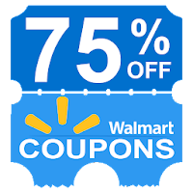
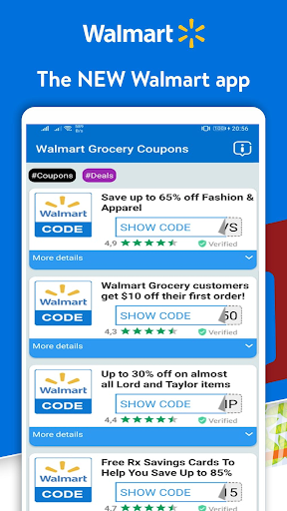
discounts at Walmart!!
Here are a few tips on how to get the best discounts at Walmart:
- Sign up for the Walmart Savings Catcher program. This program allows you to compare the prices of your local Walmart with the prices of other local stores, and if Walmart is cheaper, you get the difference refunded to you in the form of a Walmart gift card. (Schuetz, 2015).
- Use Walmart's Price Match Guarantee. If you find a lower price on an identical product at another store, Walmart will match the price and give you the difference back in the form of a Walmart gift card.
- Take advantage of Walmart's weekly ad deals. Each week, Walmart releases a new ad with deals and coupons on various items. Be sure to check the ad before you shop so you can take advantage of the savings.
- Use Walmart's store coupons. These are coupons that you can print out or find in the weekly ad and use at checkout to save money on your purchase.
- Join the Walmart Savings Catcher program. This program allows you to compare the prices of your local Walmart with the prices of other local stores, and if Walmart is cheaper, you get the difference refunded to you in the form of a Walmart gift card.
- Use Walmart's Price Match Guarantee. If you find a lower price on an identical product at another store, Walmart will match the price and give you the difference back in the form of a Walmart gift card.
- Take advantage of Walmart's weekly ad deals. Each week, Walmart releases a new ad with deals and coupons on various items. Be sure to check the ad before you shop so you can take advantage of the savings. (Kampf, 2007).

Do Walmart members get discount?
Walmart members do get a discount on their purchases. The amount of the discount depends on the item purchased. Some items may be discounted by a certain percentage, while others may have a fixed dollar amount off. The best way to find out if an item is eligible for a discount is to check the Walmart website or ask a store associate.

REFERENCES
Allgrunn, M. and Weinandt, M., 2016. Is shopping at Walmart an inferior good? Evidence from 1997-2010. The Journal of Applied Business and Economics, 18(1), p.77.
Ellickson, P.B., 2016. The evolution of the supermarket industry: from A & P to Walmart. In Handbook on the Economics of Retailing and Distribution. Edward Elgar Publishing.
Ellison, B., Duff, B.R., Wang, Z. and White, T.B., 2016. Putting the organic label in context: Examining the interactions between the organic label, product type, and retail outlet. Food Quality and Preference, 49, pp.140-150.
Haiven, M., 2013. Walmart, financialization, and the cultural politics of securitization. Cultural Politics, 9(3), pp.239-262.
Kampf, C., 2007. Corporate social responsibility: WalMart, Maersk and the cultural bounds of representation in corporate web sites. Corporate Communications: An International Journal.
LIST, T., International Business Essay on Walmart.
Roberts, B. and Berg, N., 2012. Walmart: Key insights and practical lessons from the world's largest retailer. Kogan Page Publishers
Schuetz, J., 2015. Why are Walmart and target next-door neighbors?. Regional Science and Urban Economics, 54, pp.38-48.

