The second part of the guidance document contains essential knowledge and understanding of performance management and reward. You need to ensure that your explanation includes:
the purpose and typical components of performance management. (AC 4.1)
According to the CIPD Factsheet (2025) on performance management, it is described as the attempt to maximise the value that employees create. It also states it aims to keep and improve the employee’s performance to keep in line with the objectives of the organisation. Different ways to measure performance is through task performance, contextual performance or adaptive performance. When discussing performance management, it’s important to think about the purpose of it for the organisation and for individual people. When thinking about if from the organisation side, when performance management is done well the benefits can be a good understanding of goals within the organisation. This can form a basis for a team and create work planning for individuals. Another benefit to the organisation is to have accurate performance data from what has been put in place to measure the performance. According to Waite et el (2021) there are a number of reasons why individuals need performance management. One of those reasons is to have a good understanding on how the individual performance aligns with the organisation’s overall goals. Another reason why individuals require it is potential chances for longer term career planning; this reason can mean that organisations keep staff for longer as they feel they have a future within the organisation.
two factors that need to be considered when managing performance. (AC 4.2)
When considering management performance, a factor to keep in mind is capability. This means the degree someone is able to complete their tasks. When thinking of capability, it’s important to keep in mind that a worker might be motivated to do their work tasks, but the quality of work will depend on the capability of their level of knowledge and skills. It is very important to develop knowledge and skills as they are a important condition of performance management. One-way you individuals can improve on knowledge is to consider development opportunities or training. This can vary through doing different things within the organisation, for example these can be in house training within the department or long-term workplace coaching training.
When considering management performance, a factor to keep in mind is capability. This means the degree someone can complete their tasks. When thinking of capability, it’s important to keep in mind that a worker might be motivated to do their work tasks, but the quality of work will depend on the capability of their level of knowledge and skills. It is very important to develop knowledge and skills as they are an important condition of performance management. One-way you individuals can improve on knowledge is to consider development opportunities or training. This can vary through doing different things within the organisation, for example these can be in house training within the department or long-term workplace coaching training. recognising someones capability is important as it shows that the manager has trust in that person’s knowledge. One important factor to keep in mind is motivation when manging performance. A person’s motivation can be changed from day to day and effect the way they work and how effective it is. It’s important to recognise the workers performance to show them that their motivation is a key part in delivering a great service.
different methods of performance review. (AC 4.3)
According to the CIPD factsheet (2025) on performance reviews, the purpose of them is to inform on different decisions for employees. These decisions can be things like promotion, redundancies, pay rise or bonuses. Another main use of a review of someone’s performance would be to support learning and development (L&D) purposes and can build someone’s knowledge and skills up. When reviewing performance, it is best to focus on these to aspects separately as they involve different processes and lead to different outcomes. There are different methods to review performance of individuals. According to Waite et el (2021) one of the methods can be appraisals. These can be used to review any act of reviewing a individual’s performance. Usually, goals are set at appraisal and once an appraisal has been conducted then new goals are set by the manager and the individual. Appraisals typically occur once or twice a year. When having an appraisal, there are different methods used. These methods can be self-reflection, manager assessment of performance or even peer assessment in some instances. Another method is a performance review; this is a more modern term than the traditional appraisal wording. These reviews are more likely to feel less official and more frequent than the traditional appraisal. A performance review and appraisal can both take place for an individual, this would mean a employee would have short reviews in between in-depth appraisals. Another informal, light way to review performance is through performance conversations. As the name suggests, these are shorter and likely to be more convenient than traditional twice a year appraisal. This method might be ad hoc but they also could replace the appraisal system.
key components (financial and non-financial) that are required to achieve an effective total reward system. (AC 5.1)
When thinking of total reward, WorldatWork finds 6 aspects to the work experience to the Total Reward CIPD factsheet (2025). These six aspects are performance and recognition, work/life balance, org culture, employee development, strategy and human resource strategy. According to the CIPD factsheet on reward (2025) there a number of things that are important in keeping, attracting and keeping employees engaged. These components can we financial or non-financial. When thinking of some of the positives of total reward, this helps you attract, keep and motivate employees. It also can meet both the employee and organisation priorities. A disadvantage to this that some rewards are easier to give than others. The main goal of total reward is to find a better balance between what the employer and employee need. When thinking of financial reward, pay can be divided into two categories. This can fixed pay or variable pay. According to the factsheet, pay definitions can vary for different employees. It is found that financial worries can cause a loss of productivity in the workplace.
When thinking of total reward, WorldatWork finds 6 aspects to the work experience to the Total Reward CIPD factsheet (2025). These six aspects are performance and recognition, work/life balance, org culture, employee development, strategy and human resource strategy. According to the CIPD factsheet on reward (2025) there a number of things that are important in keeping, attracting and keeping employees engaged. These components can we financial or non-financial. When thinking of some of the positives of total reward, this helps you attract, keep and motivate employees. It also can meet both the employee and organisation priorities. A disadvantage to this that some rewards are easier to give than others. The main goal of total reward is to find a better balance between what the employer and employee need. When thinking of financial reward, pay can be divided into two categories. This can fixed pay or variable pay. According to the factsheet, pay definitions can vary for different employees. It is found that financial worries can cause a loss of productivity in the workplace. According to Waite et el (2021) total reward is an approach that keeps merges the ‘whole package’ of monetary and non-financial rewards and this means that rewards go past just salary. These rewards can be advertised during the recruitment process and used to help attract new members of staff.

how reward can motivate employees to perform. (AC 5.2)
Reward can motivate factor to get employees to perform well due to the benefits they would get from the reward. Motivation is fueld by different aspects, this depends on the persons life stage and needs. According to the CIPD news article (2021) motivation is what drives our behaviour and explains what we do things. According to the People Management article (2017), it it said that rewards that are extrinsic have dominated for years but there has been a cultural shift in focus. Money is no longer a motivator for employees. It was found that routine lead jobs relied on money to motivate the work force. According to the article, it was found there are a small change of opportunity for the work force to use their capability, this normally is a job of their managers. It’s important to remember than extrinsic factors like covering pay, bonuses and employee benefits are a vital element of a reward package. It’s found that money is no longer a motivator for employees if they consider their pay not to be fair. Dan Pink wrote the following quote “Pay people enough to take the issue of money off the table.” According to the Indeed Career Guide (2025) on Intrinsic Rewards and How to Use Them at Work, reward can help increase motivation and success of the business. One intrinsic reward to motivate employees is to give your employees a choice. This means giving the workers a decision on how they work through out the day. This can show the employees that managers trust their ability to work. Another intrinsic reward to motivate employees is to encourage them to learn new skills, this makes them feel more valuable at work. This reward can build on their existing reward scheme. Maslow’s Hierarchy is a example of what can motivate employees to perform. If you look at Maslow’s Hierarchy of Needs, you can see that the base of this hierarchy is physiological needs. This means that the base is built on basic human needs like basic salary and health insurance. The second part of the hierarchy is safety; this could mean security in your position or planning to retire. The third part is belonging; in the workplace this can mean working in an inclusive workplace and feeling like a part of a team. The fourth part is esteem; this means recognition for your work and potentially getting reward for your work. The top part is self-actualisation needs, this mean to be get the best out of yourself and developing yourself.
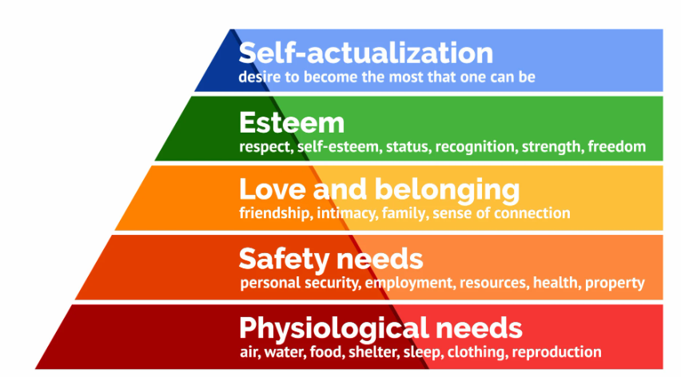
at least two reasons for treating employees fairly in relation to pay. (AC 5.3)
According to the CIPD factsheet (2024) on Pay fairness and pay reporting, due to the unfair treatment of female employees, this caused the Equal Pay Act 1970 to come into effect. This means that women can’t be treated less favourable than men when it comes to pay and conditions within employment. This means that a reason to pay men and women equally is due to the work they do. If they do the same or similar work load, this means men and women get paid equally. Another reason for treating them fairly in relation to pay would be that if men and women to work of equal value. This means when there are different potions but one of the employees claim that both require the similar of skill and ability. If employees find that they are being treated unfairly, they could be entitled to claim against their work. According to the Leigh Day article (2020), more than 100 people who are mostly female who work in Co-op shops in England and Scotland are claiming their work is equal to the work that men do. Solicitors think that the average worker can be entitled to £10,000 in compensation.
According to the CIPD factsheet (2024) on Pay fairness and pay reporting, due to the unfair treatment of female employees, this caused the Equal Pay Act 1970 to come into effect. This means that women can’t be treated less favourable than men when it comes to pay and conditions within employment. This means that a reason to pay men and women equally is due to the work they do. If they do the same or similar work load, this means men and women get paid equally. According to the Leigh Day article (2020), more than 100 people who are mostly female who work in Co-op shops in England and Scotland are claiming their work is equal to the work that men do. Solicitors think that the average worker can be entitled to £10,000 in compensation. Another way to treat employees fairly when it comes to pay, it’s important to use important criteria to determine this. This criterion is skills, knowledge and achievement against targets.
According to the CIPD factsheet (2024) on Pay fairness and pay reporting, due to the unfair treatment of female employees, this caused the Equal Pay Act 1970 to come into effect. This means that women can’t be treated less favourable than men when it comes to pay and conditions within employment. This means that a reason to pay men and women equally is due to the work they do. If they do the same or similar work load, this means men and women get paid equally. According to the Leigh Day article (2020), more than 100 people who are mostly female who work in Co-op shops in England and Scotland are claiming their work is equal to the work that men do. Solicitors think that the average worker can be entitled to £10,000 in compensation. Another way to encourage employers to pay employees fairly is through pay reporting. To pay people fairly through pay reporting, the organisation can evaluate an individual’s job to determine the pay rates. Another way they can determine fair play is having panels to review salary increases made by line managers. The focus currently is on employed staff but the CIPD factsheet (2024) says that new government plans to ensure that workers who are outsourced are included in the gender pay gap and pay ratio reporting.
References
https://www.cipd.org/uk/knowledge/factsheets/performance-factsheet/
Waite, K et al. (2021) People Practice, A Complete Guide. London: Kogan Page
https://www.cipd.org/uk/knowledge/factsheets/appraisals-factsheet/
https://www.cipd.org/uk/knowledge/factsheets/reward-factsheet/
https://www.cipd.org/uk/knowledge/factsheets/strategic-total-factsheet/
https://www.cipd.org/uk/about/news/understanding-what-really-drives-your-workforce/
https://www.peoplemanagement.co.uk/article/1743866/real-value-reward
https://uk.indeed.com/career-advice/career-development/intrinsic-rewards
https://www.simplypsychology.org/maslow.html
https://www.leighday.co.uk/news/news/2020-news/co-op-supermarkets-latest-to-face-equal-pay-claims/
https://www.cipd.org/uk/knowledge/factsheets/pay-fairness-reporting-factsheet/#payfairness

