  Component One:  What are the key skills required when working in the housekeeping team? 750 words (+/- 10%)  Contribution to Overall Module Assessment: 25% | Student No: | Martin Yankov  2126972
 | Module Title: | Operating Hotel Facilities
 | Module Code: | BMIH 4006
 | Lecturer: | Lola Villard , Kathryn Roberts
Introduction
The team of housekeeping is accountable for cleaning guest rooms, replacing dirty towels, turning down beds, and replenishing any other services in a hotel. However, accurate housekeeping in a hotel assures a safe work environment and can go a long way to assuring workers are safe and secure. Therefore, the skills needed for the housekeeping team are also important in the hospitality sector. By enhancing these skills, it is noted that working in hotels becomes much easier and more convenient.
Key skills required when working in a housekeeping team
To be able to provide customers with superior service, a competent housekeeper must be versatile and well-equipped with an appropriate set of skills and knowledge. I think a housekeeper ought to have a keen eye for details based on what I already know. This is so that they are obligated to adhere to the safety and cleanliness measures (Singh and Jaykumar, 2019). Moreover, the cleaning procedures used by a company also indicate its brand standards. According to Stevaine (2019), housekeepers need to be attentive to all details, and hence they should be detail-oriented to be effective at their job. From managing different household items to assuring that windows and floors are clean and left streak-less, these cleaning experts require a keen eye for detail to effectively act their responsibilities. Moreover, the housekeeping team also require to hold the expertise of high observation, which indicates that the team must be capable of managing communication skills. I believe that the housekeeping team should communicate with clients, managers, and co-workers to make sure the expectations for every cleaning are extensively understood. However, the housekeeping team of Hilton Hotel ensure effective communication in the team and also with employees from other departments by keeping a friendly and secure working environment. Hence, the core reason for this is that hotels have to deal with various customers at the same time. Therefore it is important to attend to all these guests at the same time (Hilton, 2022).
Furthermore, the housekeeping staff also need to be flexible for working at different hours every day on the basis of the client's requirements, such as, if a housekeeping team is assigned to clean an office building, they have to wait to start work until all workers have left the building for everything. In my opinion, being flexible can assist housekeepers in being accessible for more jobs and possibly making more profits (Chow, 2016). In addition, housekeepers require to multi-task to make sure they have every space cleaned before guests arrive for a stay. It is noted that housekeeping staff in the UK is organised and capable to multi-task, such as cleaning messy rooms and changing bed sheets when customers leave the room and preparing the room for upcoming guests (Nguyen, 2018).
Why is housekeeping important in the hospitality industry
Parmar and Dalal (2017) illustrate that the housekeeping department in hospitality is the team of workers assigned to cleaning a hotel. They care for and clean all fixtures, furniture, fittings, and linen. The responsibility of housekeeping is to reliably deliver friendly, expert, and engaging services. However, the housekeeping department plays an essential role in every hotel. It is noted that the housekeeping team is also accountable for making sure that guest areas are neat and trimmed, and without them, the state of the hotel will rapidly worsen. Advance-day housekeeping software makes it simpler than ever to make sure the hotel and its housekeeping team are managed and effective. It is demonstrated by Kansakar et al. (2019) that digital tools implement various avenues for task management and streamlined communication, ensuring the housekeeping sector is always innovative and up to date with the latest data on the basis of information attained regarding the key skills of the housekeeping team. In my opinion, cleanliness sets a first positive impression of quality and illustrates to customers how much the hotel really cares for them. On the other hand, hotels deliver numerous kinds of services such as laundry for guests, shoe polishing services, dry cleaning, etc. While quality and cleanliness of services and rooms, a hotel individually services on the sale of beverages, rooms, food and other minor facilities, such as spas, clubs, gymnasium etc. I think that I should comprehend and take into consideration these skills to ensure that if got an opportunity, then I will serve best in the hotel industry in the future.
Conclusion
It is concluded from the aforementioned analysis of the skills, I came to know that working as a housekeeper in the hospitality sector is somehow challenging without the above-mentioned skills. Flexibility, being attentive, multi-tasking, and communications are the most important skills for housekeepers.

References
Chow, H.H.C., 2016. Managing distanced flexibility: the quadrangular relationship in hotel housekeeping work.
Hilton, 2022. Job description. Available at https://jobs.hilton.com/emea/en/job/HOT097YE/Housekeeping-Team-Member. [Accessed on 21st February 2023]
Kansakar, P., Munir, A. and Shabani, N., 2019. Technology in the hospitality industry: Prospects and challenges. IEEE Consumer Electronics Magazine, 8(3), pp.60-65.
Nguyen, M., 2018. Cross-training for front-line employees in the hotel industry. Case study: Holiday Inn Helsinki City Centre.
Parmar, S. and Dalal, P., 2017. A study of musculoskeletal disorder among housekeeping staff in the hotel industry. Int J Home Sci, 3(3), pp.83-5.
Singh, A. and Jaykumar, P., 2019. On the road to consensus: key soft skills required for youth employment in the service sector. Worldwide Hospitality and Tourism Themes.
Stevanie Vickyance, S.V., 2019. Housekeeping Department In Hotel Tentrem Yogyakarta (Doctoral dissertation, Universitas Multimedia Nusantara).

Word Count | 760

Component Two:
Contribution to Overall Module Assessment: 25%
In this scenario – You have just been promoted to the team leader for a floor within the hotel. A guest complained that on their arrival, their room had not been properly cleaned. Create an action plan and answer the following questions.

Problem | Why did it happen? | What are you going to do? | How will you prevent this from happening in the future? | What measures would you introduce to improve team effectiveness?
Lack of free services | The staff do not focus on free services due to a lack of complimentary supplies. It may cause low guest satisfaction and interest in booking rooms. | It will be imperative if I will deliver various free services to my customers. Such as, I will try to offer a free ironing service, a welcome tray in a room, and extra pillows in a room. | I will prevent it in the future by training housekeeping staff and providing modified free services to customers. I will take measures of customer service performance. | I will be wise to supply a huge amount of free services in cleaning and closet stations. I will improve team performance and introduce free services in different packages to attract a large number of guests.
Lack of communication | This problem arises due to a lack of strategies and objectives. It may cause delays, errors, and wasted time. Visitors may be unhappy if a facility or service they had aimed to use is no longer available. | I will make sure that new staff will communicate effectively with the visitors. I will provide training to the staff for dealing with communication issues and ask them to be respectful and patient with guests. | In the future, I will come up with an effective strategy and use effective communication channels for my new staff. Further, a reward system will be used for an employee who communicates respectfully with visitors. | I will develop a system that will gather responses from guests regarding the behaviour of staff. In addition, I will introduce a reward system for employees if they communicate well with visitors.
Unclean room | This may occur if the staff is new and is not well-trained for the cleaning purpose, due to which cleanliness staff will be unable to manage the pressure of work and do not work efficiently. | I will hire skilled and trained staff for this role and also provide training to unskilled employees. It will make sure that staff know where, how, and when to use various cleaning tools and equipment to maintain service. | For new employees, I will provide offers for promotion if they clean the room neatly or a reward strategy that will motivate them to do their tasks efficiently. | I will set rules and regulations along with job training to resolve this issue which is important to make staff effective and well-trained in cleaning a room.
Complain of foul smell. | This smell may come from the bacteria breaking down the flesh and causing it to rot. Also, staff failed to check this on a daily basis, and it caused a foul smell in the room. | I will try to train staff on the basis of guest services, which will make them conscious of the implication of a fragrant room that incorporates a fascinating experience for the visitors. | Each room and washroom will be incorporated with a fragrant that will assist in enhancing the overall quality of air and will provide a breath-taking experience to the guests. | Also, I will use air fresheners or odour neutralisers after implementing cleaner to the excesses and plug drains.
Lack of welcoming guest service | This may occur in peak season when handling guests is slightly difficult for staff. Further, the lack of proper employee involvement is also the main cause of this issue. | For this, I will consider hiring new staff and make sure that the old staff works in a comfortable and calm environment which is most important. Also, I will ensure that the burnout of employees is prevented and controlled. | I will introduce a reward system that will create to assist employees so that any type of frustration does not interfere with their work. | I will focus on delivering quality services and making employees enthusiastic about welcoming guests by offering them rewards.

Component Three:
Contribution to Overall Module Assessment: 50%
Your task is to create and prepare a presentation following the detailed scenario provided below.

As the floor housekeeping manager and given the recent guest complaints, you need to put together a basic training presentation for your colleagues within the housekeeping team to get the best out of them, ensure that brand standard is being achieved and that Health and Safety procedures are also being followed.

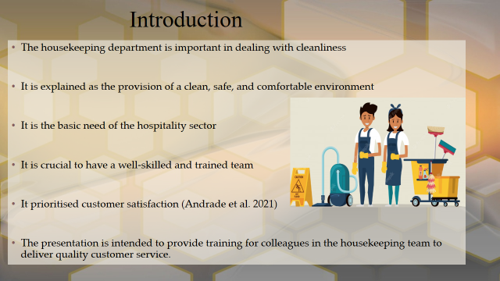

Training Notes: The housekeeping department is considered crucial to cope with cleanliness matters. It is because cleanliness sets a first impression of high quality and shows guests how hotel care for their guests. It is basic need of the hospitality sector and needs to hire individuals that are well-trained and have sufficient skills to deal with cleanliness.
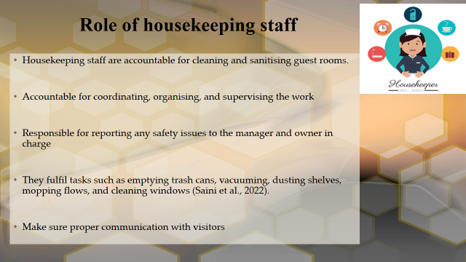

Training Notes: It has been noted that housekeeping staff are accountable for reporting and cleaning any safety problem to the managers in charge. They complete their tasks, such as sweeping, dusting shelves, and vacuuming. While some housekeeping staff change linens, do ironing and laundry and wash dishes.

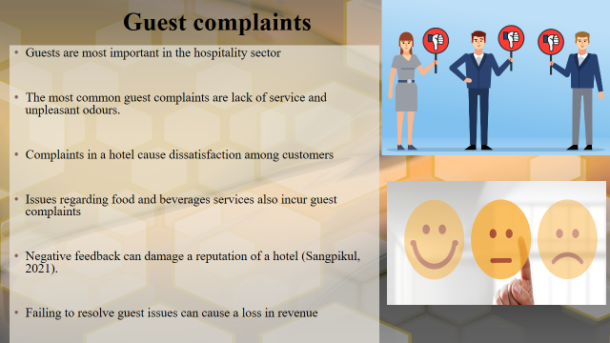

Training Notes: Guest complaints can negatively impact the reputation of the company. The emphasis of housekeeping services is on recognising the core guest complaints and modifying the training programs to avoid such worries in the future. It is noted that complaints in a hotel may dissatisfy the customers and causes a loss in revenue.

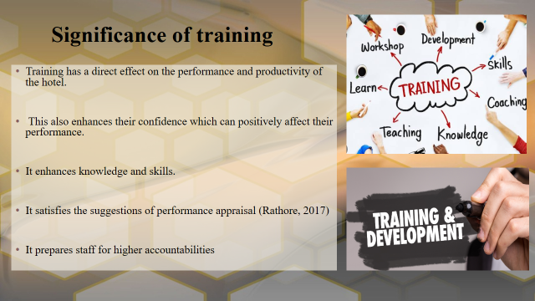
Training Notes: Training provides staff with a better understanding of their accountabilities and the skills they require to do the job. It also assists in enhancing the skills and knowledge of staff to match the numerous modification in the industry. Further, training programs can also assist in preparing staff who are moving into higher roles and taking more accountabilities in a hotel.

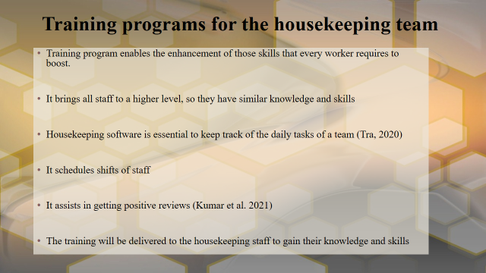

Training Notes: The housekeeping staff training assists and allows skills to improve and bring higher level, so they have the same skills. The training program is housekeeping software that is important to track every activity of staff and schedule shifts of employees.

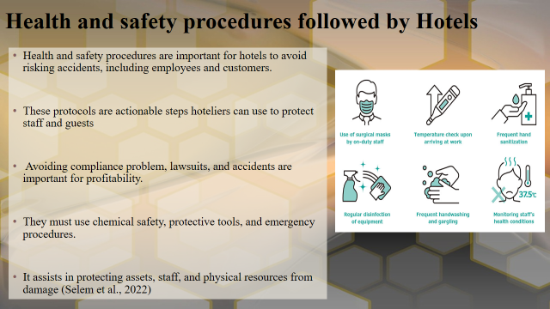
Training Notes: It is important that housekeeping staff in hotels should follow health and safety processes to make sure their safety while working in a hotel. They must avoid compliance issues, accidents and lawsuits.

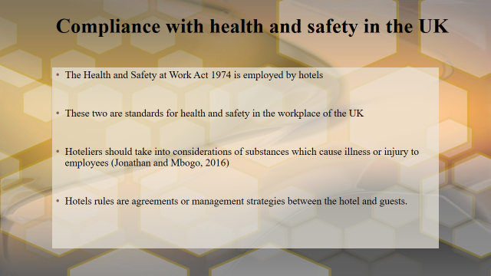
Training Notes: The hotel of the UK uses Health and Safety Work Act 1974. These are standards for health and safety in the hotels of the UK. Workers must be delivered with any proper protective equipment needed to manage harmful substances.

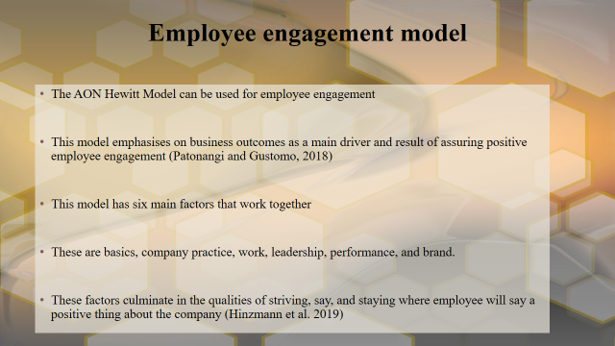
Training Notes: The AON Hewitt Model tract the connection among engagement drivers and outcomes of a business to develop more holistic employee engagement policies. It has six main components, basics, company practice, work, leadership, performance, and brand. This model connects the dots between engagement drivers and business targets by incorporating the outcomes of a business. These are important goalposts to assist leaders in controlling the level of involvement.

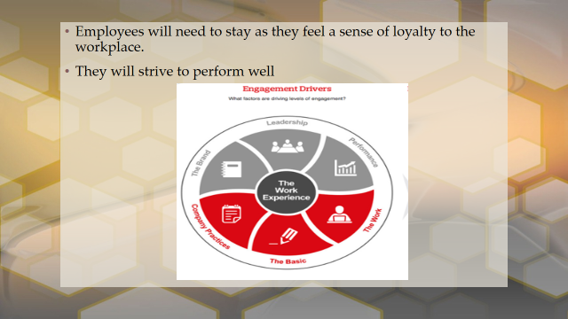

Training Notes:
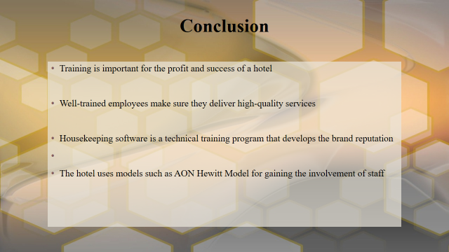

Training Notes: Training is crucial for attaining guest satisfaction and developing a robust and positive brand reputation. This training is crucial to resolving the issues faced by the hotels. Thus a training programme will assist in enhancing profits and building the skills needed for workers.

References
Andrade, M.S., Miller, D. and Westover, J.H., 2021. Job satisfaction factors for housekeepers in the hotel industry: a global comparative analysis. International Hospitality Review, 35(1), pp.90-108.
Hinzmann, R.A., Rašticová, M. and Šácha, J., 2019. Factors of employee engagement at the workplace. Do years of service count? Acta Universitatis Agriculturae et Silviculturae Mendelianae Brunensis.
Jonathan, G.K. and Mbogo, R.W., 2016. Maintaining Health and Safety at Workplace: Employee and Employer's Role in Ensuring a Safe Working Environment. Journal of Education and Practice, 7(29), pp.1-7.
Kumar, S., Ghosh, S. and Mondal, B., 2021. Training-up during COVID-19 in hotel housekeeping operations in selected hotels of Kolkata. Indian Journal of Hospitality Management, 3(1), pp.89-95.
Patonangi, A. and Gustomo, A., 2018. Improving Aon Hewitt Indonesia Employee Engagement Survey Product Using Engagement-Job Burnout Model. Jurnal Manajemen Indonesia, 18(3), pp.251-262.
Rathore, PS, 2017. Significance of training and hospitality skills for hotel employees. International Journal of Engineering and Management Research (IJEMR), 7(3), pp.53-56.
Saini, G., Panda, P.K., Sharma, M., Singh, M. and Meshram, R., 2022. Knowledge, attitude, and practices of ward attendant and housekeeping staffs towards dead body care of COVID-19 patients at tertiary care hospital: A cross-sectional study. medRxiv, pp.2022-08.
Sangpikul, A., 2021. Examining subjective and objective e-complaints and service quality in Bangkok hotels. Tourism and hospitality management, 27(2), pp.429-448.
Selem, K.M., Ahmad, M.S., Belwal, R. and AlKayid, K., 2022. Fear of COVID-19, hotel employee outcomes and workplace health and safety management practices: Evidence from Sharm El-Sheikh, Egypt. Tourism and Hospitality Research, p.14673584221119374.
Tra, T., 2020. Action plan for training new Housekeeping Employee: case: Hotel Indigo Helsinki.

