UNDERSTANDING PSYCHOLOGICAL DEVELOPMENT ACROSS THE LIFESPAN

The aim of this poster is to provide brief information to hospital staff about psychological development across the lifespan. Two psychological theories are included and compared. Erik Erikson’s first and more influential Theory of Psychological Development and Piaget’s Cognitive – Development theory
Erik Erikson (1896-1980) developed a psychological theory of development which has been widely used. This theory suggests that human psychological development happens in eight stages throughout the lifespan. He also considered that our ego identity forming is affected by our interaction with others and depends on surrounding social and cultural factors.
Erikson described eight fundamental psychosocial stages which individuals go through during their life. The length and intensity of each phase is not the same for everyone. Whether the stage is positively or negatively completed affects the next one (Syed and McLean, 2017). The 8 stages of Erikson’s theory can be considered as development tasks. At each task there is a conflict that needs to be resolved.

“AGING BEGINS AT BIRTHS AND CONTINUES THROUGH LIFESPAN” (Erber, 2013, p. 7)

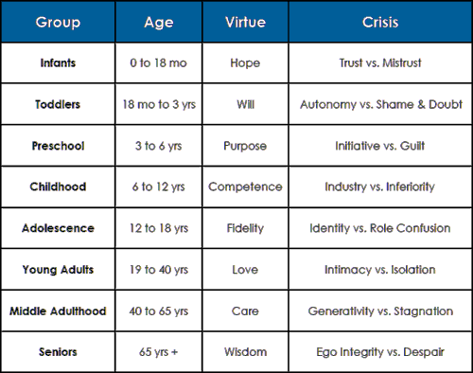
Table 1. Erikson’s theory stages. (Theodore, 2020)

Trust vs Mistrust (infancy) - in this stage infants are all dependent on their caregivers and surrounding environment. If the child’s needs are met, trust is developed. When infants are in distress, thy develop mistrust.
Autonomy vs Shame and Doubt (toddlerhood) - step of developing sense of autonomy. When this stage is successful, the child becomes secure and confident, able to make choices. When it is failed, feelings of shame and self-doubt are formed.
Initiative vs Guilt (early childhood) - autonomy goes further. Children start to take initiative. If unsuccessful children develop feelings of guilt.
Industry vs Inferiority (middle childhood) - this stage is an extension of the previous one. Children develop either feelings of competence or inferiority depending on the outcome of this stage (positive or negative).
Identity vs Role confusion (adolescence) – children develop independence and their personal identity. They either stay true to themselves or have a confused role if not appropriately encouraged.
Intimacy vs Isolation (young adulthood) – forming intimate relationships. If successful, strong relationships will be formed. If this stage fails, children will feel lonely and isolated.
Generativity vs Stagnation (middle adulthood) – phase of care giving; child- and care-focused. The care for others builds generativity but if it is lacking, the adult becomes stagnant.
Ego integrity vs Despair (older adulthood) – reflection on and conciliation to the past. Adults satisfied with their past lives and what they achieved have an ego integrity. Those who are disappointed from the past experience despair (Gillibrand, Lam and O’Donnell, 2016).

T



Jean Piaget (1896-1980) dedicated six decades of his life to studying the development of children’s logical thinking. Like Erikson, he suggested that personality is developed throughout stages, but Piaget believed that the sequence of the stages is fixed, each stage is related to a certain age and is grown out by the previous one (Cherry, 2020). According to him every stage builds a foundation for the next one and children’s progression through the stages is different as some of them do not attain the Formal operational stage (Boyd and Bee, 2019).
While Erikson viewed identity development throughout the whole life. Piaget believed that it happens in four phases - from birth to late adolescence (McLeod, 2020).
The Sensorimotor Stage (birth to 18 months) - babies understand the world using their sensory and motor actions. At the end of this period, they start to use symbols.
The Preoperational Stage (18 months to 6 years) - children learn to talk, develop their fantasy and apply it in thinking and communication. At the end of this phase, the child is able to classify objects and use logic.
The Concrete Operational Stage (6 to 12 years) - children begin to think logically and can understand the conservation concept. Logic is progressively developed.
The Formal Operational Stage (12 years to adult) - youngsters develop abstract thinking and hypotheses (Boyd and Bee, 2019).

Nina Stoilova
1921113

Figure 1. Piaget’s theory stages.(Aljojo et al., 2019)
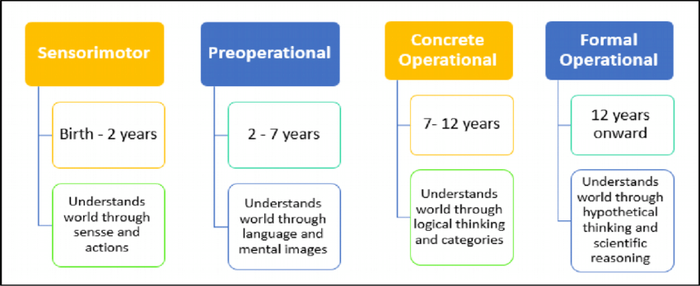
To prevent psychological problems that occur in older adults, organisations can offer services that help individuals to stop smoking or avoid starting; to moderate alcohol use; to advise on balanced and healthy diet; and offer physical and mental activities encouraging them to be active every day (Erber, 2013).

Nina Stoilova 1921113

Annotated Bibliography

Aljojo et al. (2019) ‘The design and implementation of an Arabic pronunciation application for early childhood’, Journal of technology and science education, 9(2), p.136, DOI: 10.3926/jotse.486 (Accessed: 15 June 2021).
- This study is about early years education in the Middle East which aims to develop an educational application to help children aged 3-5 improve their skills and prepare them for school.
- I only used a figure from it showing Piaget’s theory stages which I included in the poster.
- I think that it provides credible and reliable information because it is an article published in the Journal of technology and science education.

Boyd, D and Bee, H. (2019) Lifespan Development, Global Edition 8th ed. Harlow: Pearson Education, Limited.
- This book provides information about individuals’ psychological development in the lifespan as it analyzes, both physically and cognitively, every stage of life – from prenatal development to death.
- From reading chapter 2 “Theories of Development”, I found useful information about Piaget’s theory which I used in my report.
- In my opinion it is a highly credible and reliable source.
- The chapter I read (“Theories of Development”) presents information for a variety of theories. It helped me gain a deep understanding of Piaget’s theory.

Cherry, K. (2020) Jean Piaget Biography (1896-1980). [website] Available at: https://www.verywellmind.com/jean-piaget-biography-1896-1980-2795549#stages-of-cognitive-development (Accessed: 16 June 2021).
- This is an article about Piaget published on the Verywellmind website.
- I applied some knowledge I gained from this source to describe Piaget’s theory’s stages.
- I think that it is a credible source of information because the website team consists of experienced mental health specialists. Information about them can be found on the page and their contacts are provided.
- It is a very interesting and useful study giving a lot of information about Piaget. The page which presents the Stages of Cognitive Development links to other part of the website which provides very detailed explanations about each individual stage.

Erber, J.T. (2013) Aging & older adulthood. 3rd ed. Chichester, West Sussex: Wiley-Blackwell.
- This book is the result of research on aging and older adulthood. It covers aging from all aspects of life.
- Reading and understanding more about psychological needs in the older generation gave me ideas about the services which can be provided by the hospital staff to help reduce physical and mental health problems.
- It is a credible source of information because it is a published book.
- This book helped me to understand the psychopathological problems that can occur in older adults and what the main reasons for mental health issues are. This information came from chapter 11 - “Mental health, psychopathology and therapy”. It was also interesting to read, in Chapter 3, about everyday functioning, health care and physical changes that happen to our bodies.

Gillibrand, R., Lam, V., and O’Donnell, V.L. (2016) Development Psychology. 2nd ed. Pearson Education, Limited.
- This book is about development psychology and is divided in four sections: Section one is an introduction to development psychology; section two explores the stages of prenatal development and infancy; in the third section, social and emotional development is outlined; and section four explains how development psychology can be applied in practice.
- In Chapter 2 “Theoretical perspective”, Erikson’s theory is explained and at the same time compared to Freud’s theory. I applied this information in my poster explaining the eight stages of Erikson’s theory.
- It is a credible source because it is a book, published by a trustable publisher.
- Reading section one of the book helped me to understand more about development in psychological terms.

Gross, R. (2015) The Science of Mind and Behaviour. 7th ed. London: Hodder Education Group
- This book covers major perspectives in psychology. It is a good introduction to this topic.
- I did not use the information from this source in my work, but it was very interesting, informative, and useful to read it.
- I think that this is a credible book because its author R. Gross is a best-selling psychology author.
- Part 5, Chapter 32 of the book was particularly interesting for me to read. From here, I gained an understanding about attachment, infant development and building attachment between infants and their parents/caregivers. Also, about the importance of early child-parents attachment and how it varies between individuals and cultures. I also learned about the effects of deprivation and privation on attachment.

McLeod, S. (2020) Piaget’s Theory and Stage of Cognitive Development, Simply Psychology, [website]. Available at: https://www.simplypsychology.org/piaget.html (Accessed: 14 June 2021).
- This is an article about Piaget’s Theory of Cognitive Development where it and all its stages are well explained and compared to other theories.
- I used the information from the article and included it in the poster comparing Piaget’s to Erikson’s theory.
- I think that it is a trustworthy source of information because it is published via Simply Psychology Organization website, which makes me think that it is credible. Its author Dr. Saul McLeod is a qualified psychology teacher. His work has been published in other psychology journals as well.
- Even though I was aware of Piaget’s theory, from reading this material I have learnt what motivated Piaget to develop his theory. Also, I understood the difference between Piaget and others. I learned about the implication of Piaget’s Theory to education in the UK.

Syed, M. and McLean, K.C. (2017) ’Erikson’s theory of psychological development’ PsyArXiv, Available at: https://psyarxiv.com/zf35d/ (Accessed: 10 June 2021).
- This research on Erikson’s theory is an article published in journal PsyArXiv which can be accessed online.
- This article provides information about the key features of Erikson’s theory. It is focused on its eight stages and the idea of how individuals must balance between and resolve any tasks appearing through them. I included this info in my poster.
- It is reliable and credible because the website in which it is published is maintained by The Society for the Improvement of Psychological Science. Thus, it is included in SAGE Encyclopedia of Intellectual and Developmental Disorders.
- This study added to my knowledge on Erikson’s theory and gave me a closer look in its stages. I think it is very useful because it is well structured and easy to understand.

Theodore (2020) Erik Erikson (Psychologist Biography). [image] Available at: https://practicalpie.com/erik-erikson/ (Accessed: 14 June 2021).
- This is a website created and maintained by Theodore, who also runs a YouTube channel.
- This website introduces biographical information of worldwide psychologists, scientists and authors. I used a table published in it.
- I think that this source is credible because it is well designed and constructed, and well written. It contains a lot of information. The data in the table which I used corresponds to the relevant information.
- I enjoyed reading this page because it is an interesting introduction to Erikson’s personal life and work.

