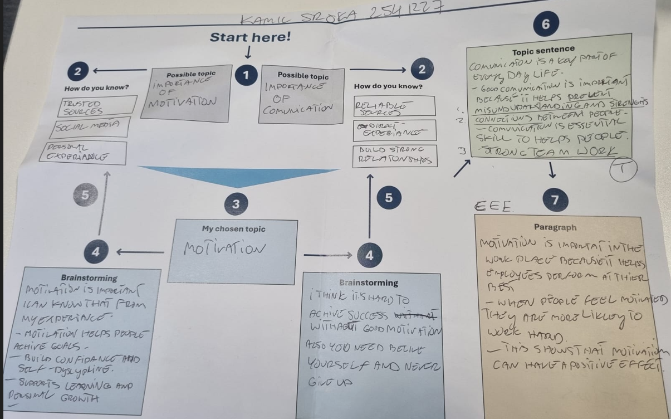
Paragraph
[ T ] Using data to make business decisions improves efficiency and reduces risk. Many businesses now analyze data to guide pricing, stock levels, and planning. [ E ] Research from McKinsey Global Institute (2017) found that data-driven organizations are significantly more likely to acquire customers and be profitable than those that rely on intuition. [EXP] This shows that using data can directly improve business performance. [ EXP] It is not just about collecting information. [ EXP ] Additionally, businesses must also use the data to make informed decisions. [E ] For example, data can highlight which products are selling well and which are not. [ EXP ] This allows managers to adjust quickly and reduce waste. [ EXP ] Over time, these small decisions can lead to higher profits and better use of resources. [ L ] Overall, using data supports more accurate and effective business decision making.
2.
- Device: Additionally Purpose: To add another idea
- Device: For example Purpose: To give an example.
- Device: Overall Purpose: To finish the paragraph

3. C – Time management is important because it helps employees' priorities tasks, meet deadlines, and reduces workplace stress, leading to higher productivity.
4. B – When employees collaborate effectively, they can share ideas, solve problems faster, and support each other’s strengths.
5. B – A study by LinkedIn (2023) found that 94% of employees said they would stay longer at a company that invests in their learning.
6. C – Overall, flexible working hours contribute to a more productive and satisfied workforce.
TEEL FINAL DRAFT:
In my opinion, workplace motivation is essential because it helps employees achieve the best possible results. Motivated employees are more willing to apply themselves to their duties, complete tasks on time, and focus on established goals. I think that they also tend to display a positive attitude and derive satisfaction from their work, which fosters better teamwork and communication. In my view, motivated and engaged employees are more productive than those who lack commitment. This demonstrates that motivation can have a beneficial impact on both the employees themselves and the company's operations. For instance, recognizing employee achievements through rewards or praise can boost confidence and encourage continued, effective performance. Motivated employees are also more likely to stay with the company for the long term and contribute to its ongoing success. In summary, motivation is a key factor because it improves efficiency, increases job satisfaction, and helps companies achieve better results.

