Learning Log Report- Llanelli
Introduction
This report has been constructed by myself, Yasemin Sapan, to highlight the distinctiveness of Llanelli, and how the Industrial Revolution played a significant role in emphasising the importance of Llanelli and its surrounding area during this period of time. Throughout the main body of this report we will be thoroughly analysing two sites of regeneration within Llanelli; one being the Llanelli Wetlands Centre, a former area of waste farm and marshland, now being run as a thriving tourist attraction, and lastly, Tata Steel Tinplate Works in Trostre, the partner site to Port Talbot Steelworks.

The Industrial Revolution and its effect on Llanelli
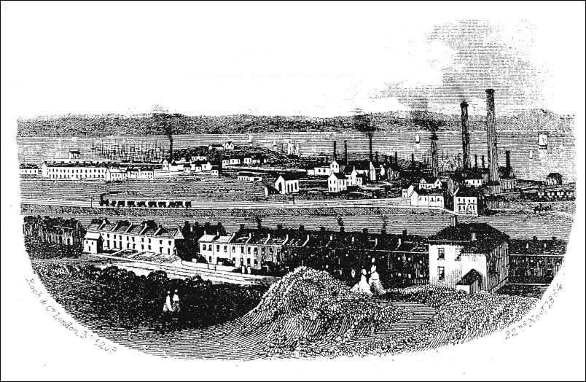
(John)
During the 1700s, Llanelli saw huge ecological and economical changes to the area, as the demand for coal deeply increased and became more popularised, particularly during the period between 1700- 1750. This is a noticeable duration of time when coal of substantially superior quality was taken from the area and exported out to other parts of the country and Europe by rail. There was an established sea trade, particularly with France. (J. Hannam, 2019).
This time of vast and rapid change meant that Llanelli was transformed from an area of largely arable farm land to one being continuously and repeatedly used for coal mining. Over the course of 150 years, the country of Great Britain was completely ‘transformed from a largely Agrarian society to an industrialised urban based one’. (J, Hannam, 2019) This new industry and way of life generated more employment opportunities for both local and foreign workers; many of whom were former farmers, having sold their land and homes to pursue a new career filled with more advantages and rewards for not only themselves, but their families included.
Our guest speaker for this topic, Julie Hannam, explained that ‘The first significant period of change occurred from about 1700 – 1750 when the coal seams below the large estates were leased out’. (J. Hannam, 2019)
To summarise, the effect that the Industrial Revolution had on Llanelli and its surrounding area as well as the rest of Great Britain, was that of utmost change and utter transformation; particularly in areas of industry and work, alongside economic growth and prosperity. Communities came together during these times, therefore having a progressive effect on society and relationships obtained amongst the local workforce and families of that period.
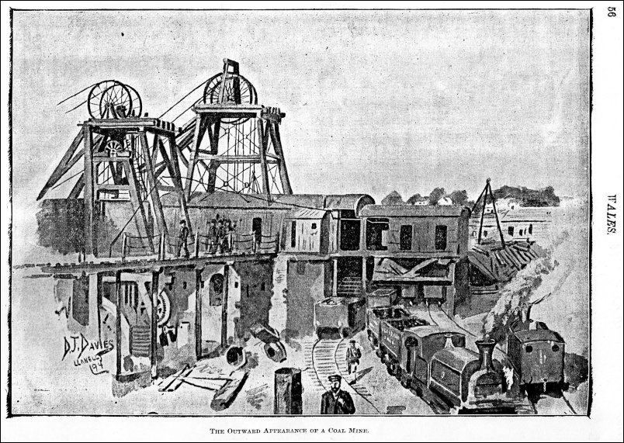
(Down a Coal Mine, 2019)

Llanelli and locations of regeneration
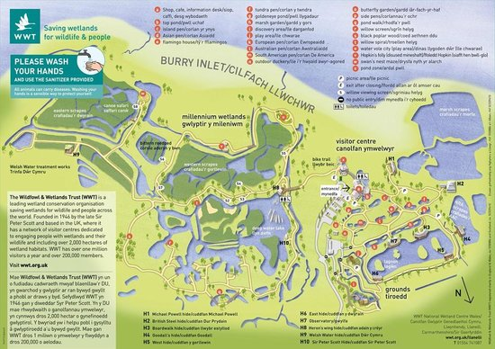
Llanelli Wetlands Centre
(Map of Llanelli WWT, 2019)

Formerly an expansive area of waste salt marshland and agricultural farmland, this area was founded by Sir Peter Scott and regenerated in 1984. It was created as a tourist attraction which has in turn set out to achieve and surpass its goal of becoming a location of high importance and interest for both local residents and visitors alike.
Sir Peter Scott believed that, ‘The most effective way to save the threatened natural world is to cause people to fall in love with it again, with its beauty and its reality’. (Scott, Our History, n.d.)
Having visited the Llanelli Wetlands Centre recently, it is apparent from the way in which it is designed, that the land that was formerly unused, is now a thriving multitude of habitats for numerous native species of bird and wildlife, a peaceful retreat where enthusiastic bird watchers and educational groups alike can congregate together to appreciate and value the significance and simplicity of nature and the extensive surrounding scenery. It is also home to many European and American species, which is a proven location for them to breed and multiply keeping the species’ numbers on a positive increase to prevent extinction. This site is a keen learning environment, not only for school and college groups, but is also stimulating and exciting for families to visit, particularly children as they have countless opportunities to feed and get up close to many species they would otherwise never be likely to encounter.
Being a primary conservation charity, the WWT claims that ‘sustainability means making the best of our resources while minimising our impacts on the environment and society’. (Sustainability, n.d.)
In conclusion, the development of the Wetlands Centre has had an increasingly positive effect on Llanelli and its area, as well as the conservation and breeding programmes that run and operate within the centre; this is a proven success story of regeneration for a previously struggling area of tourism.
Subsequently, we will observe how the Tata Group, focusing mostly on the Trostre Works site in Llanelli, has encouraged further growth of the town through its regeneration efforts.

Tata Steel Tinplate Works- Trostre
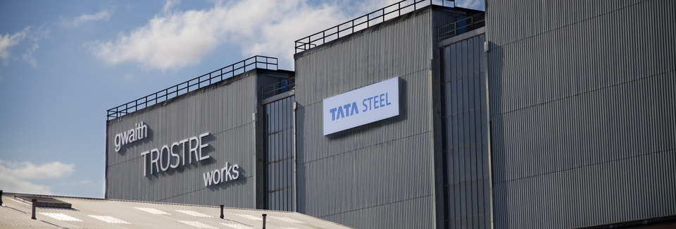
(Packaging Recycling, 2019)

On Tuesday 19th February, we had the greatest pleasure of receiving a lecture from a guest speaker, Nicola Jones, who currently works for Tata Steel in Trostre as a Packaging Recycling Manager.
‘Steel is a uniquely sustainable material because once made, it can be used, as steel, for ever’. (Steel for a sustainable future, 2019)
Nicola proceeded to explain to the group about the work that takes place in both the Port Talbot and Llanelli sites; and how this company has promoted and benefitted the area of Llanelli in which it resides as a whole.
In Llanelli, tinplate is mass produced for various companies, one of the most widely recognised and popular brand being Heinz, as well as Crown and DSC. Nicola then continued to describe in depth how the steel is produced and created in the first instance, and the processes involved in the production of this widely used material. Not only does Tata Steel manufacture tinplate; they are also responsible for creating ECCS and a polymer- coated steel named Protact.
At the main site in Port Talbot, Tata Steel is responsible for importing limestone, coal and iron from all over the world and then shipping it into their works to create steel coils. Steel that is collected from the kerbside across Wales by councils is all recycled and transformed into the coils that are produced there. (N. Jones, 2019)
Heat is pumped into the offices using recycled energy leftover from the steel making process; this is a primary example of the company using sustainable practices.
Tata Steel is inevitably a company who have succeeded greatly in regenerating areas of previous mass unemployment and unpopularity. Both sites in Port Talbot and Llanelli have undoubtedly generated much employment for the local residents of both counties and nearby towns, this being evident with a current UK employee figure of 8,500. (Tata Steel in the UK, 2017)
Conclusion
Following on from the information and research obtained within the main body of this report, it would appear that Llanelli as a whole has significantly expanded and prospered both economically, socially and ecologically from the creation of regenerated areas such as that of Llanelli Wetlands Centre and Tata Steel Trostre Tinplate Works.
The impact of the Industrial Revolution is one of historical importance when studying the history of the town and local area, There is an obvious link between Llanelli and its current state and how its coal mining past has shaped the culture and heritage that we see before us today.

References
Down a Coal Mine. (2019). Retrieved from https://www.google.com/search?q=llanelli+coal+mines&rlz=1C1CHZL_enGB814GB814&source=lnms&tbm=isch&sa=X&ved=0ahUKEwiyiKa07YThAhX1TxUIHYzgBiIQ_AUIDigB&biw=706&bih=620#imgrc=UbI84TKgN7ppSM:: https://www.google.com/search?q=llanelli+coal+mines&rlz=1C1CHZL_enGB814GB814&source=lnms&tbm=isch&sa=X&ved=0ahUKEwiyiKa07YThAhX1TxUIHYzgBiIQ_AUIDigB&biw=706&bih=620#imgrc=UbI84TKgN7ppSM:
John, L. (n.d.). The Inhabitants of Llanelli in 1847. Retrieved from https://www.llanellich.org.uk/files/371-llanelli-inhabitants-1847: https://www.llanellich.org.uk/files/371-llanelli-inhabitants-1847
Map of Llanelli WWT - TripAdvisor. (2019, March). Retrieved from https://www.tripadvisor.co.za/LocationPhotoDirectLink-g776264-d219276-i84359725-WWT_Llanelli-Llanelli_Carmarthenshire_Wales.html: https://www.tripadvisor.co.za/LocationPhotoDirectLink-g776264-d219276-i84359725-WWT_Llanelli-Llanelli_Carmarthenshire_Wales.html
Map of Llanelli WWT. (2019, March). Retrieved from https://www.tripadvisor.co.za/LocationPhotoDirectLink-g776264-d219276-i84359725-WWT_Llanelli-Llanelli_Carmarthenshire_Wales.html: https://www.tripadvisor.co.za/LocationPhotoDirectLink-g776264-d219276-i84359725-WWT_Llanelli-Llanelli_Carmarthenshire_Wales.html
Packaging Recycling. (2019). Retrieved from https://www.tatasteeleurope.com/en/sustainability/packaging%E2%80%93recycling: https://www.tatasteeleurope.com/en/sustainability/packaging%E2%80%93recycling

Scott, S. P. (n.d.). Our History. Retrieved from https://www.wwt.org.uk/who-we-are/our-history/: https://www.wwt.org.uk/who-we-are/our-history/
Steel for a sustainable future. (2019). Retrieved from https://www.tatasteeleurope.com/en/sustainability/steel%E2%80%93for%E2%80%93a%E2%80%93sustainable%E2%80%93future: https://www.tatasteeleurope.com/en/sustainability/steel%E2%80%93for%E2%80%93a%E2%80%93sustainable%E2%80%93future
Sustainability. (n.d.). Retrieved from https://www.wwt.org.uk/who-we-are/sustainability/: https://www.wwt.org.uk/who-we-are/sustainability/
Tata Steel in the UK. (2017). Retrieved from https://www.tatasteeleurope.com/static_files/Downloads/Corporate/News/tsukfactsheet.pdf: https://www.tatasteeleurope.com/static_files/Downloads/Corporate/News/tsukfactsheet.pdf
Hannam, J. (2019). Guest lecturer- Llanelli & the Industrial Revolution, January 29th , 2019.
Jones, Nicola. (2019). Guest lecturer- Tata Steel & Port Talbot Steelworks, February 19th, 2019.

