
Student: Ana Maria Elena Stanciu (1909953)
Lecturer: Edward Goka
Date: 10 December 2021

Principles of Health and Social Care Practice BMHP6009-Living with care: The older person
Do aging societies poses challenges for Health and Social Care systems?

Table of Contents
Introduction 2
Discussion 4
Current Government support for elderly population 5
Covid-19 Pandemic impact on elderly 5
Conclusion 6
Reference list 6
Appendix 8

Introduction

The greatest achievement of health care and science has increased the levels of life expectancy, therefore, diminishing the level of fertility (United Nations, 2020). Furthermore, United Nations (2020) suggests that in 2020 the were 727 million people 65 years old and over but most older people are comprised of women living longer, particularly at an advanced age. Yet by 2050 it is estimated that the number of older people worldwide will double, reaching over 1.5 billion as it is shown in Figure 1. (United Nations, 2020).

  - Figure 1.
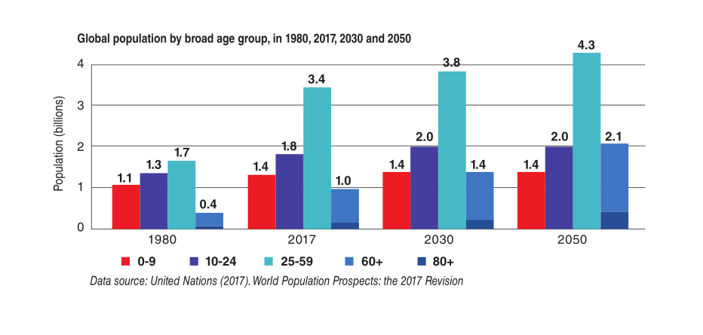
Source: https://global.chinadaily.com.cn/a/201904/09/WS5cabe02da3104842260b50cb.html.

In the UK according to the Office of National Statistics (2021), the population of the is 67.1 million of which 27% are aged between 40 and 59 years and 22% are 60 years old and over. Yet as it is shown in Figure 1. it is estimated that in 50 years the UK population will increase by 8.6 million people 65 years old, and over which is approximately the size of London and that will bring both opportunities and challenges for the economy, health services and society (Office for National Statistics, 2018).

  - Figure 2.

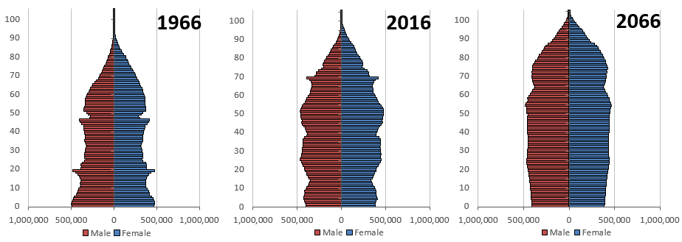
Source: https://www.ons.gov.uk/peoplepopulationandcommunity/birthsdeathsandmarriages/ageing/articles/livinglongerhowourpopulationischangingandwhyitmatters/2018-08-13.

Besides, this paper will support a debate on whether the Ageing population poses challenges for Health and Social Care in the UK. The following table describes the standing points of the two groups participating in the debate.

  - Table 1.

Ageing society poses challenges for Health and Social Care | Aging society do not pose a challenge to Health and Social Care
Insufficient funding’s to support aging population | Older people contribute to taxation
Insufficient staff to look after aging population | Working benefits of working at 65 years old and over
Aging individuals are more likely to suffer loneliness | Older people engagement in childcare overcome loneliness
Not enough suitable houses for elderly | Skills and experience
Elderly people are predisposed to increase morbidity | Volunteering keeps older people active
Older individuals are more likely to use 5 or more medications daily/polypharmacy | Technology advancement can overcome polypharmacy
More spending | Older people wisdom and knowledge/ vote

Discussion

As is shown in the above table group 1 has argued that ageing societies more than anything pose an economic challenge to Health and Social Care which is a standing argument looking at pensions, social care, housing, and well-being (Office of National Statistics, 2018). On the other hand, it can present opportunities both at the social and individual level such as working for longer in life, spending more time with the family providing care for grandchildren and other family members, community organisations and emergence different markets (Office of National Statistics, 2018).

Furthermore, the Department of Work and Pensions (2020) suggests that the standard age of the labour market has risen considerably in the last two decades reaching an increase of 3.1 years for women exiting work at 64.2 years old and an increase of 1.9 years for men exiting work at 65.2 years old. Likewise, that has increased the employment rate from 55.8% in 1984 to 72% in 2020 for those 50 years and older whereas for those 65 and older employment rate has increased from 4.9% in 1984 to 10.4% in 2020 approximately doubled which it means that older people are taxpayers.

As it turns out UK’s population is rapidly ageing, families have children later in life and not as many as before because families now are more complex (Grandparents plus, 2020.). Demographic changes are the main reason that families have fewer children nowadays but also the cost of living especially in the UK, as well as the cost of a nursery place for an under two years old, has increased to £8,684 yearly. Therefore, grandparents play an important role in childcare, being the single biggest source of childcare after the parents themselves. They not only help families economically by looking after the grandchildren and allow parents to return to work they also encourage them to have more than one child which is a very important factor considering the ageing population (Grandparents plus, 2020). Further, Grandparents plus (2020), suggests that more than half of the parents who are working studying and over are living their children in the care of grandparents.

After conducting a survey and consulting the UK Chief Economist report, Professor Jose Iparrguirre (2017), suggests that people aged 50 and over have contributed to the economy with 796 billion pounds of which 160 billion pounds were brought in by people over the age of 65. The employment contribution was 570 billion pounds with 54 billion pounds contributed from people aged 65 and over, every day added activities another 175 billion pounds, casual child supervision worth 7.7 billion pounds only from those 65 years old and over and volunteering represented another 43.4 billion pounds (Jose. I., 2017). All the above-mentioned figures illustrate how much an older individual can contribute to society and taxation but not only, these are examples of what society, and the government can do for older people to keep them active and going. Doing so brings an important contribution to Health and Social Care because an active individual is more likely to keep in good health, more unlikely to get diabetes, heart disease, some cancers, depression, and dementia (NHS, 2021).

Current Government support for elderly population

The UK Government has implemented policies and guidance’s that have the aim of helping older individuals stay productive such as, “Fuller Working Lives” published on 13 June 2014 and explains how older individuals can benefit from working longer as well as employment, community and economy, “A new vision for older workers”, published on 11 March 2015 and contains Dr Altmann’s recommendations on how to improve working lives of England's 50 and older and “Employer Toolkit”, containing guides to the management of older employees (Department for Work and Pensions, 2015).

Covid-19 Pandemic impact on elderly

Covid-19 came to be a matter of urgency in March 2020 affecting more older people. This brought “telehealth” into priority as a potential device to provide and monitor health services without the need of face-to-face communication with the patients (Fisk, M., Livingstone, A. and Pit, S. W., 2020). Coronaviruses had a major impact on the lives of thousands of older people not only in the UK but all over the world but the positive outcome of the pandemic “if it can be called that way” is telehealth, a tool designed for a short period. Proving efficiency in monitoring patients from a distance especially those elderly at risk of developing depression due to loneliness as well as a reminder of taking their medications and over it was adapted as a more permanent monitoring tool in the United Kingdom, the United States and Australia saving money and time for the National Health Services as well as for patients (Fisk, M., Livingstone, A. and Pit, S. W., 2020).

Conclusion

Finally, the older individuals should be seen for what they are, wise, caring ready to share their spare time helping family, community, and friends. The government should put in place policies and regulations that would give them greater opportunities as well as encourage them in childcare because children are the future and grandparents are the role models for our children.
Please find attached in the appendix power point slides of the debate which took place in classroom.

Reference list

- Department of Work and Pensions. (2020) Economic labour market status of individuals aged 50b and over, trends over time: September 2020. Available at: https://www.gov.uk/government/statistics/economic-labour-market-status-of-individuals-aged-50-and-over-trends-over-time-september-2020/economic-labour-market-status-of-individuals-aged-50-and-over-trends-over-time-september-2020. (Accessed: 8 December 2021).

- Department for Work and Pensions. (2015) 2010 to 2015 government policy: older people. Available at: https://www.gov.uk/government/publications/2010-to-2015-government-policy-older-people/2010-to-2015-government-policy-older-people#actions. (Accessed: 9 December 2021).
- Fisk, M., Livingstone, A. and Pit, S. W. (2020) ‘Telehealth in the context of COVID-19: changing Perspectives in Australia, the United Kingdom and the United States’, JMIR Publications, 22(6).
- Grandparents plus. (2020) Rethinking Family Life: exploring the role of grandparents and the wider family. Available at: https://www.equallyours.org.uk/wp-content/uploads/2009/03/gpreport-web-version.pdf. (Accessed: 24 November 2021).
- Government Office for Science. (2016) Future of an aging Population. Available at: https://assets.publishing.service.gov.uk/government/uploads/system/uploads/attachment_data/file/816458/future-of-an-ageing-population.pdf (Accessed: 7 December 2021).
- Jose., I. (2017) The Economic Contribution of Older People in the United Kingdom – An Update to 2017. Available at: https://www.ageuk.org.uk/globalassets/age-uk/documents/reports-and-publications/reports-and-briefings/active-communities/the_economic_contribution_of_older_-people_-update_-to_-2017.pdf . (Accessed: 17 November 2021).
- Office for National Statistics. (2018) Living longer: how our population is changing and why it matters. Available at: https://www.ons.gov.uk/peoplepopulationandcommunity/birthsdeathsandmarriages/ageing/articles/livinglongerhowourpopulationischangingandwhyitmatters/2018-08-13 (Accessed: 7 December 2021).
- United Nations. (2020) World Population Aging 2020. Available at: https://www.un.org/development/desa/pd/sites/www.un.org.development.desa.pd/files/undesa_pd-2020_world_population_ageing_highlights.pdf. (Accessed: 8 December 2021).

Appendix

