Nasir Hossain
student ID: 2211492
teacher name: christian felicas
uwtsd - university of wales trinity saint davies
learning in the digital era / e – portfolio

Learning in the Digital Era
1
Table of Contents
Introduction..................................................................................................................................... 3 1. Produce a ‘report’ template document........................................................................................ 4 1.1 Justification and Statement of Report Template ................................................................... 4 1.3 References............................................................................................................................. 5 2. Academic writing........................................................................................................................ 6 2.1 Definition of Academic Writing ........................................................................................... 6 2.2 Importance of Academic writing .......................................................................................... 6 2.3 References............................................................................................................................. 7 2.4 Explanation of Similarity Score............................................................................................ 7 3. Importance of Critical Analysis. ................................................................................................. 8 3.1 Critical Analysis.................................................................................................................... 8 3.2 Understanding of Critical Analysis and how it enhances the quality of work produced...... 8 3.3 References............................................................................................................................. 9 4. 2-minute video on Sense of Place and identity......................................................................... 10 Conclusion .................................................................................................................................... 14 References..................................................................................................................................... 15
2
Introduction
Digital technologies are used in the educational organisation to help the students learn from various sources. The technologies are used as the resources and communication which can be adapted for various reasons. The students are using technologies to improve their academic performance and learning for better outcome. This report will focus on discussing different aspects of academic writing and learning in the educational organisation.
3
1. Produce a ‘report’ template document.
1.1 Justification and Statement of Report Template
An electronic portfolio represents the collection of electronic evidence, data and information assembled and managed by a use for any document or purpose (Vandermeulen et al., 2020). Such electronic evidence can be added in nature of image, content or image or video. For the completion of the study, the template is followed where heading and sub sections are needed to be included. To work on the report, different sections are followed such as content or title of the report, introduction, main findings and conclusion, and references.
Introduction
Introduction section of the report helps the researcher to right about purpose and aim of the report. In the first section of the research paper/report, the researcher will be able to indicate the specific page elements, required content and information which are needed to be inserted and managed for standard professional piece of paper (Hodnett et al., 2022).
Main findings
Finding and discussion section allows the students to discuss the data and content of the paper under different heading and subheading. The heading will represent the content of the study and sub-headings will represent the concepts or aspects which are broken down for assessing the main content. The sub headings can help the students to discuss different issues clearly and deeply for assessing the aim of the content of the study (Rezai et al., 2022). The student can easily break down any issue and content into different pieces and can discuss them separately while engaging the whole writings in the main findings. Hence, this template will be followed for this study.
Conclusion
The conclusion section of the paper represents the key findings and summary of the research study. Also, the researcher can easily state how the aims and objectives of the study are achieved and what recommendations should be provided for the study.
4
1.3 References
Hodnett, R., MacCormick, A., Ibrahim, R., Miles, G., Puckett, M. and Aroori, S., 2022. Use of a standardized reporting template: can we improve report quality in pancreatic and peri‐ampullary malignancy?. ANZ Journal of Surgery, 92(1-2), pp.109-113.
Rezai, A., Namaziandost, E. and Rahimi, S., 2022. Developmental Potential of Self-Assessment Reports for High School Students' Writing Skills: A Qualitative Study. Teaching English as a Second Language Quarterly (Formerly Journal of Teaching Language Skills), 41(2), pp.163-203.
Vandermeulen, N., Leijten, M. and Van Waes, L., 2020. Reporting writing process feedback in the classroom using keystroke logging data to reflect on writing processes. Journal of Writing Research, 12(1), pp.109-139.
5
2. Academic writing.
2.1 Definition of Academic Writing
Academic writing represents the formal style of writing in the educational organisations, mostly for the university, journal writing and scholarly publications (Dall’Igna and Moritz, 2019). Academic writing helps students to express their view and understanding within a professional manner.
2.2 Importance of Academic writing
Every student is expected to work on their academic writing skills. Post-graduate students should work on academic writing skills (Medvid and Podolkova, 2019). The students are supposed to work on academic writing skills to express the knowledge through writing even better. Also, in the case of effective writing, academic writing skills are needed for the students where they can analyse the structure and apply the approaches. The application of academic writing skills and abilities can help the students to apply different structures, sentence making and processes (Medvid and Podolkova, 2019). Also, the students can link the information and manage the template and writing to express their view or perspectives.
The development of higher education student’s writing skills and literacy has always been a concerned of researchers. The management of academic writing skills is required for the students as they need to learn different and specific forms of acting in the academic context (Dall’Igna and Moritz, 2019). The importance of academic writing in higher education is higher for the students as they can represent their learning and information in a professional manner. Hence, the students are always encouraged to work on academic writing skills and abilities for academic performance and better writing based on their idea and knowledge.
Academic writing practices and abilities help students to learn about the disciplines. The students can meet the expectations and requirement of their academic communities while gaining learning academic writing (Yuvayapan and Bilginer, 2020). The students need to work on their academic writing skills which can be developed by the teachers in the educational organisation.
6
2.3 References
Dall’Igna, C. and Moritz, M.E.W., 2019. Academic writing in higher education: focusing on courses of graduate programs of a public Brazilian university. Revista Linguagem & Ensino, 22(3), pp.577-594.
Medvid, O. and Podolkova, S., 2019. Essay as a form of academic writing. Edukacyjna Analiza Transakcyjna, (8), pp.215-225.
Yuvayapan, F. and Bilginer, H., 2020. Identifying the needs of postgraduate students: The first step of academic writing courses. Journal of Language and Linguistic Studies, 16(2), pp.595-611.
2.4 Explanation of Similarity Score
The students can deal with the issues of similarity while writing on any issue. It is important for the students to work on an original study for enhancing their ability to write any content. I have assessed the similarity score of my writing and I have found that my references have similarities due to the collection of references from the technology sources. In some cases, the similarity score can be higher. In that case, the student should work on their writing skills while not copying or paraphrasing any sentences. Practice and learning can help in reducing the similarity in writing as well.
7
3. Importance of Critical Analysis.
3.1 Critical Analysis
A critical analysis represents the subjective writing and analysis of any data because it expresses the judgment, writer's opinion, assessment and evaluation of a text in a document (Kayaalp et al., 2020). Analysis in writing means breaking down the data, studying the parts and analyzing the issues in the parts while considering the strengths and weaknesses of the writing. Writing a critical paper helps the students to focus on two aspects such as critical reading and critical writing
(Shahsavar and Kourepaz, 2020). A critically analysis of an article or journal represents the judgment of the individual for assessing and evaluating the overall worth and effectiveness of the paper.
3.2 Understanding of Critical Analysis and how it enhances the quality of work produced.
Critical analysis helps any individual to maintain the detailed examination and evaluation of another person's writing, ideas and work (Ahmed and Asraf, 2018). The students are encouraged to work on critical analysis skills and abilities to express the interpretation and analysis of the work. In any writing, the writer may have their own point of view and bias which influence the quality and writing of the issues. Higher bias and poor knowledge can affect the quality of writing and interpretation of the data (Kayaalp et al., 2020). In this situation, the application of critical analysis can contribute to proper writing and the development of the quality in own work. In different situations, the students/individual applies critical analysis in any writing. They can use critical analysis, both reading and writing in other’s work or they can apply critical analysis in their own work (Shahsavar and Kourepaz, 2020). In both cases, critical analysis can help the individuals to develop their skills and knowledge for academic writing and analysis of writing as well. The reflection, argument, debate, and development of ideas (Ahmed and Asraf, 2018). Hence, the usages of critical analysis contribute to the quality of work and writing of the individual which also connects other skills and knowledge of the people.
8
3.3 References
Ahmed, S. and Asraf, R.M., 2018. The workshop as a qualitative research approach: lessons learnt from a “critical thinking through writing” workshop. The Turkish Online Journal of Design, Art and Communication, 2018, pp.1504-1510.
Kayaalp, F., Meral, E., Şimşek, U. and Şahin, İ.F., 2020. A search for a method to improve critical thinking skills in social studies teaching: Writing-to-learn. Review of International Geographical Education Online, 10(3), pp.400-430.
Shahsavar, Z. and Kourepaz, H., 2020. Postgraduate students’ difficulties in writing their theses literature review. Cogent Education, 7(1), p.1784620.
9
4. 2-minute video on Sense of Place and identity.
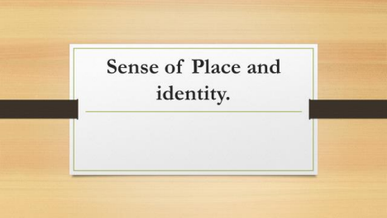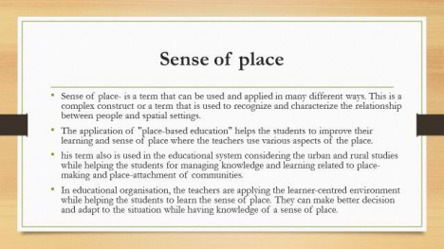10

Video LINK: https://uowtsd-my.sharepoint.com/:v:/g/personal/2211492_student_uwtsd_ac_uk/EZ0N-o0ClB5AjJLe_LexA68BMlpLSZQH6aJGs9qegddOTw?e=ZQ0Gex

Sense of place
Sense of place- is a term that can be used and applied in many different ways. This is a complex construct or a term that is used to recognize and characterize the relationship between people and spatial settings (Griffiths et al., 2018). This represents the nature, element and characteristic that some geographic location can have or some would not. In the meantime, teachers and educational organisation use this term for helping any student’s learning and their activities for coping with the environment (Nordbäck et al., 2022). The application of "place-based education" helps the students to improve their learning and sense of place where the teachers use various aspects of the place. This term also is used in the educational system considering the urban and rural studies while helping the students for managing knowledge and learning related to place-making and place-attachment of communities (Peng et al., 2020). The sense of place helps the individual in the society or community to assess and describe how someone perceives, assesses, and experiences a place or environment or the location they live or are surrounded.
In educational organisation, the teachers are applying the learner-centred environment while helping the students to learn the sense of place (Griffiths et al., 2018). They can make better decision and adapt to the situation while having knowledge of a sense of place. Hence, this has been necessary for the students to learn the sense of place and cope with the situation in order to make better decision and actions in the future. These can help the students to be more careful and positive to the situation, whether it is in teamwork or career (Nordbäck et al., 2022). Also, the students can work on their skills and experiences while gaining knowledge of a sense of place in their studies and activities.
11
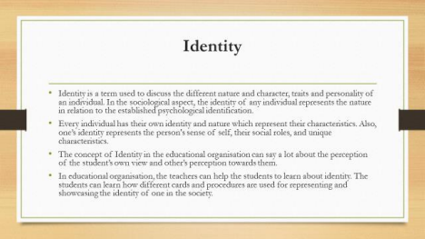Identity
Identity is a term used to discuss the different nature and character, traits and personality of an individual (Peng et al., 2020). In the sociological aspect, the identity of any individual represents the nature in relation to the established psychological identification. Every individual has their own identity and nature which represent their characteristics. Also, one’s identity represents the person's sense of self, their social roles, and unique characteristics (Griffiths et al., 2018). Moreover, the identity of any individual can be the same under different changes and circumstances as well. The concept of Identity in the educational organisation can say a lot about the perception of the student’s own view and other’s perception towards them (Nordbäck et al., 2022).
In educational organisation, the teachers can help the students to learn about identity. The students can learn how different cards and procedures are used for representing and showcasing the identity of one in the society. Academic identity has been defined and discussed how people see one individual’s academic domain (Peng et al., 2020). Academic identity of the student can affect their ways to learn in the school environment.
12
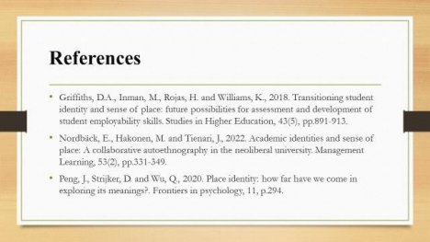References
Griffiths, D.A., Inman, M., Rojas, H. and Williams, K., 2018. Transitioning student identity and sense of place: future possibilities for assessment and development of student employability skills. Studies in Higher Education, 43(5), pp.891-913.
Nordbäck, E., Hakonen, M. and Tienari, J., 2022. Academic identities and sense of place: A collaborative autoethnography in the neoliberal university. Management Learning, 53(2), pp.331- 349.
Peng, J., Strijker, D. and Wu, Q., 2020. Place identity: how far have we come in exploring its meanings?. Frontiers in psychology, 11, p.294.
13
Conclusion
Every student has to work on their academic writing and reading skills which can contribute better academic performance and activity. The development of e-portfolio, writing and critical analysis skills can help the students to perform better and manage their own and effective writing. In the future career, they can easily apply the knowledge and perform their best as well.
14
References
Ahmed, S. and Asraf, R.M., 2018. The workshop as a qualitative research approach: lessons learnt from a “critical thinking through writing” workshop. The Turkish Online Journal of Design, Art and Communication, 2018, pp.1504-1510.
Dall’Igna, C. and Moritz, M.E.W., 2019. Academic writing in higher education: focusing on courses of graduate programs of a public Brazilian university. Revista Linguagem & Ensino, 22(3), pp.577-594.
Griffiths, D.A., Inman, M., Rojas, H. and Williams, K., 2018. Transitioning student identity and sense of place: future possibilities for assessment and development of student employability skills. Studies in Higher Education, 43(5), pp.891-913.
Hodnett, R., MacCormick, A., Ibrahim, R., Miles, G., Puckett, M. and Aroori, S., 2022. Use of a standardized reporting template: can we improve report quality in pancreatic and peri‐ampullary malignancy?. ANZ Journal of Surgery, 92(1-2), pp.109-113.
Kayaalp, F., Meral, E., Şimşek, U. and Şahin, İ.F., 2020. A search for a method to improve critical thinking skills in social studies teaching: Writing-to-learn. Review of International Geographical Education Online, 10(3), pp.400-430.
Medvid, O. and Podolkova, S., 2019. Essay as a form of academic writing. Edukacyjna Analiza Transakcyjna, (8), pp.215-225.
Nordbäck, E., Hakonen, M. and Tienari, J., 2022. Academic identities and sense of place: A collaborative autoethnography in the neoliberal university. Management Learning, 53(2), pp.331- 349.
Peng, J., Strijker, D. and Wu, Q., 2020. Place identity: how far have we come in exploring its meanings?. Frontiers in psychology, 11, p.294.
15
Rezai, A., Namaziandost, E. and Rahimi, S., 2022. Developmental Potential of Self-Assessment mSecond Language Quarterly (Formerly Journal of Teaching Language Skills), 41(2), pp.163-203.
Shahsavar, Z. and Kourepaz, H., 2020. Postgraduate students’ difficulties in writing their theses literature review. Cogent Education, 7(1), p.1784620.
Vandermeulen, N., Leijten, M. and Van Waes, L., 2020. Reporting writing process feedback in the classroom using keystroke logging data to reflect on writing processes. Journal of Writing Research, 12(1), pp.109-139.
Yuvayapan, F. and Bilginer, H., 2020. Identifying the needs of postgraduate students: The first step of academic writing courses. Journal of Language and Linguistic Studies, 16(2), pp.595-611.
16

