Student Name: Morgan Watkins
Student Number: 2316680
Programme of Study: BA Illustration
Module: ADAD5004 Research in Practice
Word Count: 2511
Tutor Name: Delyth Lloyd-Evans
Three Keywords: Value, Composition, Colour

How does value, composition, and colour contribute to effective visual communication in concept art?

This proposal aims to explore how, in a line of work where the goal is to effectively and efficiently communicate visual ideas, the principles of value, composition, and colour are vital tools. These three core fundamentals serve not only to create visually pleasing designs, but also to guide the viewers eye, convey narrative intent, and establish specific moods and themes. In the pages to follow I will explore how within concept art value, composition, and colour contribute enormously to successful visual communication, delving into the works of theorists such as Harold Speed, Rudolf Arnheim, and Johannes Ittens to support my claims. Through both historical and modern perspectives, this proposal will examine how these three fundamentals have and continue to shape narrative, visual storytelling, and artistic decisions in concept art.

Firstly, it is important to discuss value, which is one of the fundamentals of art and can be described as the lightness or darkness of a colour, often measured in black and white. Value is the first and most important consideration for every artwork, as explained by Charlie Pickard (Pickard, 2021, page 16). While talking about a famous checkerboard pattern illusion by neuroscientist Edward Adelson (2021, page 20), Pickard goes on to elucidate how colours will take on some of the value opposing their surroundings, which tells us that before colour can be introduced to a piece of art, the values first have to be sound enough in their surroundings for everything to work together. This can be reinforced by Rudolph Arnheim, who after talking about other aspects of the fundamentals of art states that “a discussion of light should have preceded all others, for without light the eyes can observe no shape, no color, no space or movement.” (Arnheim, 1974, page 303). However, we as artists will never truly be able to replicate the range of values as seen in the natural world, in fact not even our eyes can withstand the immense range – we can’t look at most light sources as they are too bright, neither can we see if light levels are too low. Humans could never create paints that come close to these two extremities. This issue can be solved with an imaginative gradient scale, however, as explained by Harold Speed (1873, page 187), where Speed discusses how all the masses and tones that go into creating value can be depicted by an imagined scale from white to black (white being used for the lightest tones and black being the darkest). This scale of values does not refer to light and shade only but also colour and the whole visual impression. The colour of the overall artwork will depend on the value used to represent it; therefore, value plays a crucial role in forming the backbone of any artwork (see fig. 1)

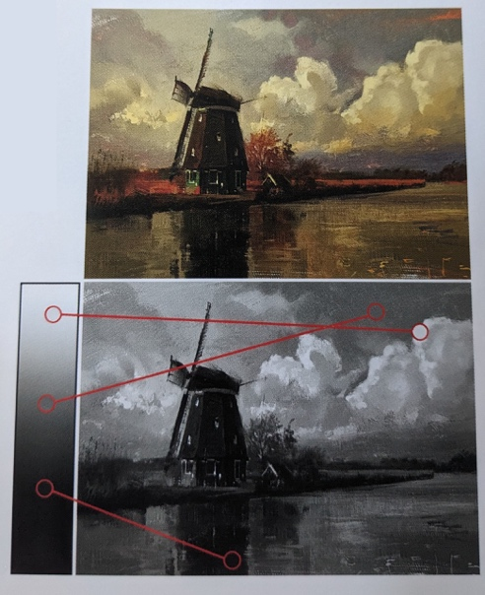
Fig. 1: Study 20 (Rutkowski, 2023).

So how, then, does this apply to concept art? When you begin with a blank canvas, it is common to try to represent what we see with lines. However, in nature, there are no lines depicting form. Rather, it is simply varying shapes of colour, which as we discussed earlier can be broken down into basic values of shadow and light. Using this as a starting point, whether it be for environmental concepts, character design, etc, values can be used to create shapes and edges and establish composition. When it comes to composition, value plays a crucial role, as explained by Greg Rutkowski. Rutkowski demonstrates that using an increased range of values can help make a painting more dynamic, and helps bring focus to certain areas of interest (2023, page 37). Looking at an example Rutkowski displays, it is clear that values can change the mood of a scene depending on the range used (see fig. 2). This is extremely important within concept art as the mood of a painting can directly influence how the viewer perceives and connects with the artwork.

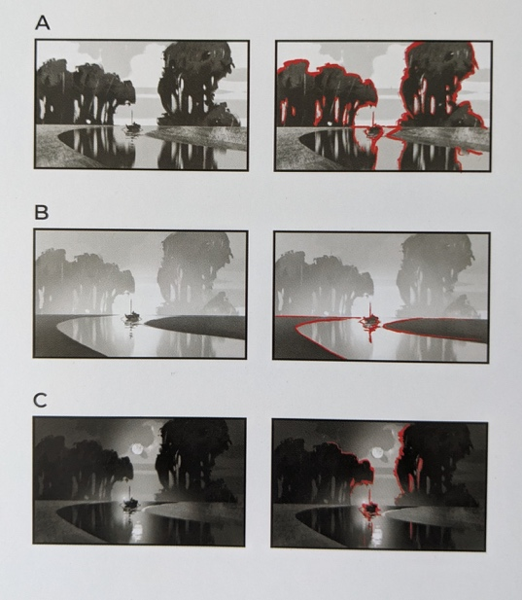
Fig 2: (Rutkowski, 2023).

The beauty of values is that not every artist needs to use them in the same way. For example, looking at the study I conducted on three different artists; Nathan Fowkes, Joshua Clare, and Devin Elle Kurtz (see fig. 3), one can clearly see that an artist doesn’t always need to use values in the same way in order to portray light, form, and shape. Clare only uses roughly the top half of the value gradient which results in a softer painting, whereas Fowkes and Kurtz uses a much broader range of values (Fowkes using about three quarters and Kurtz utilising the whole scale). This produces a much more dramatic and dynamic painting. However, with all three paintings, they have all focused their darkest values within the paintings’ focal point, which as discussed previously draws the attention of the viewer to that specific area first. This, in conclusion, demonstrates my argument of value being an essential first step in portraying form, colour, and composition within not only concept art, but all mediums of art, as without value a painting will lack depth, realism, and a focal point - confusing the viewer and thus not creating an effective piece of work.

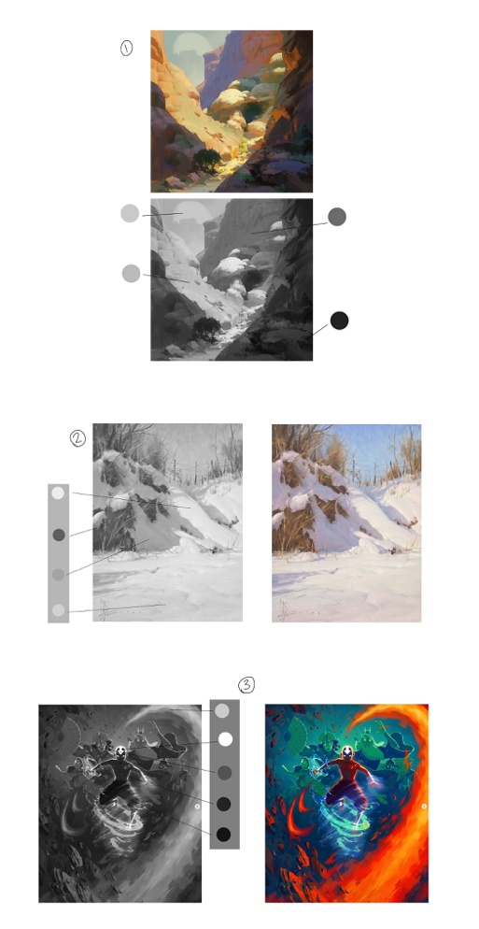
Fig. 3: Top – (Fowkes, 2023)
Middle – Ditchbank (Clare, n.d.)
Bottom – Avatar State (Kurtz, 2024).

So once a concept artist has all their values determined, what next? This is where composition comes into play. As explained by Rutkowski (2023, page 10) composition is the placement of figures, shapes, lines, and objects in a specific order. This order draws a viewer’s eye and focuses on the main elements of a piece of art. There are many different methods of placement, such as the golden ratio, the Fibonacci spiral, and the rule of thirds, all of which have been commonly used throughout history by artists such as Leonardo Da Vinci, Raphael, Aelbert Cuyp, and Solomon J. Solomon (see fig. 4). To quote Henry Rankin Poore;

Composition is the mortar of the wall, as drawing and color are its rocks of defence. Without it the stones are of little value, and are but separate integrals having no unity
(Poore, H. R, 1903, page 18).

What Poore argues here is that a piece of artwork without composition is merely just an image of no value, as no composition results in a lack of visual hierarchy which is essential for guiding the viewers’ eyes through the artwork. This can lead to confusion and disinterest, and, as explained by Elliot Lilly (2015, page 23), all it takes as a concept artist is for the right person to say ‘I don’t get it’ for your idea to be dead and pushed aside. Therefore, composition within concept art is an essential stage within the production of artwork.

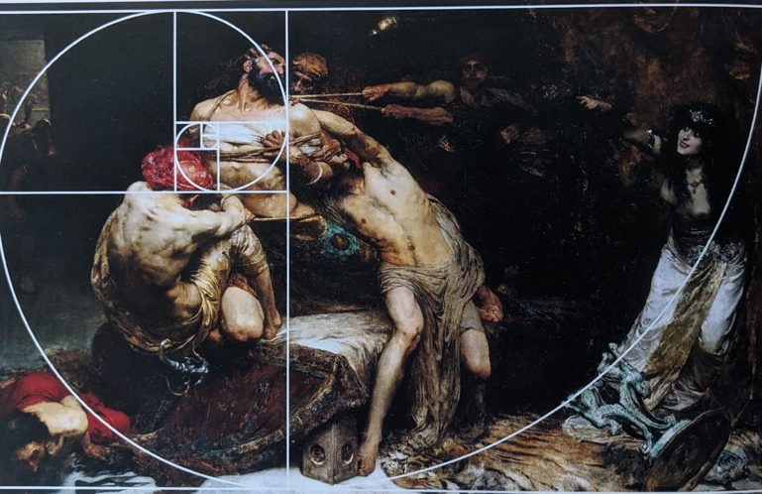
Fig. 4: The Fibonacci Spiral within ‘Samson’ (Solomon, 1897).

While traditional composition layouts have long guided creative individuals, many artists opt for more intuitive or expressive approaches, and although classical grids such as the rule of thirds remain influential, they are by no means universally followed. As observed by Rutkowski (2023, page 24), we as artists can use other elements such as shape, rhythm, perspective, scale, contrast, and texture to influence composition. There are, however, some who argue in strong favour to adhering to traditional compositional rules, whereas most modern educators are more in favour of promoting flexibility. Poore, for example, strongly advocates for foundational geometric arrangements, declaring that successful composition relies on structure, visual logic, and rhythm. Similarly, Charles Blanc (1867) believes that beauty in art stems from proportion and order, especially through geometry. Blanc’s theories enforce the idea that composition is a science, where the success depends on symmetry, structural precision, and balance. Whereas if we turn to modern artists such as Nathan Fowkes, we can observe a lot more fluidity and flexibility. Fowkes especially believes that the sole purpose of composition is to guide the viewers eye through the story, prioritising elements such as mood, visual hierarchy, and clarity of message over rigid adherence to classical composition rules. Within an online lecture, Fowkes (n.d.) states that “if the value structure doesn’t work in thumbnail, it won’t work full-size,” emphasising the importance of early compositional planning. Despite the fact that he acknowledges the importance of classical composition such as the rule of thirds, he doesn’t treat them as rules, more as starting points to build upon. To quote him from his online lecture;

Use the rule of thirds when it works. Break it when it doesn’t

(Fowkes, n.d.).

From this quote it is clearly discernible that he supports a more instinctive and goal-driven composition method. To summarise this argument, although traditional rules offer useful guidance and a base to build upon, the demands of modern digital and concept art often call for more flexibility than they are able to provide. The deviation between classical and contemporary stances on composition reflects a clear evolution in artistic priorities, highlighting the importance of adaptive and purpose-driven design approaches. Especially in the context of concept art, a more intuitive approach proves essential as narrative and atmosphere often takes precedence.

Finally, once values and composition have been established, colour can come into play. In Johannes Ittens’ own words, “Color is life; for a world without colors appears to us as dead.” (Ittens, 1961, page 13). To elaborate, colour isn’t just a visual component. It is an essential part in how we view the world around us. By describing a colourless world as ‘dead’, Itten underlines how deeply colour is rooted in our sensory and psychological engagement with life itself. This point of view perfectly aligns with how artists, especially in concept art, use colour in a way that brings imagined worlds to life, evoking specific moods and responses from the viewer. The way colour represents mood can be demonstrated within Claude Monet’s painting of Rouen Cathedral (see figure 5). Monet painted the same subject in very similar angles, however at two different times of day, both with different colour palettes. One can immediately see the difference that warmer colours including yellows and oranges, and cooler colours such as blues, can make. As described by Faber Birren (1950, page 141), warmer colours tend to be more exciting, lively, and energising, whereas cooler colours such as blue evoke feelings of calmness, perhaps even sadness and tragedy. This must be considered when depicting mood within a piece of art, as a painting meaning to depict joy and excitement will most certainly have the opposite effect if painted in purples or blues.

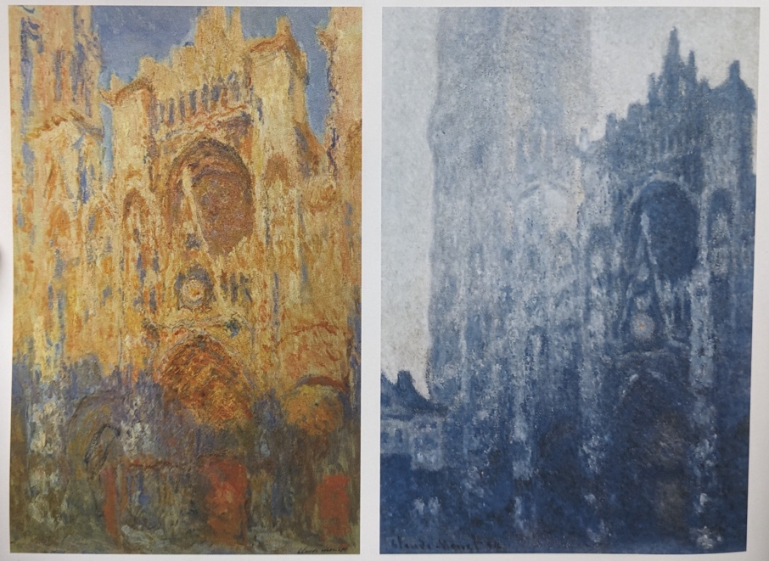
Fig. 5: Left – Rouen Cathedral. Façade (Sunset) (Monet, 1892).
Right – Rouen Cathedral (Monet, 1893).

Unfortunately for a lot of new artists, colour can appear a very daunting task, what with colour theory being one of the fundamentals of art it plays such a huge role and it being so complicated can put a lot of beginners off. Luckily, there are a few core structures that beginner and master artists alike both follow. According to Pickard (2021, page 13), the most helpful guide was created by the nineteenth century artist and colour theorist Albert Henry Munsell (1858-1918). To directly quote Pickard, “Munsell conceptualised color as a physical shape consisting of three dimensions: hue, value, and chroma.” (Pickard, page 13, 2021). To elaborate on this, hue is described as essentially the position of the color on a rainbow or spectrum, for example whether it’s red or blue. Value, as discussed previously, is essentially a colours brightness or darkness measured on a scale from black to white. Lastly, chroma is a colours intensity as measured from a neutral grey (see fig. 6). Now knowing these three dimensions, Munsell visualised them together as ‘tree of colour’, with the central trunk being ten steps of value from black to white. This trunk then expands out in each direction in ‘branches’ of hue (ten steps) and chroma (fourteen steps). This visualisation and structure allows artists to identify individual colours numerically by their position on the tree trunk. According to Art Meets Science (n.d) it was also the first system to accurately organise all colour perceptions, and unlike earlier colour theorists such as Johann Wolfgang von Goethe (1749-1832) who focused more on the psychological effects of colour, Munsell took a more scientific and rigorous approach and built upon the work of his predecessor, Sir Isaac Newton (1643-1727), whom arranged colours within a wheel. Munsell aimed to create a precise communication system which is still widely used today.

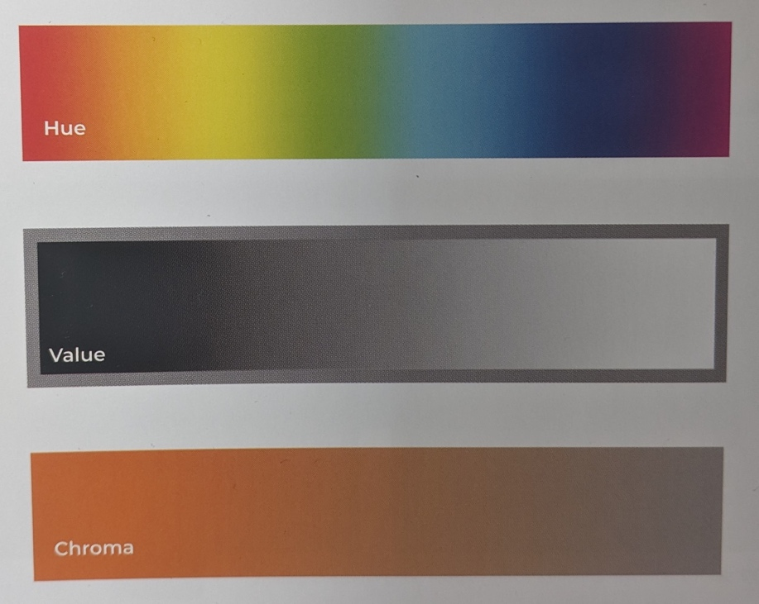
Fig. 6: Munsell’s three dimensions of colour – hue, value, and chroma. (n.d).

To conclude this section, colour is more than just a decorative feature. It is the backbone to communicating emotion and atmosphere, and in digital art where storytelling and first impressions are crucial, understanding at least the basics of colour psychology and structure is vital. Munsell’s colour theory provides a practical framework for controlling colour with precision, offering both balance and emotional intent and allowing artists, both traditional and digital, to work much more intuitively and effectively with colour.

The pages presented set out to examine how the principles of value, composition, and colour play a vital role within concept art and how they form the underlining structure to successful visual communication in regard to portraying setting, mood, and visual hierarchy in concept designs. Value establishes the hierarchy and creates depth within a painting, composition guides the viewers eye throughout the story and narrative and establishes key focal points, and colour sets the scene for portraying mood, emotion, and setting. These three key factors, when working together harmoniously, greatly strengthen the impact of a visual idea – which is clearly demonstrated in the work of concept artist Nathan Fowkes, who combines strong value contrast, stable compositional flow, and ingeniously chosen colour palettes to create captivating narrative designs (see fig. 7). On the contrary, when these three factors are out of balance – for example overly saturated colours combined with unthoughtful value placement, the emotional intent and clarity of the artwork can be completely lost, resulting in a hard to read mess. Ultimately, value, composition, and colour do not function as well in isolation – they rely heavily on each other to bring forth impact, clarity, and mood within concept art.


Fig. 7: Raya And The Last Dragon (Fowkes, 2023).

Having been inspired by key theorists such as Harold Speed, Rudolf Arnheim, and Johannes Ittens, and by successful industry professionals such as Nathan Fowkes and Devin Elle Kurtz, I plan to combine these three elements for myself in the form of a visual development portfolio for a video game, which will include concepts of environment art and character design containing, but not limited to, mood boards, colour palettes, and cultural themes, and create a captivating narrative and synopsis which will demonstrate emotion, theme, and mood, of which I will carefully and intently portray through value, composition, and colour. By doing this, I aim to explore how these three fundamentals contribute to effective visual communication within concept art. This project will not only give me an insight into the career I want to go into but also push me to further improve the skills necessary to work as a concept artist within the video game industry.

Bibliography

- Arnheim, R. (1974) Art and Visual Perception. Berkeley: University of California Press.
- Art Meets Science (n.d.). Munsell’s Colour System: The Enduring Legacy of Colour Theory, Science, and Art. Available at: https://www.artmeetsscience.co/munsells-colour-system/?srsltid=AfmBOopirNWfVwoPtNDkOyOGzkYY65Ybv10FyX8qIzCKBf3sG-4vPkLG (Accessed: 21 July 2025).

- Blanc, C. (1867) Grammaire Des Arts Du Dessin: Architecture, Sculpture, Peinture. Paris: Joules Renouard.

- Birren, F. (1950) Colour Psychology and Colour Therapy; a Factual Study of the Influence of Colour on Human Life. New York: McGraw-Hill Book Company.

- Clare, J. (n.d.) Ditchbank. Available at: https://www.joshclare.com/recentwork?pgid=kdq9en9l-137c0364-df9d-4450-9ea8-54c7fc30f33c (Accesed: 9 July 2025).

- Fowkes, N. (n.d.) Pictorial Composition. [online lecture] Schoolism. Available at: https://schoolism.com/courses/concept-art/pictorial-composition-nathan-fowkes (Accessed: 9 July 2025).

- Fowkes, N. (2023) [Digital Painting]. Available at: https://www.instagram.com/p/CymDLMLSFLx/?hl=en (Accessed: 9 July 2025).

- Fowkes, N. (2023) Raya and the Last Dragon [Digital Painting]. Available at: http://www.nathanfowkesart.com/ (Accessed: 21 July 2025).

- Ittens, J. (1961) The Art of Colour. Ravensburg: Reinhold Publishing Corporation.

- Kurtz, D. E. (2024) Avatar State. Available at: https://www.instagram.com/p/C3GZl7tPgD2/?hl=en (Accessed: 9 July 2025).

- Lilly, E. (2015) The Big Bad World of Concept Art for Video Games: An Insider’s Guide for Students. Culver City: Design Studio Press.

- Monet, C. (1892) Rouen Cathedral Façade (Sunset). Available at: https://commons.wikimedia.org/wiki/File:Claude_Monet_-_Rouen_Cathedral%2C_Facade_%28Sunset%29.JPG (Accessed: 9 July 2025).

- Monet, C. (1893) Rouen Cathedral. Available at: https://artsandculture.google.com/story/monet-s-rouen-painting-series-the-national-gallery-london/2gXhjhmKqfavLg?hl=en (Accessed: 9 July 2025).

- Pickard, C. (2021) Artists’ Master Series Color & Light. Worcester: 3dtotal Publishing.

- Poore, H. R. (1903) Pictorial Composition and the Critical Judgement of Pictures. New York City: G.P. Putnam’s Sons.

- Rutkowski, G. (2023) Artists’ Master Series Composition & Narrative. Worcester: 3dtotal Publishing.

- Rutkowski, G. (2023) Study 20. Artists’ Master Series Composition & Narrative. Worcester: 3dtotal Publishing.

- Solomon, S. J. (1897) Samson. Available at: https://artsandculture.google.com/asset/samson-solomon-j-solomon/6AFRiIReWUH60g?hl=en (Accessed 9 July 2025).

- Speed, H. (1873) The Practise and Science of Drawing. London: Seeley Service & Co.

