
Student Name: Shantel silvera

Student Number: 1808386

Module No: BMSK4003

Module Title: Digital Skills and Research Methods

Module Lecturer’s Name: Joy Botu

Course Name: Certificate of Higher Education in Skills for the Workplace

Level: Level 4

Term/Group: Term 2/Group 5

Year: 2019

Digital Skills & Research Methods
Term-2

Topic:
Free early year funding for working families

Contents page

Introduction……………………………………………………………………. Page 4
Literature review, free early year funding for working families….……………. Page 5
Research Methodology………………………………………………….……… Page 6,7
Data collection Process…………………………...……………………………. Page 8
Analysis, Findings and Discussions…………………………………….……… Page 8,9,10
Limitation of study………………………………………………………………Page 11
Recommendation for the future Research………………………………………. page 11
Ethical Consideration of Research ……………………………………………. Page 12
Conclusion………………………………………………………………………Page 12
References………………………………………………………………………Page 13

Introduction

The purpose of this assignment is to discuss about free early years funding for working class families. And to research what kinds of help the government offers and how effective will it be in the durations for working class families, present and future. This report aims is to present understanding of research methodology in Qualitative and Quantitative data in which will be used in a servery asked by the members of the public. Analysis and findings will be demonstrated through bar charts showing the results to the conclusion. The questions will be aimed about my topic using research methodology and data collection process. Also evaluate the possible solution of outcomes regarding my servery results.

Literature review

What is free early years funding for working class families?

Early years education started in 1990 which had a high political and policy profile in England in the supporting parents with young children. There has different scheme regarding help with childcare like the sure start vouchers and nurseys. according to (West, Anne and Noden, Philip, 2016). in 1995 the scheme introduced a nursey education voucher which allowed parents to pay for their child’s care. This is a run by the government which is a tax-free scheme that pays 20% towards costs. This is available to all parents with children under 12 years old. The age you can get the funding for is from the ages of 2 to 4 year old in which you get 15 hours of free childcare or early years education for 38 weeks, A total of 570 hours per year, which allows you to use flexibly with one or more childcare provider. There are some providers that will allow you to stretch the hours you want over a 52-week period, using lesser hours per week. (Thomson, 2016). Then the government decided to increase the length and flexibility of the early years funding from 12.5 to 15 hours per week, by September 2010. There is free 30 hours funding which is only available for some parents. By allocating extended access to free early funding a reduction of childcare-barriers to employment faced by parents. Offering more flexible delivery of free childcare funding provision across the private, voluntary and independent (PVI) and maintained sectors. according to (Clarke2009). To be able to receive funding for a 2-year-old you need to be on benefits or have a household income of £15,400 or less. Also, if you are not receiving benefits but your employed and have a household income of £16,190 or less before tax. There has been a real course for concern about the current situation facing Brexit. ( Learner 2016) the politicians and policy makers will be pulled into others priorities” and said: “We call on Government to deliver on its promises for early years and to see immediate action on the much-anticipated workforce strategy, the early years funding formula consultation, and to continue the important work to deliver 30 hours of free early education to eligible families from next year. It is vital that the early years does not get neglected in the the fallout from this historic decision, and that all our children, including the most disadvantaged, get the best start they deserve amidst this uncertain future.”

Research Methodology

What is Qualitative Research Methodology: It is a research method which collects primarily data and collecting information from a person in which you communicate through speech and cannot be put into figurers. it is used to gain understanding of underlying reasons, opinions and motivations. Qualitative Research helps with providing insight to the deeper problems and uncovers trends in thought. also varies using unstructured or semi-structured techniques. (Susan E. DeFranzo 2011).

What is Quantitative Research Methodology: Quantitative Research is secondary data, used to quantify the problem by generating numerical data or data that can be transformed into usable statistics. (Susan E. DeFranzo 2011). It is based on figures or number that can be measured quantified. There are many different types of Quantitative data collection process, for example;

- Online surveys
- Paper surveys
- Face to face interviews
- Online polls
- Website interceptors
- Telephone interviews
- Longitudinal studies
- Systematic observation
- Kiosk surveys

Survey questions about free early years funding for working class families
After much researching and talking to the public about their thoughts on this topic, the question presented will be related. And has grate meaning and effects to this report and to the people answering the survey as this is an ongoing matter in the UK.

- Do you prefer the new current changes to early years funding?

Strongly Agree Agree Neutral Disagree Strongly Disagree Don’t know
1
4
2
6
2

- Do you think the Government is doing enough for working class families?

Strongly Agree Agree Neutral Disagree Strongly Disagree Don’t ‘know
1
4
7
3

- Should every working parents earning under the threshold of £21,000 a year be entitled to the 2-year old, early years funding?

Strongly Agree Agree Neutral Disagree Strongly Disagree Don’t know
1
2
3
9

- Do you think its fair for some parents to be eligible for 30 hours free childcare a week?

Strongly Agree Agree Neutral Disagree Strongly Disagree Don’t know
1000000000
1
3
1

- Will the Brexit effect the future of the early years funding for working families?

Strongly Agree Agree Neutral Disagree Strongly Disagree Don’t know
5
2
5
3

Data collection Process

Survey table of results: The questions asked by the public
Questions | Strongly agree | Agree | Neutral | Disagree | Strongly disagree | Disagree | Don’t know
Q1 | 2 | 4 | 6 | 2 |  |  | 1
Q2 |  | 1 | 3 | 4 | 7
Q3 | 9 | 3 |  | 1 |  | 2
Q4 | 10 | 3 | 1 | 1
Q5 |  | 5 | 3 |  | 2 | 5
Total | 21 | 16 | 13 | 8 | 9 | 7 | 1

This table of results shows in figures the research data collection asked by the members of the public rating from strongly agree to don’t know.

Findings, Analysis and Description

Question 1 results:
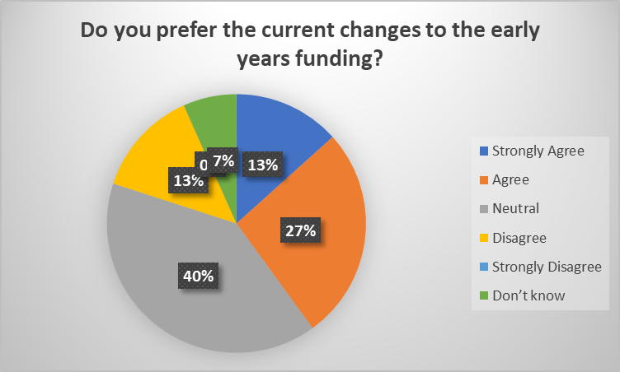
The results showing states that 40% of the public are neutral about the current changes regarding early years funding for working families

Question 2 results:
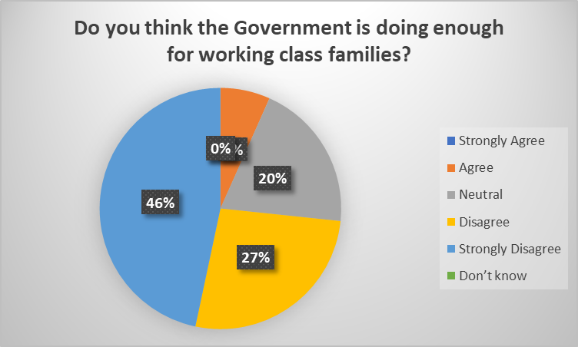
The results showing states that 27% members of the public disagree with the Governments policy in helping working class families.

Question 3 results:
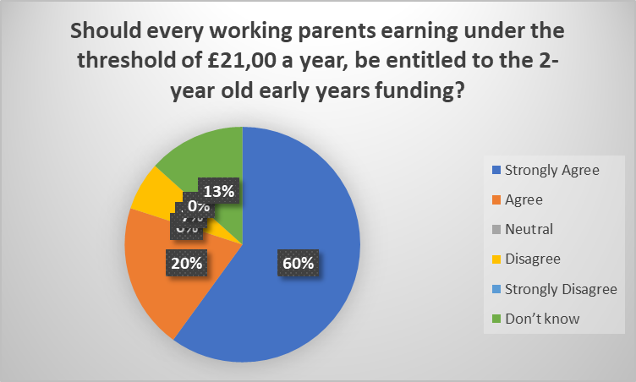
The results of this survey state a large percentage of the public which is 60% out of 100% that wants to see a change of the threshold entitlement.

Question 4 results:
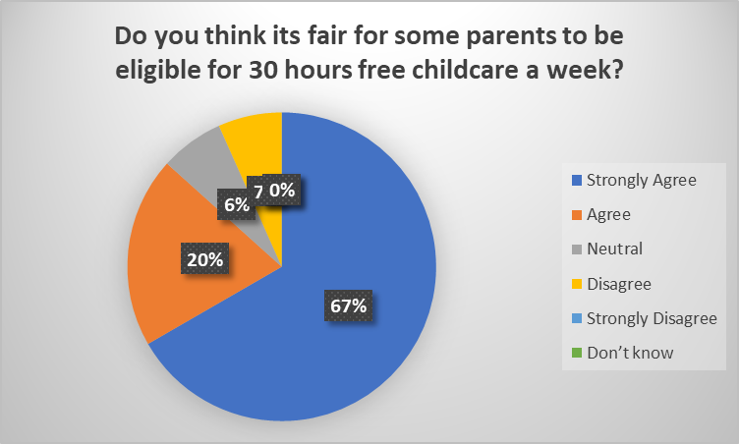
The results of this survey are showing 67% strongly agree that its not fair, only some parents are allowed the 30 hours free childcare a week.

Question 5 results:
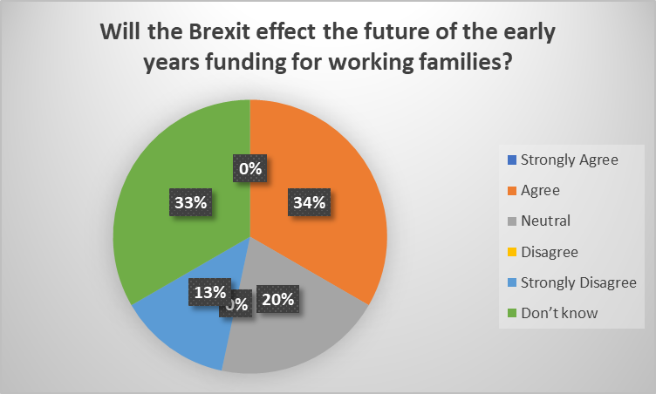
In this survey the results are more diverse as the public have different views about the Brexit impacting the funding of the early years scheme.

Description

After retrieving the information from the data collected, its clear on what the public has to say about the government and the current situation with the early year childcare. The majority find that there should be further consideration when it comes to making policy’s for working families regarding the childcare. And with the Brexit soon to come to a settlement the impact may have a big effect on the early years childcare funding, it just depends on what kind of effect will it be for the working-class families soon.

Limitation of study

In the duration of this report there has been many barriers faced, in which Time Management as one. This topic covers a wide range of material which has made it possible in finding the research and source to deliver this report, and to make sure all relevant information is within the word limit as stated by the requirement of this assignment. Also, the time to complete the work making this difficult with other prior engagements happening.

Recommendation for the future research

The aims of this report were to retrieve data collection form a survey, which I found it to be a good skill to learn. There was room for improvement in the way I planned out my time keeping and be able to spend more time working on my report. Also, the research methods used to get my sources form I find, if I had the extra time to spend reading book from the library about the history of the topic, I would have a mixer of references. But to find the relevant information for my topic and time available to me I use the internet

Ethical consideration of the research

With the data that has been collected in this survey, it is very important to keep it safe as it is permitted by law in the Data Protection Act. (Gee 2016) when conducting surveys with people’s information it needs to stay confidential as well as taking it in to consideration. Reassuring the respondents who are participating in your surveys, that the information they are giving will remain confidential is of the utmost importance and setting their minds at rest about this will improve your survey response rate. When collecting personal data from the public it is essential you make it very clear what the data will be used for and respondents prefer that you do not use their data for any other purposes than for the research you are carrying out. It is always best to reassure them of this before going ahead with the survey. If I intend on reuse the personal details again, I will need to ask for permission and make it clear to the respondents as this will minimise any possible risks to

Conclusion

In the conclusion of this assignment what I found out is there are a lot of working parents are struggling with childcare particularly early years funding, as I myself is in the same situation. In doing this module this term I have found it much useful in learning the different ways of primary and secondary data process. The information received from the survey was very interesting in finding out what the public feel about the support from the government, and possible changes that may happen after the Brexit. The results were very fair after the deliberation.

References

Clarke, C., 2009. Extended flexible entitlement for three-and four year olds : pathfinder evaluation. Available at: https://www.dera.ioe.ac.uk/11365 . Accessed: 28th April 2019.
Gee., Published 10th November 2016. Available at: https://www.blog.smartsurvey.co.uk/the-importance-of-keeping-survey-responses-confidential/ Accessed: 29th of April 2019.
Learner, Sue., Published 1st of July 2016. Available at: https://www.daynurseries.co.uk/news/article.cfm/id/1576905/brexit-impact-children-futures Accessed: 29th of April 2019.
E, Defranzo . Susan., published 16th September 2011. ohttps://www.snapsurveys.com/blog/qualitative-vs-quantitative-research/ Accessed: 27thof April 2019.
Thomson, S., 2016. Free childcare and education for 2 to 4 year olds. Available at: https://www.birmingham.gov.uk/info/20130/childcare_and_early_years/629/free_childcare_and_education_for_2_to_4_year_olds Accessed: 26th of April 2019.
West,Ann. and Noden Philp., May 2018. Available at: https://www.researchgate.net/publication/227612419_An_Evaluation_of_the_English_Nursery_Voucher_Scheme_1996-1997 Accessed: 25th of April 2019.

