
project management report
Rework

student id: 1813735
student name: KALINA KOYCHEVA

Table of Contents
Introduction 2
Task Management Approach of the Company 2
Applicable Scope 2
Gantt Chart 3
Work Breakdown Structure 3
Time Management Plan 4
Financial Plan for the Project 4
Evaluation of Necessary Resources 5
Time Management and Mapping 6
Risk Assessment of the Project 7
Human Resources in the Project 7
Conclusion 8
References 9

Introduction
The chosen business organisation for this project is SumatoSoft Incorporated. This corporation has recently approved a commitment to Bluetooth to move forward at the start of the project as part of an innovative workshop. This task will accelerate the advancement of new Bluetooth programming and support SSI's enterprise technology for delivering consistent customer responses that improve performance in both the work environment and the home climate. While Bluetooth programming is now available, SSI recognizes that new innovative enhancements will allow our team to build a response that is far better than what is currently available. The company's cost plan is £50,000.

Task Management Approach of the Company
The project manager has the common position and obligation regarding the management and implementation of this task according to this Project Plan and the Management Plans of the subsidiaries (Schwalbe, 2015). The risk group will include a workforce of quality control / confirmation collection, code collection, test collection and specialized composition collection. The task director will work with all assets to manage the ranking of projects. All plans for risk and support administrations will be evaluated and confirmed by task support. All funding choices will also be completed by enterprise support (Schwalbe, 2015). Any determination of the approval authority of the undertaking administrator must be recorded on paper and approved by both the director of tasks and the maintenance of the undertaking.
The task force will be a framework for ensuring that colleagues from each association continue to be accountable to their authoritative administration throughout the necessary and required action to take (Schwalbe, 2015). The task administrator is responsible for talking to reputable directors about the progress and performance of each risky asset.

Applicable Scope
The scope of SSI's Bluetooth project includes arranging, planning, improving, testing, and modifying the Bluetooth programming package. This product will meet or exceed the authoritative programming guidelines and additional details set forth in the enterprise sanction. The scope of this endeavour also includes the completion of all documentation, preparation of aids and manuals to be used in combination with the product. (Burke, 2010) The completion of the enterprise will occur when the package of documents and programming is effectively executed and changed to an SSI assembly package for creation.
All Bluetooth work will be done inside, and no part of this task will be overestimated. The scope of this obligation does not preclude any adjustments to the prerequisites for standard product launch frameworks, program updates or modifications.

Gantt Chart
The outline below shows the significant achievements of the Bluetooth project. This contour is uniquely made from significant achievements of the task, including completion of an enterprise stage or audit of the entrance (Burke, 2010).
Initiation
Aims
Purposes
Strategy
Methodology
Analysis
Recommendation

Work Breakdown Structure
It is possible that there are more modest achievements that are excluded from this schedule but are added to the schedule of the company and WBS (Burke, 2010). In the event that there is any delay in planning that could affect achievement, the task manager should be informed quickly so that proactive measures can be taken to moderately reduce dates.
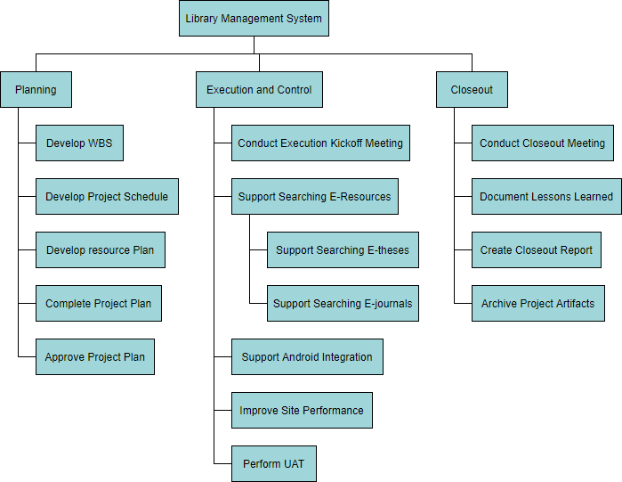

The WBS dictionary characterizes all work packages for the Bluetooth project. These definitions include all assignments, expectations and assets. Each work package in WBS is featured in the WBS dictionary and will help arrange assets, ensuring expectations that meet needs and fulfilment of orders.
The Bluetooth project plan was received from the Project Charter and the WBS with input from all task colleagues. The schedule was completed, evaluated by the project sponsor and approved and mainstream. The schedule will be maintained as an MS Project Gantt Chart by the Bluetooth Project Manager. All proposed schedule adjustments will follow the SSI change control measure. Whenever the set control limits can be exceeded, the change request will be sent by the project manager. He and the group will decide the impact of the change on the schedule, assets, extent, hazards and costs. In case it is concluded that the effects will exceed the boundary conditions, at this point the change will be sent by the project sponsor for evaluation and approval.
In case the project sponsor supports the initiative, at this point it will be implemented by the project manager, who will update the schedule and documentation and will pass the change to all partners through the process of change control.

Time Management Plan
This Communications Management Plan sets out the structure of the exchange links for this task. It will be completed as a guide for lifelong correspondence of the task and will be refreshed when the correspondence changes. This risk plan recognizes and characterizes the work of colleagues via Bluetooth, as they identify with the exchange points. Moreover, it includes an exchange grid that outlines the needs of this enterprise's correspondence and collection correspondence and other correspondence structures. In the same way, a register of enterprises is included in order to provide contact details of all partners directly related to the enterprise.
The project manager will play a leading role in ensuring irresistible exchanges of this task. The assumptions for correspondence are reported in the Communication Matrix below. The communication matrix will be used to control the type of data to be transmitted, those to be transmitted, when to transmit and to whom to transmit.

Financial Plan for the Project
The project manager will be responsible for supervising and covering the costs of the task throughout the duration of the endeavour. The project manager will present and study the implementation of the task during the monthly project status meeting. Using the purchased figures for assessment, the project manager is responsible for presenting deviations in costs and for introducing the project sponsor with opportunities to return the company to the financial plan. All selection and selection powers to incorporate cost changes are with the Bluetooth project sponsor.
The cost index and schedule (CPI and SPI separately) will be reported sequentially by the project manager to the project sponsor. Fluctuations in the execution and schedule files will change the status of the costs to yellow or preventive. They will be taken into account and if it is decided that there is no or insignificant effect on the costs of the enterprise or the scheduling model, then no activity may be required. Cost fluctuations in performance records and schedules will change the cost status to red or basic (Villafiorita, 2014). They will be reported and will require corrective action by the project manager to reimburse costs or possibly plan performance records according to the passable difference. All restoration activities will require a change of enterprise and must be approved by CCB before it can be updated very well.
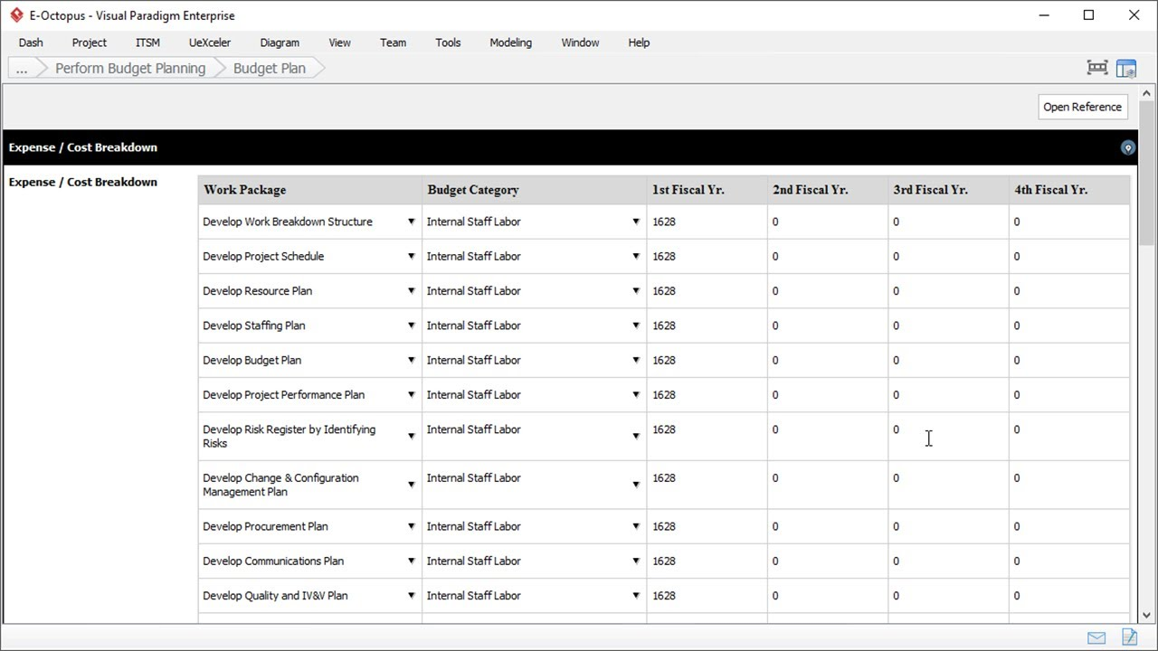

The acquired value figures will be collected by the project manager and will be revealed at the project status meeting from month to month. In case there are signs that these qualities will approach or reach the main stage before a successful meeting, the project manager will pass this on to the project sponsor immediately.

Evaluation of Necessary Resources
The project manager will provide supervision and supervisors of all acquisition exercises for this endeavour. The project manager is approved to approve all acquisition activities up to 50,000 British Pounds. All acquisition activities in excess of this amount must be approved by the project sponsor.
While this endeavour requires little or no acquisition, in the case where an acquisition is required, the project manager will work with the working group to distinguish all things or administrations that need to be provided for the successful completion of the action which is necessary in this instance. At this point, the project manager will ensure that these acquisitions are evaluated by the Program Management Office (PMO) and familiarized with the agreements and purchases. Agreements and purchases will audit acquisition activities, decide whether it is invaluable to make or purchase items or assets needed by administrations within, and begin determining the seller, purchase, and bargaining cycle.

Time Management and Mapping
In the event that an acquisition becomes material, the project manager will be responsible for the managers of each selected trader or external asset. The project manager will also assess performance as he identifies with the trader, who provides important products and additional benefits and gives this to purchasing meetings and agreements.
The degree that the Bluetooth project board will be the sole responsibility of the project manager. The degree for this task is characterized by the scope statement, the breakdown structure (WBS) and the WBS dictionary. The project manager, the sponsor and the stakeholders will create and favor documentation for the evaluation of the scope of the project, which includes feasible daily quality plans and evaluations of the implementation of the work.
The proposed changes in scope can be initiated by the project manager, stakeholders or by any person in the group of companies. All requests for change will be sent to the project manager, who will at this point assess the mentioned change of scope. Infinitely offering the demand to change the degree, the project manager will present the request to change the extension of the Change Control Board and the project sponsor for confirmation. Endlessly providing changes to extensions by the Change Control Board and project sponsor, the project manager will refresh all task reports and pass the change to all partners. In view of the criticism and contribution from the project manager and stakeholders, the project sponsor is responsible for confirming the expectations for the last task and extending the activity.
The project sponsor is responsible for the official tolerance of the last result of the enterprise. This recognition will be based on a study of all enterprise documentation, test results, beta preliminary results and performance, on equal terms / work packages and the usefulness of the items.
Task plans for the Bluetooth project will be made with the help of MS Project 2007, starting with the expectations recognized in the business breakdown structure (WBS). The motion definition will recognize the specific work packages that need to be executed to complete each result. The sequence of actions will be used to resolve the request for work packages and to allocate the links between the project exercises. The traffic length estimate will be used to determine the number of work periods required to complete the work packages. The asset valuation will be used to assign assets to work in packages to complete the progress of the plan.

Risk Assessment of the Project
The hazard monitoring methodology for the Bluetooth project includes an efficient cycle. The cycle is to recognize the record and to arrange the degree of danger and the chance of their occurrence (Best, 2015). The path to hazard identification and reporting is important not only for this task, but also for all endeavours, and it will be necessary for all colleagues to participate effectively. All hazards need to be identified in a timely manner so that measures are put in place to limit the exercise of uselessness and assets during the performance of the task (Papke-Shields and Boyer-Wright, 2017). Upon completion of the hazard identification measure, all hazards that were considered to have caused significant damage were recorded in the task plan. Arrangements were also recommended, which were memorized according to the schedule in case of each of the hazards other than the occurrence. Therefore, the group will be fully organized and will realize how to manage the dangers.
The moment the task is concluded, the head of the enterprise will be expected to summarize the cycle of the enterprise. They will be needed to investigate all the hazards that are possible from the use of the hazard cycle by managers. All necessary upgrades will be recognized and saved in the same way for future reference.

Human Resources in the Project
The Bluetooth project will include a network structure using various internal associations. All the work will be done inside. The necessary personnel for the Bluetooth project include the accompanying (Torrington, 2017):
Venture Manager - is responsible for the entire administration of the Bluetooth project. They must design, make and handle every action, trace, report, exchange, difference, staff, performance evaluation and any internal coordination.
Senior Programmer - required to regulate all coding and programming activities for the Bluetooth project. They are additionally needed in order for the capacities to be completed by the set quality guidelines. They need to team up with project managers to monitor the plans, make work packages, and finally prepare a report. The director of the enterprise is needed to be a senior developer and to offer criticism to the administrator, who is represented with considerable power there.
Developer - they must encode and execute the projects of the Bluetooth project. The software engineer is expected to study all codes and projects before they are updated. They will also differentiate hazards by examining their potential effects and compiling a report on the findings. After consumption, the reports will be submitted to the useful head of evaluations.
Senior Quality Specialist - required to assist the project administrator. They will help ensure that guaranteed principles and quality control are followed. They are also needed to maintain logs for confirmation and quality control during the implementation of the endeavour. They are also needed to submit their performance evaluation reports.
Quality Specialist - they are needed to help both experts on quality topics and task managers. Their assistance is required during the creation and follow-up of the log files for confirmation and quality control. Nevertheless, their main task is to summarize the quality and measurement reports and report them to the director of the enterprise for transmission to other people. They are also needed to complete their report to the practical chief performance appraiser, as well as others.
Specialized writer - is expected to collect and report, as indicated in the project guidelines, all works that are specified. They help in the design of managers and changes throughout the enterprise cycle. They work connected in the thigh with the administrator of the enterprise to ensure compliance with quality standards. They further depict obligations, plan project collection and ensure that all persons in the enterprise receive the data. During their work, they will be audited by project managers and will have to complete a performance evaluation report.
Testing Specialist - required to assist in setting up test data for the Bluetooth project. They were needed to do this with developers and task managers. They are needed to ensure that the test cycle is complete and well recorded. Finally, they were needed to record a performance evaluation report in the same way.

Conclusion
SSI is aiming to acquire a piece of pie because of its strong demand for item quality, adaptability, convenience and customer support. In addition, customers are aware that our items can be applied to a wide range of jobs for individual and business capacities. By leveraging our reputation for easy-to-understand and prevalent quality items and profit from new innovations, SSI can position itself as a major provider of powerful as well as easy-to-use Bluetooth applications in the current local area.

References
Best, K. (2015). Design management: managing design strategy, process and implementation. New York: Fairchild Books.
Burke, R. (2010). Fundamentals of project management: tools and techniques. Ringwood: Burke.
Papke-Shields, K.E. and Boyer-Wright, K.M. (2017). Strategic planning characteristics applied to project management. International Journal of Project Management, 35(2), pp.169–179.
Schwalbe, K. (2015). Introduction to project management. Minneapolis, Mn: Schwalbe Publishing.
Torrington, D. (2017). Human resource management. Harlow, U.K.: Pearson Education Limited.
Villafiorita, A. (2014). Introduction to software project management. Boca Raton: Crc Press, Taylor & Francis Group.

