An investigation into the rise of Primark
BY Parul Begum 1811324
University of wales –Trinity Saint David

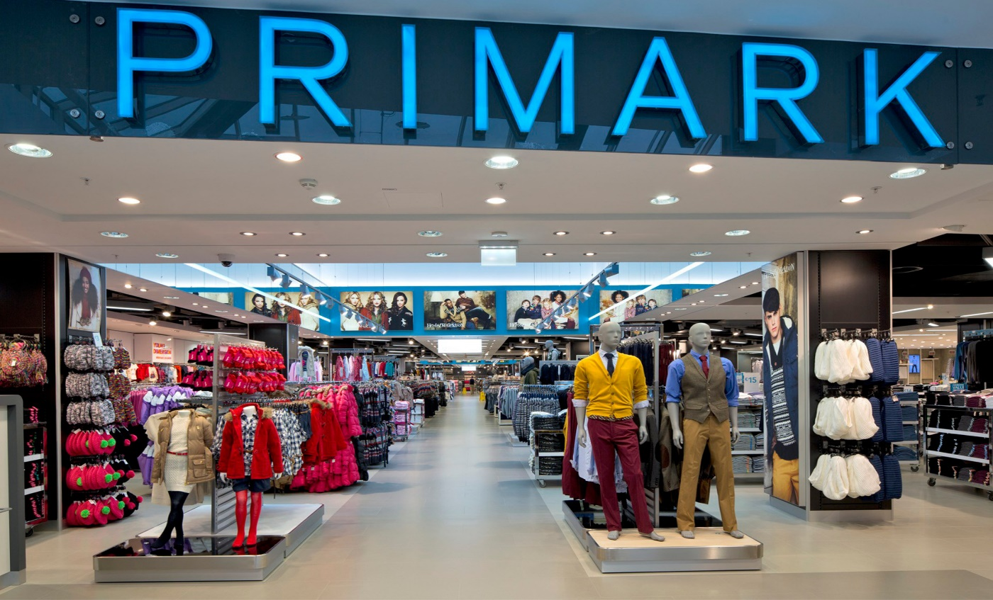

Executive summary

As we know that Primark was first opened in Dublin in 1969 by Arthur Ryan who has died of a short illness on 8/7/2019. Primark has 350 store around 11 countries and it opened one of the biggest store in Birmingham with Disney dining experience. The researcher was asked to investigate the prices of Primark; Primark’s prices are low because they use natural materials to make their products for their customers that’s why their prices are low which entices customers. Researcher Found out that Primark follows the media and its brand for e.g. when Dumbo cartoon was launched Primark got Dumbo products out for their customers for cheap prices. Researcher also found out that Primark doesn’t have online shopping services for their customers, if they did have online shopping site for their customers they would make profit by this service. Researcher has given an option for Primark to do which is to make a proposal to the shareholder to invest in the business by promoting the products online for their customers.

Contents Page

1.0 Terms of Reference………………………………………………………………………………………………….4
2.0 Procedure………………………………………………………………………………………………………………...5
3.0 Findings
3.1 Introduction…………………………………………………………………………………………………………….6
3.2 Products portfolio of Primark………………………………………………………………………………….7
3.3 Discuss how Primark has planned, communicated, monitored and reviewed previous attempts to resolve its problems………………………………………………………………………………….8-9
3.4 Describe the nature, scope and impact of the current problem Primark is facing…...9
3.4.1 Analysis of Primark……………………………………………………………………………………………….10
3.4.2 S.W.O. T Analysis of Primark……………………………………………………………………………….10-11
3.4.3 PESTLE Analysis…………………………………………………………………………………………………...11-12
3.4.4 Stakeholders Analysis Diagram………………..........……………………………………………………12
3.4.5 How stakeholders can resolve problems……………………………………………………………….13
4.0 Conclusion………………………………………………………………………………………………………………14
4.1 Current situation portfolio overview (strengths and weaknesses) …………………………...14
4.2 Main areas of concern……………………………………………………………………………………………….14
4.3 Main areas of strengths and stakeholders who can help……………………………………………14
5.0 Option/Recommendation………………………………………………………………………………………15
5.1 Plan to encourage sustainability…………………………………………………………………………….15
6.0 Appendices…………………………………………………………………………………………………………….16-17
7.0 Acknowledgements……………………………………………………………………………………………….17
8.0 Reference………………………………………………………………………………………………………………18-19
9.0 Bibliography………………………………………………………………………………………………………………20

1.0 Terms of Reference

The report was requested by the C.O.E of Primark to investigate the price of Primark, it was asked on 5/06/19. The researcher was asked to investigate the pricing of Primark and to look at the problem that Primark is facing and come up with a solution for Primark. The report needs to be submitted on the 12/07/19 by the researcher.
Even though Primark retails success is well known by the `Fast’ fashion industry, Primark has been struggling to overcome the consumer’s pre-fixed nation that fast-fashion is not sustainable, and certainly not ethically made. Researcher acknowledged that Primark’s stakeholders whether they are internal or external all want different things for e.g. shareholder want returns on their capital and this all depends on how well Primark does in financial side of business. Primark also has issues with employees who want job security, good pay and job satisfaction too. Primark’s garment factory in Bangladesh collapsed in 24 April 2013 which was called Rana Plaza it had manufactured products for 28 brands, this accident had been an awakening call for the international fashion industry to protect the most vulnerable in their supply chain.

2.0 Procedure

The researcher will be using books, articles and website to get information on the issues that Primark is facing.

3.0 Findings
3.1 Introduction

Primark is an Irish fast fashion store which opened in Dublin in 1969 under the name Penney and it still trades under that name. Primark’s headquarter is in Dublin and its chairman is Arthur Ryan who first opened Primark, they are a subsidiary of British food processing company ABF. Primark is now known as an international retailer who offers the latest, clothes, beauty and home wear at its best price on high street. It has over 350 stores in eleven countries across Europe and America. From 1969 to 2011 Primark has 335 stores around the world, during 2015 Primark operated over 8 stores in America with plans to open another one in Jersey by end of 2019. Primark also wants to open another store outside of the North Eastern Corridor, in Sawgrass Mills by 2020. Primark doesn’t do online shopping but it does do advertising on online, showing its products and how much they cost.

Please see the Appendix diagram of timeline (Primark)
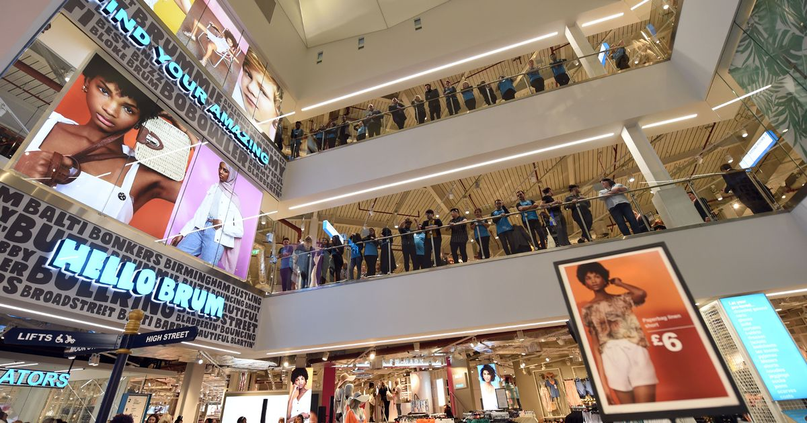
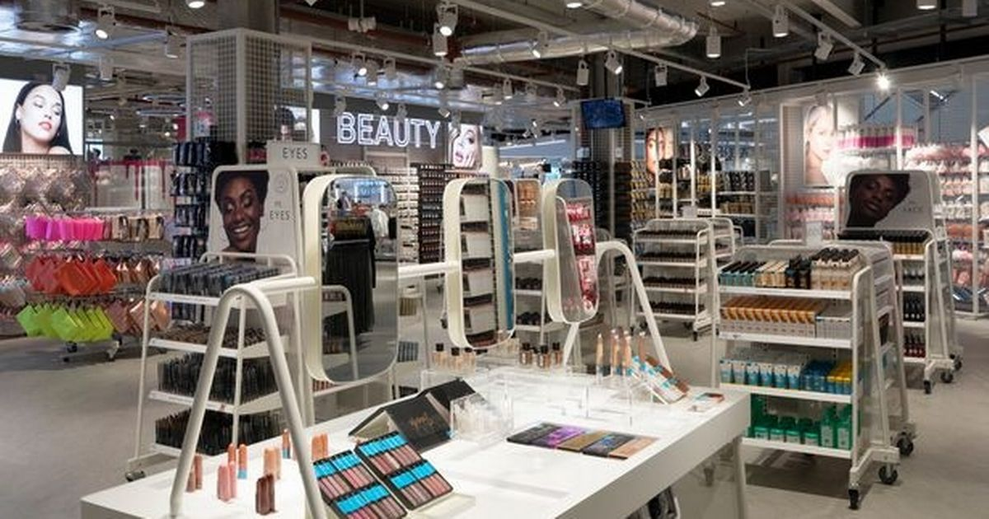
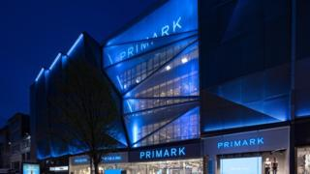
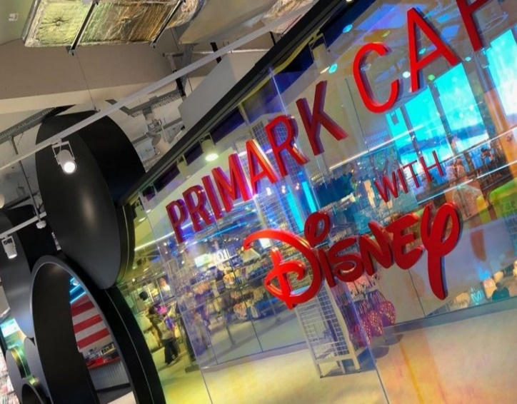
In year 2019 Primark opened one of the biggest stores in Birmingham which occupies a retail space of 160,000sqft. The store has five floor with 3 dining experience including the first Café with Disney and not forgetting the beauty studio and barbers too.
3.2 Current product portfolio of Primark

Primark has 4,516 products in the store’s and they have Women section, Men, Kids, Homeware and Beauty section too. Primark’s products aren’t known for their top quality and long-lasting nature but still they know exactly what their customers want. Primark got Disney, Harry potter collection within their fashion, kids, home and beauty rang also been met with the social media frenzy. Primark launched its first ever range of jeans which was made out of 100% cotton in 2013 in India.

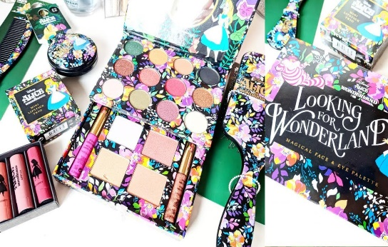
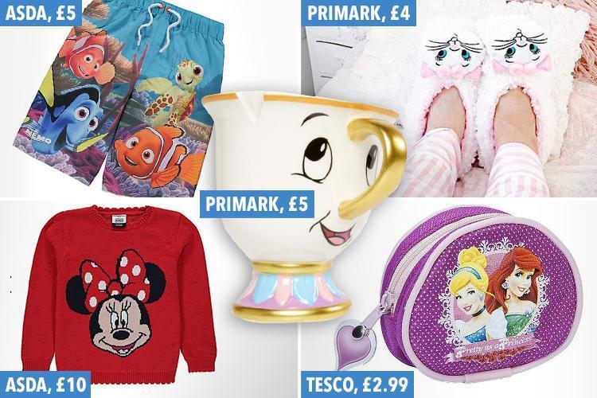
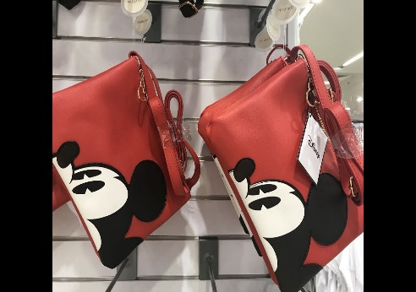
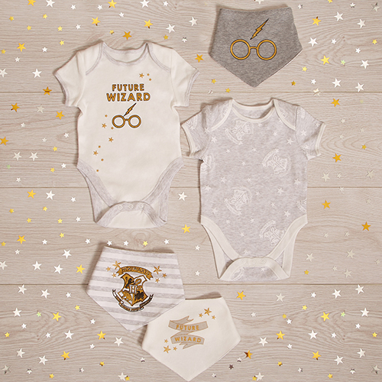
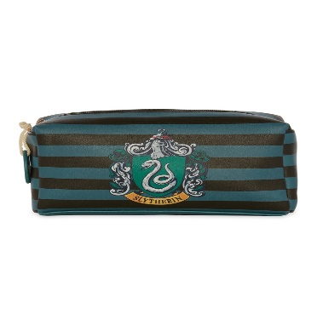

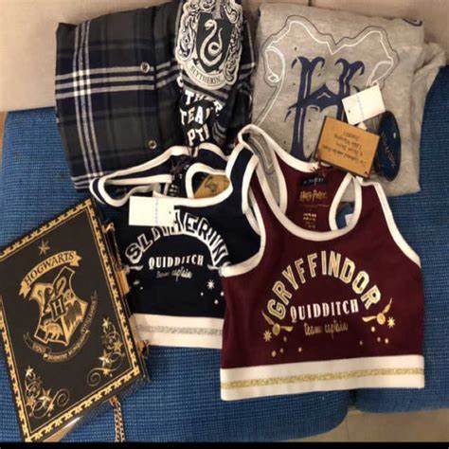

3.3 Discuss how Primark has planned, communicated, monitored and review previous attempts to resolve its problems.

In 2013 one of Primark’s garment factory collapsed in Dhaka, Bangladesh. They lost 1,138 workers and injured more than 2,000 individuals, due to this accident Primark signed the Accord on Fire and Building Safety in Bangladesh. Primark was one of the first to sign the agreement and was one of the first to provide financial and food support to victims and their families following the event. Primark communicated through media by making a statement which released on its website, a Primark spokesman said: Primark’s team in Bangladesh has been working to put in place immediate and long-term help for victims of this disaster, Primark also give interviews to newspaper called The Guardian about how they have done things to support the victims and what they are going to do. Primark partnered with local NGO to address the needs of the victims in Bangladesh. They have promised to support financially to the victims and their families in a long-term who were working in the factory that produced garments for Primark, also short-term financial assistance to 3639 workers and their families, equivalent to nine-month salary’s. Another additional $1.0 million payment to non-Primark supply chain workers to the Rana Plaza Donors Trust Found. Primark has taken action by conducting surveys since June 2013 after the Rana Plaza building collapsed, by using a team of expert’s engineer’s to conduct it to the highest standards. Primark has 40 staff in eight countries, including Vietnam and Turkey to monitor and help improve the standards of the building as well as the staff, by focusing on the structural and electrical safety through regular inspections, remediation and training, its staffs helped to respond swiftly after the Rana Plaza disaster. Food were parceled to more than 1,000 households also they signed up 4,000 victims to bank accounts so they can receive short-term financial aid. Primark also give support to all the workers in Rana Plaza building, not just those who were working for Primark.
Primark will continue to monitor the welfare of victims with long-term injuries or loss of earning and over the period has contributed a total of $14 million in aid and compensation. Primark set up a support and advice to beneficiaries on an ongoing basis, its aim is to build confidence and knowledge of those who was affected by the disaster. It focuses on children of the victims; Primark would regularly contact to monitor their development until they

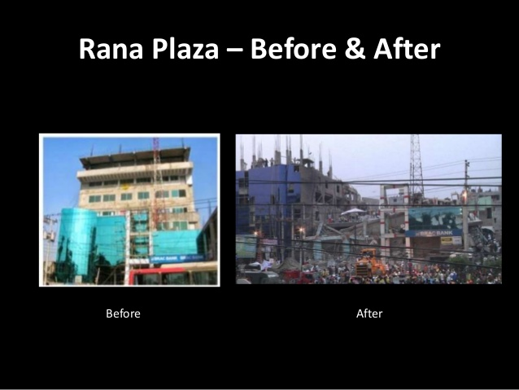
reach at least 18 years old. They also give advice on how to access health services and legal support through regular contact and 24-hour helpline. Primark also added that it would welcome a rise in the minimum wages for garment workers in Bangladesh.
Please see the Appendices (world map of Primark)

3.4- Describe the Nature, Scope and Impact of the current problems facing.
Nature- The collapse of Rana Plaza building was due to a structural failure that had seen cracks on the building appears before the actual collapse of the building.
Scope- The collapse of the building had made waves through the fashion world as it had been labelled as the worst disaster in the garment industry. This disaster affected the consumers who buy these products, employees who work for Rana Plaza and the families of the workers, also stakeholders that have been affected and not forgetting the shareholders to in this disaster. Social media played its role to support the victims and their families.
Impact- People of Bangladesh were shocked by this disaster, many worker’s men and women lost their life’s. Some got head injuries and many got arm/legs missing and some are paralyzed. Primark has supported the victims and their families who were working in Rana Plaza by providing financial support short-term as well as long-term. By supporting the victims and their families Primark lost lot of the money, media also pointed finger at Primark due to the disaster. Financially Primark need to keep its profits up and keep shareholder and stakeholder interested in its company.

3.4.1 –Analysis of Primark
Primark has grown quite rapidly since it was opened in 1969 by Arthur Ryan who is the chairman of Primark. Primark expanded its company in America and U.K and many other countries. Primark has over 350 stores which operates in eleven countries across Europe and America (Primark store limited 2019). Primark store is famous for its trading of high street quality clothes with its simple design and fabrics. Primark sells clothes for all genders, age and various sizes to fashion conscious individual for cheap price. It has not just taken 3 year’s hard graft to build the world’s biggest Primark out of the old Pavilion shopping Centre in Birmingham. Primark in Birmingham occupies a retail space of 160,000 sqft (14,800m2) spreads over five floors. This store features 3 dining experiences, also has Disney café and barber store.
3.4.2 Undertake a SWOT analysis to identify why the organization is faced with its current problems. Identify areas within the SWOT that help them resolve these problems.
Strengths –
- It is a large scale expanding business with over 300 stores operating in 11 counties.
- It is also one of the fastest growing retailers in America
- It has a large percentage of the market share (7%) and is not far off the leader Marks and Spencer’s
- It has a broad selection of products at low prices which entices customers
Weaknesses
- Does not sell products online.
- They don’t produce eco-friendly clothing or products
- They have been at the source of mass controversies as 260 of their employers have been paying staff less than the legal minimum wage.
- Customers have complained that the products are low quality and have no uniqueness
Opportunities
- It has the potential to further expand within the UK and Ireland.
- It also has the ability to expand in both eastern and western Europe.
Threats
- It has fierce competition in the forms of other retail stores such as Matalan, Next and Debenhams.
- Competing online competition
The reason why customers complain about low quality products because Primark uses natural materials to make its products. To resolve this problem Primark can ask their shareholders to invest more into the business so they can use good quality materials for its products.
The reason they have fierce competition is because their prices are low. By having shareholder invest in their business, Primark can use good materials to boost its products prices up.

3.4.3 PESTLE – Using only 3 of the pestle identify issues that maybe impacting on the organization and contributing to its problems. Within these 3 areas identify any future positive issues that may help the organization to Resolve its problems.

Environmental:
Primark is a member of the Ethical Trading initiative and have adopted this conduct. Primark aims to offset their environmental impact by using paper bag instead of plastic bag.
Primark have joined with charity organization to donate their unsold items. Primark reduces it usage of chemicals. Primark also has made commitment for 2020 as part of Greenpeace Detox campaign.
Donating their unsold clothes to the charity Newlife, which provides support for disabled and terminally ill children and their families.
Sociological:
Primark uses social media to advertise its products, Primark products get promoted by their customers. The customers wear the products and sending images online and they comment on the products for e.g. the quality of the product and its price.
“Stimulating sales, increasing brand awareness, improving brand image user traffic to online platforms, reducing marketing cost and creating user interactivity on platforms by stimulating user to post or share content” (Felix et al, 2017)
Primark commitment to behave ethically and contributed to economic development, improving the quality of life of workforce and their families as well as local community and society.
Primark volunteered in community project sponsoring and supporting charity workers contributing time and money to improve environmental impact.
Technological:
Energy efficiency impact on Primark’s overall usage of energy efficiency in the store.
Primark joined with Energy Reduction Group (ERG) to identify and implement energy saving initiatives in their store. Primark used number of technical measures, such as advice that can regulate the speed of fans and unnecessary usage of energy.
Primark management made decisions in relation to the usage of energy in the store, they used a system to intuitive controls to modify the usage of heating, cooling and lighting system. This system has been installed in almost 100 stores of Primark.
Using Environmental information on how Primark helps children’s and their families with disability and terminal illness, this will help Primark build its image to its consumers and it suppliers. Primark uses Witter and Facebook to promote it products.

3.4.4 Compile a stakeholder analysis diagram demonstrating where the main stakeholders would be placed by the organization.
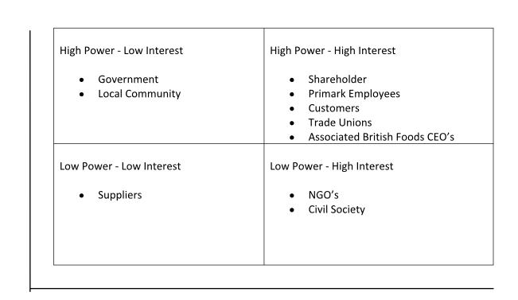

Level of Power

Level of Interest

3.4.5 Using the stakeholder analysis diagram describe how particular stakeholders may help resolve the problems the organization is currently facing.

Customers could help by donating/raising money for workers in developing nation such as Bangladesh. In doing so supporting them and their families and potentially enabling them to work a safer environment. This could be similar to Borgen project which Marissa Wandzel did in June 12.2018.
Shareholders are able to contribute to the business by investing more into the business; this money could then go towards a boost of quality merchandise, which would increase customer satisfaction. Using the boost of quality merchandise, Primark would no longer be restricted and would be able to access an online platform. This is similar to an article by Laura Suter called “four little-known British companies that have increased their dividend every year for five decades” written in May 25th 2017.

- Conclusion
4.1- Provide an overview of the current situation of the organization in terms of strength/weakness of its products portfolio. Have past poor decision impacted on this portfolio.
Strength:
Primark’s recent Disney collection is out and Primark celebrated the new film launch of Dumbo, they featured 62 products in total. They also announced another Disney collection is coming to its store.
Weakness:
Weakness Primark products aren’t available online, so if their customer can`t get to a store……… at this point other business like Sainsbury and Matalan have pretty solid selection of Dumbo and Disney-theme items on their website, such as Dumbo sleep suit for £8:00 so on.

4.2 Based on your analysis undertake using SWOT etc. highlight the main areas of concern to the organization.
Based on the S.W.O.T analysis the main areas of concern to Primark’s are:
Primark is center of controversies.
They don’t produce eco-friendly clothes or products.
They have online competition.
Primark also has a board selection of products at low price which entices customers.

4.3 Using the analysis section identifying the main areas of strength and stakeholders who could assist the organization in resolving its problems.

Primark’s main areas of strength are having low cost on their products which entices customers. Primark’s employees who are the stakeholder can help Primark with promoting their products by talking to their friends and families about the products and say how good and cheap it cost to buy.
As its been mentioned above that shareholders can invest in the Business by promoting the products online for the customers, by doing this the profit will go up because this will give the customer the chance to do their shopping online. Primark’s main areas of strength are having low cost on their products which entices.
- Options

5.1 Develop a plan which encourages suppliers to ‘think sustainability’ when sourcing materials.
Primark can suggest that the shareholders to invest in the business by promoting the products online. But first Primark needs to get their stakeholders involved by having a meeting with their employees and telling them how they are going to try and get the shareholder to agree with their proposal to invest in the business. So by getting both party involved this will help to get information around to customers about how Primark is going online, so their customers can do shopping by sitting home.
The agreement between shareholders and setting the website might take a year or so. When the website is opened the profit will start to shoot up because customers don’t need to go out and shop they can do it at home. Primark can make an agreement with the shareholder on how much they invest in the company for e.g. say if shareholder invested 10% in the business then the profit that Primark’s makes 10% he shareholders will have.

- Appendices

Timeline
1969 - first store opens in Dublin, Ireland. We operate 37 Penneys branded stores in Ireland.
1973 - first store opens in Derby, UK. We now operate over 188 stores in the UK.
May 2006 - Madrid, Spain. We now operate over 45 stores in Spain
December 2008 - Rotterdam, The Netherlands. We now operate 20 stores in The Netherlands
December 2009 - Lisbon, Portugal. We now operate 10 stores in Portugal
December 2009 – Bremen, Germany We now operate over 28 stores in Germany
December 2009 - Liege, Belgium. We now operate over 6 stores in Belgium
November 2011- Primark branded concessions open in Selfridges Birmingham & Manchester, UK
September 2015 - Boston, America. We now operate over 8 stores in America with plans to open in American Dream, New Jersey by the end of 2019. Primark will also open its first store outside of the North Eastern Corridor, in Sawgrass Mills, Miami in 2020.
April 2016 - Arese, Italy. We now operate 4 stores in Italy
April 201 - The world’s biggest Primark opens in Birmingham, UK
June 2019 - Ljubljana, Slovenia. Primark enters its 12th market and 1st in Central Eastern Europe. (Primark.com, 19)

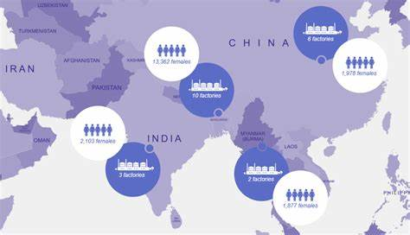

(Primark.com,2019)

Primark has a large number of differs stakeholders, therefore they have a multitude of methods to engage with them, such as the method in which Primark communicates to their customers via the Ethical Trading’s website. (Thebusinesstime,2018)

- Acknowledgements

I would like say thanks to the librarian, my lecture, friends and my families who helped me to do my assignment.

- Reference

Websites:

Marissa A. Wandzel, M.A.W, (2018). [Online] Available at: https://borfebporject.org./support-farmers-in-developing-countries, [Accessed on: 12.06.19], (Time: 20:04)

(2019). [Online] Available at: https://www.Primark.com/en/aboutus, [Accessed on: 28.06.19], (Time: 1:31pm)

(2019). [Online] Available at: https://www.birminghammail.co.uk, [Accessed on: 28.06.19], (Time: 2:00pm)

(2018). [Online] Available at: https://www.Newsexpolred.co.uk/pri-mania-as-worlds-largest-primark-opnes-in-birmingham, [Accessed on: 26.06.29], (Time: 10:00pm)

[Online] Available at: https://prezi.com/lhskhdx9d4jo/primark-/, [Accessed on: 09.07.19], (Time: 6:00pm)

[Online] Available at: https://www.primark.com/en/categories?q=%3Arelvane&page=6, [Accessed on: 29.06.19], (Time: 23:58)

(2019). [Online] Available at: https://www.primark.com/en-us/our ethics/communities/health-and-wellbeing, [Accessed on: 29.06.19], (Time: 5:56pm]

(2019). [Online] Available at: https://fashionunited.uk/primark-sustainabltitly, [Accessed on: 06.07.19] (Time: 07:39pm)

Amy Westerville, A.V, (2015). [Online] Available at: https://www.theguradian.com, [Accesses on: 06.07.19], (Time: 08:30pm)

Kate Abnett, K.A, (2016). [Online] Available at: https://www.businessoffashion.com/community/voices/discussion/can-fashion-industry-become-sustainable/three-years-on-form-rana-plaza-has-anything, [Accessed on: 07.07.19], (Time: 09:35pm)

[Online] Available at: https://businessethicscases.blogspot.com/2014/04/deadliest-garment-industry-disaster.html, [Accessed on: 03.07.19], (Time: 12:00)

(2018). [Online] Available at: https://www.primark.com/en/our-ethics/newsroom/support-porvided-by-primark-since-theprana-plaza-building-collapse-in-Bangladesh/a/4e41843-e200-44, [Accessed on: 03.07.19], (Time: 1:00)

Laura Suter, L.S, (2016). [Online] Available at: https://www.telegraph.co.uk/investing/share/four-little-british-comapnies-have-increased-dividen/, [Accessed on:09.07.19], (Time: 08:21)
Books:
Werther, B, W. et al. (2006), Strategic Corporate Social Responsibility: Stakeholders in a Global Environment, pages 26-30, New Delhi, Sage Publishers.

Browaeys, M-J. et al. (2015), Understanding Cross-Cultural Management 3rd ed, 450 pages, London, Pearson Education Limited.

- Bibliography

Woods, F. et al. (1999) Business Accounting 1, page 59-65. Great Britain.
Maund, A. et al. (2017) Certificate in Higher Education: Skills for the Workplace Student Yearbook, page 105-109. Los Angeles.

