

The Building Regulations 2010

Approved
Document ECR
Charlie Gardner
Student Number - 2405435

Embodied Carbon for New Domestic Buildings

For Use in Wales*
2025 Edition

Contents

1. Glossary 3
2. Scope 4
3. What is Net Zero 4
4. Whole Life Carbon 5
5. Whole Life Carbon Assessments 6
6. Mandatory Limits on Embodied Carbon 7
7. Requirements of embodied carbon in new build homes 8
8. Calculating your GIA (Gross Internal Area) 8
9. Embodied Carbon Calculation 9
10. Embodied Carbon Scopes 10
11. Embodied Carbon Assessment 11
12. When to report your embodied Carbon 11
13. References 12
14. Bibliography 14

1. Glossary

Embodied Cardon – Refers to the greenhouse gas emissions that are released during and following the lifecycle stages (Anon, n.d.).
Greenhouse Gas (GHG) – is a category of gases that absorb heat energy emitted from the planet's surface and they remain in Earth's atmosphere for a long time (NOAA, 2023).
Carbon dioxide equivalent (CO2e) – Is an equation for the impact of greenhouse gases on a carbon dioxide basis RICS (2023).
Carbon removal - the process by which CO2 is removed from the atmosphere and
Stored RICS (2023).
Whole life carbon (WLC) - Whole life carbon emissions are the total sum of greenhouse gas emissions over its lifecycle (modules A0–A5, B1–B7, B8 optional, C1–C4, all including biogenic carbon)).
Activity Data refers to the measurement of the amount of the action. This could be your mileage from business mileage, Kilowatt hours of electricity used, tonnes of fuel used.
Emission Factor are publicly available values, that are available from the Government and other sources that enable you to convert quantities of activity into carbon emissions. It describes how much carbon emissions are produced by an activity. Welsh Government (2025).
Gross Internal Area (GIA) – This refers to the measurement of the internal area of your project, you can find how to measure this on section 8 of this building regulation.
kgCO₂e/m² - refers to the Carbon Dioxide Equivalent of greenhouse gases, which measures the warming effect of various gases in relation to carbon dioxide. this is the unit of measurement for that you are required to meet as part of this regulation. You can find how to calculate this on section 9 of this building regulation.
Environmental Product Declaration (EPD) – Is a standardised document that has detailed analysis of a product lifecycle

Approved Document ECR
Embodied Carbon for New Domestic Buildings

2. Scope
This document has been approved by the Welsh assembly government as guidance on ways of complying with the requirements of the Building Regulations Wales, this document is in relation to limiting embodied carbon for new domestic buildings, it applies to building work in Wales only.
This regulation applies to all newly constructed domestic buildings, including single-family properties, multi residential buildings of up to six stories.
This Building regulation is to be used as in conjunction with Building Regulation Part L

3. What is Net Zero
In this document it will inform you of ways to improve your embodied cardon when building new domestic buildings in Wales, this will help to hit the UK governments 2050 net zero target.
Net zero is defined by the office for national statistics (ONS) as a target set by the UK government to reduce greenhouse gas (GHG) emissions by 100% comparable to levels of 1990 by the year 2050, they are aiming to achieve this target by emission reduction and emission removal. The change to this legislation came in to force on 27th June 2019 and amended the Climate Change Act 2008’s target of an 80% reduction in greenhouse gas emissions compared to the 1990 levels (Office for national statistics, 2019). The international scientific consensus is that we are required to limit the global warming to just degrees Celsius (BREEAM, 2025).
Net zero is not the same as carbon neutral although they both refer to removing carbon dioxide from the environment, carbon neutral refers to limiting any increase in future carbon emissions, while using offsets to neutralise existing emissions. Net zero focuses on reducing carbon emissions as much as possible first, and only offsetting unavoidable, residual CO2 as a last resort (National Grid, 2023).
The Welsh Government have set out a strategic plan to achieve net zero by 2030 as shown in image 1 below it shows operational emission changes as per the strategy. To achieve net zero they will have to reduce their total emissions in 2030 by at least 90% relative to our baseline year of 2019-20, however in their initial pathway modelling for the strategic plan indicates they will only achieve between 55-75% reduction meaning they will miss this target a minimum of 15%. To enable the Welsh government to meet the required 90% reduction target they will need to accelerate all activities and go further than the strategic plan to meet the goal (Welsh Government, 2022).
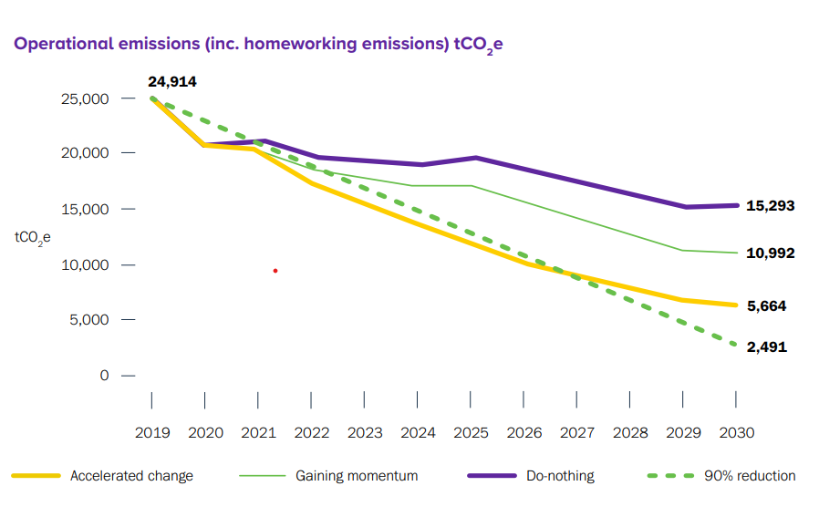

Image 1 – (Welsh Government, 2022).
4. Whole Life Carbon
Whole life carbon is defined by the UK Green Building Council (UKGBC) as greenhouse gasses that are emitted throughout a building’s lifecycle, the lifecycle starts at the raw materials that the building is made up of, the energies used to run the building, all the way through to the building’s demolition and end of life treatment of the building’s materials, for more information on this can be found on image 2 below which details the whole life cycle as per the UKGBC. It can also be defined as 'the combined total of embodied and operational emissions over the whole life cycle of a building' (WHY IS IT IMPORTANT?, n.d.). The royal Institute of Chartered Surveyors also define whole carbon as Whole life carbon refers to the carbon impacts over the entire life cycle of a built asset, from its construction through to its end of life (RICS, 2023). As shown on image 4 55% of embodied carbon happens during construction with only 2% happening in the end of life demolition.
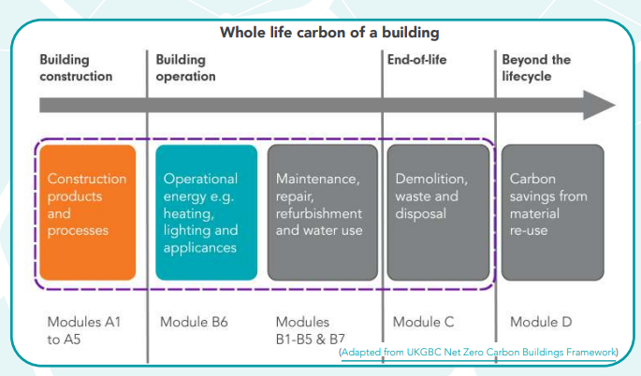
Image 2 - (WHY IS IT IMPORTANT?, n.d.).

5. Whole Life Carbon Assessments
The Royal Institute of Chartered Surveyors (RICS) detail how to measure your whole carbon emissions by adopting the whole life carbon assessment (WLCA) (RICS, 2023). A whole life carbon assessment (WLCA) is the process in which you calculate and report your expected carbon throughout the project’s lifecycle. It also includes an assessment of the potential benefits and loads occurring beyond the system boundary (RICS, 2023). Image 3 below shows an overview of the process of completing a WLCA, more details for this can be found on their website.
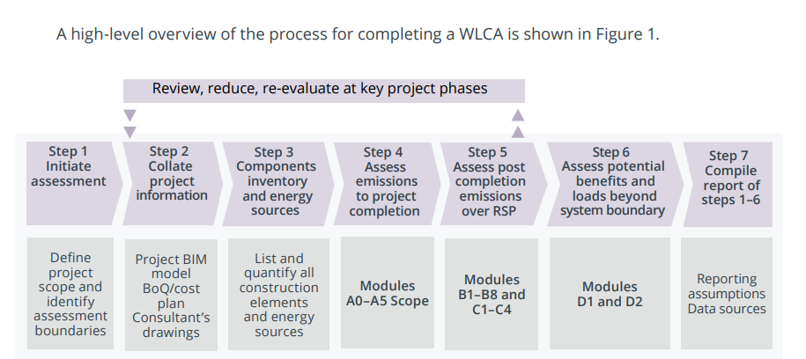
Image 3 - (RICS, 2023)

6. Mandatory Limits on Embodied Carbon
All domestic new builds shall meet the following embodied carbon limits by 2030.
Maximum of 500 kgCO₂e/m² GIA (gross internal area) - For low rise family homes (1-2 storeys)
Maximum of 650 kgCO₂e/m² GIA (gross internal area) - For multi-unit residential buildings of up to 6 Storeys
The mandatory limits for new builds will then reduce to the following embodied carbon limits in April 2040.
Maximum of 350 kgCO₂e/m² GIA (gross internal area) - For low rise family homes (1-2 storeys)
Maximum of 500 kgCO₂e/m² GIA (gross internal area) - For multi-unit residential buildings of up to 6 Storeys
These limits apply to lifecycle stages A1–A5 and C1–C4. Stages B2 and B4 are reported but not included in the limit calculation, the lifecycle stages can be found below -

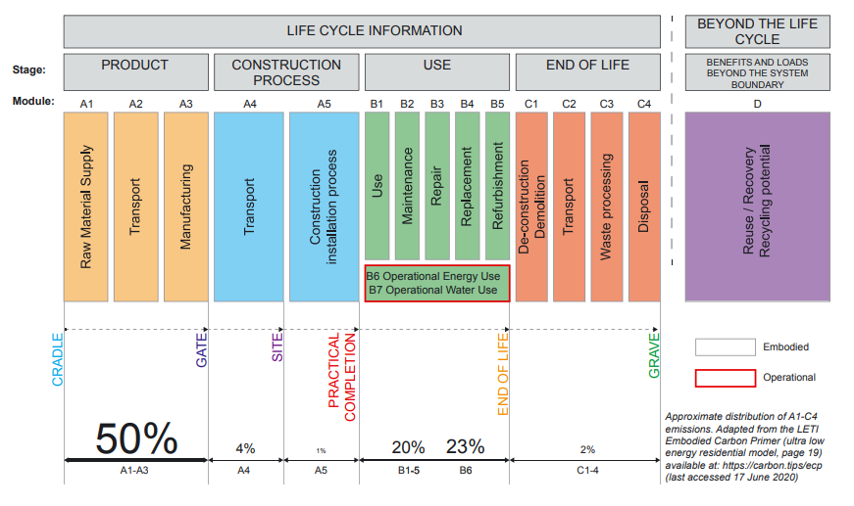
Image 4 - (Orr, Gibbons and Arnold, 2020)

7. Requirements of embodied carbon in new build homes
The below requirements are for new build domestic properties in Wales as of this regulation being published.
Design phase – during the design phase of the project this is where you can select the right materials that you are going to construct your building with, this is an essential part of lowering your embodied carbon.
Sustainable materials – ensure sustainable material are used with the best possible carbon qualities.
Location of materials – ensure your materials are from a local area to reduce transport emissions.

8. Calculating your GIA (Gross Internal Area)
Gross Internal Area is the whole enclosed area of a building from within its external walls, this should take in to account each floor and exclude any external wall thickness. Gross Internal Area is calculated in M2.
Below shows a list of what you should include and exclude from your GIA measure it is not limited to this list.
Include
- Rooms – all types
- Circulation areas - corridors, internal lobbies, entrance halls
- Internal storage areas
- Bathrooms, toilets and washrooms
- Kitchens and tea points
- Plant rooms and boiler rooms (inside the building)
- Lift shafts and stairwells at each floor level
- Internal structural walls, columns, and piers
- Partitions (fixed or movable)
- Mezzanine floors
- Basements and cellars (if usable for the intended purpose)
- Internal car parks (within the external walls)
- Internal loading bays
- Areas with restricted height (e.g., under stairs or sloping ceilings)
- Internal balconies and galleries
Exclude
- External balconies and terraces
- External car parks
- Canopies - not enclosed by walls.
- Open lightwells/courtyards/roof terraces
- Void spaces
- Thick external walls
- External fire escapes
- Plant rooms located outside the building envelope.
- Areas not capable of being used due to severe height restrictions (commonly less than 1.5m, depending on the standard)
For more information on how to measure your gross internal area you can go to the Royal Institute of Chartered Surveyors (RICS) code of measuring practice - https://www.rics.org/content/dam/ricsglobal/documents/standards/May_2015_Code_Of_Measuring_Practice_6th_Edition.pdf

9. Embodied Carbon Calculation
Environmental Product Declaration (EPD) is a standardised document that details the full analysis of a products carbon emission lifecycle.
There are a few different types of EPDs. There are two EPDs that the industry use -
Single-company product-specific EPDs assess the life-cycle impact of an individual product produced by a single manufacturer (Anon, 2025).
Industry-wide EPDs (Also known as sector EPDs assess the environmental impact of a specific industry or product type. Examples include concrete components, construction timber and bricks (Anon, 2025).
Once you have your EPD you can then move on to working out the carbon emission as per the calculation below -
The process to calculating carbon emissions is to multiply units of activity data by an emission factor (EF), the calculation below summarises this.
Activity data x Emission Factor = Carbon Emissions
Worked Example
Activity Data
Natural gas consumption in an organisation’s operated building: 98,500 KWh
Emission Factor Gross natural gas EF (direct): 0.18293 kg CO2e /kWh Well to Tank EF: 0.03021 kg CO2e /kWh
The component parts of the published emission factors are combined to give the overall EF: 0.18293 + 0.03021 = 0.21314 kg CO2e/kWh
Calculation
Multiply kWh activity by the fuel specific EF to get total emissions from natural gas consumption.
98,500 x 0.21364 = 20,994kg CO2e
(Welsh Public Sector Net Zero Carbon Reporting Guide Version 1 2025 Produced by the Welsh Government Energy Service on behalf of Welsh Government, n.d.)
Once quantities and carbon factors are established, calculations are straightforward:
Embodied carbon = material quantity × carbon factor (kgCO₂e/unit).
This calculation is repeated for each material and lifecycle stage. Emissions for transport, site activities and waste must also be included using appropriate factors. The results are then summed to generate total emissions for each lifecycle stage and for the whole building. Commonly, results are normalised per square metre of gross internal area (e.g., kgCO₂e/m² GIA) to enable comparison between projects.

10. Embodied Carbon Scopes
When reporting your embodied carbon on new build properties, it is important to know what you should be reporting, below you will see three scopes of reporting -
Scope 1 – scope one covers direct emissions from owned or controlled sources such as fuel combustion, company vehicles and fugitive emissions (Carbon Trust, 2019).
Scope 2 - scope two covers indirect emissions from purchase and the use of energy supplies such as electricity, steam, heating and cooling (Carbon Trust, 2019).
Scope 3 – Scope three includes all indirect activities of an organisation, this includes purchased goods and vehicles, business travel, employee commuting, waste disposal and leased assets (Carbon Trust, 2019).
The majority of an organisations greenhouse gas emissions are outside of their own operations. Addressing scope three emissions can help advance in the organisation’s decarbonisation and sustainability journey. If organisation can all work toward this then it increases the chances of the government hitting the net zero target, it also has benefits for the organisations as it could lead to cost reduction opportunities.

11. Embodied Carbon Assessment
Embodied Carbon is described as the emissions associated with materials or any construction processes throughout the lifetime of a structure or building. Embodied carbon assessments are an essential component to sustainable construction, it provides a structured way of measuring the greenhouse gas emissions associated with a building project or building materials. It is usually used as part of a lifecycle assessment which in turn captures the carbon footprint of a material from cradle to grave Carbon Zero (2025).
You can find report templates and how to report your embodied carbon on the below industry approved sites –
- One Click LCA - https://oneclicklca.com/en-gb/book-a-demo/carbon-calculator?utm_source=Bing&utm_medium=paidsearch&utm_campaign=UKI&utm_term=lca&utm_term=embodied%20carbon%20analysis&utm_campaign=&utm_source=bing&utm_medium=ppc&hsa_acc=2144966036&hsa_cam=482501499&hsa_grp=1233653074532568&hsa_ad=&hsa_src=o&hsa_tgt=kwd-77103603616552:loc-188&hsa_kw=embodied%20carbon%20analysis&hsa_mt=p&hsa_net=adwords&hsa_ver=3&msclkid=56a4253d0b101932e5834c0bcc632583
- UKGBC - https://ukgbc.org/resources/embodied-carbon-modelling-and-reporting/
- RICS - https://ww3.rics.org/uk/en/journals/construction-journal/bcis-life-cycle-evaluator-carbon-assessments-more-efficient.html
- AECOM - https://aecom.com/without-limits/article/six-recommendations-for-tackling-embodied-carbon-in-new-buildings
For new build properties the assessments must be reported in kgCO₂e/m².

12. When to report your embodied Carbon
The below guidance is when to report your embodied carbon -
An initial embodied Carbon report will be submitted during the design phase of your project which will forecast how much embodied carbon you are expecting on your project.
On completion of the project, you will submit a final embodied carbon report with accurate data.

13. References
- Anon, (n.d.). What is Embodied Carbon? – SE2050. [online] Available at: https://se2050.org/resources-overview/embodied-carbon/what-is-embodied-carbon/.[Accessed 8th Dec. 2025].
- NOAA (2023). What Are Greenhouse Gases and Why Do They Matter. [online] NOAA Climate.gov. Available at: https://www.climate.gov/ghg/what-are-greenhouse-gases-and-why-do-they-matter. [Accessed 8th Dec. 2025].
- Welsh Public Sector Net Zero Carbon Reporting Guide Version 1 2025 Produced by the Welsh Government Energy Service on behalf of Welsh Government. (n.d.). Available at: https://www.gov.wales/sites/default/files/publications/2025-05/welsh-public-sector-net-zero-carbon-reporting-guide.pdf [Accessed 6th Dec. 2025].
- Office for national statistics (2019). Net zero and the different official measures of the UK’s greenhouse gas emissions - Office for National Statistics. [online] Ons.gov.uk. Available at: https://www.ons.gov.uk/economy/environmentalaccounts/articles/netzeroandthedifferentofficialmeasuresoftheuksgreenhousegasemissions/2019-07-24. [Accessed 2nd Dec. 2025].
- ‌BREEAM (2025). Net zero carbon buildings - BREEAM - Liferay DXP. [online] BREEAM. Available at: https://breeam.com/about/net-zero-carbon. [Accessed 6th Dec. 2025].
- ‌National Grid (2023). What is net zero? [online] www.nationalgrid.com. Available at: https://www.nationalgrid.com/stories/energy-explained/what-is-net-zero.
- Welsh Government (2022). Net Zero Strategic Plan. [online] Available at: https://www.gov.wales/sites/default/files/publications/2022-12/welsh-government-net-zero-strategic-plan.pdf. [Accessed 6th Dec. 2025].
- WHY IS IT IMPORTANT? (n.d.). Available at: https://ukgbc.org/wp-content/uploads/2023/02/Whole-life-carbon.pdf. [Accessed 2nd Dec. 2025].
- RICS (2023). Whole life carbon assessment for the built environment RICS PROFESSIONAL STANDARD. [online] Available at: https://www.rics.org/content/dam/ricsglobal/documents/standards/Whole_life_carbon_assessment_PS_Sept23.pdf. [Accessed 5th Dec. 2025].
- Orr, J., Gibbons, O. and Arnold, W. (2020). A brief guide to calculating embodied carbon. [online] Available at: https://www.istructe.org/IStructE/media/Public/TSE-Archive/2020/A-brief-guide-to-calculating-embodied-carbon.pdf. [Accessed 6th Dec. 2025].
- Carbon Trust (2019). What are Scope 3 emissions and why do they matter [online] https://www.carbontrust.com/our-work-and-impact/guides-reports-and-tools/what-are-scope-3-emissions-and-why-do-they-matter. Available at: https://www.carbontrust.com/our-work-and-impact/guides-reports-and-tools/what-are-scope-3-emissions-and-why-do-they-matter. [Accessed 8th Dec. 2025].
- Carbon Zero (2025). What is a Lifecycle Cycle Assessment [Online] Available at: What-is-an-LCA-EPD-and-Product-Embodied-Carbon-assessment.pdf [Accessed 5th Dec. 2025].
- Welsh Government (2025). Welsh Public Sector Net Zero Carbon Reporting Guide (Online) Available at: https://www.gov.wales/sites/default/files/publications/2025-05/welsh-public-sector-net-zero-carbon-reporting-guide.pdf [Accessed 8th Dec. 2025].
- Anon, (2025). Everything you need to know about Environmental Product Declarations. [online] Available at: https://www.marley.co.uk/blog/everything-you-need-to-know-about-environmental-product-declarations

14. Bibliography
- Whole Life Carbon. (n.d.). Available at: https://www.leti.uk/_files/ugd/252d09_c4aa3410d7614e8d8b524e87b1b8fd2a.pdf.
- UKGBC (2023). A Pathway to Net Zero for the UK Built Environment Net Zero Whole Life Carbon Roadmap Progress Report. [online] Available at: https://ukgbc.org/wp-content/uploads/2023/12/Progress-Report-Roadmap-December.pdf.
- UKGBC (2023). Embodied and whole life Carbon [Online] Available at: Embodied_and_Whole_Life_Carbon_of_Future_Homes_Standard_Options_Report_v1.pdf
‌

