CASE STUDY: BASIL'S BAKERY
Student Name: YANIK GREENE
Student Number: 2430249
Module Code & Name: LCLM4004
Lecturer's Name: DR. Mubashir Qurashi
Submission Date: 13/07/2026

Presentation Title & Context Overview

- Presentation Structure (Agenda)
​This briefing analyses the operational and macro-environmental roadblocks strangling growth at Basil’s Bakery. The presentation follows a strict diagnostic sequence:
- ​Context & Baseline: Tracking the decline from the 2019 baseline.
- ​Problem Scope: Mapping modern brick-and-mortar retail challenges in Coventry.
- ​Root-Cause Frameworks: Application of the 5W2H, PESTEL, and Ishikawa (Fishbone) models.
- ​Strategic Findings: Synthesis of core threats and recommendations.

Case Study Overview
​Basil’s Bakery is a premium, artisan establishment in Coventry, UK, built on organic sourcing and a hyper-local retail-park footprint.
The business model faces a structural mismatch: a rigid physical location trying to serve a customer base that has permanently shifted toward hybrid work-from-home (WFH) schedules and digital delivery expectations.

​Nature and Scope of Stagnation Issues
​Basil’s 25% revenue deficit is not a temporary dip; it is the result of permanent structural shifts in consumer behaviour and retail economics.

​The Triple-Squeeze Framework
- ​The Footfall Collapse: The retail park is suffering from a "vicious vacancy cycle." As macro-retailers close down every few months, the overall pull-factor of the park drops, destroying the spontaneous footfall Basil relies on.
- ​The Hybrid Work Disruption: Local office workers working from home 2–3 days a week has effectively erased 40% of Basil’s high-margin weekday lunch rush.

PESTEL Analysis
​The macro-environment in Coventry has grown hostile to traditional brick-and-mortar setups. This PESTEL analysis evaluates the external pressures shaping Basil's reality.

​Political & Legal
- ​Business Rates & Local Governance: UK business rate reassessments put immense pressure on physical shops. High retail-park property rates penalize independent businesses that cannot spread costs across multiple locations.
- ​Employment Regulations: Minimum wage increases in the UK squeeze margins further when artisan production requires highly skilled, physical onsite labour.

​Economic
- ​The Inflationary Squeeze: Post-2023 structural inflation in the UK has escalated rent, insurance, and energy costs.
- ​Squeezed Consumer Wallets: Organic, premium items are highly price-elastic. As disposable income drops across Coventry, consumers shift from artisan bakeries to lower-cost supermarket alternatives.

​Socio-Cultural
- ​The Commuter Shift: The permanent adoption of hybrid WFH schedules means the traditional 5-day office lunch trade is obsolete.
- ​The Convenience Economy: Consumers now expect friction-free purchasing, including app-based pre-ordering, click-and-collect, and third-party delivery options.

​Technological
- ​Digital Exclusion: Basil’s reliance on a traditional landline telephone for pre-orders creates a major bottleneck, leaving digital-first competitors to capture the market.

​Environmental
- ​Organic Supply Chain Volatility: Organic farming avoids synthetic pesticides, making it highly vulnerable to crop failures caused by erratic UK and European weather patterns. This creates severe, unpredictable wholesale cost spikes for Basil.

Root-Cause Analysis (Fishbone Diagram)
​To fix these issues, we must separate the symptoms (low sales) from the root causes. The Ishikawa (Fishbone) diagram below breaks down the internal and external drivers behind Basil’s revenue stagnation.
CAUSES EFFECT

MANPOWER PROCESS MATERIAL
(Artisan Bound) (Analog Barriers) (Organic Volatility)
│ │ │
├─ Basil tied to oven ├─ Landline phone bottleneck ├─ Crop failures
│ (Cannot deliver) │ (Unanswered calls) │ (Unpredictable stock cost)
│ │ │
└─ Retail redundancies └─ No digital delivery option └─ Purely organic focus
(Loss of loyal base) (Missed WFH market) (Hard to budget)
│ │ │ ──┐
────┴──────────────────────────────────┴───────────────────────────────┴───────────────┐ │
────┬──────────────────────────────────┬───────────────────────────────┬───────────────┤ ───► STAGNANT SALES
│ │ │ │ │ (25% Below 2019)
├─ Empty retail units ├─ Remote work (WFH) shift ├─ Utilities │ ──┘
│ (Vicious vacancy cycle) │ (Missing lunch crowd) │ (Energy crisis)
│ │ │
└─ Declining footfall └─ High Coventry retail park └─ Rent & rates
(Fewer park visitors) overheads (Fixed cost hikes)
│ │ │
ENVIRONMENT MARKET/CLIENT MONEY
(Physical Retail Park) (Shift to Hybrid) (Overhead Hikes)

Deep-Dive Analysis of the Diagram
- ​Manpower vs. Process: Basil is trapped in the business rather than working on it. Because artisan baking requires his physical presence, the business cannot scale an analogue delivery service. The process relies on an outdated landline, causing long waiting times and missed orders.
- ​Environment vs. Market: The physical location is no longer an asset. The retail park is losing its anchor tenants, while the adjacent industrial site has embraced hybrid schedules, reducing the bakery's core daytime audience.
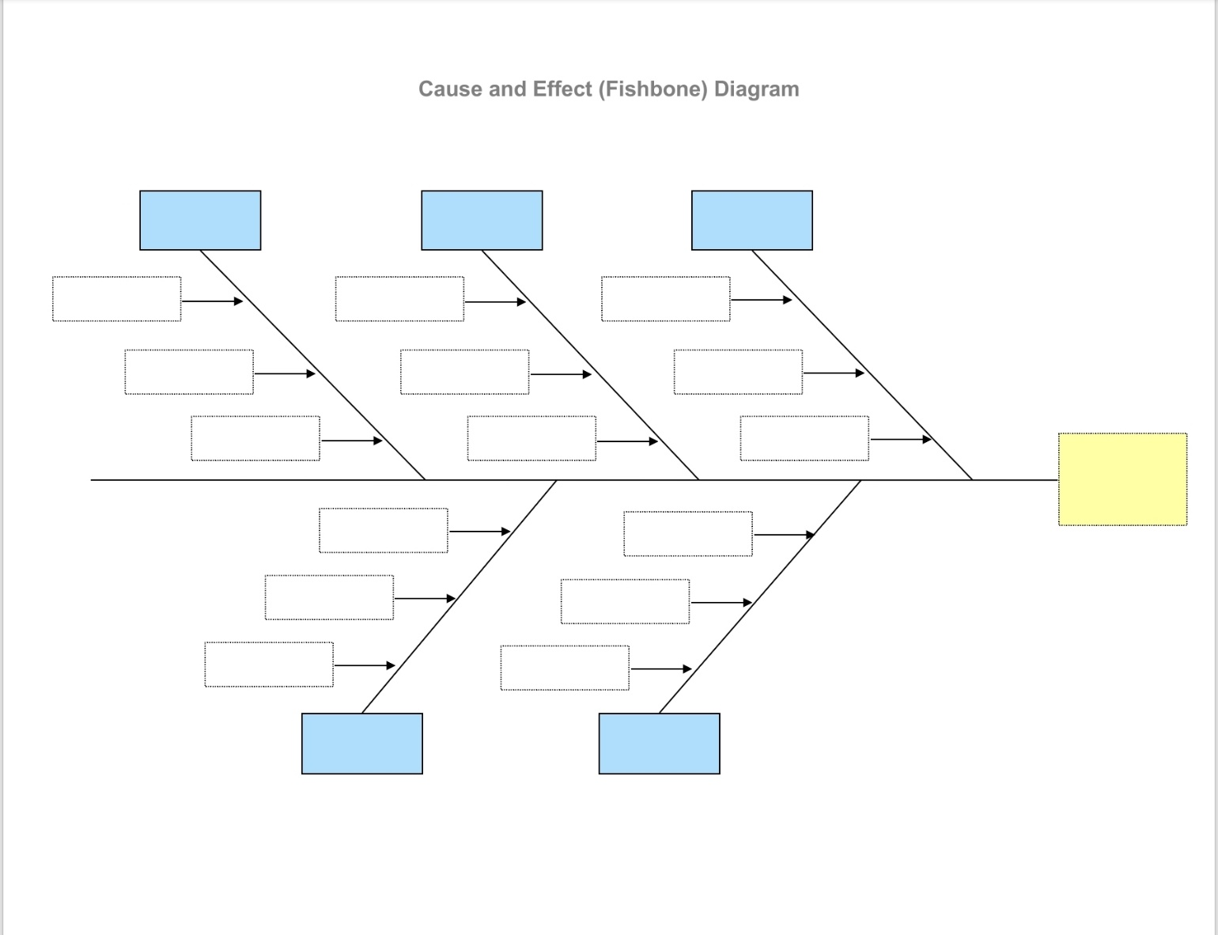

Key Findings & Academic References

​Summary of Key Findings
- ​Structural, Not Cyclical: The 25% revenue drop is a permanent structural shift caused by hybrid work and a dying retail park ecosystem, not a temporary post-pandemic dip.
- ​Operational Bottlenecks: The bakery's current format relies entirely on footfall and phone orders, failing to capture customers who want convenience or work from home.
- ​The Margin Squeeze: High fixed overheads combined with volatile organic ingredient costs make the current low-volume, physical-only model unsustainable.
- ​Strategic Imperative: Basil must decouple his revenue from physical footfall by introducing digital pre-ordering and exploring third-party hub delivery options.

​

Academic Reference List
- ​British Chambers of Commerce (BCC), 2024. The Impact of Rising Overheads on Small and Medium Enterprises in the UK Retail Sector. London: BCC Research.
- ​Chartered Institute of Personnel and Development (CIPD), 2025. Hybrid Work Practices and Their Ripple Effects on Local Service Economies. London: CIPD.
- ​Department for Environment, Food & Rural Affairs (DEFRA), 2025. Organic Farming Statistics and Crop Yield Volatility Report. London: HM Stationery Office.
- ​Ishikawa, K., 1986. Guide to Quality Control. Tokyo: Asian Productivity Organization.
- ​Johnson, G., Whittington, R., Regnér, P., Scholes, K. and Angwin, D., 2023. Exploring Strategy: Text and Cases. 12th ed. Harlow: Pearson Education.
(Used for PESTEL Application).

​

5W2H Diagnostic Model: Basil's Bakery
​Based on the case study details, here is the structured 5W2H analysis isolating the operational and macro-environmental boundaries of the bakery’s current deadlock.

Element | Diagnostic Question | Application to Basil's Bakery
Who | Who is affected by the problem? | Basil (restricted by onsite baking constraints) and three declining customer segments: retail shoppers, local shop workers facing redundancies, and hybrid office/warehouse staff.
What | What is the exact problem? | Revenue stagnation at 25% below 2019 baselines, heavily driven by an absolute lack of digital ordering infrastructure and exploding fixed overheads.
Where | Where is the problem occurring? | The physical retail park unit in Coventry, UK, which is poorly positioned adjacent to a declining industrial site and suffering from a "vicious vacancy cycle."
When | When did the issue solidify? | It was triggered by the 2020 pandemic lockdowns and solidified into permanent, structural stagnation between 2023 and 2025.
Why | Why is it happening? | A permanent structural shift to hybrid WFH models, mass retail park closures, a missing online delivery mechanism, and severe climate-impacted organic ingredient supply chain volatility.
How | How can the problem be seen/measured? | Through operational symptoms: unanswered landline phone calls during rush hours, long customer wait times, an increasing number of empty adjacent retail units, and shrinking profit margins.
How Much | How much is it costing the business? | A persistent 25% top-line sales loss relative to historical baselines, paired with double-digit percentage increases across fixed utility bills, rent, and property rates.

Presentation Question & Solutions Tip
Anticipated Question: “If Basil is too busy baking to handle deliveries, how can he realistically launch a delivery service without destroying his margins?”
Solution: Basil should not buy a delivery van or do it himself. Instead, he can partner with local, aggregate third-party delivery platforms (like JustEat, Deliveroo, or local Coventry couriers) and set a specific “click-and-collect” window. This automates the process, shortens in-store queues, and reaches hybrid workers at home without requiring extra staff.

